PROECT BASED LEARNING

190330124-KONDURU PRANAV

190330143-M VINAY KUMAR

190330085-G NRITHESH REDDY

**FACIAL EMOTION RECOGNITION**

**Definition of Project:**

Human facial expressions can be easily classified into 7 basic emotions: happy, sad, surprise, fear, anger, disgust, and neutral. Our facial emotions are expressed through activation of specific sets of facial muscles. These sometimes subtle, yet complex, signals in an expression often contain an abundant amount of information about our state of mind.

Design:

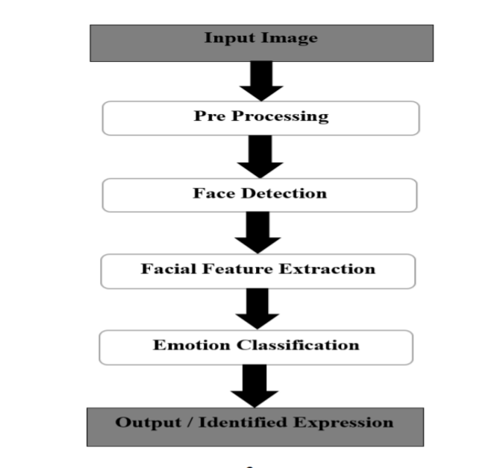

**Objective:**

The very first example can be feedback through moods at any restaurants and hotels about their services and foods. It can be much impactful in the field of military. Its very usage can be helpful for recognizing the people's behaviour at the border areas to find out the suspects between them. This project is just an implementation of the environment and not the actual software that can be useful in the real time environment.

**Requirements:**

This project consists of models made through various algorithms of machine as well as deep learning. It also uses some of the very powerful packages in python to create an application software that recognizes the expression of human in real time. Some of the libraries are: TensorFlow, Keras, OpenCV, Matplotlib. This implementation can be used at various places and platforms.

This project consists of two modules: (i)Processing and generating the model for the application using different algorithms and (ii) Application for using the model using OpenCV to recognize the human facial expression.