**Analysis:**

* Dataset consists of three columns (Date, MyWay, Paper Ticket)
* Date format – dd/mm/yyyy
* Date Range – 01/04/2023 to 30/04/2024
* Used Python for analysis

**Line Graph: (First 30 days)**

* It represents the comparison of Date and MyWay value

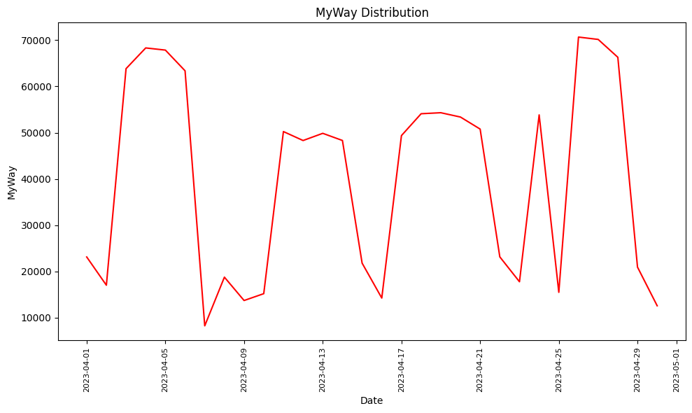

* Starts from April 1st 2023 and ends on April 30th 2023
* There is a peak on April 3rd till April 5th
* Sudden drop on April 7th
* Highest MyWay was on April 3rd
* Lowest MyWay was on April 7th

**Bar Graph Representation: (First 30 days)**

* It represents the comparison of Date and MyWay value

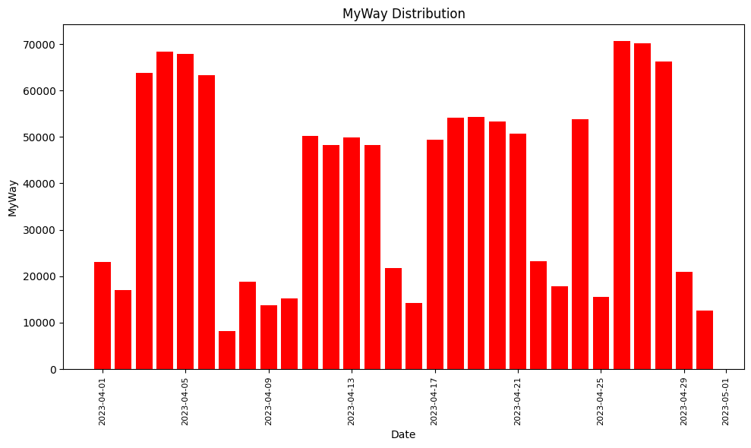

* Starts from April 1st 2023 and ends on April 30th 2023
* There is a peak on April 3rd till April 5th
* Sudden drop on April 7th
* Highest MyWay was on April 3rd
* Lowest MyWay was on April 7th

**Line Graph: (Last 30 days)**

* It represents the comparison of Date and MyWay value.

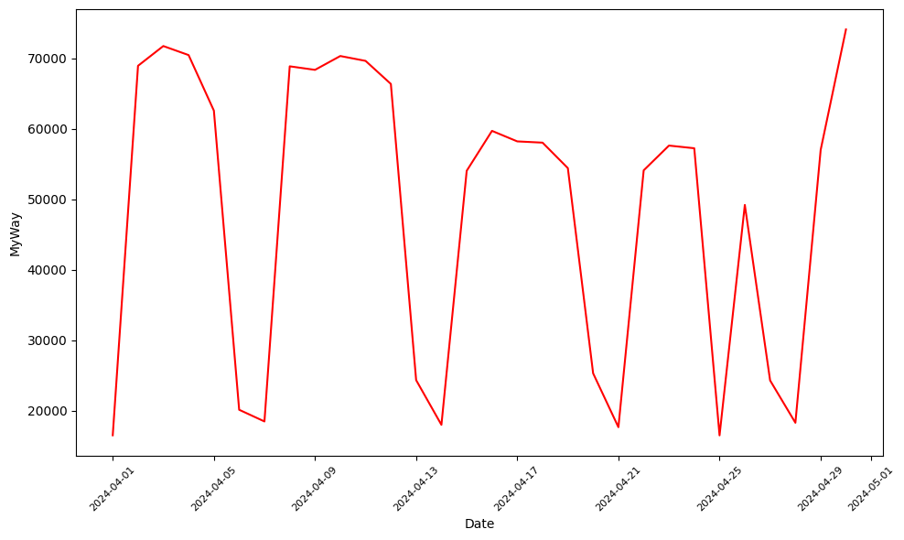

* Starts from April 1st 2024 and ends on April 30th 2024.
* There is a peak on April 3rd till April 5th.
* Sudden drop on April 7th.
* Highest MyWay was on April 3rd.
* Lowest MyWay was on April 7th.

**Bar Graph Representation: (Last 30 days)**

* It represents the comparison of Date and MyWay value.

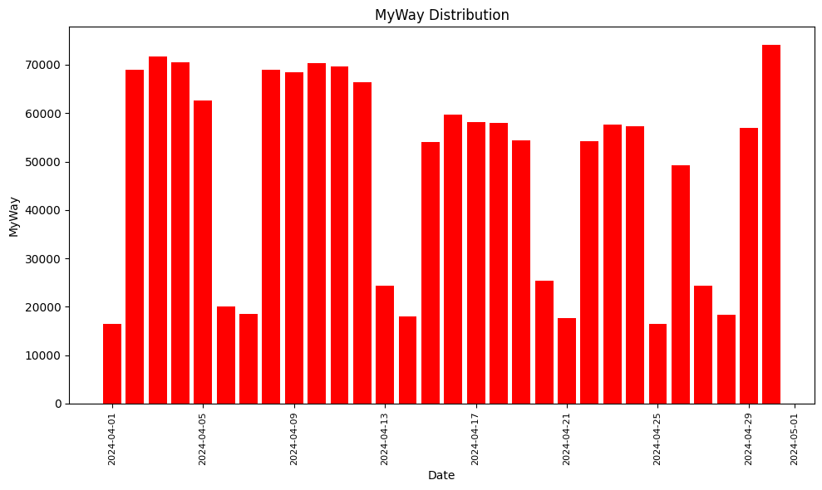

* Starts from April 1st 2024 and ends on April 19th 2024.
* There is a peak on April 3rd till April 5th.
* Sudden drop on April 7th.
* Highest MyWay was on April 3rd.
* Lowest MyWay was on April 7th.

**Insights:**

* The MyWay pecks on specific days of the month (Example – April 3rd, 4th, 5th).
* The MyWay gets low on specific days of the month (Example – April 7th ,14th, 25th).
* This same pattern is followed for both the years.
* There is a possibility this might be followed for all months.

**For May 2023:**

* Date ranges from May 1st 2023 to May 31st 2023.

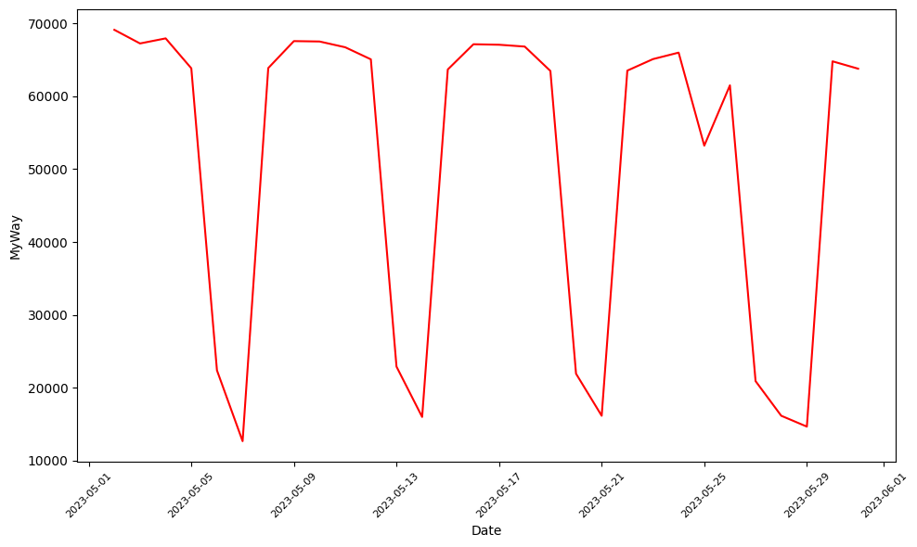

* It follows the same pattern as April 2023 and April 2024.
* MyWay peaks on certain days and goes down on certain days.
* Therefore, the pattern is based on the days of the month.