**Prediction:**

* Prediction is done using ARIMA (Auto Regressive Integrated Moving Average) model and Linear Regression.
* ARIMA is used since we use time forecast for the data.
* The prediction is done based on the given dataset.
* Input class is ‘Date’ and the target class is ‘MyWay’.
* Used Linear regression for finding the relation of ‘Date’ and ‘MyWay’.
* Used ARIMA for future predictions.
* Done evaluation Mean Absolute Error (MAE), Mean Squared Error (MSE), Root Mean Squared Error (RMSE), Mean Absolute Percentage Error (MAPE) and Forecast Bias for ARIMA model.
* R-squared Score is calculated for Linear Regression

**Evaluation Results:**

**ARIMA Model:**

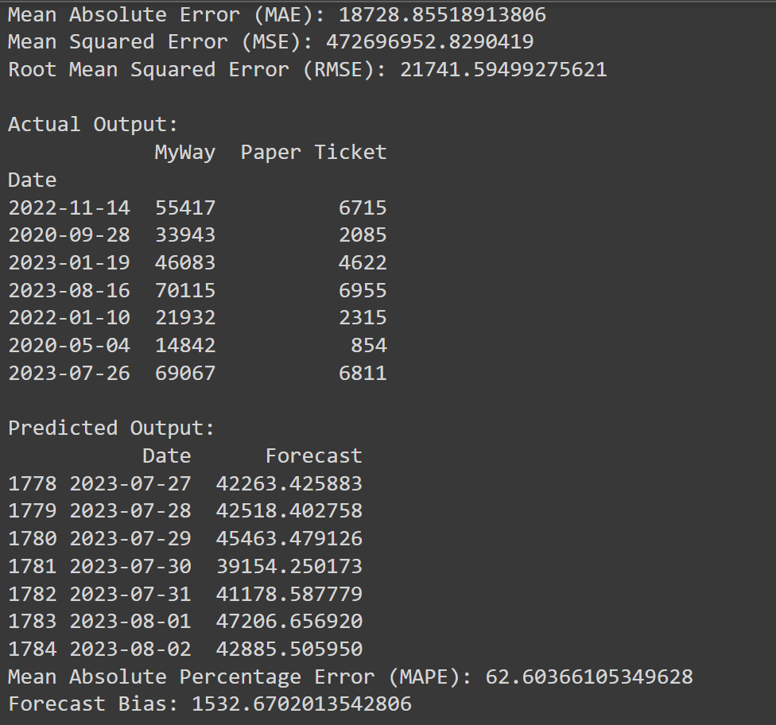

**Linear Regression:**

