**ADVANCED DIGITAL SYSTEM DESIGN WITH FPGAs**​

**DESIGN OF VENDING MACHINE USING​**

**VERILOG HDL​**

Pranav Kulkarni, Mujeeb Javed – Dept. of Electrical and Electronics Engineering

VIT, Chennai

​**ABSTRACT**: The vending machine is an automated machine that dispenses various products such as snacks, beverages, newspapers, tickets etc. to customers when money or credit card is inserted. Vending machines are more accessible and practical than the convention purchasing method Now, vending machine market is a big business with huge annual revenue for leading nations like The USA, Japan, China and some other Asian countries including India. The paper aims to design a vending machine that can dispense three products of different prices with additional features of ‘return change’ when a coin of higher denomination is inserted and ‘return money’ when request is cancelled. The machine accepts coins of denominations five and ten. The finite state machine (FSM) approach is adopted for the design of vending machine. The design is achieved by formulating the Verilog code for the FSM-based machine using behavioral modeling and simulating the testbench for three products using Xilinx ISE tool.

**Introduction**

The Vending Machine is an automatic machine that sells food such as canned soups and packaged sandwiches, snacks such as potato chips, chocolate bars, and candy); hot drinks (coffee, tea, and hot chocolate); cold drinks (juice, bottled water, soft drinks, and in some cases, milk or chocolate milk); or other items such as newspapers or tickets. The machines usually work when a product is selected and some money (usually coins or paper money) is put in a slot. Then, a button needs to be pushed, or a lever pulled. If there is enough money, the selected item will be dropped to a tray, where it can be taken out by the person making the purchase. From 2000-2010, the specialization of vending machines became more common. Vending extended increasingly into non-traditional areas like electronics, or even artwork or short stories. Machines of this new category are generally called Automated retail kiosks. When using an automated retail machine, consumers select products, sometimes using a touch screen interface, pay for purchases using a credit or debit card and then the product is dispensed, sometimes via an internal robotic arm in the machine. The trend of specialization and proliferation of vending machines is perhaps most apparent in Japan where there is 1 vending machine for 23 people. Apparently similar to the development of traditional mobile phones into smartphones, vending machines have also progressively, though at a much slower pace, evolved into smart vending machines. Newer technologies at a lower cost of adoption, such as the large digital touch display, internet connectivity, cameras and various types of sensors, more cost-effective embedded computing power, digital signage, various advanced payment systems, and a wide range of identification technology (NFC, RFID, etc) have contributed to this development.. Integrated sensors and cameras also represent a source of such data as customer demographics, purchase trends, and other locality-specific information. It also enables better customer engagement for the brands through interactive multimedia and social media connectivity. Smart vending machines were #79 by JWT Intelligence on its list of 100 Things to Watch in 2014. According to market research by Frost & Sullivan, global shipments of smart vending machines are forecasted to reach around 2 million units by 2018 and further to 3.6 million units by 2020 with penetration rate of 20.3 percent.

**Finite state machines**

To know the working of our machine its necessary for us to have prior knowledge of Finite state machineA state machine is a behavior model. It consists of a finite number of states and is therefore also called finite-state machine (FSM). Based on the current state and a given input the machine performs state transitions and produces outputs. There are basic types like Mealy and Moore machines and more complex types like Harel and UML state charts.

Our project is based on Mealy and Moore machines

The basic building blocks of a state machine are states and transitions. A state is a situation of a system depending on previous inputs and causes a reaction on following inputs. One state is marked as the initial state; this is where the execution of the machine starts. A state transition defines for which input a state is changed from one to another. Depending on the state machine type, states and/or transitions produce outputs.

Consider the simple state machine above. It consists of two states, Off and On. On is the initial state here; it is activated when the state machine is executed. The arrows between the states denote the possible state transitions. They define for which input a state change occurs. Here, the active state is changed from On to Off for the input button pressed, and back again to On for the same input.

***Moore***

Moore machine, named after its inventor Edward Moore, who introduced the concept in 1956. Moore machines consist of states and transitions. States are able to produce outputs, and the output is determined solely by the current state, not by any input.

***Mealy***

Mealy machines were invented by George H. Mealy in 1955. In comparison with Moore machines, Mealy machines produce outputs only on transitions and not in states. This often results in state diagrams with fewer states because more logic can be put on transitions.

**Working of the design code:**

First, we have fixed 3 input formats, if the input is 2’b01=Rs5 or 2’b10=Rs10 or 2’b11=Rs20. Also 2’b11 equals Rs20 only if it is given as input otherwise 2’b11 represents Rs15 State. Now a module has been created and the ports have been mentioned within the brackets. Within the module block we first mention the parameters s0,s1,s2,s3 these will signify our different states of the FSM model we developed In the previous sections. Rs0 state/Reset state, Rs5 state, Rs10 state, Rs15 state are represented by s0,s1,s2,s3 respectively. We also have created a parameter n which will act as our product selector i.e whether it is a Rs10,Rs15,Rs20 product. Now inside the always block, according to the value of n there will be a different section of the code that will run and give us the output. For example if n=10:- This program runs based on case statements. The first case is for s0: within these cases there are multiple if loops that will determine the next state of the vending machine and also the output. If the input is of 2’b00 which is essentially Rs0 the state of the machine will not change and also won’t give any output, now when the input is 2’b01 the next becomes s1 as the input given was Rs5 but it is not sufficient to give the desired product which is of worth Rs10 and so the machine waits for more currency to be added until it has enough to dispense the product with the change if any. Similarly the program will run the same way our FSM model works.

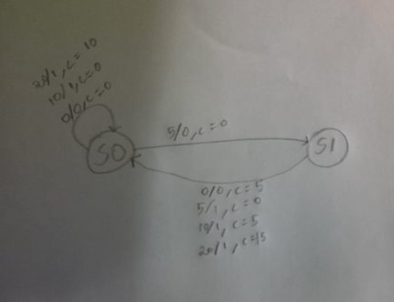

**STATE DIAGRAM FOR PRODUCT = RS10​**

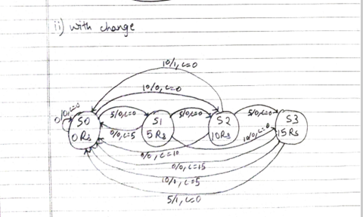

**STATE DIAGRAM FOR PRODUCT = Rs20​**

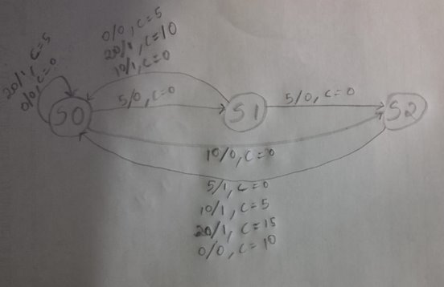

**STATE DIAGRAM FOR PRODUCT= RS15**

**Working of the test bench code:**

Test bench coding is necessary as it will verify the design of our program and it also ensures the timing and overall functionality of the machine designed. Code starts with module creation, inside the module we define the input and output ports as reg and wire respectively. Then we instantiate the design module that we had created in the section prior to this. Now we initialize rst=1 and clk=0, when rst=0 the machine will start working with every positive edge of the clk waveform. After a #6 delay we set rst to zero and give our first denomination input which is 2’b01 (Rs5), after another #19 delay we give our second input of 2’b10 (Rs10) this delay is given so that we can study and understand the working accurately. Further input of 2’b11 (Rs20) is given after another #20 for the same reason and the block is ended. We set the clock waveform to have high and low values every 5ns.

**Waveforms:**

N=10

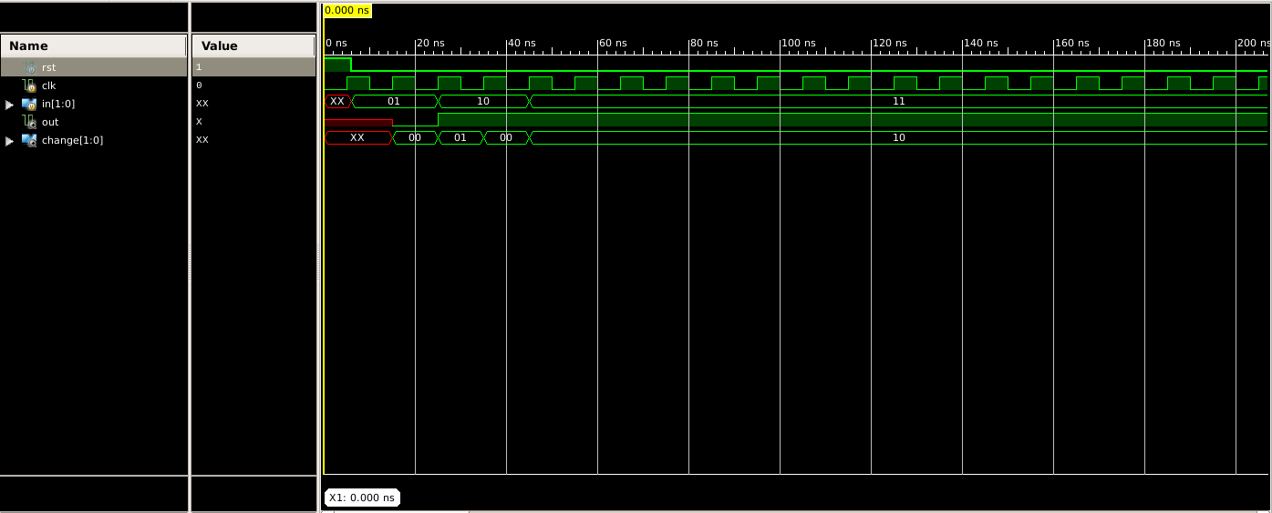

N=15

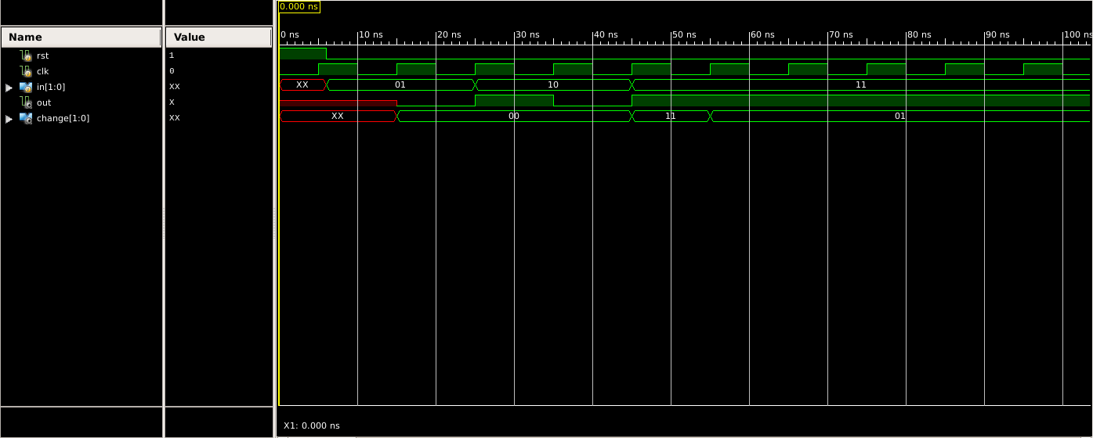

N=20

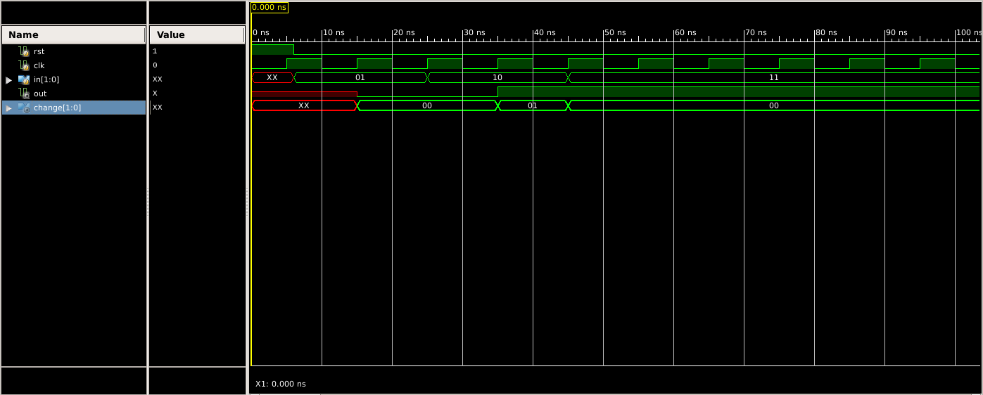

**Applications ​**

***Foods and Drinks****​*

Greatest application for vending machines is either food or drink or both! Snack and cold/hot drink are the best thing we ever get out of these machines. ​

***For tickets sale​***

It is used to sell tickets ahead of any specific event ranging from a local baseball game to a music concert to a drama show. ​

***For Condom distribution​***

This sounds strange! But is a fact that nobody can ignore! Walk around your street and we bet, you’ll notice at least one of it. So why to go to medical or retail shop? Just locate yourself to nearby condom vending machine and get it off the machine. ​

***Advanced uses/applications​***

With recent massive technological changes, we have come across some other non-traditional uses of vending machines wherein we have witnessed machines that dispense gold, newspapers and many other items. ​

***Development continues​***

Since its evolution, we have witnessed simple to smart machines, but wait, the development is still under the process and we are sure to come across even smarter, better and wider range of vending machine that are sure to make our life easier! ​

**CONCLUSIONS**

The vending machine was successful in dispensing three products A, B and C of prices Rs.10/-, Rs.15/- and Rs-20/- respectively, with the additional features of dispensing product along with returning change when higher denomination coin is inserted and returning total money when request is cancelled. The vending machine is successful in meeting the specifications laid out prior to the design.

**REFERENCES**

[1] R. Kiran Kumar, “FSM Based Design on the Replication of one-hot code using Verilog HDL,” Global Jouranl of Advanced

Engineering Technologies, Vol.2, Issue-3, 2013.

[2] Abishek Luthra, “Design and Implementation of Vending Machine using Verilog HDL on FPGA,” International Journal of

Innovative Research in Science, Engineering and Technology, Vol.4, Issue-11, November, 2015.

[3] Ana Monga, Balwinder Singh, Academic and Consultancy-Services Division, Centre for Development of Advanced

Computing (C-DAC), Mohali, India, “Finite State Machine based Vending Machine Controller with Auto-Billing Features,”

International Journal of VLSI design and Communication Systems (VLSICS), Vol.3, No.2, April 2012.

[4] P. Pradeepa, T. Sudhalavanya, K. Suganthi, N. Suganthi, M.Menagadevi, Suganthi, et. al., “Design and Implementation of

Vending Machine using Verilog HDL,” International Journal of Advanced Engineering Technology.

[5] Muhammad Ali Qureshi, Abdul Aziz, Hafiz Faiz Rasool, Muhammad Ibrahim, Usman Ghani, Hasnain Abbas, “Design and

Implementation of Vending Machine using Verilog HDL,” 2nd International Conference on Networking and Information

Technology, IPCSIT, Vol.7, 2011.

[6] Ana Monga, Balwinder Singh, “Finite State Machine based Vending Machine Controller with Auto-billing Features,”

International Journal of VLSI Design and Communication Systems, Vol.3, No.2, April, 2012.

[7] Ashwag Alrehily, Ruquiah Fallatah, Vijey Thayananthan, “Design of Vending Machine using Finite State Machine and

Visual Automata Simulator,” International Journal of Computer Applications, Vol.115, No.18, April, 2015.

[8] B. Jyothi, I. Sarah, A. Srinivas, “Implementation of FPGA based Smart Vending Machine,” International Journal of

Engineering Research and Applications, National Conference on Engineering Developments, Advances and Trends, January,

2015.

[9] Chexel D. Augustin, Sarah Grace P. De Castro, Paul Jonathan B. Dimaano, Sarah Dyan S. Garraton, Rionel Belen Caldo,

“Password Protected Vending Machine with Moore Finite State Machines using Verilog,” Laguana Journal of Engineering

and Computer Sciences, Vol.3, No.2, March 2016.

[10] Ritika Kalihari, Toran Verma, Alka Jaiswal, “Concept of Automated Machine using Mealy,” International Journal of

Computer Applications Technology and Research, Vol.2, Issue-3, pp.335-339, 2013.