NAME: Madhavi Kadam CLASS: FYMCA-B SUBJECT: AR-VR ROLLNO: 65

Assignment-2

**Assignment Title-** A VR (Virtual Reality) device is a piece of hardware that allows users to experience virtual reality, an immersive digital environment that simulates physical presence in a

computer-generated world. VR devices typically consist of a headset or goggles equipped with displays, sensors, and sometimes audio systems, as well as handheld controllers for interaction.

HTC Vive:

* The HTC Vive is a high-end VR headset developed in collaboration with Valve Corporation.
* It utilizes external base stations placed in the room to track the headset and controllers with sub-millimeter accuracy.
* The Vive features room-scale tracking, allowing users to physically move around in a designated play area.
* It offers high-resolution displays, precise motion tracking, and hand controllers for immersive experiences.

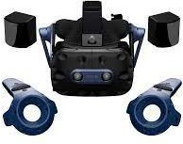

Google Cardboard:

* Google Cardboard is a low-cost VR platform developed by Google.
* It consists of a simple cardboard viewer into which a compatible smartphone is inserted.
* The smartphone's screen acts as the display, and its sensors enable basic head tracking.
* Cardboard experiences are typically less immersive compared to high-end VR systems but provide an accessible entry point to VR content.

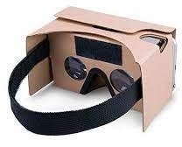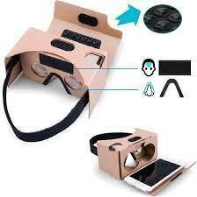

Google Daydream:

* Google Daydream is a more advanced VR platform compared to Cardboard.
* It features a comfortable headset with a built-in controller for navigation and interaction.
* Daydream-compatible smartphones slot into the headset, providing a high-resolution display and responsive tracking.
* Daydream offers a growing library of VR apps and experiences, including games, educational content, and immersive videos.

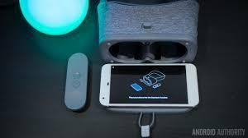

Samsung Gear VR:

* Samsung Gear VR is a VR headset developed in partnership with Oculus VR.
* It is designed specifically for Samsung Galaxy smartphones, which serve as the headset's display and processing unit.
* Gear VR offers a wide field of view and low-latency tracking, providing immersive VR experiences.
* It includes a touchpad and buttons on the side of the headset for navigation and interaction.
* Each of these VR devices caters to different user needs and budgets, ranging from high-end, room-scale experiences with the HTC Vive to more accessible and portable options like Google Cardboard and Samsung Gear VR.

