PORE-LM: A Personalized Outcome-Aware Real-World Evidence Module for Language Models
Pranav Manjunath¹, Brian Lerner¹,Brad J Kolls, MD, PhD¹, Timothy W. Dunn, PhD¹
¹Duke University, Durham, NC, USA

Abstract
Language models perform well on medical benchmarks but often struggle with individualized real-world clinical patient outcome prediction. We introduce PORE-LM, a Personalized Outcome-aware Real-World Evidence module that augments language models by retrieving similar prior patients as contextual evidence. Evaluated on a multimodal emergency dataset for a cohort of traumatic brain injury encounters. PORE-LM improves outcome prediction across language models and clinical outcomes, highlighting the importance of outcome-aware patient retrieval.
Figure 1. PORE-LM Workflow: A test patient is converted into a textual summary and encoded as an embedding. An outcome-aware adapter transforms the embedding to retrieve the top-K similar patients, which are incorporated as textual evidence for the language model.

Introduction

Today, language models are seeing widespread adoption for answering medical-related questions¹ and have demonstrated strong performance on standardized medical examinations and benchmark datasets, often achieving scores comparable to or exceeding those of clinical professionals². However, language models that perform well on general medical knowledge tasks may struggle when faced with individualized clinical contexts and outcome prediction tasks³, as clinical reasoning often requires interpreting heterogeneous patient-specific data. Recent work⁴ has demonstrated that augmenting language models with real-world evidence (RWE), context derived from similar prior patients, can improve performance on real-world clinical outcome prediction though these evaluations have typically focused on individual outcomes or model settings. Extending prior work, we introduce PORE-LM, a Personalized, Outcome-aware RWE module for Language Models, and demonstrate its robustness across multiple clinical outcomes in traumatic brain injury (TBI) care. PORE-LM retrieves outcome-relevant prior patients as contextual evidence for each test case, enabling personalized outcome prediction. Across language models and outcomes, we demonstrate that incorporating RWE as context yields consistent performance gains and that RWE is inherently outcome-aware: the set of prior patients most informative for a given individual varies systematically with the clinical outcome being predicted.

Methods
We evaluated PORE-LM on a large multimodal cohort of TBI emergency department (ED) encounters collected from three institutions within the Duke Health System. Each encounter was treated as an individual patient instance. The dataset includes laboratory analytes, vital signs, CT-derived imaging features, radiology report labels, and clinical orders recorded during the ED visit. Patients who expired in the ED were excluded from the cohort. Performance was evaluated on a held-out test set of 2,236 patients, with patient retrieval performed over a database of 9,466 patients. We consider three clinically relevant binary outcomes: ED disposition, predicting whether a patient is admitted to the hospital or discharged from the ED (29.7% admission rate); favorable discharge disposition, defined as discharge to home or rehabilitation versus unfavorable negative outcomes (13.5% negative rate) such as critical care, long-term acute care, transfer, skilled nursing facility placement, or in-patient death; and in-patient mortality, a highly imbalanced outcome indicating whether a patient died during the hospital stay (~3% event rate).
As illustrated in Figure 1, each test patient is represented into a textual summary and the patient’s multimodal clinical data using an autoencoder to obtain a generalizable patient encounter embedding. To support outcome-aware retrieval, we learn lightweight outcome-aware gating adapters on top of this embedding space, each trained using supervised contrastive learning to reshape the representation according to the outcome of interest. Retrieved patients are then converted into structured textual summaries and appended as contextual evidence to the language model. We evaluate PORE-LM across six language models: SmolLM, Phi, Qwen, MediPhi, MediPhi Guideline, and MediPhi Clinical.
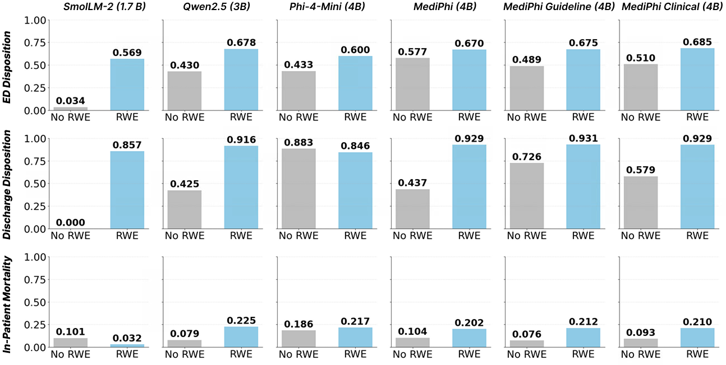
Figure 2. Predictive Performance (F1 Scores) with and without RWE (K=5) as context across clinical outcomes and language models

Results
Figure 2 shows that incorporating similar past patients as context in PORE-LM improves performance across the majority of models and clinical outcomes. On average, we observe increases in F1 score of 0.234 for ED Disposition, 0.391 for Discharge Disposition, and 0.077 for Expired across all language models. As illustrated in Figure 3a, outcome-aware embedding space for ED Disposition and Discharge Disposition leads to noticeable improvements across all language models, while for in-patient mortality the improvements are observed for all models except SmolLM. Figure 3b shows that most test patients share only 1–2 of 5 neighbors between outcome-aware and generalizable embedding spaces, suggesting that personalization significantly reshapes patient neighborhoods.
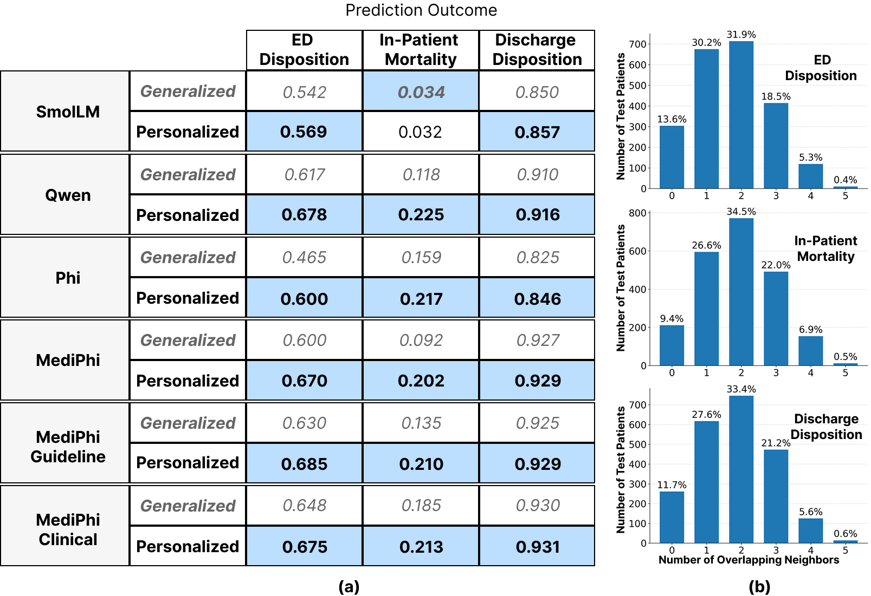
Figure 3. [K=5] (a) F1 Scores for Generalized Embedding space vs Outcome-aware Personalized Embeddings space across all language models (b) The average distribution of overlapping neighbors between the generalized and outcome-aware embedding space across outcomes.

Discussion
These findings highlight the importance of incorporating outcome-aware real-world evidence when applying language models to patient-specific clinical decision-making. By retrieving clinically similar prior patients in an outcome-aware embedding space, PORE-LM grounds predictions in relevant clinical precedents and improves performance across models and outcomes. More broadly, our results suggest that personalized retrieval of real-world evidence may help adapt general-purpose language models to complex, individualized clinical reasoning tasks.

Conclusion
Together, these results demonstrate that incorporating outcome-aware real-world evidence can substantially enhance the ability of language models to perform patient-centered clinical outcome prediction. PORE-LM provides a scalable framework for grounding language model reasoning in clinically relevant prior cases, enabling more personalized and context-aware decision support in real-world healthcare settings.

References
1. Al Shboul MKI, Alwreikat A, Alotaibi FA. Investigating the Use of ChatGpt as a Novel Method for Seeking Health Information: A Qualitative Approach. Sci Technol Libr. 2024 Jul 2;43(3):225–34. doi:10.1080/0194262X.2023.2250835
2. Singhal K, Tu T, Gottweis J, Sayres R, Wulczyn E, Amin M, et al. Toward expert-level medical question answering with large language models. Nat Med. 2025 Mar;31(3):943–50. doi:10.1038/s41591-024-03423-7
3. Bedi S, Cui H, Fuentes M, Unell A, Wornow M, Banda JM, et al. MedHELM: Holistic Evaluation of Large Language Models for Medical Tasks. arXiv; 2025. doi:10.48550/ARXIV.2505.23802
4. Manjunath P, Lerner B, Dunn TW. Trust Your Neighbors: Multimodal Patient Retrieval for TBI Prognosis. IEEE J Biomed Health Inform. 2025 Dec;29(12):8775–82. doi:10.1109/JBHI.2025.3622508

