BME 240L Lab 4

Pranav Maddula

Alexa Panrudkevich

Nicole Clark

Problem 1:

Code:

%% Problem 1 - Jump Height

%Calculates heights for jumps of given time

y1 = jump_height(.14);

y2 = jump_height(.26);

y3 = jump_height(.34);

y4 = jump_height(.59);

y5 = jump_height(.78);

%Stores X and Y values in a vector

X = [.14,.26,.34,.59,.78]

Y = [y1,y2,y3,y4,y5]

%plots x and y values

plot(X,Y)

title('Jump Height vs. Time') %Graph Title

xlabel('Time (sec)'); %X axis label

ylabel('Height (m)'); %Y axis label

annotation('textbox', [0,0.05,0.5,0],'string','This a figure that shows the relationship between 5 flight times (.14,.26,.34,.59,.78 sec) and the heights of the resulting jumps.');

Function:

function [height] = jump_height(time)

%Calculates jump height based on flight time, using given equations 1.1 and

%1.2

height = ((9.8*time/2)^2) / (2*9.8);

end

Graphs:

Problem 2:

Code:

%% Problem 2 - Hip Forces

% Given Values

FW=667;

FC1=0;

FC2=120;

FC3=120;

A=.1;

B=.08;

C1=0;

C2=.3;

C3=.3;

disp('First is standing with no cane, next is standing with a cane ipsilateral, and finally is standing with a cane contralateral')

disp('first is FM and second is FJ')

%Calculate values

[FM1,FJ1] = Standing_No_Cane(FW,FC1,A,B,C1);

[FM2,FJ2] = Standing_Cane_On_Same_Side(FW,FC2,A,B,C2);

[FM3,FJ3] = Standing_Cane_On_Other_Side(FW,FC3,A,B,C3);

format long g %format values

%display values

disp([FM1,FJ1])

disp([FM2,FJ2])

disp([FM3,FJ3])

Functions:

function [FM,FJ] = Standing_No_Cane(FW,FC,A,B,C)

%Calculates FM and FJ given FW,FC,A,B,C

FM = (FW*A)/B;

FJ = FM+FW-FC;

end

function [FM,FJ] = Standing_Cane_On_Same_Side(FW,FC,A,B,C)

%Calculates FM and FJ given FW,FC,A,B,C

FM = ((FW*A)+(FC*(C-A)))/B;

FJ = FM+FW-FC;

end

function [FM,FJ] = Standing_Cane_On_Other_Side(FW,FC,A,B,C)

%Calculates FM and FJ given FW,FC,A,B,C

FM = ((FW*A)-(FC*(C+A)))/B;

FJ = FM+FW-FC;

end

Output:

First is standing with no cane, next is standing with a cane ipsilateral, and finally is standing with a cane contralateral

first is FM and second is FJ

833.75 1500.75

1133.75 1680.75

233.75 780.75

Problem 3:

Code:

%% Problem 3 - Cardiac Mechanics pt. 1

% Use given start and ending times

t_start = 80

t_end = 230

%given initial values

y0 = 2.4

%Stores calculated values from ode45

[t,y] = ode45(@Cardiac_Mechanics, [t_start t_end],[y0]);

figure(2) %starts fig

plot(t,y) % Plots

title('Sarcomere length vs. Time') %Graph Title

xlabel('Time (ms)'); %X axis label

ylabel('SL (um)'); %Y axis label

annotation('textbox', [0,0.05,0.5,0],'string','A plot of sarcomere length vs time, solved by ode45, using the conditions of 80ms to 230ms');

Function:

function [dSLdt] = Cardiac_Mechanics(t,SL)

T=40;

SL0=2.4;

SLZ = 1.6;

SL_rest = 2;

v_max = .006;

ta = 500;

t_max = 100;

B = 68.67;

t_star = t/ta;

tau = t_max/ta

%ft_star = 0

if t_star <= tau

ft_star = sin((pi*t_star)/(2*tau)).^2;

else

ft_star = sin((pi*(1-t_star))/(2*(1-tau))).^2;

end

dSLdt = v_max * ((T/((ft_star * B)*((1-(((SL-SL0)^2)/((SLZ-SL0)^2))*(SL/SL_rest))))) -1)

end

Output:

Problem 4:

Code:

%% Problem 4 - Cardiac Mechanics pt. 2

%Given Start and stop times

t_start = 120

t_end = 270

%given initial values

y0 = 2.4

%Stores calculated values from ode45

[t,y] = ode45(@Cardiac_Mechanics, [t_start t_end],[y0]);

figure(3) % Starts fig

plot(t,y) % Plots

title('Sarcomere length vs. Time') %Graph Title

xlabel('Time (ms)'); %X axis label

ylabel('SL (um)'); %Y axis label

annotation('textbox', [0,0.05,0.5,0],'string','A plot of sarcomere length vs time, solved by ode45, using the conditions of 120ms to 230ms');

Function:

Same as Problem 3.

Output:

**MATLAB Publish Output:**

**Contents**

* Problem 1 - Jump Height
* Problem 2 - Hip Forces
* Problem 3 - Cardiac Mechanics pt. 1
* Problem 4 - Cardiac Mechanics pt. 2

**Problem 1 - Jump Height**

%Calculates heights for jumps of given time

y1 = jump_height(.14);

y2 = jump_height(.26);

y3 = jump_height(.34);

y4 = jump_height(.59);

y5 = jump_height(.78);

%Stores X and Y values in a vector

X = [.14,.26,.34,.59,.78]

Y = [y1,y2,y3,y4,y5]

%plots x and y values

plot(X,Y)

title('Jump Height vs. Time') %Graph Title

xlabel('Time (sec)'); %X axis label

ylabel('Height (m)'); %Y axis label

annotation('textbox', [0,0.05,0.5,0],'string','This a figure that shows the relationship between 5 flight times (.14,.26,.34,.59,.78 sec) and the heights of the resulting jumps.');

X =

Columns 1 through 3

0.14 0.26 0.34

Columns 4 through 5

0.59 0.78

Y =

Columns 1 through 3

0.02401 0.08281 0.14161

Columns 4 through 5

0.4264225 0.74529

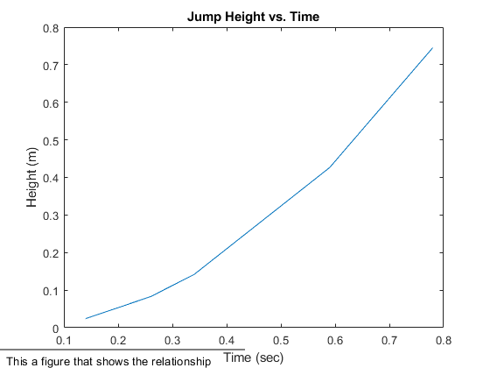

**Problem 2 - Hip Forces**

Given Values

FW=667;

FC1=0;

FC2=120;

FC3=120;

A=.1;

B=.08;

C1=0;

C2=.3;

C3=.3;

disp('First is standing with no cane, next is standing with a cane ipsilateral, and finally is standing with a cane contralateral')

disp('first is FM and second is FJ')

%Calculate values

[FM1,FJ1] = Standing_No_Cane(FW,FC1,A,B,C1);

[FM2,FJ2] = Standing_Cane_On_Same_Side(FW,FC2,A,B,C2);

[FM3,FJ3] = Standing_Cane_On_Other_Side(FW,FC3,A,B,C3);

format long g %format values

%display values

disp([FM1,FJ1])

disp([FM2,FJ2])

disp([FM3,FJ3])

First is standing with no cane, next is standing with a cane ipsilateral, and finally is standing with a cane contralateral

first is FM and second is FJ

833.75 1500.75

1133.75 1680.75

233.75 780.75

**Problem 3 - Cardiac Mechanics pt. 1**

% Use given start and ending times

t_start = 80

t_end = 230

%given initial values

y0 = 2.4

%Stores calculated values from ode45

[t,y] = ode45(@Cardiac_Mechanics, [t_start t_end],[y0]);

figure(2) %starts fig

plot(t,y); % Plots

title('Sarcomere length vs. Time') %Graph Title

xlabel('Time (ms)'); %X axis label

ylabel('SL (um)'); %Y axis label

annotation('textbox', [0,0.05,0.5,0],'string','A plot of sarcomere length vs time, solved by ode45, using the conditions of 80ms to 230ms');

t_start =

80

t_end =

230

y0 =

2.4

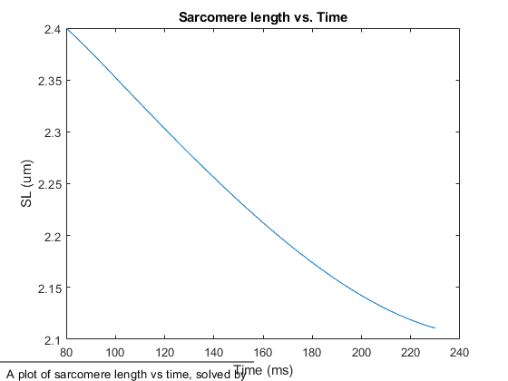

**Problem 4 - Cardiac Mechanics pt. 2**

%Given Start and stop times

t_start = 120

t_end = 270

%given initial values

y0 = 2.4

%Stores calculated values from ode45

[t,y] = ode45(@Cardiac_Mechanics, [t_start t_end],[y0]);

figure(3) % Starts fig

plot(t,y); % Plots

title('Sarcomere length vs. Time') %Graph Title

xlabel('Time (ms)'); %X axis label

ylabel('SL (um)'); %Y axis label

annotation('textbox', [0,0.05,0.5,0],'string','A plot of sarcomere length vs time, solved by ode45, using the conditions of 120ms to 230ms');

t_start =

120

t_end =

270

y0 =

2.4

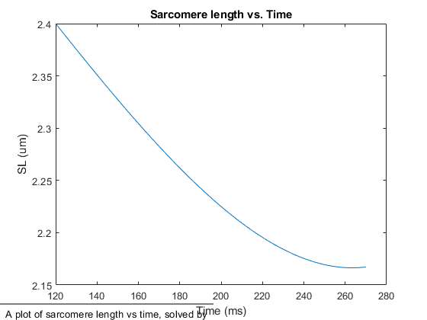

[*Published with MATLAB® R2018a*](https://www.mathworks.com/products/matlab/)