**Introduction:**

The objective of this lab is to build a model for light adaptation feedback in the retina of turtles. This is done by building the model proposed by *Tranchina et al., 1984* in Simulink. The model is described via the equations below:

$$H\left(f,I_{0}\right)= \frac{A(f)}{1+I_{0}B(f) } and R\left(t\right)= R_{0}+ R_{1}sin⁡(2πft+ θ)$$

$$A\left(s\right)= \frac{A_{0}}{τ_{1}^{3}τ_{2}^{7}}\frac{1}{{(s- \frac{-1}{τ_{1}})}^{3}{(s- \frac{-1}{τ_{2}})}^{7}} and B\left(s\right)=B_{0}\frac{τ_{1}τ_{2}^{3}}{τ_{3}τ_{4}^{3}}\frac{(s- \frac{-1}{τ_{1}}){(s- \frac{-1}{τ_{2}})}^{3}}{(s- \frac{-1}{τ_{3}}){(s- \frac{-1}{τ_{4}})}^{3}}$$

Where $s=iω$ and $ω=2πf$

For this set of equations, *H(f,I0)*, represents the output, which is in the form of *R(t)*. R0 represents the steady-state DC value of the output, while R1 represents the amplitude of the steady-state oscillation. The paper originally gives functions for *A(f)* and *B(f)*, however, they have been rewritten in the standard zero pole form to work more easily with Simulink. *A(f)* and *B(f)* were transformed to *A(s)* and *B(s)* by the substitutions $s=iω$ and $ω=2πf$.

The input for the model was $I_{0}+ I_{1}sin⁡(2πft)$, where I0 is the mean light level, and I1 is the amplitude of the changing light signal. Thus, to capture the dynamics of the system, the relative gain, ${R_{1}}/{I_{1}}$, is the parameter of interest for the rest of the lab. For the equations for *A(s)* and *B(s), τ* is an experimentally derived constant. Note that τ1 and τ2 for *A(s)* and *B(s)* are not the same.

**Results:**

Recreating the first part of **Fig. 1** from *Tranchina et al., 1984,* using the Simulink model built yields the following:

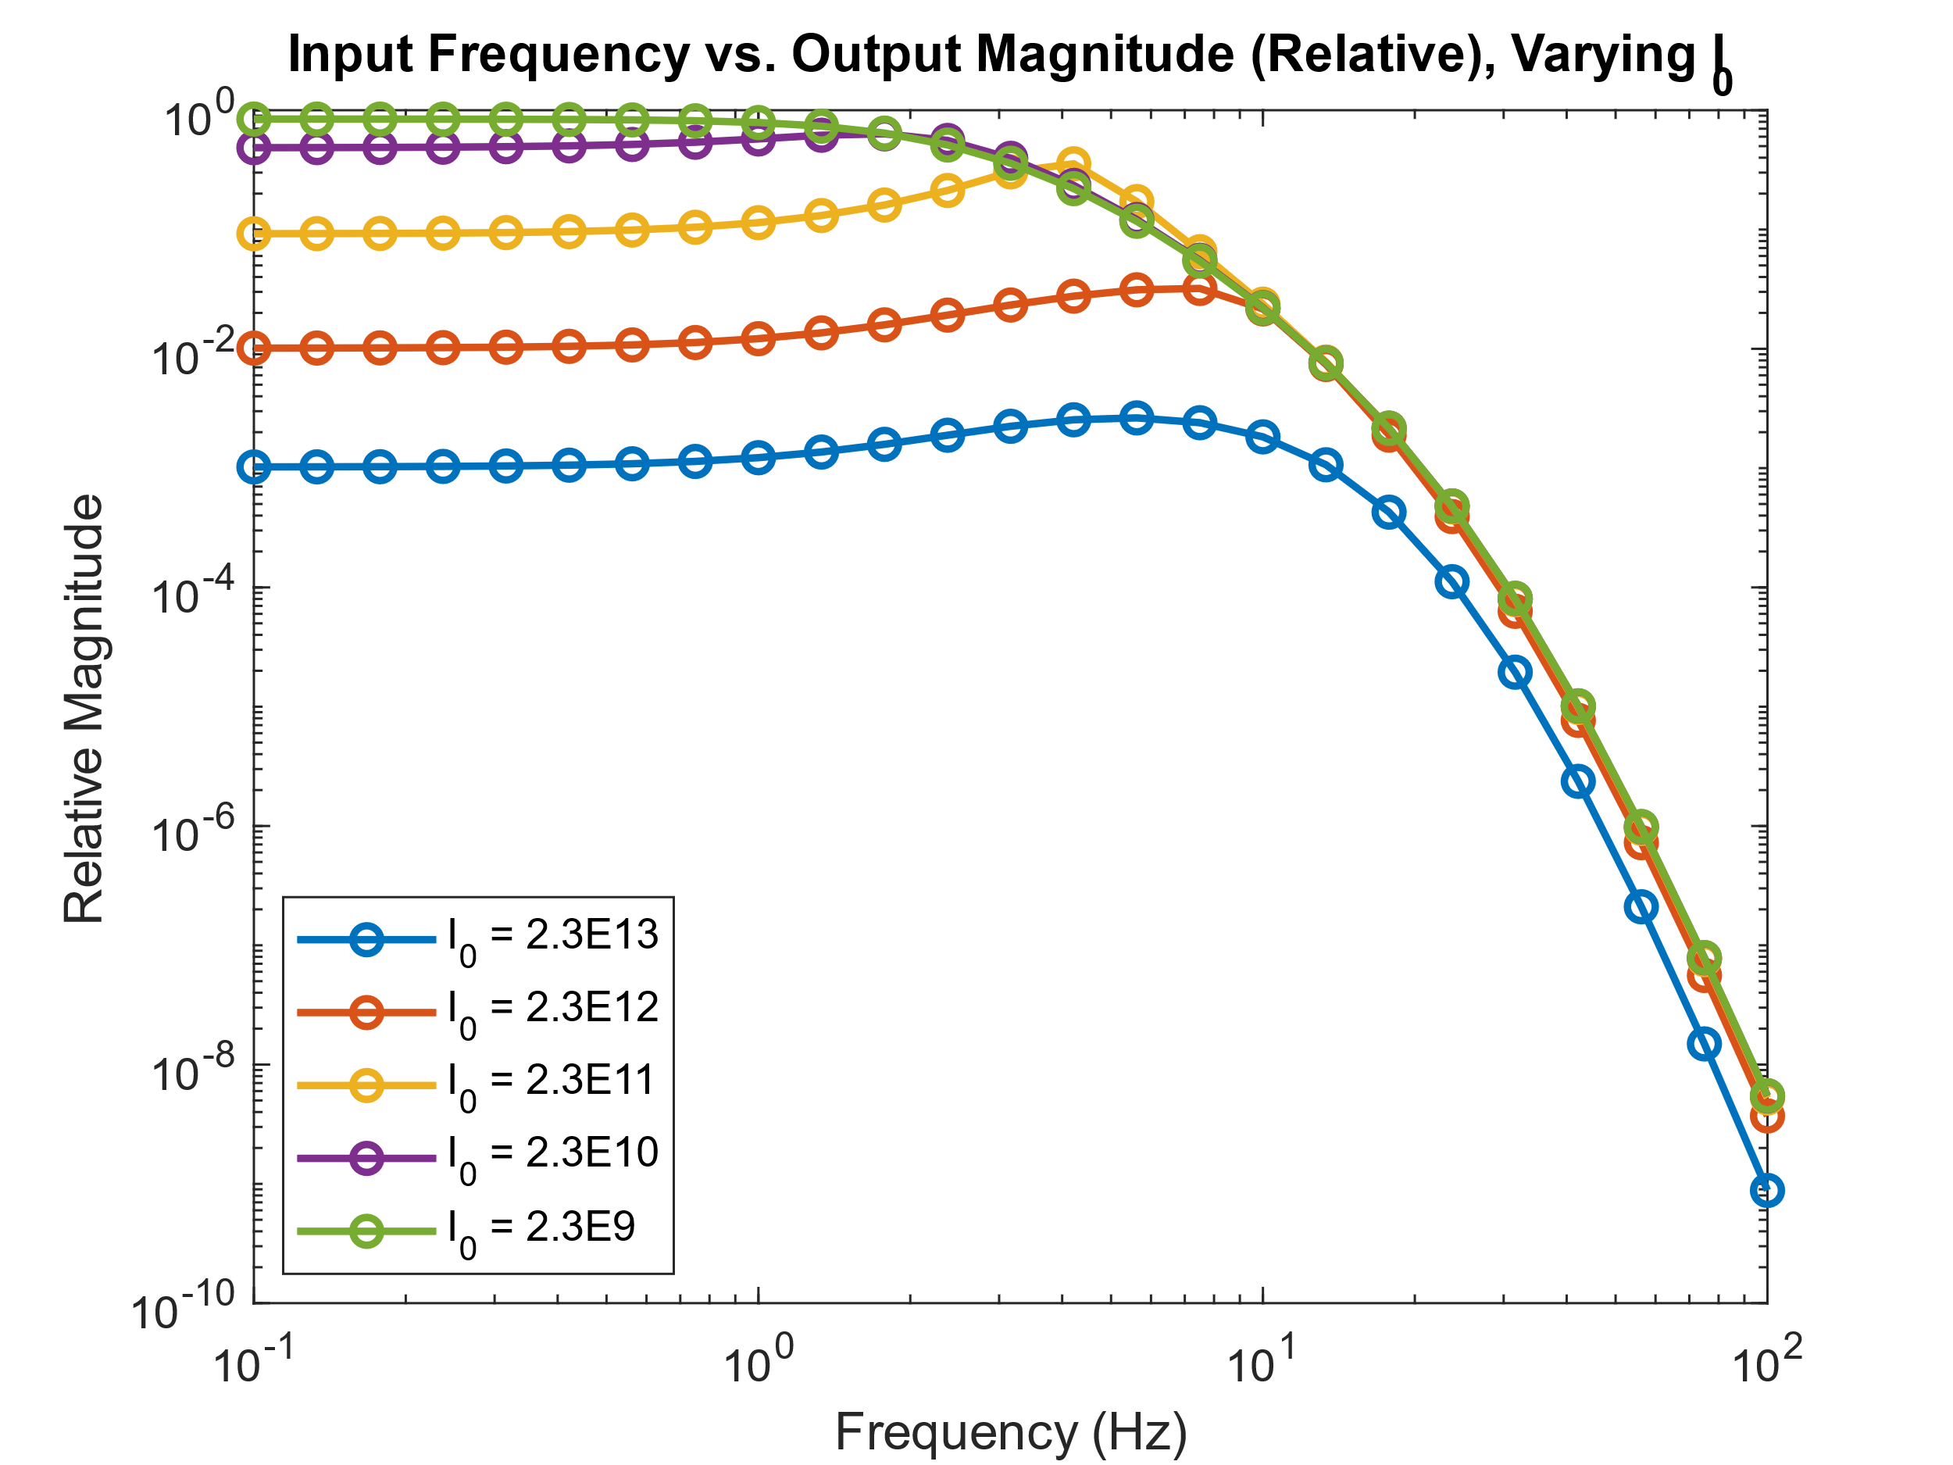**Figure 1:** This figure shows the frequency response curves for the model proposed by *Tranchina et al., 1984*, at varying input frequencies and levels of steady-state light intensity, I0. I0 is varied in log units from 0 to -4 from the initial value of 2.3*1013. I1 remains constant at 2.3*109, and it can be seen that as the difference between I0 and I1 decreases, the relative magnitude at lower frequencies increases; however, at higher frequencies, the difference is significantly less pronounced, as all values appear to converge.

Likewise, the same procedure was completed, however, this time in the feedback loop, the value of I0 was decoupled from the feedback term *B(s)*. This produced the following result:

**Figure 2:** This figure shows the frequency response curves for a modified *Tranchina* model at varying frequencies and levels of steady-state light intensity, I0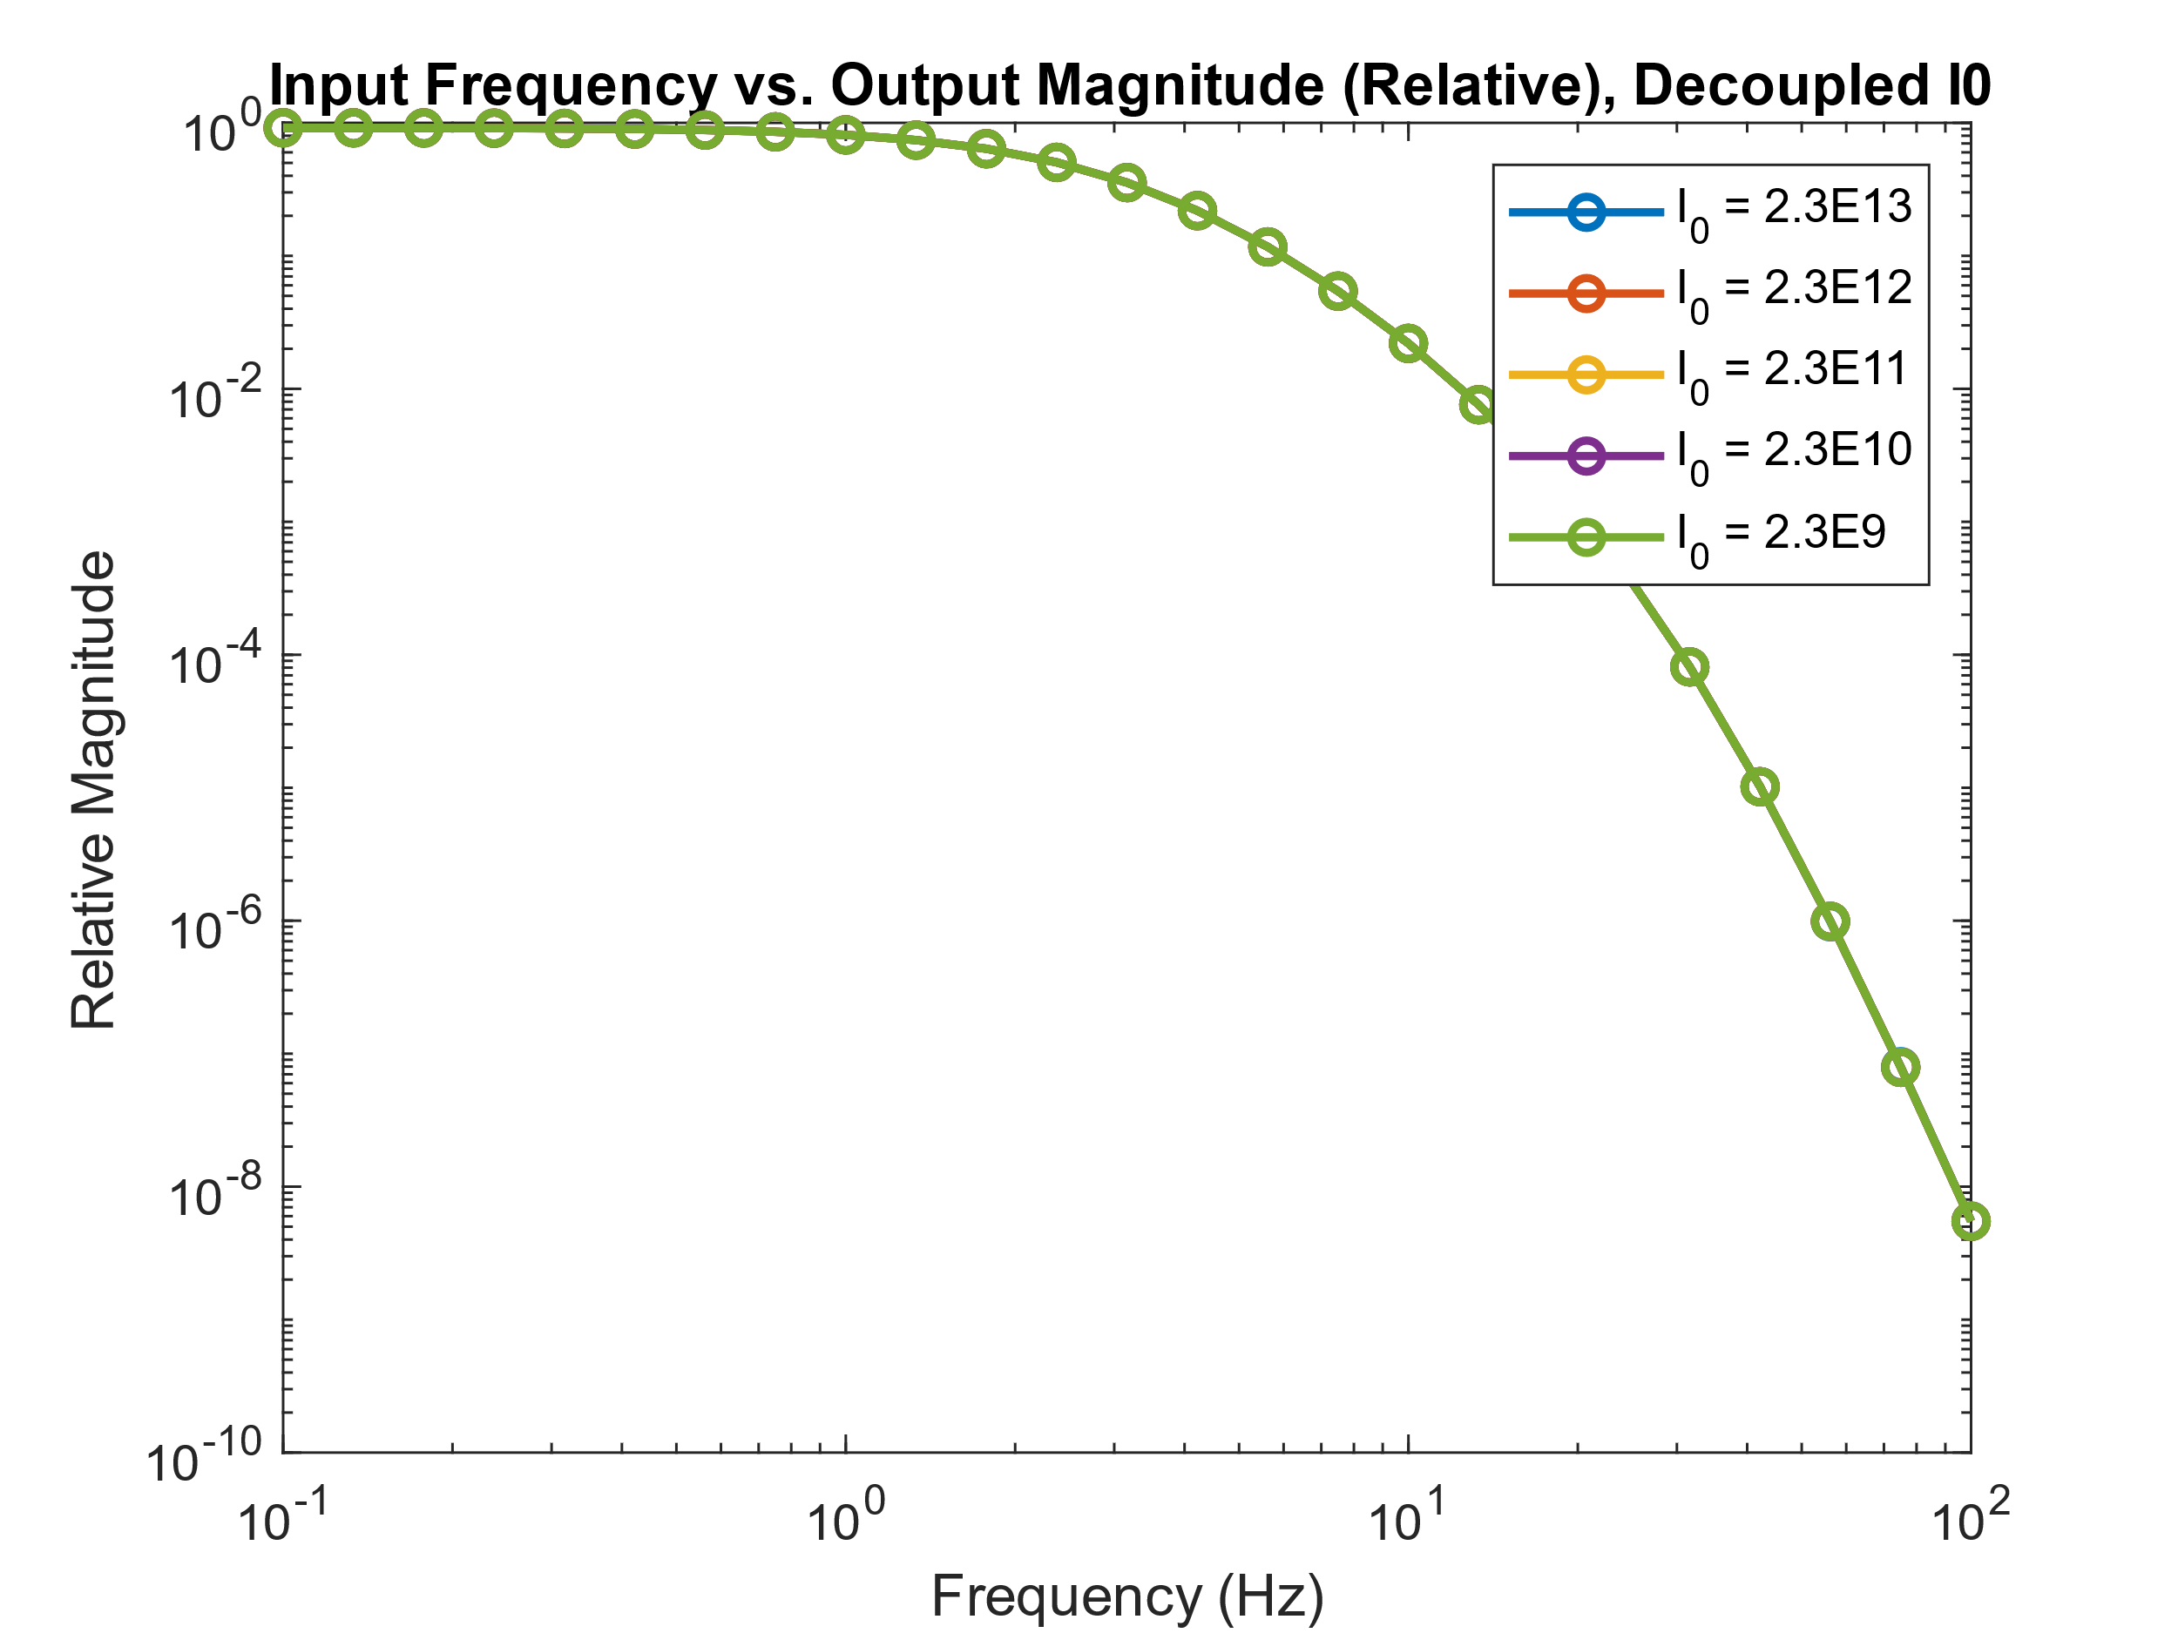. As above, I0 is varied in log units from 0 to -4 from the initial value of 2.3*1013. I1 remains constant at 2.3*109. However, in this version, as mentioned above, I0 was decoupled from the feedback term *B(s)*. This yields an interesting phenomenon wherein the steady-state intensity of light does not affect the relative magnitude of the output; only the frequency does.

**Analysis:**

Comparing the results of the Simulink model to those from the original *Tranchina* paper, it can be seen from the comparison of **Figure 1** from *Tranchina et al.* and the results above, an exceptionally similar trend can be witnessed. The general trend from the original paper is seen; however, the relative magnitude values are just slightly greater in the Simulink model used in the lab. This discrepancy is likely caused by the fact that **Fig 1** from *Tranchina* uses experimental data and curve fitting, while the Simulink model relies solely on the provided best fit estimates in the paper.

Looking deeper into the results shown in **Figure 1**, it can be seen that the plot shown looks very similar to the frequency response curve of a lowpass filter. Seeing that as frequency increases, the magnitude of the output decreases and that there appears to be a smooth curve for the cutoff, this hypothesis is backed up. Furthermore, the nonlinearity in the roll-off of the magnitude for the non-initial I0 values follow a pattern that is seen in higher-order filters (specifically chebyshev filters). Thus from this revelation, it can be seen that the nonlinearity in the *H(f,I0)* function yields this nonlinearity in the change of output magnitude. This is the case as if *H(f,I0)* was linear the frequency response for the model would also be linear, however, that is not the case.

Further, it can be seen from **Figure 2** that eliminating the I0 term from *H(f,I0)* makes the model react equivalently regardless of the steady-state light value. This behavior is physiologically odd; however, from the mathematics of the model, it does make sense. This is the case as from the depiction of the model in **Figure 2** of *Tranchina et al.,* it can be seen that in the standard model *B(s)* is the feedback term which is scaled by I0. Thus, when coupled with the description of the output from *H(f,I0)* it can be seen that *B(s)* is being multiplied by I0 in the denominator, which would make the values of the output larger when the value in the divisor is lower. This makes sense as when the difference between the ambient light levels (steady-state) and the magnitude of the changing light levels is equivalent, the system has maximal gain and would have the most sensitivity. However, when I0 is decoupled from B(s), this comparison does not occur, and thus the response is the same regardless of light levels, which is exactly what is seen in **Figure 2**.

With the completion of this CLab, a more robust model of the eye can be built. Leaning on the work of *Westheimer et al.*, from CLab 2, another dimension of the ocular system is understood and modelable. Furthermore, the concepts of transfer functions and low-pass filters from CLab 1 and Modules 1 and 2 from lecture are tied into the models at deeper and deeper levels.

**Sources:**

* *Tranchina et al., 1984*
* *The Scientist and Engineer's Guide to Digital Signal Processing, Analog Devices*
* *CLab Manual*
* *Professors N. Ledbetter & P. Widder*
* *Fellow Students: Mark Q., Anthony W., Keshav K.*