**Introduction:**

This CLab contains two major sections. Section 1 dealt with the design and implementation of low and high pass filters in Simulink, while section 2 dealt with modeling and implementing a feedback system in Simulink based on a know integral feedback design. For section 1, our low pass filter design was based on the RC (Resistor-Capacitor) network, while our high pass filter was based on the (Capacitor-Resistor) network. For section 2, we turned to the Csete and Doyle 2002 review for the mathematical model behind the feedback system we implemented in Simulink. All Simulink models utilized a selection of only 4 blocks; gain, summation, integration, derivative, aside from sources and sinks.

**Results: Filters**

As stated above, in the first section of the CLab, we built two filters, the first of which being the low pass filter, and the second being the high pass filter (as can bee seen in Fig. 1 and Fig. 2 respectively). For both filters, we used a 10 kOhm Resistor, and a 1 uF Capacitor. This leads to both filters having a cutoff frequency of 100hz as the cutoff frequency for first order (RC & CR) filter is $\frac{1}{RC}$ which in our case is equal to 100Hz.

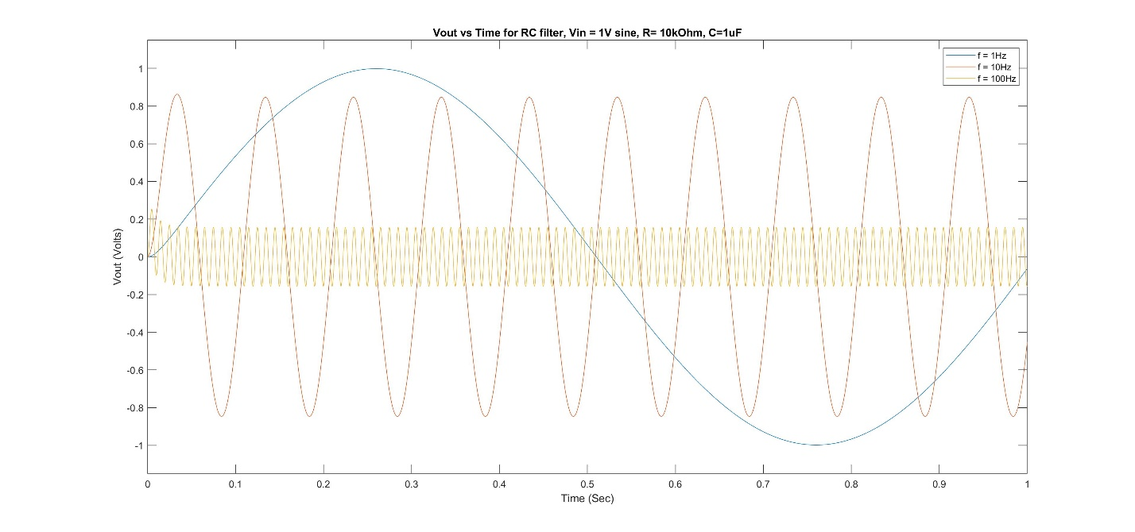**Figure 1: Vout vs Time for RC filter, Vin = 1V sine, R= 10kOhm, C=1uF**

This figure shows the output voltage of 3 different 1 volt signals fed into the RC low pass filter. We can see that the 1 Hz signals is essentially unaffected, while the 10 Hz signal appears to be slightly attenuated, and the 100 Hz signal is significantly attenuated

**Figure 2: Vout vs Time for CR filter, Vin = 1V sine, R= 10kOhm, C=1uF**

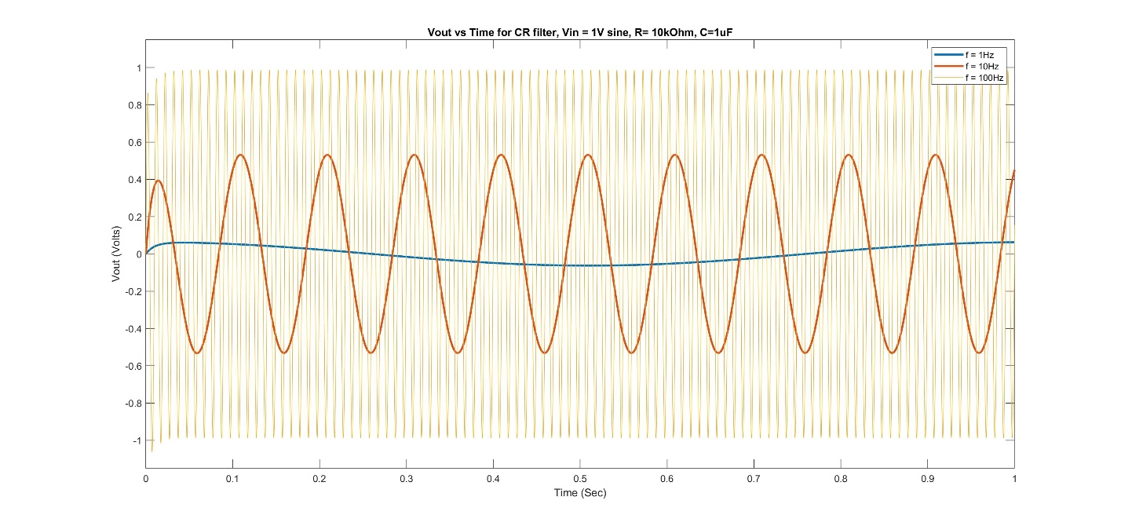

This figure shows the output voltage of 3 different 1 volt signals fed into the CR high pass filter. We can see that this time the 1 Hz and 10 Hz signals are both significantly attenuated, whole the 100 Hz signal appears to be unaffected

**Discussion: Filters**

Based on the results seen above in figures 1 and 2, we can safely conclude that the RC circuit (fig. 1) is a low pass filter, with a cutoff of 100 Hz, while the CR circuit (fig. 2) is a high pass filter, again with a cutoff of 100 Hz. We can be sure of this fact, as we see in figure 1 that the amplitude of the high frequency, 100 Hz signal is significantly attenuated when compared to the amplitude of the two lower frequency signals. Likewise in figure 2, we can see that the two low frequency components of 1 Hz and 10 Hz have significantly smaller amplitudes (especially the 1 Hz signal) when compared to the higher frequency 100 Hz signal that appears to be unchanged.

**Results: Control Systems**

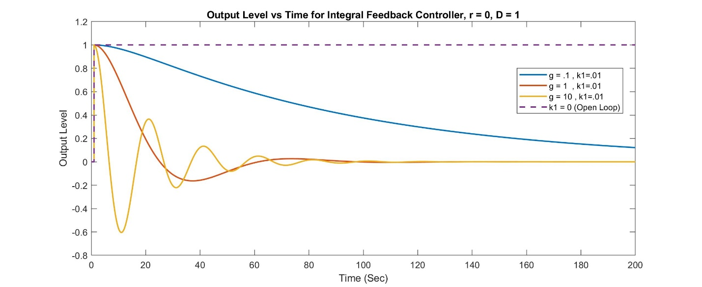**Figure 3: Output Level vs Time for Integral Feedback Controller, r = 0, D = 1**

This figure shows the output responses over time for a system with a steady state of zero and a step disruption of 1 at time = 0. We vary g and k1, while setting k2=10*k1. We see that by varying the ‘g’ parameter we get differing decay curves that appear to corospond to under, over and critical damping. We also see that without k1 (and by extension k2) we get no return to steady-state

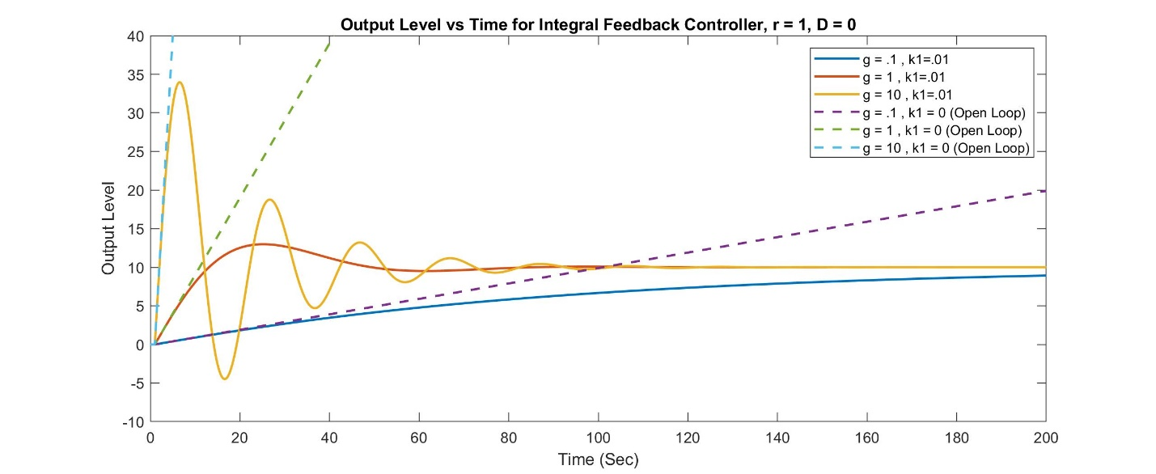**Figure 4: Output Level vs Time for Integral Feedback Controller, r = 1, D = 0**

This figure shows the output responses over time for a system with a steady state signal of 1 and no step disruption. We once again vary g and k1, while setting k2=10*k1. We see that by varying the ‘g’ parameter we get differing decay curves that appear to corospond to under, over and critical damping. However, in this case we also see that our new steady state convergent value does not equal 1. In fact the paper postulates that the system will converge to $(\frac{k2}{k1})r$, which is what we see in our figure, as the orange, yellow and blue lines seem to be converging on 10. Likeweise we see that the gain value is also an important factor in the open loop behaviour of the system. A higher gain yeilds a quicker divergence from the expected closed loop output of the system. This can be seen from the dashed lines, representing the open loop appearing to track their closed loop counterparts for the first few seconds (~5 sec for g=10, ~10 sec for g=1 and ~20 sec for g=.1).

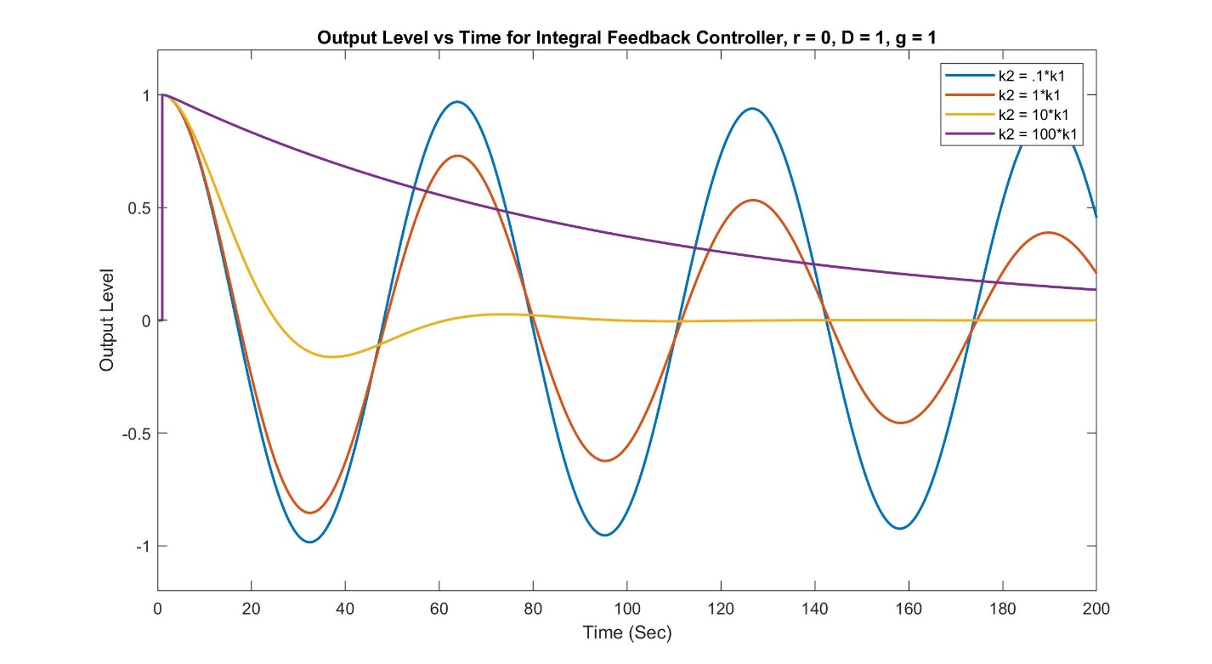**Figure 5: Output Level vs Time for Integral Feedback Controller, r = 0, D = 1, g = 1**

This figure shows the output responses over time for a system with a steady state of zero and a step disruption of 1 at time = 0. We keep g constant at 1 and vary the ratio of k2 to k1 to determine the relatonship between convergence & damping to the ratio of k2 to k1. We see that if the ratio is less than 1, the system will not converge, while a ratio of exactly 1 appears to be converging, albeit quite slowly. However it appears that if the ratio is significantly larger than 1, the system will converge relatively quickly, with a ratio of 10 appearing to converge the quickest out of all of the ratios tested. It is also important to note that a ratio of 10 is the baseline used for all of the figures in the paper the model is based off of.

**Discussion: Control Systems**

Our system appears to be able to represent ‘r’ and reject ‘D’ fairly well, assuming timescale is not a problem. As can be seen in Figure 3, we see that with the right tuning parameters, we can achieve a complete rejection of the disruption in under 100 seconds. Furthermore, from figure 4 we can see that within the same 100 second time frame we can get a fairly stable representation of the signal ‘r’ with a gain of ${k2}/{k1}$, which only gets better the longer one gives the system to quilibrate. Thus we can conclude that this system is a fairly good implementation of a feedback controller that aims to pass ‘r’ while rejecting ‘d’. We also found from the findings in Figure 5 that the ratio of k2 to k1 is of cirtical importance, and the paper backes up this finding. In the papers findings, they explain that as long as k2>>k1 the system will converge independent of large variations in g and D. We see exactly this across figures 3 and 5, where in figure 5 we see that if k2 ≤ k1, the system does not appear to converge in a reasonable time scale, however, at the larger ratios tested, the system converges in a reasonable scale. Similiarly in figure 3 we see that regardless of the value of g, the system will be brought back into steady state equlibrium. However, we can see that the values of k1, k2, and g do affect how quickly and with how much oscillation the system will return to steady state equilibrium. Thus we can assume that the factors k1, k2 and g act like the tuning parameters in a second order differential equation, leading to the various forms of damping possible with a system of that nature.