**Introduction:**

The objective of this lab is to model horizontal rotation of the eyeball by investigating how well a second-order model can account for data observed from actual 45° saccade eye movements. This is done by implementing the Westheimer Model from *Westheimer et al., 1954.* The second-order model proposed in the paper is given below, with a rearranged version to the right:

$$\frac{ θ''}{ω_{n}^{2 }} + \frac{ 2ζθ'}{ω_{n}} + θ = k → θ^{''}=kω_{n}^{2 }- \frac{ 2ζθ'}{ω_{n}} - {θω}_{n}^{2 }$$

For this model, $θ$ is the value of angular displacement in degrees, while $ω_{n}$, $ζ$ and $k$ are constants that characterize the system and act as tuning parameters for approximating numerical solutions. This Lab tests the goodness-of-fit of this model against empirical data and explores the effects of varying the tuning parameters $k, ω_{n}$ and $ζ$ on the output of the model.

**Results:**

The lab starts by varying the three turning parameters provided to explore the specific effects they have on the output of the model. The first parameter tweaked was $k$, leading to the following result after graphing the output at with various values of $k$.

**Figure 1: Modeled Eye Movement, Varying $k$: ${ ω}_{n} = 100, ζ=.70$**

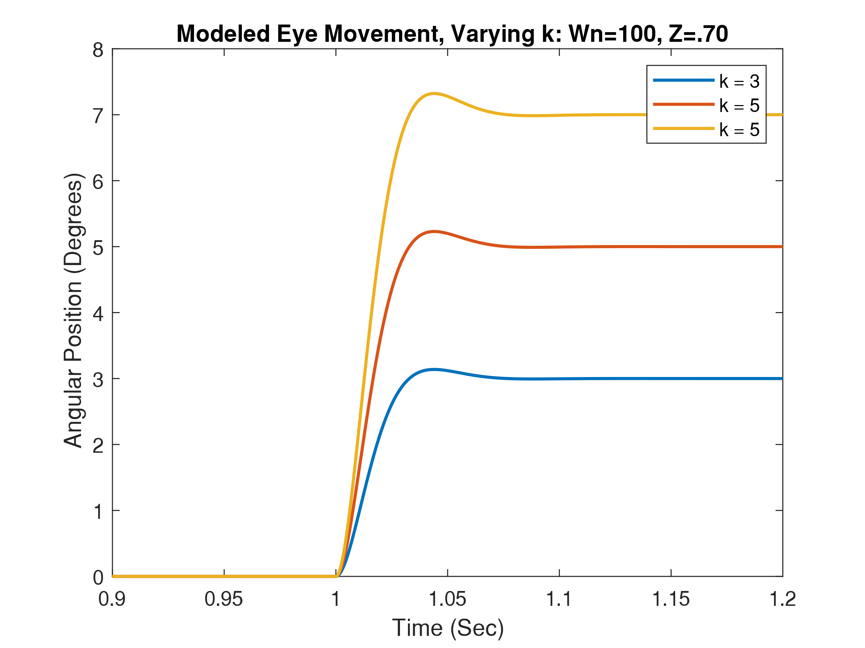 *This figure shows the resulting angular displacement for three different values of $k$ used in the model. It can be seen that the value of $k$ directly corresponds to the steady-state displacement of the eye for the model. For example, $k = 5$ has a steady-state displacement of 5, etc.*

Following this, the values for ${ ω}_{n}$ were altered as to build an understanding of the effect of ${ ω}_{n}$ on the output of the model. The results are as follows:

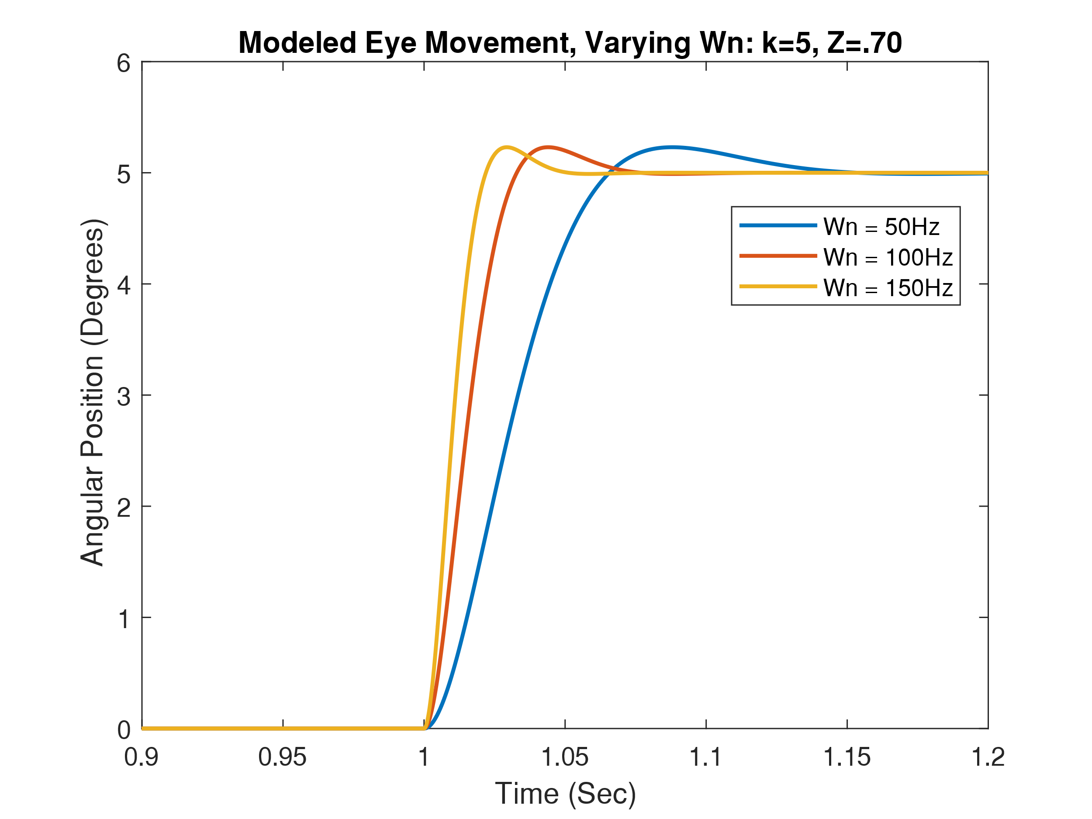**Figure 2: Modeled Eye Movement, Varying ${ ω}_{n}$: $k= 5, ζ=.70$**

*This figure shows the resulting angular displacement for three different values of $ω_{n}$. It can be seen that the value of $ω_{n}$ corresponds to the slope of the saccade, which is how fast the eye is moving. It can also be seen that changing $ω_{n}$ does not affect the steady-state position or the overshoot in the rising edge. From the figure, we can see that the lower the frequency of $ω_{n}$, the lower the value of the slope.*

After this part of the lab, the values for $ζ$ were varied to illustrate the effects of the parameters on the output of the model. The results are as follows:

**Figure 3: Modeled Eye Movement, Varying $ζ$: $k= 5, { ω}_{n}=100$**

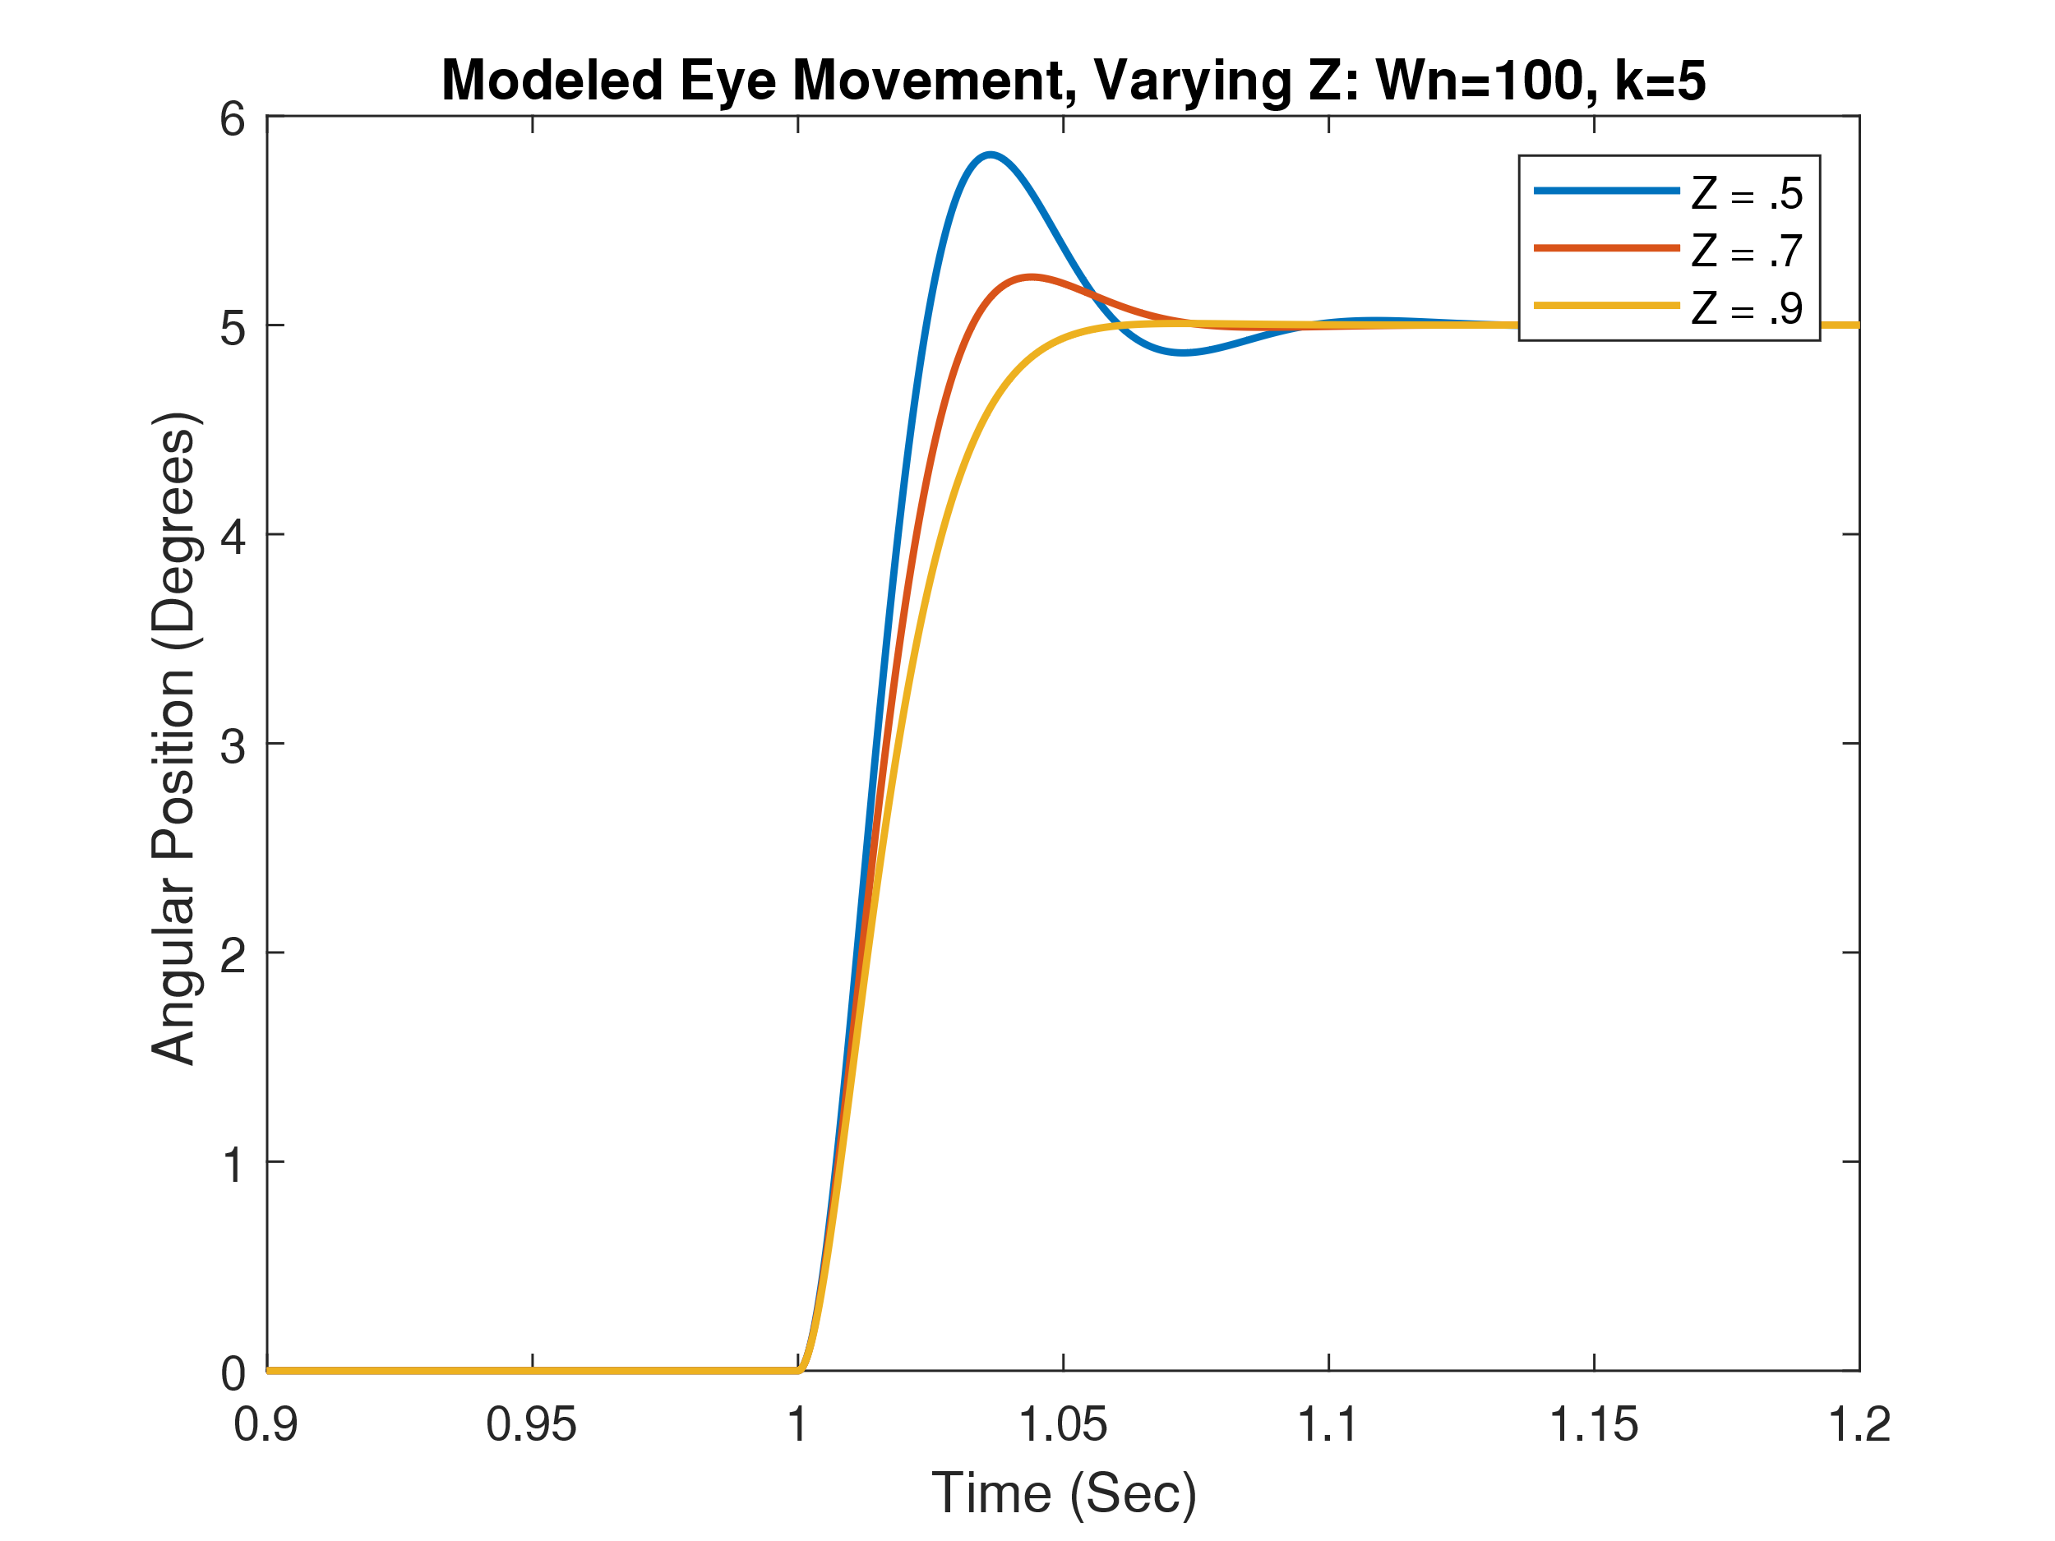

*This figure shows the resulting angular displacement for three different values of $ζ$. It can be seen that the value of $ζ$ corresponds to two aspects of the model. The first is the overshoot on the rising edge of the signal; a smaller $ζ$ has a larger overshoot. The second aspect is that the slope of the saccade leading up to the overshoot is steeper with lower values of $ζ$.*

The final portion of this lab was to combine the findings from the previous section and asses the ability of the second-order model proposed by *Westheimer et al.* to fit empirical data. The empirical data to be modeled was recorded via LabChart and tracked the movement of an eye across a 45° saccade. The data from LabChart included multiple movements of the eye, so for this portion, a single, well defined, rising edge from a saccade was selected, exported and then imported into Matlab. The imported data went through light pre-processing where the data was first time-shifted so that the rising edge would start at T=1 second to match the Simulink model built. The next preprocessing step was to normalize the data and scale it to a 45° saccade, as the units LabChart measured were relative units from a sensor (mV) and not absolute units like degrees. Once the data pre-processing was complete, all three parameters were tuned to get the Westheimer model to best fit the empirical data given. The results are as follows:

**Figure 3: Modeled Eye Movement Vs. Empirical Data: $k = 43, ω_{n} = 48Hz, ζ = .63$**

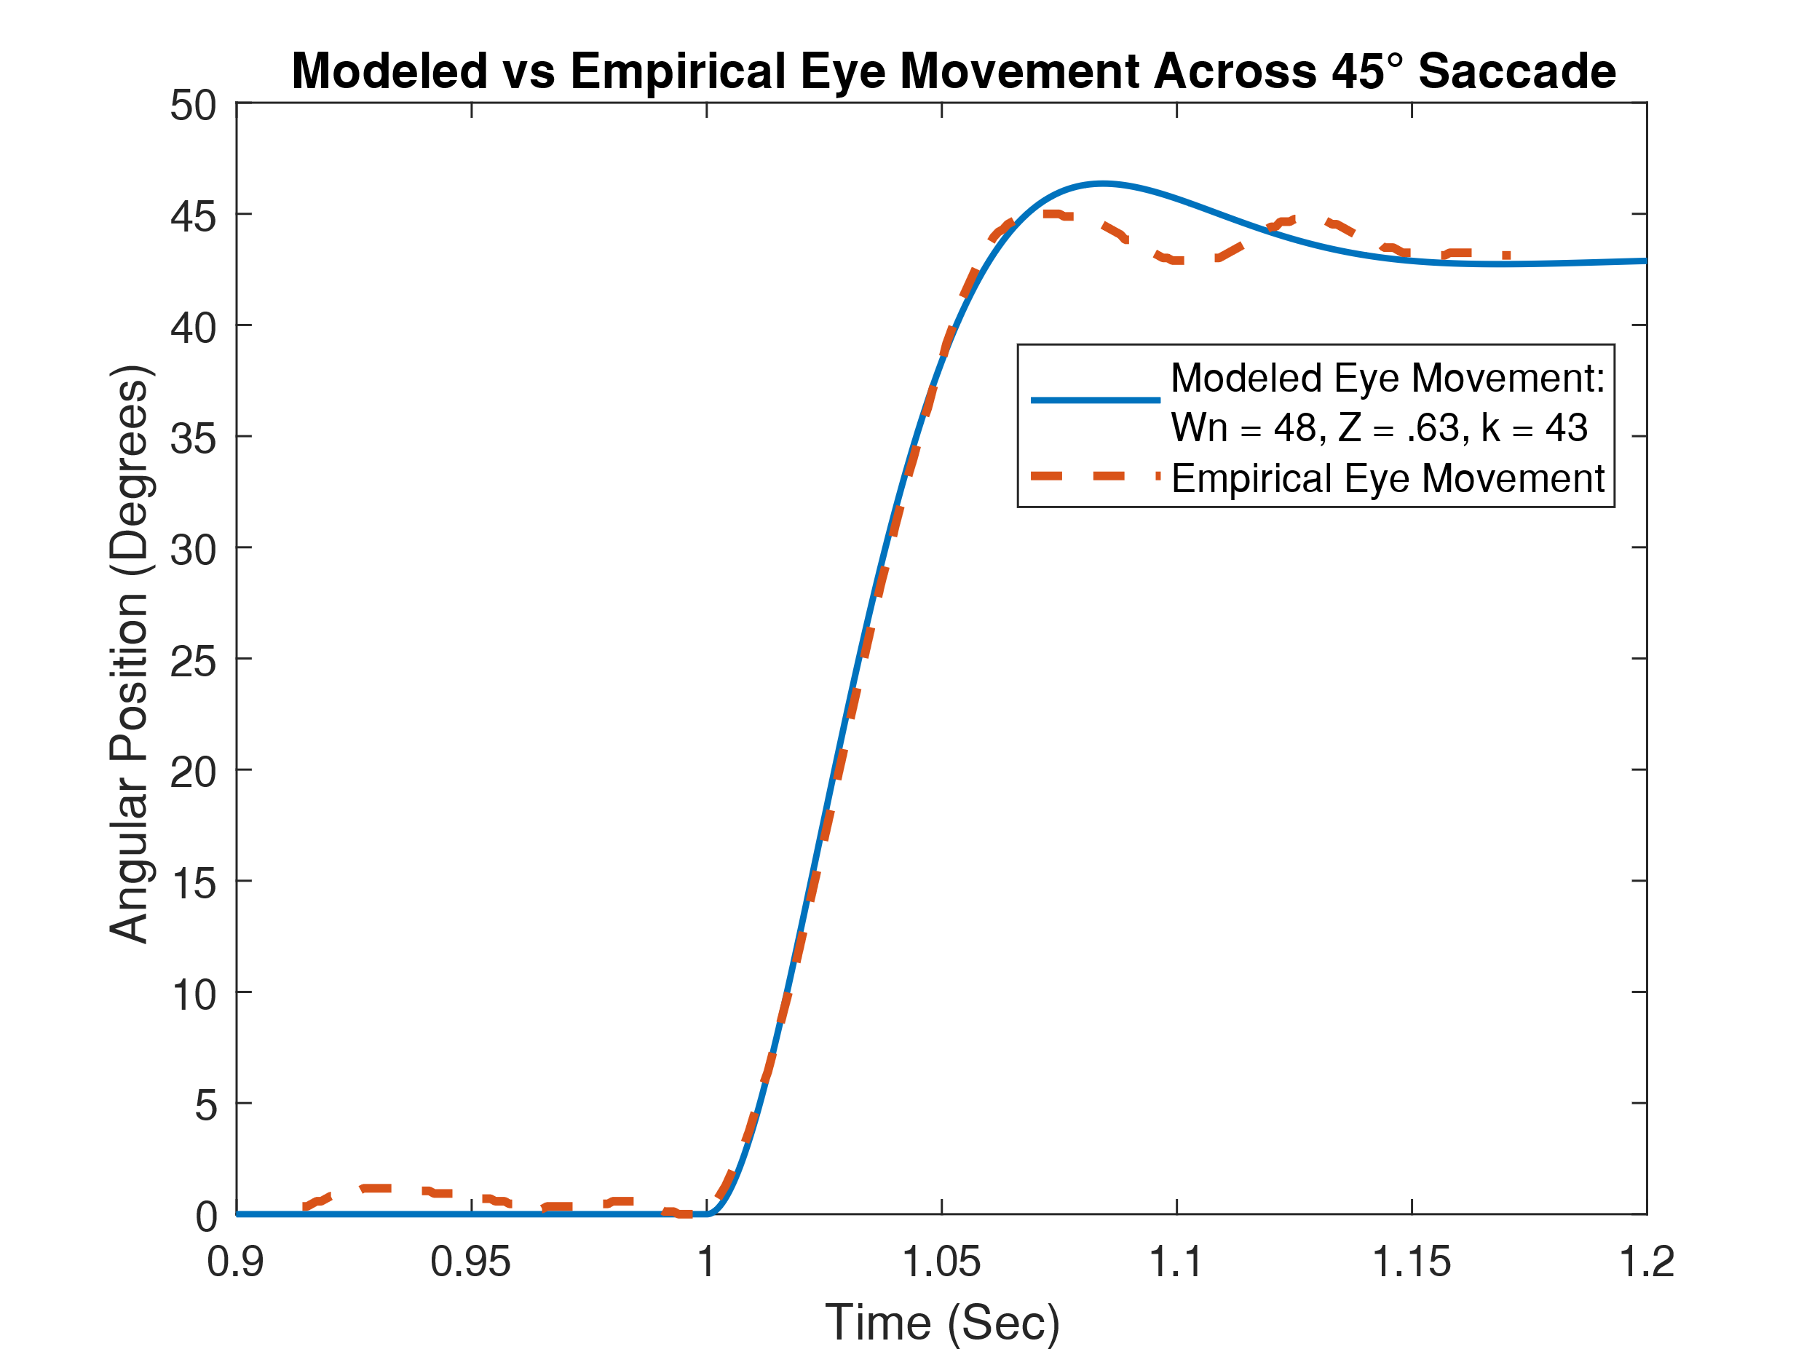

*This figure shows the modeled eye movement (blue) overlaid against the empirical data (dashed red line). The $k, ω_{n}$ and $ζ$ used to match the model to the data are 43, .63, and 48, respectively. It can be seen that the slope of the saccade is well-matched. However, there is deviation at the start and end of the rising edge, and the overshoot cannot fully capture the double bounce seen in the empirical data. It is also worth noting that the 45° motion appears to be 43° in actuality*

From this modeled result, a few points can be inferred. First, as noted in the figure caption, it can be seen that the actual magnitude of the displacement is 43° and not 45° as was in the test methodology. Another key point is that the model fits the rising edge fairly accurately, however it undershoots the test data at the beginning and end while overshooting in the middle. Similarly, the empirical data has a double overshoot, with undershoot at the end of the rising edge, while the Westheimer model only has a single overshoot, and no discernable undershoot. Thus showing that there is more nuance to the real-world data than a simple second-order model can encompass.

Thus it can be concluded that the model provided by *Westheimer et al.* is an excellent base model to work from, and does a reasonably good job at modeling the dynamics of the system. However, a more detailed model will have to be of a higher order to capture the nuances in data from real-world systems.