**Introduction:**

The objective of this lab is to build a model of how action potentials in neurons are initiated and propagated. This is done by building the Hodgkin-Huxley model of action potentials. The model implemented in this lab was sourced from *Koch Ch. 6, 1997.* The equations used are as follows:

(Where w is n,m, or h)

For this set of equations, Equation (1) represents the total circuit equation derived from the following figure:

**Figure 1: Hodgkin-Huxley Model Circuit Representation**

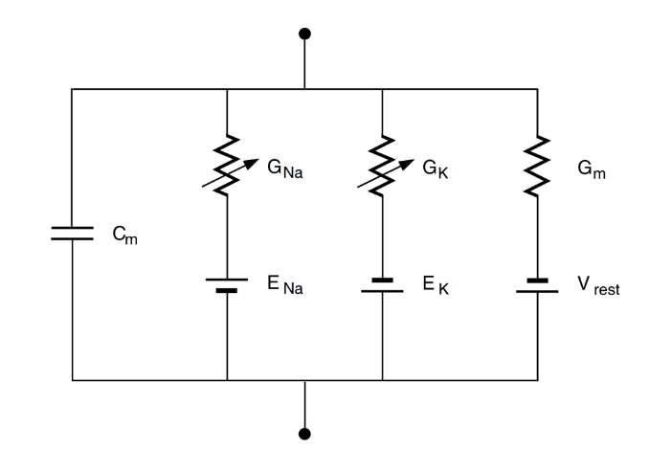

***Figure 1:*** *This figure shows a circuit representation of the Hodgkin-Huxley Model. Each ion is described by a series resistor and battery, with a capacitance in parallel. The capacitance is from the ion separation due to the cell membrane, while the battery is derived from the Nernst potential of the ions across the cell membrane. Finally, the variable resistor represents the conductance of the ion channel.*

Utilizing these ten equations, the Hodgkin-Huxley model is constructed in Simulink. From this model, the students are to answer the question presented: an investigation of threshold behavior. Specifically, the lab asks the students to investigate why one current injection can lead to no AP, while a slightly larger injection can lead to an AP. The extra credit question posed askes the students to investigate the effects of changing the magnitude of and on the current required to reach the threshold for an AP.

**Results:**

For the first part of the lab regarding the investigation of the current required to hit the action potential threshold, the model produced the following results:

*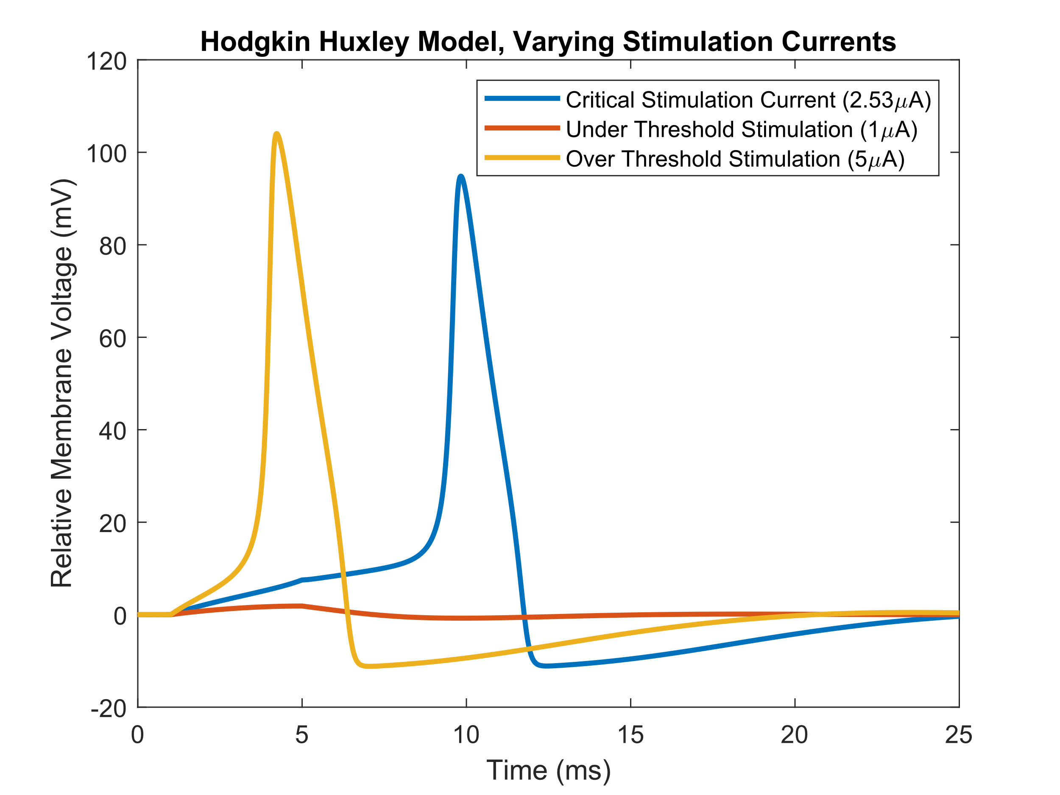****Figure 2:*** *This figure shows the action potentials that resulted from three different values of used in the model. It can be seen that regardless of the magnitude of the system returns to the same steady-state level (at zero mV). Similarly, it can also be seen that low values of to not trigger an action potential.*

From the results of this figure, along with the explanation provided in *Koch Ch. 6*, an explanation thresholding can be drawn. As both the conductance of the sodium and potassium channels that are governed by the ‘m’ and ‘n’ gates are voltage-dependent, changing the membrane voltage via a depolarising current () changes the conductance of both channels (Equations 5-10). Furthermore, the time constant () for sodium is one order of magnitude lower than for potassium (Eqn. 5,7). Thus the conductance change for sodium will occur much more rapidly than for potassium. So, if the magnitude of the depolarising can increase the membrane voltage to the point where the sodium current can take over, an action potential will follow. Similarly, if the membrane voltage is not increased sufficiently due to the current, the potassium current will takeover, which will prevent an action potential. From this, we see the hallmark thresholding phenomenon.

From the understanding developed above, the results from Fig. 2 can be interpreted. In the case of the “critical stimulation current,” it can be seen that the depolarizing stimulation current was just slightly above the threshold voltage. This means that the sodium current was just barely higher than the potassium current, which is reflected in the relatively long period it took to trigger an action potential (~6ms). This is then contrasted with the “over threshold stimulation,” where it can be seen that the action potential is fired relatively quickly (~1ms) after the current was injected. It can also be noted that the peak of the “critical stimulation current” action potential is lower than the peak of the “over threshold stimulation” action potential. Finally, there is the “under threshold stimulation,” where it can be seen that the depolarizing current was not large enough, and the resulting increase in the membrane voltage was not large enough for the sodium current to overtake the potassium currents. Thus, it is seen that the stimulation leads to no action potential, and the membrane returns to resting voltage after some time (~5ms). These results can be seen in the following Figure:

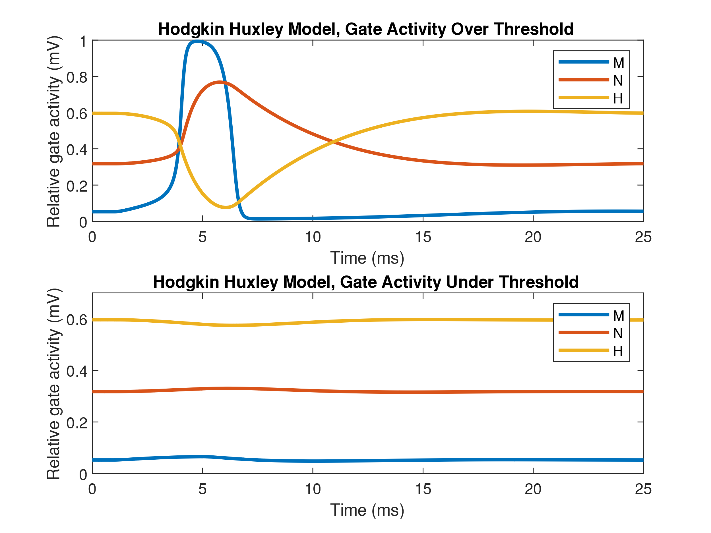

***Figure 3:*** *This figure shows the relative activity for the three ion gates, M, N, and H, for a stimulation that is past the threshold (top) and a stimulation that does not meet the threshold (bottom). It can be seen that for the beyond threshold stimulation, all of the gate activities cross, with the M gate going from inactive to fully active, while the H gate goes inactive from being active. However, for the under threshold graph, there is a slight blip in the activities; however, they do not cross, and quickly return to the baseline.*

The second part of this lab was an exploration of the effects of changing the magnitude of the time constants of m and n, and . The results are as follows:

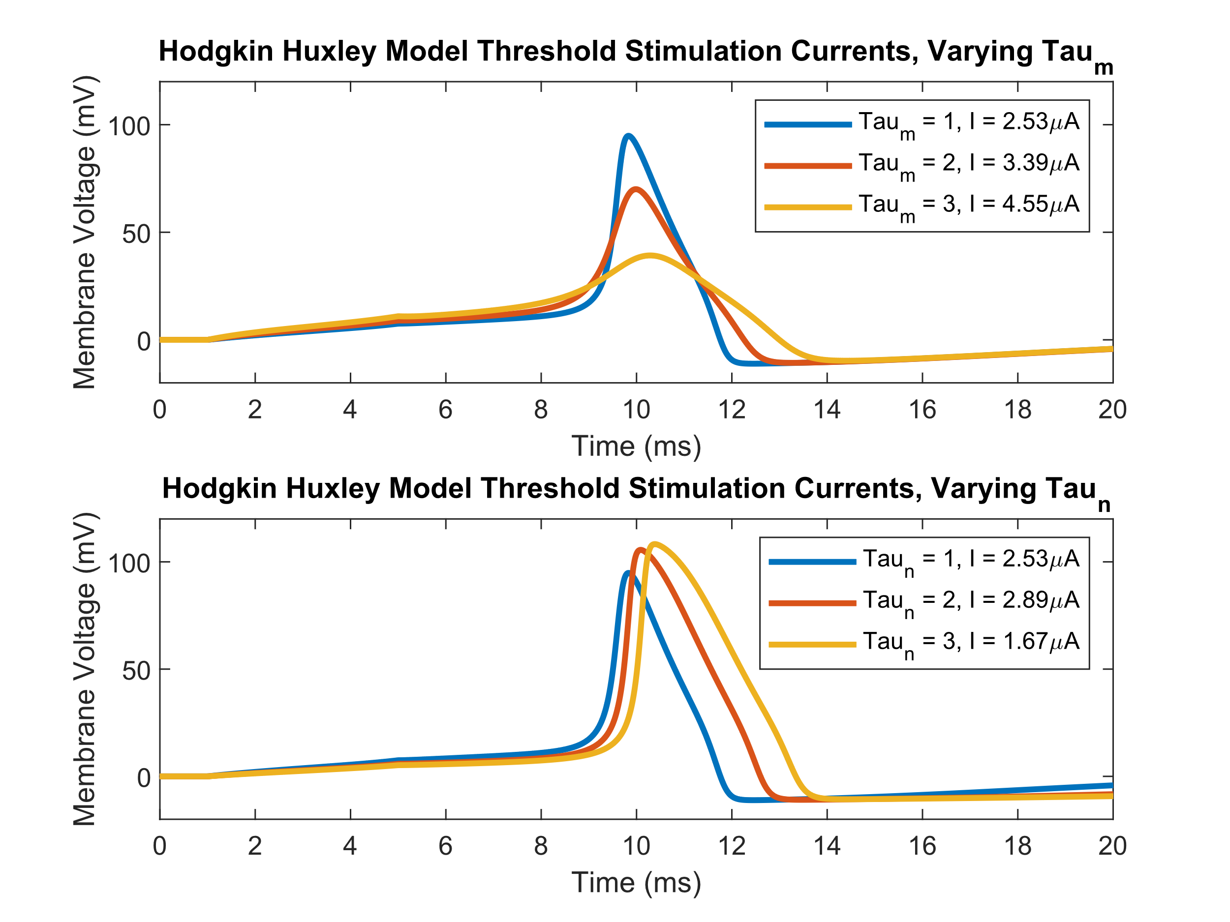

***Figure 4:*** *This figure shows the action potentials that resulted from varying the gain for*  and  *to 3 different levels (1x, 2x, 3x). It can be seen that as the gain of increases, the threshold current increases in a non-linear way. However, for as the gain increases, the threshold current decreases in a non-linear way. It can also be seen that for increased gain values, the action potential has a lower amplitude, while as increases, the amplitude increases.*

These results can be explained using the information provided above; it is known that represents the time constant, which governs how long the gates on the ion channel take to open. It is also known that the m and n refer to sodium and potassium activation. Thus, the following conclusions can be drawn for figure 4; with the gain in , the sodium channels are slower to open, and thus the threshold voltage required to drive the neuron to an AP is higher, which can be seen in the top part of fig. 4. The opposite is seen for where an increase in the gain makes the threshold lower, making an AP easier to fire. This is the case as an increase in slows the activation of the potassium channels allowing the sodium channels more time to bring up the membrane voltage and trigger an AP.