**Introduction:**

This lab aims to teach students about the alternative action potential models that are present in the scientific literature. The three alternative models that the lab focuses on are the Reduced Hodgkin Huxley Model, the FitzHugh-Nagumo (FHN) Model, and the Izhikevich Model. Each of these models aim to be more simple representations of action potentials when compared to the original Hodgkin Huxley (HH) model. The equation for the reduced HH model is as follows:

The equations for the FHN model is as follows:

Finally, the equations for the Izhikevich model are as follows:

**Results:**

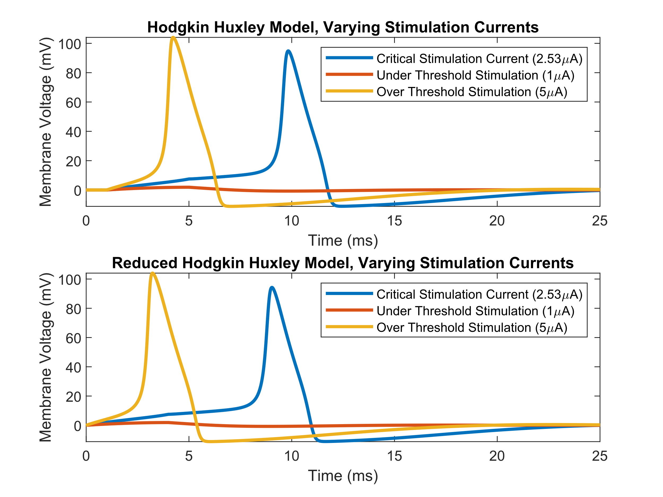

***Figure 1:*** *This figure shows a comparison between the reduced and standard HH models. Both models appear to have very similar spike shapes and similar thresholding behavior. The primary difference appears to be a temporal shift in the spiking, where the reduced HH model fires earlier when exposed to the same stimulation parameters*

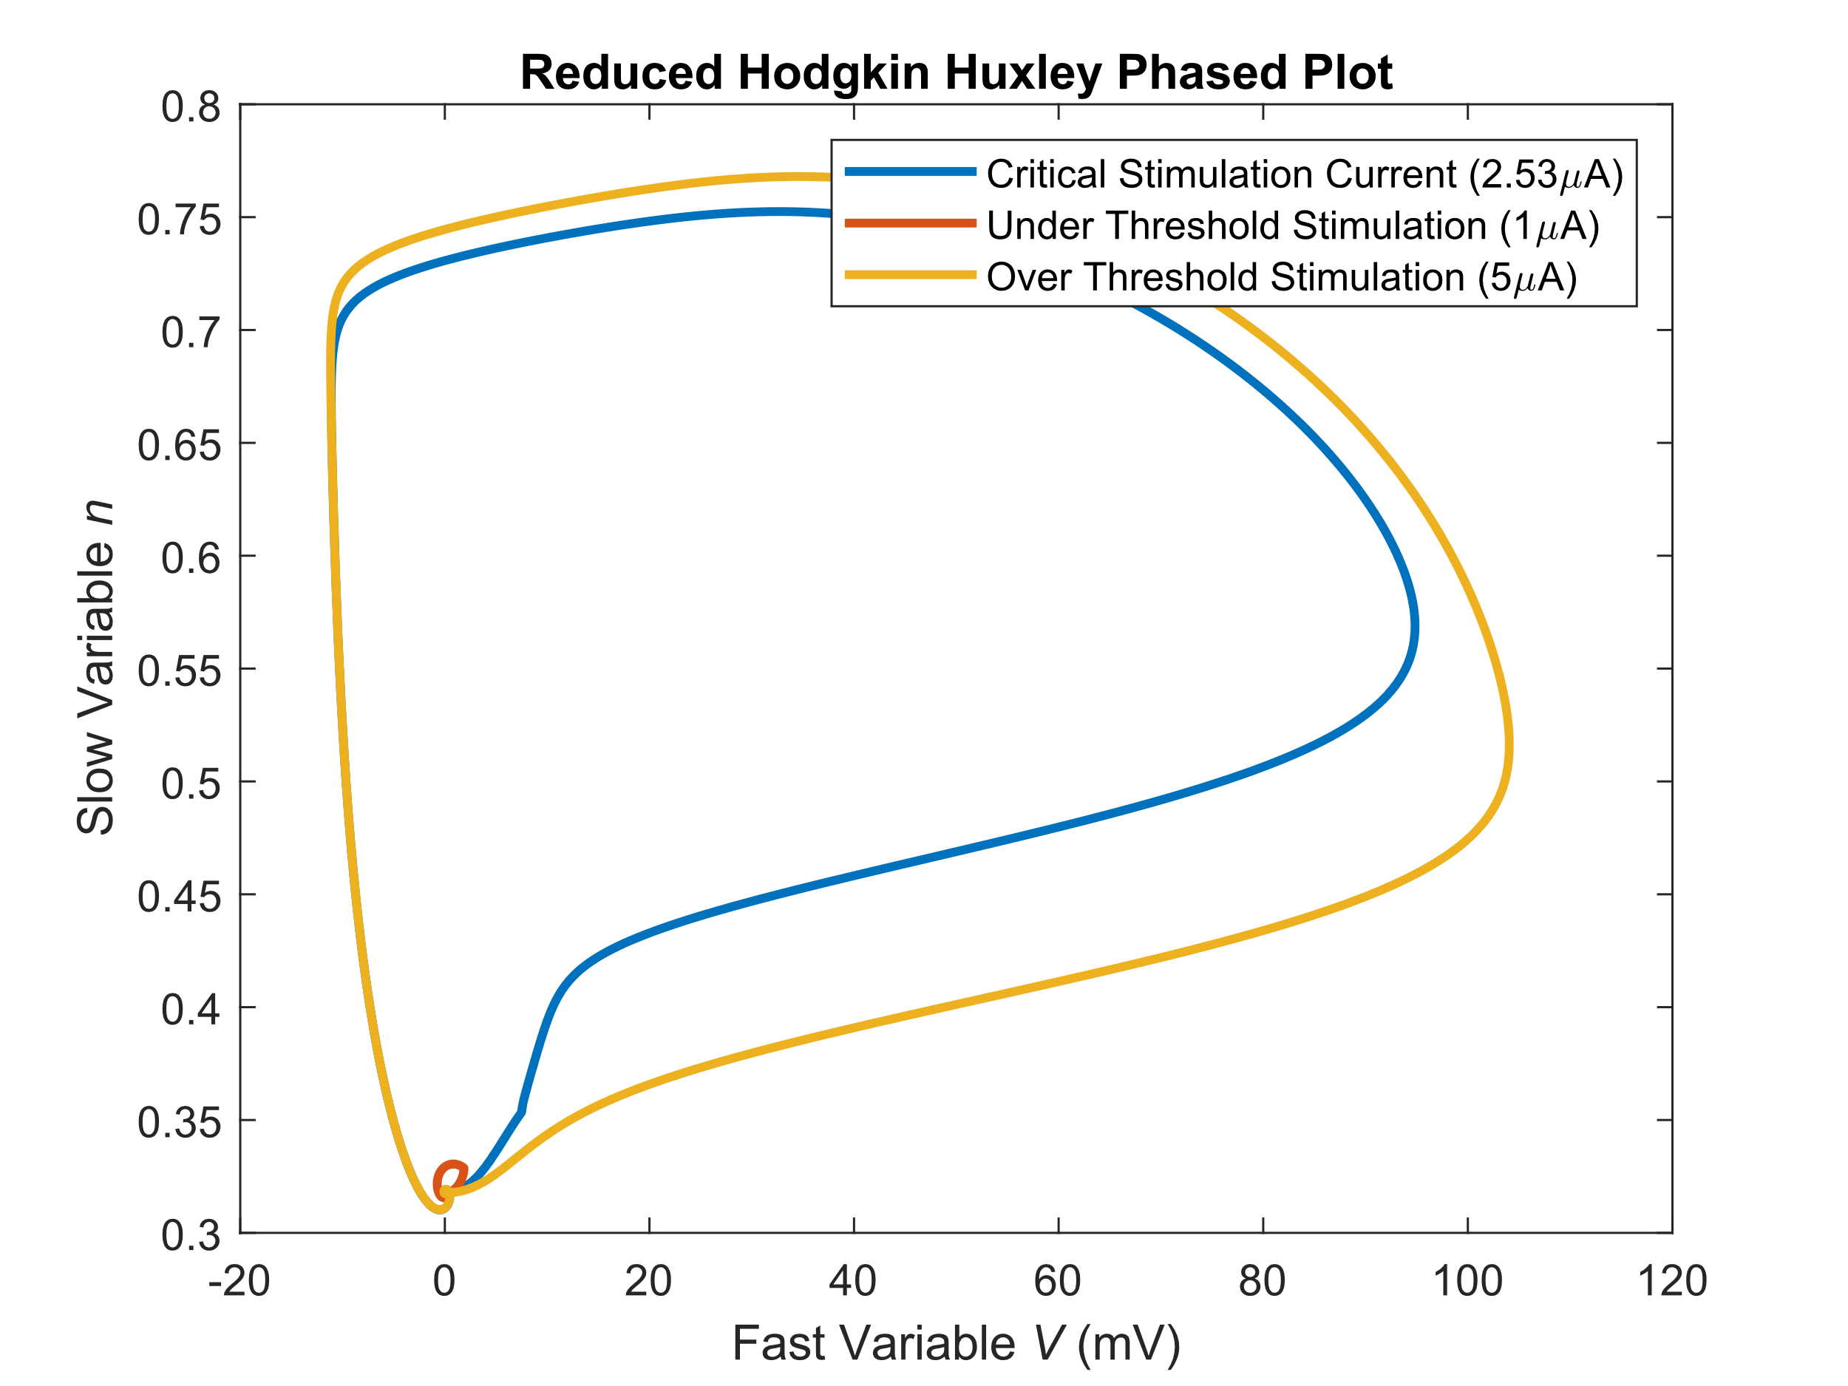

***Figure 2:*** *This figure shows a phased plot comparing the fast variable V and the slow variable N. This phased plot is generated for the same three stimulation levels used to generate figure 1, with the results overlaid. It can be seen that the phased diagram for each stimulation level follows the same general shape; however, with a different magnitude.*

From the results in figure 1, it can be seen that the reduced HH model still exhibits the standard behavior expected from an action potential model. Namely, exhibiting thresholding behavior and action potential shape. Both the reduced and the standard HH models appear to have virtually identical spike shapes and very similar thresholding behavior. From the results in the bottom subplot of figure 1, it can also be seen that the reduced model has a temporal shift when compared to the standard model. This shift is likely due to the faster dynamics of when compared to the dynamics of . However, the rest of the AP that results from the model is essentially identical.

Likewise, from the results in figure 2, the dynamical behavior of the system can be better understood. From these results, it can be seen that both *n* and *V* complete a cycle, where both *n* and *V* change synchronously. This is the case as when *n* increases *V* also increases. However, this is then followed by *n* decreasing and *V* decreasing. Thus, the relationship between *n* and *V* follows a counter-clockwise loop starting from *V*=0. Likewise, it can also be seen that as the stimulation current increases, the magnitude of the cycle increases. However, this appears to be non-linear in nature, as under stimulation generates a cycle many orders of magnitude smaller than critical stimulation or overstimulation.

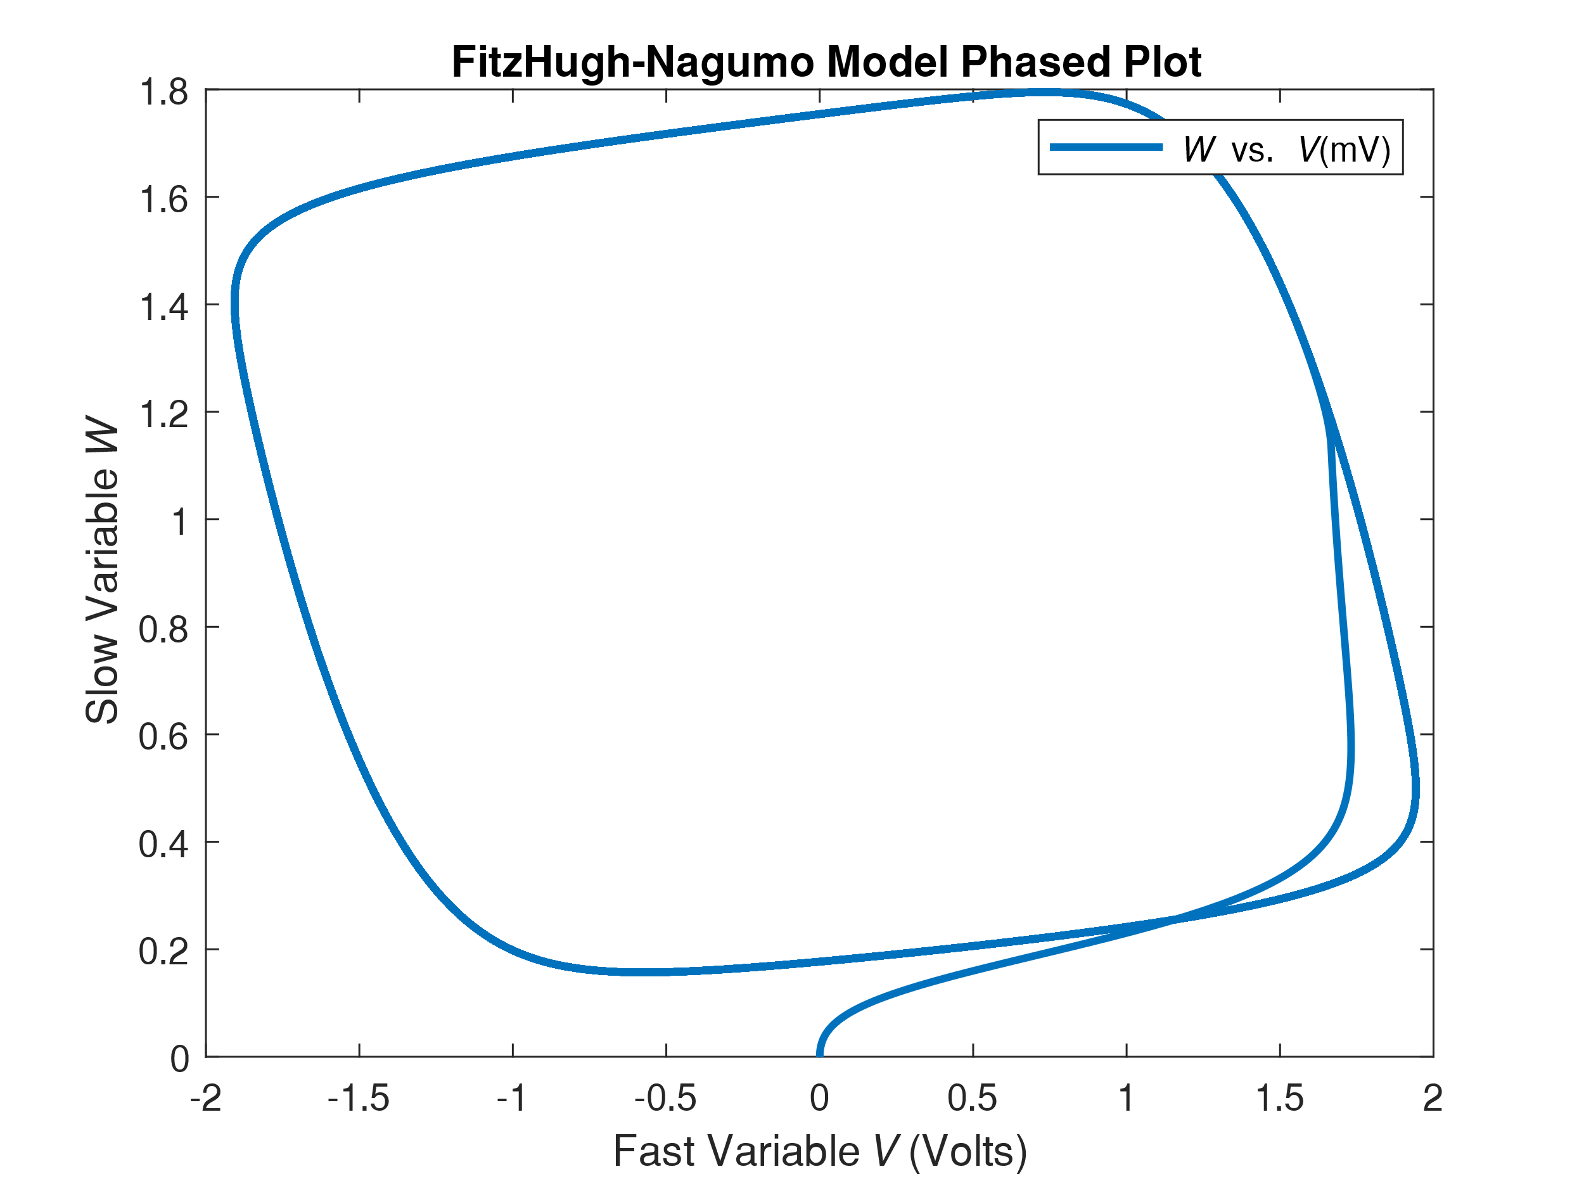

***Figure 3:*** *This figure shows a phased plot comparing the variables W and V, Where V is the fast-changing variable and W is the slow changing variable. For this model, it can be seen that after the model settles from the initial conditions, it falls into a constant cycle. Of note is the fact that this model generates APs that peak at over a volt, which is significantly higher than other models which generate APs on the order of 100m*

From Figures 2 and 3, various comparisons can be drawn between the reduced HH and FHN models. From the general shapes of the two cycles, it can be seen that the FHN model appears to be more simplistic than the reduced HH model. This is the case as the HH model has an irregular shape, and thus forms a more complex AP. However, the FHN model forms an elementary cycle that appears to be relatively symmetric across a diagonal axis. This relative simplicity in the cycle shape directly maps to a more simple firing pattern, more akin to oscillator than a spiking model. This can also be seen as the FHN model has similar lengths for each leg of the cycle and the fact that it appears to oscillate between 2 and -2 volts. However, both models are similar in that they both follow counter-clockwise cycles, and both have quite similar

general shapes, especially when the reduced HH model with overcurrent is compared to the FHN model. This is the case as they both have sharp declining segments and two segments with relatively small slopes.

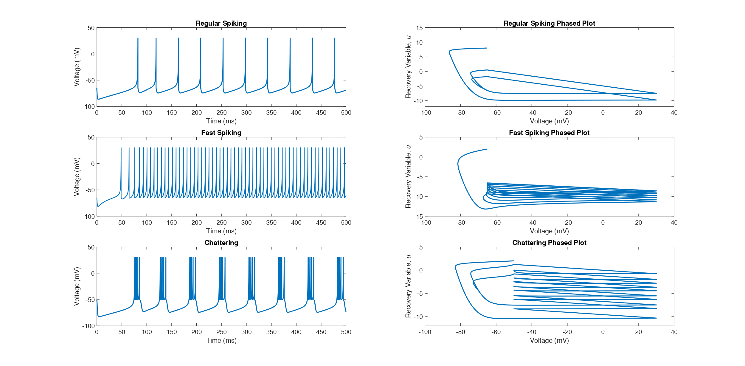***Figure 4:*** *This figure shows plots of the various conditions of the Izhikevich Model. The left column shows the spiking activity as a function of voltage vs. time, while the right column shows phase plots for each of the conditions modeled. The conditions were set via varying initial conditions for resting voltage, neuron sensitivity, recovery decay rate, and recovery threshold.*

For the results in the figure, the change of initial state (represented by regular spiking) that lead to the fast spiking mode was an increase in the recovery decay rate, and the changes that led to the chattering mode was an increase in resting voltage and a reduction in the recovery threshold. From the figure comparisons across each of the three neuron firing modes can be drawn. First, it can be seen that a similar time is required to fire an initial AP to fire for each of the modes. Similarly, it can be seen that the shape of each individual AP is quite similar across the model. However, the rate and pattern of APs are vastly different across the various firing modes.

Comparing the phase plots in the right-hand column of Figure 4, it can be seen that the overall shape of the phase for each mode is quite similar; however, an interesting pattern of ‘stacking’ the cycles is seen. For example, in the regularly spiking phased plot, the duckbill shaped cycle appears to occur twice, stacked on top of each other. However, for the Fast Spiking mode, there appear to be around eight tightly stacked cycles on each other. Likewise, the chattering firing mode appears to have around ten stacked cycles; however, these cycles are loosely and irregularly stacked. The number and the density of the stacking appears to correspond directly to the number rate and pattern of spikes in the corresponding Voltage vs. Time graph.