**Lab 1: The Electrooculogram**

**Pranav Maddula**

**Lab Partners:** Bryce Maxwell, Andrew Whitaker

Washington University in St. Louis

BME 301A

**Lab Instructor:** P. Widder

**Experiment date:** 9/27/19

**Submission Date:** 10/8/19

I hereby certify that this report is my own original work: **Pranav Maddula**

**Introduction:**

This lab introduces students to the principals of ocular movement and guides an establishment of a strong foundational understanding of key visual responses. The data used for building this foundational understanding of ocular movement is collected using an Electrooculogram (EOG). The EOG collects data in one plane based on differential voltage readings across its two electrodes. The total system used has three electrodes, two electrodes in a differential configuration, and a reference electrode. Using this EOG, data for standard saccades for known angular displacements, along with data for tracking, smooth pursuit, reaction times, and vergence, are collected. Following this, the lab warps up with the collection of VOR and OKN response data, which are formed out of a combination of the constituent parts (saccades and smooth tracking) from above.

**Methods:**

The lab starts by having the groups of students pick one member to be the test subject for this lab. The test subject then has the EOG electrodes places around their eyes in the manner outlined in the PLab manual. Following this, random eye movement data is collected to ensure that the PowerLab device and LabChart are working correctly. After this is complete, the first data collection section of the lab starts.

This first data collection portion of the lab consists of measuring standard saccades. The first step is to use the angular ruler to mark out points that are 5, 11, 23, and 45 degrees apart. The subject is then to look between the points slowly at first, but speeding up until they cannot move any more quickly. This is then repeated under differing conditions such as looking in different directions (diagonal, up, down, etc.), reading text, or with the eyes closed. Once this section is complete, the lab moves onto testing smooth pursuit in part 3.

Smooth pursuit is measured by having the subject track the finger of another lab member moving to the beat of a metronome. Various frequencies of the metronome should be tested until the subject cannot continue to track the finger. Once this section is complete, this experiment is then repeated under differing conditions such as the subject having their eyes closed, tracking an imaginary finger in the dark, etc. The subject should also try to move similar to a smooth pursuit but on a static image. Record the results of this trial, and the opinions of the subject on this trial. Following this section, the reaction times of the subject are tested.

The reaction times are tests by having another student in the group call out a direction to look in, while the subject looks in that direction as soon as they can. The test starts by only calling one direction (right only), however, the next trial adds another direction (left and right), while the final trial adds two additional directions (up, down, left, and right). Once the response time for these scenarios is recorded, the students then move onto measuring the reaction times of a saccade and a smooth pursuit motion. This is done by having a stimulus in the periphery of the subject's vision that the subject should move their eyes to as soon as they register the stimulus. Likewise, the smooth pursuit reaction time is measured by having the subject start tracking a moving hang that starts in the focus of the subject's vision upon a visual stimulus. Once the data is collected, the lab moves on to measuring vergence.

Vergence is measured by having the subject focus on something far away and then focus on something close. However, vergence can also be measured by having the subject cross their eyes. In an ideal setup, there would be no reading for vergence; however, there often will be a small signal registered during the vergence measurement. Following this, the complex VOR and OKN responses are measured.

As mentioned earlier, VOR is a combination of saccadic and smooth pursuit motions. For this lab, VOR is measured by having the subjects head static while they are tracking a fixed point. Though the head is static (relative to the body), the whole body is rotated. This is done using the pivoting chair to move the subjects whole body. Following this control VOR measurement, the experiment is then repeated under differing conditions such as having the subject do mental math, having the subject track the point with their eyes closed, or having the subject track the point in the dark. Next, the OKN response is measured. This is done by having the subject watch one of the OKN test videos provided in the PLab manual, while not focusing on any particular part of the video.

**Results:**

In order to help orient the reader to the nature of the subsequent results, a sample of the raw EOG data is provided in the following figure:

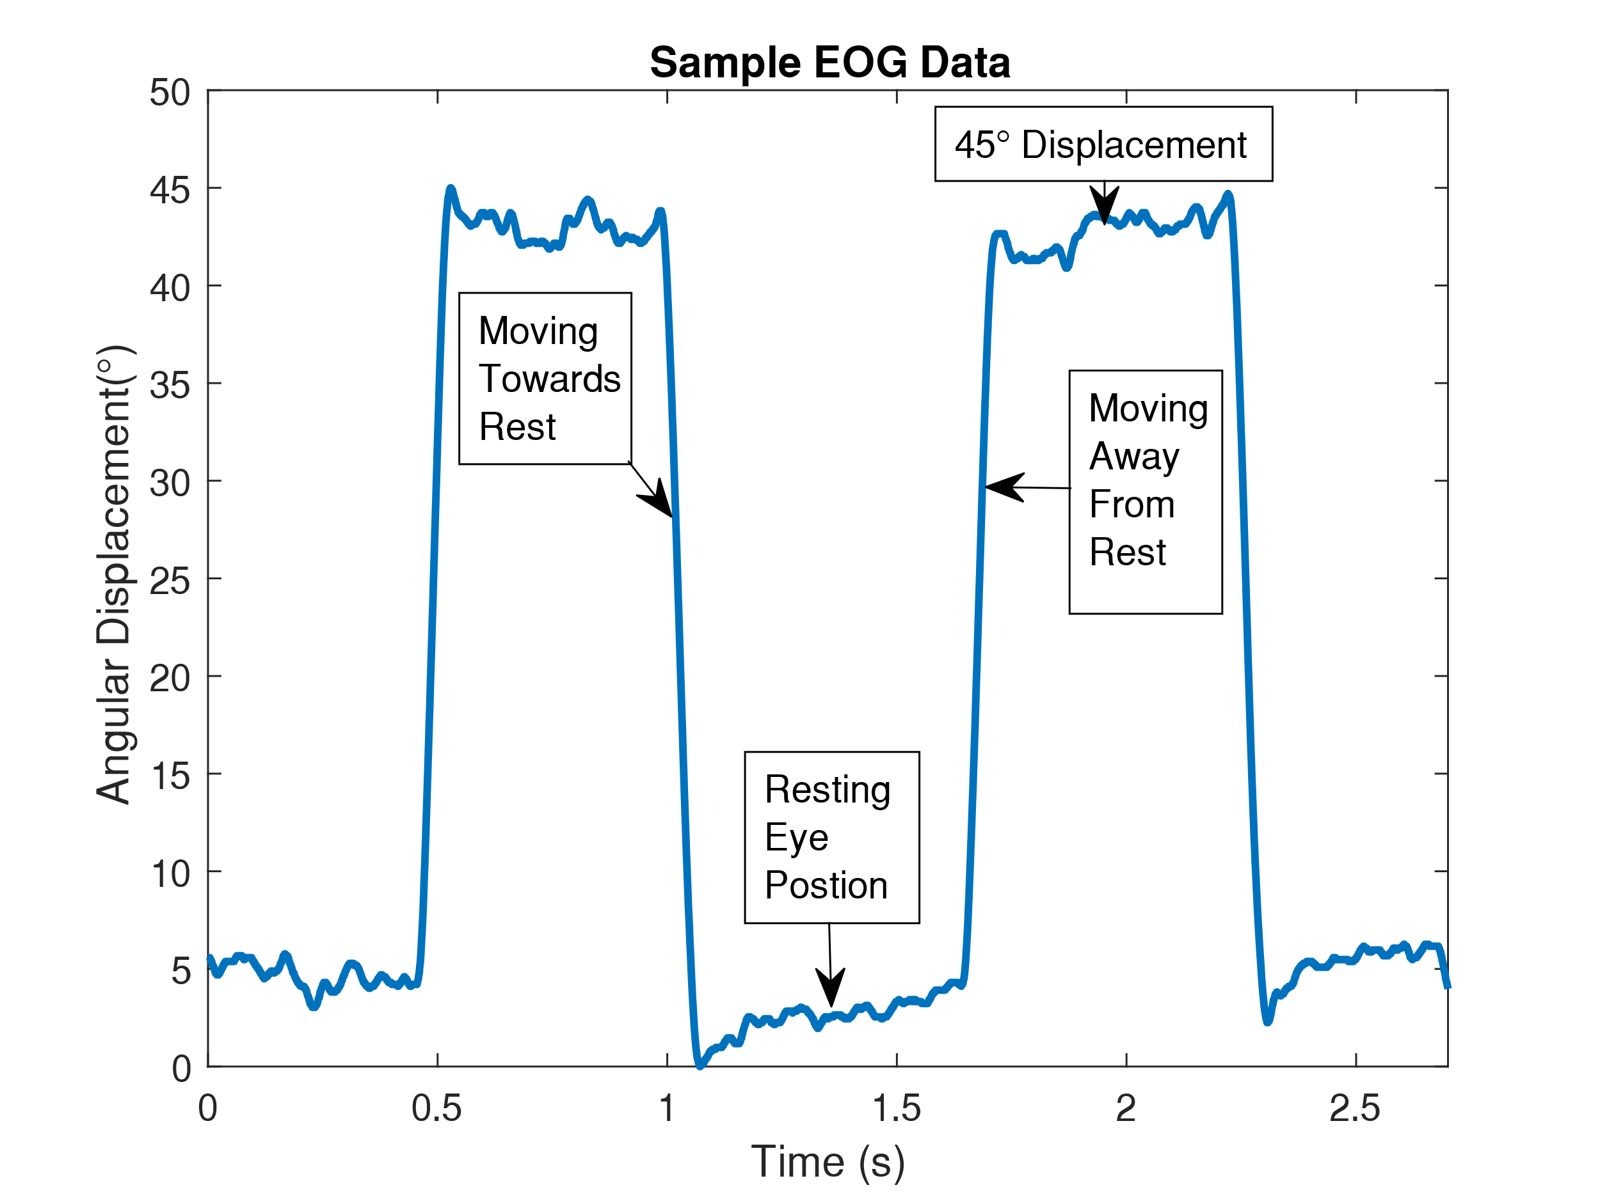

***Figure 1:*** *This figure shows raw EOG data acquired from the 45° saccade in the first part of the lab. The initial y-axis measurement was recorded in mV; however, the data was converted to angular displacement using the model from Fig. 2. Text boxes annotate the critical features of the data within the figure.*

Using the results of the first section of the lab, a calibration curve is built from the set displacement saccades. The result is as follows:

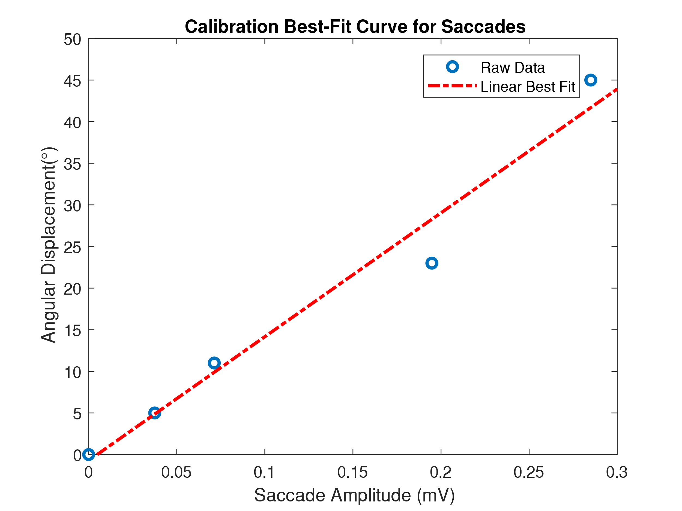

***Figure 2:*** *This figure shows the relationship between the angular displacement of the eyes and the amplitude of the saccade. A linear best fit line is generated so that angular displacement for future data be easily inferred. The model follows the form , where and .*

Following the generation of the best fit model, the peak angular velocity for each of the four standard saccades was measured, and the results are as follows:

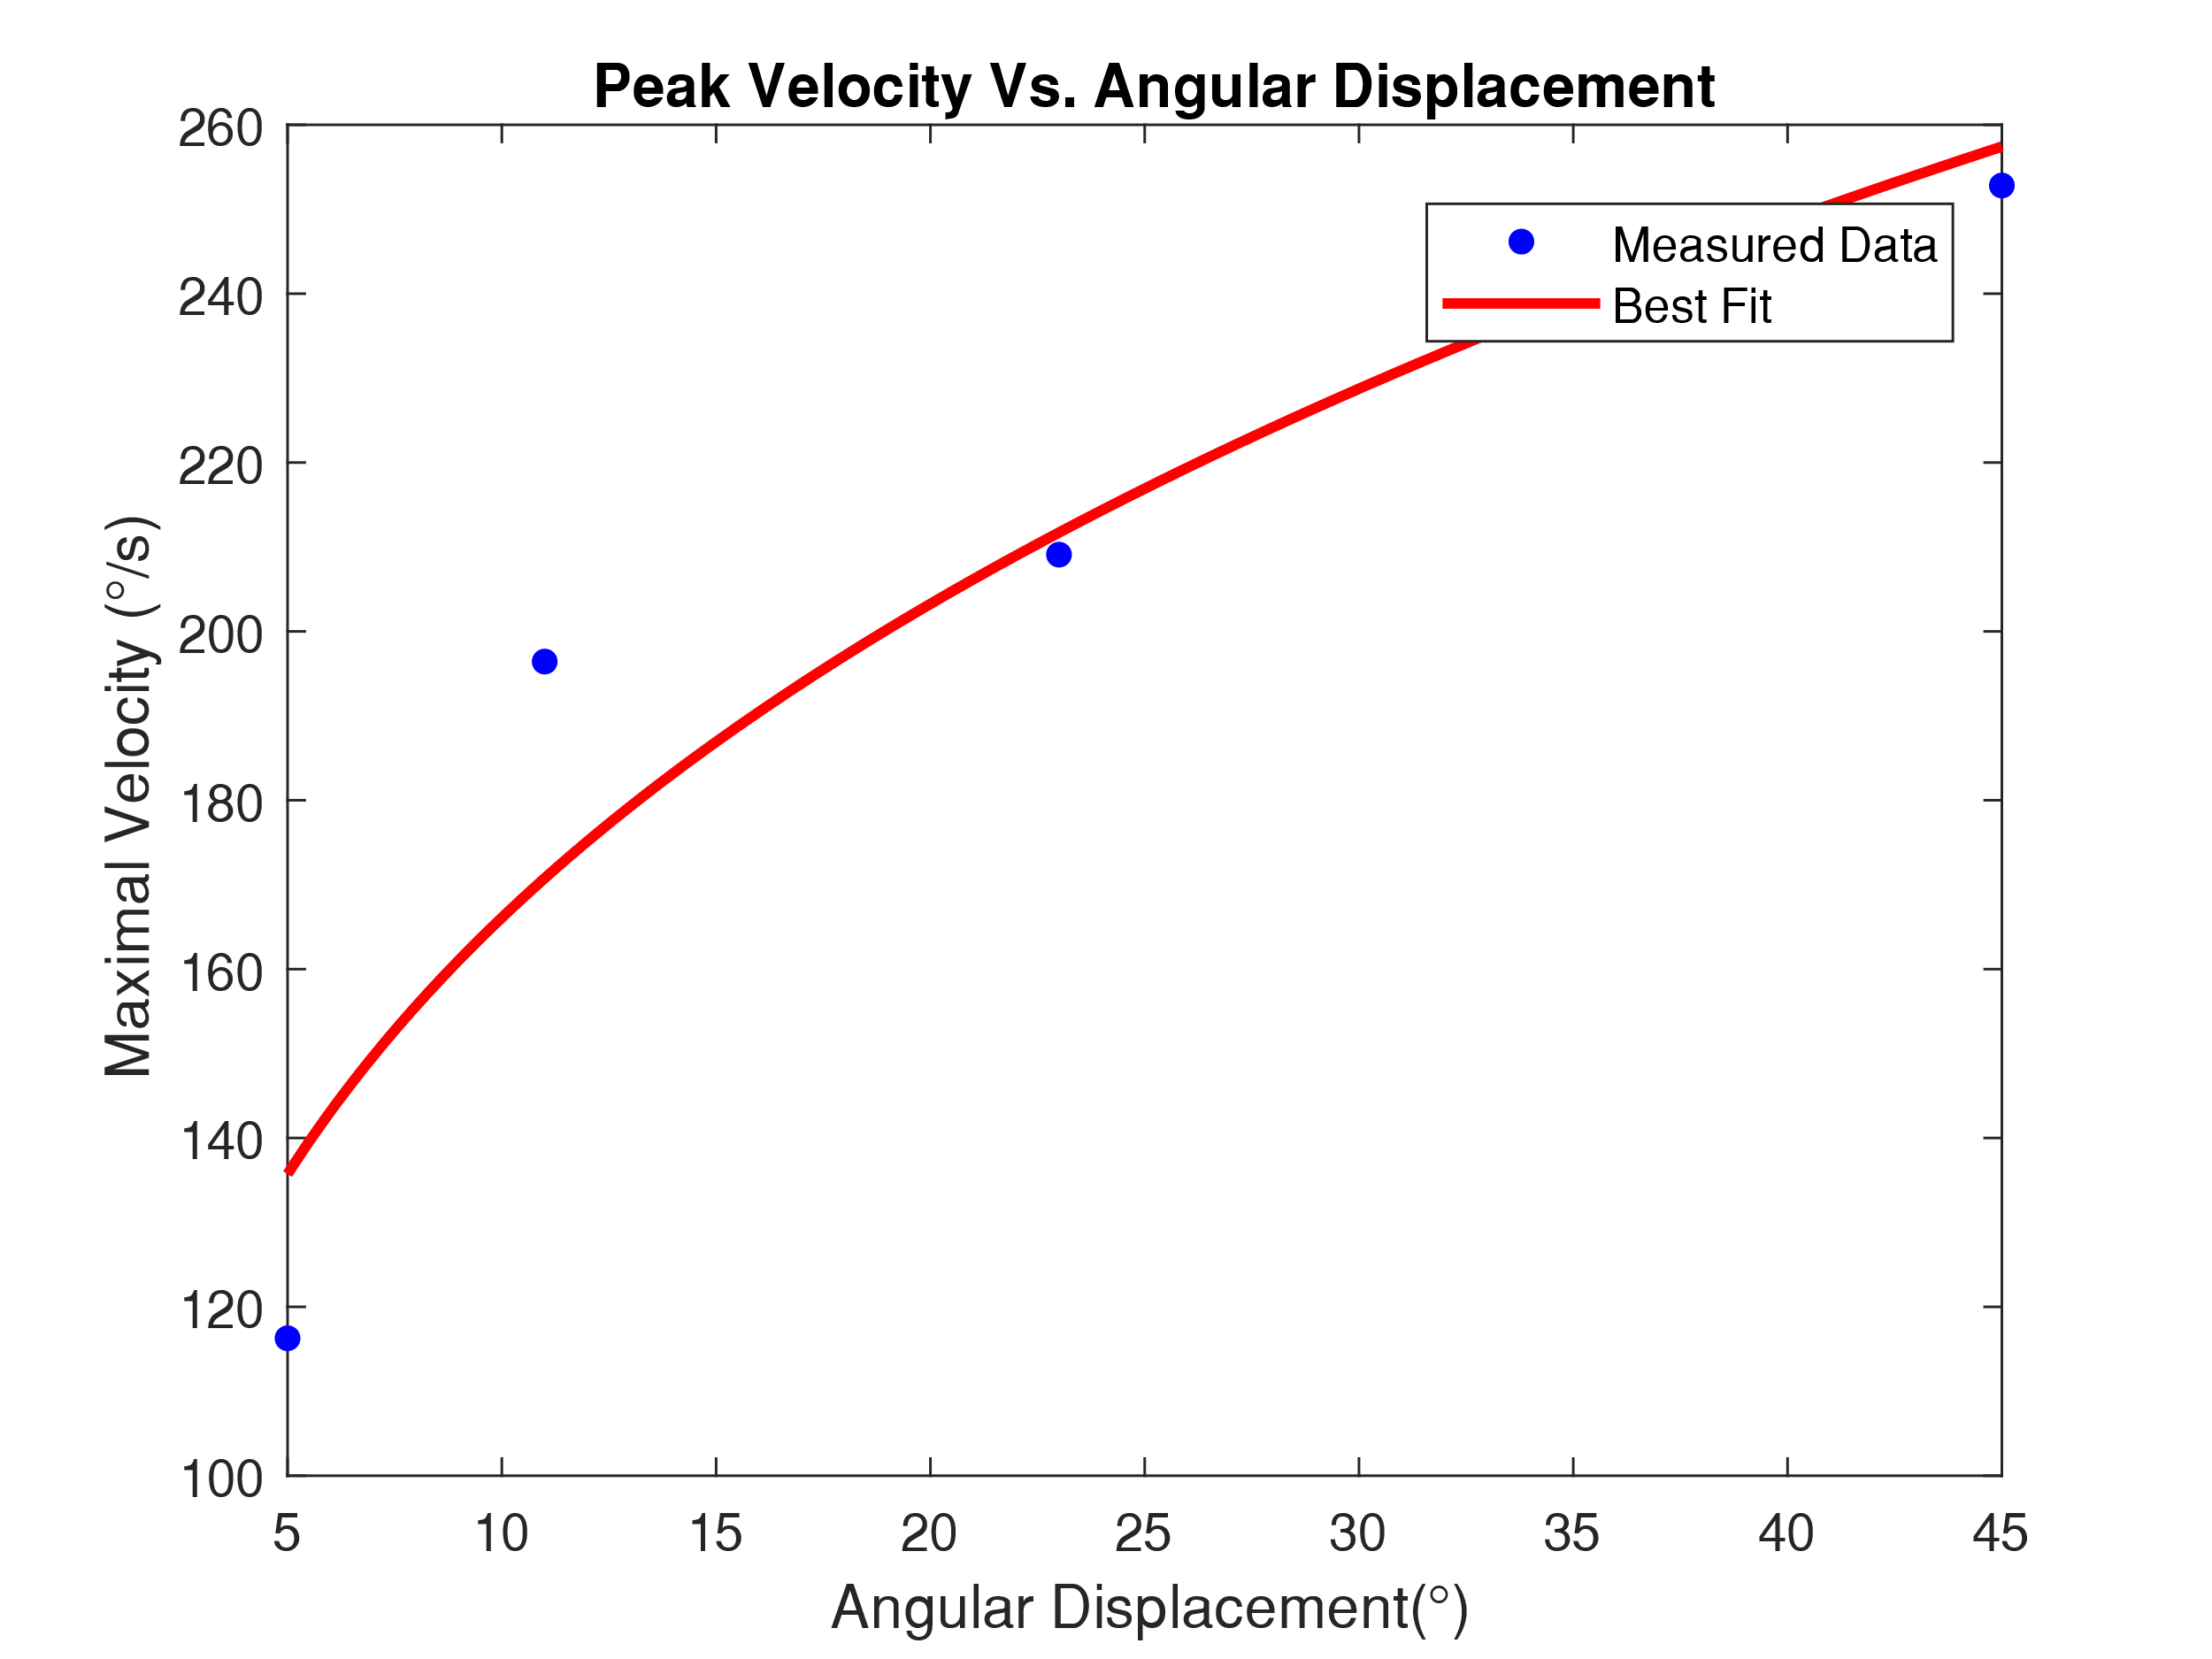

***Figure 3:*** *This figure shows the relationship between the angular displacement of the eyes and the maximal velocity of the eye during the saccade to the set displacement. A power model was found to fit the results best. The model was in the form , where and .*

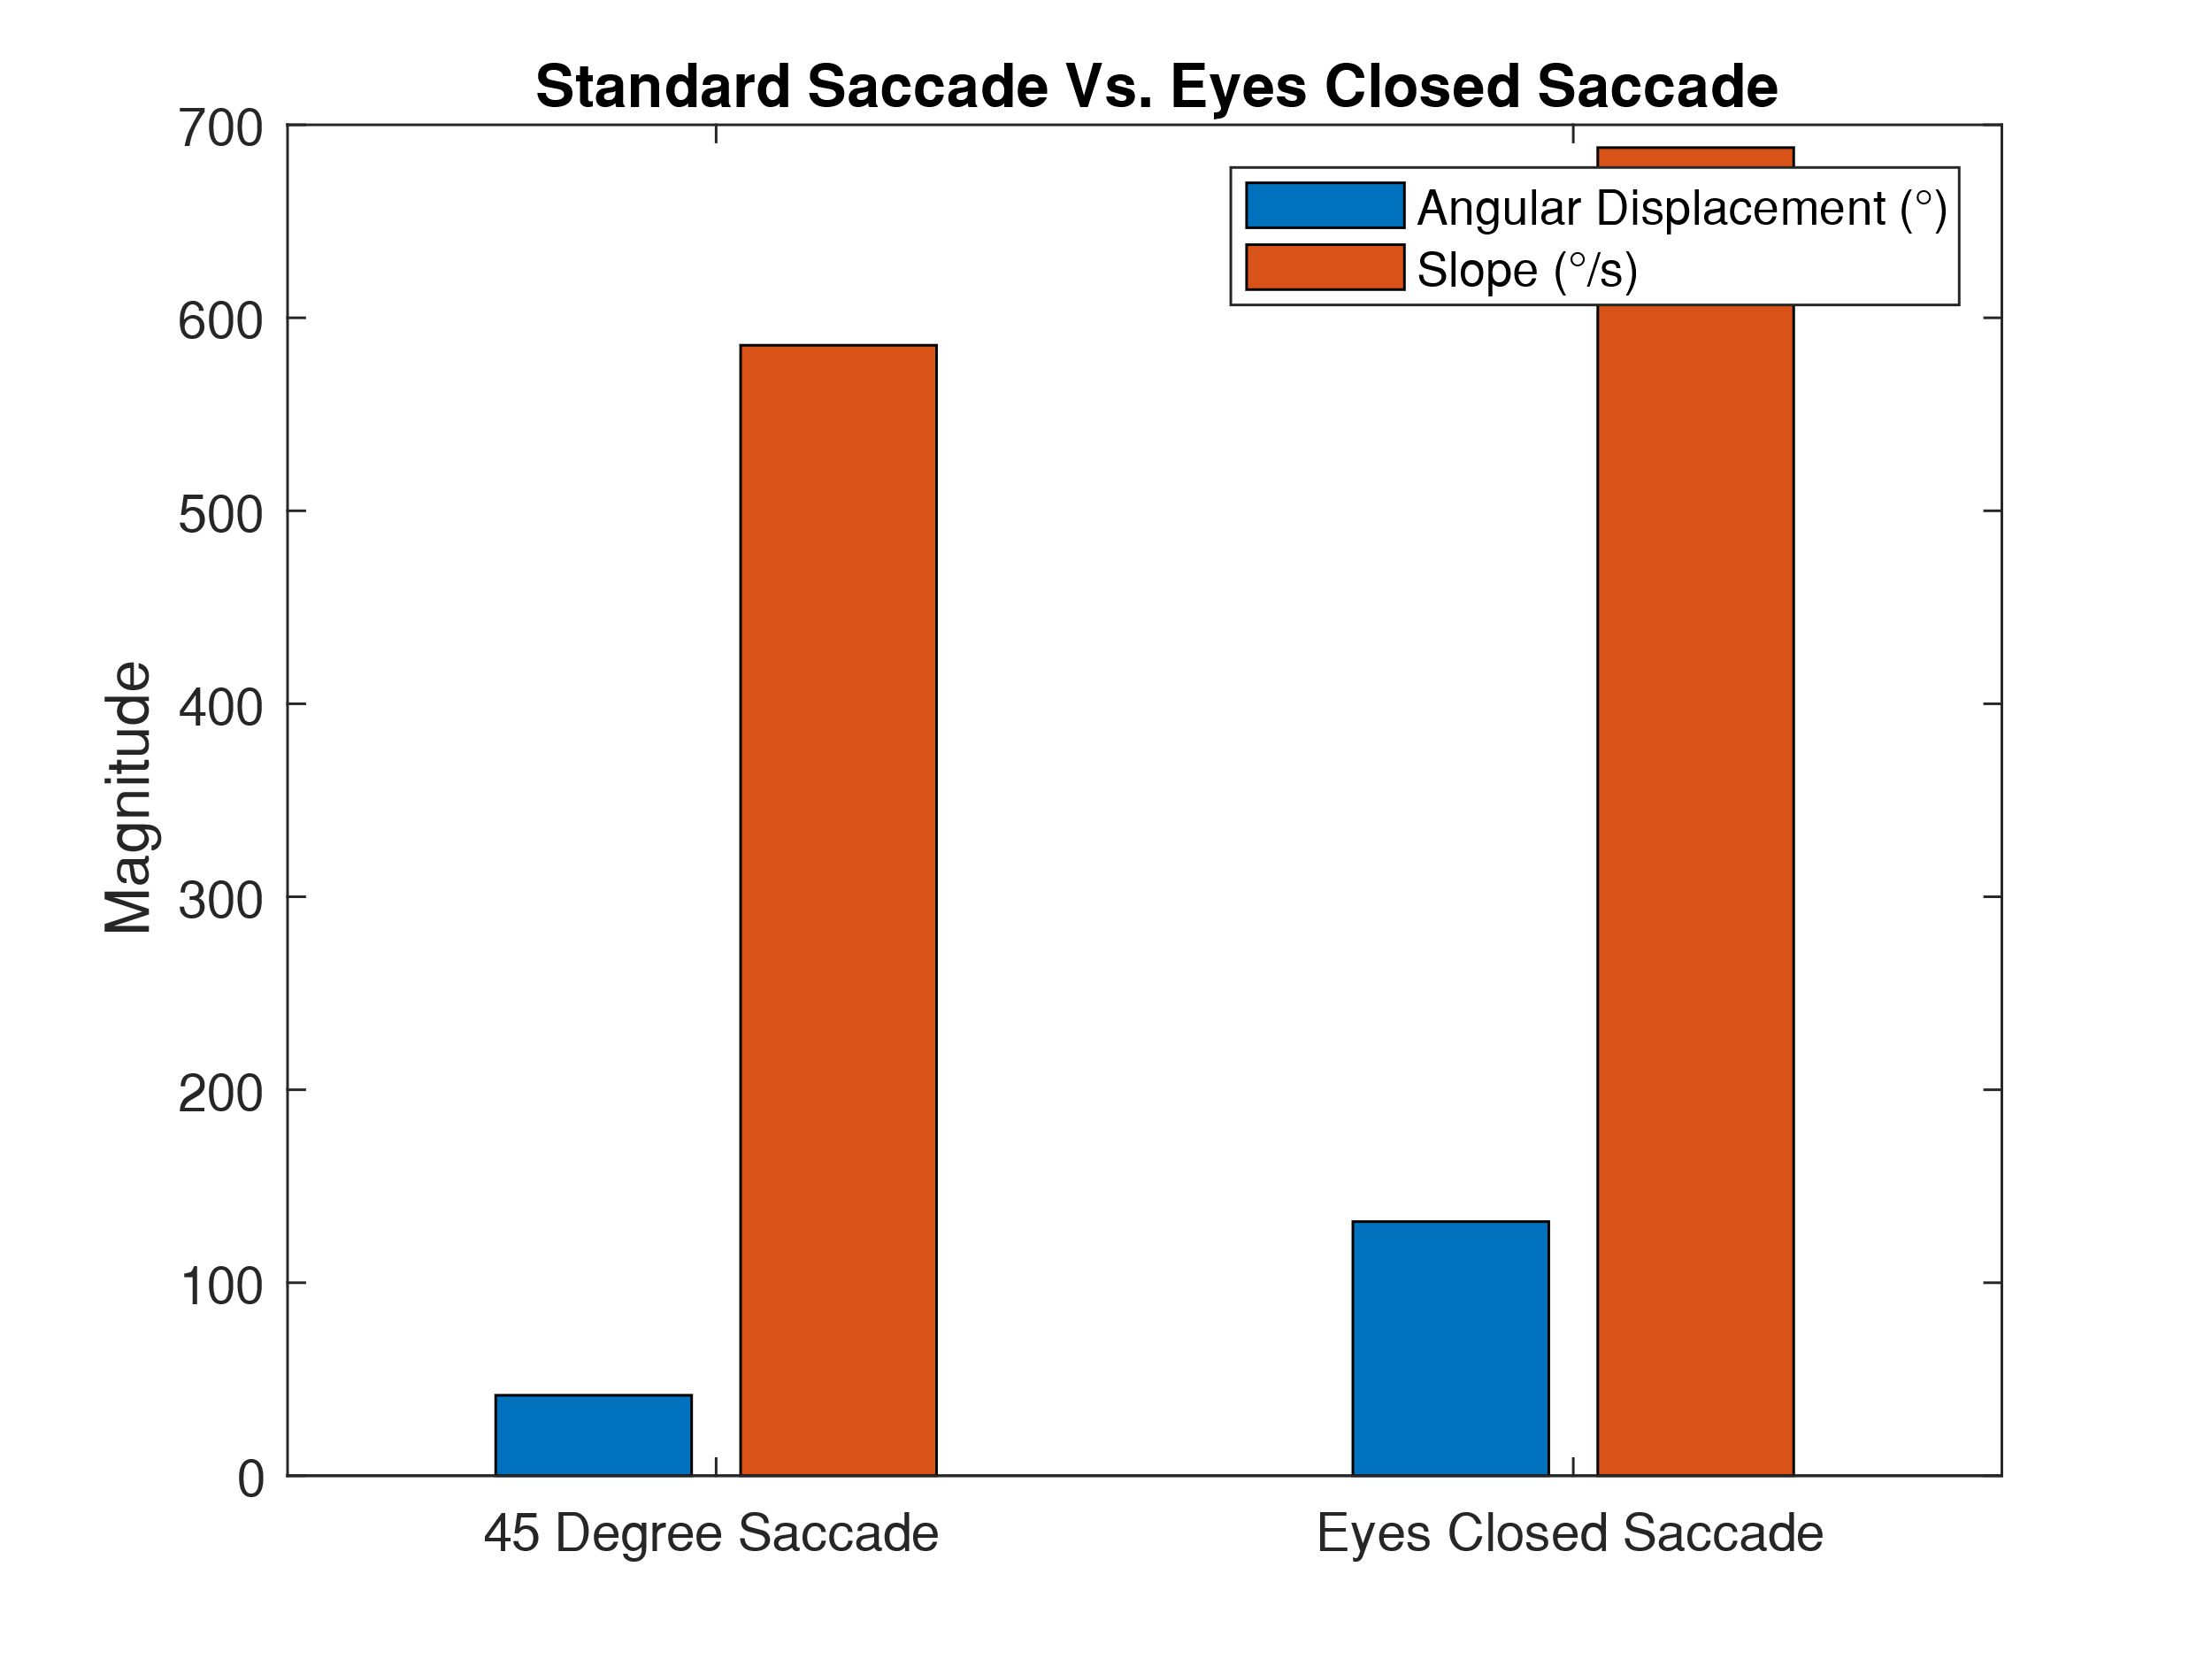After measuring the standard saccades, non-standard saccades were measured as well. One of these non-standard saccades was generated with the subject’s eyes closed. A quantitative comparison follows:

***Figure 4:*** *This figure shows the quantitative differences between a standard 45° saccade, and a non-standard saccade generated with the subject’s eyes closed. It can be seen that the non-standard saccade has a much higher angular displacement, and a much greater velocity when compared to the standard saccade.*

In the next section of the lab, the ability to track a moving object, also known as smooth pursuit, was tested. The EOG data of the speeds at which tracking could be held were analyzed, and the angular velocity was extracted. The data is as follows:

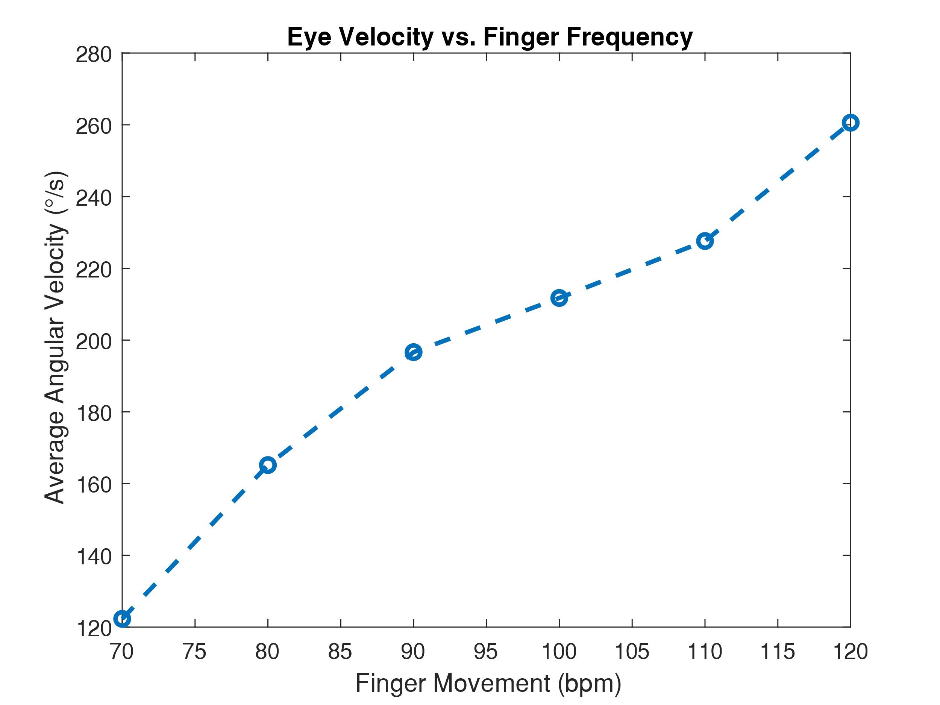

***Figure 5:*** *This figure shows the relationship between the velocity of the eye and the velocity of the finger that the eye was tracking. In this case, the velocity of the finger is represented by proxy as the frequency of finger movement in beats-per-minute. This is done to normalize for variations in travel distance of the finger and distance between the subject and the finger.*

In the next section of the lab, the reaction time for a dictated eye movement was tested and measured. The results are as follows:

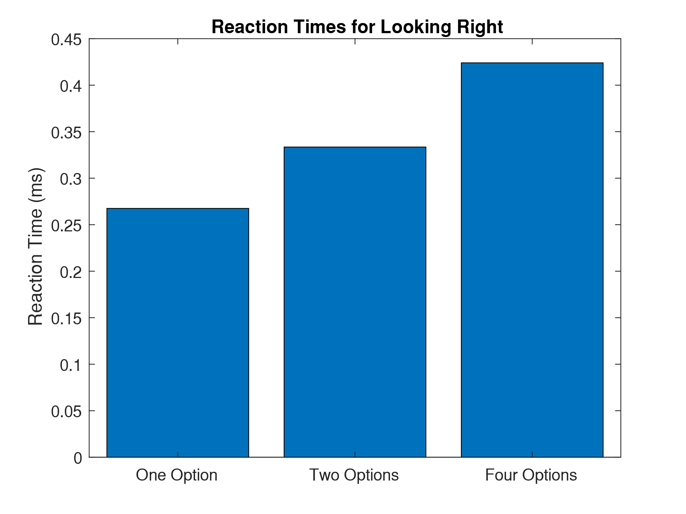

***Figure 6:*** *This figure shows the reaction times for three different experiments testing reaction times. All results are the average of three trials, and only the rightward movement reaction times were recorded. It can be seen that as the number of options increased, the time required to react increased.*

Following this baseline measurement for reaction times, two specific response times were tested for: saccade and pursuit. The results from these tests are as follows:

**Table 1: Reaction times for saccade and pursuit**

|  |  |
| --- | --- |
| **Reaction Type** | **Mean Reaction time** |
| Saccade | 0.2812 |
| Pursuit | 0.2260 |

*This table shows the mean reaction times for a saccade and a pursuit action. The reaction times provided are the average of three trials. It can be seen that the Saccade has a slower reaction time than the pursuit.*

Afterward, the lab moved on to testing if the measurement configuration used could detect vergence. The results for the test are as follows, with standard saccade data included for reference:

**Table 2: Vergence Measurements**

|  |  |  |
| --- | --- | --- |
| **Measurement** | **Saccade** | **Vergence Average** |
| **Amplitude (°)** | 45 | 24.5203 |
| **Velocity (°/s)** | 252.8090 | 215.5920 |

*This table shows the differences between a standard 45° saccade and the average of the vergence data across three trials. It can be seen that the velocity for vergence is similar to the saccade velocity.*

Finally, the lab moved onto measuring VOR and OKN. A sample of the control VOR Data is as follows:

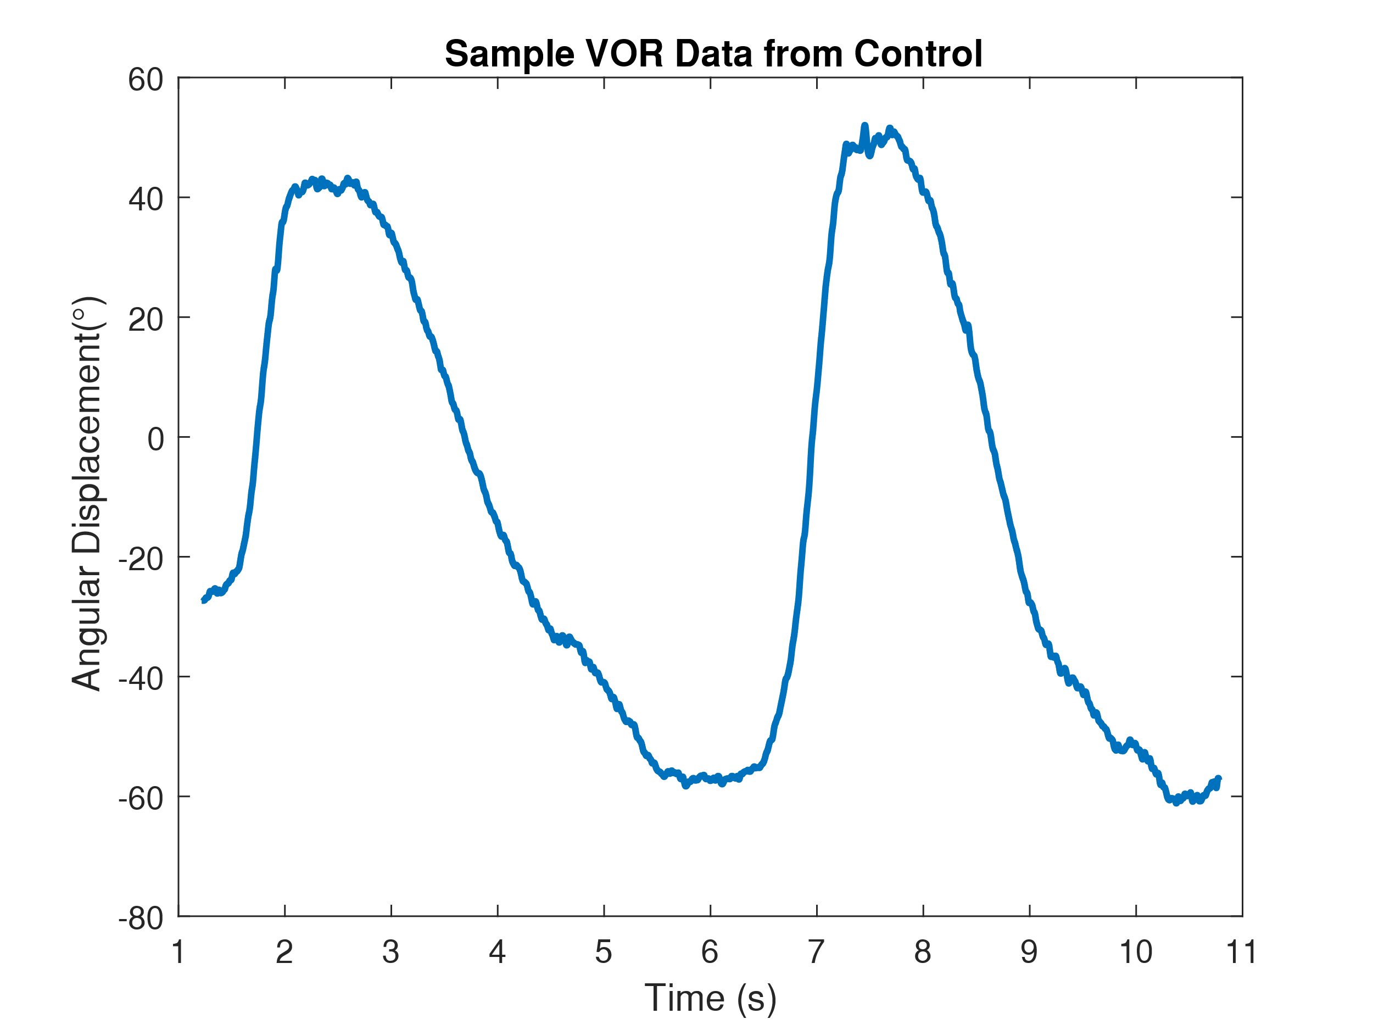

***Figure 7:*** *This figure shows sample data from the control experiment performed for VOR. This data was collected by gently spinning the subject using an office chair while the subject focuses on tracking a fixed point with their eyes. It can be seen from this sample data the subject's eyes swing over 100° during the experiment in order to keep tracking.*

Likewise, the results from the alternate VOR conditions are summarized as follows:

**Table 3: VOR Measurements**

|  |  |  |  |  |
| --- | --- | --- | --- | --- |
| **Measurement** | **Control** | **Mental Math** | **Bag & Math** | **Far Away** |
| **Velocity (°/s)** | 419.9460 | 391.6460 | 632.1960 | 278.4460 |
| **Average Angular Displacement (°)** | 55.3741 | 62.8736 | 46.5615 | 73.4125 |

*This table shows the differences in velocity and average angular displacement between 3 different conditions for VOR along with a control experiment. It can be seen that there is a wide range between angular displacements and velocities across the four different testing conditions.*

Following the VOR experiments, OKN experiments were conducted. A sample of the recorded OKN data is as follows:

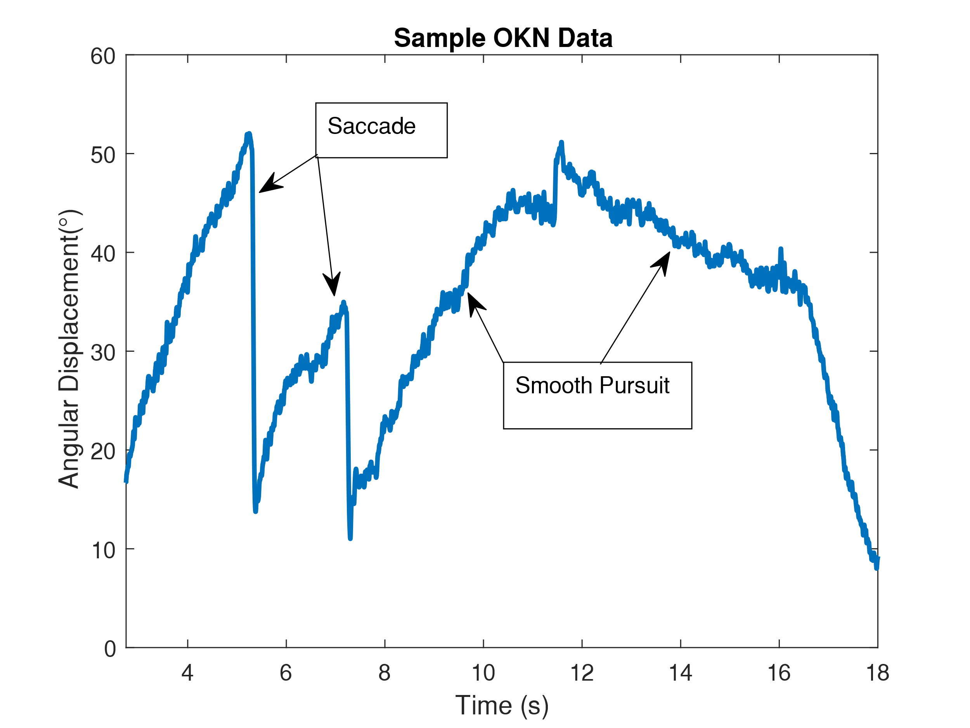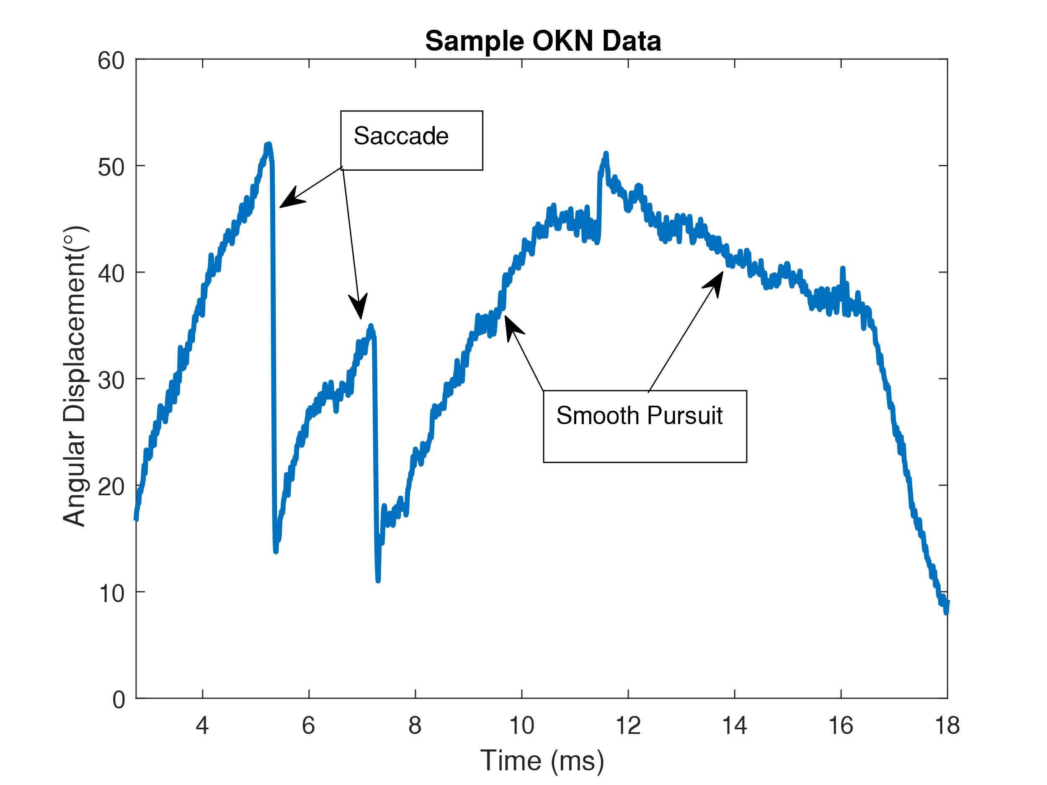

***Figure 8:*** *This figure shows sample data from the OKN experiment. This data shows both saccadic and smooth pursuit motion. This data was recorded while the subject was watching the optokinetic test. In the test, a random assortment of light spots on a black background moves from right to left.*

Finally, the specific measurements for the saccadic and smooth pursuit portions of the OKN were tabulated, and the results are displayed below, with standard saccadic and smooth motion data provided for comparison:

**Table 4: OKN Measurements**

|  |  |  |  |  |
| --- | --- | --- | --- | --- |
| **Measurement** | OKN Saccade | OKN Smooth Pursuit | Standard Saccade | Smooth Pursuit |
| **Amplitude (°)** | 12.4260 | 6.7660 | 45 | 10.2560 |
| **Velocity (°/s)** | 419.9460 | 335.0460 | 455.3210 | 136.9460 |

*This table decomposes the two primary components of an OKN response and compares the constituent components against the previously measured quantities for movements of the same type. It can be seen from the results that the amplitude of the OKN measurements are lower than the measurements for the constituent parts, while the velocity for the OKN smooth pursuit is much higher than the velocity measured for regular smooth pursuit.*

Finally, a Fourier transform of a standard 45° saccade is included for use in the discussion section:

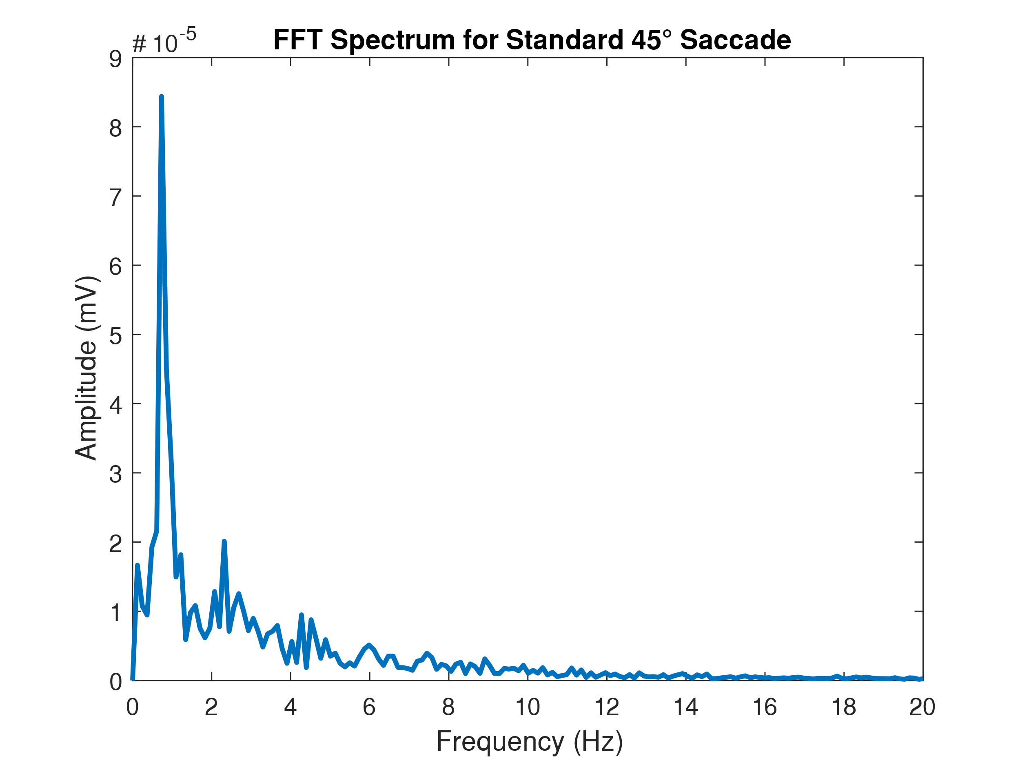

***Figure 9:*** *This figure shows the Fourier transform for the signal recorded from the standard 45° saccade. A very prominent peak is seen around .73Hz, with numerous other smaller peaks seen down to 18Hz after which it tapers off.*

**Discussion:**

From the sample data shown in figure 1, it can be seen that it takes around .25 of a second to fire off another saccade after returning to the baseline. This means that the eyes can oscillate at a rate of roughly 40Hz. This frequency is not precisely seen in the FFT of the signal, however, a signal around 18Hz, which is essentially half of the 40Hz maximum movement rate seen in the previous section. Thus from what is seen in the FFT (Fig. 9), it can be concluded that a minimum sampling rate of 40Hz is required to reconstruct the EOG signal for this movement perfectly. This is the case as the Nyquist–Shannon sampling theorem dictates that the sampling rate must be at least two times larger than the highest frequency component in the signal being acquired.

Following this introduction, the lab moved onto measuring the peak velocities for the four fixed displacement saccades tested. From the data shown in Fig. 3, it can be seen that as the displacement increases, the velocity of the associated saccade increases as well. However, this increase in velocity does not appear to be linear, and in-fact seems to follow a power function. This makes sense as eventually the eye cannot move any faster as it has gone as far as possible, and the forces resisting the motion of the eye will equal the force applied to the eye preventing it from accelerating further. Thus, from this understanding, as it would be ideal for the eye to move as quickly as possible to the targeted displacement, a more significant target displacement will have a larger speed for the eye movement to get there. This phenomenon can also be seen in the saccadic motion for the non-standard testing conditions from part two of the lab.

An example of this is saccadic motion while the eyes were closed. In this case, both a greater angular displacement was measured, as there is no way to measure how far the eye moved easily, and a higher velocity was measured as well (Fig. 4). The higher velocity maybe because the eye could not ‘overshoot’ as it was to turn until it could no longer. Similarly, under the reading condition tested (data not shown), the saccadic magnitude is much lower, and the velocity is much less than the 45° saccade. This is the case as while reading, the eye is moving significantly less far (angular displacement wise) and needs to have smaller, more precise movements in order to allow for the subject to keep reading accurately. However, when the eye is making movements from the bottom right to the top left of the range of motion, the resulting saccade is quite analogous to the standard 45° saccade. This is likely because it is a very similar motion, with defined targets to hit (in terms of angular displacement), and thus it looks quite similar to the standard saccade.

Following this, in section 3 of the lab, the subject was asked to track a moving finger until smooth pursuit movement could no longer be held. In this lab, the subject could track smoothly until 120bpm or around 2Hz. However, once this smooth pursuit motion was broken, the EOG data showed many large saccades as the eyes rushed to try to catch up with the finger it was tracking. However, while smooth pursuit was being maintained, there were no excessively large saccades present, with only small readings registering on the EOG. Asking the test subject afterward to try tracking on a static scene displayed similar EOG readings to tracking the finger once smooth tracking was broken. Asking the subject if they felt tracking on a static image was possible, they said: “it felt impossible to do.”

For the next part of the lab, section 4, the reaction time of the subject was tested for three different scenarios of varying numbers of degrees of freedom (Fig. 6). From this figure, it can be seen that as the number of choices increases, the reaction time increases correspondingly. In the case of the subject used in this lab, the reaction time when given only one choice is 40% faster than the reaction time when allowed four choices. Specifically, the average reaction time for just one option is .2675 seconds, while the reaction time for four choices is .4240 seconds, a 58.5% increase in response time for just three more choices. The second part of this section of the lab regarded measuring the response times for saccadic motion and pursuit. From the results shown in Table 1, it can bee seen that pursuit has a slower reaction time than saccadic motion. This may be the case as saccadic motion requires the subject to react to a stimulus in the periphery of the subject's vision, thus making the action take longer to register, increasing the reaction time. Conversely, the pursuit action occurs directly in the subject's focus, potentially allowing for the stimulus action to register faster, allowing for faster reaction times.

In the three trials for vergence that were conducted, vergence was detected in two of the trials. For the first trial, there was essentially no reading registered on the EOG for vergence. In this case, vergence was simulated by focusing on something far away and then focusing on something close by. For the next two trials, the subject forcibly crossed his eyes in order to simulate vergence to a greater magnitude than just focusing across the lab. This artificially inflated vergence did register on the EOG, and the results are displayed above in Table 2. In a perfectly setup measuring system, however, any degree of vergence would not be measured as the currents of the eyes would be in opposition, and the EOG setup used with two differential electrodes would not be able to register a difference in the two readings.

For the VOR measurements, as seen in Figure 7, it can be seen that VOR consists of relatively large and relatively smooth saccades that are used to track a fixed position as the head moves continually. This standard VOR result is then contrasted with some of the results acquired using alternate testing conditions, as can be seen in Table 3. What table 3 does not show is the lack of uniformity in the data present. The data for all of the alternative conditions is significantly less smooth than the VOR control. Similarly, there exist many more saccades of larger magnitude than what is seen in the control experiment. From the table, though, it can be seen that specifically for the bag over the head and completing mental math task the peak velocity was much greater, illustrating further the jerky nature of the data. Likewise, the increase in magnitude of the saccades is directly related to rotational displacement the subject went through. This jerky, non-smooth movement is what is expected to be seen in a patient who has a VOR impairment[1]. However, in order to capture the full picture of what is happening during a VOR, more tools will be needed. This is the case as two whole planes of motion are ignored in the measuring methodology used in this lab. Thus, in order to fix this problem, four more electrodes would be needed. These electrodes would need to be placed 90° above and below the current electrode pair, along with being placed 90° to the left and right of the current electrode pair. Thus all the orthogonal planes can be measured for movement, allowing for a full picture of VOR movement to be built.

Finally, for OKN movements, two distinct types of motion could be seen. The first was saccadic motion, while the second was smooth pursuit (Fig. 8). In the case of the data recorded from the subject used for this lab, the average saccadic movement was around 12°, while an average velocity of around 420°/s was recorded. Comparatively, the smooth pursuit had lower amplitudes and velocities. From the data, an average displacement of around 7° was measured, while an average velocity of around 330° was measured. Expanding on this, if a patient potentially had difficulties with OKN, it would be expected to see larger more frequent saccades with little to no smooth pursuit. This was not observed in our data; however, if alternate conditions like those used for VOR testing were to be applied to OKN testing there likely would be an emergence of data following such a pattern.

However, being said, there are proper clinical applications for VOR and OKN measurements. For example, VOR is used to diagnose brainstem death,[2] as it is a low-level instinctive response that does not require conscious or active input to complete. Similarly, OKN responses can be used to test whether or not the visual pathway for infants is intact if blindness or other visual disorders are suspected[3].

**Conclusion:**

Overall this lab was successful in teaching the students about the fundamentals of ocular movement and introducing and cementing the understanding of saccades, smooth pursuit, vergence, tracking and reaction times of the visual system. It also served as a strong introduction for the principals of EOG and further expanded the students understating of LabChart and the PowerLab device. The lab successfully synthesized the learning of the students in the measurement and consequent analysis of the VOR and OKN responses. The single plane limitations of the EOG system employed in the lab were explored as well through the vergence measurement. Further, during the discussion, the students built an understanding of the potential failings of the VOR and OKN responses, and the actual clinical applications of these physiological responses.

**References:**

1. Lab Partners: Bryce Maxwell, Whitaker Andrew
2. Barbour Lectures 1-4
3. PLab Manual
4. Diagnosis of death Author, Oram, JohnMB ChB FRCA DICM & Murph, PaulMA FRCA. June 2011
5. KIFF RD, LEPARD C. Visual Response of Premature Infants: Use of the Optokinetic Nystagmus to Estimate Visual Development. Arch Ophthalmol. 1966;75(5):631–633.
6. Daye, Pierre M et al. “Vestibulo-ocular reflex suppression during head-fixed saccades reveals gaze feedback control.” *The Journal of neuroscience : the official journal of the Society for Neuroscience* vol. 35,3 (2015): 1192-8. doi:10.1523/JNEUROSCI.3875-14.2015

**Unofficial References:**

1. Other Individuals were consulted. However, there was no collaboration, only discussion
   1. Students are: Anthony Wu, Spencer Kaminsky, Precious Oluwakemi, Emily Ray
   2. Instructors include: Professor Widder, Professor Ledbetter

1. Daye, Et Al.
2. Oram, Et al.
3. Kiff, Et al.