**Lab 3: Compound Action Potentials in Frog Sciatic Nerves**

**Pranav Maddula**

**Lab Partners:** Bryce Maxwell, Andrew Whitaker

Washington University in St. Louis

BME 301A

**Lab Instructor:** P. Widder

**Experiment date:** 10/18/19

**Submission Date:** 10/29/19

I hereby certify that this report is my own original work: **Pranav Maddula**

**Introduction:**

Neurophysiology is a significant research topic within the field of biomedical engineering. This lab attempts to convey the basics of neurophysiology, neural recordings, and advanced topics in neural modeling. This is done via a hands-on exploration of a complex physiological system in the form of a sciatic nerve from a frog. This exploration exposes students to the concepts of Compound Action Potentials (CAPs) and two significant methods of neuron recording: biphasic and monophasic. The lab also introduces how to evaluate and analyze signals recorded from complex biological systems. Further, the students build on their previous skills of understanding modern biomedical instrumentation, accurate data collection, and recording, along with building effective technical communication skills.

**Methods:**

This lab starts with the dissection of a bullfrog to extract the sciatic nerves for later testing. The sciatic nerves run down the legs of the frog and are extracted in a three-step process. First, the frog is killed, and the skin is removed. Following this, the urostyle and the dorsal muscles are separated, and the sciatic nerve is exposed. Finally, the sciatic nerve is extracted and immersed in Ringer’s Solution. Once both sciatic nerves are extracted, simulation and recording APs from these nerves can commence. Utilizing the given nerve conduction chamber, the neuron held in place across the electrodes in the chamber. For this setup, there is one set of stimulating electrodes and two sets of recording electrodes – proximal and distal – allowing propagation velocity and magnitude to be measured.

Once the neuron is in place, a LabChart macro is run to capture biphasic compound action potentials (CAPs) from which A-α and A-β components of the CAP can be discerned. Following this, another macro is run. This macro stimulates the neuron at different voltages for different durations allowing for a transfer function for AP amplitude based on stimulation voltage and time to be generated. Next, the refractory period for the neuron is tested. Once again, this is done via a macro that delivers two stimulations at varying voltages and intervals. This test allows for a calculation of the absolute and relative refractory periods for the neuron. For the last part of the lab, the stimulating electrodes are swapped for the distal electrodes, and then swapped again with the proximal electrodes. For both of these conditions, a macro is run to generate a monophasic CAP, from which monophasic latency and conductivity can be measured.

From the data collected for the biphasic CAPs, the conduction velocity for the neuron should be calculated by finding the latency and the length of the neuron. Two different latencies should be calculated for each channel, and two latencies should be calculated across channels, for a total of 6 latencies. These latencies are stimulus to takeoff and stimulus to peak, for the two channels. Across the channels, takeoff to takeoff and peak to peak latencies should be measured. From these latencies and the measured distance between the recording electrodes, conduction velocity can be calculated via the formula $\frac{Latency (sec)}{Distance (m)} = Velocity (m/s)$. This process is to be completed for both the A-α and A-β peaks, so that conduction for both the A-α and A-β fibers are calculated. Similarly, the threshold and saturation values for both A-α and A-β, along with the CAP as a whole, should be noted down.

For the next portion of data collected, for the strength-duration curves, two values must be isolated from the data. The first of which is isolating which combinations of stimulus voltage and stimulus duration leads to a CAP with a peak amplitude between ¼ and ½ of the peak CAP amplitude of the neuron at saturation. Likewise, the second value that is to be tracked is the combinations of stimulus voltage, and stimulus duration leads to a CAP with a peak amplitude between ¼ and ½ of the peak CAP amplitude of the neuron at the threshold. From these two sets of data, the strength-duration curves for the neuron at both conditions can be generated.

Following this, with the refractory period data that is collected, one needs to calculate the amplitude of the second CAP for each of the ISI durations, along with finding the minimum ISI duration that still results in a CAP. With this Minimum ISI, another test is to be run that will test the neuron at various stimulation voltages at 1.5x the minimum ISI. This data is then used to plot the amplitude response of both the first and second CAPs, relative to stimulation voltage at the critical ISI.

For the final section of the lab, the data for the monophasic CAP is used to calculate the conduction velocity via once again, by calculating the latency from stimulus to takeoff and the latency from stimulus to peak. This is to be done in both the forward and reverse monophasic propagation. Similarly, the threshold voltage and saturation voltage should be noted down.

**Analysis:**

For the Lab, the neuron used had an in situ length of 6.2cm; however, once in the apparatus, the neuron was slightly stretched to 7.0cm. The stimulating electrode was located 3cm away from the proximal recording electrode and 5cm away from the distal recording electrode. The distance between the two recording electrodes was thus 2cm. As the first part of the lab deals wholly with biphasic CAPs, a sample biphasic CAP is as follows to help the reader orient themselves wit the nature of the data being recorded.

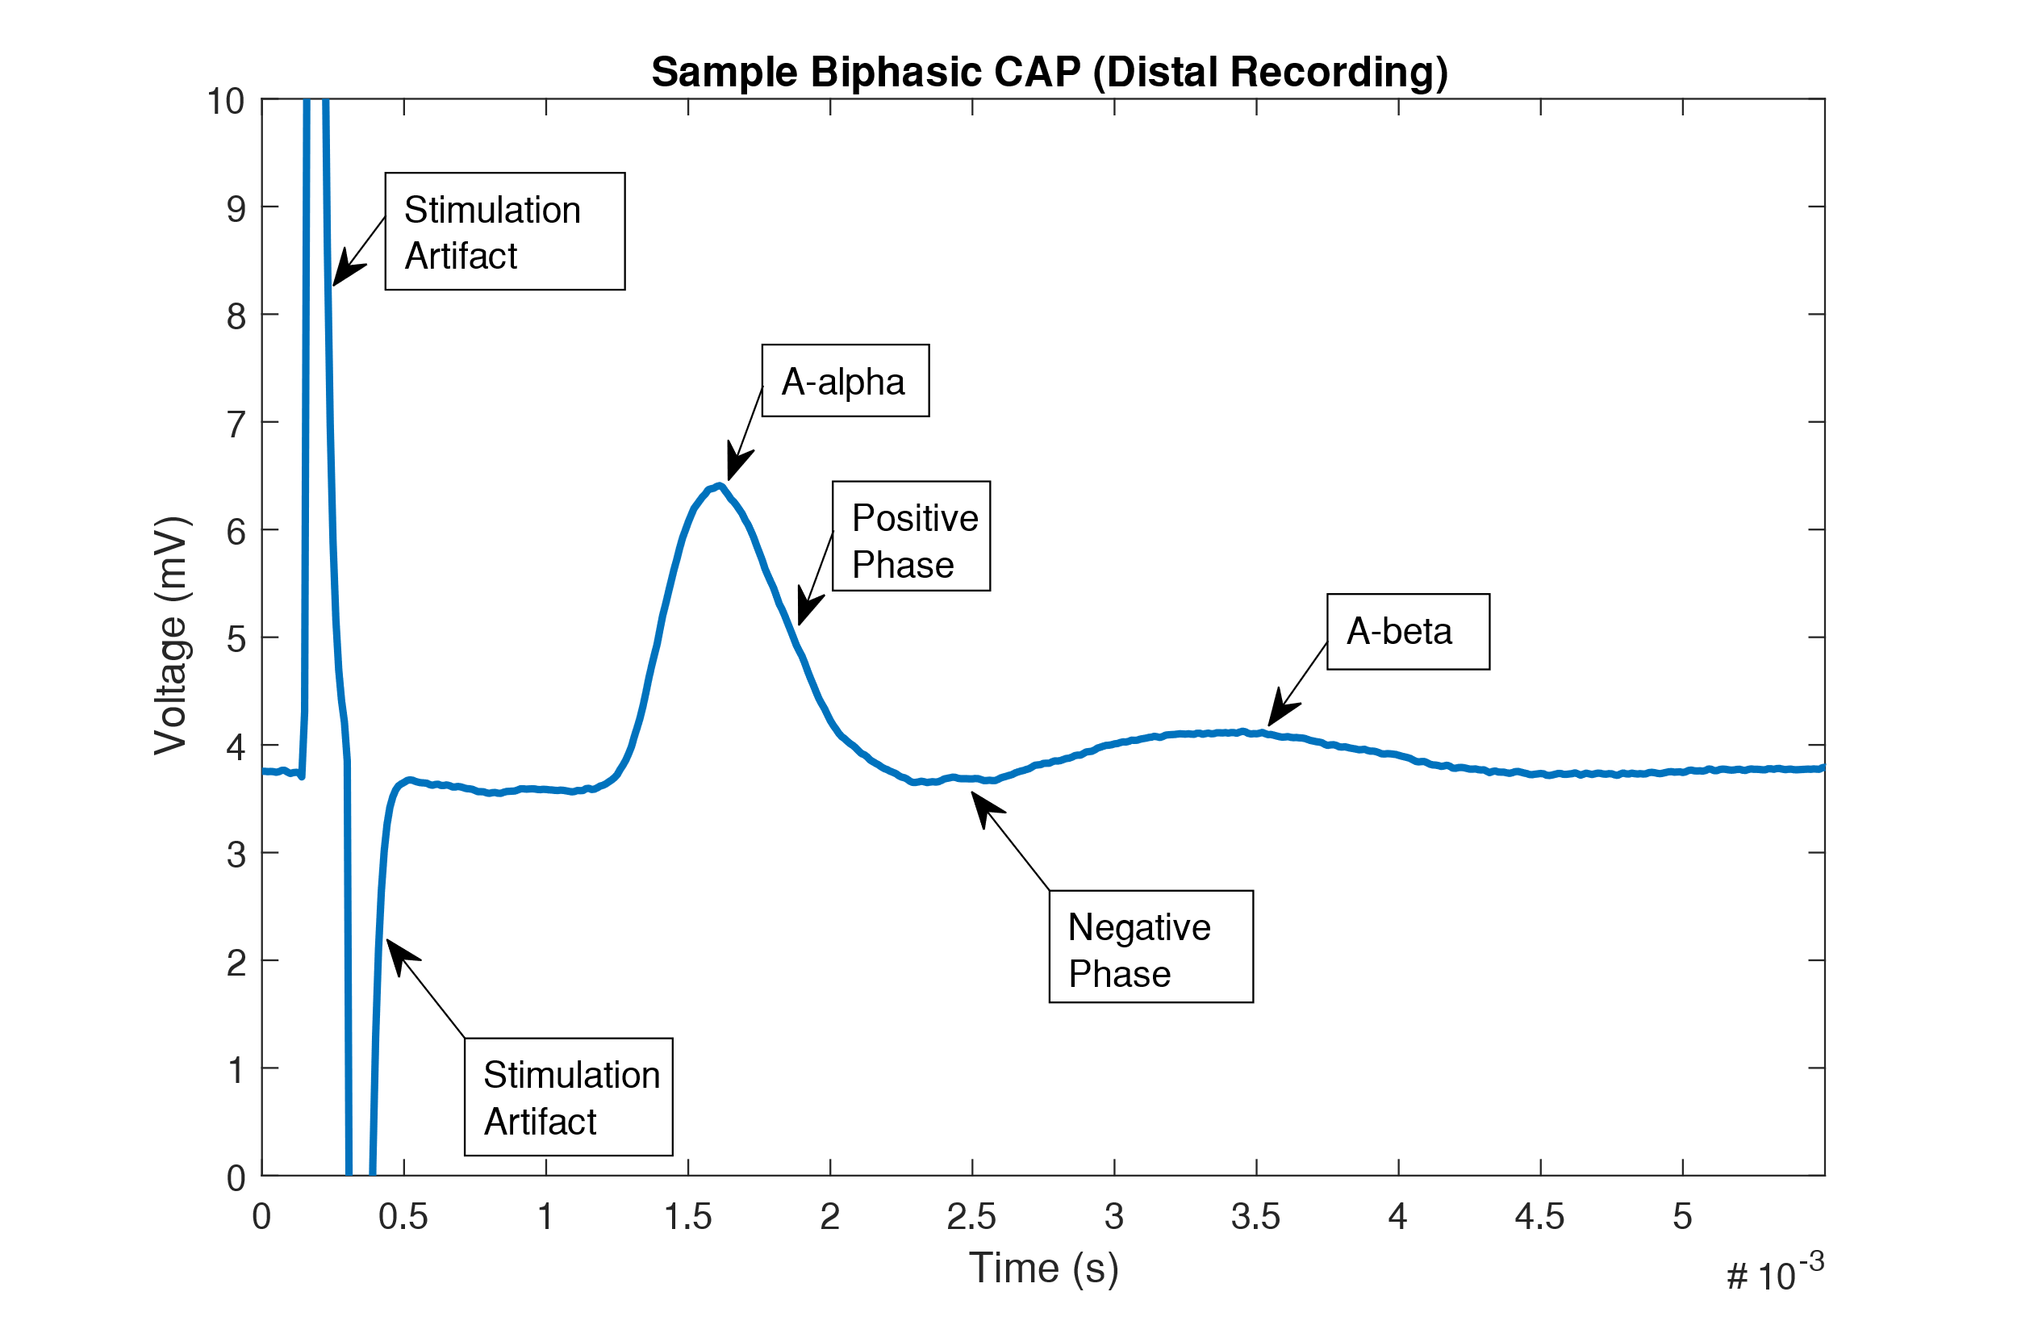

***Figure 1:*** *This figure shows an example of a biphasic CAP recording. This particular recording is from the distal electrode. There are four significant landmarks for this recording: the stimulus artifact, the positive and negative phases of the A-* *α signal, and the A-* *β signal. These landmarks are annotated on the figure.*

From the recorded biphasic data, the most critical data has been extracted and presented in **Tables 1 & 2**. This data includes threshold voltages, saturation voltages, latencies, and conduction velocities.

**Table 1:** Calculated Values for Biphasic Latency and Conduction

|  |  |  |  |  |
| --- | --- | --- | --- | --- |
| **Channel** | **Landmarks** | **Latency (sec)** | **Distance (m)** | **Velocity (m/s)** |
| Ch 1 | Stim-Takeoff | .0004 | .03 | 75 |
| Ch 1 | Stim-Peak | .00066 | .03 | 45.45 |
| Ch 2 | Stim-Takeoff | .00108 | .05 | 46.296 |
| Ch 2 | Stim-Peak | .00146 | .05 | 34.246 |
| Both | Takeoff-Takeoff | .00069 | .02 | 28.9855 |
| Both | Peak-Peak | .00081 | .02 | 24.6914 |

***Table 1:*** *This table shows the calculated values for six latencies. These latencies are then coupled with the formula Velocity = Distance/Latency in order to find the conduction velocity for the neuron.*

**Table 2:** Calculated Values for A-α and A-β: Threshold, Saturation, Velocity

|  |  |
| --- | --- |
| A-α Threshold Voltage | 230 mV |
| A-α Saturation Voltage | 370 mV |
| A-β Threshold Voltage | 350 mV |
| A-β Saturation Voltage | 460 mV |
| A-β Stim-Takeoff Latency & Velocity | 0.00246 sec, 20.325 m/s |
| A-β Stim-Peak Latency & Velocity | 0.00326 sec, 15.337 m/s |

***Table 2:*** *This table shows the calculated values for the A-* *α and A-* *β threshold and saturation voltages. Similarly, the latency and conduction velocity for A-* *β are calculated in the same way as latency and conduction velocity in* ***Table 1****.*

For the data shown in **Tables 1 & 2**, there is high confidence in the data. This is the case as the neuron had standard responses for the stimulations, along with a very prominent A-β signal (as can be seen in **Figure 1**). Furthermore, the conductances that were calculated mostly fell within the range of 15 to 35 m/s, which is in line with previous findings of frog sciatic never conduction velocity of 37.5 to 15.2 m/s[1]. Thus there is strong confidence in the data.

Following the calculation of biphasic conductance, strength-duration curves for the neuron at saturation and threshold were constructed. These results are shown below in **Figures 2 & 3**.

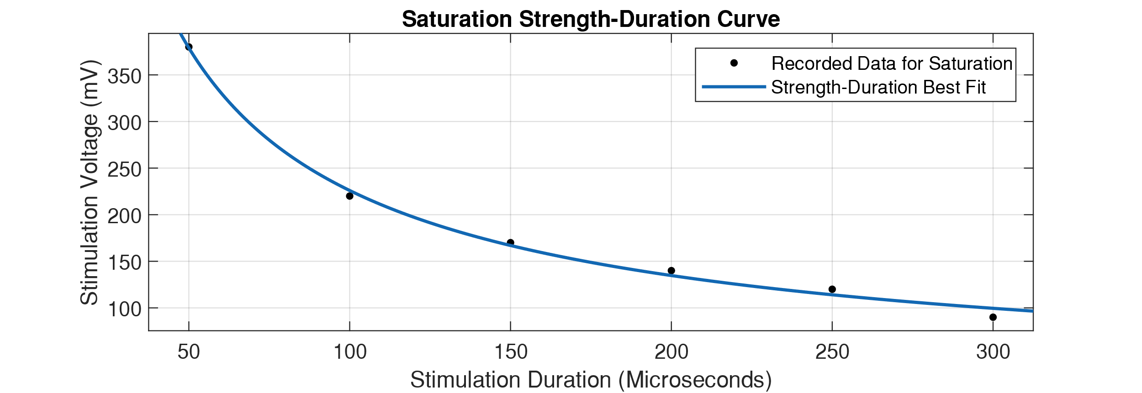

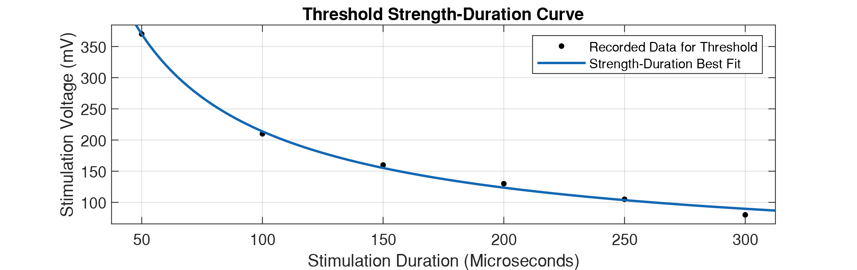***Figures 2 & 3:*** *Figure 2 is the top plot, while figure 3 is the bottom plot. Both of these figures depict strength-duration curves for the neuron tested. The top figure depicts the curve for neuron at saturation while the bottom depicts the curve for the neuron at threshold. The estimated chronaxie is ~100mV for Fig. 1 and ~75mV for Fig. 2. Both curves appear to follow a power fit of the form axb, where a = 7016 for Fig. 1, and a = 8153 for Fig. 2. b = -.746 for Fig. 1 and b = -.7906 for Fig. 2.*

From these results, rheobase, and chronaxie are calculated. These values help describe the intrinsic system behavior of the neuron and help build a transfer function that relates CAP amplitude to stimulation voltage and stimulation duration. The data for this section of the lab is also held in high confidence, as the resulting strength-duration curves fit the known functional form[2] of axb, which produces the fit seen in **Figures 2 & 3**.

Following this, the lab moves on to testing the refractory period for the neuron. The results of this are shown below in **Figure 4**.

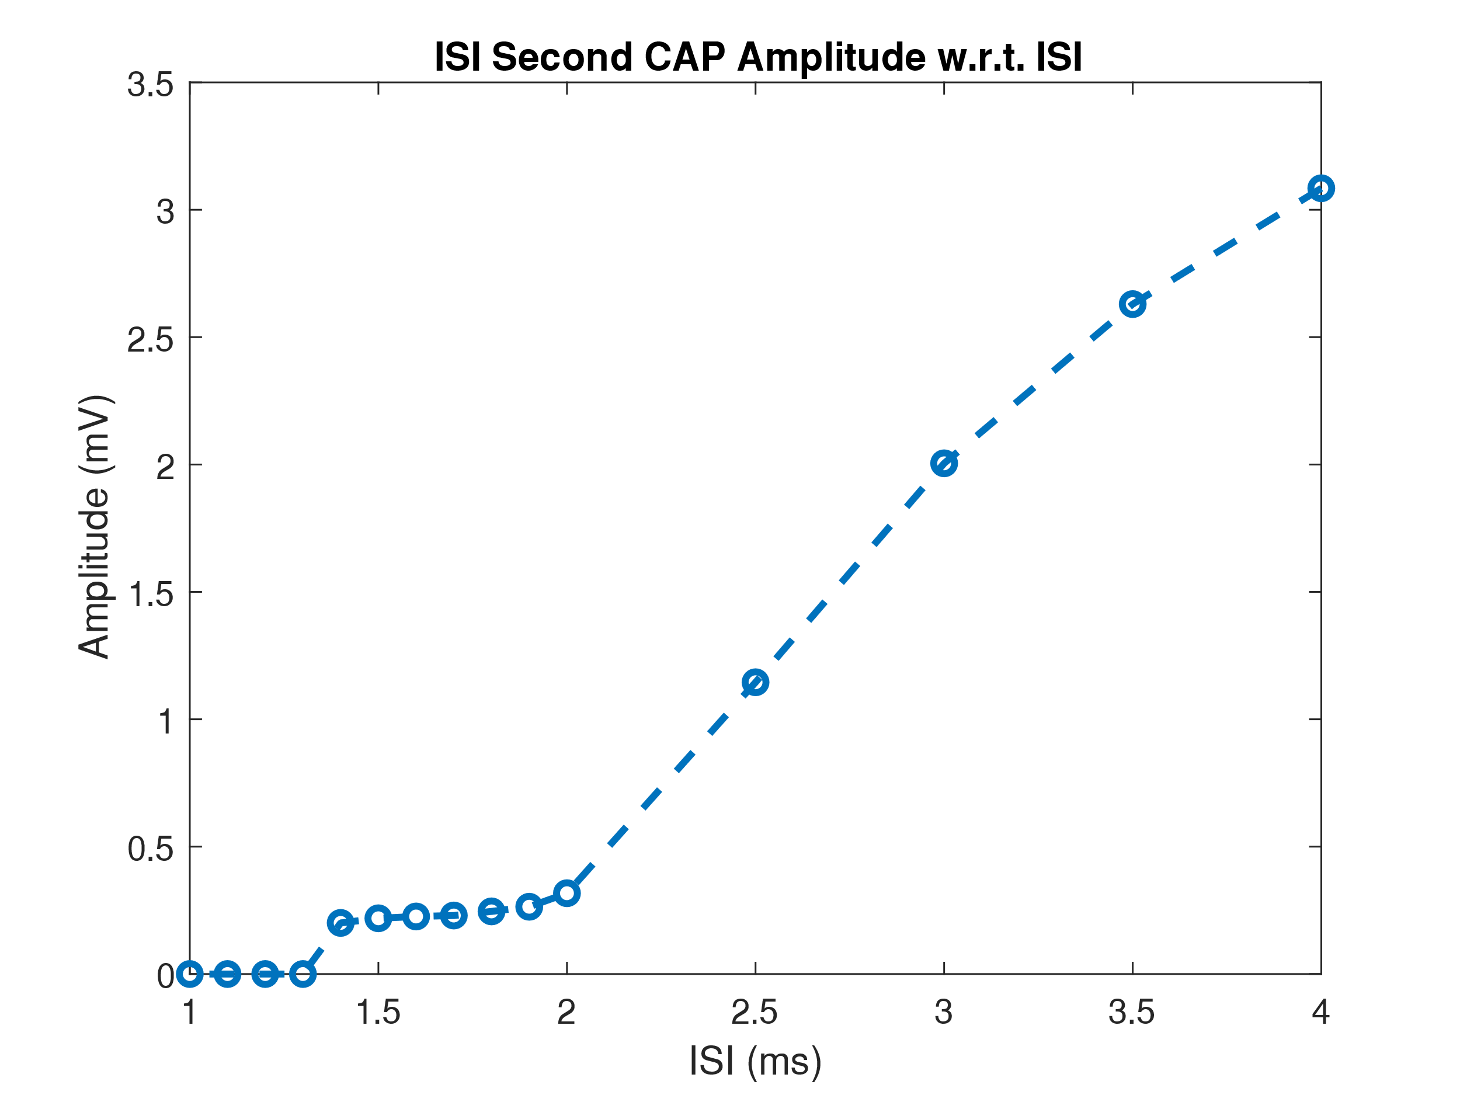

***Figure 4:*** *This figure shows the relationship between ISI and peak amplitude for the second CAP. The CAP appears to have a minimum ISI time, which reflects on the absolute reflection period, while the following period of gently increasing amplitude reflects on the relative refractory period of the AP. For this testing, the stimulation voltage was fixed at the threshold of 230mV.*

This result shows that there is a minimum ISI required to fire an AP and that there is also a range of ISI where the threshold is not able to launch a CAP. There is also strong confidence in the data for this section as the results follow the pattern of absolute and relative refractory periods, and the curve follows previously published work[3] , which further cements confidence in the results.

Following this, the amplitudes of the first and second CAPs were compared across various stimulation voltages, while holding the ISI constant. The results follow in **Figure 5**.

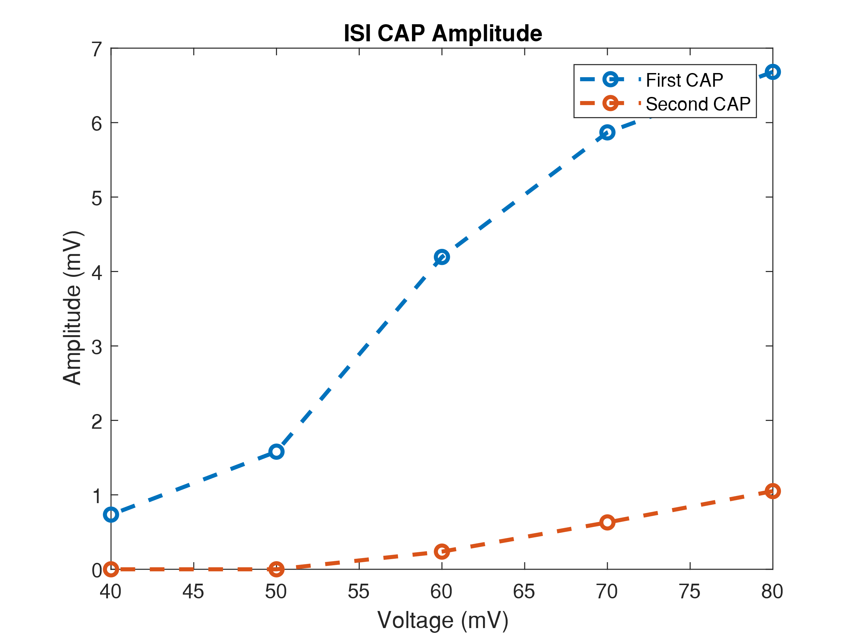

***Figure 5:*** *This figure shows the relationship between the first and second CAPs relative to the stimulus voltage at a constant ISI. The ISI used was 1.5x the minimal ISI that generated a CAP. In this case, the ISI used is .00265s. It can be seen that the amplitude of the second CAP always lags the amplitude of the first CAP. Likewise, the second CAP has a much higher threshold (~60mV) than the first CAP, which will fire even at 40mV.*

*This data is sample data provided on Canvas.*

From these results, it can be seen that there is a significant difference between the amplitude of the first and second CAPs. The estimated saturation amplitude for the first CAP is around 7.5mV, with a saturation stimulation voltage of ~90mV. Likewise, the estimated saturation amplitude of the second CAP is around 2mV, with a saturation stimulation voltage of ~100mV. Unlike the rest of the data collected for this lab, there is not as much confidence in this section. This is the case as the secondary CAP appears to be very small and there are very few data points recorded for this section. However, due to the fact that this data is the sample data provided, there is still sufficient confidence to present the findings from this segment of the lab.

For the final portion of the lab, the monophasic conduction velocity is being tested for and calculated. This differs from the previous parts of the lab which were all tested for in a biphasic manner. Thus, in an attempt to orient the reader to monophasic data, a sample monophasic CAP is depicted below in **Figure 6**.

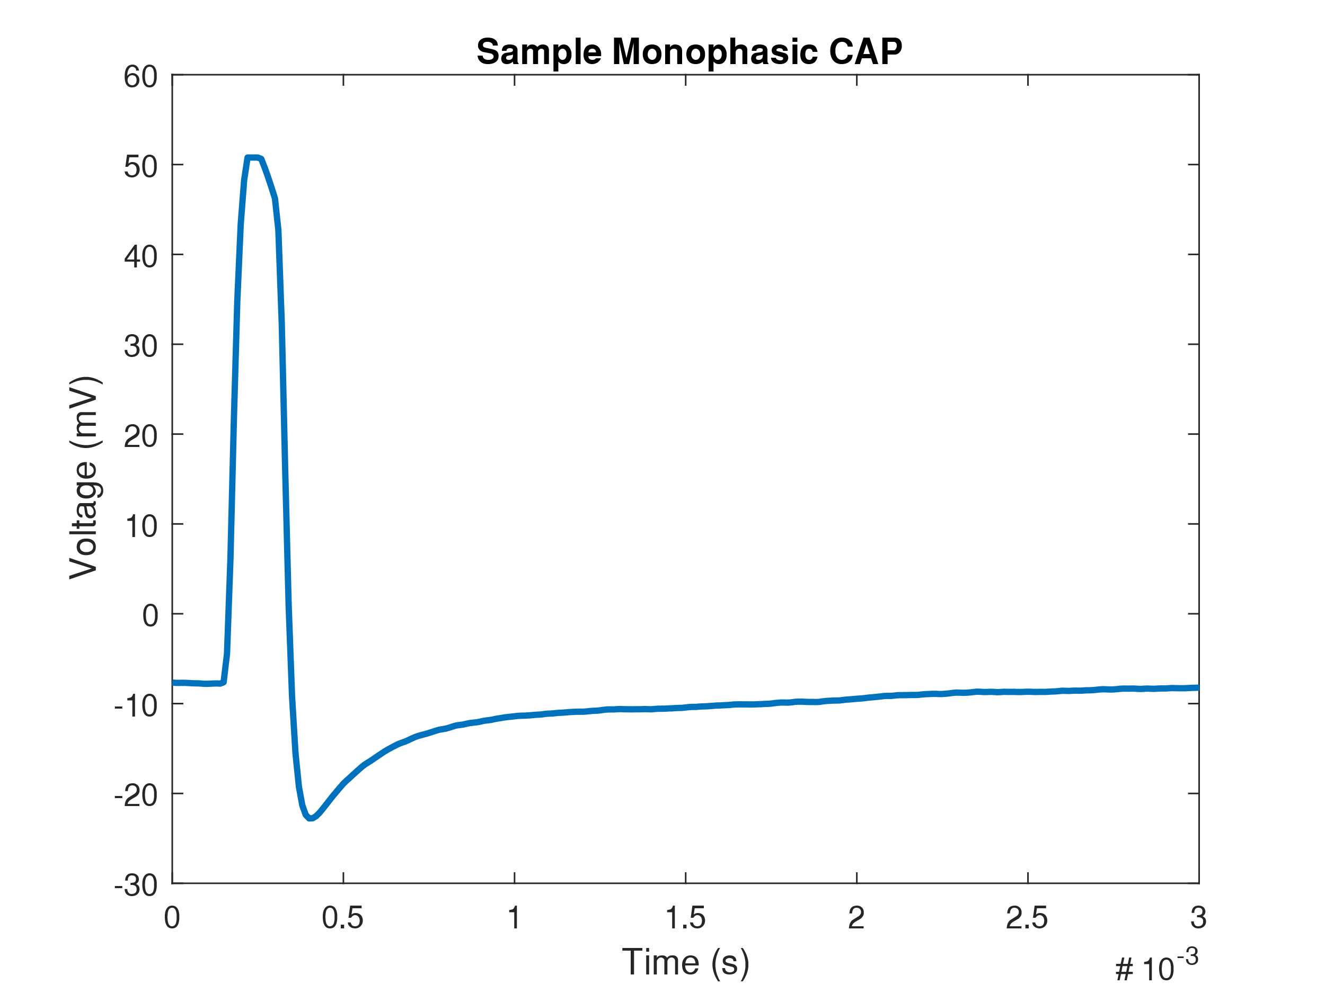

***Figure 6:*** *This figure shows a sample monophasic CAP. This monophasic CAP has more action potential like shape when compared to the biphasic CAP. However, this shape is, in fact, due to the stimulus artifact, and the following action potential that dips negative.*

From this monophasic recording data, the conduction velocity is once again calculated. However, this time the velocity is calculated for both the forward and reverse direction. The results are as follows:

**Table 3:** Calculated Values for Monophasic Latency and Conduction

|  |  |  |  |  |
| --- | --- | --- | --- | --- |
| **Direction** | **Landmarks** | **Latency (sec)** | **Distance (m)** | **Velocity (m/s)** |
| Forward | Stim-Takeoff | .00076 | .04 | 39.474 |
| Forward | Stim-Peak | .00099 | .04 | 30.303 |
| Reverse | Stim-Takeoff | .00082 | .04 | 36.585 |
| Reverse | Stim-Peak | .00107 | .04 | 28.037 |

***Table 3:*** *This table shows the calculated values for the forward and reverse conduction latencies from the monophasic data. These latencies are then coupled with the formula Velocity = Distance/Latency in order to find the conduction velocity in both directions for the neuron. Velocity in both directions appears to be quite similar.*

**Table 4:** Calculated Values for Monophasic Threshold and Saturation

|  |  |  |
| --- | --- | --- |
| **Direction** | **Threshold Voltage** | **Saturation Voltage** |
| Forward | 160 mV | 300 mV |
| Reverse | 190 mV | 320 mV |

***Table 4:*** *This table shows the calculated values for the forward and reverse saturation and threshold voltages in the monophasic regime. Both threshold and saturation for both directions appear to be quite similar in magnitude.*

This monophasic, directional conductance is quite useful as it allows comparisons between forward and backward CAP propagation, which is essential for understanding the role of the neuron in the body. For this monophasic portion of the lab, there is ample confidence in the validity of the data and results. This is because the calculated conductances for the monophasic recordings are in line with what was found for the biphasic data. Likewise, the monophasic data appears to closely match the general appearance of previously published work in the monophasic regime[4].

**Discussion:**

The focus of this lab is on measuring and characterizing compound action potentials generated from the frog sciatic nerve. These CAPs are formed from the summed response from a group of neurons, which in this case, are primary A-α and A-β fibers. These two fibers differ in diameter and thus propagation speed, forming the wide CAP seen. For the majority of the CAPs generated in the lab, they were biphasic in nature, as they had both positive and negative portions of the CAP, as can be seen in **Figure 1**. The smooth hump that is seen is the positive phase, while the slight depression following the hump is the negative phase. This positive phase is generated from the summing of the APs of the many neurons that make up the sciatic nerve; however, the negative phase is not so simple. The negative phase is created from a combination of two factors, the hyperpolarization of a neuron after an AP and the recording technique used. Due to the way that the recording is conducted, as the CAP propagates, part of the CAP will lie only in the region of the negative recording electrode, thus driving the recording negative and generating the negative phase in the recording.

From the data seen in **Table 1**, it can be seen that the conduction velocity calculated for the first landmark is consistently faster than the conduction velocity calculated for the second landmark. However, it can also be seen that the proximal conduction velocities are also faster than the distal conduction velocities and the difference can be anywhere from 10 to 30 m/s. Thus, in light of these discrepancies, the most accurate measurement for conduction velocity is likely calculated from the latency between the peak of the proximal to the peak of the distal. This is the case as measuring the conduction velocity this way removes the potential effects of the stimulation artifact on the latency calculation as well as averaging the velocity of the A-α and A-β fibers that consist of the neuron. This averaging of the A-α and A-β conduction velocities is essential, as the conduction rates of the two types of fibers differ, which can be seen in **Table 2**. From the results shown in this table, it can be seen that the total conduction, as seen in **Table 1,** is faster than the conduction for just the conduction of A-β fibers, as seen in **Table 2**. Not only is there a difference in conduction velocity, there is also a difference in threshold voltage. As can also be seen from the results in **Table 2**, the threshold voltage for the A-β fibers appears to significantly higher than the threshold voltage of the A-α fibers. This difference in conduction velocity and threshold is a product of the physiological difference between A-α and A-β fibers. As A-α fibers are larger in diameter, by the cable equations, the conduction velocity of the A-α is higher as velocity is a function of the diameter of the cable. Similarly, as diameter increases, the current density *J* required to stimulate the neuron decreases, also by the cable equations. Thus, from ohms law, *E = ρJ,* it can be seen that a lower *J* implies a lower *E*, which means that the electric field potential (i.e., voltage) required for stimulation is decreased.

Further, for all of this testing and all of the following testing, the cathode has been distal to the anode. Having the cathode distal to the anode for the stimulator is essential is it produces a plus to minus drop across the neuron. This plus to minus drop forces current to be injected into the neuron at the cathode triggering APs. Furthermore, the current leaving the neuron at the cathode acts as a depolarizing current that also triggers APs. Without this arrangement, there would not be a strong CAP produced that propagates along the neuron. Without this propagating CAP, there would be nothing to measure for this lab.

For the following part of the lab, two strength-duration curves for the neuron tested are generated. The first of these curves are generated for saturation CAP amplitudes, while the second curve is generated for threshold CAP amplitudes. These strength-duration curves can be seen in **Figures 2 & 3**. Both strength-duration curves appear to be quite similar, differing only by an initial offset. Wherein the strength-duration curve for saturation appears to be shifted higher by ten or so mV when compared to the threshold. Both of the strength-duration curves appear to conform to a power fit and appear similar to results published for human myelinated neurons[5]. This relationship seen in the strength-duration curve is purported to exit due to the charge distribution variance along the nerve. From the cable equations, it can be seen that the effect of a point charge along a neuron decays at an exponential, or power, rate. This decay is mirrored in the shape of the strength-duration curve. However, if the point charge is applied for a sufficient duration, charge equalization occurs, and a horizontal asymptote develops. This asymptote is known as the rheobase. From this rheobase, the chronaxie can be calculated, as is described in the captions for **Figures 2 & 3**. Specifically, for the data acquired, the rheobase is estimated to be around 100mV for the saturation curve and 75mV for the threshold curve. This leads to a chronaxie of around 110 microseconds for saturation and around 115 microseconds for threshold.

In the next section of the lab, the refractory period of the neuron is tested. For a neuron, there are two components of the refractory period, the absolute refractory period and the relative refractory period. During the relative refractory period, an AP can still be triggered with a sufficiently large stimulation; however, during the absolute refractory period, an AP cannot be triggered regardless of the stimulation used. This is because during the relative refractory period, all of the ion gates have reset; however, the resting voltages of the neuron are not yet stabilized. But during the absolute refractory period, the neuron is currently in the process of an AP; thus, the gates are not in a position to trigger another AP regardless of stimulation magnitude. Moreover, during the relative refractory period, although an action potential can be triggered, it is much more challenging to do so due to the lingering activation of the sodium inactivation gates, thus leading to a larger threshold voltage required for an AP. This phenomenon is exemplified in **Figure 5.**

From the data in **Figure 5**, it can be seen that the threshold for the second CAP is significantly higher than the threshold for the first CAP. This is illustrated by the fact that the second CAP does not occur until a 60mv stimulus, while the first CAP was present at even the lowest stimulus tested (40mV). Furthermore, the saturation voltage of the second CAP appears to be significantly lower than the saturating voltage of the first CAP. This can be seen through the fact that the second CAP has amplitudes that are consistently multiple millivolts higher than the peak amplitudes of the second CAP. Thus we can safely assume that the saturation voltage of the first CAP is significantly greater than the saturation voltage of the secondary CAP. Physiologically this is because the active sodium-potassium pumps have not yet had the chance to reestablish the ion gradients across the neuron fully. This leads to increased potassium Nernst potentials and depressed sodium Nernst potentials, which makes any AP that occurs during this time have a lower peak amplitude, as the sodium Nernst potential is depressed.

Following this, the lab transitioned to testing for monophasic CAPs. For the monophasic CAP, as exemplified in **Figure 6**, the general shape of the AP is significantly different from the biphasic CAP, as seen in **Figure 1**. At first glance, it appears as though the monophasic CAP looks more like a standard AP, as it has a tighter and taller peak while also having a more classic looking hyperpolarisation after the peak. Another key difference is that a stimulating artifact is not seen in the monophasic plot, even though it features prominently in the biphasic plot. This intrinsic difference is a function of the changed recording methodology. In the monophasic recording setup, the reference electrode is the only electrode recording, while the positive electrode remains unconnected, and thus recording a floating voltage. This setup changes the way the potential difference across the electrodes is measured and thus removes the ability for there to be different readings across the two recording electrodes. Furthermore, this testing setup also allows for larger and more compact CAPs to be detected as the reference voltage is fixed and not varying with the same neural signal.

Digging into the monophasic data, the latencies and conduction velocities for forwards and backward CAP propagation are calculated. These results are found in **Table 3**. Similarly, the threshold and saturation voltages for the monophasic results in both directions were found, and the results are shown in **Table 4**. Of interesting note is the fact that the latencies for the monophasic results were different from the biphasic latencies (**Tables 1 & 3**). This difference, however, can be mainly chalked up to the difference in distance between the electrodes across the two testing methodologies. However, in the event that the distances between electrodes were identical, it is to be expected that the latencies between the monophasic and biphasic recordings would be essentially the same. Likewise, the data shows virtually identical forward and reverse conduction velocities (**Table 4**), which would make sense, as there is no logic in having a neuron that can only propagate an AP in one direction. Physiologically, this is quite difficult to do as the sodium and potassium gates span the axon of the neuron and can propagate an AP in both directions. Furthermore, blocking the backpropagation of APs makes control much more difficult as there is one less feedback mechanism in place. From the data gathered, it is seen that the threshold voltage in the forward and reverse directions of the monophasic recording are quite similar; however, the threshold appears to be significantly lower in the monophasic regime. This is unexpected, however, it may be because the monophasic recording methodology is more sensitive than the biphasic recording. Thus a lower threshold voltage is detected, but a similar saturation voltage is observed.

**Conclusion**

This lab has successfully delivered on the mission of informing students about the basics of neurophysiology and neural recording. The lab also delivered on reinforcing skills in biomedical instrumentation operation, and the evaluation of data from complex biological systems. These techniques in neural recording can now be used further to aid in the understanding of the structure and function of neurons physiologically. Within the discussion, the students built a deeper understanding of CAPs and how propagation velocities are calculated, and the differences between monophasic and biphasic recordings. Likewise an understanding of the ISI and the refractory period of neurons were built. Finally the strength duration curve, along with the cable equations were introduced practically in order understand the transfer function for a action potential.

**References:**

1. Lab Partners: Bryce Maxwell, Whitaker Andrew
2. PLab Manual
3. Michael R Franz, Current status of monophasic action potential recording: theories, measurements and interpretations, Cardiovascular Research, Volume 41, Issue 1, January 1999, Pages 25–40,
4. Stegeman et. al., Modelling compound action potentials of peripheral nerves in situ. III. Nerve propagation in the refractory period., 1999
5. Nelson Spruston, Greg Stuart, Information Processing in Dendrites and Spines, 2013
6. Rattay F, Paredes LP, Leao RN. Strength-duration relationship for intra- versus extracellular stimulation with microelectrodes. Neuroscience. 2012
7. Fozzard, et. al., Strength-duration curves in cardiac Purkinje fibres, 1972
8. Parker et. al., Electrically evoked compound action potential recording in peripheral nerves, 2017
9. Minwegen, et. al., A correlative study of internode proportions and sensitivity to procaine in regenerated frog sciatic nerves., 1985
10. BME 471, Bioelectric Phenomena, Lecture notes. Dr. Moran

**Unofficial References:**

1. Other Individuals were consulted. However, there was no collaboration, only discussion
   1. Students are: Anthony Wu, Spencer Kaminsky, Precious Oluwakemi, Emily Ray
   2. Instructors include: Professor Widder, Professor Ledbetter

1. Minwegen et. al., 1985
2. Spruston et. al, 2013
3. Stegeman et. al, 1983
4. Franz, 1999
5. H. A. Fozzard et. al, 1972