**Title:** Comparison of Integrated vs. Discrete Op-Amps:

**Lab Section:** Friday Lab, Brauer

**Group Members:** Pranav Maddula, Bryce Maxwell, Andrew Whittaker

**Scientific Question:**

Do discrete transistor op-amps perform comparably to integrated circuit op-amps across a wide frequency spectrum?

**Hypothesized Answer:**

No, we do not believe that the transistor op-amp will perform comparably to the integrated circuit op-amp due to parasitic resistances and capacitances in the breadboard.

**Purpose:**

The scientific aim of this lab is to explore the differences between op-amp architectures and analyze the potential benefits and drawbacks of each op-amp choice. This experiment is important as it builds a deeper understanding of the underlying principals and intuition behind op-amps and the variations in op-amps.

**Equipment:**

* Four NPN transistors—models 2N2222 or 2N3403
* Two PNP transistors—models 2N2907 or 2N3906
* Two 10 kΩ potentiometers, single-turn, linear taper
* One 270 kΩ resistor
* Three 100 kΩ resistors
* One 10 kΩ resistor
* Function generator – BK Precision 4017A
* Oscilloscope – Tektronix TDS 210 or 1002B
* Oscilloscope probe, 10× or 10×/1×
* BNC-to-BNC patch cables, short (2)
* BNC-to-mini-grabber connector (3)
* Banana-to-mini-grabber, black
* Banana-to-mini-grabber, red
* Banana-to-banana, black
* Banana-to-banana, red
* Resistor decade box
* Powered circuit board with amplifiers
* BNC-to-DIN8 adapter

**Overview:**

1. Build the discrete transistor op-amp circuit by following the schematic:

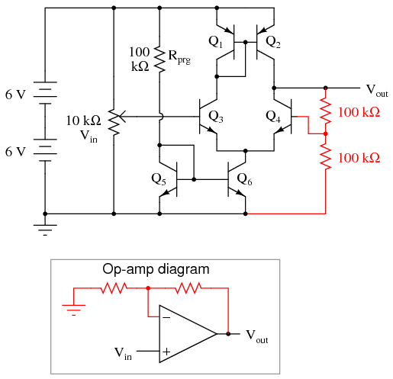

***Figure 1:*** *Discrete Op-amp Schematic*

1. Setup the LM741 on the breadboard, same as PLab 1a setup
2. Measure and test differential gain, common-mode gain, and input impedance for both op-amps
3. Present comparison of the various parameters and aspects of each op-amp architecture

**Procedure 1: Amplifier Gain Comparison**

The scientific aim of this procedure is to explore the differences in differential gain between op-amp architectures and analyze the potential benefits and drawbacks of each op-amp choice.

**Resources:**

Construct an op-amp that follows the schematic from figure 1 on the breadboard. Construct an op-amp circuit with the same 2x 100-ohm feedback resistors. Follow PLab Procedure 1A if unsure.

**Methods:**

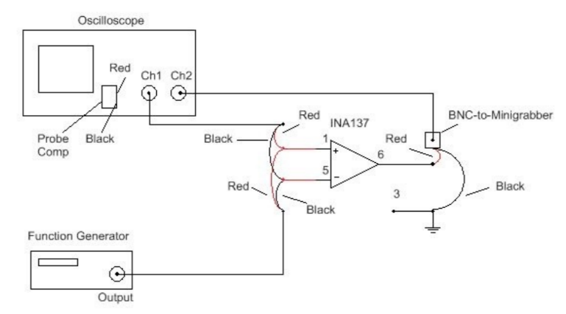***Figure 2:*** *Wiring diagram for op-amp testing configuration.*

The oscilloscope will display the input voltage, Vin, on Channel 1 and the output voltage, Vout, on Channel 2. It is a good idea to monitor both the input and output voltages.

**Data Collection**

Apply a sinusoidal signal of approximately 1 Vp-p to Vin. Record the exact value of Vin and Vout, and calculate the differential gain Gd of each amplifier.

**Procedure 2: Common Mode Rejection Ratio**

The scientific aim of this procedure is to explore the differences in common gain between op-amp architectures and calculate the common-mode rejection ratio, which is a measure of how well the device can measure small signal differentials in the face of noise.

**Methods**

The common-mode gain (Gd) for both op-amps has already been measured in the previous procedure. Now measure Gc by connecting the two input pins to the same input signal with respect to ground. The function generator signal is still Vin, but you should connect the positive lead of the function generator output to both input pins, and the negative lead of the function generator output should be connected to ground. Read Vout with respect to ground. Read Vin on Ch1 and Vout on Ch2 of the oscilloscope.

**Data Collection**

Use the same 1 Vp-p signal as before for your input. Use frequencies of 10 Hz, 100 Hz, 1kHz, and 10kHz for both op-amps. Record Vin and Vout at each frequency, and calculate the common-mode gain Gc of each amplifier when the function generator signal is applied to both amplifier inputs. It may be difficult to measure Vout as it is small.

**Procedure 3: Measurement of Input Impedance**

**Resources**

Using an external resistance in series with the function generator signal, one can measure the input impedance of the op-amp under test, via the method covered in PLab 1. The Input impedance can be measured via the formula: Vout = GVin = G (Ri/(Ri + Re))Vs

**Methods**

The function generator will be used to measure the input impedance of the two amplifier chips. Connect the output of the function generator in the place of Vs, and the resistor decade box in the place of Re, as shown in the following figure

*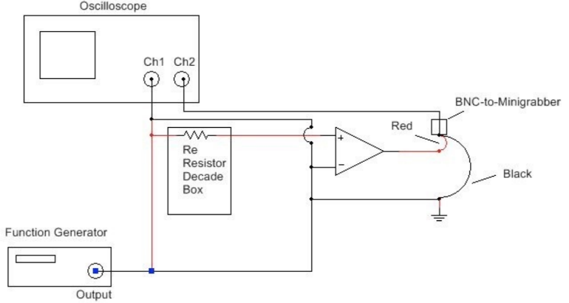****Figure 3:*** *This figure shows the wiring setup for measuring the input impedance of the op-amp*

**Data Collection**

Increase the resistance on the decade box until a significant drop in Vout is seen. There will likely be large amounts of noise and drift in the output signal. Record your final values for Re,Vs, and Vout for each of the two amplifiers.