**1a. Simulation of a Standard Rayleigh’s Clarinet**

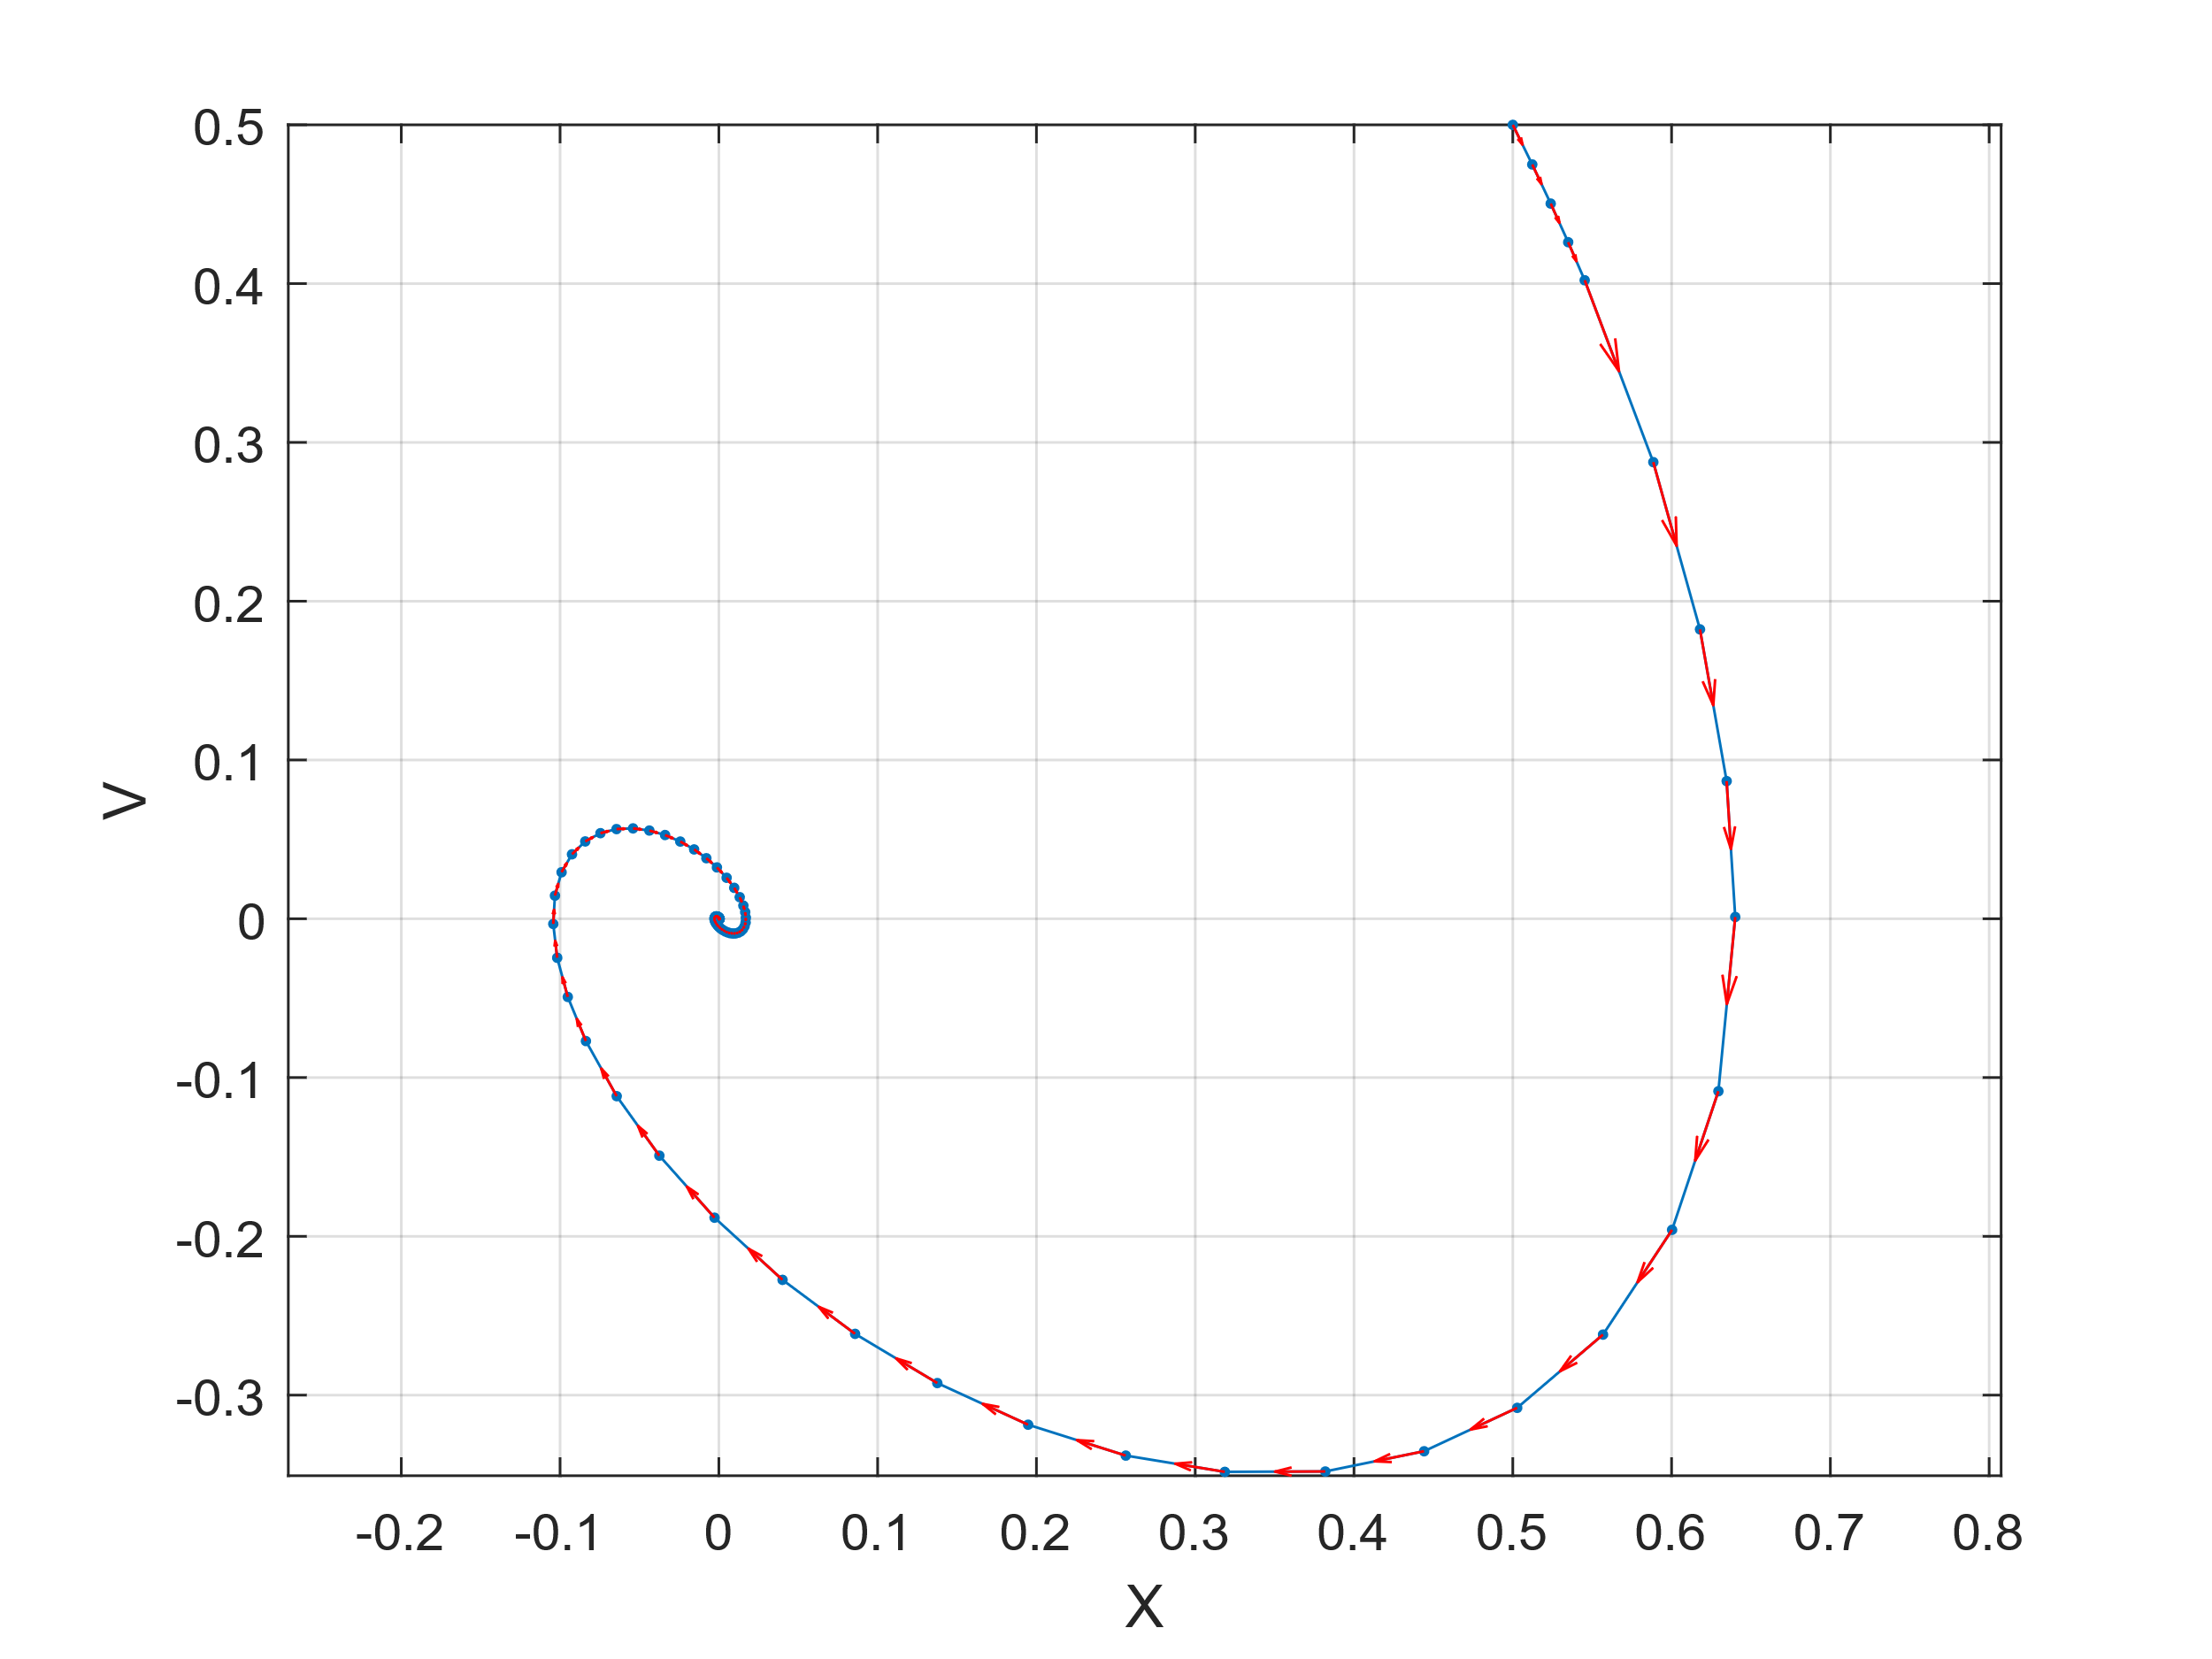

Standard Rayleigh’s Clarinet generated using the equation from figure 1.3 in the PLab manual. X and V had initial conditions of 0.5. An inwards spiral is witnessed.

**1b. Simulation of Rayleigh’s Clarinet with a Negative FF Term**

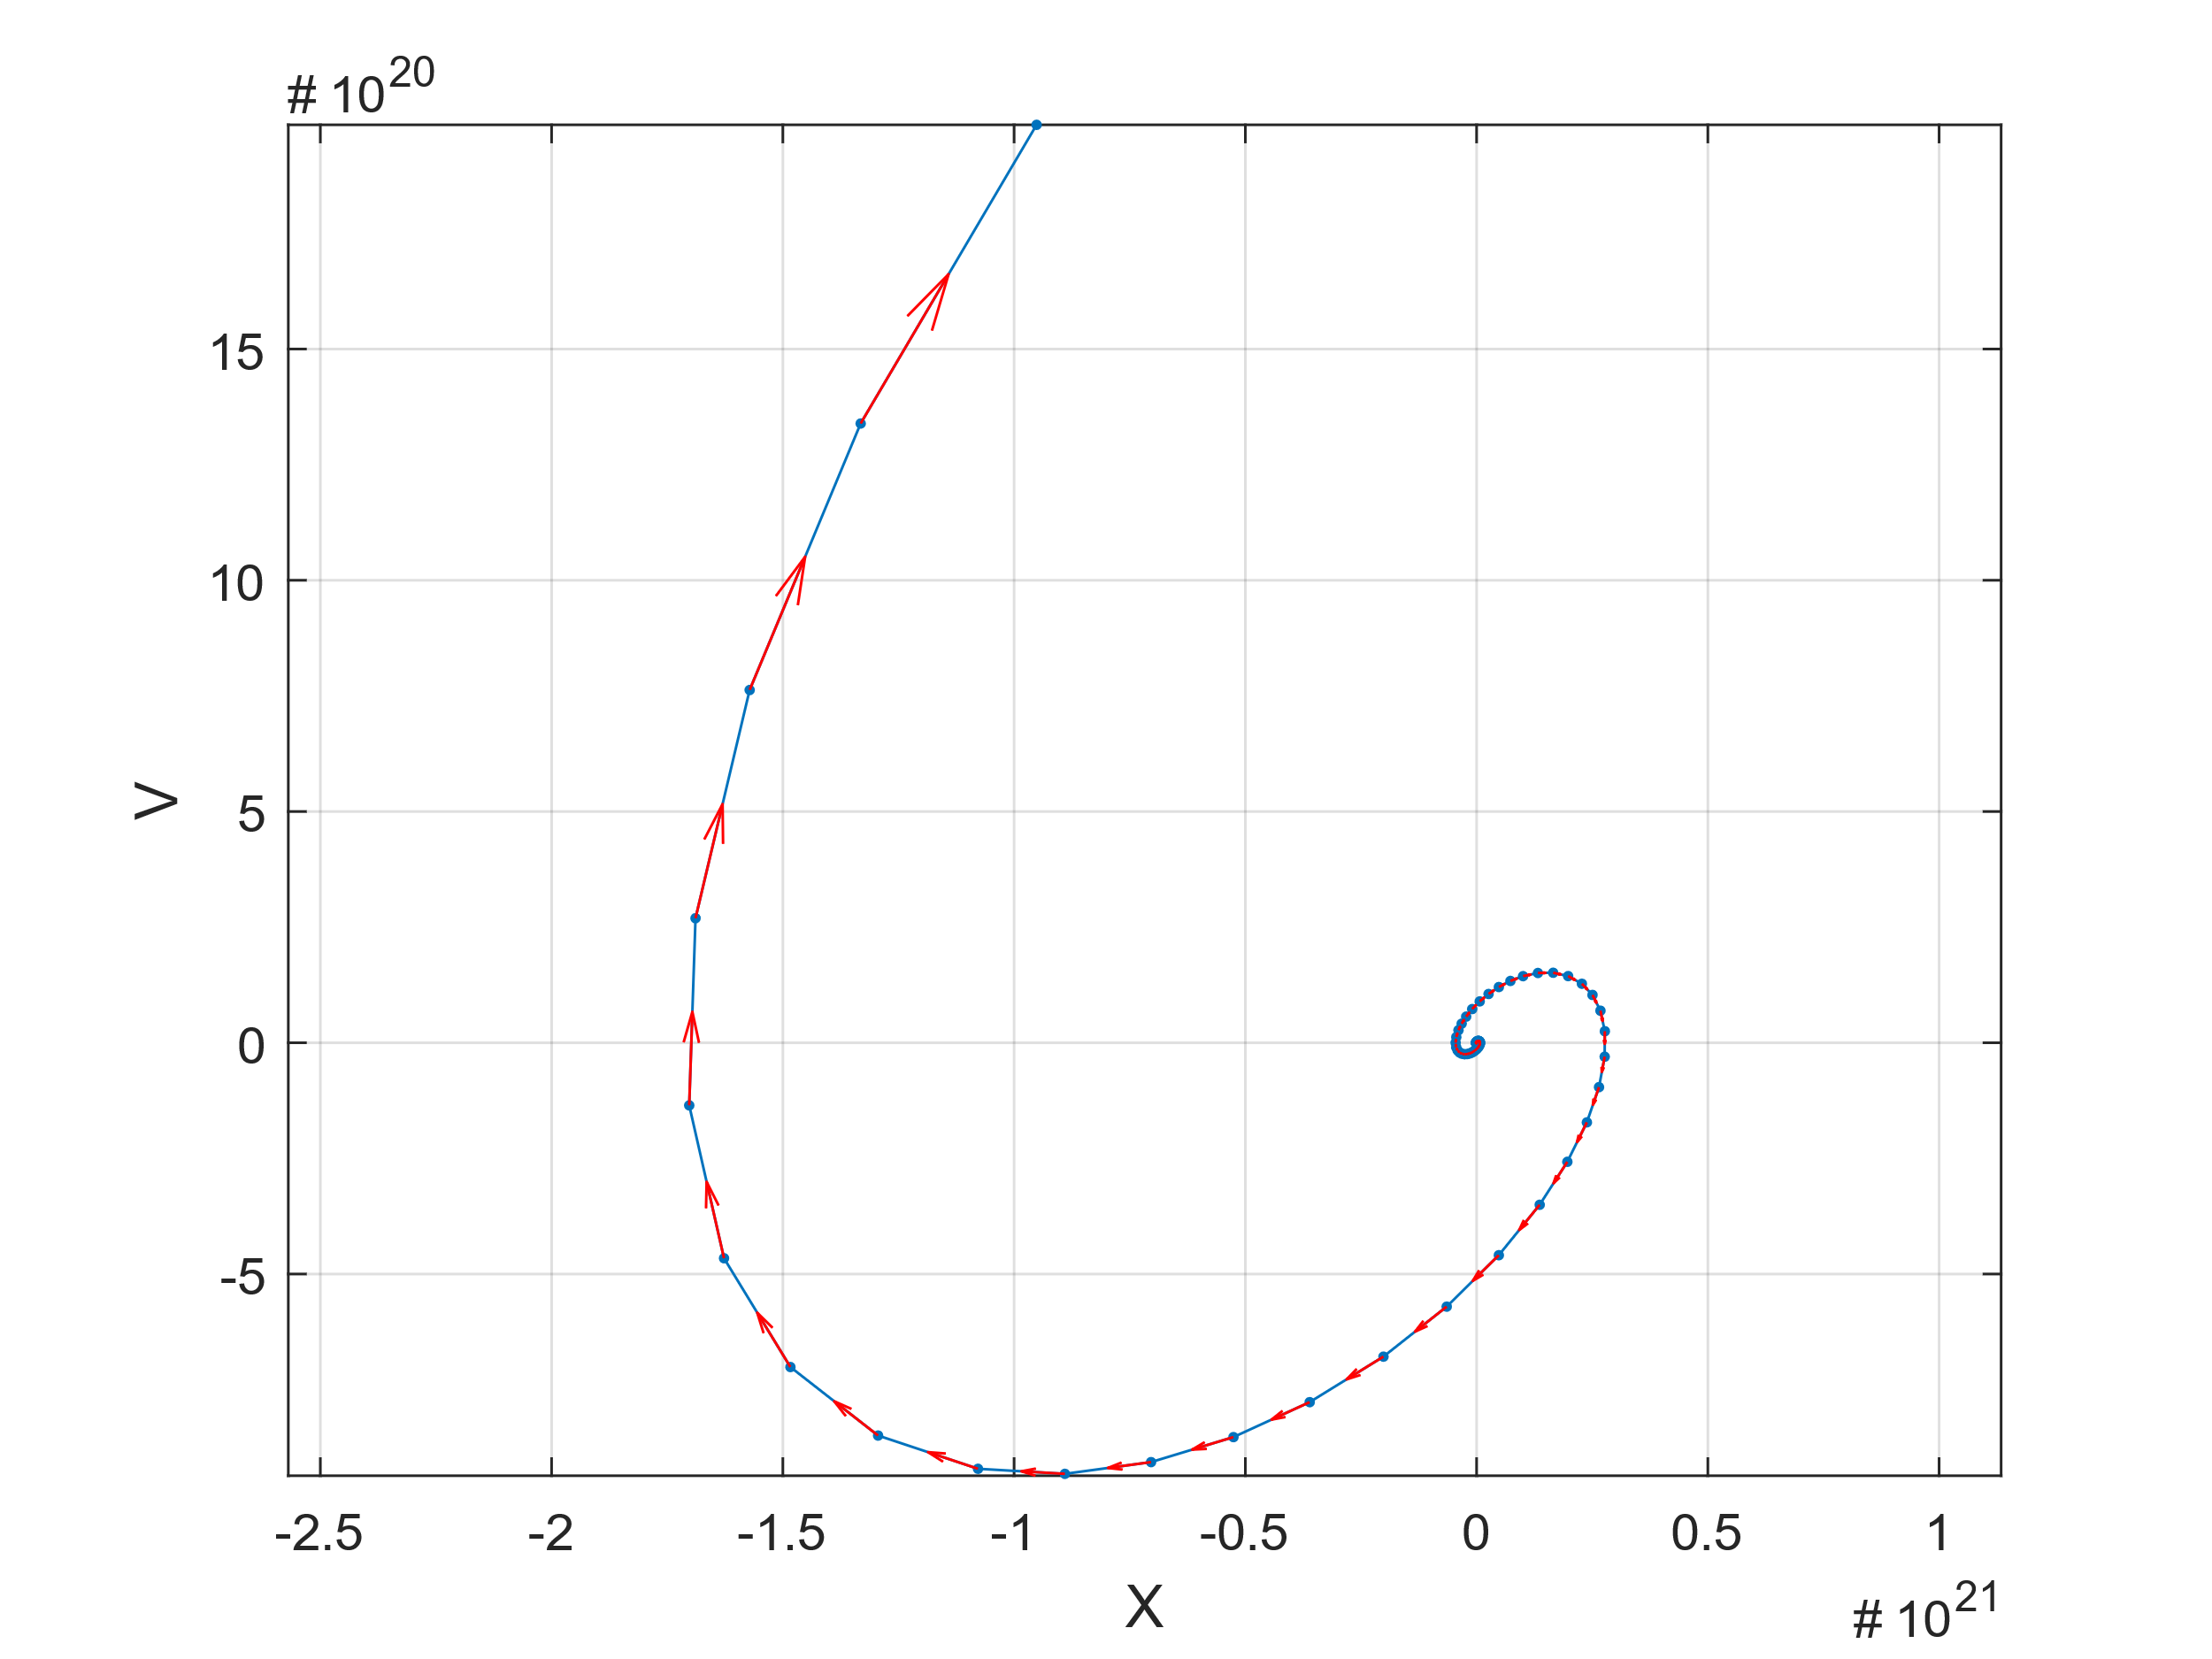

Rayleigh’s Clarinet generated using the equation from figure 1.3 in the PLab manual. In this case, the equation is modified to make FF negative (negative friction). X and V had initial conditions of 0.5. An outwards spiral is witnessed.

**1c. Simulation of Rayleigh’s Clarinet with a Cubic FF Term**

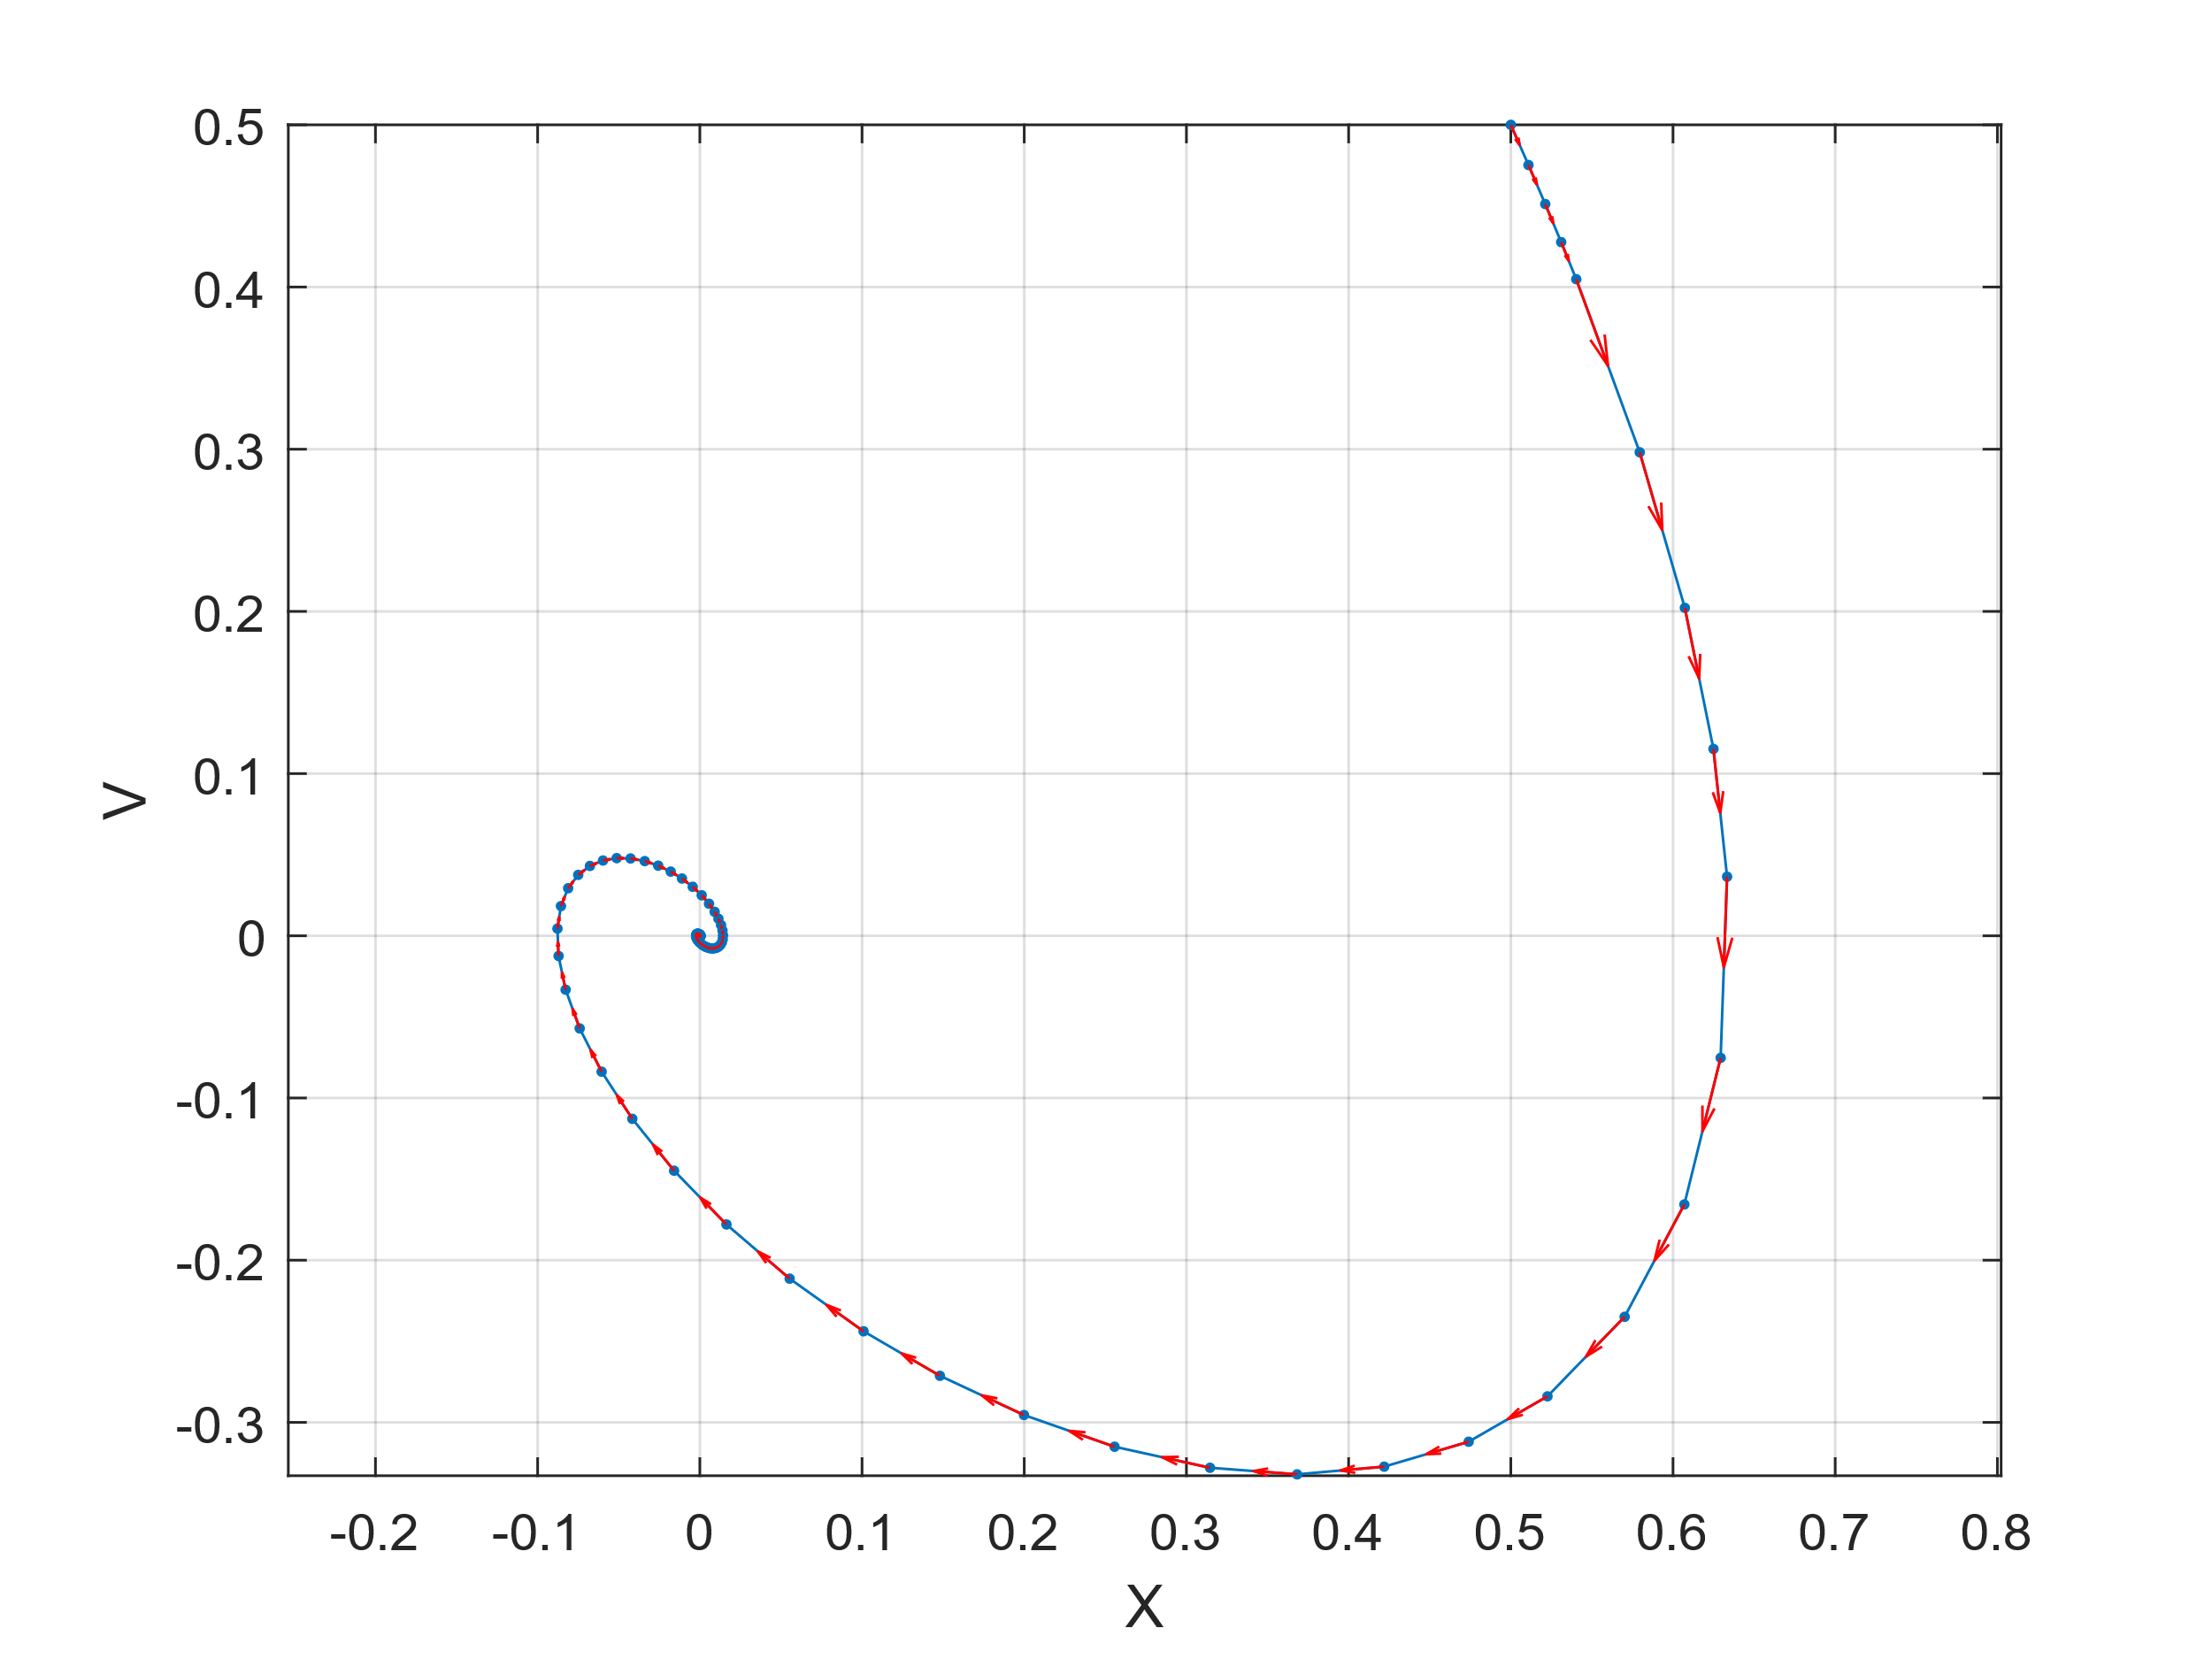

Rayleigh’s Clarinet generated using the equation from figure 1.3 in the PLab manual. In this case, the equation is modified to make FF  V3 – V (friction is a cubic function). X and V had initial conditions of 0.5. An inwards spiral is witnessed.

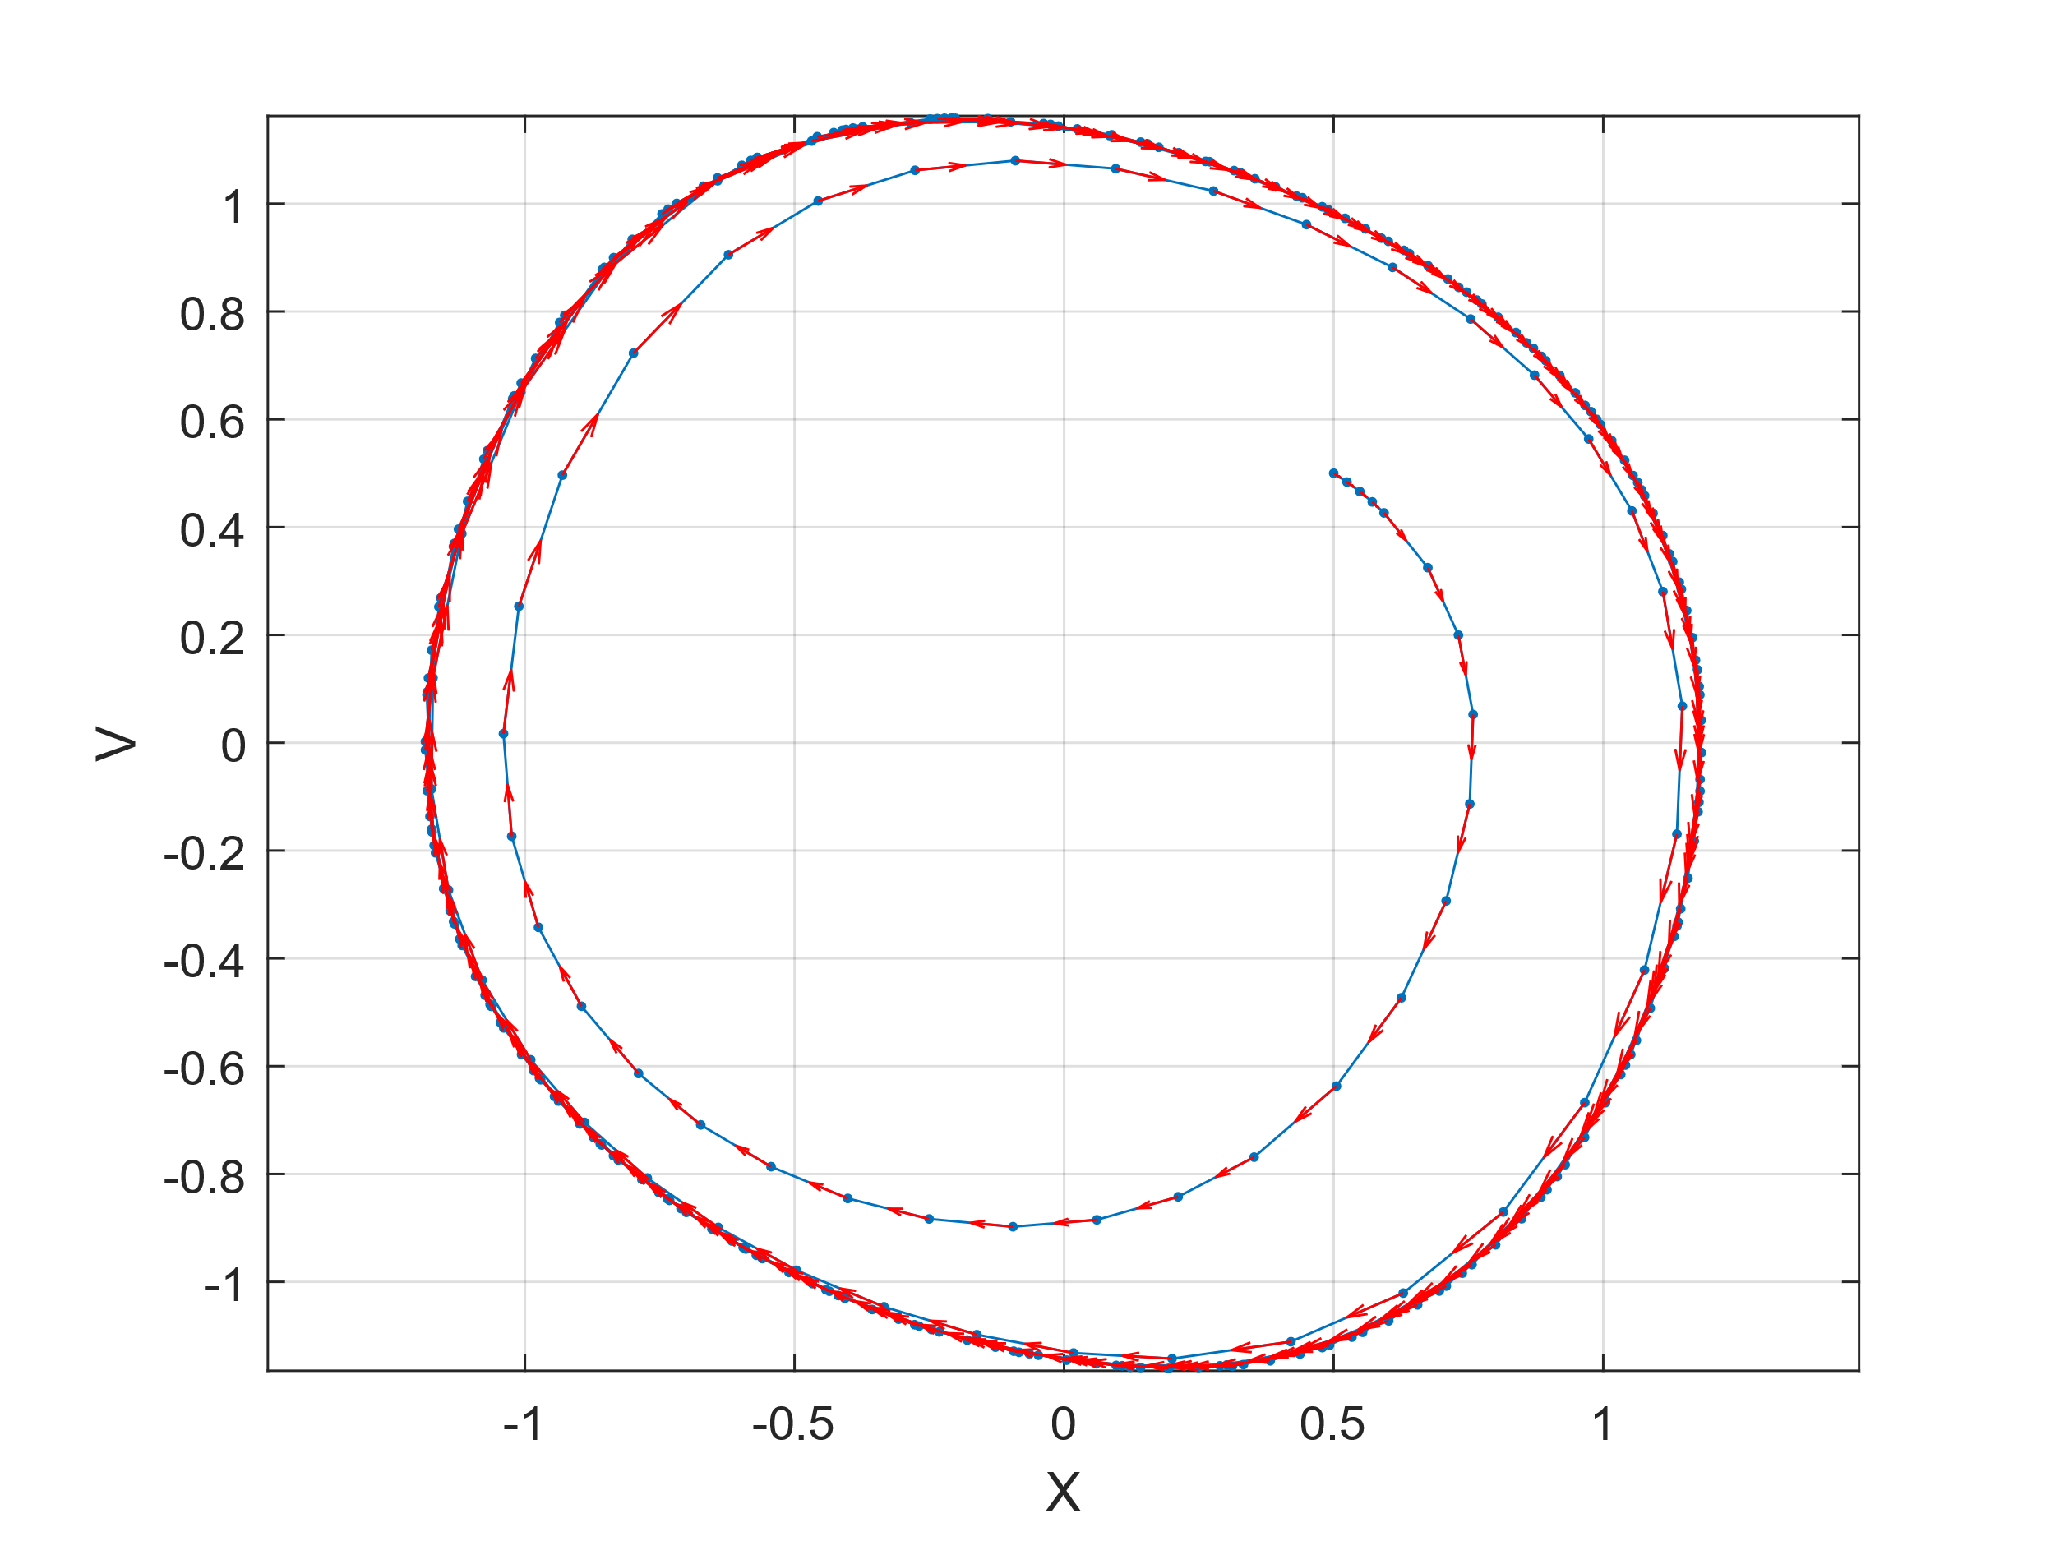

**2a. Simulation of Rayleigh’s Clarinet with a Control Parameter, ‘c.’**

**Figure 1** is generated with a small positive value for C (.5). This generates an outwards spiral which eventually joins a stable limit cycle

Figure 1

**Figure 2** is generated with 0 as the value for C. This generates a stable cycle.

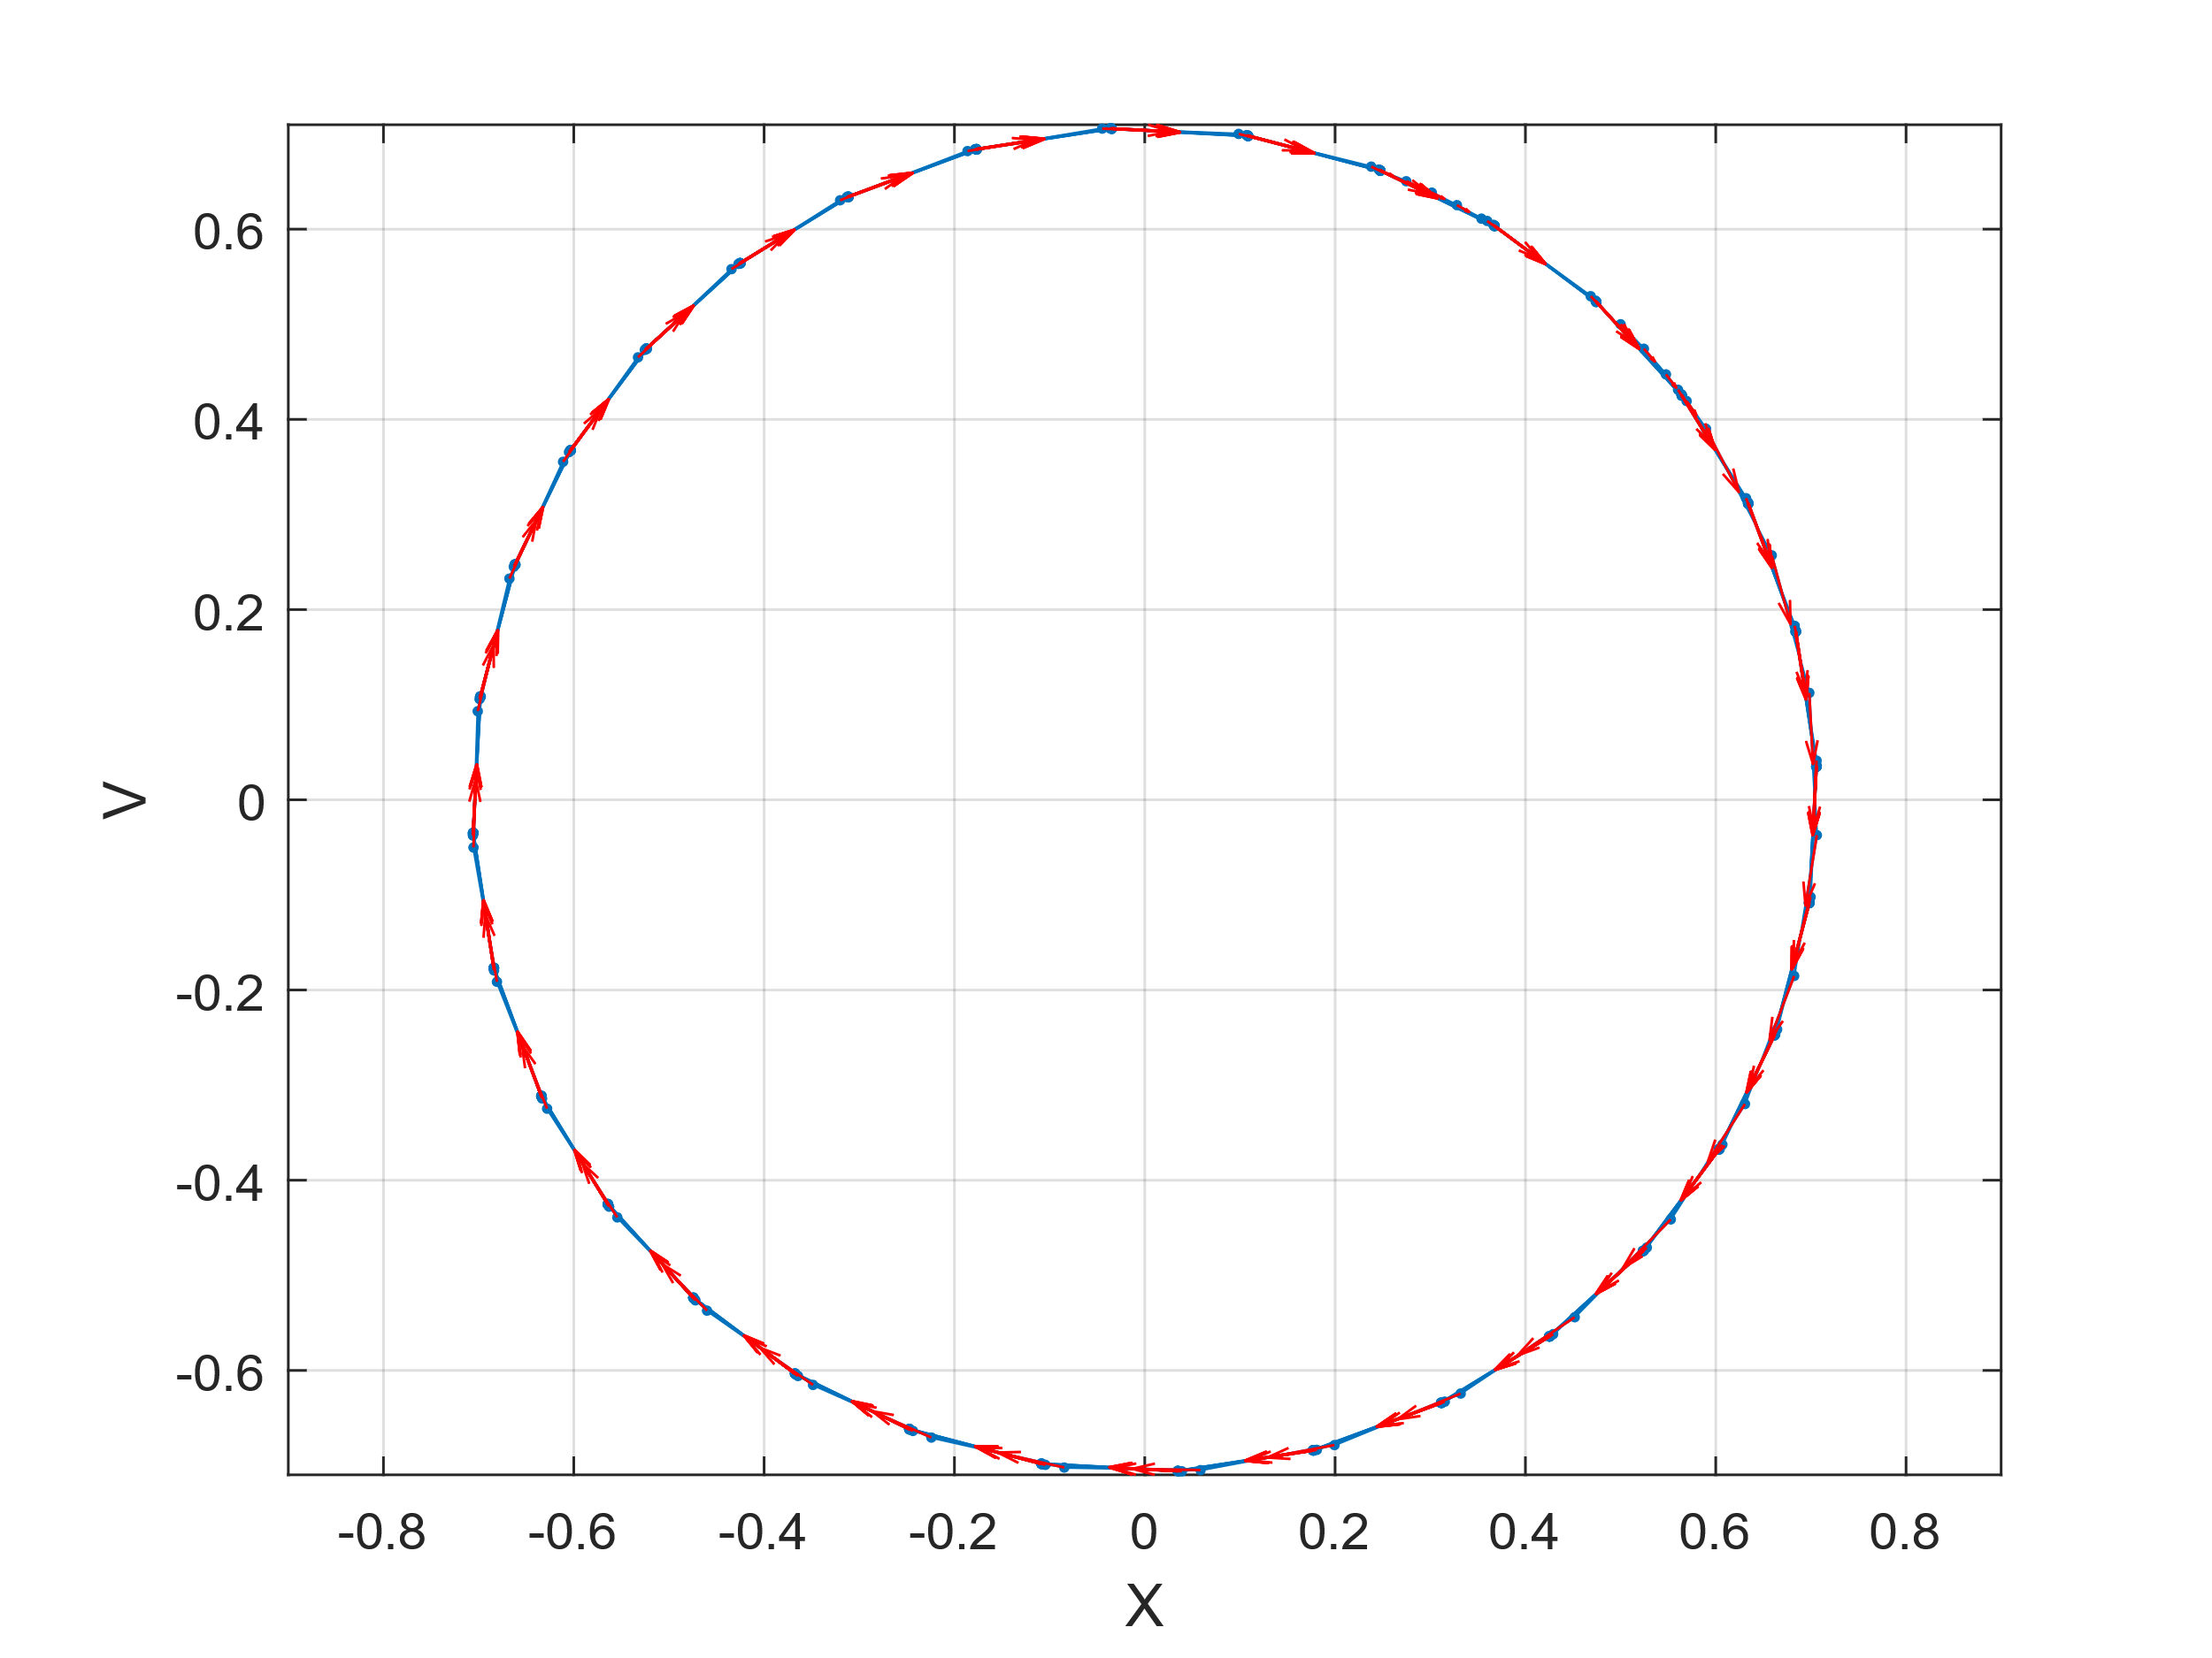**Figure 3** is generated with a small negative value for C (-.5). This generates an inwards spiral.

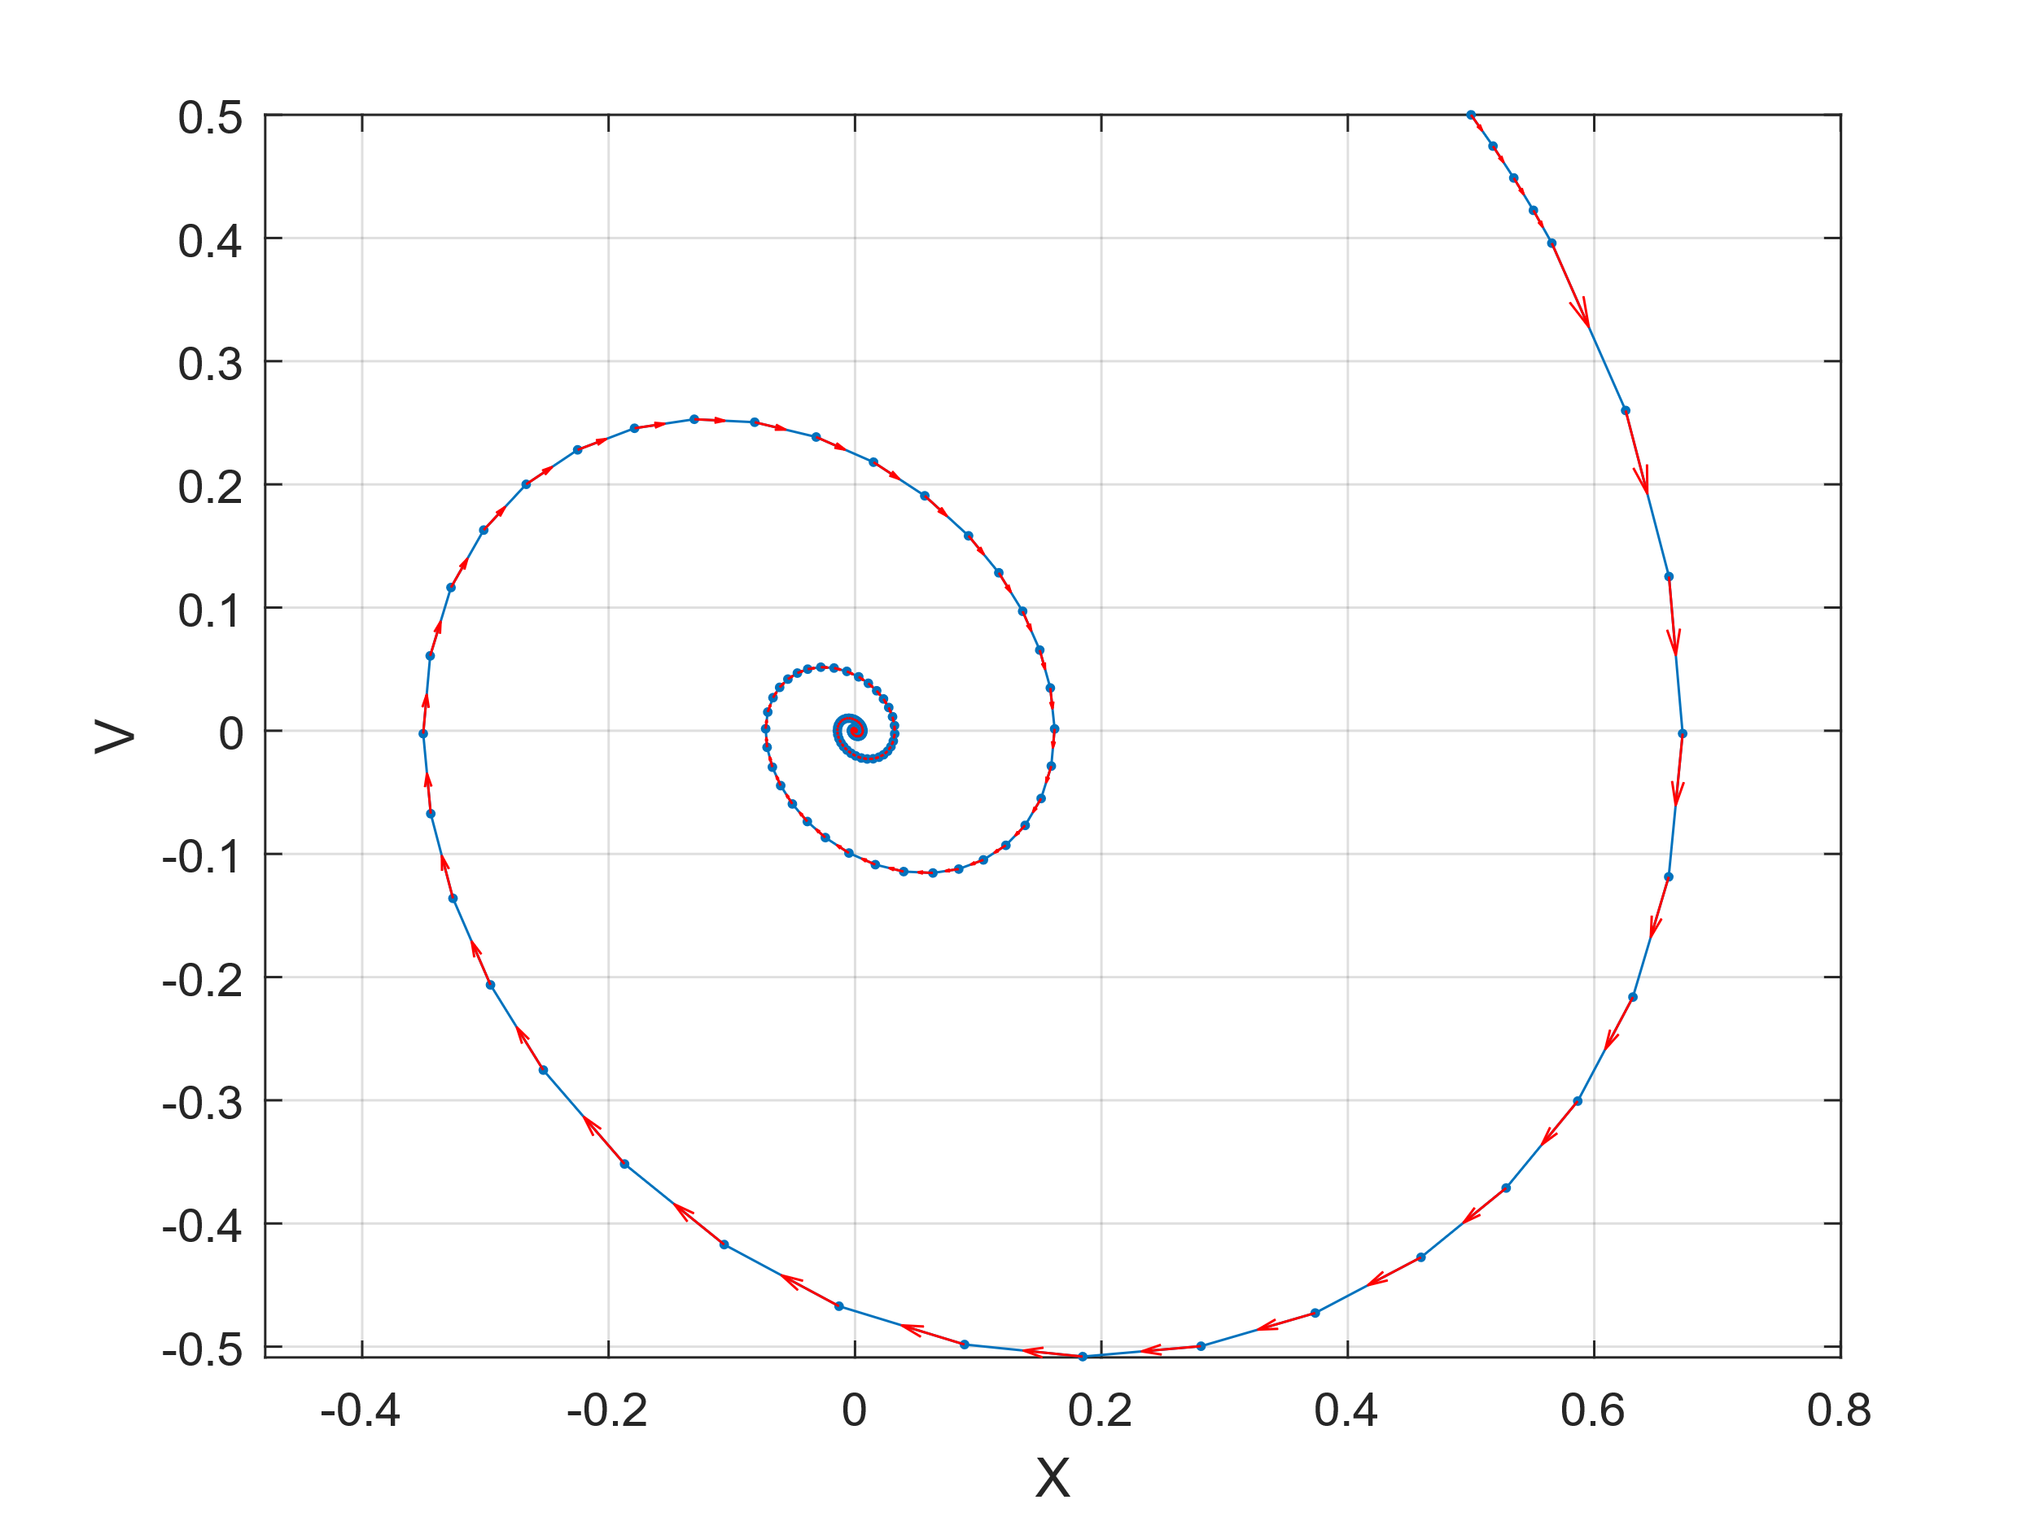**Eigenvalue Calculations:**

Figure 2

Figure 3

From this, we can see that in the cases we have a negative eigenvalue (Fig 1), we approach a stable system of a limit cycle. When two integer eigenvalues are present (Fig 2), we see a stable cycle as well. However, when we only have a positive real eigenvalue (Fig 3), we see a spiral towards a point. All of these results match up with what is expected from the criteria of Eigen stability, as discussed in class.

**2b. Simulation of Rayleigh’s Clarinet with a Control Parameter, ‘c’ and Various Friction Constatns k1 and k2.**

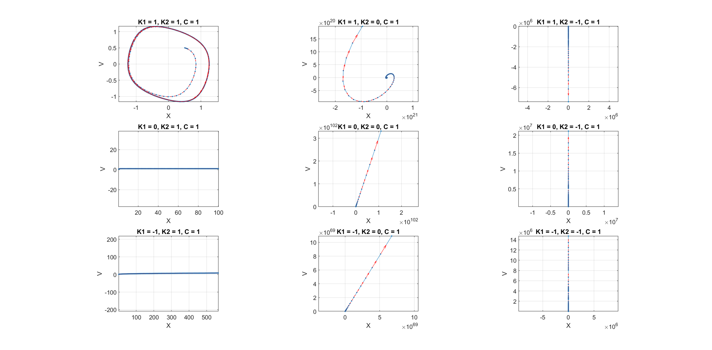

For this figure, all possible combinations of K1 and K2 (in terms of positive, negative, and zero) were tested. We see all of the possibilities that the system can take on, including a limit cycle, an unstable spiral out, and numerous straight line relations between X and V.

For the case where Fs = − k1 ∙ X and FF = k2 ∙ V, we see the results in the last figure in the left-most column. In this case, the eigenvalue is as follows:

This leads to the expected eigenvalue plot, which matches with the result above:

Eigenvalue Plot