Question 1:

See code in Appendix 1

Question 2: I_stim = 275 µA

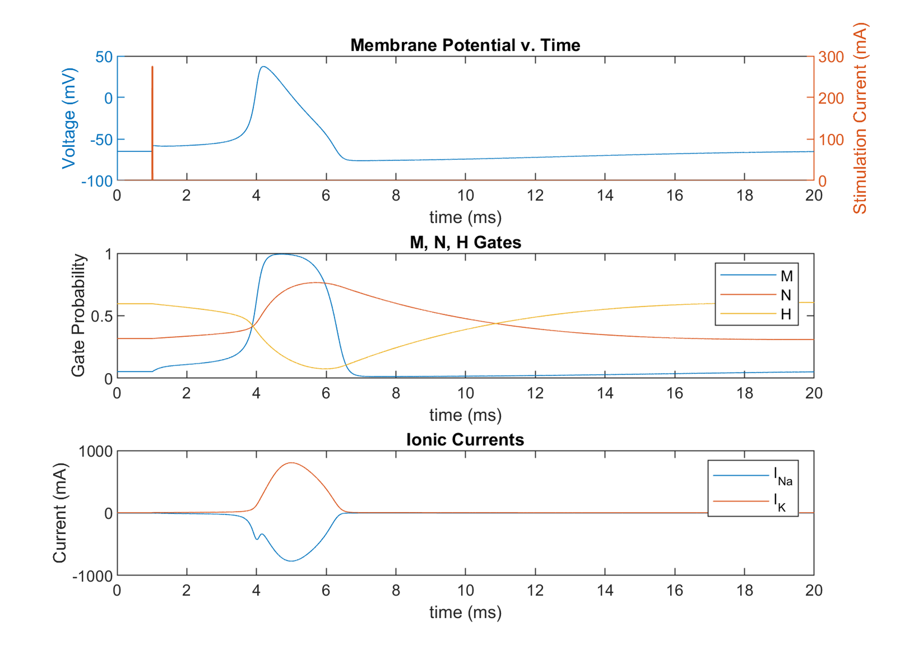

Figure 1: Membrane voltage, stimulation currents, ionic currents and M, N, H gate values for a .25ms stimulation of 275 µA.

Question 3A: I_stim = 275 µA, Refractory Period = 17.2ms

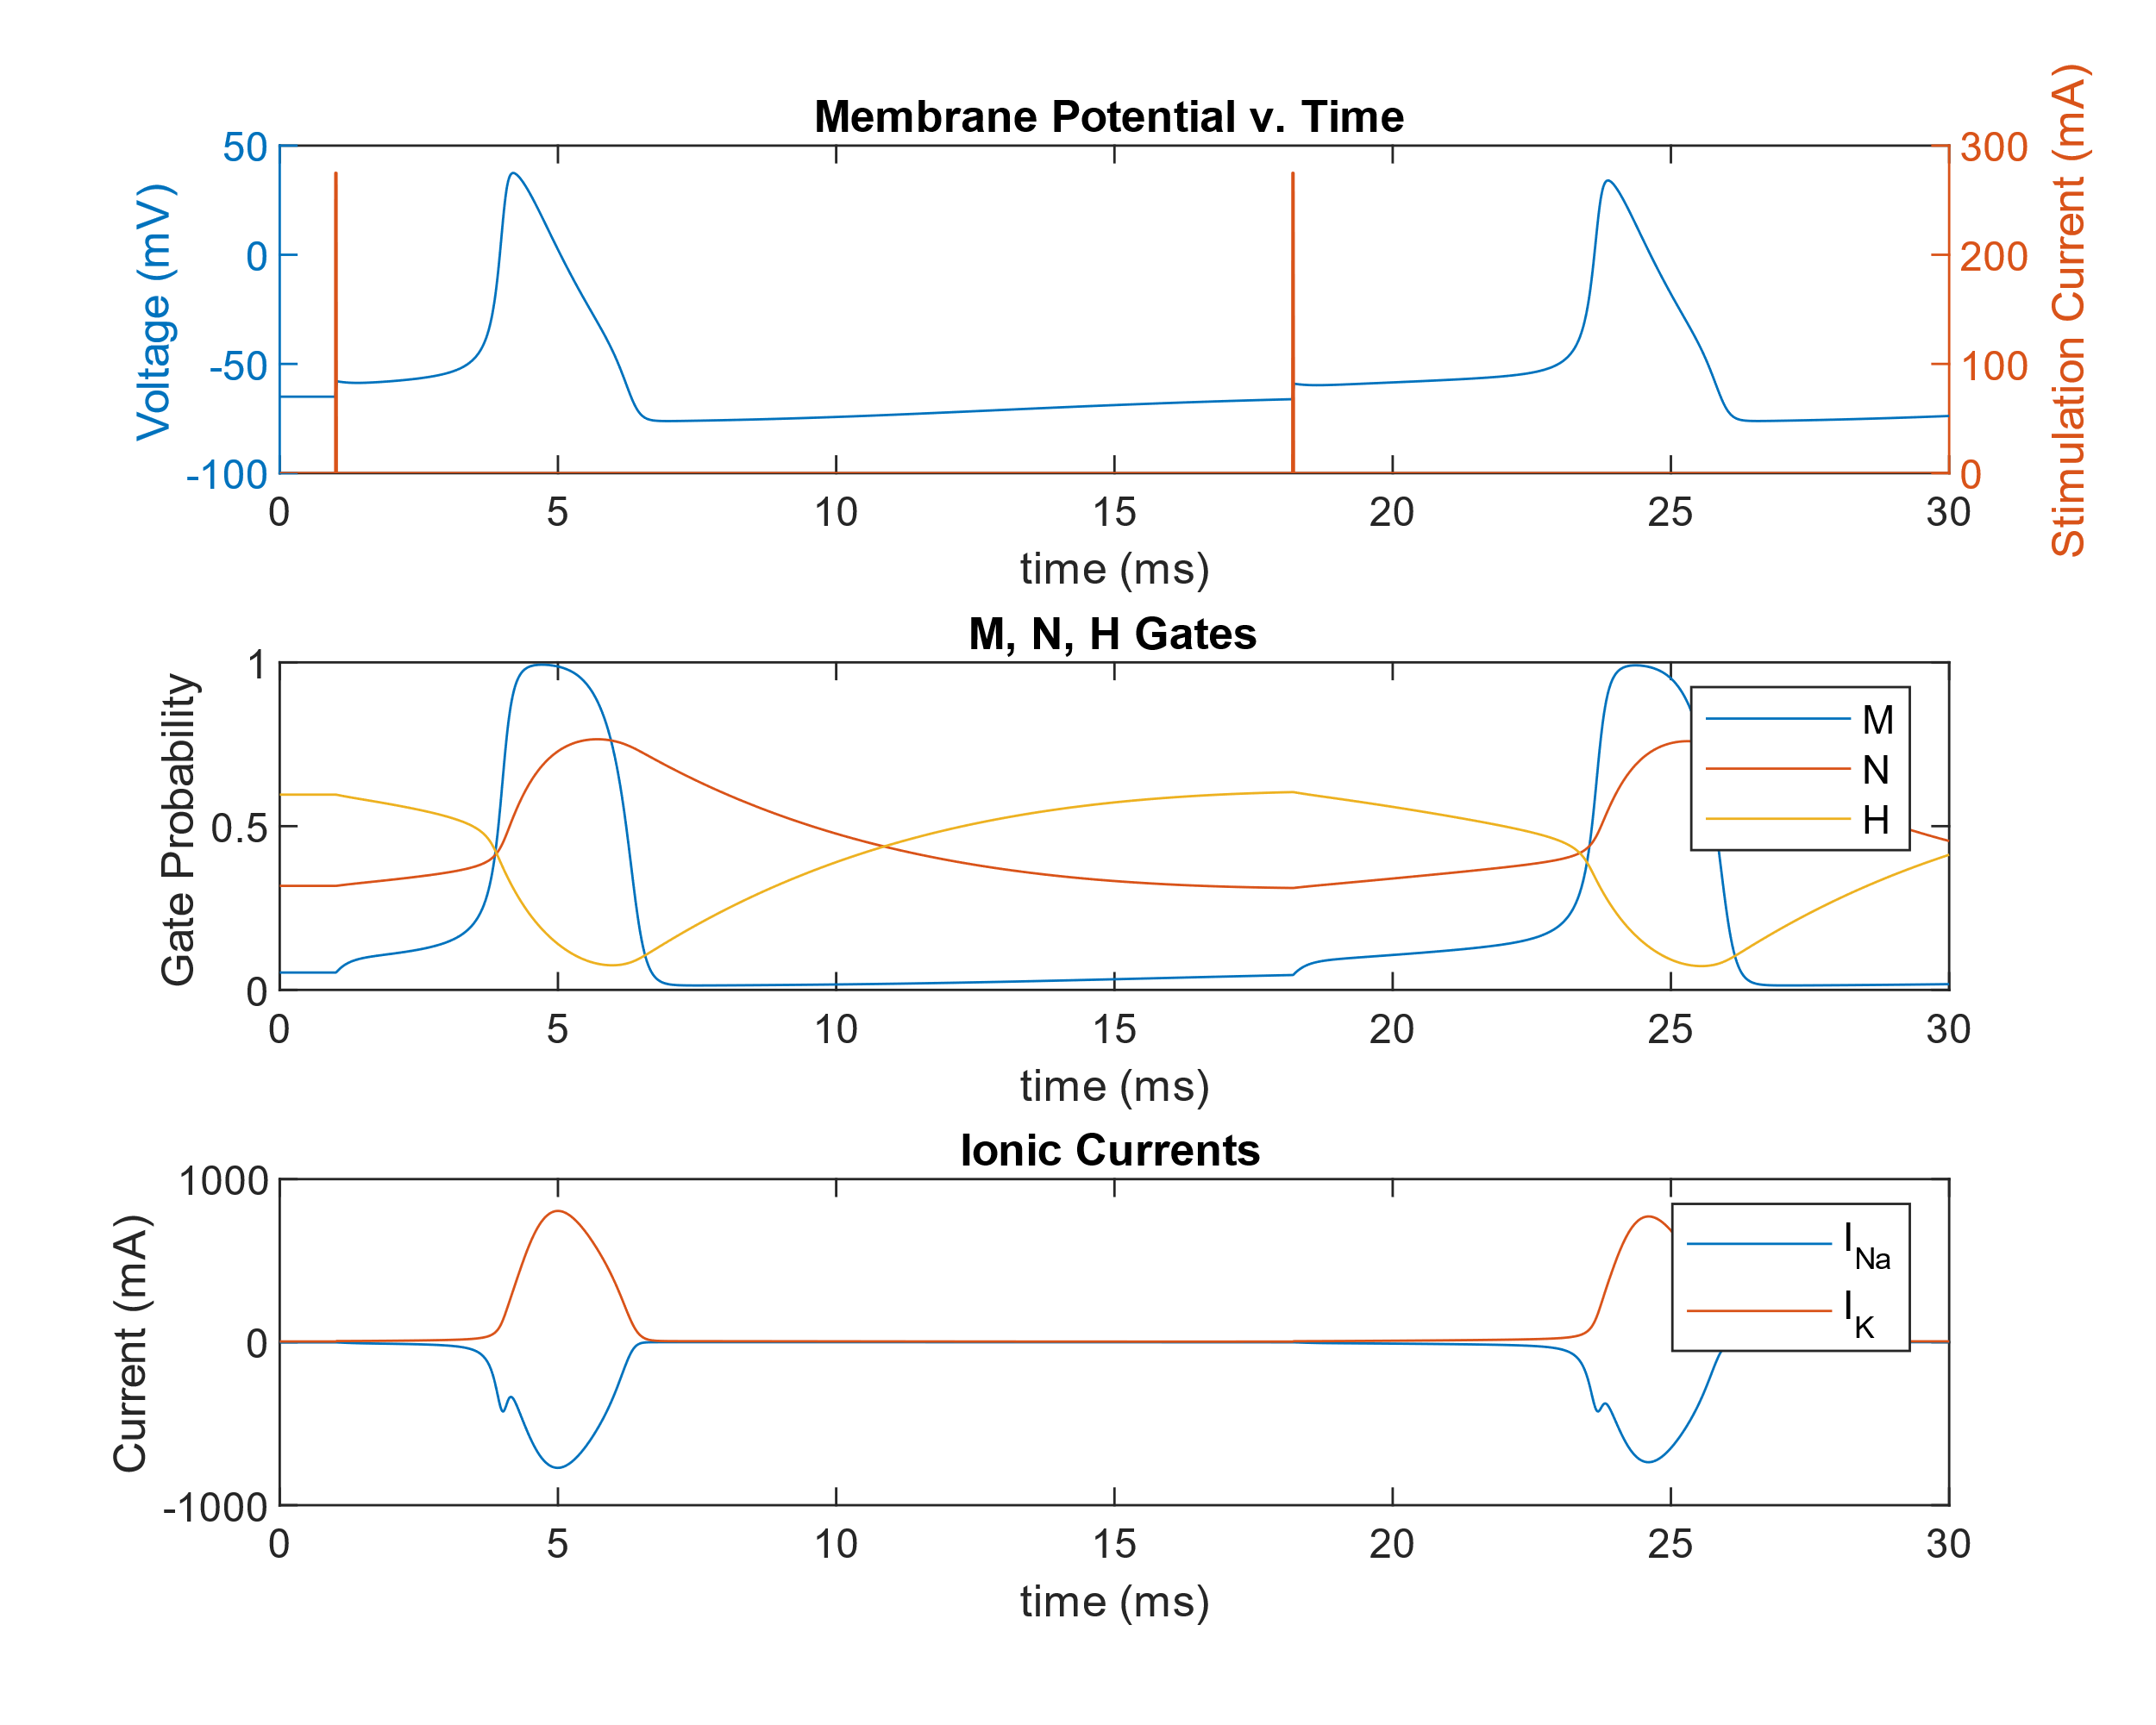

Figure 2: Membrane voltage, stimulation currents, ionic currents and M, N, H gate values for two .25ms stimulation of 275 µA. The minimum refractory period (relative) is 17.2 milliseconds.

Question 3B: I_stim = 275 µA and 825 µA, Refractory Period = 11.8 ms

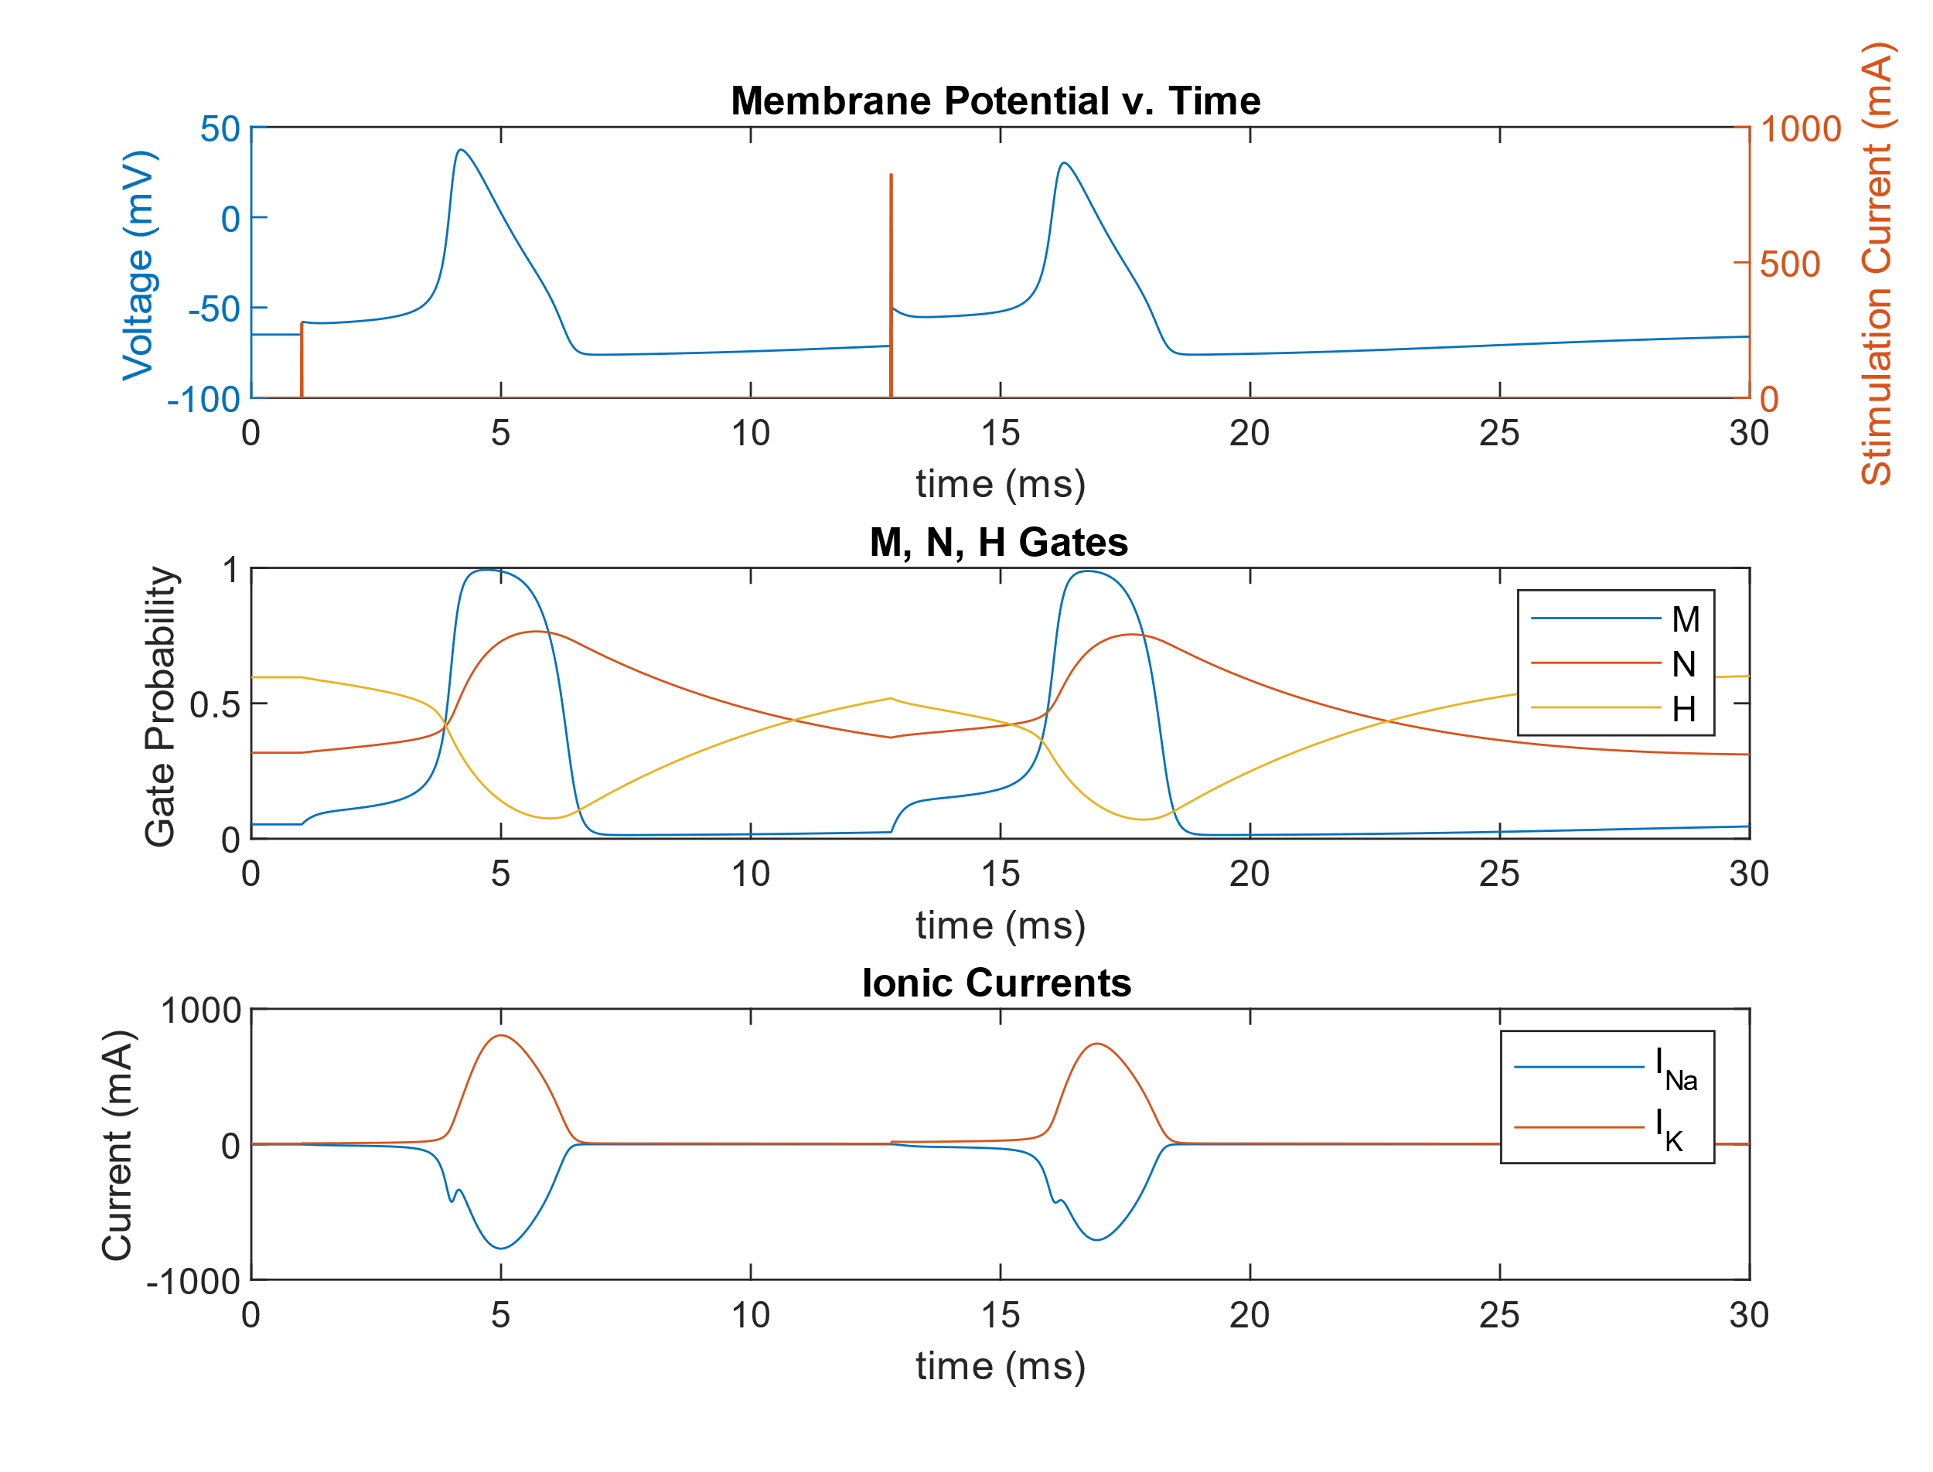

Figure 3: Membrane voltage, stimulation currents, ionic currents and M, N, H gate values for two .25ms stimulation, first of 275 µA, and second of 825 µA. The minimum refractory period (relative) is 11.8 milliseconds.

Question 4: : I_stim = -100 µA for .5ms

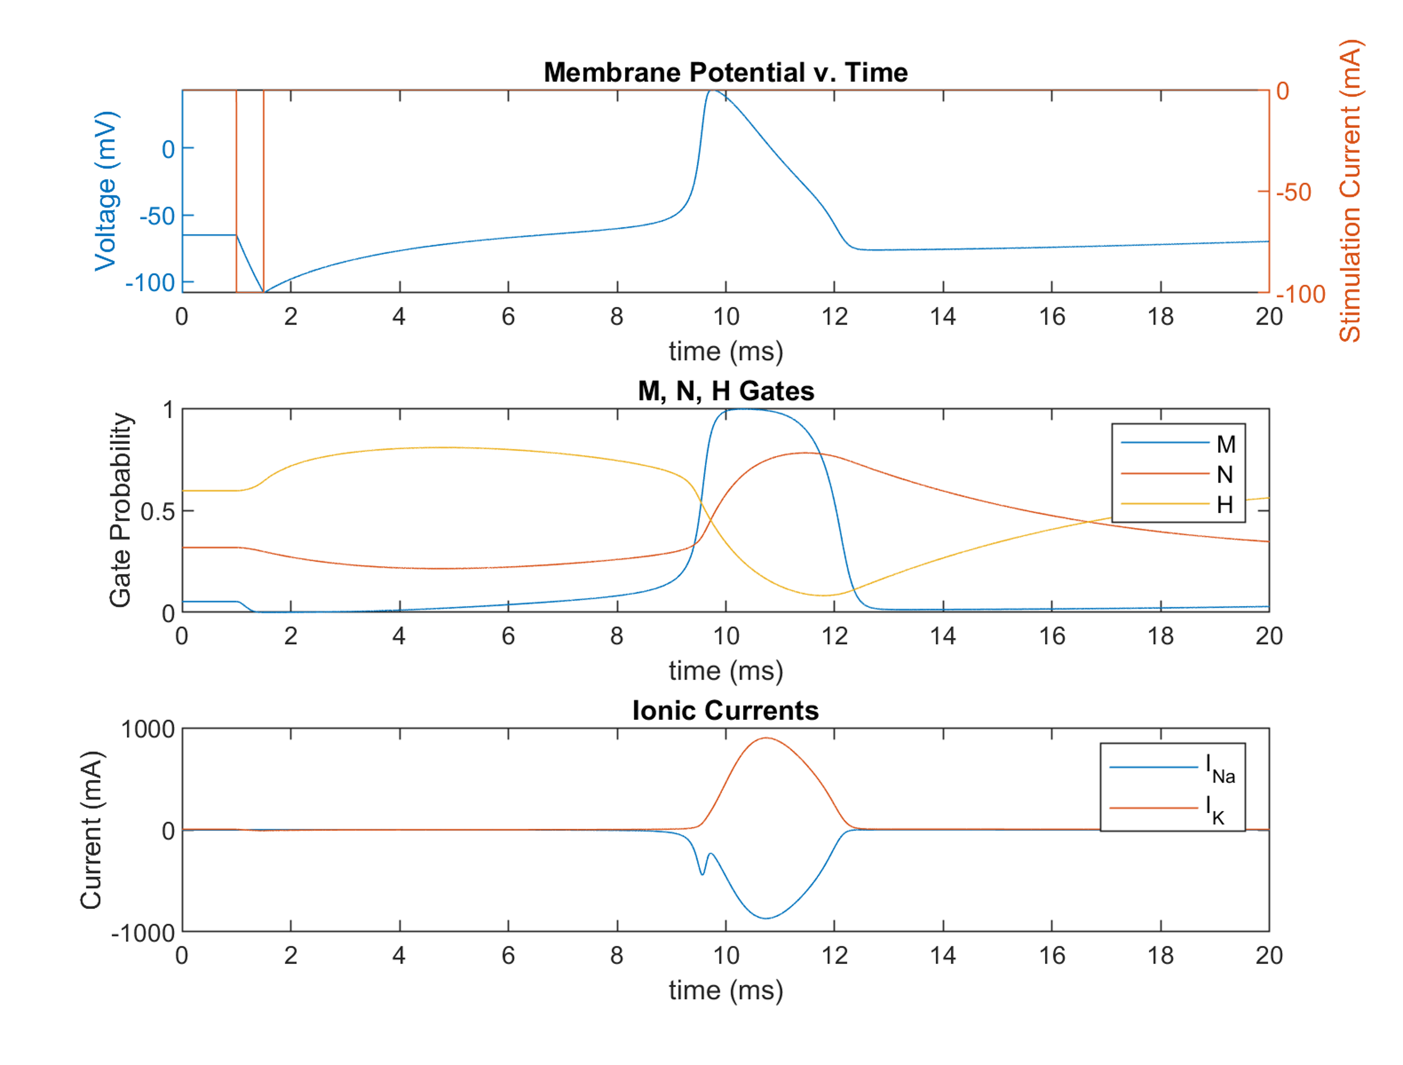 Figure 4: Membrane voltage, stimulation currents, ionic currents, and M, N, H gate values a .5 millisecond long hyperpolarizing pulse of -100 µA to trigger an anode break excitation.

**Appendix 1:**

HH_Run

close all; clear all; clc;

T = 6.3;

gNa = 120;

gK = 36;

Na_Out = 490;

Na_in = 50;

K_out = 20;

K_in = 400;

R = 8.314;

F = 9.6485*10^4;

E_Na = 1000*(R*T/F)*log(Na_Out/Na_in);

E_K = 1000*(R*T/F)*log(K_out/K_in);

V_rest = -60.34;

m_0 = 0.05;

n_0 = 0.32;

h_0 = 0.6;

y_0 = [V_rest; m_0; n_0; h_0];

dt = [0,20];

options = odeset('RelTol',1e-4,'AbsTol',[1e-8,1e-8,1e-8,1e-8],'MaxStep',0.01);

[t,y] = ode45(@(t,y) HH(I),dt,y_0,options);

V = y(:,1);

M = y(:,2);

N = y(:,3);

H = y(:,4);

figure;

plot(t,V); title('Voltage'); xlabel('Time (ms)'); ylabel('Voltage (mV)');

figure

plot(t,M);

hold on; plot(t,H);

hold on; plot(t,N);

title('M, N, H Gates');

xlabel('Time (ms)');

ylabel('Probability Open');

legend('M','N','H');

I_K = gK.*N.^4.*(V-E_K);

I_Na = gK.*M.^3.*H.*(V-E_Na);

figure;

plot(t,I_K);

hold on; plot(t,I_Na);

title('Ionic Currents'); xlabel('Time (ms)'); ylabel('Current (mA)');

legend('I_{Na}','I_{K}');

ODE

function Dydt = HH(t,y)

I_s = 0

V_rest = -65 ;

T = 6.3;

T_k = 273.15+T;

V = y(1,1);

m = y(2,1);

n = y(3,1);

h = y(4,1);

v_m = V-V_rest;

gNa = 120;

gK = 36;

gL = 0.3;

Na_out = 490;

Na_in = 50;

K_out = 20;

K_in = 400;

R = 8.314;

F = 9.6485*10^4;

E_Na = 1000*(R*T_k/F)*log(Na_out/Na_in);

E_K = 1000*(R*T_k/F)*log(K_out/K_in);

E_L = -50;

C = 1.0;

k = 3^(0.1*T-0.63);

alpha_m = .1*(25-v_m)./(exp((25-v_m)/10)-1);

alpha_h = .07*exp(-v_m/20);

alpha_n = .01*(10-v_m)./(exp((10-v_m)/10)-1);

beta_m = 4*exp(-v_m/18);

beta_h = 1/(exp((30-v_m)/10)+1);

beta_n = .125*exp(-v_m/80);

dVdt = (1/C).*(I_s-gNa*m^3*h*(V-E_Na)-gK*n^4*(V-E_K)-gL*(V-E_L));

dmdt = (-(alpha_m+beta_m)*m+alpha_m)*k;

dndt = (-(alpha_n+beta_n)*n+alpha_n)*k;

dhdt = (-(alpha_h+beta_h)*h+alpha_h)*k;

Dydt = zeros(4,1);

Dydt(:,1) = [dVdt; dmdt; dndt; dhdt];

end