Question 1:

See code in Appendix 1

Question 2:

|  |  |
| --- | --- |
| Distance | Minimum Current |
| 1 mm | 175 µA |
| 2 mm | 556 µA |
| 4 mm | 2189 µA |
| 8 mm | 11019 µA |

*See video in Canvas

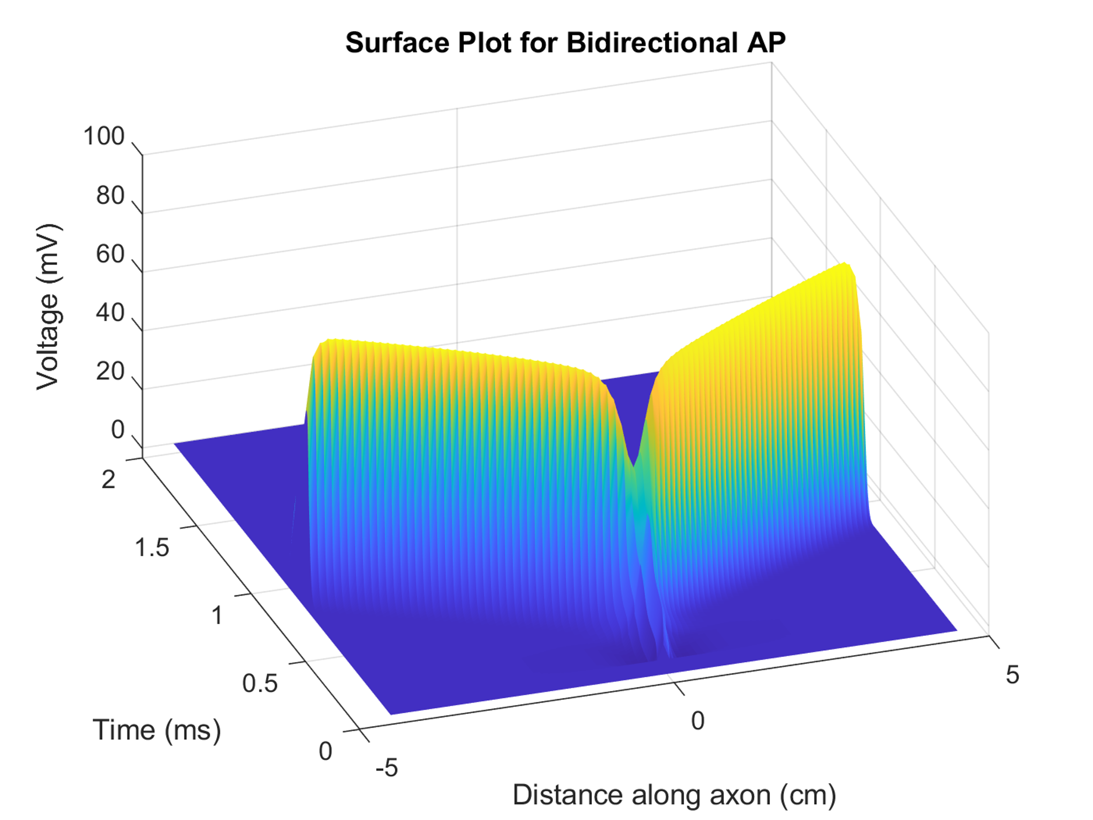

Figure 1: Surface plot of voltage along axon for a bidirectional action-potential

Question 3:

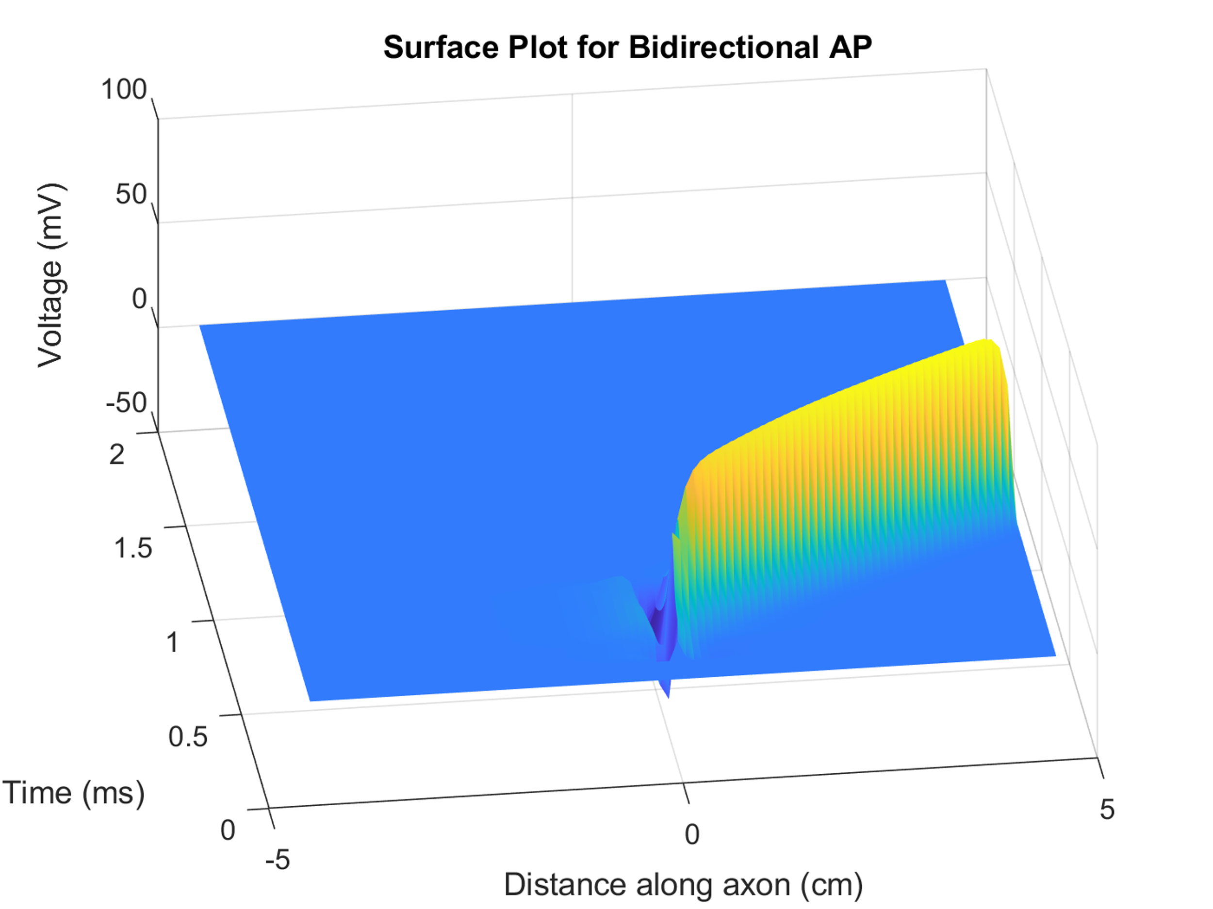

Figure 2: Surface plot of voltage along axon for a monodirectional action-potential

*See video in Canvas

**Appendix 1: Code**

clear all;

close all;

clc;

dt = 0.001;

t = 0:dt:2;

dx = .1;

x = -4.5:dx:4.5;

Re = .350;

Ri = .110;

Cm = 2.5;

a = 10E-4;

l = 1E-4;

gNa = 1445;

gL = 128;

Ena = 115;

El = -0.01;

I_Stim = 175;

Ist = zeros(size(t));

Ist(100:250) = -I_Stim;

z = 0.1;

%z = 0.2;

%z = 0.4;

%z = 0.8;

Ve = zeros(length(t), length(x));

for i = 1:length(t)

for j = 1:length(x)

Ve(i, j) = (Re * Ist(i)) / (4 * pi * sqrt(x(j)^2+z^2));

end

end

im = zeros(1, length(x));

i_longitudinal = zeros(1, length(x));

V = zeros(length(t), length(x));

m = zeros(length(t), length(x));

h = zeros(length(t), length(x));

for i = 1:length(t)

for j = 2:(length(x) - 1)

Vm = V(i, j);

alpha_m = (97 + 0.363 * Vm) / (1 + exp((31 - Vm)/5.3));

beta_m = alpha_m / exp((Vm - 23.8)/4.17);

beta_h = 15.6 / (1 + exp((24 - Vm)/10));

alpha_h = beta_h / exp((Vm - 5.5)/5);

dmdt = -(alpha_m + beta_m) * m(i, j) + alpha_m;

m(i+1, j) = m(i, j) + dmdt * dt;

dhdt = -(alpha_h + beta_h) * h(i, j) + alpha_h;

h(i+1, j) = h(i, j) + dhdt * dt;

dVdt = (-gNa * m(i, j)^2 * h(i, j) * (Vm - Ena) - gL * (Vm - El) + ((2 * a * dx) / (4 * Ri * l)) * (((V(i, j-1) - 2 * Vm + V(i, j+1)) / dx^2) + ((Ve(i, j-1) - 2 * Ve(i, j) + Ve(i, j+1)) / dx^2))) / Cm;

V(i+1, j) = V(i, j) + dVdt * dt;

end

end

figure

surf(x, [0, t], V), title('Surface Plot for Bidirectional AP'), xlabel('Distance along axon (cm)'), ylabel('Time (ms)'), zlabel('Voltage (mV)')

shading flat

rotate3d on

% Make a video

% % video = VideoWriter('BidirectionalAP: Z=1mm.mp4');

% % open(video);

% % figure

% % for i = 1:length(t)

% % plot(x, V(i, :));

% % axis([-4.5, 4.5, -25, 100]);

% % title('Bidirectional Action Potential'), xlabel('Distance along axon (cm)'), ylabel('Voltage (mV)');

% % mov(i) = getframe(gcf);

% % writeVideo(video, mov(i));

% % end

**Appendix 2: Unidirectional AP**

Ist1 = zeros(size(t));

Ist2 = zeros(size(t));

Ist1(100:200) = -300;

Ist2(100:500) = 300;

Ve = zeros(length(t), length(x));

z = 0.1;

for i = 1:length(t)

for j = 1:length(x)

Ve1 = (Re * Ist1(i)) / (4 * pi * sqrt(x(j)^2+z^2));

Ve2 = (Re * Ist2(i)) / (4 * pi * sqrt((x(j) + 0.1)^2+z^2)); %only propogate to right

% Ve2 = (Re * Ist2(i)) / (4 * pi * sqrt((x(j) - 0.1)ˆ2+zˆ2)); %only propogate to left

Ve(i, j) = Ve1 + Ve2;

end

end