**Flowcharts🡪**

Flowchart is a graphical representation of an algorithm. Programmers often use it as a program-planning tool to solve a problem. It makes use of symbols which are connected among them to indicate the flow of information and processing.

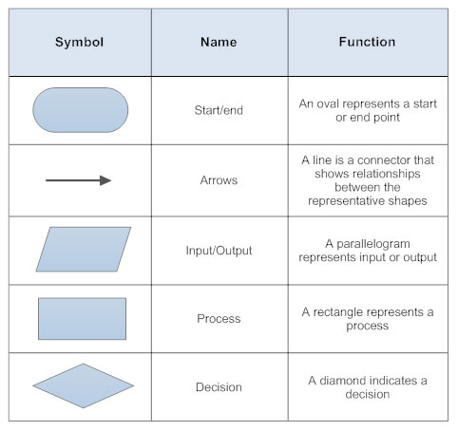

**EXAMPLE 🡪 Sum of 2 numbers**

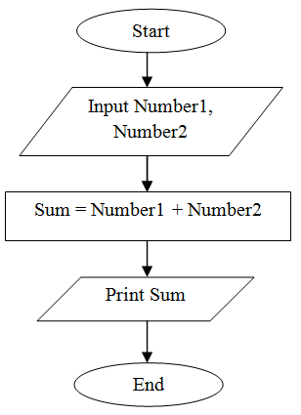

**Pseudocode 🡪** Generic way of representing code

**Example 🡪**

**Sum of 2 numbers**

1. **Start**
2. **Read a**
3. **Read b**
4. **Let sum be 0**
5. **sum = a+b**
6. **Print sum**

* **Ques** 🡪 Flowchart and Pseudocode for whether a<b

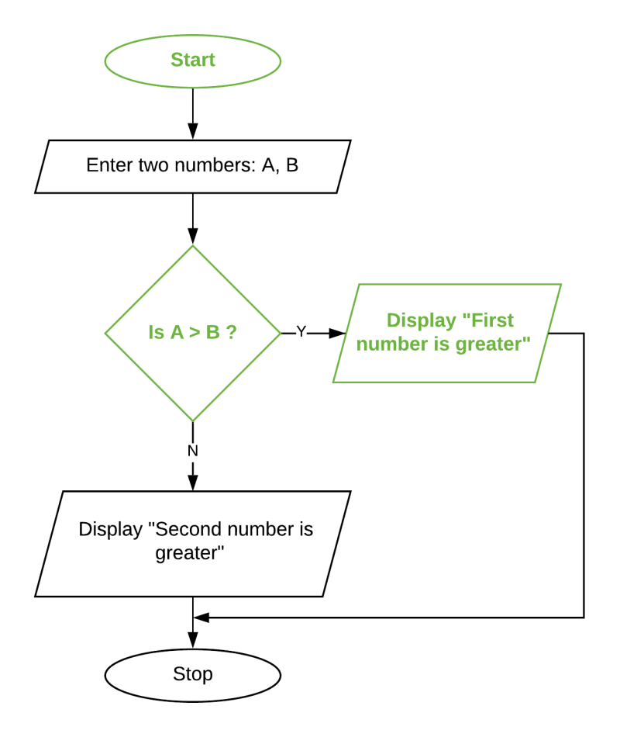

* **Ans 🡪**

1. Start
2. Read a and b
3. If a<n

Print “YES”

Else

Print “NO”

1. End

**Q – Even or Odd FLOWCHART**

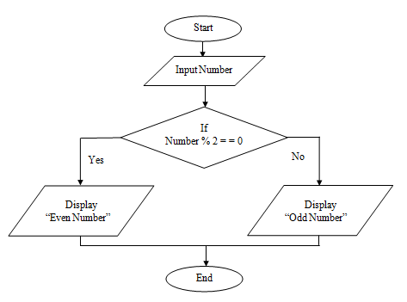

**Q – Even number between 1 to 10**

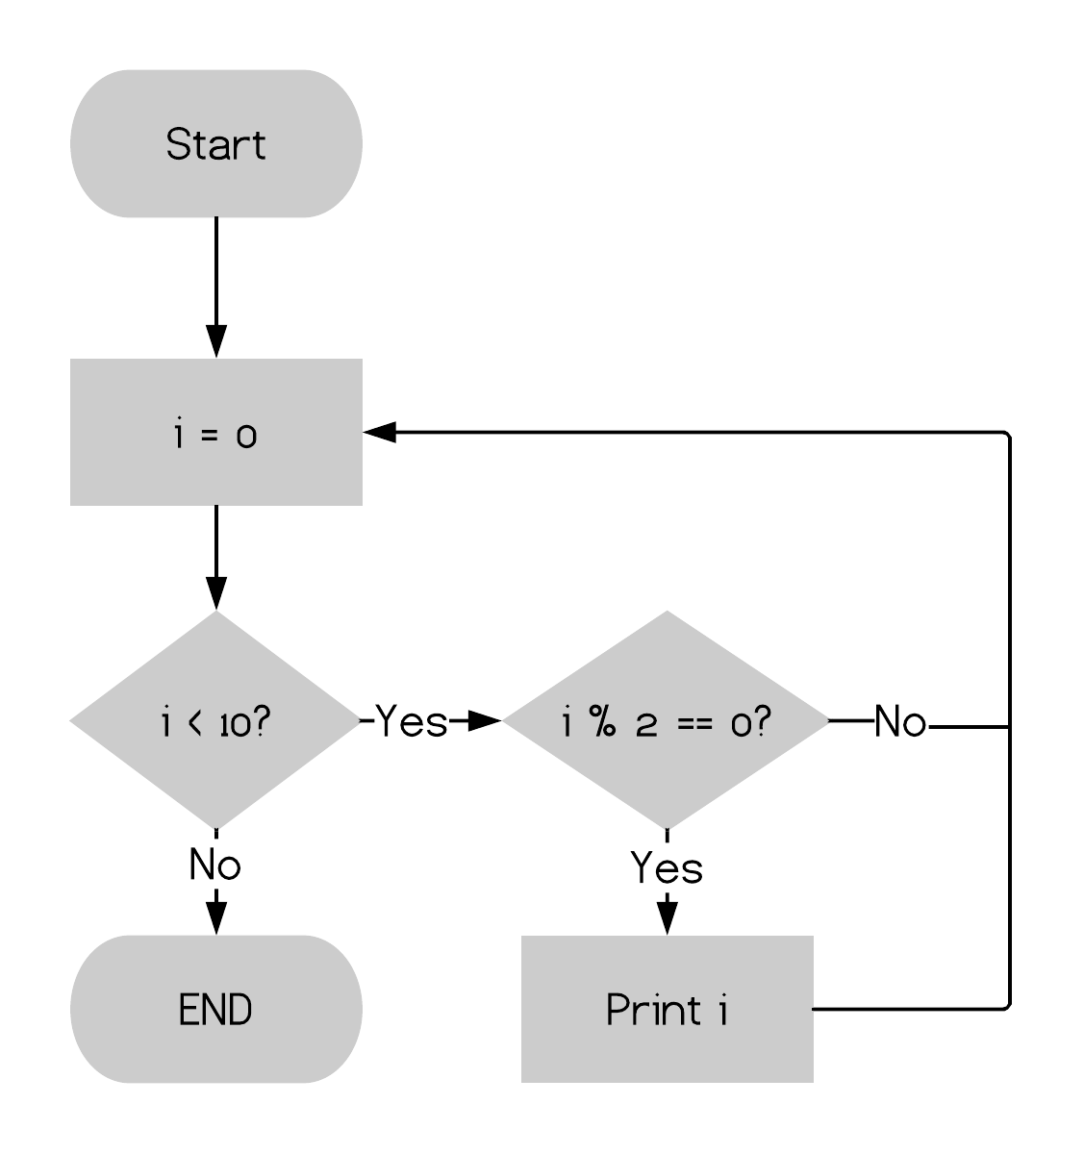

**Q – Sum from 1 to N**

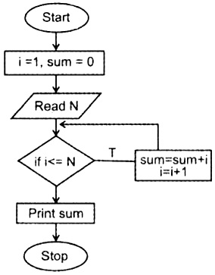

**Q – Prime or not**

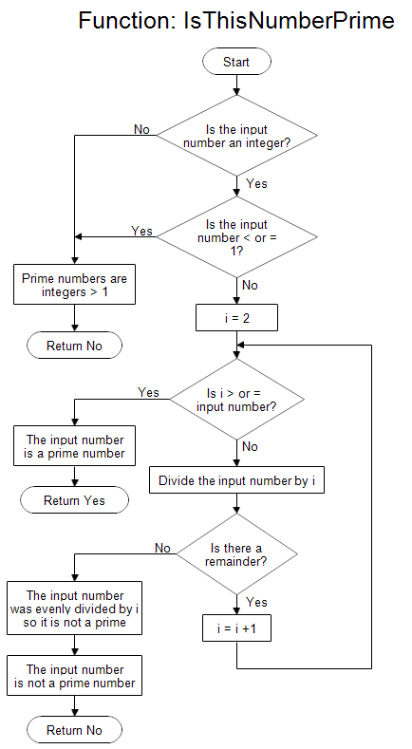

**IDE 🡪** Integrated Development Environment

**Q – What is Programming Language?**

A – A programming language is a **computer language** that is used by **programmers (developers) to communicate with computers**. It is a set of instructions written in any specific language ( C, C++, Java, Python) to perform a specific task.

**Q – What is Compiler?**

A – A compiler is a special program that processes statements written in a particular programming language and turns them into machine language or "code" that a computer's processor uses. Typically, a programmer writes language statements in a language such as C one line at a time using an editor. The file that is created contains what are called the source statements. The programmer then runs the appropriate language compiler, specifying the name of the file that contains the source statements.

CHECK THIS FOR MORE EXAMPLE

[Design Flowchart In Programming (With Examples) - Programiz](https://www.programiz.com/article/flowchart-programming)

[Flow Chart - Questions and Answers | Basic to Advance Level (auditor101.com)](http://auditor101.com/flow-chart-examples-questions-answers/)

[algorithm-manual.pdf (yspuniversity.ac.in)](https://www.yspuniversity.ac.in/images/campus-life/cic/algorithm-manual.pdf)

[ALGORITHM AND FLOW CHART | Lecture 1 (faradars.org)](https://faradars.org/wp-content/uploads/2015/07/Algorithm-and-Flow-Chart.pdf)