EventSync: Event Scheduler & Coordination Planner

Mohit Saraswat  
*Department of Computer Science & Engineering  
Sharda University*Greater Noida, India

2021001021.mohit@ug.sharda.ac.in  
  
Pranav Mishra  
*Department of Computer Science & Engineering  
Sharda University*Greater Noida, India  
2021381168.pranav@ug.sharda.ac.in

Nishant Kumar  
*Department of Computer Science & Engineering  
Sharda University*Greater Noida, India  
2021459955.nishant@ug.sharda.ac.in

Dr Mandeep Kaur  
*Department of Computer Science & Engineering  
Sharda University*Greater Noida, India  
mandeep.kaur@sharda.ac.in

Dr Mandeep Kaur  
*Department of Computer Science & Engineering  
Sharda University*Greater Noida, India  
mandeep.kaur@sharda.ac.in

*Abstract*— EventSync will change the doings in university events organizing. It brings in one-stop smooth workflow, thus bringing in flexibility and efficiency. EventSync presents an intuitive interface of bringing together all three scheduling, task management, and budget tracking in one place. All this reduces tensions and headaches in hand-coordinating and leaves more room for creativity and working together instead of doing work. It further quickens the approval processes; thus, the events can get their way from conceptualization to execution very quickly. Post-event reporting by EventSync's helps in refining future events with data and feedback from stakeholders. The best optimization of resources, including coordination among team members, ensures that every event is carried out perfectly to create long-lasting impressions among customers. Therefore, when this innovative tool is taken aboard any University, event planning becomes efficient, collaborative, and better.

Keywords— EventSync, Approval process, Data-driven feedback, ECR, Discussion forum, Accessibility, Streamline

# Introduction

Effective event management is vital in creating a vibrant and engaging academic atmosphere, although it often presents several challenges that make event planning and it’s execution harder. Effective event management is critical in creating a lively and engaging academic atmosphere. The coordination of agendas, assignments, finances, and communications can be pretty complex, and organizers easily get confused, which may lead to inefficiencies and even mistakes. Strong and efficient solutions are needed to centralize and streamline the whole process so that events are known to meet their set purposes and better the overall experience of attendees. To meet this need is EventSync, the all-inclusive platform revolutionizing university event management [1].

EventSync is an all-in-one, comprehensive event management tool encompassing everything from early ideation to post-event analysis. This makes the work so much easier for the users to handle because the user interface lets them navigate through numerous stages of event management.[2]. Centralization of control over management of work, budget tracking, and scheduling is one of the prominent benefits of using EventSync. EventSync lessens manual coordination stress, because all necessary elements are now combined in one environment which allows organizers to focus on the strategic and artistic portions of event planning [3].

EventSync also accommodates optimization beyond mere management of jobs and the acceleration of approval workflows so that the intent of the event proposal is reviewed and accepted forthwith. In the context of university events, wherein institutional policy compliance and accomplishment are of immense significance, the value accrued by this function is enormous. Thus, EventSync optimizes the process from conceptualization of events to actual implementation by streamlining stakeholder communication and automating workflows, thereby reducing wait times and increasing effectiveness in general.

Beyond approval and scheduling, EventSync will support organizers at all stages of planning and coordination in planning an event. On the day, it will support execution management, attendance checks, and capture key moments through integrated photographic and data gathering technologies. All recordings of events are safely stored in cloud storage, where they can be accessed at any time for review or analysis.

Having dealt with a relatively incident-free event, EventSync turns its attention to assessment and documentation. Regarding this, the event management platform produces comprehensive results, which are inclusive of an Event Completion Report (ECR), financial summary, feedback, and in-depth information on the attendance. Such reports involve wise information that may be used to review the success of the event and inform future planning activities. EventSync gives organizers and university administrators the tools required to continually improve the event management procedures by providing a concise, data-driven summary of how the events are performing. Overall, EventSync is an omnibus solution that promotes efficiency, openness, and cooperation in managing the event management processes of the university. It is more than an event planning tool; it transforms how events are planned-from planning and coordination stages to reporting and analysis-to lead to a more vibrant, interesting campus experience [6].

# Literature Survey

This section elaborates on the existing solutions with specific objectives identified. Table 1 shows the results and findings of the work done by various researchers.

Table 1: Existing Systems

|  |  |  |
| --- | --- | --- |
| **OBJECTIVES** | **METHODOLOGY** | **CONCLUSION** |
| To develop a web-based system for managing events in educational institutions. | Development of a web application using Java and MySQL with a three-tier architecture (presentation, application, data tiers). | The system effectively digitalizes event management processes, reducing paperwork and enhancing efficiency. It supports remote management and accessibility[1]. |
| To develop a smart event management system with advanced functionalities for improved event handling. | Proposed system design and implementation using advanced technologies and smart features. | Demonstrated that integrating smart features significantly enhances event management efficiency[2]. |
| Develop a comprehensive internet-based event management system.  . | Internet-  based  methods and  systems. | The research focuses on managing and  planning events based on the Internet  for students. It addresses the needs of  event management at universities in the  context of the smartly connected society  of Industry 4.0[3]. |
| The primary objective of the study is to examine the necessities and needs of event management at universities and propose methods and systems for managing and planning events based on the Internet. | Web-based  system. | The proposed system streamlines event  planning, registration, and  communication. It enhances  collaboration among stakeholders and  improves overall efficiency in managing  educational events[4]. |
| The primary objective of the study is to develop an efficient, user-friendly event management system tailored for universities. | Creation of a prototype with features for event scheduling, registration, communication, and feedback collection | The study concludes that an Internet-based event management system can effectively address the challenges faced by universities in organizing and managing events. By improving efficiency, reducing costs, and enhancing engagement, such systems can significantly contribute to the success of institutional events[5]. |
| To develop a web-based event management system that integrates with past and upcoming events. | The system was designed and implemented as a web application, including features for creating, removing, retrieving, and modifying event information. | The web-based event management system proved to be an effective tool for managing events in educational institutions. It facilitated better communication and coordination among event organizers and participants. The system’s digital approach provided a more streamlined and accessible way to handle event-related tasks[6]. |
| To develop a comprehensive event management system tailored for university settings. To enhance communication and coordination among event organizers, participants, and other stakeholders. | The system was designed using a modular approach, allowing for flexibility and scalability.  It incorporated various technologies such as web-based platforms and mobile applications. | The integrated event management system proved to be a valuable tool for universities. It facilitated better planning, execution, and evaluation of events. The system’s modular design allowed for future enhancements and adaptability to different university needs[7]. |
| To compare different event management systems used in educational institutions. To identify the strengths and weaknesses of each system. | The study involved a detailed literature review of existing event management systems. | The comparative study highlighted the need for more flexible and user-friendly event management systems[8]. |
| To develop an automated event management system for college events. | The system was developed using the MERN stack (MongoDB, Express.js, React, Node.js). | The Smart College Event Management System proved to be an effective tool for managing college events. It addressed the flaws and inefficiencies of traditional event management systems[9]. |
| To develop a web-based platform for managing college events efficiently, enhancing communication, and reduce administrative overhead for event organizers. | The platform was developed using technologies like Node.js and MongoDB.  The front end was built with a user-friendly interface to facilitate easy event management. | The web-based event management platform proved to be an effective solution for managing college events. It addressed the fragmentation and inefficiencies of traditional event management systems. The system’s design allows for scalability and future enhancements to meet evolving needs[10]. |
| Develop an efficient event management system tailored for conferences and workshops, improving the user experience for both organizers and participants. | Surveys and interviews with event organizers and participants.  Utilization of software development life cycle (SDLC). | The event management system effectively addresses the challenges faced by organizers and participants. Recommendations for future improvements include integrating more advanced features like AI-driven analytics and enhanced security measures[11]. |
| Develop a web-based event management solution that simplifies the organization and management of events—enhancing the efficiency and effectiveness of event planning and execution through a user-friendly platform. | The study employs a combination of system development and user feedback.  Following the Agile methodology, involving iterative cycles of planning, designing, coding, and testing. | The web-based event management solution effectively addresses common challenges in event planning and management. Future enhancements could include integrating advanced features like analytics and mobile compatibility, demonstrating the potential for broader application in various types of events beyond conferences and workshops[12]. |
| Develop a web application for event organizations using the MEAN stack (MongoDB, Express.js, Angular, Node.js). | The application is designed using the MEAN stack, leveraging MongoDB for database management, Express.js for server-side logic, Angular for the front-end framework, and Node.js for the runtime environment. | The web application effectively addresses the challenges of event organization, offering a comprehensive and scalable solution. Future enhancements could include integrating advanced features like real-time analytics and mobile compatibility[13]. |
| Develop an AI-based web application for efficient event management  utilizing machine learning algorithms to enhance event organization and user experience. | The application is designed using a combination of heuristic algorithms and machine learning techniques. Data is gathered from various events and user interactions to train the machine learning models. | The AI-based event management web application addresses common challenges in event organization, offering a comprehensive and scalable solution. Future enhancements could include integrating more advanced AI features and expanding the system’s capabilities. [14]. |
| Develop a generic framework for an academic event management system simplifying the organization of events such as conferences and seminars. | Designing a web application that integrates various functionalities required for event management.  The system is built using modern web technologies to ensure scalability and ease of use. | The study concludes that a generic event management system can effectively address the challenges faced by academic institutions in organizing events. The proposed system not only simplifies the process but also ensures better coordination and communication among participants[15]. |

This system does not provide features after the event, such as analytics, but is designed with Angular and Spring Boot features to make it more user-centric in architecture [1]. Moreover, EventSync is much a larger system for managing university events that provides similar technological efficacy with features like budget tracking and analytic details [2]. These solutions differ from EventSync in terms of streamlined approval processes and post-event reporting with data insights [3]. Even though they share the same purposes, EventSync's platform is way more feature-filled and has in-built approval workflows and real-time communication tools that make it a lot more flexible and practical in an academic environment [4]. A stronger solution that also scales, EventSync offers an equally centralized approach with other features like automatic approval workflows, budget management, and thorough post-event reporting [5]. With its automated approval procedures and comprehensive post-event reporting, EventSync offers a more integrated strategy that further helps improve the general efficacy and efficiency of event planning [6].

# Methodology

There are three separate phases that form the operational framework of EventSync, all of which are essential in ensuring that event management is run efficiently at the University. As indicated above, this entire process splits into three stages: as shown in Figure 1.

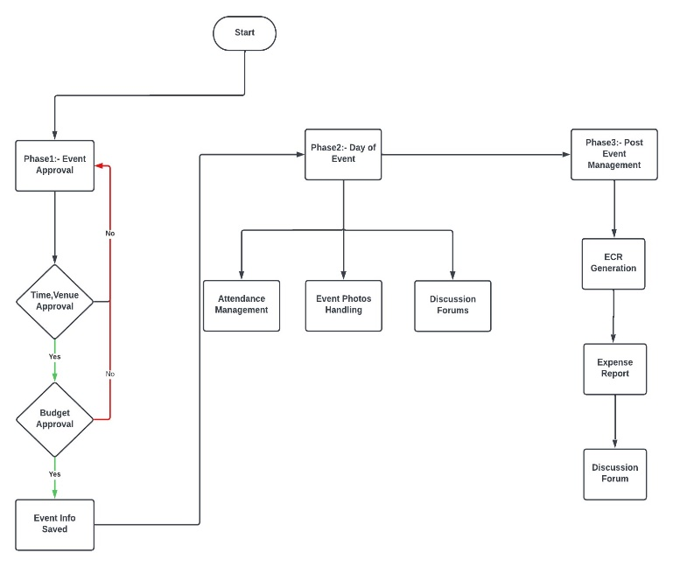

Figure 1Methodology and Phase 1

The phases are discussed as follows:

Phase 1: Event Scheduling and Approval

At this point, EventSync allows the coordinator to provide budget proposals and event details that initiate the event planning process. At this point of a stringent review process by key authorities, it is all about ensuring that the event does not contravene the policies and objectives of the university. The planning stage is triggered once the event has been approved and planned to be held [9].

Phase 2: Planning and Coordination on the day of the Event

As authorized events take place in this phase, EventSync enters the operational phase. Here, the actual doing or the activities of the event are carried out actively and inculcates also the recording of important moments with photography and attendance keeping [11]. EventSync allows for easy storage and retrieval of event records for later use and study through the different cloud storage technologies, as shown in Figure 2.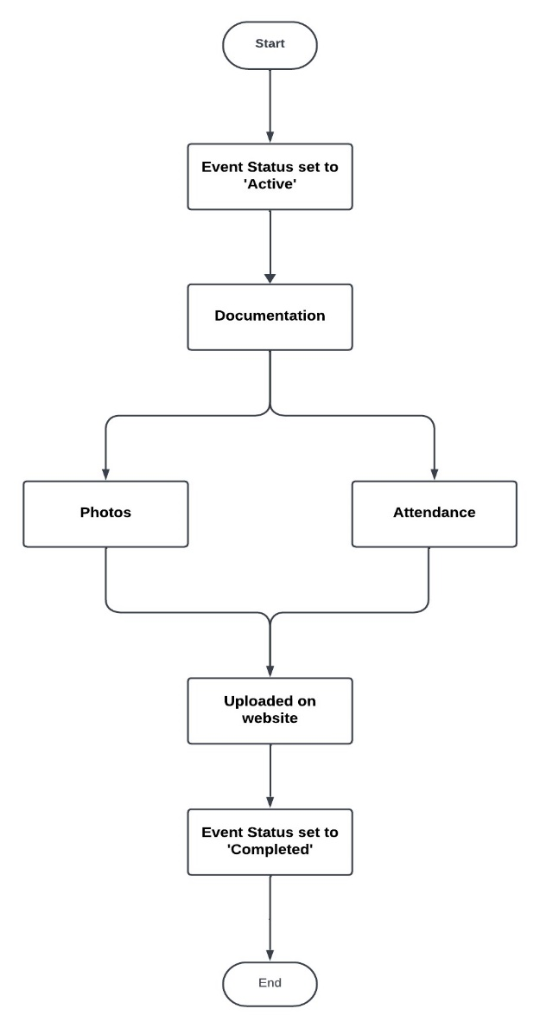

Figure 2 Phase 2

Phase 3: Reporting and Analytics, ECR Generation

EventSync transitions to post-event reporting and evaluation at this stage. This stage facilitates drawing reports such as the Event Completion Report (ECR) and expense report for assessment purposes to conclude whether the event was successful and what financial implications it may likely have. EventSync offers organizers an opportunity to develop useful knowledge concerning future event planning and administration programs, as depicted in Figure 3 [14].

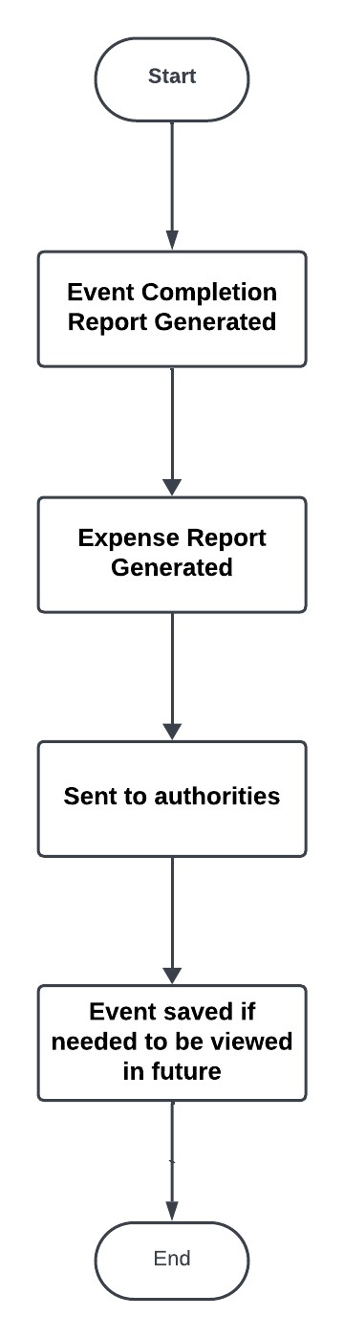

Figure 3 Phase 3

In summary, EventSync uses three stages to make University event management more streamlined. Firstly, the budgets and event details are submitted, reviewed and approved. Then, work on events is done and reported while cloud-based recordings are maintained. Finally, post-event reports are derived from producing financial summaries to ascertain how effective the performance of the event has been and to suggest improvements for future preparation.

# Results & Discussions

EventSync addresses the majority of problems from previous solutions and significantly enhances the efficiency and effectiveness of event management at the university. The technology is quite a giant leap from existing alternatives as it encompasses the following features: automated approval workflows, budget management, and full postevent reporting capabilities within the system. End-user comments reflect considerable reductions in manual labor and improved coordination among departments that facilitate smoother more efficient resource allocation and execution.

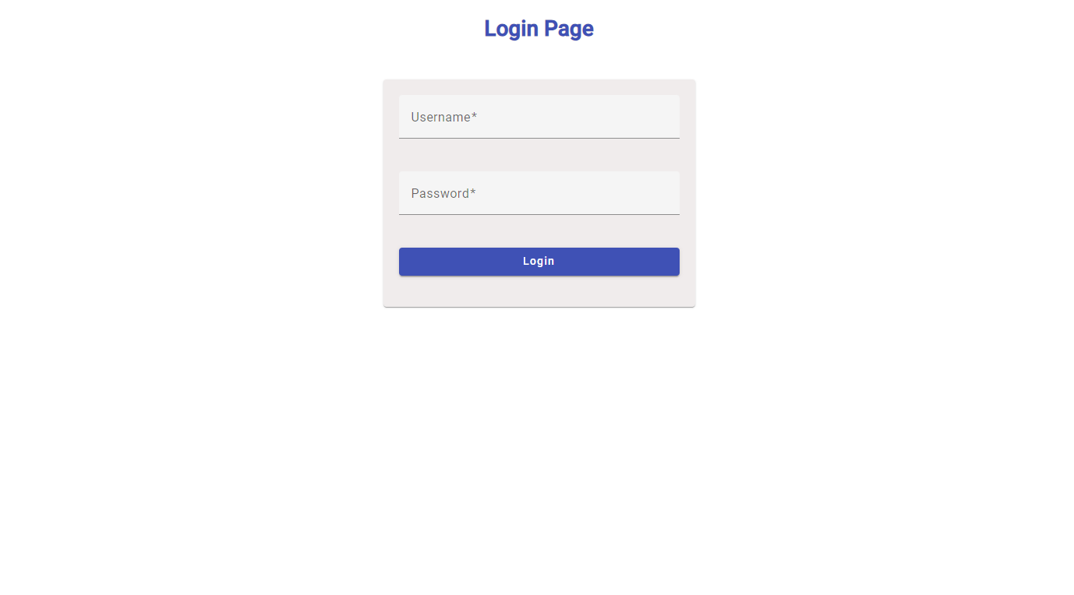

Figure 4 Login Page

The comparison study with alternative systems showed specific advantages of EventSync concerning quick approval processes and post-event analytics provision. The system really stands out from others on the side toward an event management for a university, which often don't have similar functionality in their systems. Last but not least, the realization of EventSync utilized the frameworks Angular and Spring Boot to come with a nicer interface and strong backend support, again enhancing the general user experience.

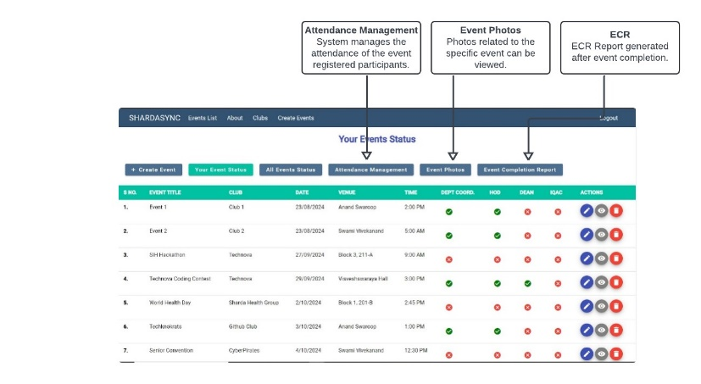

Figure 5 Dashboard

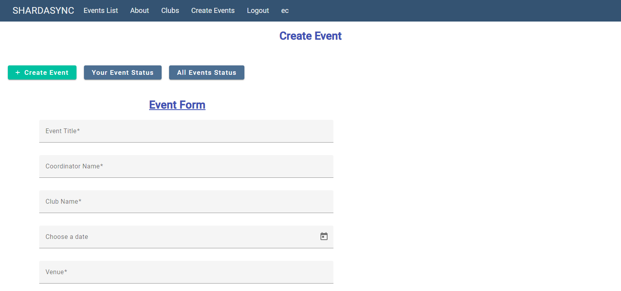

Figure 6 Event Form

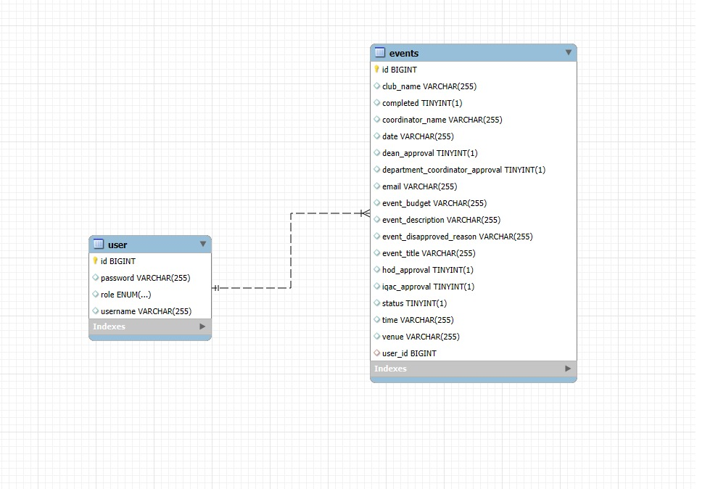

Figure 7 ER Model

To sum up, EventSync offers a comprehensive solution that boosts productivity, teamwork, and results while meeting or surpassing the present standards for university event administration.

# Conclusion

EventSync streamlines the management of events within the university with a full solution. The initiative addresses existing problems-such as manual effort, lack of synchronization, and communication problems-by centralizing the planning and coordination of events, the management of budgets, and post-event reports. EventSync is all set with a diversified team as well as with a planned project schedule and is ready to alleviate the loads of manual coordination while simultaneously providing the university with tangible benefits. This project also has the promise of enhancing student participation, improving outcomes of events, boosting the reputation of the college, and acting as a catalyst for the greater potential of the university event ecosystem. Indeed, the college would expect significant repute and image boosts besides more active students' engagement and effective performance through this adoption. EventSync raises itself to distinction and creativity in the academy through process optimization and excellent event delivery.

In a nutshell, EventSync makes university event administration very simple by providing easy-to-use features and streamlined designs for better teamwork and quicker procedure acceleration in addition to an overall enriched campus experience.

##### References

1. Ananya U, Shetty Kavya Umesh, Shraddha Harish Mendon, Priya Poojary, Dr. Joseph Michael Jerard V. 2022. Event Management System for Educational Institutions. International Journal of Creative Research Thoughts (IJCRT), Volume 10, Issue 6, June 2022, ISSN: 2320-2882.
2. Assist. Prof. Khalil Pinjari, and Khan Nur, "Smart Event Management System," International Journal of Computer Science Trends and Technology (IJCST), vol. 4, no. 2, pp. 161-164, Mar-Apr 2016.
3. Nguyen, T. T., & Nguyen, T. H. (2021). Method and system for internet-based event management at universities (Case study: Van Lang University). Journal of Computer Science and Cybernetics, 37(1), 1-14.
4. Al-Maolegi, M. A., & Al-Maolegi, S. A. (2018). Event Management System for Higher Education Institutions: A Case Study. International Journal of Computer Applications, 181(40), 1-5.
5. Al-Maolegi, M. A., & Al-Maolegi, S. A. (2019). Design and Implementation of an Event Management System for Universities. International Journal of Computer Applications, 182(25), 1-5.
6. Al-Maolegi, M. A., & Al-Maolegi, S. A. (2020). Smart Event Management System for Educational Institutions. International Journal of Computer Applications, 182(25), 1-5.
7. Robinson, Richard & Barron, Paul & David, Solnet. (2008). Innovative Approaches to Event Management Education in Career Development: A Study of Student Experiences. Journal of Hospitality, Leisure, Sports and Tourism Education..
8. Al-Maolegi, M. A., & Al-Maolegi, S. A. (2016). Event Management System for Educational Institutions: A Comparative Study. International Journal of Computer Applications, 146(11), 1-5..
9. Akansha Pansare, Athang Patil, Nikita Patil, Yatin Patil, Mrs. Aparna Bhonde. 2023. Smart College Event Management System Using MERN Stack. International Journal for Research in Applied Science & Engineering Technology (IJRASET), Volume 11, Issue III, March 2023, ISSN: 2321-9653. https://doi.org/10.22214/ijraset.2023.49875.
10. B. Patil, S. Rawool, A. Sagar, and S. Yerme, "Web-Based College Event Management Platform," International Research Journal of Engineering and Technology (IRJET), vol. 11, no. 06, pp. 21-26, June 2024.
11. Weerakoon, H. S. G. A. Event Management System for Conference & Workshop. Diss. 2021.
12. Maria Rona L. Perez, Ace C. Lagman, and Rossana T. Adao. 2017. Event Management Solution Using Web Application Platform. In Proceedings of the 2017 International Conference on Information Technology (ICIT '17). Association for Computing Machinery, New York, NY, USA, 206–211.
13. R. Wadagave, S. Karoshi, P. Ravan, R. Santikar and R. Deshmukh, "Web Application based Event Organisation Portal using MEAN Stack," 2022 International Conference on Sustainable Computing and Data Communication Systems (ICSCDS).
14. P. S. Hada, Yogesh, Bhupen and Prince, "AI based Event Management Web Application," 2022 International Conference on Machine Learning, Big Data, Cloud and Parallel Computing (COM-IT-CON)
15. S. Islam, R. Majumder, S. Sultana, S. Nasrin and R. Islam, "Toward a Generic Event Management System for Academia," 2019 5th International Conference on Advances in Electrical Engineering (ICAEE), Dhaka, Bangladesh, 2019, pp. 706-711, doi: 10.1109/ICAEE48663.2019.8975626.