­­­­

**EventSync: Sharda Event Scheduler & Coordination Planner**

**EVALUATION - 2**

**BACHELOR OF TECHNOLOGY**

**COMPUTER SCIENCE**

SUBMITTED BY

Mohit Saraswat (2021001021)

Pranav Mishra (2021381168)

Nishant Kumar (2021459955)

September 2024



Prof. (Dr.) Mandeep Kaur

Professor, CSE Department

**DEPARTMENT OF COMPUTER SCIENCE ENGINEERING,**

**SCHOOL OF ENGINEERING AND TECHNOLOGY,**

**SHARDA UNIVERSITY, GREATER NOIDA**

**ABSTRACT**

EventSync stands as a beacon of innovation within Sharda University, addressing the intricate web of challenges that often encumber event planning endeavors. With its user-friendly interface and robust features, EventSync revolutionizes the way events are conceptualized, executed, and evaluated. By consolidating scheduling, task delegation, and budgetary oversight onto a single platform, EventSync alleviates the burden of manual coordination, empowering organizers to focus on the creative aspects of event curation.

Furthermore, EventSync's optimization capabilities streamline approval processes, expediting the journey from concept to execution. Its post-event reporting functionality provides invaluable insights, allowing stakeholders to glean actionable data for future endeavors. As Sharda University embraces this innovative solution, a paradigm shift occurs, fostering an environment where collaboration flourishes, resources are optimized, and event outcomes transcend expectations.

EventSync will serve as a game-changer for event organization at Sharda University. Its user-friendly interface and comprehensive features will simplify the entire process, from planning to execution and assessment. By bringing together scheduling, task management, and budget tracking in one place, EventSync will reduce the usual headaches of event coordination, all the while optimizing resources, making collaboration smoother, efficient and ensuring every event exceeds expectations.

**MOTIVATION**

The idea for EventSync sprouted from the users which was found during the survey conducted for the event planning at Sharda University. As students and organizers felt the frustration of dealing with manual processes, scheduling conflicts, and communication gaps. These struggles required the need of EventSync, a solution aimed at simplifying event management tasks.

The goal of the project is straightforward: to make event planning easier for everyone involved—students, faculty, and staff. EventSync is the answer to the inefficiencies the user faces. It's designed to streamline processes, eliminate manual effort, and improve communication, all to enhance the overall event experience at Sharda University. EventSync is striving to make event planning more accessible, efficient, and enjoyable for everyone.

At its core, EventSync aims to democratize event planning, ensuring it's a smooth process for all students, faculty, and staff. By addressing the challenges identified through user feedback, EventSync is committed to enhancing efficiency, reducing manual labor, and fostering better communication channels. Ultimately, the objective is to elevate the overall event experience at Sharda University, making event planning accessible, efficient, and even enjoyable for everyone involved.

**OBJECTIVES**

EventSync objectives are based on the surveys conducted and the challenges discovered while conducting an event, and to improve this process, the objectives are as follows :-

**Streamline Event Planning**: To simplify event planning processes by centralizing scheduling, task coordination, and communication.

**Enhance Coordination**: To facilitate seamless collaboration among organizers, stakeholders, and team members.

**Optimize Budget Management**: To track expenses and ensure events stay within budgetary constraints.

**Streamline Approval Processes**: To automate workflows to expedite event proposal approval by stakeholders.

**Generate Comprehensive Reports**: To capture attendance data, feedback, and financial summaries for post-event analysis.

**Promote Efficiency and Transparency**: To improve event execution, communication, and accountability within the college community.

The goal of the EventSync project is to revolutionize event management at Sharda College by providing a comprehensive solution that streamlines planning, coordination, budget management, approval processes, and post-event reporting. EventSync aims to enhance efficiency, transparency, and overall event experience for students, faculty, and staff, ultimately contributing to the success and reputation of Sharda College’s events and activities.

**LITERATURE SURVEY**

|  |  |  |
| --- | --- | --- |
| **OBJECTIVES** | **METHODOLOGY** | **CONCLUSION** |
| To develop a web-based system for managing events in educational institutions. | Development of a web application using Java and MySQL with a three-tier architecture (presentation, application, data tiers). | The system effectively digitalizes event management processes, reducing paperwork and enhancing efficiency. It supports remote management and accessibility[1]. |
| To develop a smart event management system with advanced functionalities for improved event handling. | Proposed system design and implementation using advanced technologies and smart features. | Demonstrated that integrating smart features significantly enhances event management efficiency[2]. |
| Develop a comprehensive internet-based event management system.  . | Internet-based methods and systems. | The research focuses on managing and  planning events based on the Internet  for students. It addresses the needs of  event management at universities in the  context of the smartly connected society  of Industry 4.0[3]. |
| The primary objective of the study is to examine the necessities and needs of event management at universities and propose methods and systems for managing and planning events based on the Internet. | Web-based  system. | The proposed system streamlines event  planning, registration, and  communication. It enhances  collaboration among stakeholders and  improves overall efficiency in managing  educational events[4]. |
| The primary objective of the study is to develop an efficient, user-friendly event management system tailored for universities. | Creation of a prototype with features for event scheduling, registration, communication, and feedback collection | The study concludes that an Internet-based event management system can effectively address the challenges faced by universities in organizing and managing events. By improving efficiency, reducing costs, and enhancing engagement, such systems can significantly contribute to the success of institutional events[5]. |
| To develop a web-based event management system that integrates with past and upcoming events. | The system was designed and implemented as a web application, including features for creating, removing, retrieving, and modifying event information. | The web-based event management system proved to be an effective tool for managing events in educational institutions. It facilitated better communication and coordination among event organizers and participants. The system’s digital approach provided a more streamlined and accessible way to handle event-related tasks[6]. |
| To develop a comprehensive event management system tailored for university settings. To enhance communication and coordination among event organizers, participants, and other stakeholders. | The system was designed using a modular approach, allowing for flexibility and scalability.  It incorporated various technologies such as web-based platforms and mobile applications. | The integrated event management system proved to be a valuable tool for universities. It facilitated better planning, execution, and evaluation of events. The system’s modular design allowed for future enhancements and adaptability to different university needs[7]. |
| To compare different event management systems used in educational institutions. To identify the strengths and weaknesses of each system. | The study involved a detailed literature review of existing event management systems. | The comparative study highlighted the need for more flexible and user-friendly event management systems[8]. |
| To develop an automated event management system for college events. | The system was developed using the MERN stack (MongoDB, Express.js, React, Node.js). | The Smart College Event Management System proved to be an effective tool for managing college events. It addressed the flaws and inefficiencies of traditional event management systems[9]. |
| To develop a web-based platform for managing college events efficiently, enhancing communication, and reduce administrative overhead for event organizers. | The platform was developed using technologies like Node.js and MongoDB.  The front end was built with a user-friendly interface to facilitate easy event management. | The web-based event management platform proved to be an effective solution for managing college events. It addressed the fragmentation and inefficiencies of traditional event management systems. The system’s design allows for scalability and future enhancements to meet evolving needs[10]. |

**METHODOLOGY**

EventSync operates through a structured framework encompassing three distinct phases, each crucial in orchestrating seamless event management at Sharda University. The overall methodology consists of 3 phases. These are as follows:-

Phase 1: Event Scheduling and Approval

In this phase, EventSync initiates the event management journey by facilitating the submission of event details and budget proposals by the coordinator. This phase focuses on ensuring alignment with university policies and objectives through a thorough review process by key authorities. Once approved, the event is scheduled for execution, marking the beginning of the planning phase.

Phase 2: Planning and Coordination on day of Event

In this phase, EventSync transitions into the operational stage as the approved event takes place. This phase involves the active execution of event activities, coupled with the crucial task of documenting key moments through photography and attendance tracking. By leveraging cloud storage solutions, EventSync ensures the seamless preservation and accessibility of event records for future reference and analysis.

Phase 3: Reporting and Analytics, ECR Generation

In this phase, EventSync shifts its focus towards post-event evaluation and reporting. This phase entails the generation of comprehensive reports, including the Event Completion Report (ECR) and expense report, to assess the event's success and financial implications. Through meticulous analysis, EventSync enables organizers to glean valuable insights for optimizing future event planning and management endeavors.

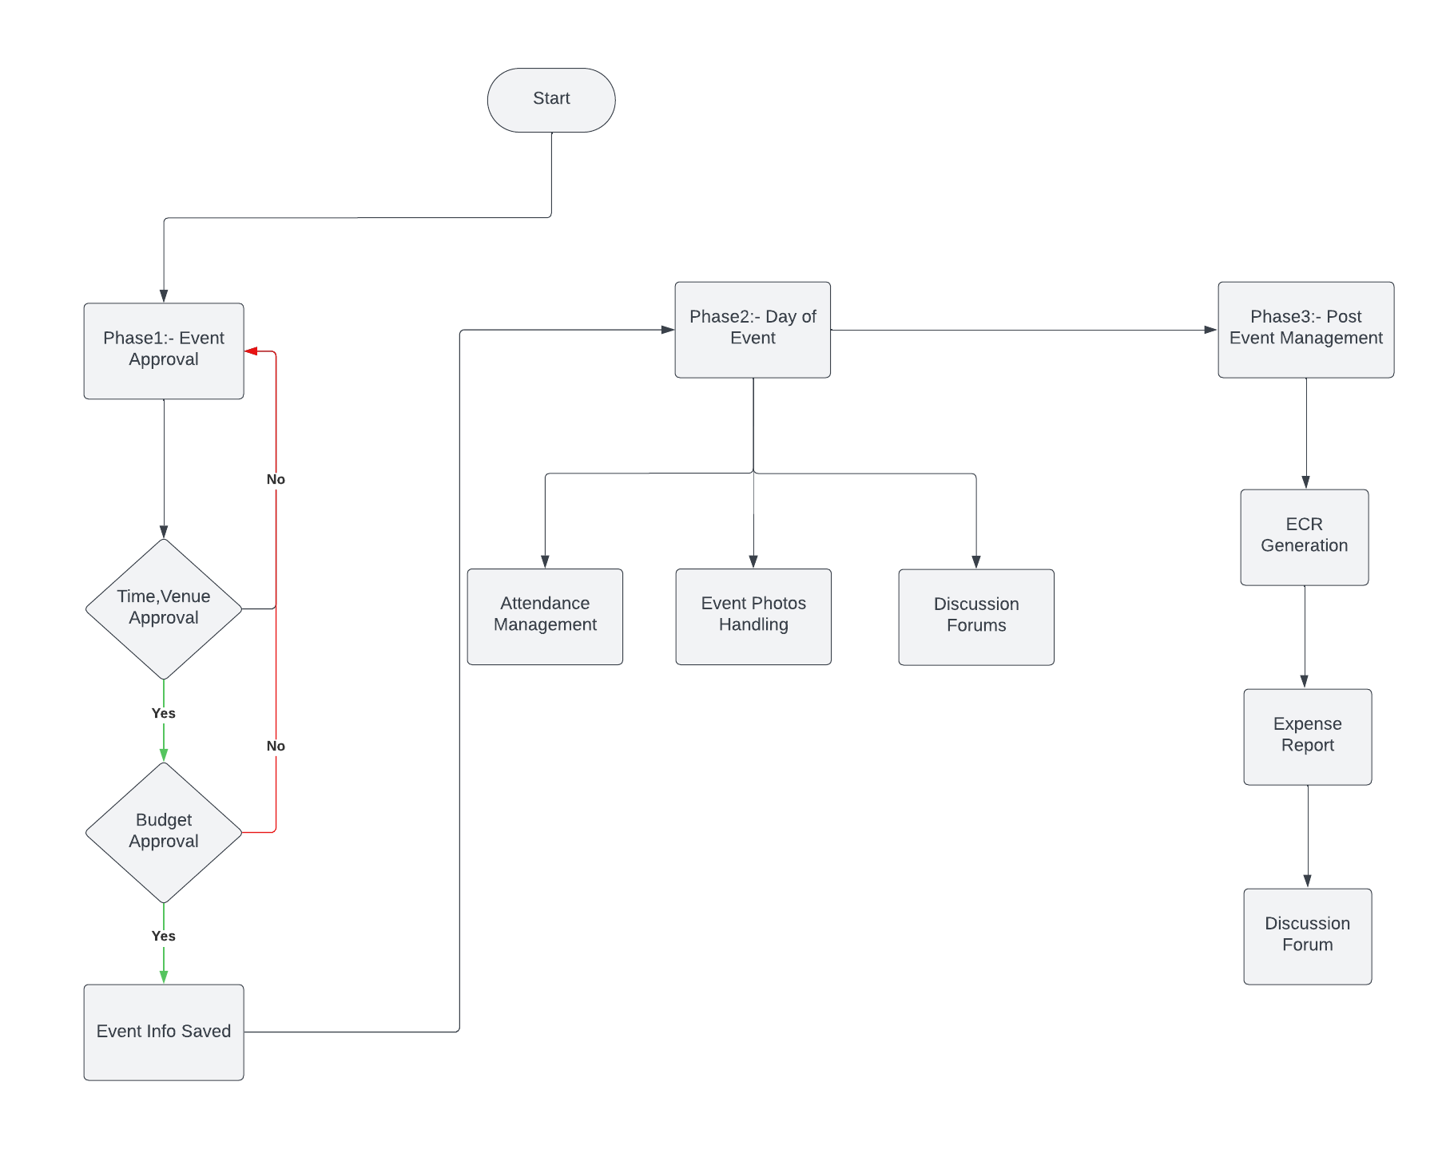

Figure 1Methodology

**REQUIREMENTS**

**Software Requirements:-**

**Frontend**: Angular, MERN

Angular is a free and open-source JavaScript-based web framework for developing single-page applications.

MERN stands for MongoDB, Express, React, and Node.js, with each component playing a role in the development process. MongoDB serves as a document-oriented database that can efficiently store data in JSON format.

**Backend:** Spring Boot, Node.js, Firebase

Spring Boot is an open-source Java framework used to create a Micro Service. Spring boot is used for programming standalone, production-grade Spring-based applications with minimal effort.

Node.js is a cross-platform, open-source JavaScript runtime environment that can run on Windows, Linux, Unix, macOS, and more. Node.js lets developers use JavaScript to write command line tools and for server-side scripting.

Firebase, Inc. is a set of backend cloud computing services and application development platforms provided by Google. It hosts databases, services, authentication, and integration for a variety of applications, including Android, iOS, JavaScript, Node.js, Java, Unity, PHP, and C++.

**Database :** MySQL, MongoDB, PostgresSQL

MySQL is an open-source relational database management system.

MongoDB is a source-available, cross-platform, document-oriented database program. Classified as a NoSQL database product, MongoDB utilizes JSON-like documents with optional schemas.

PostgreSQL, also known as Postgres, is a free and open-source relational database management system emphasizing extensibility and SQL compliance.

**Development Tools:**

Integrated Development Environments such as IntelliJ, Visual Studio Code, Postman for coding and debugging.

**Hardware Requirements:-**

**Laptop/PC:** A standard laptop or PC with sufficient processing power, memory and a working internet connection.

**FEASIBILITY STUDY**

**1.** **Technical Feasibility**

* **System Requirements**: The Event Sync system will require specific hardware and software components. Key requirements include:
  + Hardware: Servers with sufficient processing power, memory, and storage.
  + Software: Development platforms and frameworks such as React, Angular for the frontend, Node.js, SpringBoot for the backend, and a suitable database (e.g., MongoDB or MySQL).
* **Integration Capabilities**: The system should integrate seamlessly with existing college infrastructure and third-party services. This includes:
  + Email Systems: For notifications and communications.
* **Development Tools**: The project will use tools and technologies like version control (e.g., Git), and testing tools.

**2. Operational Feasibility**

* **Process Management**: Event Sync will manage processes across three phases:
  + **Pre-Event**: Event Approval, Budget Approval, Time and Venue Approval.
  + **Day of Event**: Attendance Management, Event Photos Handling, Discussion Forums.
  + **Post-Event**: ECR(Event Completion Report) generation, Expense Report, Discussion Forums.
* **User Experience**: The system will be designed for ease of use, ensuring an intuitive interface for event organizers, attendees, and staff.
* **Support and Training**: A comprehensive training program will be developed for users and administrators. Ongoing support will be provided to address any issues and maintain system functionality.

**3. Economic Feasibility**

* **Cost Analysis**: The estimated costs include:
  + **Development Costs**: Software development, testing, and deployment.
  + **Hardware Expenses**: Server costs and other infrastructure needs.
  + **Licensing Fees**: If any proprietary software or services are used.
* **Budget**: The project budget will be reviewed to ensure it aligns with the estimated costs. Potential funding sources will be identified if necessary.
* **Cost-Benefit Analysis**: The benefits of Event Sync, such as reduced paper usage, streamlined processes, and improved event management efficiency, will be weighed against the costs to determine overall value.

**4. Legal and Compliance Feasibility**

* **Institutional Policies:** The system will adhere to college policies regarding data handling, security, and event management.

**5. Scheduling and Resource Feasibility**

* **Timeline:** A detailed project timeline will be created, including key milestones and deadlines for each phase of development and deployment.
* **Resource Allocation:** Resources such as development team members, tools, and facilities will be assessed to ensure they are available and sufficient for project completion.

**DESIGN SPECIFICATIONS**

Figure 2 Design Specifications

The flowchart (Fig 2) illustrates the functional specifications of the EventSync system for the Team Project Proposal (TPP). It begins with a Homepage where users can access the List of Events and view details about events via the Event Information module. After logging in through the Login page, users are directed to a Dashboard that provides key functionalities, such as the Event Creation Form, where users can propose new events, view Event Approval Status, manage event participation via Attendance Management, and access a Discussion Forum for collaboration. Additionally, the Post Event module allows users to submit an ECR Form (Event Completion Report), view event photos, and access a Budget Report. The flowchart visually maps out the entire event management process from creation to post-event evaluation, aligning with Agile-based development for efficient, iterative improvements.

**COMPUTING FRAMEWORKS**

The EventSync system is a **web-based event management application** designed with a **client-server architecture**. The frontend will interact with the backend using RESTful APIs. The system is divided into two main components:

1. **Frontend** (Angular)
2. **Backend** (Spring Boot)

**Architecture Diagram:**

* Created using **Lucidchart**, representing how the frontend and backend will interact.
* The architecture will illustrate the communication flow between client-side components (Angular) and server-side components (Spring Boot REST APIs), along with external services like databases and authentication mechanisms.

**FRONTEND DESIGN SPECIFICATIONS**

The **frontend** of EventSync will be developed using **Angular**, with UI components designed using **Bootstrap** and **Angular Material**.

**Tools Used:**

* **Figma**: For wireframing and designing UI layouts.
* **Lucidchart**: For visualizing the component architecture and interaction between components.

**Key Design Decisions:**

1. **Responsive Design**:
   * Use **Bootstrap** grid system to ensure the platform is responsive on various devices (mobile, tablet, desktop).
   * Key screens (login, event dashboard, event approval) will adapt based on screen size.
2. **Angular Material Components**:
   * Use **Angular Material** for interactive UI elements (buttons, dialogs, date pickers, etc.).
   * Material Design principles will guide the design of buttons, forms, and other elements for a modern, cohesive UI.
3. **Component-Based Architecture**:
   * UI components will be broken down into reusable parts using Angular’s component structure.
   * Examples:
     + **Navbar Component**: For the navigation header across the application.
     + **Dashboard Component**: To display user-specific event details.
     + **Event Request Form Component**: To submit new event requests.

**Wireframes (created in Figma):**

* **Login Page**:
  + Basic login form with username and password fields.
  + Designed with **Material Input Fields** and a **Submit Button** (Angular Material).
* **Event Dashboard**:
  + List of events (approved, pending) in a table format.
  + Each event can be clicked for more details.
* **Event Request Form**:
  + Form with dropdowns for event type, date picker for event scheduling, and a submit button.
  + All inputs designed using **Angular Material’s form fields and validators**.

**Design Mockups (created in Figma):**

* Provide detailed color schemes, typography (using Material Design principles), button styles, and hover effects.

**5. Agile SDLC**

The **Agile SDLC** will be followed from requirements gathering through development, testing, and delivery. The Agile model ensures iterative development with continuous stakeholder feedback.

**Agile Phases:**

1. **Requirements Gathering**:
   * Involved defining the scope of Phase 1 (user login, event scheduling, and approval).
   * Use **Lucidchart** for creating high-level flowcharts and diagrams representing workflows.
2. **Design**:
   * Frontend wireframes and mockups were created in **Figma**.
   * **Lucidchart** used to create database ER diagrams, flow diagrams, and system architecture designs.
3. **Development**:
   * The frontend is developed in **Angular** using **Bootstrap** for responsiveness and **Angular Material** for interactive UI components.
   * Backend developed using **Spring Boot**, exposing REST APIs for frontend interaction.
4. **Testing**:
   * Unit tests for individual backend modules (Spring Boot) and frontend components (Angular).
   * Integration testing using tools like **Postman** to verify the API functionality.
   * Mock testing of data flow between frontend and backend.

**PROTOTYPING**

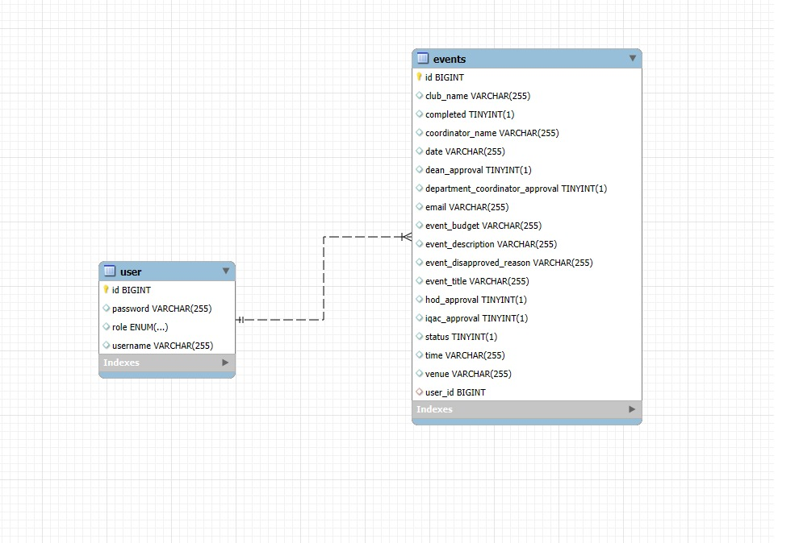

Figure 3 Event Schema ER Diagram

The Event entity represents events with attributes like id, eventTitle, coordinatorName, clubName, email, date, time, venue, eventBudget, eventDescription, and various approval statuses. It has a many-to-one relationship with the User entity, where each event is coordinated by a single user, but a user can coordinate multiple events. The User entity, representing system users, includes attributes like id, username, password, and role. The foreign key user_id in the events table references the id in the user table. This relationship allows for operations like associating events with coordinators and fetching a user's coordinated events. Cascade operations ensure that changes to a user propagate to their events. These schemas are represented in Fig 2.

**DEVELOPMENT**

**Phase 1**

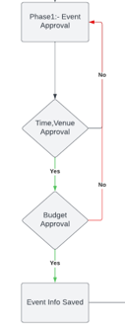

Figure 4 Phase 1 Flowchart

Phase 1 of the EventSync project focuses on Event Approval by the respective authorities.

This phase includes:

* **Creation of Registration and Login Page:** New users can register and log in to use the website.
* **Event Coordinator Capabilities:** Users assigned as Event Coordinators can create new event requests and wait for approval from the respective authorities. They can also track the approval progress of their own events as well as those created by other Event Coordinators.
* **Authority Roles and Actions:** Users with roles such as Department Coordinator, HOD, Dean, IQAC team, etc., can log in, view details of the requested events, and either approve or deny them.
* **Automated Notifications:** Upon approval or disapproval of an event, automated emails will be sent to the respective authorities, informing them of the event's status, whether it has been approved, disapproved, or if a new event is awaiting their approval.

**CONCLUSION**

EventSync offers a comprehensive solution to streamline event management at Sharda University. By centralizing event planning, coordination, budget management, and post-event reporting, The project addresses current challenges such as manual effort, lack of synchronization, and communication issues. With a multidisciplinary team and a structured project timeline, EventSync is poised to deliver tangible benefits to Sharda University and also alleviate the burdens of manual coordination. The project's importance lies in its potential to improve event outcomes, foster student engagement, enhance the college's reputation, and also serve as a catalyst for realizing the full potential of Sharda University’s event ecosystem.

With its implementation, the college can anticipate not only smoother operations and enhanced student engagement but also a significant boost to its overall image and reputation. By streamlining processes and delivering successful events, EventSync becomes a symbol of excellence and innovation within the college community.

In summary, EventSync provides a straightforward solution to improve event management at Sharda University. Its simplified features and ease of use aim to streamline processes, encourage teamwork, and enhance the overall campus experience.

**REFERENCES**

1. Ananya U, Shetty Kavya Umesh, Shraddha Harish Mendon, Priya Poojary, Dr. Joseph Michael Jerard V. 2022. Event Management System for Educational Institutions. International Journal of Creative Research Thoughts (IJCRT), Volume 10, Issue 6, June 2022, ISSN: 2320-2882.
2. Assist. Prof. Khalil Pinjari, and Khan Nur, "Smart Event Management System," International Journal of Computer Science Trends and Technology (IJCST), vol. 4, no. 2, pp. 161-164, Mar-Apr 2016.
3. Nguyen, T. T., & Nguyen, T. H. (2021). Method and system for internet-based event management at universities (Case study: Van Lang University). Journal of Computer Science and Cybernetics, 37(1), 1-14.
4. Maria Rona L. Perez, Ace C. Lagman, and Rossana T. Adao. 2017. Event Management Solution Using Web Application Platform. In Proceedings of the 2017 International Conference on Information Technology (ICIT '17). Association for Computing Machinery, New York, NY, USA, 206–211.
5. R. Wadagave, S. Karoshi, P. Ravan, R. Santikar and R. Deshmukh, "Web Application based Event Organisation Portal using MEAN Stack," 2022 International Conference on Sustainable Computing and Data Communication Systems (ICSCDS).
6. Al-Maolegi, M. A., & Al-Maolegi, S. A. (2020). Smart Event Management System for Educational Institutions. International Journal of Computer Applications, 182(25), 1-5.
7. Robinson, Richard & Barron, Paul & David, Solnet. (2008). Innovative Approaches to Event Management Education in Career Development: A Study of Student Experiences. Journal of Hospitality, Leisure, Sports and Tourism Education..
8. P. S. Hada, Yogesh, Bhupen and Prince, "AI based Event Management Web Application," 2022 International Conference on Machine Learning, Big Data, Cloud and Parallel Computing (COM-IT-CON)
9. Akansha Pansare, Athang Patil, Nikita Patil, Yatin Patil, Mrs. Aparna Bhonde. 2023. Smart College Event Management System Using MERN Stack. International Journal for Research in Applied Science & Engineering Technology (IJRASET), Volume 11, Issue III, March 2023, ISSN: 2321-9653. <https://doi.org/10.22214/ijraset.2023.49875>.
10. B. Patil, S. Rawool, A. Sagar, and S. Yerme, "Web-Based College Event Management Platform," International Research Journal of Engineering and Technology (IRJET), vol. 11, no. 06, pp. 21-26, June 2024.