Stress and Anxiety Detection via Facial Expression through Deep Learning

Mohit Saraswat  
*Department of Computer Science & Engineering  
Sharda University*Greater Noida,India

2021001021.mohit@ug.sharda.ac.in  
  
Roshan Kumar  
*Department of Computer Science & Engineering  
Sharda University*Greater Noida,India  
2021448136.roshan@ug.sharda.ac.in

Jyoti Harbola  
*Department of Computer Science & Engineering  
Sharda University*Greater Noida,India  
2021001271.jyoti@ug.sharda.ac.in

Divyanshi Kalkhundiya  
*Department of Computer Science & Engineering  
Sharda University*Greater Noida,India  
2021478383.divyanshi@ug.sharda.ac.in

Dr Mandeep Kaur  
*Department of Computer Science & Engineering  
Sharda University*Greater Noida,India  
mandeep.kaur@sharda.ac.in   
  
Dr Mayank Kumar Goyal  
*Department of Computer Science & Engineering, School of Engineering & Technology, Sharda University*Greater Noida, India   
mayank.goyal2@sharda.ac.in

*Abstract*—In today's world, stress and anxiety are major issues, particularly for young adults. It is crucial to deal with it because it is difficult to eradicate. Find out how to eliminate tension and anxiety, even in a few days. Learn techniques for reducing stress and how to manage anxiety in daily life. Model to check the stress level is based on the contraction of eyebrows and their deviation from the mean position are used to gauge the level of stress which is then written between 1 to 100, this is done after calculating the dist. Between left and right eyebrow. To gauge one's degree of tension and anxiety, a camera can be used to monitor facial expressions and eye brow movements. The body and emotions revolve around the face. It is possible to learn and evaluate facial features using deep learning models, which is a type of machine learning. We were able to develop a facial recognition system separate and recognise the emotions of human subjects thanks to one of our most recent initiatives. A face can identify if someone is smiling, furious, depressed, or worried, but it cannot distinguish between a smile and a frown.

Keywords— Stress and Anxiety, Anxiety Management, Stress reduction techniques, Eyebrow contraction

# Introduction

Facial expression analysis is a simple, economical method of identifying tension and anxiety, and it also represents a proactive solution to the urgent social problems of our day. The level of stress and worry has recently increased to a critical point, requiring an immediate and steadfast response. Getting expert help as soon as possible is the best way to handle these emotional problems. Early detection has the ability to reduce the impact of these problems and maybe save lives in our fast-paced, high-stress environment [1].

The On-Time Stress Detection module encompasses two pivotal elements: 1. Stress Level Calculation: This facet of the system operates by astutely tracking the contractions of eyebrows and their deviation from the mean position. These minute, yet telltale, facial cues serve as the basis for quantifying stress levels. The result is a numerical representation on a scale spanning from 1 to 100. This calculation is made possible through the meticulous evaluation of the Euclidean distance between the left and right eyebrows [2]. 2. Emotion Detection: The second module integrates a sophisticated framework, which involves several integral stages, such as Image Preprocessing, Feature Extraction, and Feature Classification. These stages are executed with ease, facilitated by the utilization of pre-trained models. This streamlined process effectively identifies and categorizes a spectrum of emotions in real-time as shown in Fig 1 [3].

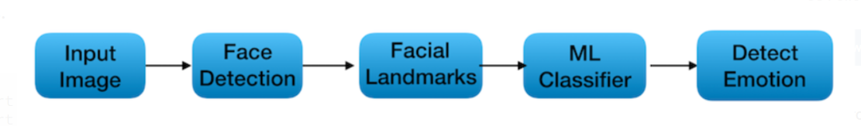

Fig. 1 Image Classification Process [3]

An upgraded model performs exceptionally well in the Emotion Detection module, effectively sorting faces into two unique categories: enhanced and non-enhanced faces. This skill comes from extensive training on a solid dataset. The model uses pre-trained models from a repository, focusing especially on the iBUG300-W dataset. With the use of this dataset, it is possible to determine 68 coordinate points (x, y) on a person's face, which results in a thorough map of their facial expressions as shown in Fig 2 [4].

These face coordinates are used by the Stress Detection Model to accurately determine stress levels. The right and left eyebrows' Euclidean distances must be determined for this computation. The approach expresses the stress level in exponential form and categorises individuals into two groups: those under stress and those not, based on this critical parameter. This creative approach's success depends on using DLib, an adaptable, free-and-open-source C++ library. Important features like networking, threading, and a wide range of machine learning techniques are all smoothly integrated into DLib. DLib greatly improves the precision and effectiveness of stress and emotion recognition with its features, which include viewpoint mapping into human faces and facial detection [4].

In conclusion, the ability of this all-inclusive technology to precisely identify stress levels and emotions in real-time is exceptional. Furthermore, it provides a useful and timely intervention, which is a crucial step forward in tackling the problems brought about by a world that is getting more and more stressed.

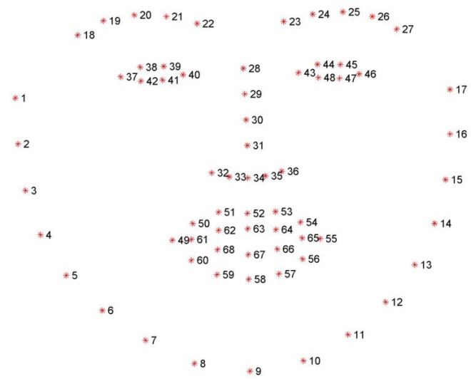

Fig. 2 Face Mapping [4]

# Literature Survey

This section elaborates the existing solutions with specific objectives identifed. The table 1 shows the results and findings of the work done by various researchers.

Table 1: Existing Systems

|  |  |  |
| --- | --- | --- |
| **Objective** | **Methodology** | **Data Source / Dataset** |
| Study and model emotion regulation processes for stress and anxiety management | Psychophysiological measures (e.g., heart rate, electrodermal activity), self-report questionnaires, behavioral observations | Experimentally collected data during emotionally evocative situations [5] |
| Estimate the prevalence and comorbidity of psychiatric disorders, including anxiety | DSM-IV criteria, structured interviews, questionnaires | Epidemiological surveys (e.g., National Comorbidity Survey Replication) [6] |
| Develop systems to recognize and respond to human emotions for stress and anxiety detection | Sensors, facial recognition, natural language processing | Audio-visual data (videos, speech recordings), textual data (e.g., social media), physiological data (facial expressions, voice modulation) [7] |
| Understand cognitive and motivational aspects of anxiety | Cognitive-behavioral therapy, self-report measures | Self-report measures (anxiety-related questionnaires), structured clinical interviews, observations in controlled experimental settings [8] |
| Analyze HRV to detect and manage stress and anxiety | Time domain and frequency domain analysis of HRV, biofeedback, and relaxation techniques | Electrocardiogram (ECG) recordings, wearable heart rate monitors, and biofeedback devices [9] |
| Detect emotional content in text for stress and anxiety assessment | Text processing, sentiment analysis, and machine learning techniques | Textual data from social media, online forums, and electronic health records [10] |
| Detect emotional states using EEG signals for stress and anxiety assessment | EEG signal processing, spectral analysis, and machine learning algorithms | EEG recordings from electrodes placed on the scalp during emotional tasks [11] |
| Develop algorithms using smartphone sensors for real-time stress detection | Accelerometers, gyroscopes, GPS data, and heart rate monitoring | Sensor data collected from smartphones (e.g., movement, location, and physiological measurements) [12] |
| Develop biofeedback systems for anxiety reduction | Biofeedback training, monitoring physiological parameters (e.g., heart rate, skin conductance) | Data recorded during biofeedback sessions with physiological sensors [13] |

# Methodology

The advanced system makes use of real-time video footage that was taken with the powerful and flexible cv2 module, a crucial component of the OpenCV library. When our Frontal Face Detector, deftly incorporated from the DLib library, recognizes faces in the video stream, magic starts to happen. This first phase prepares the audience for a complex dance between information and feelings.

With its ability to categorize and analyze emotions, the "mini_XCEPTION.1020.66.hdf5" model is a powerful instrument that skillfully handles the complexities of emotions. Our emotion recognition framework is based on this model, which provides real-time, high-precision results. After categorizing emotions, we examine the finer points of face expressions. Our technology follows the movements of the brows with great care, accurately distinguishing between the left and right ones. The so-called "facial landmarks" offer important clues about the emotional state of the subject [14] [15].

The computation of the Euclidean distance between the left and right eyebrows is the essential component of our approach as shown in Fig 3.

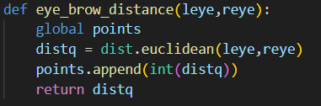

Fig. 3 Eucledian’s Distance

This measurement is an essential tool for assessing the level of stress that the person is displaying. Moreover, these measures are correlated with the emotions that were previously categorized, resulting in a thorough and all-encompassing evaluation of the subject's emotional health. The values undergo normalisation to provide the highest level of accuracy and comparability. In order to provide a consistent scale for measuring stress and emotions, normalisation is essential. This enables precise comparisons and tracking throughout time.

The system is essentially a symphony of state-of-the-art technology and well calibrated algorithms. It incorporates accurate stress level monitoring, emotion recognition, and real-time video analysis with ease. It is a complete solution that enables both professionals and individuals to better understand and manage stress and emotions in the demanding environment we live in today. It is not just a tool for gathering data. The methodology is shown in Fig 4.

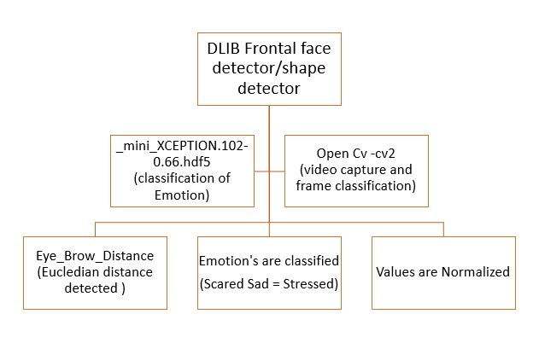

Fig. 4 Methodology

# Results & Discussions

A concise and enlightening notice indicating the subject's stress level will be shown clearly on the frame screen upon program execution. The purpose of this message is to clearly convey the person's emotional condition at the moment, distinguishing between "Stressed" and "Not Stressed". The program flow is shown in Fig 5.

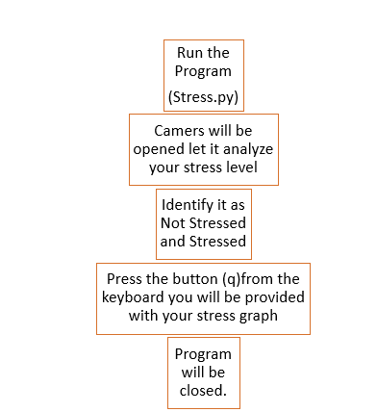

Fig. 5 Program Flow

In the event that the user has to end the program, there is a straightforward and understandable procedure they can follow. The frame screen can be quickly closed by hitting the 'q' key on the keyboard, which guarantees an easy and quick way to end the application.

The user will see a detailed graphical depiction of their stress levels after the program closes. This graph offers an insightful visual representation of their emotional state during the program's execution, revealing important information on stress dynamics.

By offering people a dependable and user-friendly tool for tracking and controlling their stress levels, this painstakingly created user experience hopes to facilitate a smooth transition from intelligent data visualization to real-time stress assessment. The results of the proposed work as categorized in stressed or not stressed. The Euclidian’s distance between two eyebrows is in normal range and mood is happy/normal as shown in Fig 6 and Fig 7. The Euclidian’s distance between the two eyebrows is really close and not in normal range and mood is angry/sad as shown in Fig 8 and Fig 9.

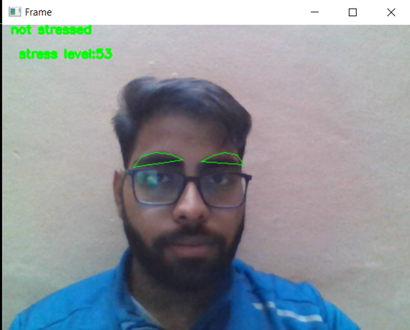

Fig. 6 Mood not stressed / normal

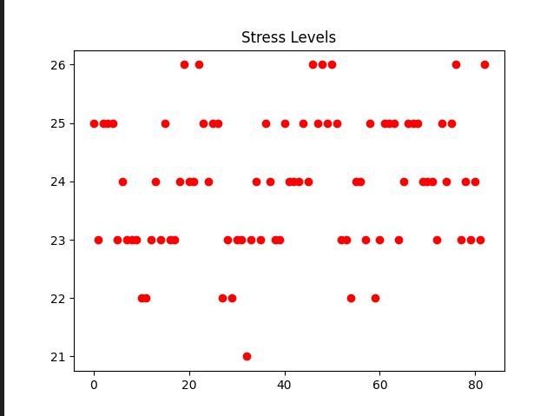

Fig. 7 Graph for Not Stressed Mood

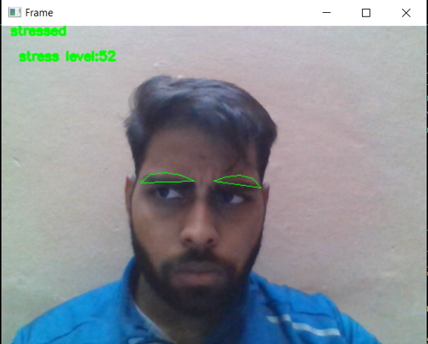

Fig. 8 Stressed Mood

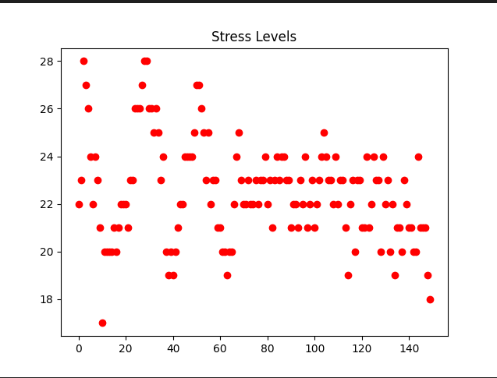

Fig. 9 Graph for Stressed Mood

# Conclusion And Future Work

This novel stress detection model offers a potent way to track a person's mental health in addition to offering an accurate way to gauge stress levels. This technology has several advantages, and its prospects for development in the future seem bright. The present features of the model pave the way for a host of upcoming advancements and enhancements, such as:

1. Lip Movement Analysis: Adding lip movement analysis to the model can improve its accuracy even more. Lip movement can give a more complete picture of a person's mental state by serving as a useful stress and emotion indicator.

2. Real-Time Image and Video Processing Synchronization: The responsiveness and general performance of the system can be greatly enhanced by achieving smooth real-time image and video processing synchronization. Stress assessments may become more precise and timely as a result of this synchronization.

3. Breathing Pattern Assessment: Another area of research is the integration of breathing pattern analysis. Breathing patterns and rates might provide important clues about a person's emotional state. This inclusion would provide a comprehensive evaluation of stress levels.

4. Integration with Various Wearable Devices: Linking the model to a variety of wearable gadgets could offer a more comprehensive understanding of a person's physiological reactions to stress. To generate a thorough stress profile, data from gadgets like skin conductance sensors, heart rate monitors, and EEG headsets can be synchronized.

These techniques and sources of data can all be combined and adjusted with the use of sophisticated mathematical models, possibly with the use of exponential functions. This would produce a more accurate and quantitative assessment of a person's stress level, taking into account a wide range of behavioral and physiological cues. Using a measure this extensive would provide priceless information about the subject's emotional state. These possible developments could have far-reaching effects that go beyond personal health. They could be useful in a variety of domains, such as workplace stress management, mental health diagnostics, and even improving human-computer interaction by allowing computers to react to people' emotions with empathy. To sum up, the current model is only the start of an exciting adventure in the field of stress and emotion detection. By incorporating these developments, we will be able to comprehend human emotions more comprehensively and improve both the general quality of life for people and society as a whole.

##### References

1. Cohen, S.; Kamarck, T.; Mermelstein, R. A Global Measure of Perceived Stress. J. Health Soc. Behav. 1983, 24, 385–396. [CrossRef] [PubMed]
2. Yogesh, C.; Hariharan, M.; Yuvaraj, R.; Ruzelita, N.; Adom, A.; Sazali, Y.; Kemal, P. Bispectral features and mean shift clustering for stress and emotion recognition from natural speech. Comput. Electr. Eng. 2017, 62, 676–C691.
3. Dupere, V.; Dion, E.; Harkness, K.; McCabe, J.; Thouin, É.; Parent, S. Adaptation and Validation of the Life Events and Difficulties Schedule for Use With High School Dropouts. J. Res. Adolesc. 2016, 27, 683–689. [CrossRef] [PubMed]
4. Lee, B.; Chung, W. Wearable Glove-Type Driver Stress Detection Using a Motion Sensor. IEEE ITSC 2017, 18, 1835–1844. [CrossRef]
5. Gross, J. J. (2008). Emotion regulation: Affective, cognitive, and social consequences. Psychophysiology, 45(2), 563-578.
6. Kessler, R. C., Chiu, W. T., Demler, O., & Walters, E. E. (2005). Prevalence, severity, and comorbidity of twelve-month DSM-IV disorders in the National Comorbidity Survey Replication (NCS-R). Archives of General Psychiatry, 62(6), 617-627.
7. Picard, R. W. (2000). Affective computing. MIT Press.
8. Mogg, K., & Bradley, B. P. (1998). A cognitive-motivational analysis of anxiety. Behaviour Research and Therapy, 36(9), 809-848.
9. Massaro, S., & Pecchia, L. (2019). Heart Rate Variability (HRV) Analysis: A Methodology for Organizational Neuroscience. Organizational Research Methods, 22(1), 354-393. https://doi.org/10.1177/1094428116681072
10. W. Y. Chong, B. Selvaretnam and L. -K. Soon, "Natural Language Processing for Sentiment Analysis: An Exploratory Analysis on Tweets," 2014 4th International Conference on Artificial Intelligence with Applications in Engineering and Technology, Kota Kinabalu, Malaysia, 2014, pp. 212-217, doi: 10.1109/ICAIET.2014.43.
11. M. Soleymani, S. Asghari-Esfeden, Y. Fu and M. Pantic, "Analysis of EEG Signals and Facial Expressions for Continuous Emotion Detection," in IEEE Transactions on Affective Computing, vol. 7, no. 1, pp. 17-28, 1 Jan.-March 2016, doi: 10.1109/TAFFC.2015.2436926.
12. K. Frank, P. Robertson, M. Gross and K. Wiesner, "Sensor-based identification of human stress levels," 2013 IEEE International Conference on Pervasive Computing and Communications Workshops (PERCOM Workshops), San Diego, CA, USA, 2013, pp. 127-132, doi: 10.1109/PerComW.2013.6529469
13. Pons P, Navas-Medrano S, Soler-Dominguez J. Extended reality for mental health: Current trends and future challenges. Frontiers in Computer Science 2022;4
14. Ciabattoni, L.; Ferracuti, F.; Longhi, S.; Pepa, L.; Romeo, L.; Verdini, F. Real-time mental stress detection based on smartwatch. In Proceedings of the 2017 IEEE International Conference on Consumer Electronics (ICCE), Las Vegas, NV, USA, 8–10 January 2017; pp. 110–111.
15. Han, H.; Byun, K.; Kang, H. A deep learning-based stress detection algorithm with speech signal. In Proceedings of the 2018 Workshop on Audio-Visual Scene Understanding for Immersive Multimedia, Seoul, Korea, 22–26 October 2018; pp. 11–15.