**MULTIMETER**:

As is obvious by its name a multimeter can measure multiple things i.e. Resistance, Voltage and Current- AC & DC.

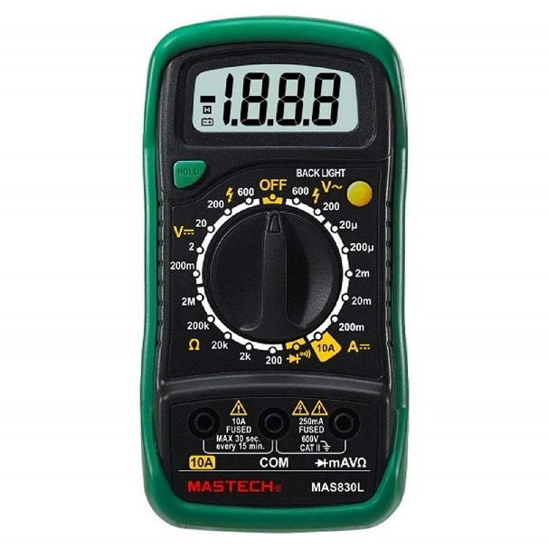

Figure MASTECH MAS830L

Usually powered by a 9V battery. One very important function of a multimeter is the **Continuity checker**. Higher quality multimeters also include Diode tester functionality.

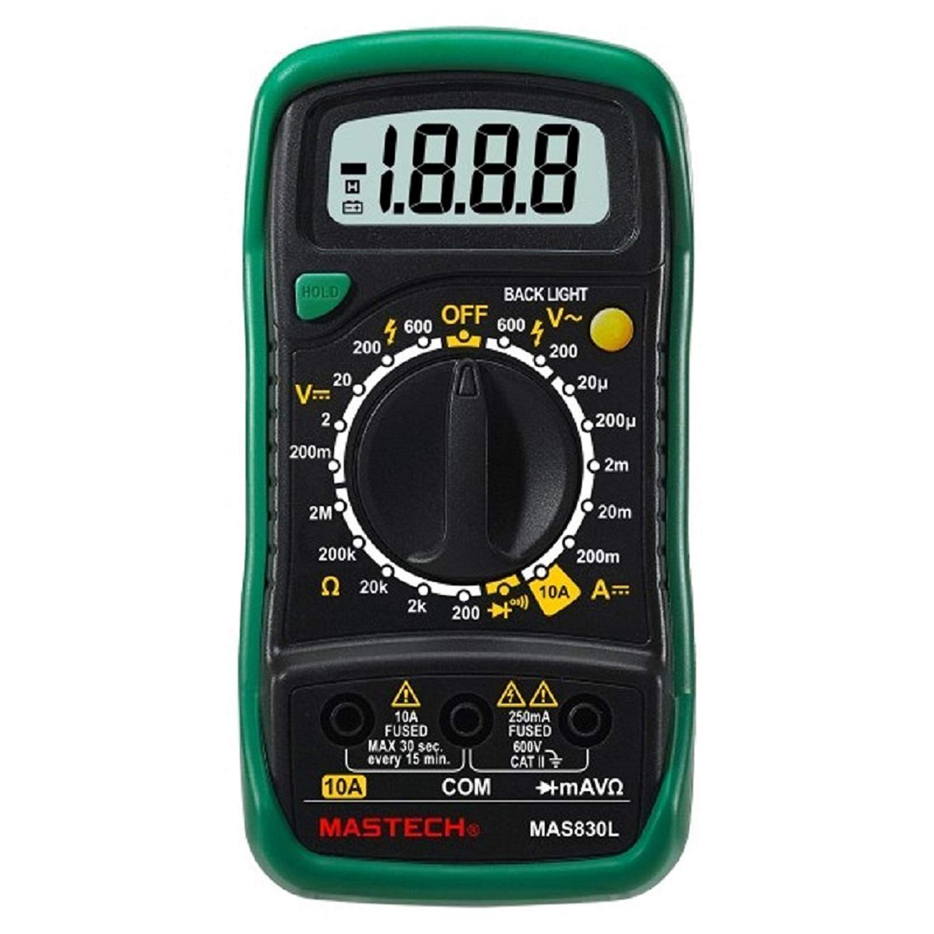

Figure 3 Probe ports of a multimeter

The COM port is common/ground port. The Black probe goes in here.

For measuring current upwards of 250mA to 10A, the red probe is inserted in the 10A port.

For measuring Voltage, Resistance, checking continuity or measuring current in the milliamp range(<250mA), the mAVΩ port is used.

They are readily available on Amazon and other ecommerce platforms as well as local hardware shops.

Cost around 500Rs for a good quality one.

**CLAMPMETER:**

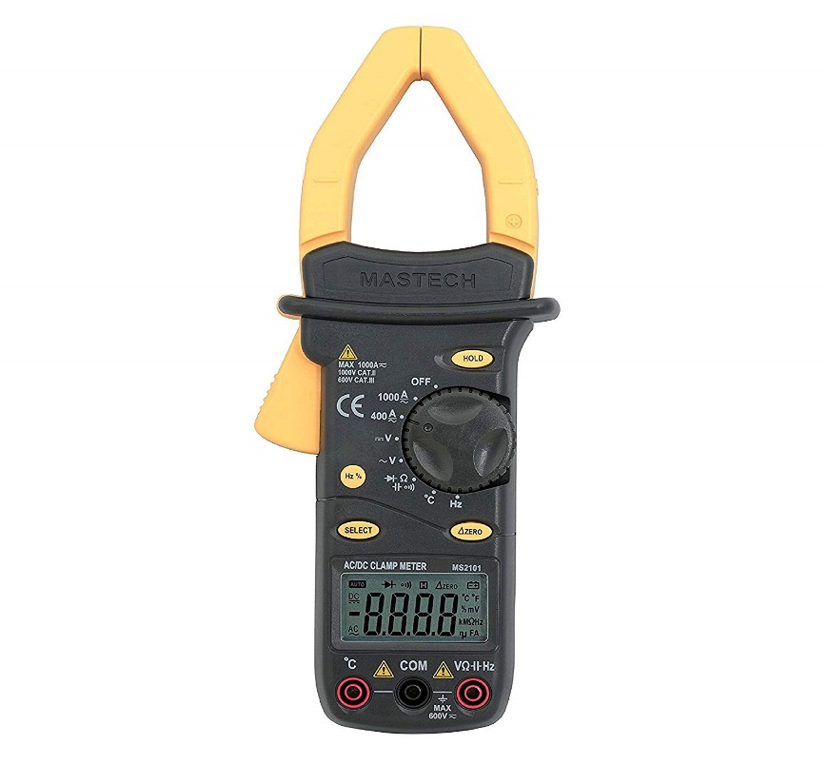a.k.a Current clamp/current meter.

Mastech MS2101 Digital AC/DC Clamp Meter

Depending on the model a clamp meter can perform almost all the functions of a multimeter, as well as **measure high values of current** (400-500A)

A clamp meter is generally not that useful for us as we generally do not deal with such high current in our projects. One more factor is that it costs quite a bit more compared to a multimeter.

Clamp meters are also readily available in local shops as well as ecommerce websites.

A good quality clamp meter can cost in the range of: 1000-4000Rs.

**OSCILLOSCOPE:**

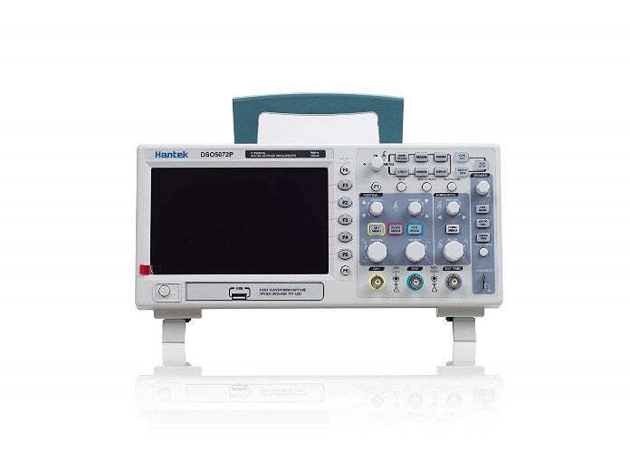CRO – Cathode Ray Oscilloscope

DSO – Digital Storage Oscilloscope

An oscilloscope is used to display and analyze the waveforms of electronic signals. Includes: Frequency, Duty cycle, Amplitude etc. It makes debugging a circuit easier and over all it is an essential for electronics.

It is an expensive device hence, smaller DIY oscilloscope kits are better for our purposes.

E.g.: [DIY Oscilloscope](https://www.amazon.in/REES52-Welded-Assembled-Oscilloscope-Digital/dp/B07KR74GF4/ref=sr_1_4?keywords=oscilloscope&qid=1564310922&s=industrial&sr=1-4) (Based on STM32)

**TACHOMETER:**

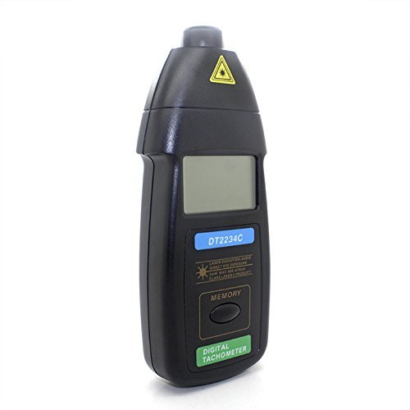

It is used to measure RPM.

A Laser Tachometer uses infrared light to measure the speed of rotation. The number of frequency changes per unit time gives the speed of rotation of the object.

This device can be used to ensure that the motors that we’re using are running @ the rated RPM.

It is available both online and in offline hardware shops. Price ranges from 1000-3000Rs.