Last year, Mayank bhaiya asked me if it was possible to generate variable duty cycle PWM signals without using Arduino.

After a little research I found that 555 Timer IC when wired in monostable mode, can be used to generate required signal.

Link to the proteus file: [link](https://drive.google.com/open?id=1e9lDVKv8bxxe696rn8WNHHqS1El0FUSI)

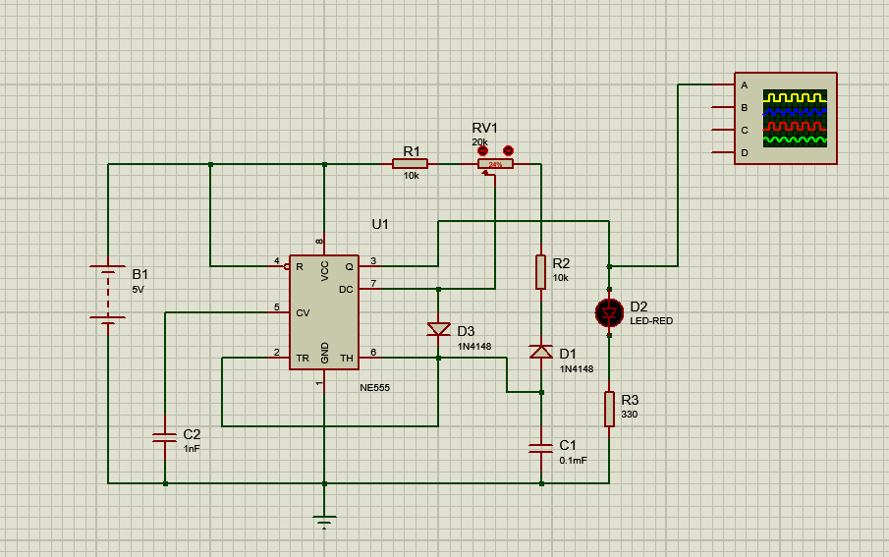

The **RV1 variable resistance** in the above circuit diagram can be used to vary the duty cycle of the signal.