Report---Coding ---Task4

Kirti Bhagat- electrical department

Array of LEDs showing Potentiometer output:

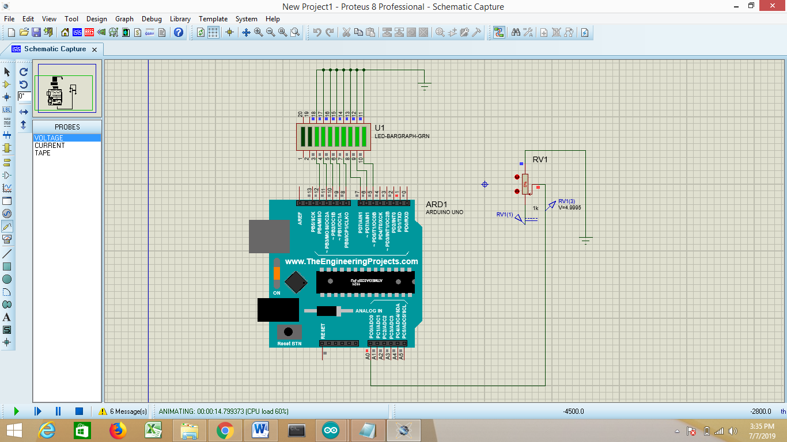 V=4.99

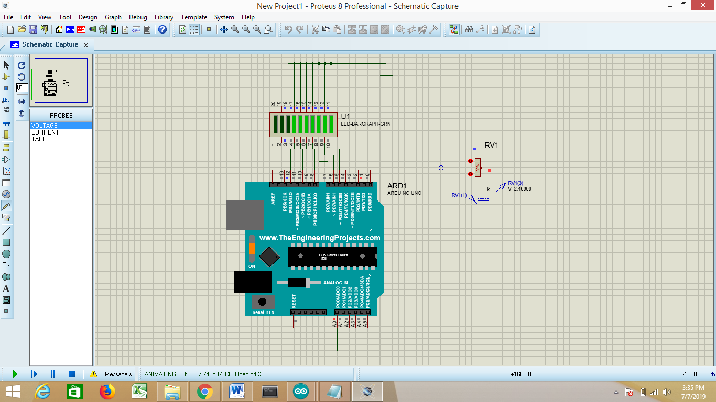V=2.499

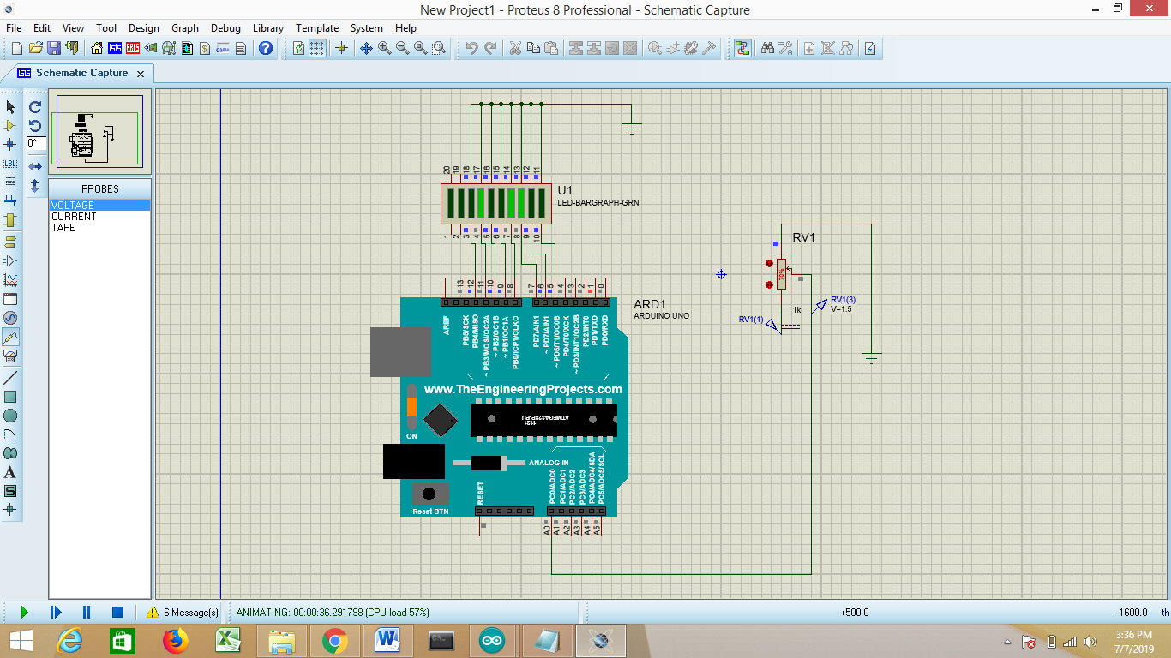 V=1.5

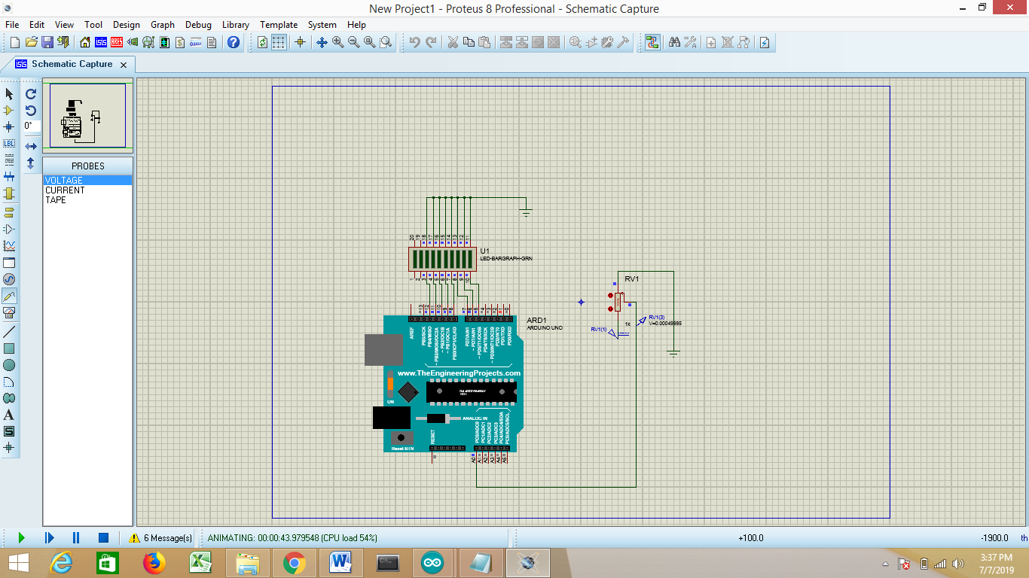V=0.004

Arduino code:

void setup() {

pinMode(5, OUTPUT);

pinMode(6, OUTPUT);

pinMode(7, OUTPUT);

pinMode(8, OUTPUT);

pinMode(9, OUTPUT);

pinMode(10, OUTPUT);

pinMode(11, OUTPUT);

pinMode(12, OUTPUT);

pinMode(A0,INPUT);

Serial.begin(9600);

}

void loop() {

int Value = analogRead(A0);

Value = map(Value, 0, 1023, 0, 255);

digitalWrite(5, (Value & 1));

digitalWrite(6, (Value & 2));

digitalWrite(7, (Value & 4));

digitalWrite(8, (Value & 8));

digitalWrite(9, (Value & 16));

digitalWrite(10, (Value & 32));

digitalWrite(11, (Value & 64));

digitalWrite(12, (Value & 128));

delay(100);

}

LCD Simulation:

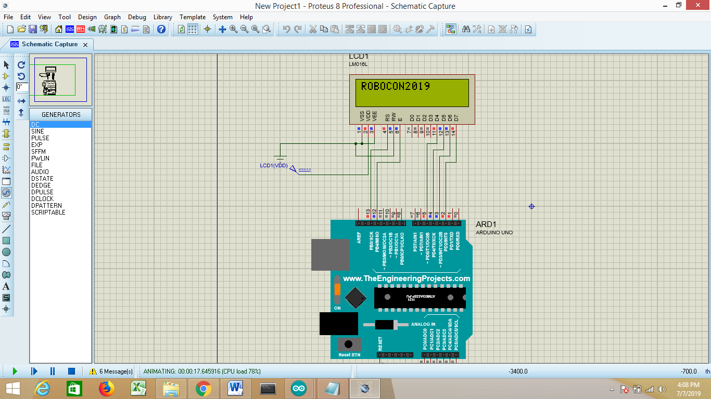

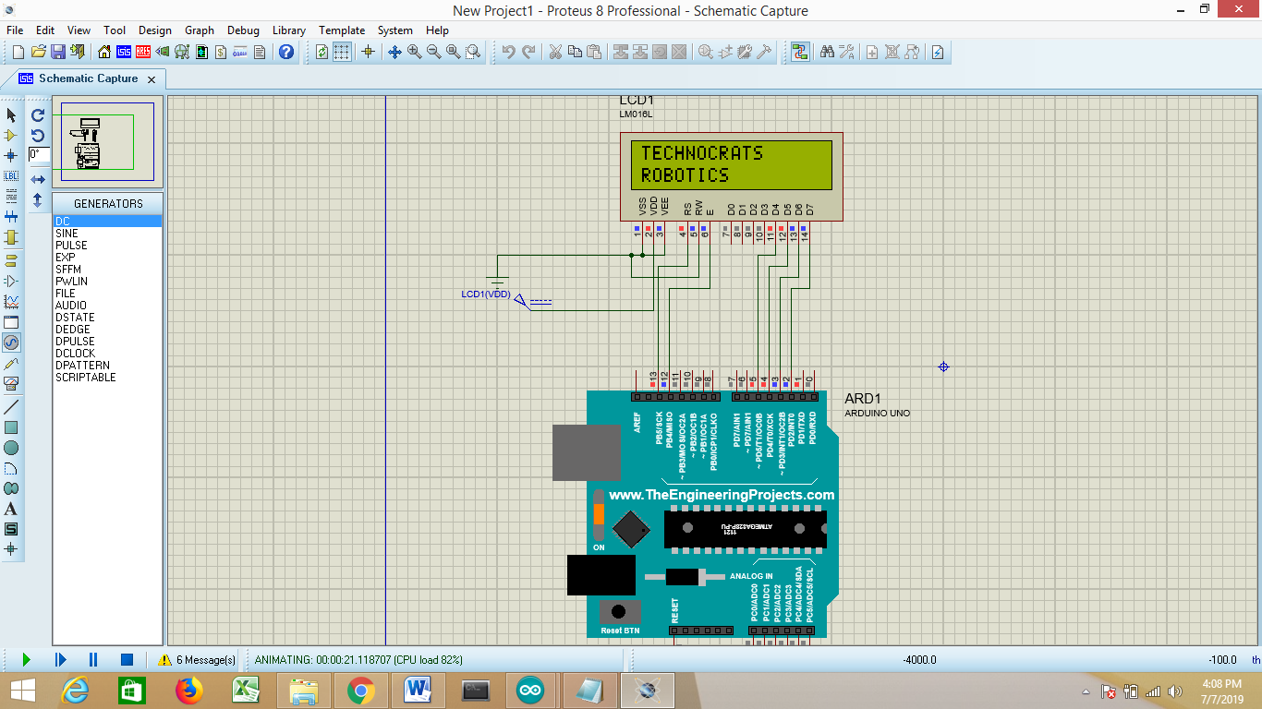

Arduino code:

#include<LiquidCrystal.h>

String word1="TECHNOCRATS";

String word2="ROBOTICS";

String word3="ROBOCON2019";

LiquidCrystal lcd(13,12,5,4,3,2);

void setup()

{

Serial.begin(9600);

lcd.begin(16,2);

lcd.setCursor(0,0);

}

void loop()

{

lcd.clear();

lcd.setCursor(0,0);

lcd.print(word1);

lcd.setCursor(0,1);

lcd.print(word2);

delay(5000);

lcd.clear();

lcd.setCursor(0,0);

lcd.print(word3);

delay(5000);

}