

Summer Vacation Task

By Shreya Sandilya

17BEE1159

UART:

UART stands for universal asynchronous receiver and transmitter. UART or serial communication allows two devices to communicate any data back and forth, and this communication is done over wires.

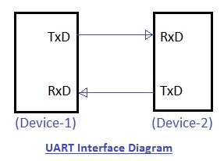

The UART take bytes of data and send the individual bits in sequential manner. It is important if you would like to interface with a PC or other UART enabled devices to trade information. One of the best things about UART is that it only uses two wires to transmit data between devices.

I2C:

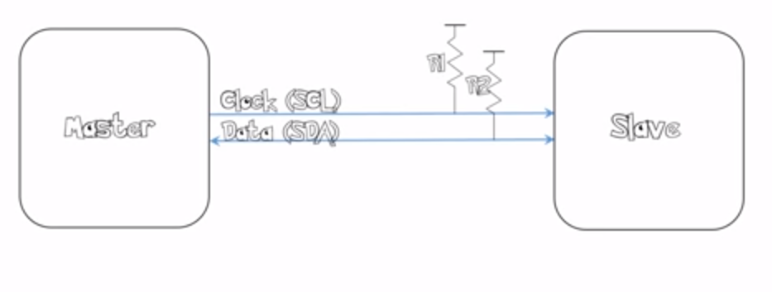I2C stands for inter integrated circuit. It is a master to slave communication protocol. I2C requires two wires SDA (serial data line) and SCL (serial clock line) to carry information between devices. R1 and R2 are just pull up resistance.

The benefit with I2c is that the data can be sent over to thousands of slaves by a single master.

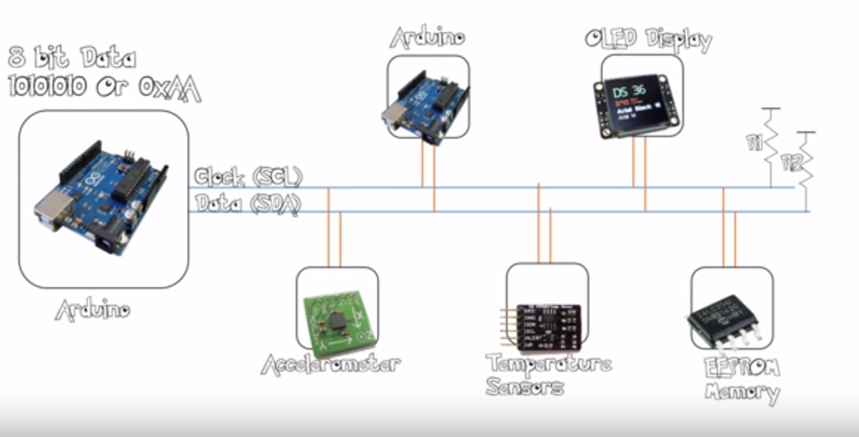

SPI:

SPI stands for serial peripheral interface. It requires four wires MOSI, MISO, SS, and SCLK.SPI protocol used to communicate the master and slave devices.

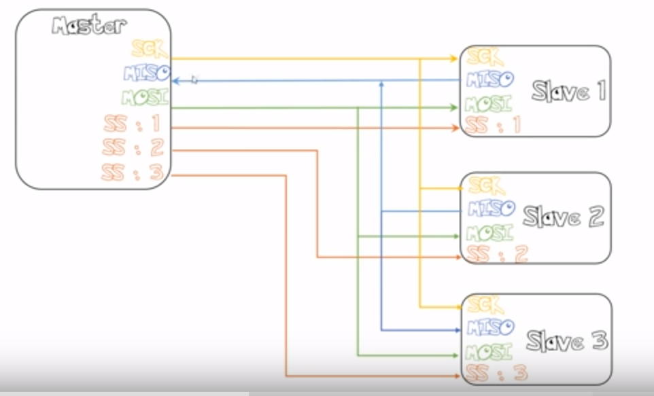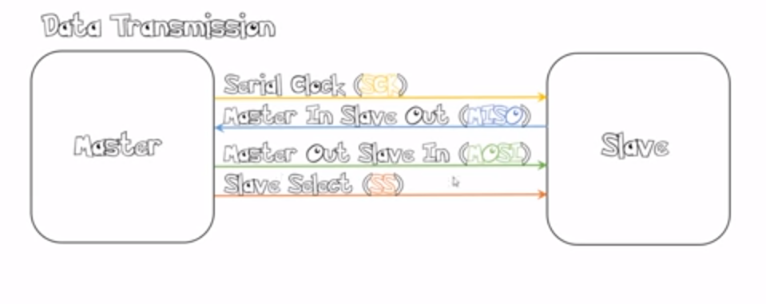

Unlike the I2C protocol, here if the number of slaves are increased we have to increase the number of slave select (as shown in the image).

Now its advantages over UART and I@C is that the speed is higher, also its power requirement is lesser.

And it can again manage to send date to more than one slave.

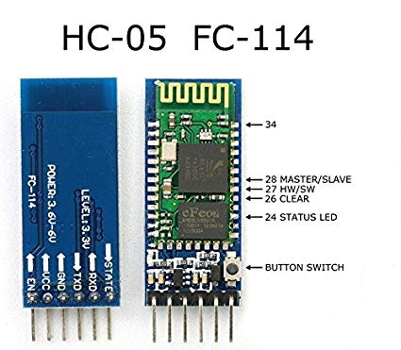BLUETOOTH:

Bluetooth is a **standardized protocol** for sending and receiving data via a 2.4GHz wireless link. It's a secure protocol, and it's perfect for short-range, low-power, low-cost, wireless transmissions between electronic devices.

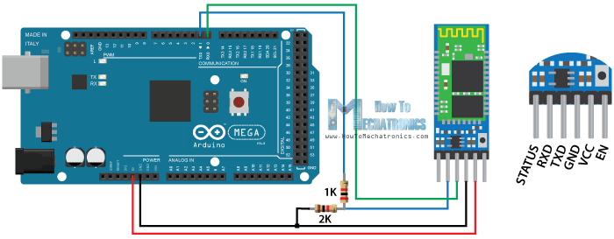Most commonly used Bluetooth module is HC-05 model;

Connection of HC05 with Arduino:

RF:

RF or radio frequency signal refers to a wireless electromagnetic signal used as a form of communication. RF communication is used in many industries including television broadcasting, radar systems, computer and mobile platform networks, remote control, remote metering/monitoring, and many more.

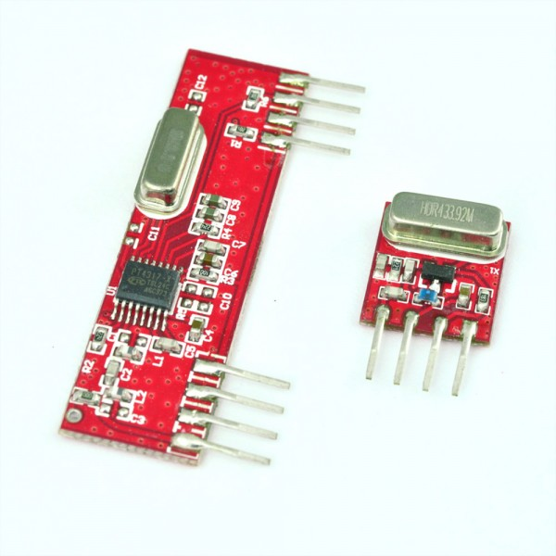RF modules corresponds to frequency range 30KHz to 300GHz. Transmission through RF is better than IR (infrared).

This **RF module** comprises of an**RF Transmitter**and an **RF Receiver**. The transmitter/receiver (Tx/Rx) pair operates at a frequency of **433 MHz**. The transmitted data is received by an RF receiver operating at the same frequency as that of the transmitter.

The module shown here is 433MHz model.

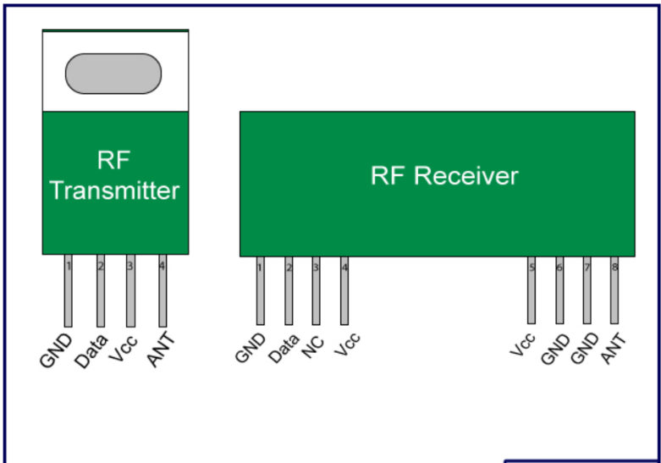

Pin configuration of the module:

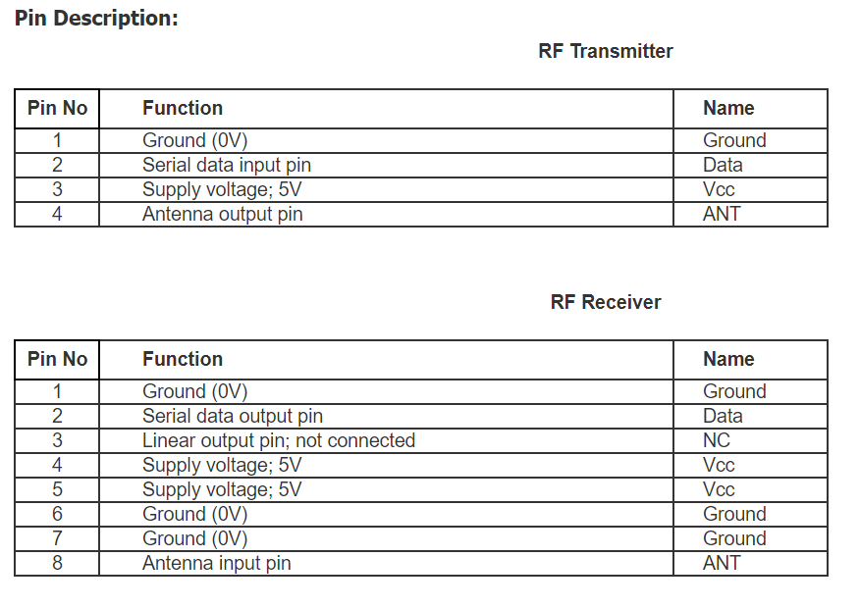

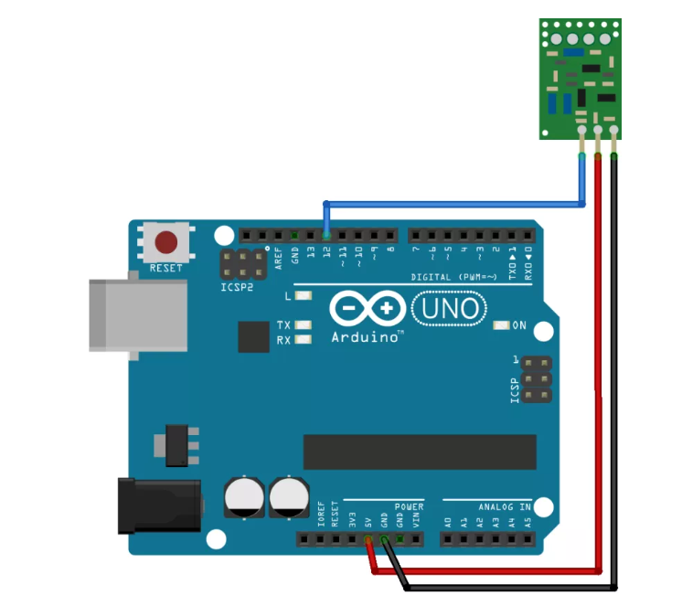

Connection of RF transmitter with Arduino:

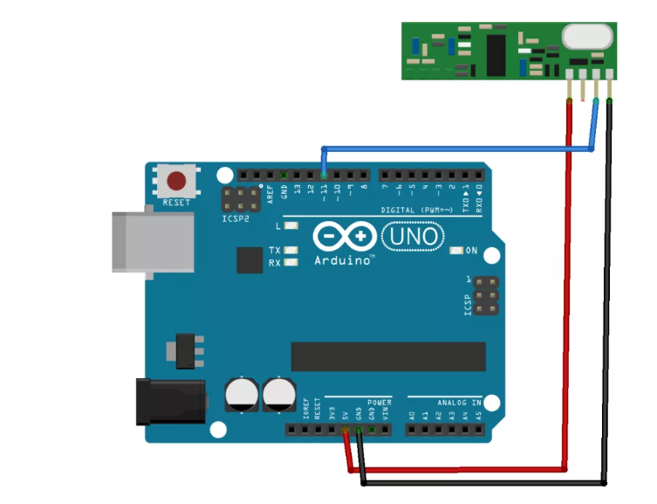

Connection of RF receiver with Arduino:

LORA:

LoRa is the wireless modulation scheme utilized to create long distance communication link.The biggest advantage of LoRa over other communication technology is its long-range capability. LoRa is developed to provide IoT devices extended battery life in the range of several years at the same time a LoRa network has extended range and is cost effective to deploy.

LoRa Advantages:

1. Better battery life
2. Long range
3. Cost effective for large deployment

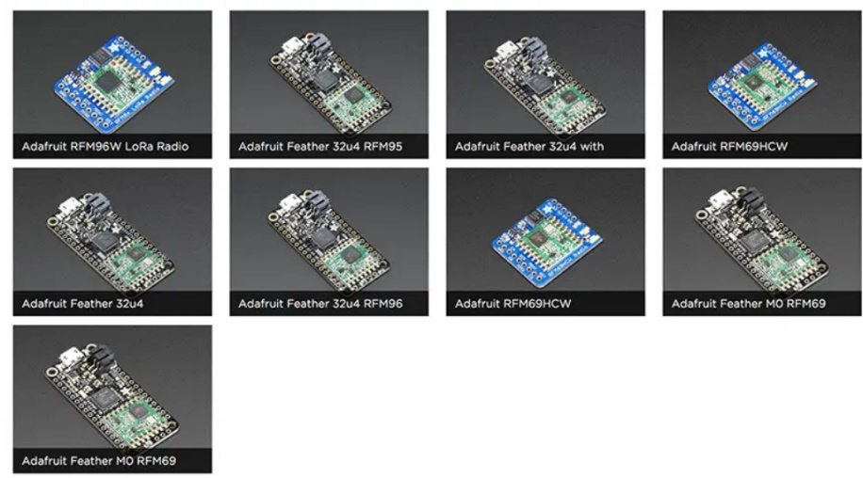Semtech corporation is the leader in LoRa wireless technology and as such have introduced a number of LoRa RF modules for the market. In particular, the SX127x family of RF transceivers for the IoT/M2M markets.

These RF modules operated between 860-1000 MHz and 137-960MHz. Semtech also offer evaluation and testing devices at 860MHz band.

Adafruit has introduced a number of breakout boards and development boards based around the Semtech RFM69 and RFM95 modules for a range of frequencies such as 433, 868 and 960 MHz.

PS2 CONTROLLER:

The standard PS2 controller has 15 buttons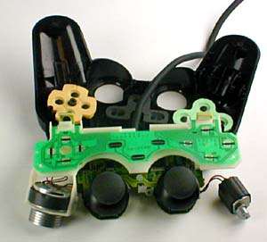. All of them, except for Analog, Start and Select are analog. These are:

* four buttons arranged as a directional pad on the top left
* Analog, Start and Select buttons in the top middle
* four action buttons on the top right
* two action buttons on the front left
* two action buttons on the front right
* one analog joystick on the top left
* one analog joystick on the top right

Each button has a tiny curved disk attached to its bottom. This disk is very conductive. When the button is depressed, the disk is pushed against a thin conductive strip mounted on the controller's circuit board. As the button is pressed harder, more of the disk comes into contact with the strip, gradually increasing the level of conductivity. This varying degree of conductivity makes the buttons pressure-sensitive. Two potentiometers, variable resistors, are positioned at right angles to each other below the joystick. Current flows constantly through each one, but the amount of current is determined by the amount of resistance. Resistance is increased or decreased based on the position of the joystick. By monitoring the output of each potentiometer, the PS2 can determine the exact angle at which the joystick is being held, and trigger the appropriate response.