

Summer Vacation Task

By Shreya Sandilya

17BEE1159

Multimeters:

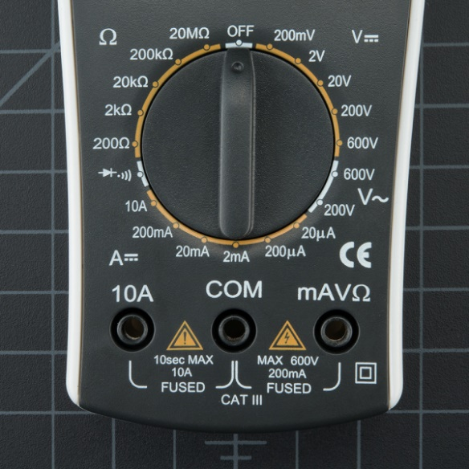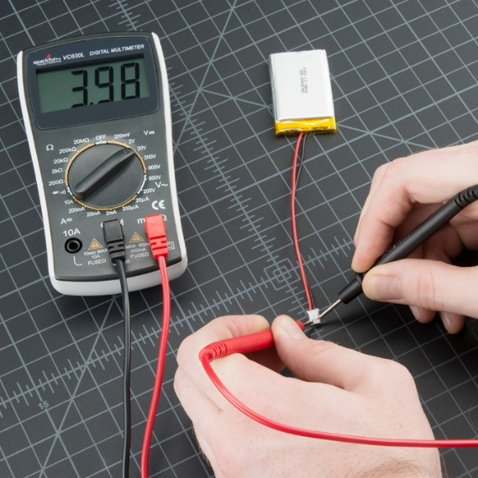

Using a multimeter we can calculate DC voltage, AC voltage, Current, Resistance. Check continuity.

The multimeter is provided with 3 terminals.

The black probe is always connected to the COM, and the red one is connected to the one value that needs to be measured. Different set of ranges are provided in the multimeter to accurately measure the quantity by the multimeter.

*Few precautions we should take while using a digital multimeter is:*

1. Make sure you never apply any input that is more than the maximum allowable quantity of the selected range.

2. Make sure that you connect the terminals to the right place. Also, make sure the probes are connected properly to the circuit.

3. Also, make sure that the power is given to the digital multimeter.

*Steps to measure a quantity with a digital multimeter:*

1. Set the power ON.

2. Move the range selector to the proper DC/AC Voltage, or current, or resistance.

3. i. For DC/AC voltage connect the terminals in parallel with the circuit.

ii. For current measurements connect the terminals in series with the circuit. This, can be done by connecting the black probe to low potential side and red probe to high to high potential side.

iii. For resistance measurement connect the probes across the resistor to be measured.

4. Pay attention to the position of the decimal point while taking the reading.

*Where to buy one from?*

Online many models like*, Meco DMM63, Fluke* etc.

Some links are:

<https://www.amazon.in/s?k=digital+multimeter+fluke&adgrpid=57811516286&gclid=CjwKCAjwza_mBRBTEiwASDWVvicrF27KIDJ7mIfj2ZG9YdJwQdW9lWfWOVXQ4Hs5OmhYay73n5mgXhoCwggQAvD_BwE&hvadid=294101089611&hvdev=c&hvlocphy=9061848&hvnetw=g&hvpos=1t1&hvqmt=b&hvrand=4578451933784010040&hvtargid=kwd-324423742&hydadcr=9249_1781366&tag=googinhydr1-21&ref=pd_sl_51zxkanhh7_b>

<https://www.flipkart.com/marshal-ms-11-digital-multimeter/p/itmfyabzhb3edzzv?gclid=CjwKCAjwza_mBRBTEiwASDWVvp7NRjV_w4ZIFX3yd4SesBmWUrD3HKgfLY-lXfqpQ9UGwhyW2aITbBoCMwYQAvD_BwE&pid=MTMFYABZHGCVNSMZ&lid=LSTMTMFYABZHGCVNSMZFHP9NL&marketplace=FLIPKART&cmpid=content_multimeter_8965229628_gmc_pla&tgi=sem,1,G,11214002,g,search,,161598646720,1o2,,,c,,,,,,,&ef_id=CjwKCAjwza_mBRBTEiwASDWVvp7NRjV_w4ZIFX3yd4SesBmWUrD3HKgfLY-lXfqpQ9UGwhyW2aITbBoCMwYQAvD_BwE:G:s&s_kwcid=AL!739!3!161598646720!!!g!306379101530!>

For offline dealers, some dealer’s contacts are listed below:

<https://www.justdial.com/Chennai/Digital-Multimeter-Dealers/nct-10162375>

orders can be placed on phone and the respective store will deliver the components on the main gate.

Clamp meter:

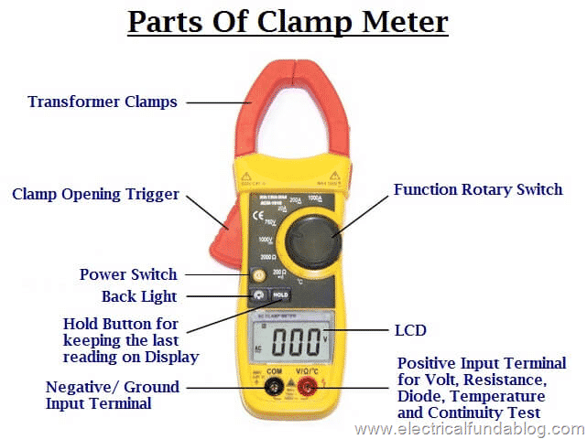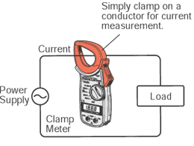

A clamp meter is an electrical tester that combines a basic digital multimeter with a current sensor. Clamps measure current. Probes measure voltage. Having a hinged “clamp” jaw integrated into an electrical meter allows users to simply clamp around wire, cables and other conductors at any point in the electrical system and measure its current, without disconnecting it.

Why are they becoming more popular nowadays is because due to this new clamp method, to measure the current there is no need of physical connection between the probes and the measuring material. The clamp has to be placed just around the current carrying wire and without any physical contact or any disturbance to the circuit the current can be measured. Also during the process of measurement the circuit doesn’t need to be switched off or anything, which is somewhat efficient compared to other methods.

*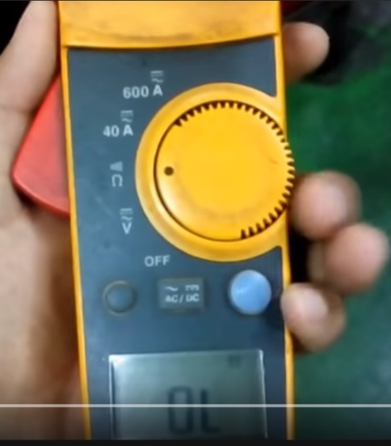How to use a clamp meter?*

We’ll use a clamp meter to measure the AC/DC voltage and current in a circuit and also measure the continuity of the circuit.

The particular clamp meter shown here can be used to measure AC/DC Voltage, Continuity and resistance, and AC/DC current of range 40, 600A.

1. First switch on the device.

2. Open the Clamp and wrap it around the conductor carrying current.

3. The digital display will display the current, make sure to apply the suitable range.

4. For measurement of voltage connect the probes, black one to COM and red one to V terminal. Connect/touch the terminals at the points across which you want to measure the voltage. The knob should be turned to the voltage range.

5. For resistance turn the knob to resistance and continuity, in the same position as that of voltage the digital display will give resistance value. If the resistance is lower than a certain value, that is if it is almost negligible the meter just beeps to show the continuity in the circuit.

*Where to buy one from?*

Offline stores contacts:

<https://www.justdial.com/Chennai/Digital-Clamp-Meter-Dealers/nct-10162109>

online store:

<https://dir.indiamart.com/chennai/digital-clamp-meter.html>

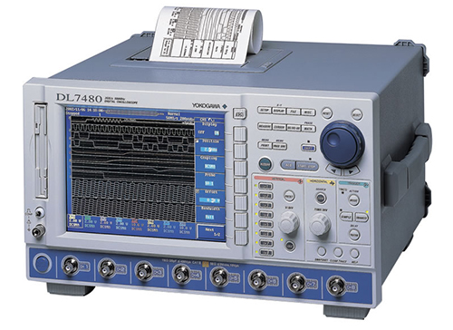Digital Storage Oscilloscope (DSO):

An oscilloscope is a laboratory instrument commonly used to display and analyze the waveform of electronic signals. In effect, the device draws a graph of the instantaneous signal voltage as a function of time.  DSO, is a type of [electronic test instrument](https://en.m.wikipedia.org/wiki/Electronic_test_instrument) that graphically displays varying signal [voltages](https://en.m.wikipedia.org/wiki/Voltage), usually as a two-dimensional plot of one or more signals as a function of time. In our college also we use this is many laboratories.

The DSO can measure the following time based and voltage based characteristics:

1. Time based:

* Frequency and period
* Duty cycle
* Rise and fall time

2. Voltage based:

* Amplitude
* Maximum and minimum voltages
* Average and mean voltages

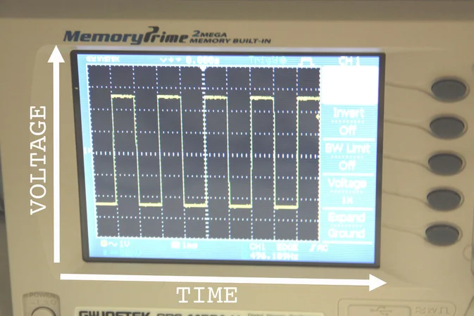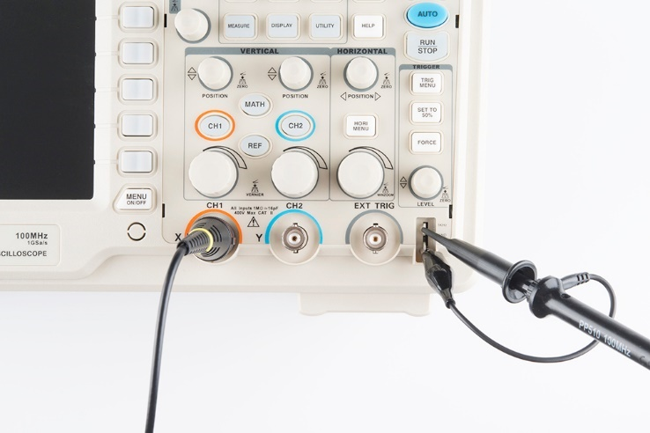*How to use it?*

First we have to connect the probes to the CH1, if there are two output waves to be measured the CH2 will also be utilised. After attaching the probes take the terminals of the probe and attach the red, black terminals to positive and negative terminal of the output respectively.

Then switch on the DSO.

The output wave form will appear. But to take the required readings we have to move the cursors to required position. This can be done by the switches provided for vertical and horizontal movement.

Press the vertical movement and then with use of the buttons cursor 1 and 2 adjust the cursors to take the required measurements. Similarly adjust the horizontal cursors.

After doing that press the measure button available on the panel. By pressing that some values will appear on the side of the screen display. There you’ll get the mean/average/rms voltage.

You can change the type by pressing the type button available on the panel.

Note down the time based characteristics and voltage based characteristics.

You can also save the wave form by attaching a pendrive in the slot provided.

Sometimes it happens that the DSO maybe faulty, that can be checked by attaching the ends of the probe in the hook kind of thing provided (shown in the first figure). If a square wave appears then the DSO is working just fine.

*Where to buy one from?*

The DSO used in the college is also from the brand Tektronix. The link is given below:

<https://www.tektronixindia.com/digital-oscilloscope>

Online platform for buying DSO:

<https://dir.indiamart.com/chennai/digital-oscilloscope.html>

Some offline traders of DSO in Chennai:

<https://www.tradeindia.com/chennai/digital-oscilloscope-city-187278.html>

<https://www.justdial.com/Chennai/Oscilloscope-Dealers/nct-10345274>

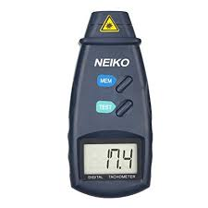Tachometer :

Tachometers measure rotational speed, and indicates the speed of a rotating object. Power, accuracy, RPM range, measurements and display are the specifications of a tachometer. Tachometers can be analog or digital indicating meters.

Since the tachometer measure rotational speed, which is particularly valuable for robot building. The speed of the motors determines the speed of the robot. Before building an entire robot around a pair of motors, you want to know how fast the motor shaft turns at the highest and lowest voltages supplied throughout the life of the battery.

*How to use a tachometer?*

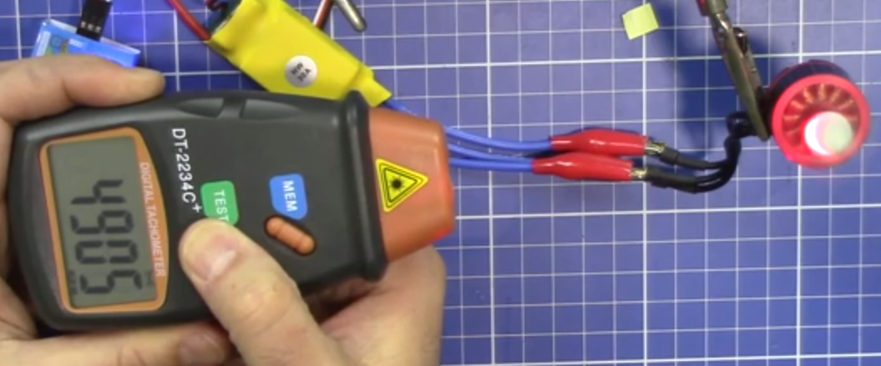

The tachometer have two buttons one is test and another one is memory.

If we press the test button and point the front of the tachometer from which the light comes out towards the rotating machine, the device will start calculating the speed in RPM.

After doing this if we press the memory button we’ll get the value back.

This only works till we’re pressing the button.

*Where to buy one from?*

Online store:

<https://dir.indiamart.com/chennai/digital-tachometer.html>

Contacts of some offline dealers:

<https://www.justdial.com/Chennai/Digital-Tachometer-Dealers>