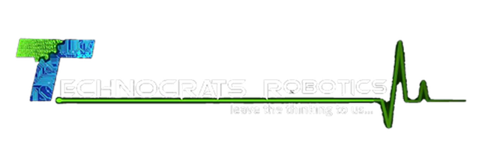

Summer Vacation Task

By Shreya Sandilya

17BEE1159

Line Sensors:

LSA08-

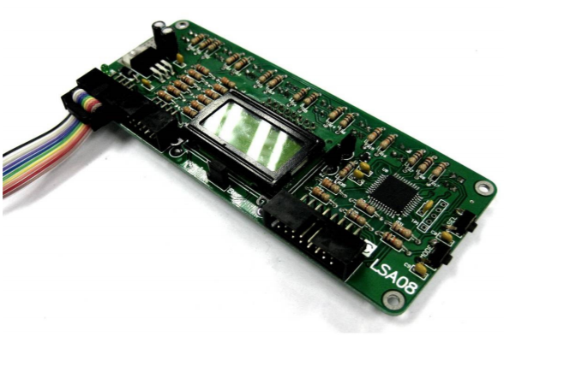LSA08 (Advance Line Following Sensor Bar) consist of 8 IR transmitter and IR receiver pairs. LSA08 is typically used for embedded system or robots for line following task. LSA08 is capable to operate on surface with colour of Red, Green, Blue, White, Black, Gray and other possibly colours.

Some advantage of LSA over IR sensors are:

* LSA08 has low current consumption, typically around 26mA.
* Power polarity protection on LSA08 prevents damage by applying reversed voltage.
* LSA08 provides multiple interface methods, namely serial (UART), analog output and direct digital outputs (parallel output).
* LSA08 has total of 8 sensors spaced at 16mm. This minimizes the user effort of setup the sensor system for the line following robot.
* LSA08 has LCD which displays the sensors and line information.
* LSA08 also has setting buttons (SEL and MODE) which enables instant setting up of LSA08. Auto calibration feature of LSA08 calibrates the sensors to the line and background surface easily.
* LSA08 with special selected transmitters and receivers sensor is capable to work on reflective or glossy surface which is difficult to normal infrared (IR) sensor.

Parts of LSA08:

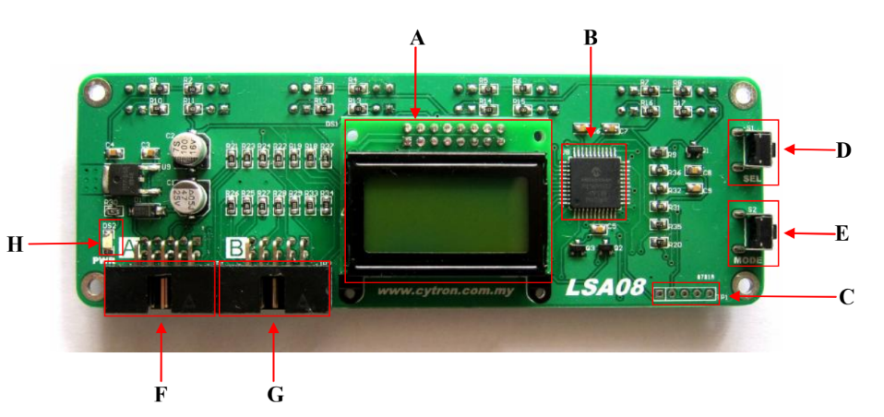

A – 2x8 LCD unit to display the line information and setting menus.

B – Main controller for data processing.

C – Reserved for Manufacturing purpose. D – SEL button is used to enter the selected mode or setting.

E – MODE button is used to select mode or setting.

F – Port A is UART and Analog port

G – Port B is digital parallel output port

H – Power indicator LED (green) for indication of power supplied to LSA08.

Available modes in the LSA08:

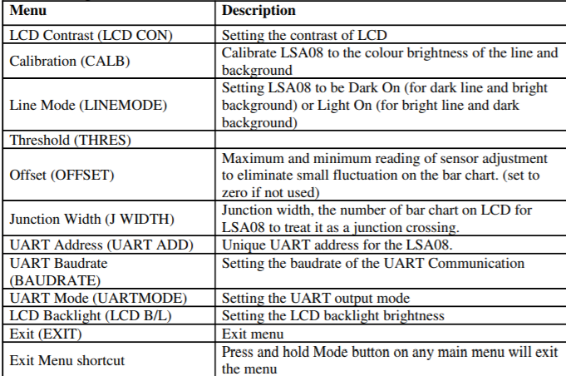

Now since the LSA08 works in 3 different modes, there are three different connections for each of the modes. The connection of these different modes is given. A pictorial representation with SK40C

( a basic microcontroller). Similar connections can be done with Arduino, or any microcontroller available with you.

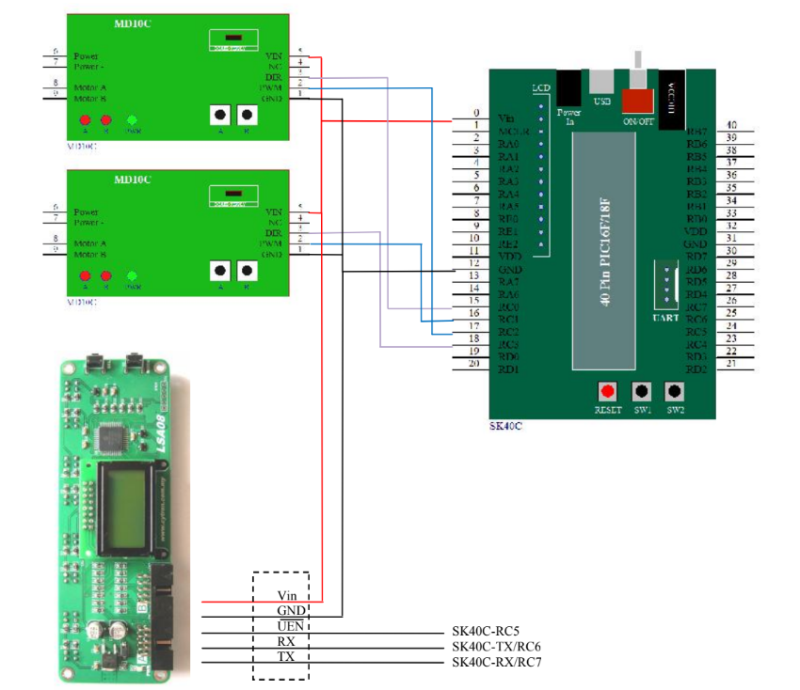UART MODE:

Here two MD10C are attached, to illustrate the whole circuit for a line following robot.

Here as you can see Port A is used in UART mode.

RX, TX of the port is attached to the respective RX, TX of the micro controller.

UART output enable pin to any digital pin.

And the Vin and GND to Vin and GND of the micro controller.

ANALOG MODE:

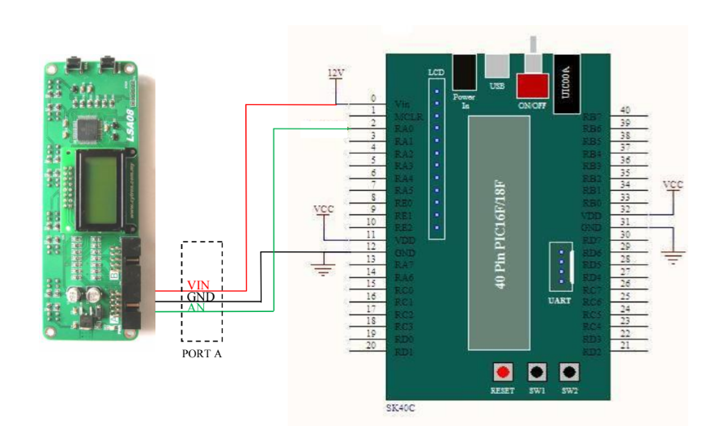As shown in the figure, the analog output pin is connected to the analog pin of the micro controller.

And the Vin and GND to Vin and GND of the micro controller.

DIGITAL MODE:

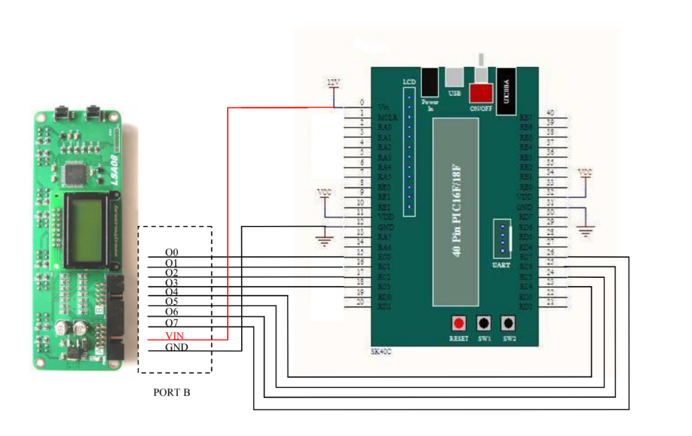The 8 pins of the Port B is connected to 8 digital pins of the micro controller.

And the Vin and GND to Vin and GND of the micro controller.

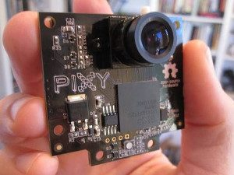PIXY CAMERA-

Image sensors are useful because they are so flexible. With the right algorithm, an image sensor can sense or detect practically anything.

But there are two drawbacks with image sensors:

* They output lots of data, dozens of megabytes per second
* Processing this amount of data can overwhelm many processors

Pixy addresses these problems by pairing a powerful dedicated processor with the image sensor.

Pixy processes images from the image sensor and only sends the useful information to your microcontroller.

The information is available through one of several interfaces: UART serial, SPI, I2C, digital out, or analog out. So, the Arduino or other microcontroller can talk easily with Pixy and still have plenty of CPU available for other tasks.

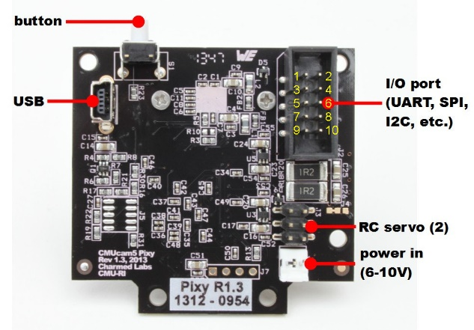

Pins of the Pixy Cam:

Connection of Pixy Cam with Arduino:

Pixy comes with a special cable to plug directly into an Arduino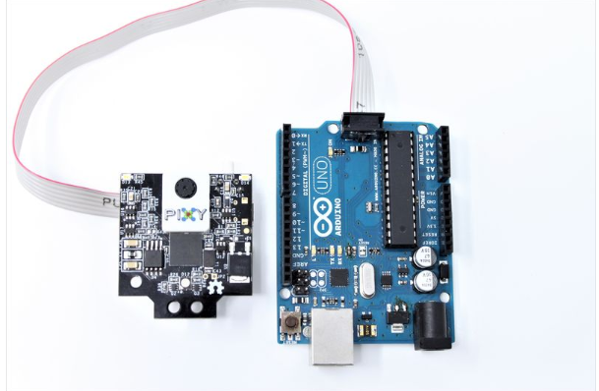.

Servo Driver Modules:

16 channel PCA9685-

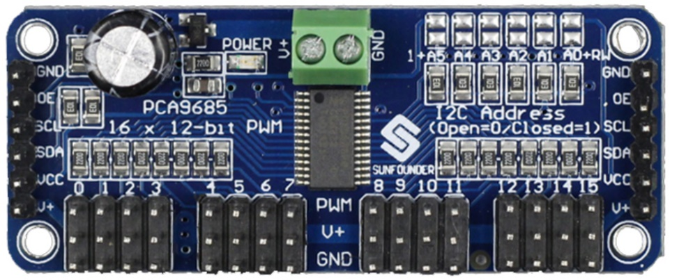The PCA9685 is a 16-channel I2C-bus controlled LED controller optimized for Red/Green/Blue/Amber (RGBA) colour backlighting applications. Each LED output has individual 12-bit resolution (4096 steps) PWM controller with a fixed frequency. The controller operates at a programmable frequency from a typical 24 Hz to 1526 Hz with a duty cycle that is adjustable from 0% to 100% so the LED can be set to output a specific brightness. All outputs are set to the same PWM frequency.  
With the PCA9685 as the master chip, the 16-channel 12-bit PWM Servo Driver only needs 2 pins to control 16 servos, thus greatly reducing the occupant I/Os. Moreover, it can be connected to 62 driver boards at most in a cascade way, which means it will be able to control 992 servos in total.

Connection of the module with Arduino and servo: 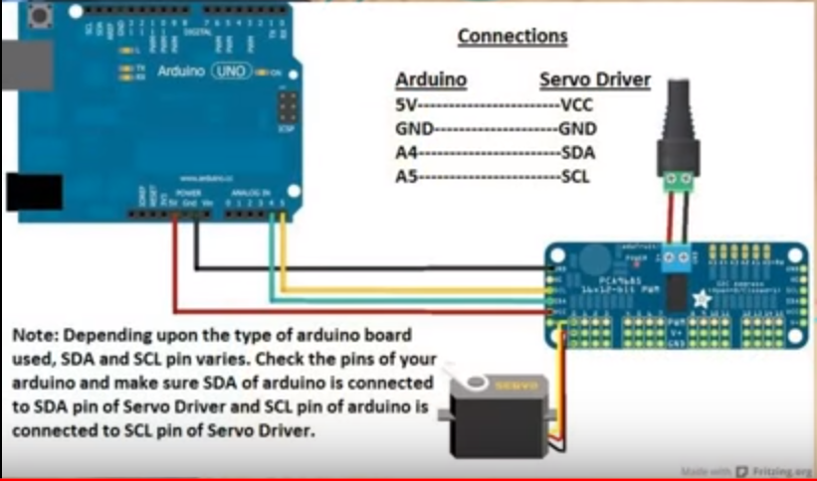

* Vcc of the module is connected to the arduino’s 5V pin.
* GND of the module is connected to the gnd of the Arduino borad.
* SDA and SCL to any analog pin of Arduino board
* The screw connectors are connected to an external 5V supply to supply all the 16 servos.
* The pins provided are where the servo is connected.

Cytron SC16A-

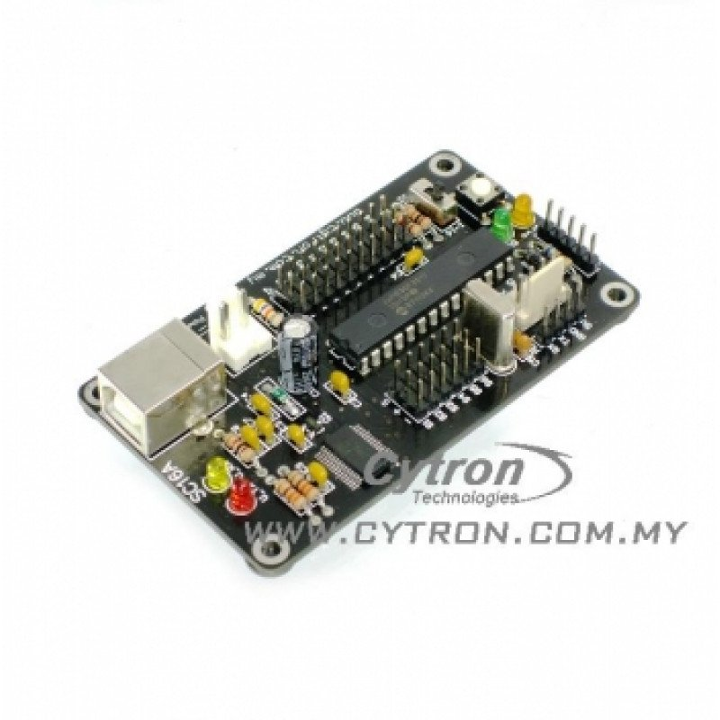

SC16A offers to control 16 independent standard RC (Remote Control) servo motors simultaneously in a single board. Each servo signal pin is able to generate servo pulses from 0.5 ms to 2.5 ms, which is greater than the range of most servos, further allows for servos to operate 180 degrees. Through serial communication, SC16A can be daisy chain in 2 boards to offer independent control over 32 RC servo motors simultaneously. The host of SC16A can either be a PC desktop, Laptop with USB port, or microcontroller with UART interface. Both USB and UART interface present a flexible, fast and easy to use feature.

Features of SC16A:

• 16 channels: Servo driven independently

• Extendable to 32 Channels: Two controller linked together to drive 32 servos

• Optional Position Reporting: User may request position of an individual servo

• Optional Servo Ramping: Choose one of 63 ramp rate (speed rate) for each servo

• Sample GUI for computer*: User may control the servo via sample GUI software

• Resolution: 1.367us

• UART: 9600 baud rate

• Servo pulse: 0.5ms to 2.5ms

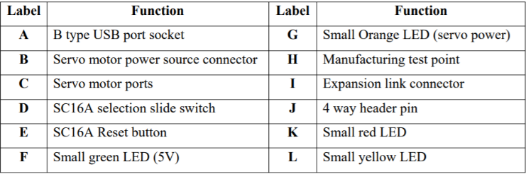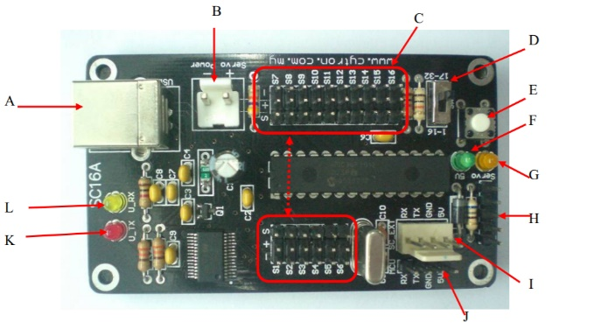

A - is for USB connection to PC desktop or laptop; B – is 2 way 3961 connector for servo motor power source.

C – are 16 servo motor ports; D – is a slide switch to configure SC16A for expansion mode.

E – is Reset button for SC16A.; F – is a small green LED to indicate 5V for dsPIC operation.

G – is a small orange LED to indicate power for servo motor.; H – is 5 ways header pin reserve for manufacturing test point.

I – is a 4 ways 2510 connector for expansion board link.; J – is a 4 ways header pin for user to connect power and signal wire from microcontroller host.

K – is a small red LED, this LED is indicator for on board USB converter’s Tx indicator.; L – is a small red LED, this LED is indicator for on board USB converter’s Rx indicator.

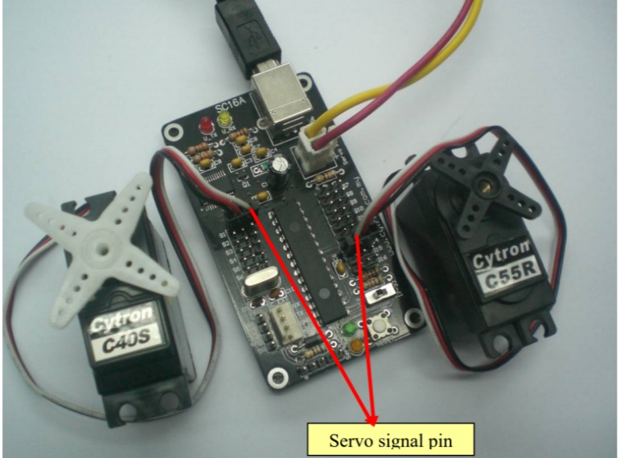

**Basic connection of SC16A**

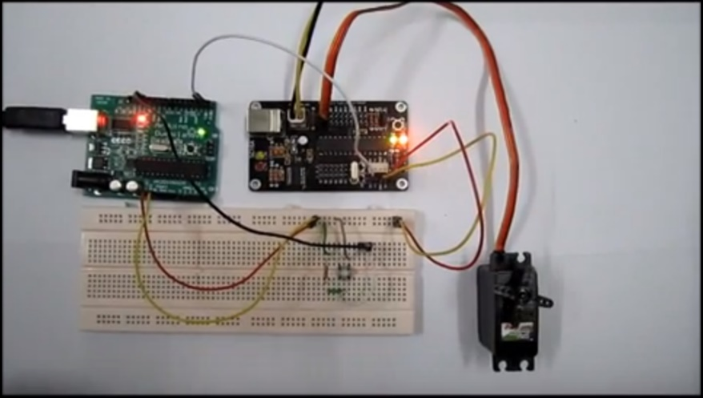

**Connection with the Arduino:**

* SC16A’s RX and TX is connected to RX and TX of the Arduino.
* Also the 5V and GND of SC16A to 5v and GND respectively of Arduino.
* The servo motor is connected to one of the ports of the servo controller.
* Its power is obtained from an external 9V alkaline battery which is connected to the servo controller.

Motor Driver:

Cytron MDDS10-

It is one of the latest smart series motor drivers designed to drive medium power brushed DC motor with current capacity up to 30A peak (few seconds) and 10A continuously.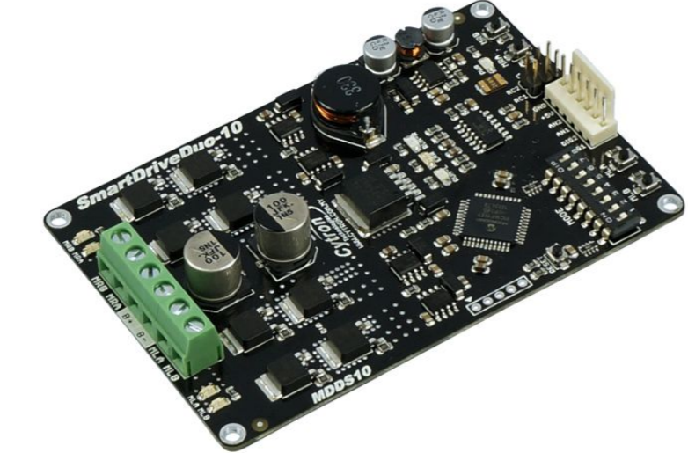

This driver is designed specially for controlling differential drive mobile robot using RC controller.

Features of MDDS10:

● Bi-directional control for dual brushed DC motor.

● Support motor voltage from 7V to 35V.

● Maximum current up to 30A peak (few seconds), 10A continuously.

● 16 KHz switching frequency for quiet operation.

● Battery low voltage indicator.

● Battery over voltage indicator.

● Thermal protection.

● Multiple input modes: RC, Analog, PWM, Simplified Serial and Packetized Serial.

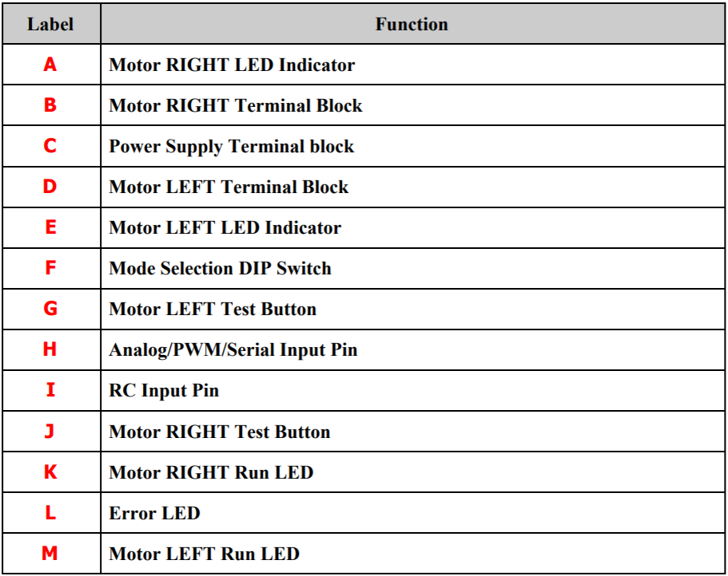● On board push buttons for fast test and manual operation.

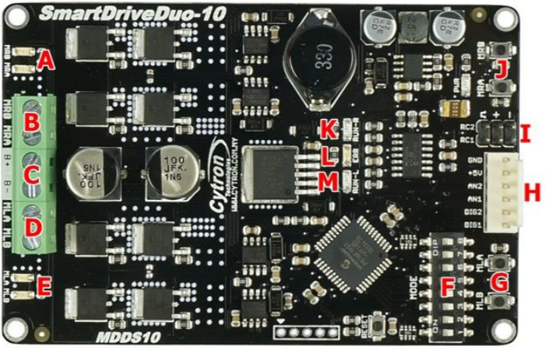

Connection of MDDs10:

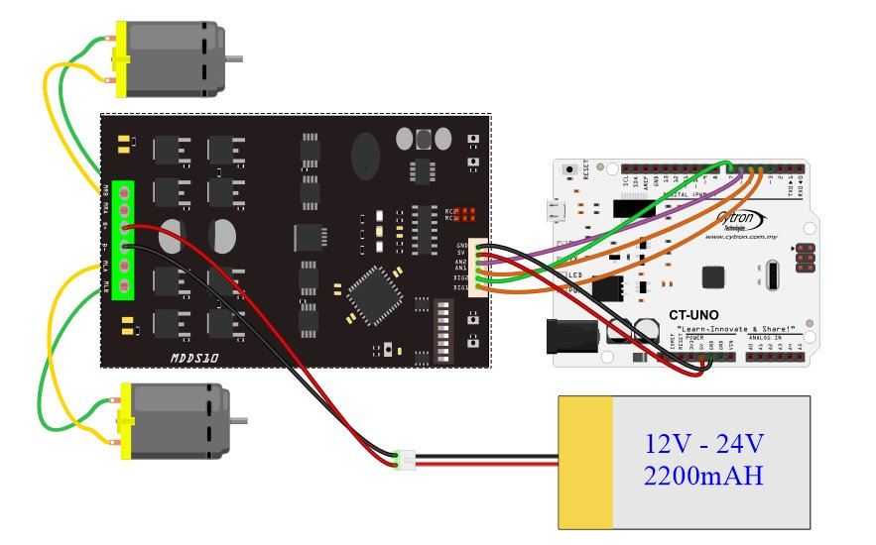

* C is connected to the power supply.
* B and D are connected to the motor terminals irrespective of the polarity.
* 5V and GND of mdds10 is connected to 55v and GND of the Arduino respectively.
* The analog pins are connected to the PWM pins(~) of the Arduino.
* The digital pins are connected to the digital pins of the Arduino.