

E-Commerce Website for Local Goods

Software Requirements Specification Report
Software name: Gathr

123cs0058 G V Sri Vardhan
123cs0052 M Vighnesh Prasad
123cs0011 Ankit Kumar
123cs0004 N Pranav
Table of Contents

1. Description of Software……………………….1
2. Major Inputs to the System………………….2
3. Major Outputs of the System……………….3
4. Major Processing Functionality……………4
5. Modules of the Proposed System…………5
6. Business Constraints and Technical Constraints….6
7. User Characteristics…………………………..7
8. Data Model and Description…………………8
9. Masters Information………………………….11
10. Transaction Information…………………..12
11. Data Flow Diagrams………………………….13
12. Specific Requirements……………………..14
13. Performance Requirements………………15

1. Description of Software
The Local Goods Ordering and Delivery System is designed to connect customers with nearby shopkeepers for purchasing groceries, fruits, vegetables, and other daily-use items. Customers can select a vendor from a list of available shops in their locality, browse their product catalog, place an order, and choose a payment method (online or cash on delivery).

Shopkeepers can manage product listings, update stock availability, and accept or reject orders based on inventory. Delivery personnel are assigned to pick up accepted orders from shopkeepers and deliver them to customers’ specified addresses.
The system supports three user roles:
- Customer – browses products, places orders, tracks deliveries.
- Shopkeeper – manages product catalog, accepts orders, updates status.
- Delivery Person – receives delivery assignments, updates delivery status.

2. Major Inputs to the System

From Customers
- Login credentials (email/phone & password or OTP).
- Delivery address & contact number.
- Selected products and quantities.
- Payment details for online transactions.

From Shopkeepers
- Product details (name, price, stock quantity, category).
- Inventory updates (stock in/out).
- Order acceptance or rejection.

From Delivery Person
- Login credentials.
- Delivery confirmation status (picked up, on the way, delivered).

From System or External Sources
- Payment gateway inputs for transaction verification.
- Location and GPS coordinates for delivery routing.

3. Major Outputs of the System

From Customers
- Order confirmation message.
- Delivery status updates (order accepted, dispatched, out for delivery, delivered).

From Shopkeepers
- New order alerts.
- Order details with customer name, items, and address.
- Payment confirmation from system.

From Delivery Person
- Login credentials.
- Navigation directions to customer’s address.
- Delivery completion confirmation.

4. Major Processing Functionality

User Authentication and Role Management

Secure login or signup with separate dashboards for each role.

Product Catalog Management

Add, edit, delete, and update stock for vendor products.

Order Processing

Accept/reject orders, manage payment, update status.

Delivery Management

Assign delivery personnel based on availability and location.

Payment Handling

Integrate payment gateways for online transactions.

Notifications System

Send real-time order and delivery status updates to customers and vendors.

Tracking and Mapping

GPS integration for delivery tracking.

5. Modules of the Proposed System

Authentication Module

Handles login, signup, and role verification.

Customer Module

Product search, ordering, payment, order tracking.

Vendor Module

Product inventory management, order acceptance, and reporting.

Delivery Module

Delivery assignment, live location updates, completion reporting.

Payment Module

Secure payment handling and refund processing.

Notification Module

SMS, push, and email alerts.

6. Business Constraints and Technical Constraints

Business Constraints
- The platform will only support vendors within a specified local radius.
- Orders will be delivered within a fixed time window (e.g., 9 AM – 9 PM).
- Delivery charges may vary based on distance and order size.

Technical Constraints
- Currently only available on the web application.
- Payment gateway must support local currency and comply with RBI guidelines.
- Server must handle at least 1000 concurrent users.
- Real-time updates require stable internet and GPS access.

7. User Characteristics

Customer

Basic smartphone, browsing and internet skills. Needs simple navigation and fast checkout.

Shopkeeper
Familiar with basic web app usage, able to manage product listings.

Delivery Person

Can operate a GPS-enabled smartphone, read and follow delivery instructions.

8. Data Model and Description
Table Name | Description | Key Fields
Users | Stores all platform users including customers, shopkeepers, and delivery personnel. | id (PK), created_at, first_name, last_name, email, role, clerk_id
Shops | Represents vendor shops managed by shopkeepers. | id (PK), created_at, owner_id (FK→Users), location (JSON), addr, shop_name, contact, account_no, rating
Users | Stores all platform users including customers, shopkeepers, and delivery personnel. | id (PK), created_at, user_id (FK→Users), location (JSON), mobile_no, title, description
Addresses | Stores customer delivery addresses. | id (PK), created_at, owner_id (FK→Users), location (JSON), addr, shop_name, contact, account_no, rating
Cart | Holds items added by customers before checkout. | id (PK), created_at, updated_at, status, user_id (FK→Users)
Items | Product listings in shops. | id (PK), created_at, name, description, rating, quantity, price, images (JSON), sold_qt, category, shop_id (FK→Shops)

Table Name | Description | Key Fields
Orders | Stores confirmed orders with assigned delivery personnel and payment info. | id (PK), created_at, carrier_id (FK→Users), customer_id (FK→Users), address_id (FK→Addresses), status, cart_id (FK→Cart), shop_id (FK→Shops), payment_method, transaction_id
Payments | Tracks payment transactions. | id (PK), created_at, user_id (FK→Users), order_id (FK→Orders), amount, status
Comments | User reviews or feedback on items. Supports nested comments. | id (PK), created_at, user_id (FK→Users), comment, parent_id (self-FK), likes, dislikes, item_id (FK→Items)

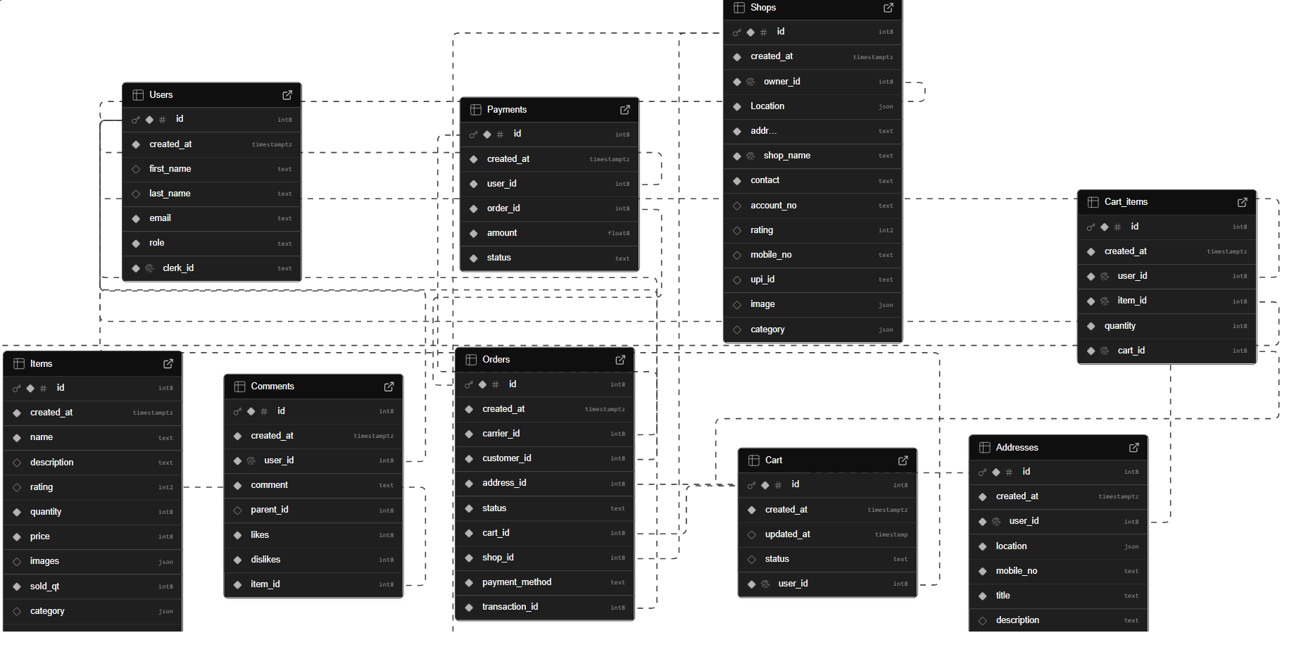
9. Masters Information
- User Roles Master
Defines the roles: Customer, Shopkeeper, Delivery Person, Admin.
- Shop Categories Master
Classification of shops (e.g., Grocery, Fruits & Vegetables, Bakery, Dairy, Meat, Household Items).
- Item Categories Master
Classification of products within shops.
- Payment Methods Master
Supported payment modes (e.g., Cash on Delivery, UPI, Card, Net Banking).
- Order Status Master
Possible statuses (Pending, Confirmed, Out for Delivery, Delivered, Cancelled).

10. Transaction Information
- User Registrations
Storing new customer, shopkeeper, and delivery personnel profiles.
- Shop Onboarding
Adding new shops with owner details and product listings.
- Cart Transactions
Adding, updating, and removing items in carts.
- Order Transactions
Placing orders, assigning delivery personnel, and tracking order status.
- Payment Transactions
Recording payment method, amount, and transaction status.
- Delivery Updates
Status updates from delivery personnel until the order is completed.

11. Data Flow Diagrams

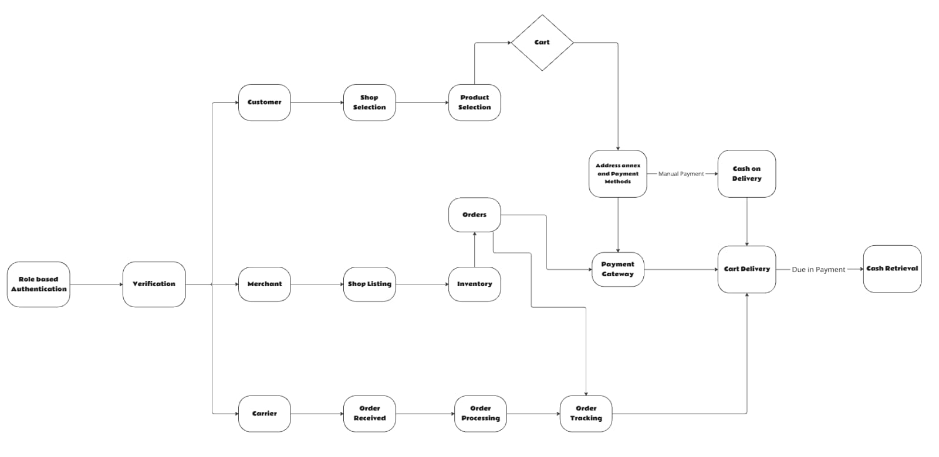
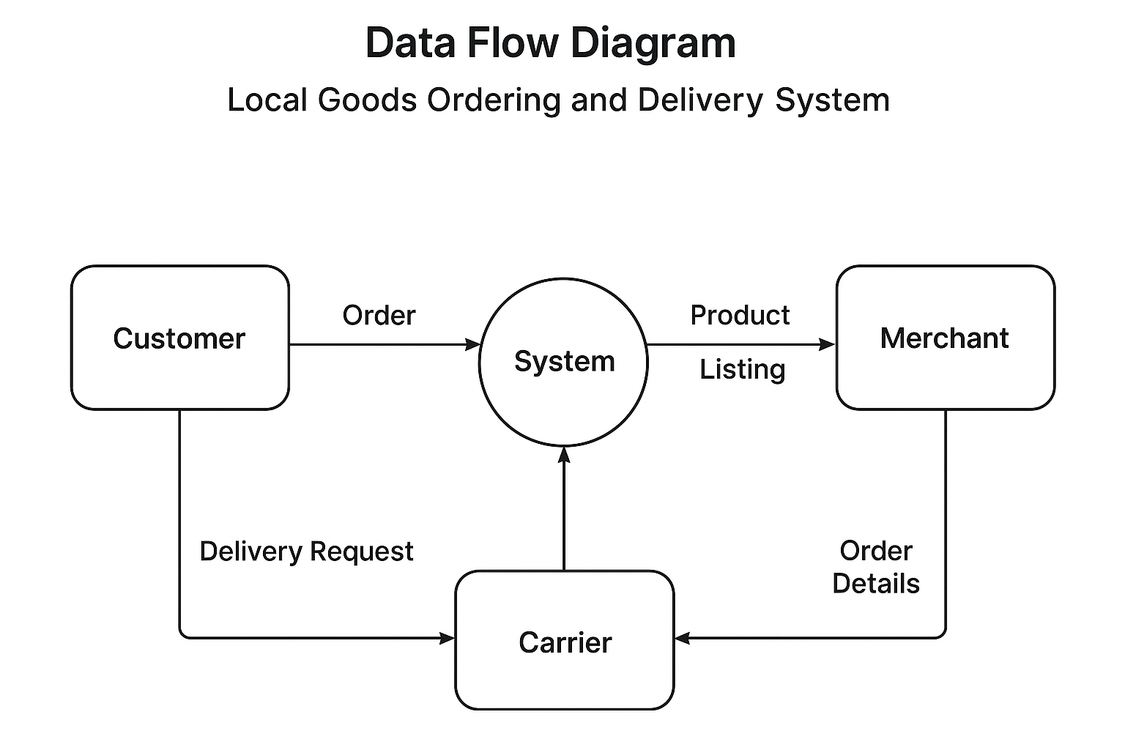
12. Specific Requirements

User Interface Requirements

Customer UI

Simple dashboard, product catalog, cart, order tracking, notifications.

Shopkeeper UI

Inventory management, incoming orders, sales overview.

Delivery UI

Assigned orders, navigation map, delivery status updates.

Admin UI

Manage users, shops, payments, and reports.

General UI

Responsive design, consistent color coding for order statuses, accessibility features.

Hardware and System Software Requirements

Server

Quad-core CPU, 16 GB RAM, 1 TB SSD, Ubuntu Linux, Node.js, MongoDB or PostgreSQL.

Client Devices

Smartphones (≥2 GB RAM, Android/iOS) or PC with modern browsers.

Network or Communication Interface

All communication over secure HTTPS.

REST APIs for standard data transfer.

WebSockets for real-time updates.

GPS APIs for delivery tracking.

Network or Communication Interface

External

Payment gateway API, Google Maps API

Internal

Authentication service (Clerk), ORM/Database connector (supabase ORM).

13. Performance Requirements

Support ≥1000 concurrent users.

API response time ≤2 seconds.

Database queries ≤300ms.

Real-time updates delivered within 3 seconds.

Availability: 99.5% uptime.

