1. Write a program for error detecting code using CRC-CCITT (16-bits) using JAVA

import java.util.*;
public class crc
{
public static void main(String args[])
{
Scanner s=new Scanner(System.in);
int n;
System.out.println("Enter the size of the data:");
n=s.nextInt();
int data[]=new int[n];

System.out.println("Enter the data, bit by bit:");
for(int i=0; i < n; i++)
{
data[i]=s.nextInt();
}
System.out.println("Enter the size of the divisor:");
n=s.nextInt();
int divisor[]=new int[n];
System.out.println("Enter the divisor, bit by bit:");
for(int i=0; i < n; i++)
divisor[i]=s.nextInt();
int remainder[]=divide(data,divisor);
System.out.println("\n The crc code generated is:");
for(int i=0; i < data.length; i++)
System.out.print(data[i]);
for(int i=0; i < remainder.length-1; i++)
System.out.print(remainder[i]);
System.out.println();
int sent_data[]=new int[data.length+remainder.length-1]; System.out.println("Enter the data to be sent:");
for(int i=0; i < sent_data.length; i++)
sent_data[i]=s.nextInt();
receive(sent_data,divisor);
}
static int[] divide(int old_data[],int divisor[])
{
int remainder[],i;
int data[]=new int[old_data.length+divisor.length];
System.arraycopy(old_data, 0,data, 0,old_data.length); System.out.println("Message bits after appending divisor_length-1 0's:");
for(i=0; i<data.length-1; i++)
System.out.println(data[i]);
remainder=new int[divisor.length];
System.arraycopy(data, 0, remainder, 0, divisor.length);
for(i=0; i < old_data.length; i++)
{
if(remainder[0]==1)
{
for(int j=1; j<divisor.length; j++)
{
remainder[j-1]=exor(remainder[j],divisor[j]);
}
}
else
{
for(int j=1; j < divisor.length; j++)
remainder[j-1]=exor(remainder[j],0);
}
remainder[divisor.length-1]=data[i+divisor.length];
}
return remainder;
}
static int exor(int a, int b)
{
if(a==b)
return 0;
return 1;
}
static void receive(int data[],int divisor[])
{
int remainder[]=divide(data, divisor);
for(int i=0; i < remainder.length; i++)
{
if(remainder[i] != 0)
{
System.out.println("There is an error in received data");
return;
}
}
System.out.println("Data was received without any error");

}
}

OUTPUT:

student@student-H61M-S2-B3:~$ gedit crc.java &
student@student-H61M-S2-B3:~$ javac crc.java
student@student-H61M-S2-B3:~$ java crc
enter the size of the data:
7
Enter the data, bit by bit:
1 0 1 1 0 0 1
Enter the size of the divisor:
3
Enter the divisor, bit by bit:
1
0
1
Message bits after appending divisor_length-1 0's:
1 0 1 1 0 0 1 0 0

The crc code generated is:
1 0 1 1 0 0 1 1 1
Enter the data to be sent:
1
0
1
1
0
0
1
1
1
Message bits after appending divisor_length-1 0's:
1 0 1 1 0 0 1 1 1 0 0
Data was received without any error

2. Write a program for congestion control using a Leaky Bucket Algorithm using JAVA Program.

import java.math.*;
import java.util.*;
import java.util.Random;
import java.io.*;
import java.lang.*;
public class leaky_bucket
{
public static void main(String[]args)
{
int drop=0,mini,i,o_rate,b_size,nsec,p_remain=0;
int packet[]=new int[100];
Scanner in=new Scanner(System.in);
System.out.print("Enter the bucket size:\n");
b_size=in.nextInt();
System.out.print("Enter output rate:\n");
o_rate=in.nextInt();
System.out.print("Enter the number of seconds to simulate:\n");
nsec=in.nextInt();
Random rand=new Random();
for(i=0;i<nsec;i++)
packet[i]=(rand.nextInt(1000));
System.out.println("seconds|packet received|packet sent| packets left|packets dropped\n");
System.out.println(" ");
for(i=0;i<nsec;i++)
{
p_remain+=packet[i];
if(p_remain>b_size)
{
drop=p_remain-b_size;
p_remain=b_size;
System.out.print(i+1 +" ");
System.out.print(packet[i] +" ");
mini=Math.min(p_remain,o_rate);
System.out.print(mini +" ");
p_remain=p_remain-mini;
System.out.print(p_remain+" ");
System.out.println(drop +" ");
System.out.print(" \n");
drop=0;
}
}
while(p_remain!=0)
{
if(p_remain>b_size)
{
drop=p_remain-b_size;
}
mini=Math.min(p_remain,o_rate);
System.out.print(" "+p_remain +" " +mini);
p_remain=p_remain-mini;
System.out.println(" "+p_remain +" " +drop);
drop=0;
}
}
}

OUTPUT:

student@student-H61M-S2-B3:~/DCN_24-25$ gedit leaky_bucket.java
student@student-H61M-S2-B3:~/DCN_24-25$ javac leaky_bucket.java
student@student-H61M-S2-B3:~/DCN_24-25$ java leaky_bucket
Enter the bucket size:
10
Enter output rate:
4
Enter the number of seconds to simulate:
10
seconds|packet received|packet sent| packets left|packets dropped

1 517 4 6 507

2 103 4 6 99

3 536 4 6 532

4 139 4 6 135

5 976 4 6 972

6 811 4 6 807

7 921 4 6 917

8 827 4 6 823

9 273 4 6 269

10 625 4 6 621

6 4 2 0
2 2 0 0
3. Write a Socket Programming in JAVA using TCP-Iterative Client-Server Program

TCP Server program

import java.net.*;
import java.io.*;
public class tcpser
{
public static void main(String args[])throws Exception
{
ServerSocket sersock= new ServerSocket(4000);
System.out.println("sever ready for connection");
Socket sock=sersock.accept();
System.out.println("connection is successful and waiting to serve");
InputStream istream=sock.getInputStream();
BufferedReader fileRead=new BufferedReader(new InputStreamReader(istream));
String fname=fileRead.readLine();
BufferedReader contentRead=new BufferedReader(new FileReader(fname));
OutputStream ostream=sock.getOutputStream();
PrintWriter pwrite=new PrintWriter(ostream,true);
String str;
while((str=contentRead.readLine())!=null)
{
pwrite.println(str);

}

}
}

/*TCP Client program*/

import java.net.*;
import java.io.*;

public class tcpcl
{
public static void main(String args[])throws Exception
{
Socket sock=new Socket("127.0.0.1",4000);
System.out.println("enter the file name");
BufferedReader keyRead=new BufferedReader(new InputStreamReader(System.in));
String fname=keyRead.readLine();
OutputStream ostream=sock.getOutputStream();
PrintWriter pwrite=new PrintWriter(ostream,true);
pwrite.println(fname);
InputStream istream=sock.getInputStream();
BufferedReader SocketRead=new BufferedReader(new InputStreamReader(istream));
String str;
while((str=SocketRead.readLine())!=null)
{
System.out.println(str);
}
pwrite.close();
SocketRead.close();
keyRead.close();
}
}

2. Write a Socket Programming in 'JAVA' using UDP and Network Monitoring and Analysis with Wireshark.

UDP Server program

import java.io.*;
import java.net.*;
class udpser
{
public static void main(String args[]) throws Exception
{
DatagramSocket serversocket=new DatagramSocket(9876);
BufferedReader br=new BufferedReader(new InputStreamReader(System.in));
byte[] receiveData=new byte[1024];
byte[] sendData=new byte[1024];
DatagramPacket receivePacket=new DatagramPacket (receiveData,receiveData.length);
serversocket.receive(receivePacket);
String sentence=new String(receivePacket.getData()); System.out.println("RECEIVED:"+sentence);
InetAddress IPaddress=receivePacket.getAddress();
int port=receivePacket.getPort();
System.out.println("enter the message");
String data=br.readLine();
sendData=data.getBytes();
DatagramPacket sendPacket=new DatagramPacket(sendData,sendData.length,IPaddress,port);
serversocket.send(sendPacket);
serversocket.close();

}

}

UDP Client program

import java.io.*;
import java.net.*;
class udpcl
{
public static void main(String[]args)throws Exception
{
BufferedReader in=new BufferedReader(new InputStreamReader(System.in));
DatagramSocket clientsocket=new DatagramSocket();
InetAddress IPaddress=InetAddress.getByName("localhost");
byte[] sendData=new byte[1024];
byte[] receiveData=new byte[1024];
String sentence="hello server";
sendData=sentence.getBytes();
DatagramPacket sendPacket=new DatagramPacket (sendData,sendData.length,IPaddress,9876);
clientsocket.send(sendPacket);
DatagramPacket receivePacket=new DatagramPacket(receiveData,receiveData.length);

TCP Client program

import java.net.*;
import java.io.*;

public class tcpcl
{
public static void main(String args[])throws Exception
{
Socket sock=new Socket("127.0.0.1",4000);
System.out.println("enter the file name");
BufferedReader keyRead=new BufferedReader(new InputStreamReader(System.in));
String fname=keyRead.readLine();
OutputStream ostream=sock.getOutputStream();
PrintWriter pwrite=new PrintWriter(ostream,true);
pwrite.println(fname);
InputStream istream=sock.getInputStream();
BufferedReader SocketRead=new BufferedReader(new InputStreamReader(istream));
String str;
while((str=SocketRead.readLine())!=null)
{
System.out.println(str);
}
pwrite.close();
SocketRead.close();
keyRead.close();
}
}

clientsocket.receive(receivePacket);
String modifiedsentence=new String(receivePacket.getData()); System.out.println("FROM SERVER:" +modifiedsentence);
clientsocket.close();
}
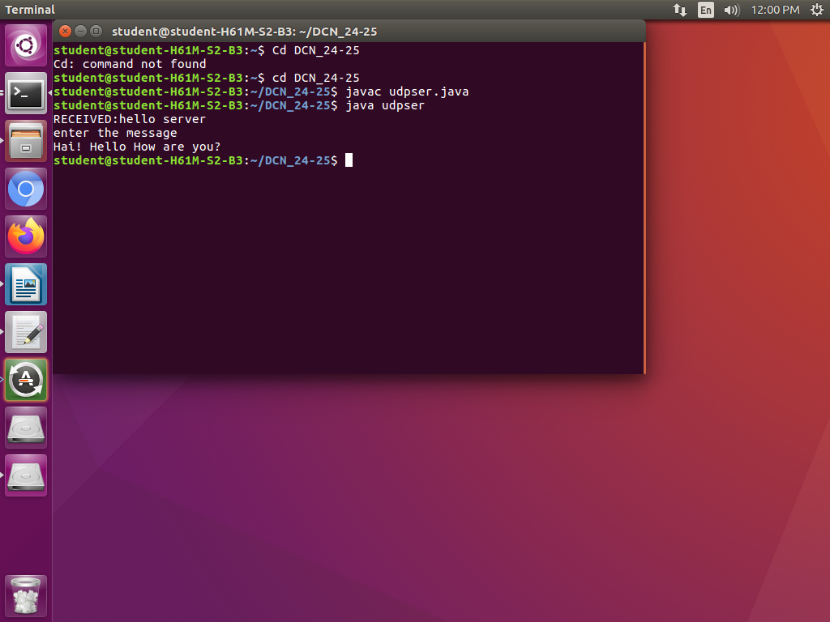
}

OUTPUT:

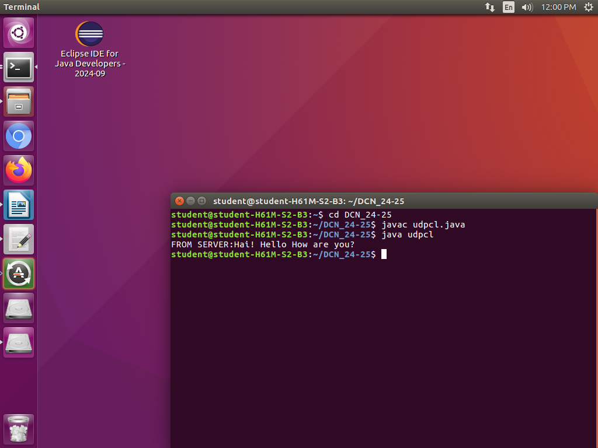

3. Write a Socket Programming in JAVA using TCP-Iterative Client-Server Programs */

TCP Server program

import java.net.*;
import java.io.*;
public class tcpser
{
public static void main(String args[])throws Exception
{
ServerSocket sersock= new ServerSocket(4000);
System.out.println("sever ready for connection");
Socket sock=sersock.accept();
System.out.println("connection is successfull and waiting to serve");
InputStream istream=sock.getInputStream();
BufferedReader fileRead=new BufferedReader(new InputStreamReader(istream));
String fname=fileRead.readLine();
BufferedReader contentRead=new BufferedReader(new FileReader(fname));
OutputStream ostream=sock.getOutputStream();
PrintWriter pwrite=new PrintWriter(ostream,true);
String str;
while((str=contentRead.readLine())!=null)
{
pwrite.println(str);

}

}
}

/*TCP Client program*/

import java.net.*;
import java.io.*;

public class tcpcl
{
public static void main(String args[])throws Exception
{
Socket sock=new Socket("127.0.0.1",4000);
System.out.println("enter the file name");
BufferedReader keyRead=new BufferedReader(new InputStreamReader(System.in));
String fname=keyRead.readLine();
OutputStream ostream=sock.getOutputStream();
PrintWriter pwrite=new PrintWriter(ostream,true);
pwrite.println(fname);
InputStream istream=sock.getInputStream();
BufferedReader SocketRead=new BufferedReader(new InputStreamReader(istream));
String str;
while((str=SocketRead.readLine())!=null)
{
System.out.println(str);
}
pwrite.close();
SocketRead.close();
keyRead.close();
}
}

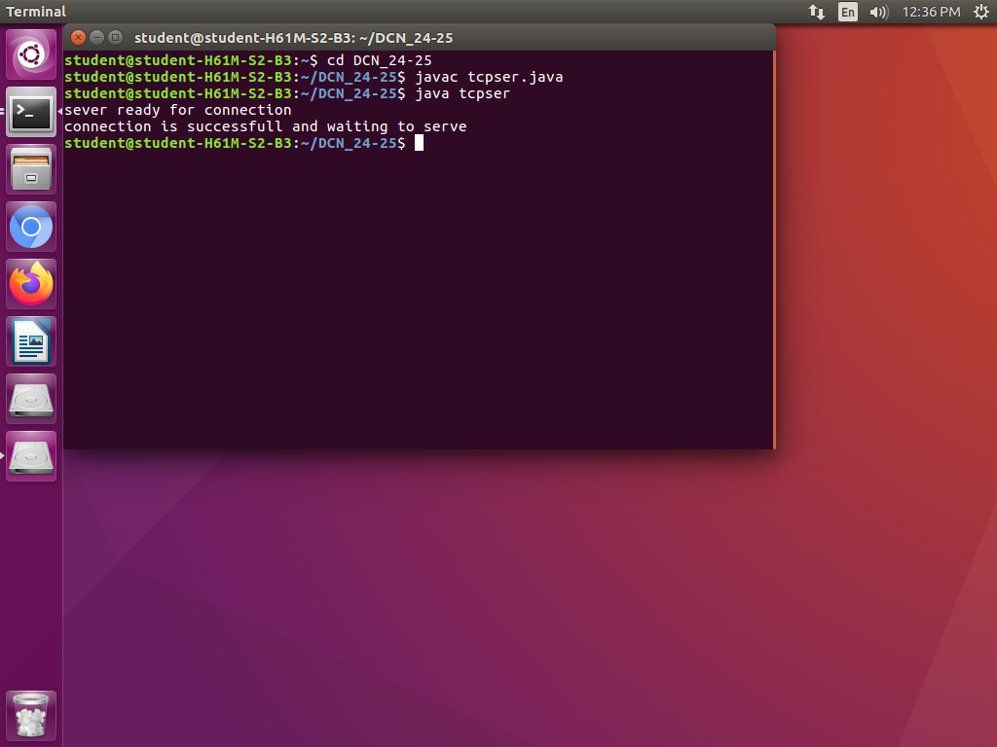

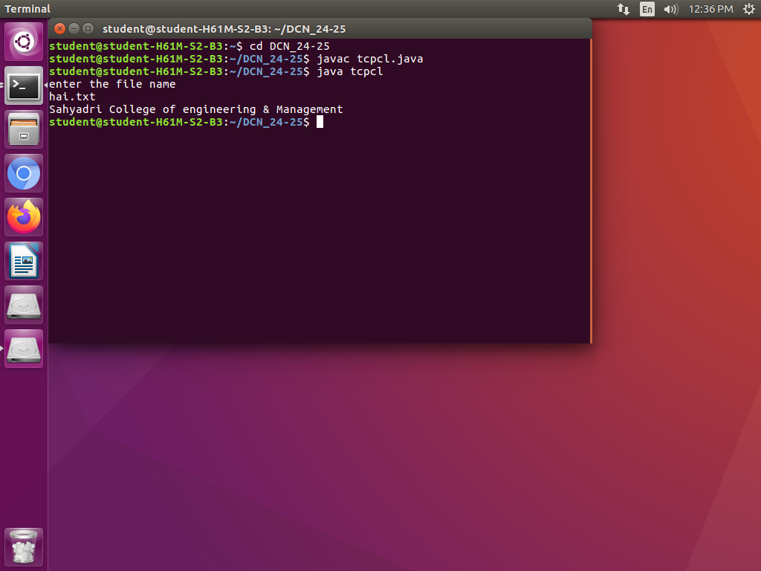

8. Write a program for error detecting code using CRC-CCITT(16-bits)using JAVA

import java.util.*;
public class crc
{
public static void main(String args[])
{
Scanner s=new Scanner(System.in);
int n;
System.out.println("enter the size of the data:");
n=s.nextInt();
int data[]=new int[n];

System.out.println("enter the data ,bit by bit:");
for(int i=0; i < n; i++)
{
data[i]=s.nextInt();
}
System.out.println("enter ther size of the divisor:");
n=s.nextInt();
int divisor[]=new int[n];
System.out.println("enter the divisor,bit by bit:");
for(int i=0; i < n; i++)
divisor[i]=s.nextInt();
int remainder[]=divide(data,divisor);
System.out.println("\n the crc code generated is:");
for(int i=0; i < data.length; i++)
System.out.print(data[i]);
for(int i=0; i < remainder.length-1; i++)
System.out.print(remainder[i]);
System.out.println();
int sent_data[]=new int[data.length+remainder.length-1]; System.out.println("enter the data to be sent:");
for(int i=0; i < sent_data.length; i++) sent_data[i]=s.nextInt();
recieve(sent_data,divisor);
}
static int[] divide(int old_data[],int divisor[])
{
int remainder[],i;
int data[]=new int[old_data.length+divisor.length];
System.arraycopy(old_data, 0,data, 0,old_data.length); System.out.println("message bits after appending divisor_length-1 0's:");
for(i=0; i<data.length-1; i++)
System.out.println(data[i]);
remainder=new int[divisor.length];
System.arraycopy(data, 0, remainder, 0, divisor.length);
for(i=0; i < old_data.length; i++)
{
if(remainder[0]==1)
{

