**Assignment_ Module_1: -Fundamental**

**Q) What is SDLC?**

**Ans:** - SDLC means Software Development Life Cycle it is structured Process to developers develop high quality of software.

**Q) What is software testing?**

**Ans: -** Software testing is process used to identify the correctness, completeness and quality of developed software.

**Q) Write SDLC phases with basic introduction?**

**Ans: - 1) Requirement Gathering: -**Collect detail from client about the project.

**2) Analysis: -**Analyse the requirement

**3) Design: -** To Prepare Design as per requirement.

**4) Implantation: -** Coding.

**5) Testing: -** to verify the correctness, completeness and quality of the software developed**.**

**6) Deployment: -** deploy the product.

**7) Maintenance: -**corrective, adaptive, perfective.

**Q) What is SRS?**

**Ans: -** SRS Stands for System Requirement. Specification is a complete description of the behaviour of the System to be developed.

**Q) Explain Phases of the waterfall model?**

**Ans: - 1) Requirement Collection: -** Collect complete requirements from the client.

**2) Analysis: -**Analyse the requirement

**3) Design: -** Prepare Design as per customer requirement.

**4) Implantation: -** Developer start writing the coding.

**5)Testing: -** The system is tested for errors, bugs, and failures**.**

**6)Deployment: -**The final product is delivered to the customer.

**7)Maintenance: -** Once the system is live, it may need updates, bug fixes, or enhancements.

**Q) Write phases of spiral mode?**

**Ans: -1) Planning: -** Requirements are gathered from customer.

**2) Risk Analysis: -** Analise all possible risk.

**3) Engineering: -** Actually developer the code.

4) **Evaluation: -** customer check the product right work or not?

**Q) What is agile methodology?**

**Ans: -** Agile model means delivering working software in small parts with continuous feedback and improvement.

**Q) Write agile manifesto principles?**

**Ans: -** 1) iterative incremental model

2) Work divided into small parts

3) Daily meeting

4) Continuous improvement

5) Customer are involved in every phase

6) changing requirement through the development phase

7) Fast And Flexible delivery

8) Continues testing feedback

9) Customer no need to wait for long time.

**Q) Explain working methodology of agile model and also write pros and cons?**

**Ans: -** 1) Project divided into small parts.

2)at the team decides what features to build.

3) Daily Meeting.

4) Design, development, and testing in the same time.

5) After finishing they show the work to the customer.

• 6) Continuous feedback customer.

**Pros: -** 1) Easy to handle changes anytime during the project.

2) Delivers working software faster.

3) Regular customer feedback improves quality.

4) Issues are found and fixed early.

**Cons: -** 1) Time and cost are hard to predict.

2) Team should have good experience and skills.

3) Not suitable for small project.

**Q) What is Oops?**

**Ans: -** Oops means object-oriented programming language.

**Q) Write Basic Concepts of oops?**

**Ans: -** 1) Class

2) Object

3) inheritance

4) Encapsulation

5) Polymorphism

6) Abstraction

**Q) What is object?**

**Ans: -** Object gives permission to access functionality of class.

**Q) What is class?**

**Ans: -** It is a collection of data member and member function.

**Q) What is encapsulation?**

**Ans: -** Encapsulation in Java is the process of wrapping up of data.

**Q) What is inheritance?**

**Ans: -** inheritance to drive attribute of some other class.

**Q) What is polymorphism?**

**Ans: -** polymorphism means one name multiple form.

**Q) Draw Use case on online bill payment system (Paytm)?**

**Ans: -**

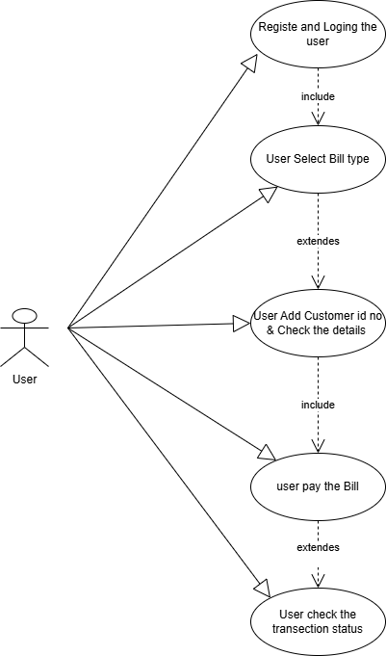

**Q) Draw Use case on banking system for customers?**

**Ans: -**

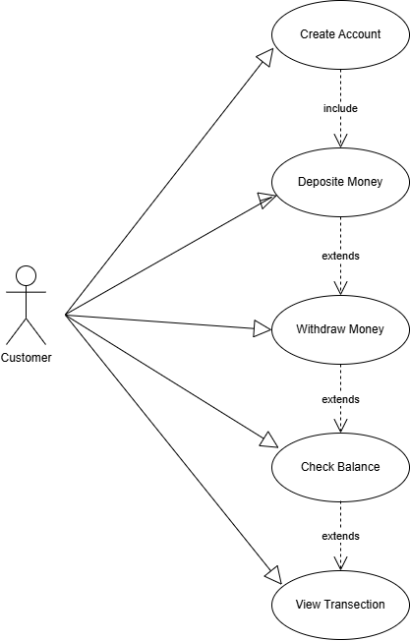

**Q) Draw Use case on Broadcasting System?**

**Ans: -**

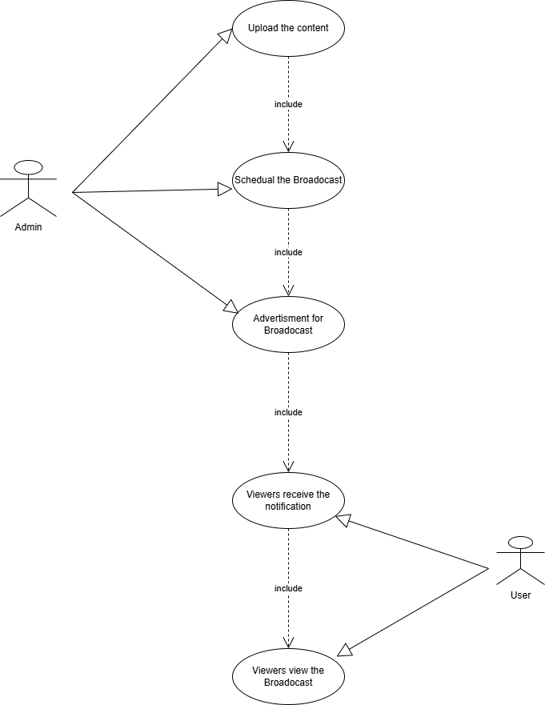

**Q) Draw use case on OTT Platform?**

**Ans: -**

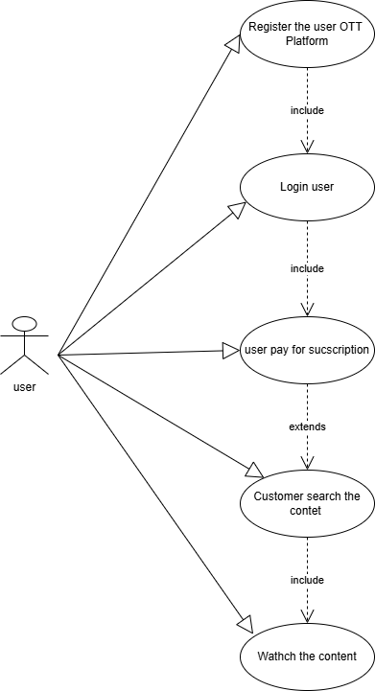

**Q) Draw use case on E-commerce application?**

**Ans: -**

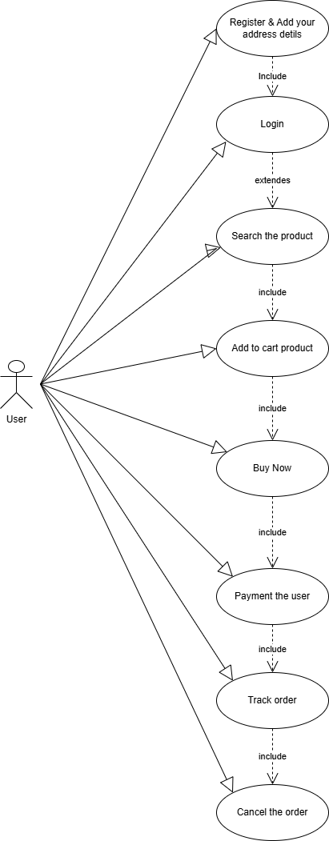

**Q) Draw use case on Online shopping product using payment gateway?**

**Ans: -**

