**Experiment 2 : Web Analytics**

|  |  |
| --- | --- |
| **Name of Student** | **Pranav Pol** |
| **Class Roll No** | **D15A / 41** |
| **D.O.P.** |  |
| **D.O.S.** |  |
| **Sign and Grade** |  |

**AIM : To study a Web Analytics Tool**

**Theory:**

**1. What is Web Analytics?**

Web analytics refers to the measurement, collection, analysis, and reporting of web data to understand and optimize web usage. It helps businesses track user behavior, monitor website traffic, and improve the overall user experience.

There are two main types of web analytics:

* **On-site Web Analytics**: Tracks visitor behavior on a specific website.
* **Off-site Web Analytics**: Analyzes web data outside a specific website, including social media and search engine trends.

**2. Web Analytics Tools and Their Features**

**a. Google Analytics**

* Tracks website traffic and user behavior.
* Provides insights on audience demographics, sessions, and page views.
* Monitors events like clicks, scrolls, and conversions.
* Allows goal tracking and funnel visualization.

**b. Adobe Analytics**

* Offers real-time analytics and data segmentation.
* Uses AI-powered insights and predictive analytics.
* Provides advanced customer journey tracking.
* Customizable dashboards and reporting tools.

**c. Hotjar**

* Visual behavior tracking through heatmaps and session recordings.
* User feedback collection through surveys and polls.
* Click-tracking and scrolling behavior analysis.
* Helps improve user experience based on interactions.

**d. Matomo (formerly Piwik)**

* Open-source and privacy-friendly analytics tool.
* Offers detailed visitor logs and behavior tracking.
* Provides customizable reports and goal tracking.
* Supports self-hosted analytics for full data control.

**e. Crazy Egg**

* Heatmap and scrollmap tracking for user engagement analysis.
* A/B testing for optimizing web page designs.
* Session recordings to track visitor behavior.
* Identifies areas for improving conversions and UX.

**3. Why is it Important to Learn Web Analytics?**

* Helps businesses **understand user behavior** and optimize website performance.
* Allows tracking of **conversion rates** and sales effectiveness.
* Identifies **high-performing and underperforming pages**.
* Enhances **marketing strategies** by analyzing traffic sources.
* Helps in making **data-driven decisions** for business growth.

**4. Key Performance Indicators (KPIs) for Your Website**

**KPIs** are essential for measuring the success of a website. Some common KPIs include:

* **Number of Users & Sessions**: The total number of visitors and the number of times they visit.
* **Page Views**: The total number of pages viewed by visitors.
* **Bounce Rate**: Percentage of visitors who leave the site without interacting.
* **Conversion Rate**: The percentage of visitors who complete a desired action (e.g., sign-up, purchase).
* **Average Session Duration**: The average time a user spends on the site.
* **Traffic Sources**: Shows whether users come from direct searches, referrals, or advertisements.
* **Event Counts**: Tracks user interactions like clicks, scrolls, or form submissions.

Link to website:

https://portfolio-snehalpatil.netlify.app/

1. show landing page of Google Analytics, where it shows the basic analytics of website like users, event counts (like scroll, click), conversion rate & new users.

Sample image

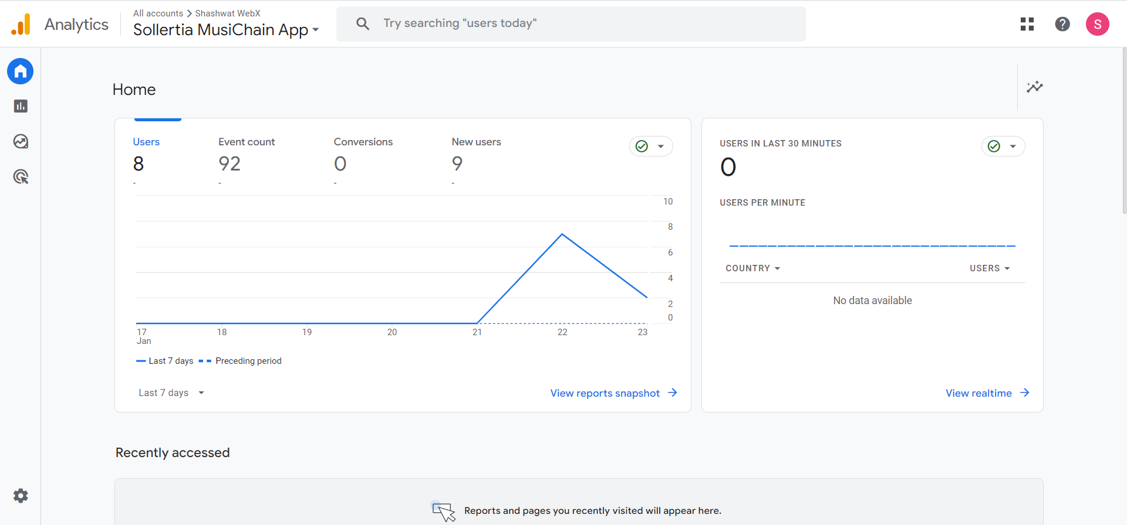



This gives the analysis of traffic on each page of website.

1. Show demographic information of user base

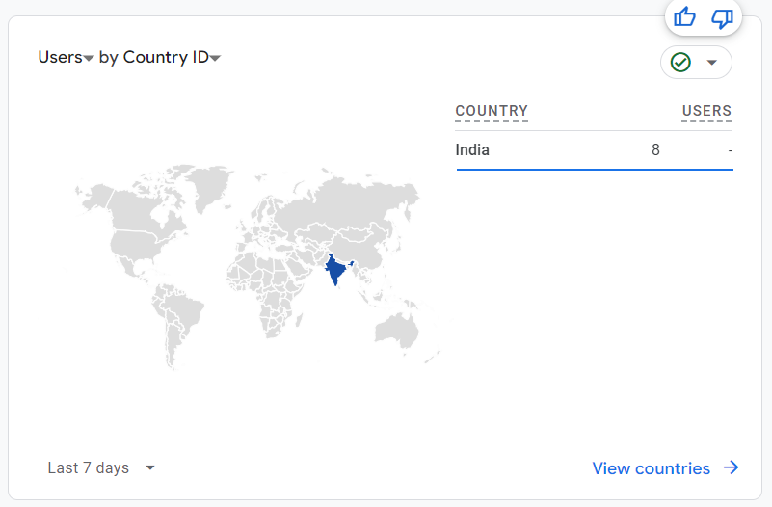

The above picture gives us demographic information from where our user base is.

1. shows how my website url is visited ‘direct’ if it is directly searched and visited ‘referal’ if it redirected through any third party website.

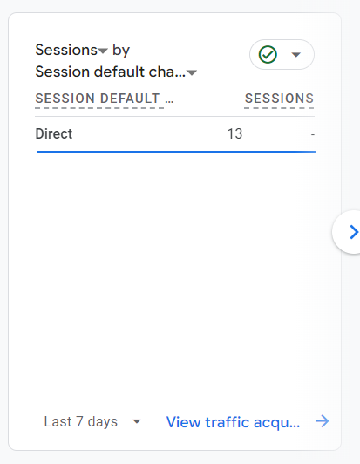

1. shows what all events have been done by users on website for example:53 people viewed the page.

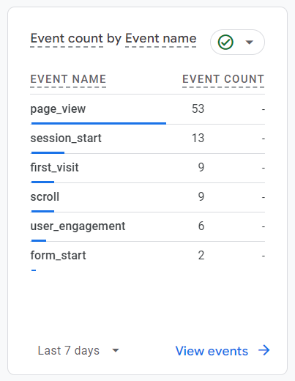

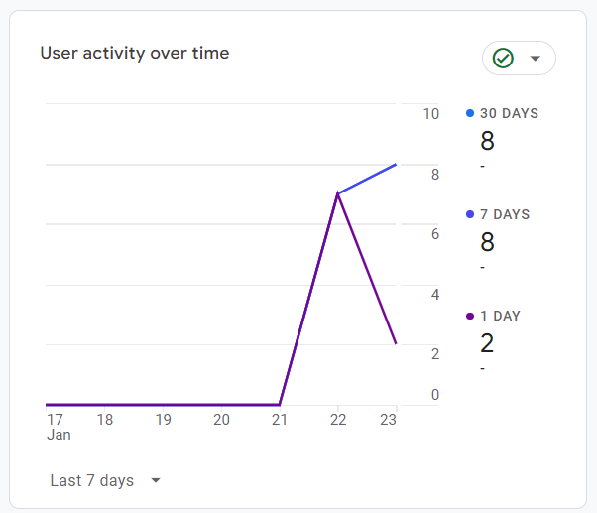

1. Show the user activity over the past 7 days, after adding Google Analytics script to website.

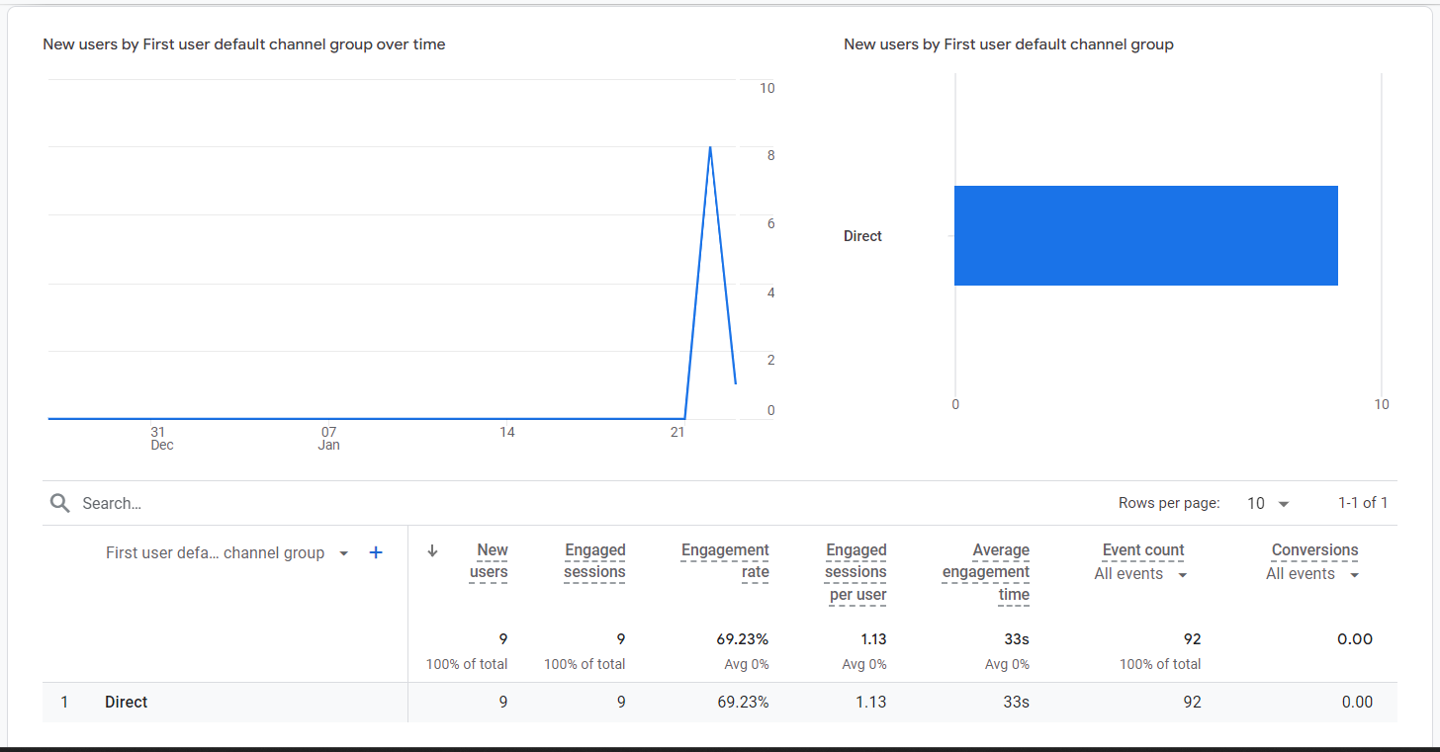

This shows the complete details about the engagement session, avg engagement time, event counts, etc.

**CONCLUSION :**

1. **Search Engine Optimization (SEO):**
   * **Keyword Research:** Identify and incorporate relevant keywords that potential visitors might use to find your content.
   * **On-Page SEO:** Optimize meta tags, headings, and content structure to improve search engine rankings.
   * **Regular Content Updates:** Maintain a blog or news section to keep content fresh and engaging.
2. **Leverage Social Media:**
   * **Cross-Promotion:** Share your website content on platforms like LinkedIn, Twitter, and Facebook to reach a broader audience.
   * **Engagement:** Interact with your audience through comments and messages to build a loyal community.
3. **Utilize Visual Platforms:**
   * **Instagram:** Post images and stories that showcase your projects and link back to your website.
4. **Email Marketing:**
   * **Newsletter:** Collect visitor emails and send regular updates about new content or projects to encourage repeat visits.
5. **Networking and Collaboration:**
   * **Guest Blogging:** Write articles for other websites in your niche to reach new audiences.
   * **Collaborations:** Partner with other professionals to create joint content or projects.
6. **Analyze and Adapt:**
   * **Traffic Analysis:** Use tools like Google Analytics to monitor visitor behavior and identify popular content.
   * **Feedback Collection:** Implement surveys or feedback forms to understand visitor preferences and improve user experience.

By implementing these strategies, you can enhance the visibility and appeal of your personal website, thereby attracting and retaining more users.