**Biggest and Smallest Number**

**Ex. No: 3**

**Data:**

1a. Finding Biggest in an array of numbers

.model small

.data

array db 7,20,4,3,100

N db 5

.stack

.code

.startup

mov cx,00

mov cl,N

mov al,array[si]

dec cl

inc si

sorting: cmp al,array[si]

ja next

mov al,array[si]

next: inc si

loop sorting

.exit

END

1b. Finding Smallest in an array of numbers

Appendix:

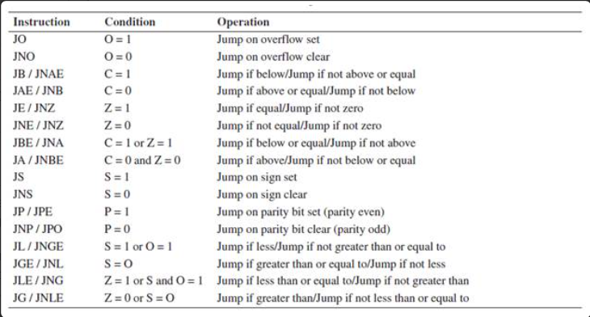

Assignment:

1. Write an 8086 assembly language program to arrange an array of numbers in descending order.