EXPENSE TRACKER APPLICATION

BY TINT

|  |  |  |
| --- | --- | --- |
| NAME | ROLL NO. | MOBILE |
| Aakash Krishna | CB.EN.U4CSE15301 | 7708278142 |
| Vijay Nirmal | CB.EN.U4CSE15341 | 7708365034 |
| Saumya Rai | CB.EN.U4CSE15349 | 8800604838 |
| Shantam B | CB.EN.U4CSE15350 | 9670976709 |
| Shradhaa J | CB.EN.U4CSE15352 | 8056078454 |

**TABLE OF CONTENTS**

1. ABSTRACT ……………………………………………… 3
2. TOOLS ...…………………………………………………. 4
3. SRS ……………………………………………………….. 5
4. CLASS DIAGRAM ………………………………………. 9
5. DFD ………………………………………………………. 10
6. TEST CASES …………………………………………….. 11

**ABSTRACT**

The Expense Tracker is a mobile application which enables a user to manage his income and expenses efficiently. Every user has a unique account where the data related to his expense is tracked and managed. The expenses are grouped into categories and each category has a spending limit. If the limits are breached, the user is alerted of the same. The expenses can be tracked by the user by means of various visualization tools which makes the app attractive and easy to understand by the user. New expenses and categories can be managed effectively in the app.

**TOOLS**

1. VERSIO CONTROLLING: Git and GitHub
2. DEVELOPING ENVIRONMENT: Android Studio
3. DEVELOPING LANGUAGE: Java and XML
4. LOCAL DATABASE: SQLite
5. ONLINE DATABASE: Google Firebase

**SOFTWARE REQUIREMENT SPECIFICATION**

# Introduction

## Purpose/Goal

The objective of this software is to design a system which will allow the user to efficiently manage his or her expenses.

## Intended Audience and Reading Suggestions

This document is intended for developers, project managers, marketing staff, users, testers, and documentation writers who may be interested in an expense tracking tool. The SRS contains descriptions of the characteristics and functionalities of the expense tracker. The reader may follow the sequence given in the contents section.

## Product Scope

This application is a financial tool meant to facilitate management of personal expenses. It aims to help the customer keep track of expenses with minimal effort by providing an eay-to-use interface, efficient categorization and even SMS automation.

# Overall Description

## Product Perspective

This product is a stand-alone application built to provide a solution to a financial pain point. A person has to maintain meticulous records on a daily basis in order to track his expenses. Manual calculations also result in errors that may lead to losses. To counter this problem, this software has been designed to make the task of keeping expenses in check and efficient.

## Product Functions

The software has the following functions:

* Enables the user to set category-wise spend limit
* Alerts the user when limits are breached
* Incoming messages are tracked, processed and classified under different categories
* Login management
* Profile management
* Settings management
* Shows transactions

## User Classes

User classes for this product include users with:

* Basic English knowledge
* A smartphone and a working sim card
* A source of income
* Bank accounts and credit/debit cards

## Operating Environment

The operating environment used to build and deploy this product include:

* Android Studio
* Android 7 and above
* SQLite

## Design and Implementation Constraints

The primary design constraint is the mobile platform. Since the application is designed for mobile, limited screen size and resolution will be a major consideration. Creating a user interface which is both effective and easily navigable will pose a difficult challenge. Other constraints such as limited memory and processing power are worth considering.

## User Documentation

User documentation components meant to assist the user include a user manual which guides the user on how to enter details and view reports.

## Assumptions and Dependencies

The product is partially dependent on the SMS application available on most smartphones and an adequate network connection for their delivery.

# External Interface Requirements

## User Interfaces

* Graphical User Interface (GUI) will be easy to use and clean looking
* Hamburger menu is used to simplify the page navigation
* Charts to understand data
* Error message with appropriate reason

## Hardware Interfaces

* Need android phone
* Need sim card to send and receive SMS
* SMS Data
* Interactions will be handled by touch screen

## Software Interfaces

* Using SQLite for database
* Android operating systems
* Android Studio development environment
* Data are gathered from SMS
* An API will be written to interact with the database

# System Features

## Login Management

4.1.1 Description and Priority

Upon clicking this button the user can log in into the application. A user’s expense will only be manageable if the user has logged in with correct credentials.

4.1.2 Stimulus/Response Sequences

The user opens the login page. He is required to type in user-id, password and OTP when needed. If the login is successful he will be directed to next page otherwise the application allows the user to retry or retrieve password through forgot password method.

4.1.3 Functional Requirements

The requirement is to login the correct user and verify his credentials. Due to some human error the application also gives the user a chance to retry and get new password.

## Profile Management

4.2.1 Description and Priority

Upon clicking this button the user can view his personal details. A user can also edit any information is needed.

4.2.2 Stimulus/Response Sequences

The user is directed to the profile page. He can view information and can click the edit button if he wants to update name, address, Dob, password, preferences and bank details.

4.2.3 Functional Requirements

The requirement is to facilitate the user to update and view his personal information when he wishes to do so.

## Settings

4.3.1 Description and Priority

Upon clicking this button the user can view the categories of his expenditure and view his percentage expenditure in each.

4.3.2 Stimulus/Response Sequences

The user can go to the settings button. He can select the button to view categories where all the categories of his expenditure, his current expenditure and his limit for each category are listed. He can click on a button to add new categories and modify his limit on these categories. Also the user can list the shops that he most frequently visits and can update this list.

4.3.3 Functional Requirements

The basic requirement here is to provide an interface for the user to identify his expenditure in each category while also facilitating him to manage the resources on which he spends frequently in each category.

## Show Analysis

4.4.1 Description and Priority

Upon clicking this button the user can view the transactions he has made in each category for the date range the user selects. He can view this in form of charts or graphs also, showing his percentage expenditure in the categories.

4.4.2 Stimulus/Response Sequences

The user can click this button to know the transactions. He selects a range of dates to view transactions. He can select the button to receive the SMS message for that transaction, move transactions to different categories, delete transactions and add transactions manually. He can also click the button to view charts and graphs showing his percentage expenditure.

4.4.3 Functional Requirements

The requirement is to manage the transactions and their percentage under each category for the month and reset this to zero at the beginning of each month. It is needed to maintain the transactions in each month.

# Other Nonfunctional Requirements

|  |  |
| --- | --- |
| **FUNCTIONALITY** | **REQUIREMENT** |
| Usability | * There is a consistency in all the modules and webpages * To ease the navigation there is a back tab to provide 9 access to previous page * There is proper instruction on each page |
| Reliability | * Each data record is stored on a well-built efficient database scheme * There is no risk of data loss * The internal evaluation of data is well coded |
| Supportability | * The system is well built to support any machine * Maintainability of the system is easy * All the plans for future augments can be easily incorporated within the present system |
| Performance | * In order to ease the accessibility, the types of expenses are categorized along with an option to name on the own * Throughput of the system is increased due to light weight database support |
| Availability | * The system is available all the time, no time constraint, on suitable platforms |

**CLASS DIAGRAM**

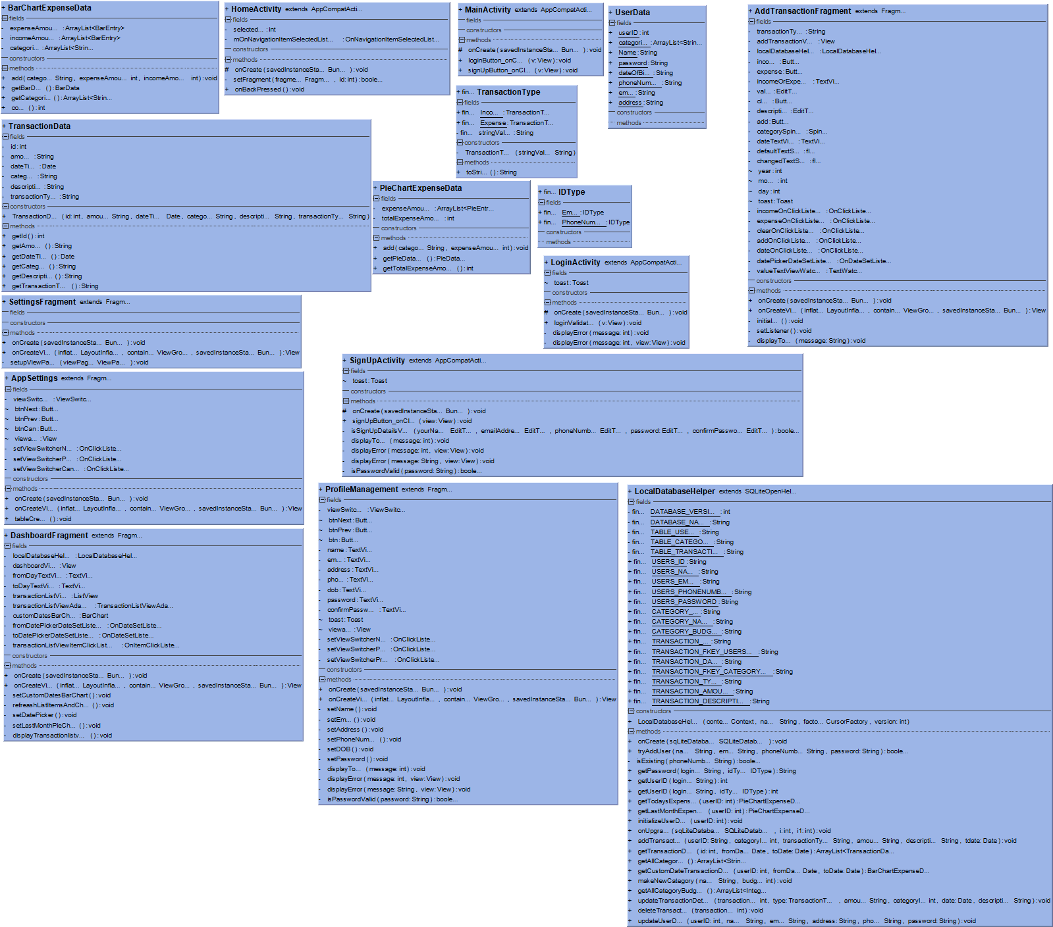

**DATA FLOW DIAGRAM**

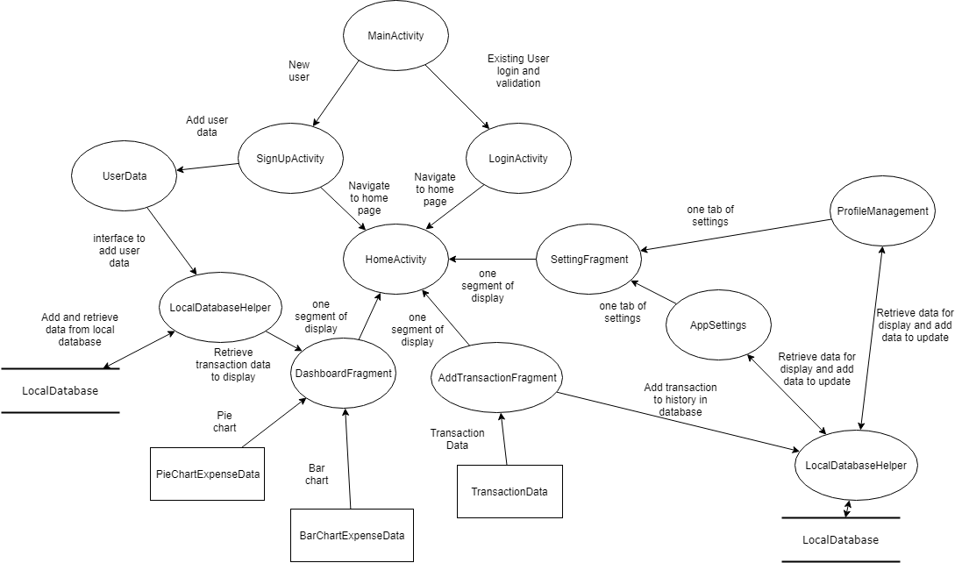

**TEST PLAN**

**Project Number: 06-CSE D**

**Project Name: Expense-Tracker Application**

**Description: An android application which keeps the track of all the expenses made by the user and also maintains the record of all the transactions made in the past.**

**Project Test Plan :**

|  |  |
| --- | --- |
| **Test plan objectives** | ***To ensure that Expense tracker System will:***   * ***Function consistently and reliably in accordance with current business operations*** * ***Meet the user requirements and technical specification.*** |
| ***Testing Assumption*** | ***It is assumed that there are few users whose personal details are already stored in the database.*** |

|  |  |
| --- | --- |
| **Features to be Tested** | ***All features, modules, reports and interfaces affected by the Expense tracker System will be tested. These include:***  ***Login Module***  ***Sign-up Module***  ***Transaction Module***  ***Profile Management***  ***Settings Management*** |

**Sign-Up Module :**

**To sign-up to the application :**

* No field Should be empty otherwise it will show an error .
* Email validation : It should be a valid email address otherwise it will throw an error.

|  |  |
| --- | --- |
| **Test Cases** | **Valid/Not Valid** |
| shantamb@yahoo.in | Valid |
| aakash97@gmail.com | Valid |
| dskbsdbsddsk@isdnidn | Not valid |
| pnirmal@gmail.com | Valid |
| aaweddrf@ghhnns | Not valid |
| expensetrack@hjjdfjk | Not valid |
| sammarthb@gmail.com | Valid |

**Password Validation :**

* Password should be of minimum 8-14 letters with an uppercase,a number and a special character else it will show an error while signing up.

|  |  |
| --- | --- |
| **Test Cases** | **Valid /Not Valid** |
| Asdfghjkl@22 | Valid |
| qwertyuiop!98 | Not valid |
| Qwertyui@!98 | valid |
| asdfghjkl | Not valid |
| newn | Not valid |
| Newnumber@12 | Valid |
| ubajbsd | Not valid |

**Other cases:**

* If the user has already signed up before then he/she cannot use the same credentials to sign-up again.
* If the password and confirm password doesn’t match it throws an error.
* All the fields should be filled else throws an error.
* After validating it stores the details of the person in the database.

**Login Module :**

* A user can login using either phone number /email.
* If the user’s credentials are wrong it throws an error.
* It checks the database and matches the credentials of the user .
* If the password and the credentials matches it goes to a user dashboard where he can manage his profile , settings etc.

**Transaction Module :**

* Add transaction in particular category with description, income or expense and date of transaction.
* Remove transaction with transaction id
* Update transaction details with transaction id
* Display transaction in a list view for a custom dates range.

**Test cases add transaction**

|  |  |
| --- | --- |
| **Add amount** | **Accept /not accept** |
| 100 | accept |
| 0 | Not accept |
| 12.545782 | accept |
| 0.1545 | accept |

1. Delete transaction will work for all cases.
2. Update transaction will work for all cases including when amount is “ 0 .”
3. Display transaction will work for all cases.

**Profile Management Module :**

* **Display user data**
* **Update user data**

**Display user data:**

* Displaying user data in all cases.
* If user doesn't exist cannot display the dat**a**

**Updating user data:**

* If user exist he/she can update the user details and the updated details will be displayed.