Game Design Document

Fill up the Following document

1. Write the title of your project.

### Adventures Of Hunter

1. What is the goal of the game?

To find the Sword of Ares and defeat the Herald

1. Write a brief story of your game?

### Hunter

is a young hero from Arcadia. He had started his adventure yesterday

And he is going to the Cave of the Herald. But he needs the Sword of Ares

If he wishes to defeat the Herald. Fortunately for him the sword is found at the entrance of the Herald but he has to venture through the Howling Jungle and defeat all the creatures.

1. Which are the playing characters of this game?

* Playing characters are the ones which respond to the user based on the input from the user
* Cars, monkeys, dinos, wizards etc, are the playing characters in the game.

|  |  |  |
| --- | --- | --- |
| Number | Character Name | What can this character do? |
| 1 | Hunter | He can summon energy blasts from his staff. |
| 2 |  |  |
| 3 |  |  |
| 4 |  |  |
| 5 |  |  |
| 6 |  |  |
| 7 |  |  |
| 8 |  |  |

1. Which are the Non Playing Characters of this game?

* Non Playing characters are the ones which don't have an action or a behaviour when the user interacts with the game.
* Hurdles, stones, bananas, coins, etc are non playing characters in the game.

|  |  |  |
| --- | --- | --- |
| Number | Character Name | What can this character do? |
| 1 | Herald |  |
| 2 | Crawlers | Ground obstacles |
| 3 | Flyers | Air obstacles to give adabtivity |
| 4 | Sword of Ares | Gives bonus speed to Link |
| 5 |  |  |
| 6 |  |  |
| 7 |  |  |
| 8 |  |  |

Draw your imagination of this game. What does this game look like?

* Draw the game either on your computer or on paper,
* Add images of scenes of the game to show each of the playing and non-playing characters at least once.

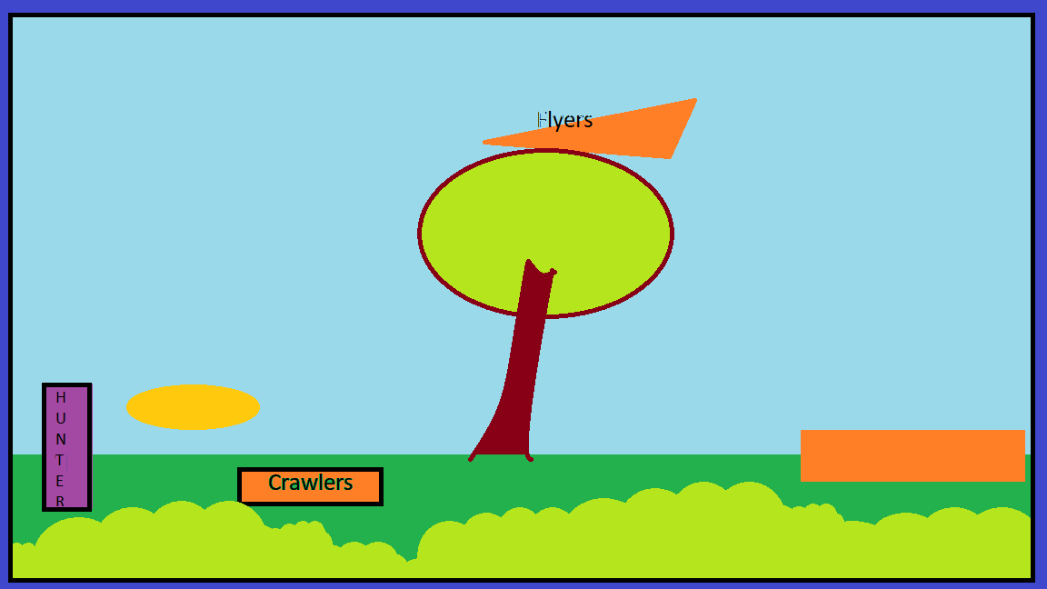

How do you plan to make your game engaging?

Sword of Ares increases speed

Increase Number of Flyer Spawn