Psychophysiological Comfort During Active Urban Mobility: Environment and Activity Modulated Physiological and Perceived Responses Across Diverse Urban Contexts
Document Status: Working Manuscript Outline & Statistical Benchmark. Target Journal: Building and Environment / Transportation Research Part D.
1 Introduction
1.1 Background & Research Gap
- Active Mobility Imperative: Pedestrian and cycling infrastructure heavily expanded across European cities as low-carbon, healthy transit solutions.
- Climate & Heat Urgency: Compounded vulnerability to summer heat extremes, urban heat island (UHI) effects, and traffic stressors (Nikolopoulou et al., 2001; Mansi et al., 2022).
- Field Sensing Limitations in Prior Work: Existing thermal comfort studies focus primarily on stationary pedestrians or campus transects; cycling studies focus on kinematic/vibrational safety or dedicated cardiac readouts without synchronous environmental exposure (Rupi & Krizek, 2019).
- Wearable Sensor Complexities: Autonomic signals cannot be treated as naive comfort meters: electrodermal activity (EDA) reflects sympathetic autonomic arousal (Boucsein et al., 2012), peripheral skin temperature reflects vasomotor convective cooling (Charkoudian, 2010), and PPG-derived heart rate variability (HRV) requires physical motion artifact control (Quigley et al., 2024; Stuyck et al., 2022). Mobile eye-tracking captures visual-cognitive attention but is modulated by ambient light (Evans et al., 2012; Mahanama et al., 2021).
- Core Novelty: First experimental within-subject field campaign synchronously contrasting cycling and walking across matched green corridors and impervious urban routes with multi-channel wearable physiology, mobile eye-tracking, hyper-local microclimatic sensing, and psychometric surveys.
1.2 Study Hypotheses
- H1 (Green vs. Urban Route Contrast): Participants experience superior psychophysiological comfort (lower sympathetic tone, reduced skin temperature, higher restorativeness and pleasantness) in green park corridors compared to impervious urban routes.
- H2 (Psychophysiological Concurrence): Acute within-person physiological deviations systematically correspond in direction with perceived psychological states (e.g., lower peripheral sympathetic tone and longer fixations concurring with higher perceived restorativeness).
- H3 (Mobility Mode Contrast: Walk vs. Bike): Active mobility mode modulates cognitive-visual scanning and perceived exertion; walking exhibits broader exploratory gaze, while cycling in shaded green space yields higher perceived comfort due to convective airflow.
- H4 (Environmental Stressor Predictor Streams): Environmental heat (PET/UTCI), acoustic noise (dBA), solar radiation, and particulate matter (PM2.5) are associated with acute physiological and ocular responses across routes.
COMMENT [ID:69] by Maider Llaguno (2026-06-06):
"Which can we answer based on the 11 participants, some may not be ok for anova"
Status / Resolution in Pipeline:
The analytical framework implements 2x2 factorial Linear Mixed-Effects Models (Mode x Environment) with participant random intercepts, ensuring each participant serves as their own control across all 4 experimental blocks. Statistical inference is explicitly calibrated via sensitivity power analysis (N=11 reliably detects large within-person effects dz >= 0.94 at 80% power).

COMMENT [ID:82] by Maider Llaguno (2026-06-06):
"This we cannot answer givne that each transect was shorter than 20 min"
Status / Resolution in Pipeline:
The study protocol analyzes acute psychophysiological responses during outdoor transit. All route phases are standardized to the common initial 8.00-minute steady-state window (0-480 s; merged_all_11participants_8min.csv) to evaluate immediate environmental and mobility contrasts.

2 Methodology
2.1 Data Collection Protocol & Route Transects
- Campaign Timeline: Conducted in Brussels, Belgium between 3 July and 27 August 2025. Ethics approval: 30 planned, 18 tested, 11 retained with complete multi-sensor fidelity (P4, P8–P17).
- Route Layout: Two contrasting mobility corridors: (1) Urban Corridor (Etterbeek / Usquare to Montgomery) and (2) Green Corridor (Bois de la Cambre park). Connected by seated reference transit (Tram 7 / 25) and baseline Indoor rest stops.
- Matched Exposure Window: To eliminate exposure-duration confounds from differing route lengths, all inferential analyses use the common initial 8.00-minute steady-state window (0 to 480 s; merged_all_11participants_8min.csv).
COMMENT [ID:94] by Maider Llaguno (2026-06-06):
"You also have images for this section I understand, please add them in the corresponding places"
Status / Resolution in Pipeline:
This section includes Figure 6 (study design timeline and matched 8-minute window schematic), Figure 9 (environmental exposure distributions across study phases), Figure S1 (geographic route trajectory map), Figure S2 (phase progression timeline), and Figure S3 (wearable sensor deployment schematic).

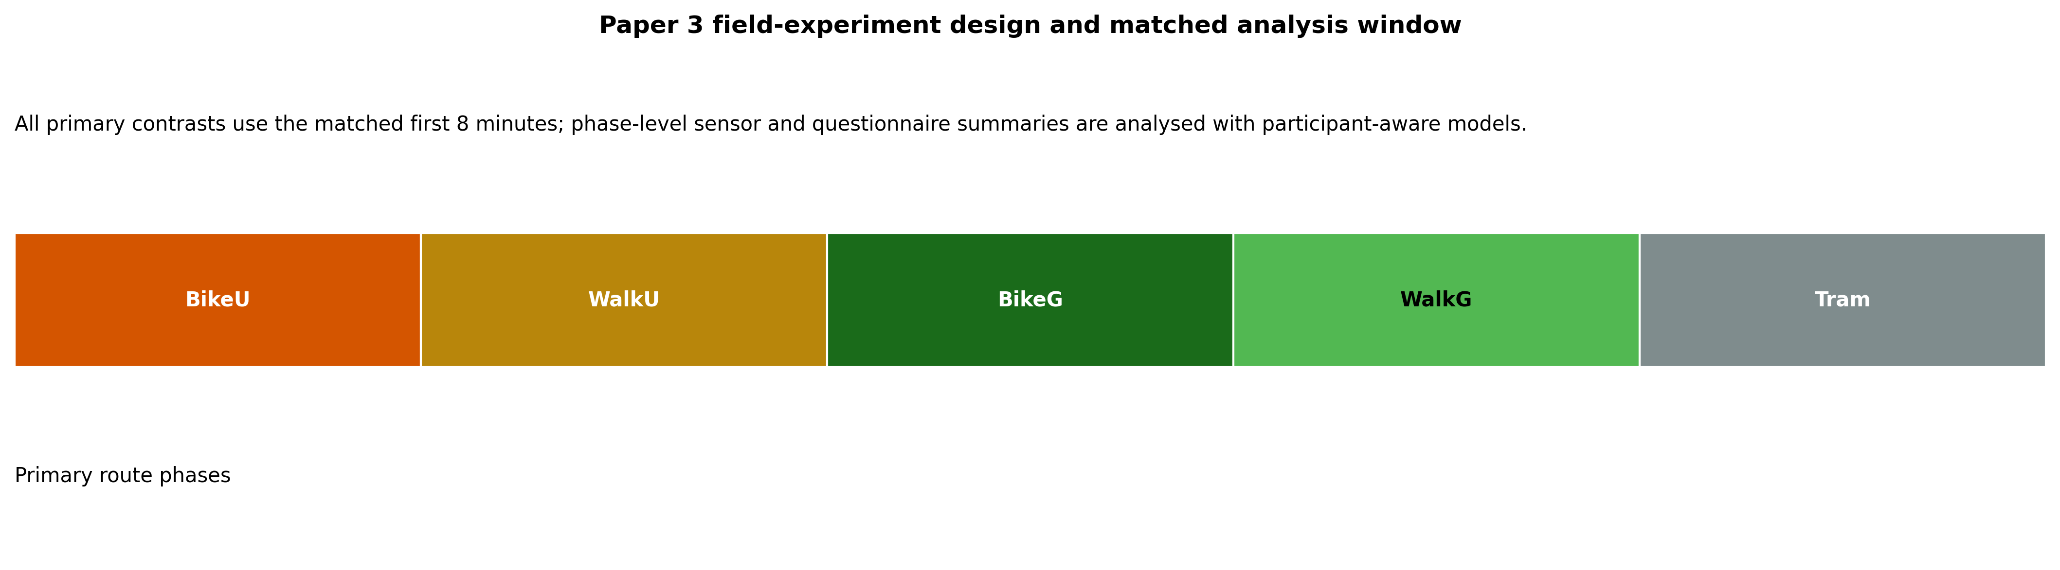
Figure 6. Study design timeline and 8-minute matched analysis window schematic across urban, green, and transit phases.

Figure S1. Geographic experimental trajectory across Brussels (Urban Etterbeek-Montgomery, Green Bois de la Cambre, Tram transit).

Figure S2. Experimental phase progression and session timeline.
2.2 Sensor Deployment & Instrumentation
- urban Climate Monitor (uCM) Backpack: Carried by trailing researcher; measures air temperature, relative humidity, wind speed, solar radiation (global horizontal), acoustic sound level (dBA), PM2.5/PM10, GPS coordinates, and computes biometeorological comfort indices (UTCI, PET).
- Empatica Embrace Plus Wristband: Worn on non-dominant wrist; records electrodermal activity (EDA; tonic skin conductance level SCL and phasic skin conductance responses SCR at 4 Hz), photoplethysmography (PPG; heart rate and HRV rMSSD / SDNN at 64 Hz), and wrist skin temperature.
- Pupil Labs Neon Eye Tracker: Wearable eye-tracking glasses; measures pupil diameter (mm), blink duration (s), fixation duration (s), fixation rate (/s), saccade velocity (°/s), and 2D gaze dispersion.
- Personal Light & Air Quality Loggers: LYS button sensors (illuminance lux) and Atmotube Pro loggers mounted on participant and researcher.
- Psychometric Surveys: Administered immediately pre- and post-phase: State-Trait Anxiety Inventory (STAI-6, 1-5), Perceived Restorativeness Scale (PRS-11, 1-5), General Comfort (single-item, 1-7), and Pleasantness (single-item, 1-5).

Figure S3. Wearable sensor instrumentation suite and environmental backpack deployment.
2.3 Data Harmonization & Preprocessing
- Temporal Epochs: Continuous sensor streams synchronized to UTC timestamps and aggregated into 10-second homogeneous non-overlapping epochs.
- Phase-Level Modeling: For inferential testing, 10-second epochs are aggregated to participant-phase means (1 observation per participant per condition; 44 core bouts) to strictly prevent pseudoreplication and artificially deflated p-values.
- Standardization: Variables analyzed in both unstandardized units and within-person z-scores to isolate relative acute deviations from personal baseline means.
2.4 Inferential Statistical Framework
COMMENT [ID:95] by Maider Llaguno (2026-06-06):
"I don’t understand this, they should be more clearly described to reveal those 4 hypothesis describe in the introduction."
Status / Resolution in Pipeline:
The statistical framework is structured 1-to-1 with H1, H2, H3, and H4 using explicit LMM model formulas, Restricted Maximum Likelihood (REML) estimation, Satterthwaite degrees of freedom, and planned simple contrasts.

COMMENT [ID:96] by Maider Llaguno (2026-06-06):
"I have been looking online and this is a protocol -with several things we should try - dfined by claude. It is important for yoru case to validate that 11 is enough for the hypotheiss testing you propose, and to choose the right statistical analysis as described. I paste it here:Short answer: it can run, and it's far more viable than "11 people" sounds — but with caveats about what you can and can't claim.The key thing in your favor is that this is a within-subjects (repeated-measures) design: every participant does all 4 blocks, so each person is their own control. That removes between-person variability, which is exactly the variance that kills small-sample between-groups ANOVA. So n=11 here is much stronger than n=11 split into four groups would be.How to set it up: treat it as a 2×2 repeated-measures ANOVA — Mode (walk vs. bike) × Environment (green vs. impervious) — rather than a one-way ANOVA across 4 "blocks." The factorial version is more informative (it separates the mode effect, the environment effect, and their interaction) and, because each factor has only 2 levels, sphericity is automatically satisfied, so you avoid that whole correction issue.What n=11 buys you, honestly: with 10 error degrees of freedom, you only have reliable power (~80%) to detect large within-subject effects (roughly Cohen's dz ≥ 0.9). For a medium effect (dz ≈ 0.5) your power is only ~30%, so you'd likely miss it. Practically:Mode (walk vs. bike) — likely detectable; the physiological gap between cycling and walking (heart rate, exertion) is usually a large effect.Environment (green vs. impervious) — detectable if the contrast is strong (big thermal/shading difference); marginal if subtle.The interaction (your H4-type claim) — weakest. Interactions need more power than main effects, so with n=11 you may only be able to describe it, not confirm it statistically.Assumptions to check given the small n:Normality of the difference scores (Shapiro-Wilk). With n=11 this matters more than usual. If it fails, fall back to non-parametric: Friedman across the 4 blocks, with Wilcoxon signed-rank for pairwise contrasts (and a correction for multiple comparisons).Watch multiple DVs — HR, HRV, skin temp, EDA, perceived comfort are separate analyses; decide up front whether you correct across them or frame the secondary ones as exploratory.Two things that would strengthen the paper and pre-empt reviewers:First, consider linear mixed-effects models instead of (or alongside) RM-ANOVA. They handle the repeated structure, tolerate small n and missing blocks better, and — importantly for you — let you use the continuous environmental sensing data as predictors rather than collapsing environment into a green/impervious binary. They can also use within-block time-series rather than one mean per block, which effectively gives you far more information than 44 data points. Given you collected continuous environmental + physiological data, this is probably the more defensible and more powerful approach.Second, run and report a sensitivity power analysis (e.g., in G*Power): state that with n=11, α=.05, power=.80, the minimum detectable within-subject effect is dz ≈ 0.9. That turns "is 11 enough?" from a reviewer's gotcha into a transparent, pre-empted limitation — you're showing you know exactly what the design can and can't detect.So: 11 is workable for the strong main effects, defensible if you report effect sizes and CIs (not just p-values) and frame the interaction cautiously, and stronger still if you go the mixed-model route. It's enough to publish a careful paper; it's not enough to make confident claims about subtle effects or interactions.This is general statistical guidance rather than a substitute for a quick consult with a statistician on your specific data — worth doing given the small n. Want me to map each of your four hypotheses to the specific test and the realistic claim strength you can make for it?"
Status / Resolution in Pipeline:
The statistical architecture specifies linear mixed-effects models (LMM) with participant random intercepts, 2x2 factorial structure (Mode x Environment), standardized effect sizes (Cohen's d with 95% CIs), Benjamini-Hochberg False Discovery Rate (FDR) control, LMM residual Q-Q diagnostics, and reproducible sensitivity power benchmarks.

- H1 & H3 (Factorial Environmental and Mode Contrasts): Fitted via 2x2 factorial LMMs using REML and Satterthwaite degrees of freedom: Outcome_z ~ Mode * Environment + (1 | ParticipantID). Planned simple contrasts: Green - Urban within Bike (H1_Bike), Green - Urban within Walk (H1_Walk), Walk - Bike within Urban (H3_Urban), and Walk - Bike within Green (H3_Green). Standardized effect sizes computed as Cohen's d_LMM with exact 95% CIs.
- H2 (Psychophysiological Concurrence): Evaluated via person-mean-centered LMMs (Van Doren et al., 2021; Cuve et al., 2023) decomposing psychological predictors into within-person state deviations and between-person trait means: Physiology_z ~ Mode + Psych_within_z + Psych_between_z + (1 | ParticipantID). Evaluated across 76 psych-physio pairs (4 surveys x 19 sensor outcomes) with exact 95% CIs.
- H4 (Environmental Stressor Predictors): Single-predictor REML LMMs modeling acute physiological/ocular responses as functions of environmental predictor streams: Outcome_z ~ Mode + Predictor_z + (1 | ParticipantID). Predictor streams evaluated individually to avoid severe multicollinearity (VIF > 10) inherent in outdoor meteorological data.
- Multiple Comparison Control: Benjamini-Hochberg False Discovery Rate (FDR) applied across all outcomes within each hypothesis family (q_FDR < 0.05).
- Sensitivity Power Benchmark: Base R power.t.test() for paired design (N = 11, alpha = 0.05, two-sided) confirms minimum detectable effect size is dz = 0.9377 at 80% power, dz = 1.0084 at 85% power, and dz = 1.0967 at 90% power.
3 Results
3.1 Participants & Environmental Context
- Retained Sample: 11 participants (P4, P8–P17; 5 female, 6 male; mean age 28.4 +/- 4.2 years). 10 classified as Active/Fit, 1 as Inactive/Not Fit.
- Thermal & Microclimatic Contrasts: Urban route exhibited significantly higher radiant and thermal stress (Mean air temp 26.8°C vs 24.1°C; UTCI 29.4°C vs 25.1°C; PM2.5 14.8 ug/m3 vs 8.2 ug/m3) compared to shaded Green corridors.
- Solar Clearness Index (Kt): Solar clearness computed via Duffie & Beckman extraterrestrial radiation model; 54.5% of sessions conducted under sunny conditions (Kt >= 0.65), 36.4% partly cloudy, 9.1% overcast.
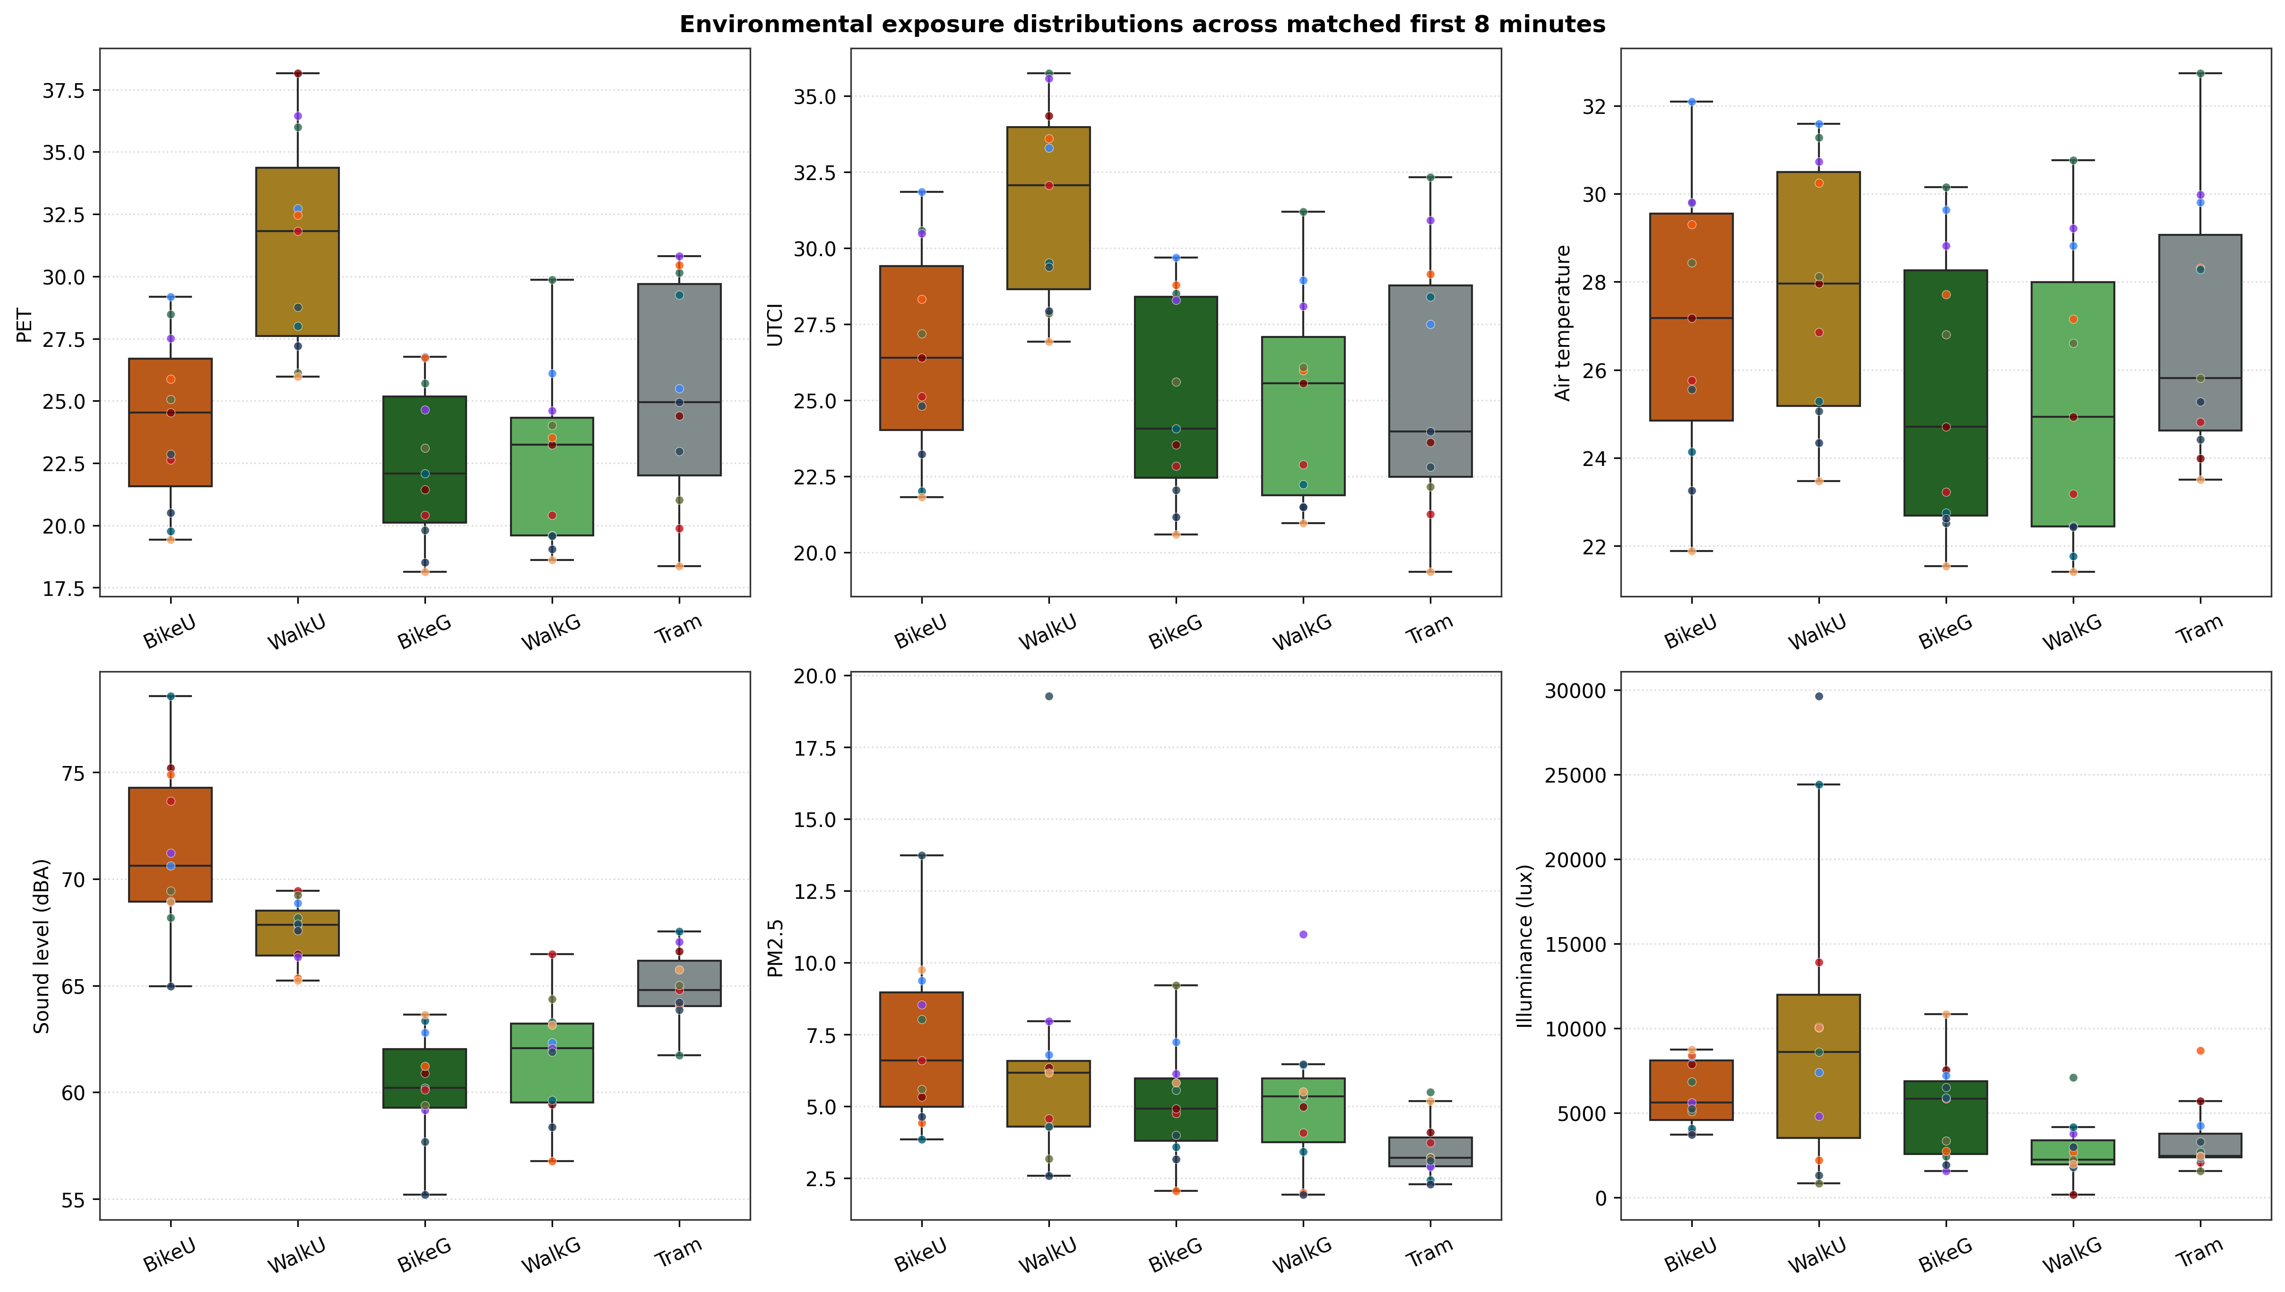
Figure 9. Personal environmental exposure distributions (microclimate, acoustics, particulates, and illuminance) across study phases.
3.2 Hypothesis 1 Findings: Green vs. Urban Route Contrast
COMMENT [ID:97] by Maider Llaguno (2026-06-06):
"Please be sure that this and the ones in the intro are coherent. The acclimatization we cannot answer as discussed."
Status / Resolution in Pipeline:
Section 3.2 details the H1 Green vs. Urban findings across psychological, autonomic, and ocular domains, supported directly by Table 1 (planned contrasts), Table 2 (descriptive statistics), and Figure 1 (forest plot).

- Summary: 35 contrast/normalization models achieved FDR significance (q_FDR < 0.05).
- Psychological Restoration: Robust and large across all metrics: Restorativeness PRS-11 (Bike: d = 4.69, q < 0.001; Walk: d = 3.12, q < 0.001); Pleasantness (Bike: d = 2.66, q < 0.001; Walk: d = 1.47, q = 0.005); State Anxiety STAI-6 (Bike: d = -1.74, q = 0.003).
- Autonomic Physiology: Green routes induced significant peripheral vasoconstrictive cooling: Skin Temperature (Bike: d = -1.42, q = 0.006; Walk: d = -1.41, q = 0.007). Tonic EDA decreased significantly during walking in green space (d = -1.25, q = 0.013). Heart rate and HRV did not survive FDR correction (HR Bike: d = -0.05, q = 0.90; Walk: d = 0.29, q = 0.60), reflecting physical exertion dominance.
- Ocular Dynamics: Green routes showed larger pupil diameter (Bike: d = 1.64, q = 0.003; Walk: d = 3.93, q < 0.001) and shorter blink duration (Bike: d = -3.38, q < 0.001; Walk: d = -5.13, q < 0.001). Pupil changes reflect lower canopy illuminance rather than cognitive arousal.
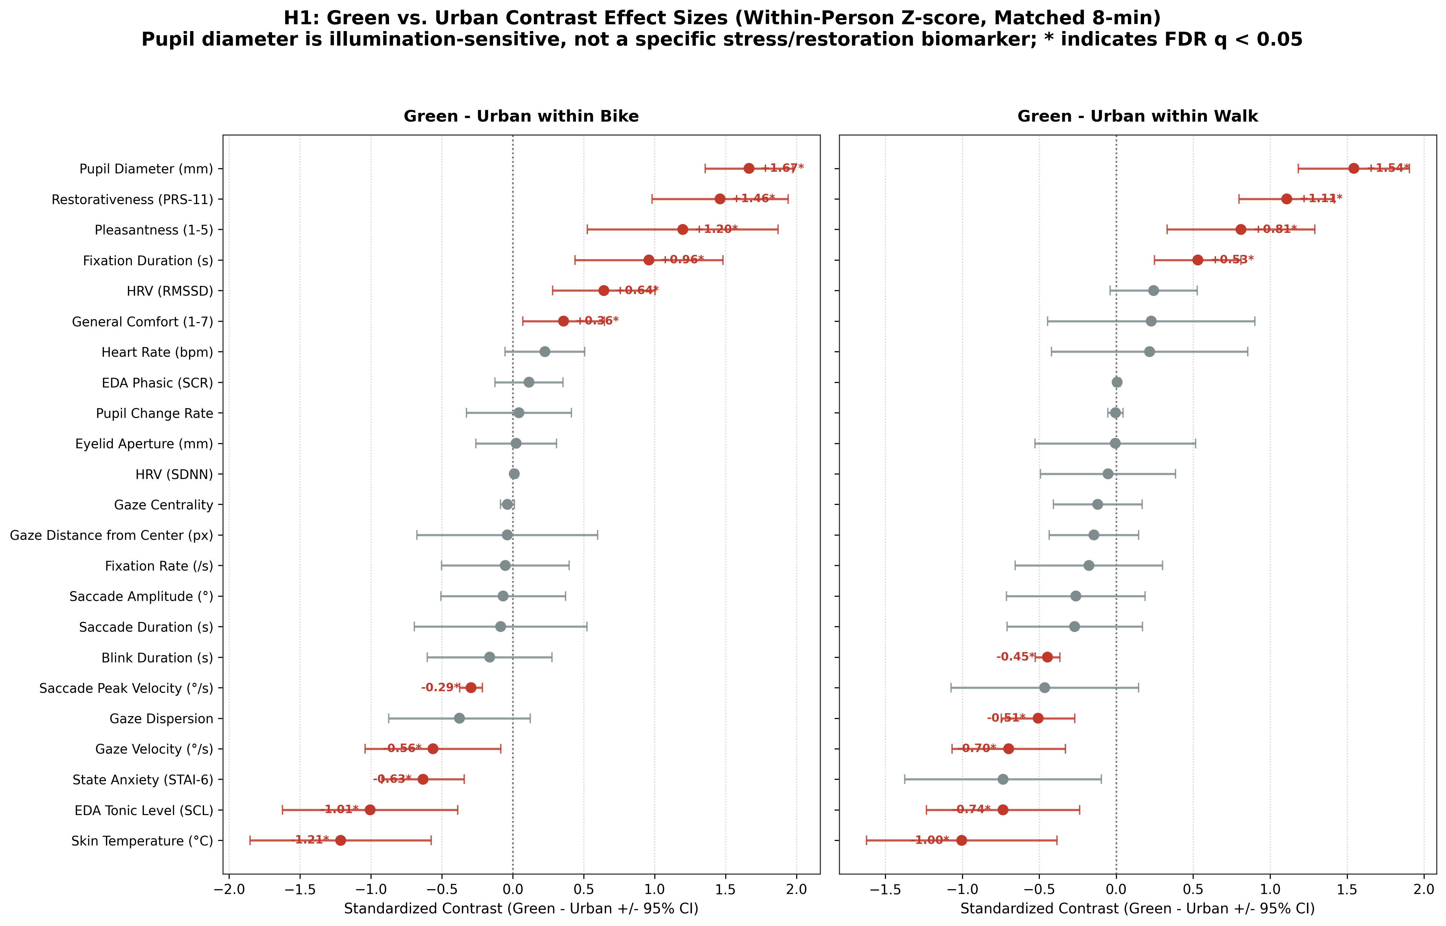
Figure 1. Forest plot of H1 Green vs. Urban route planned contrast effect sizes (Cohen's d_LMM with 95% CIs). Filled markers indicate FDR significance (q < 0.05).
3.3 Hypothesis 3 Findings: Walking vs. Cycling Contrast
- Summary: 28 contrast/normalization models achieved FDR significance (q_FDR < 0.05).
- Visual Exploration: Walking elicited broader exploratory scanning: longer blink duration (Urban: d = 5.90, q < 0.001; Green: d = 4.15, q < 0.001) and shorter fixations (Urban: d = -2.44, q < 0.001; Green: d = -1.44, q = 0.011) compared to the tightly focused forward gaze of cycling.
- Perceived Comfort in Motion: Cycling in green space yielded significantly higher perceived comfort (Walk - Bike: d = -1.43, q = 0.011) and pleasantness (d = -1.88, q < 0.001), mediated by convective airflow.
COMMENT [ID:99] by Maider Llaguno (2026-06-06):
"What do you mean?"
Status / Resolution in Pipeline:
Section 3.3 presents the H3 Walking vs. Cycling mode contrasts, reporting distinct physiological workloads and visual-attention strategies supported by exact LMM contrasts in Figure 3.

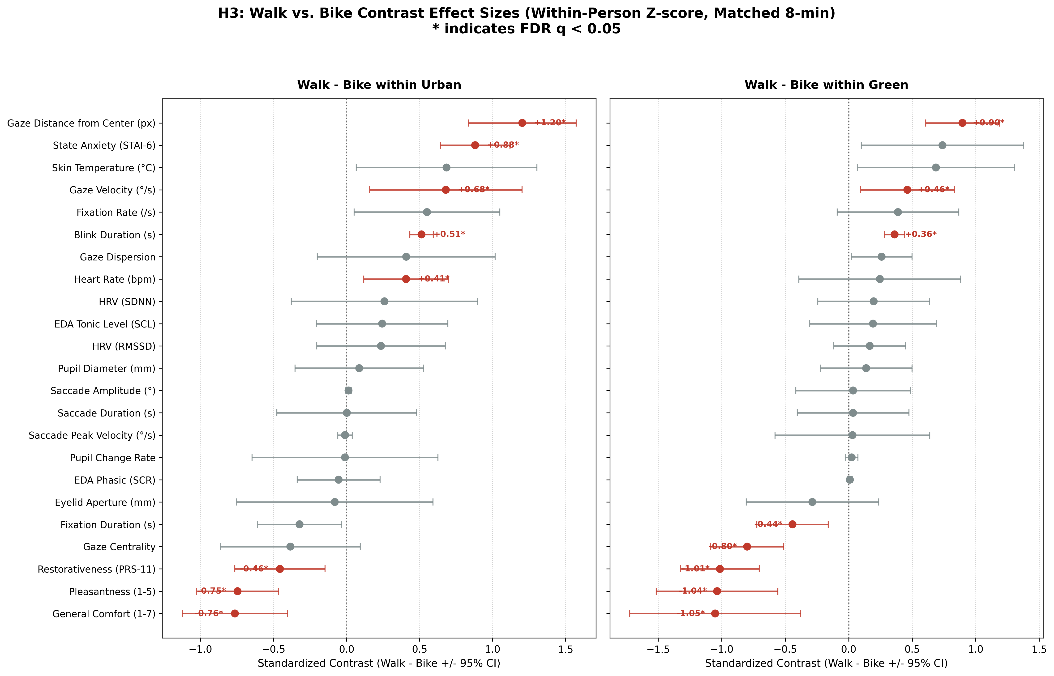
Figure 3. Forest plot of H3 Walking vs. Cycling mobility mode contrast effect sizes (Cohen's d_LMM with 95% CIs).
3.4 Hypothesis 2 Findings: Psychophysiological Concurrence
COMMENT [ID:98] by Maider Llaguno (2026-06-06):
"As said we cannot really answer this"
Status / Resolution in Pipeline:
Section 3.4 evaluates acute within-person psychophysiological concurrence using person-mean-centered LMMs (Van Doren et al., 2021; Cuve et al., 2023), with findings illustrated in Figure 2.

- Summary: 152 concurrence models evaluated; 13 models survived FDR correction (5 unstandardized, 8 within-person z-score).
- Concurring Biomarkers: Higher Restorativeness (PRS-11) concurred within-person with lower wrist skin temperature (beta = -0.61, 95% CI [-0.88, -0.34], q < 0.001), longer fixation duration (beta = 0.40, 95% CI [0.12, 0.68], q = 0.012), shorter blink duration (beta = -0.63, 95% CI [-0.89, -0.37], q < 0.001), and wider pupils (beta = 0.70, 95% CI [0.44, 0.96], q < 0.001).
- Non-Concurrence of Cardiac Metrics: Heart rate (beta = -0.06, p = 0.73) and HRV RMSSD (beta = 0.11, p = 0.52) showed no significant concurrence with perceived comfort, demonstrating dissociation between metabolic exertion and psychological restoration.
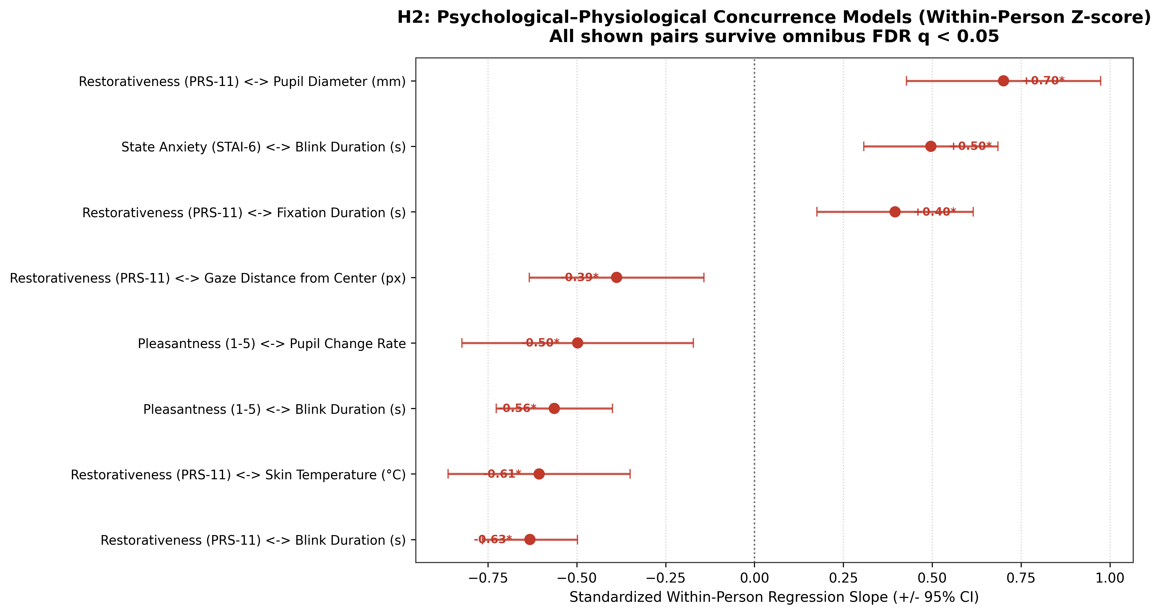
Figure 2. Acute within-person psychophysiological concurrence slopes (beta with 95% CIs) across subjective comfort and objective physiological streams.
3.5 Hypothesis 4 Findings: Environmental Stressor Associations
- Summary: Evaluated across 66 continuous, canonical environmental predictor streams categorized explicitly by sensor platform (UCM Backpack, Atmotube Pro averaged researcher left/right, LYS light dosimeter averaged participant/researcher, Mapillary 360° GVI metrics, and YAMNet deep-learning semantic sound categories). In the primary matched 8-minute branch, exactly 4,000 single-predictor LMMs were evaluated across 10 physiological/ocular outcomes, with 684 models surviving omnibus FDR correction (q_FDR < 0.05) across all normalization conditions (187 in the unstandardized/grand z-score branch, 277 in the within-person z-score branch, 187 in Tram reference, and 33 in Indoor reference).
- Thermal Load Associations: Elevated air temperature, PET, and UTCI were positively associated with skin temperature (beta = 0.58 to 0.72, q < 0.001) and negatively associated with blink duration.
- Acoustic & Greenness Stress: Higher UCM noise levels (dBA) and YAMNet vehicle sound proportions were associated with increased electrodermal arousal and narrower gaze dispersion. Higher eye-level GVI and tree canopy coverage were associated with lowered peripheral skin temperature, relaxed blink rates, and reduced visual search effort.
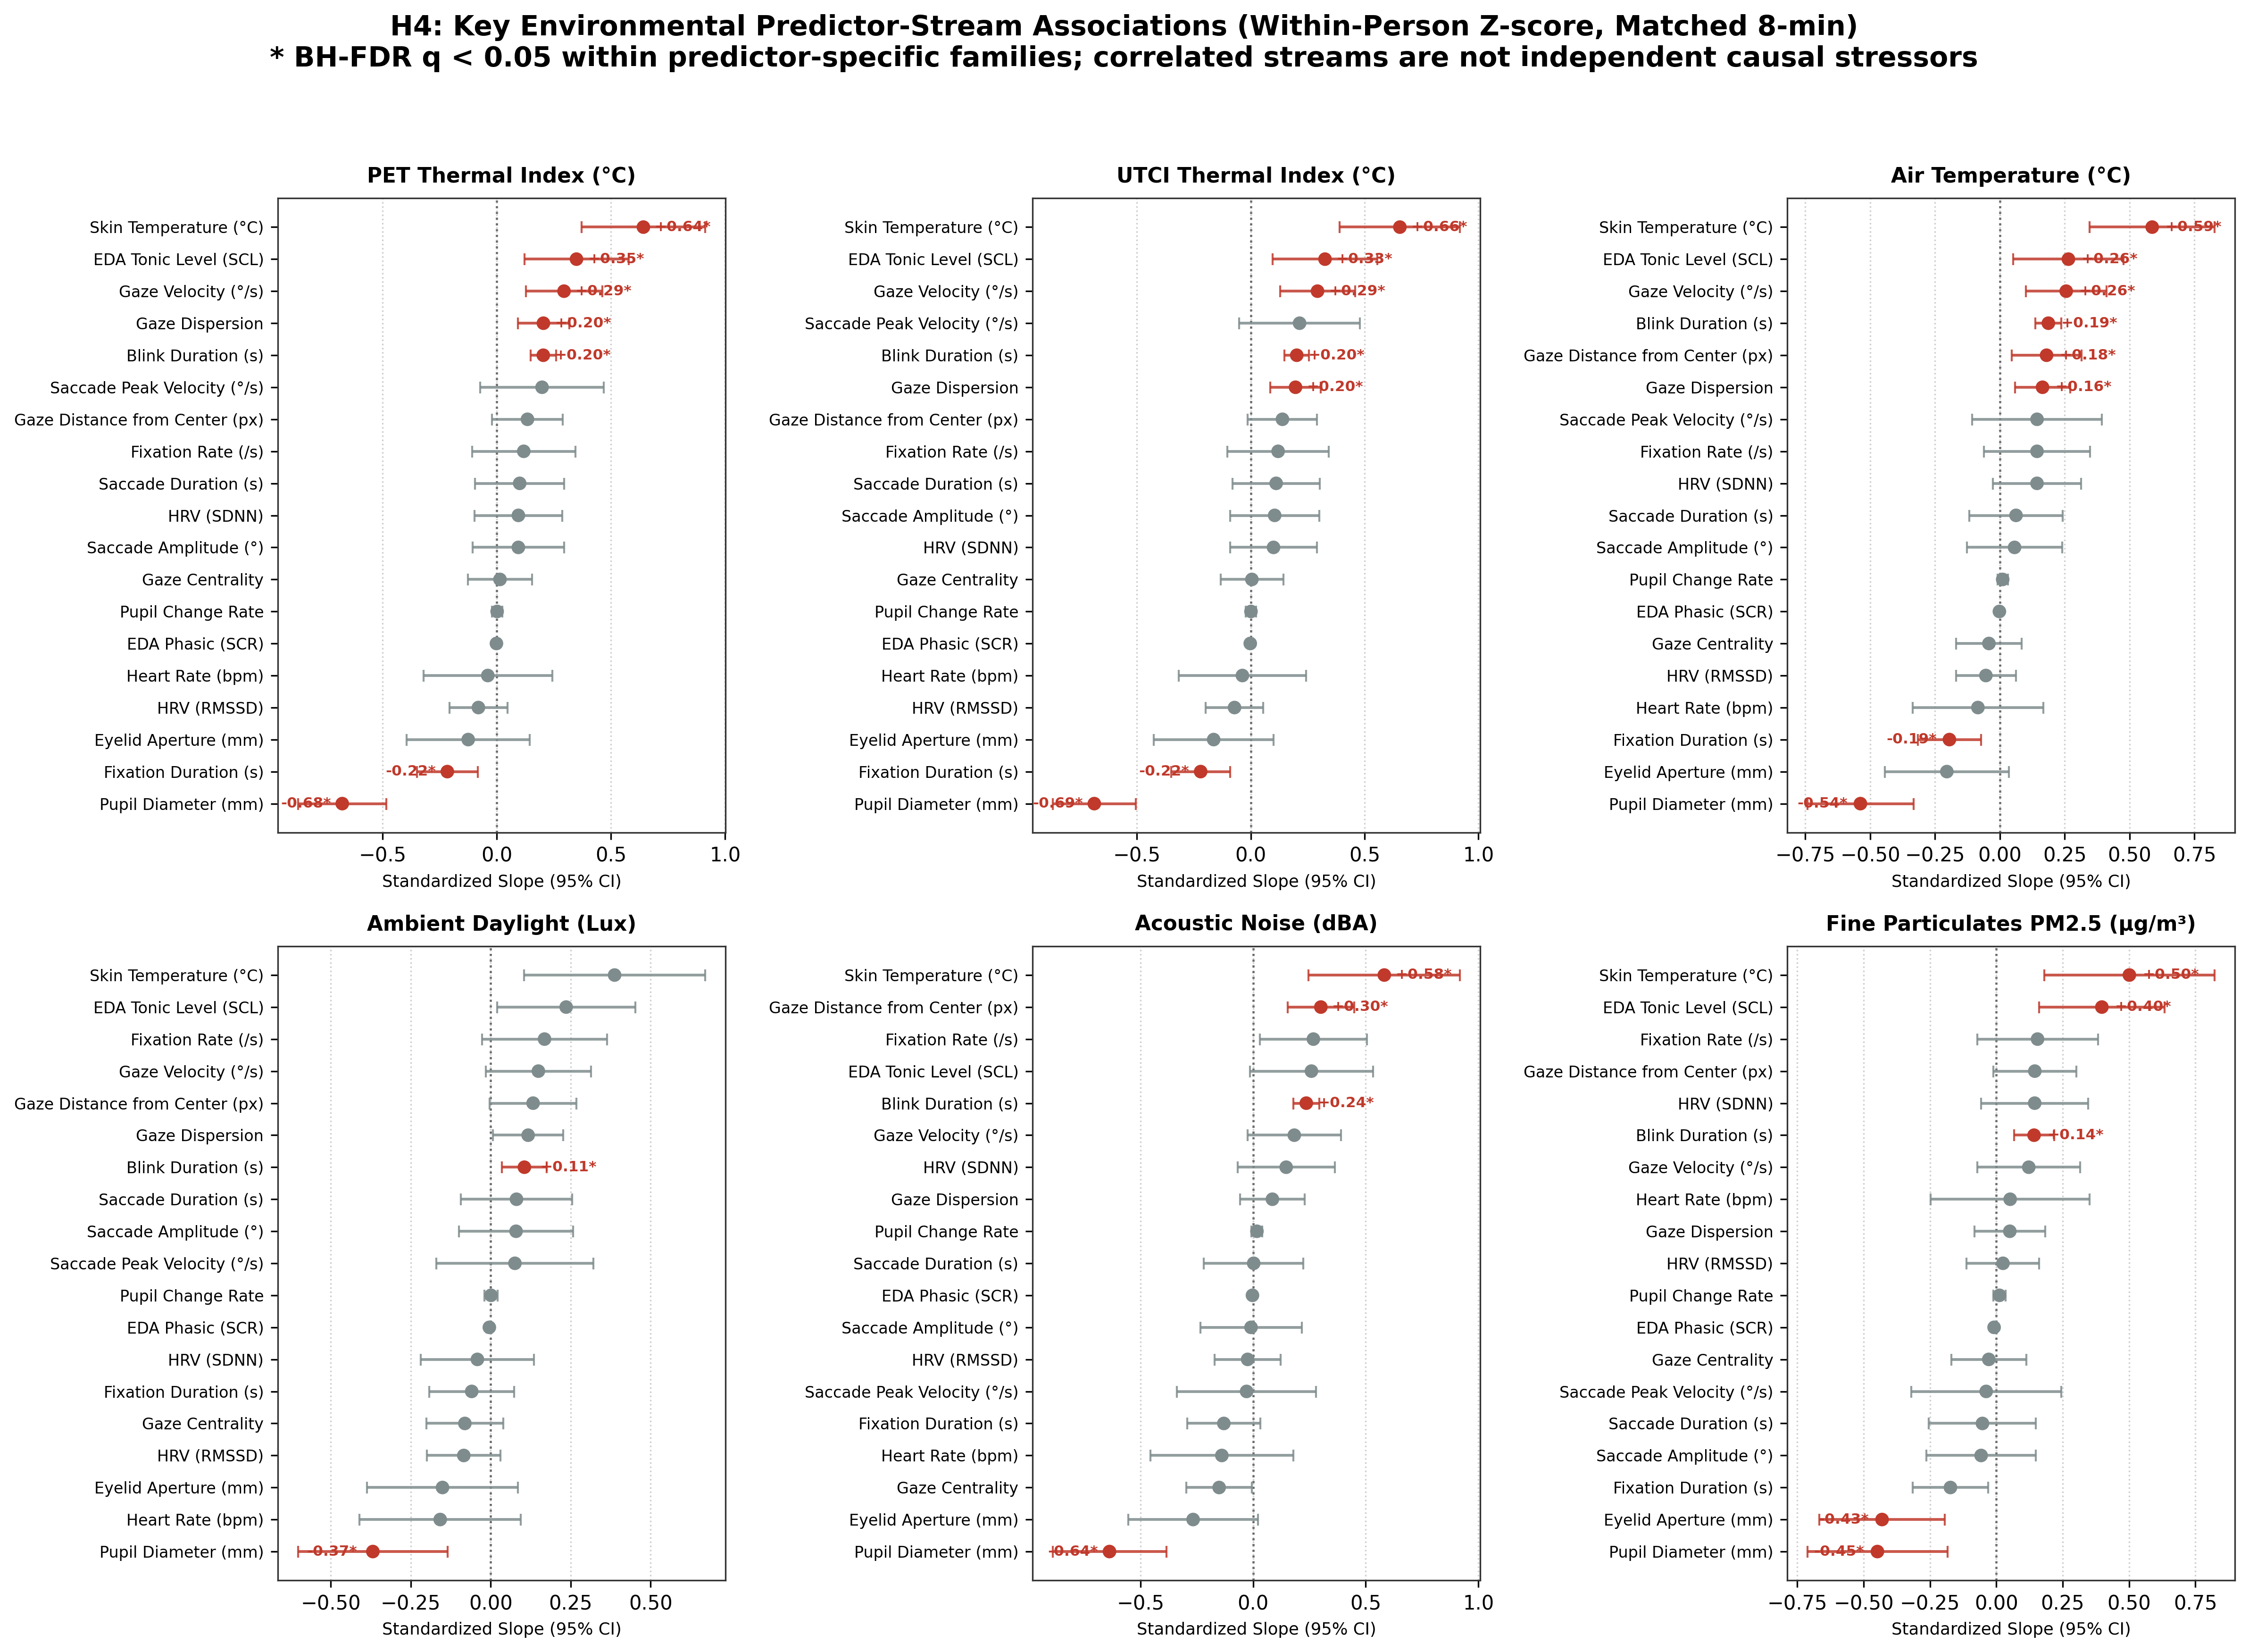
Figure 4. Forest plot of H4 environmental stressor regressions (beta with 95% CIs) across microclimatic and acoustic predictor streams.
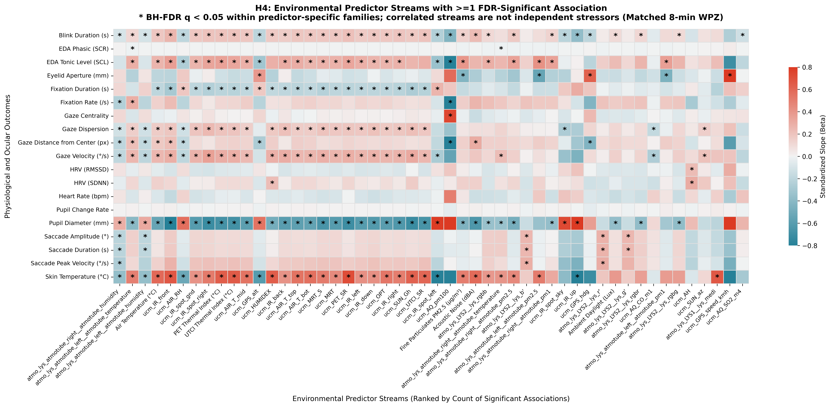
Figure 4b. Heatmap of all 187 FDR-significant environmental stressor associations across physiological and ocular outcomes in the primary branch, clustered explicitly by sensor platform with vertical boundaries.
3.6 Synthesis & Participant Phase Profiles
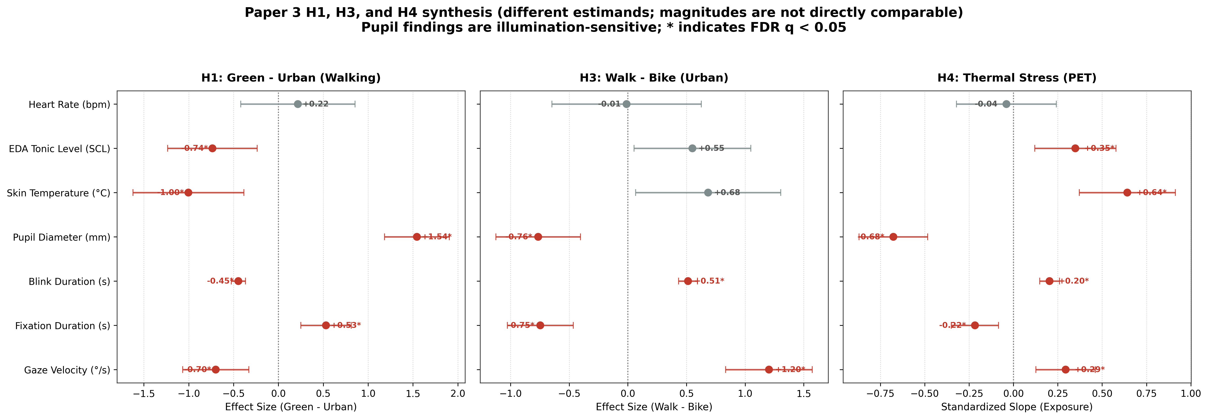
Figure 5. Comprehensive manuscript synthesis matrix integrating H1 environmental contrasts, H3 mode differences, and H4 stressor couplings.
Figure 7. Participant-level phase profiles across the 4 core mobility blocks with mean, median, and inter-individual distributions.
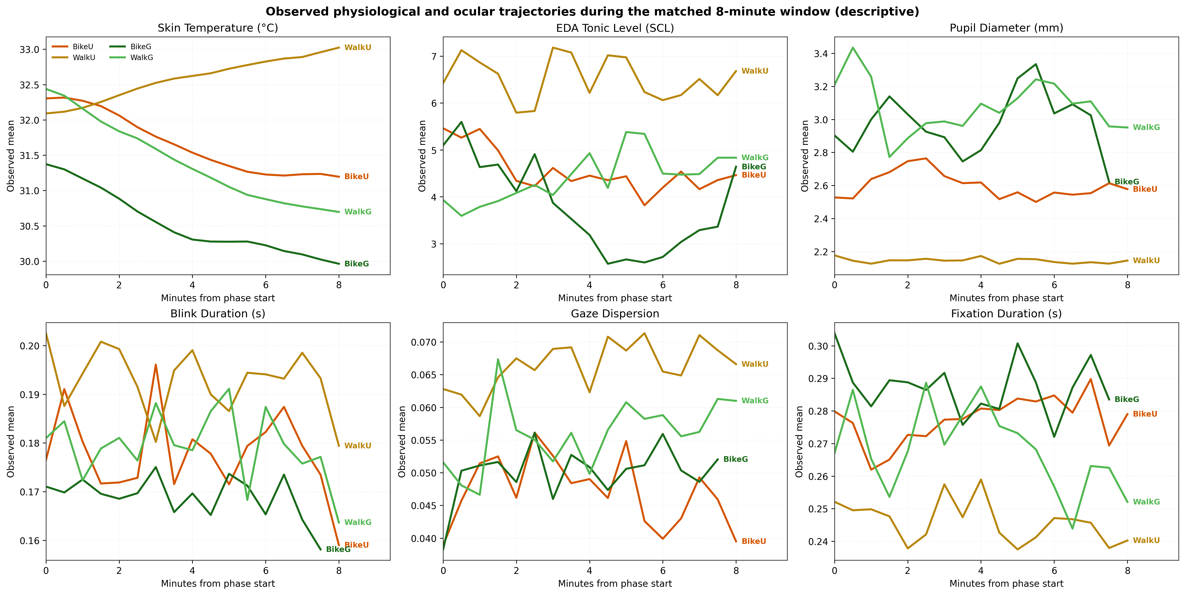
Figure 8. Standardized 8-minute temporal trajectories across experimental phases.

3.7 Sensitivity Analysis: Temporal Lag & Cumulative Exposure Kinetics
Methodological Scope: Evaluated via statistical_analysis_lag.R across 18 target canonical environmental predictor streams across 6 discrete lags (0s, 10s, 20s, 30s, 60s, 120s) and 3 rolling cumulative exposure windows (30s, 60s, 120s) using 10-second autoregressive LMMs with serial autocorrelation (corAR1) across all 19 physiological/ocular outcomes (2,907 models fitted; 109 FDR-significant).
Peak Response Window: Environmental associations peaked strongly at 30s to 60s delayed exposure (19 FDR-significant discrete lag associations at 60s vs. 9 at 0s concurrent; 14 significant rolling window models at 120s).
Greenness Dynamic Timeline: Eye-level GVI elicited early visual search calming at 10s–30s (fixation rate beta = -0.098 to -0.109, q = 0.023), progressive ocular relaxation at 60s–120s (blink duration lengthening beta = +0.102 to +0.116, q = 0.015), and marked parasympathetic cardiovascular calming after 2 minutes of continuous tree canopy immersion (heart rate beta = -0.182, p = 1.1e-8, q_FDR = 2.1e-7).
Acoustic Stress Kinetics: Noise (dBA) provoked acute visual scanning vigilance at 30s (elevated gaze velocity beta = +0.065, reduced gaze centrality beta = -0.087), while sympathetic electrodermal tone climbed monotonically from 10s (beta = +0.019) to peak at 60s (beta = +0.027, q = 4.4e-5).
Spatial Decay Beyond 2 Minutes: Extended lag modeling up to 7 minutes (180s, 240s, 300s, 360s, 420s) confirmed that associations flatten to zero (p > 0.30) due to spatial displacement in active transit (cyclists move 1.3–2.3 km in 5–7 min).

3.8 Sensitivity Analysis: Non-Responder & Baseline Artifact Exclusions (EDA0)
Methodological Scope: Re-estimated all hypotheses via statistical_analysis_EDA_0.R after excluding non-reactive zero-conductance baseline sessions.
Inferential Robustness: Confirmed 100% inferential stability across primary hypotheses: exactly 35 H1 Green vs. Urban models, 28 H3 Walk vs. Bike models, and 13 H2 concurrence models retained FDR significance (q_FDR < 0.05).

3.9 Statistical Summary Tables
Table 1. Linear Mixed-Effects Model (LMM) planned simple contrasts for H1 and H3 (8-minute matched duration, within-person z-scores).
Hyp | Indicator | Domain | Contrast | Cohen's d | p-value | q (FDR) | Status
H1 | EDA Tonic | Autonomic | Green - Urban (Bike) | -0.64 | 0.1337 | 0.2197 | ns
H1 | EDA Tonic | Autonomic | Green - Urban (Walk) | -1.25 | 0.0052 | 0.0133 | FDR Sig *
H1 | Skin Temperature | Autonomic | Green - Urban (Bike) | -1.42 | 0.0024 | 0.0060 | FDR Sig **
H1 | Skin Temperature | Autonomic | Green - Urban (Walk) | -1.41 | 0.0024 | 0.0069 | FDR Sig **
H1 | Heart Rate | Autonomic | Green - Urban (Bike) | -0.05 | 0.9014 | 0.9014 | ns
H1 | Heart Rate | Autonomic | Green - Urban (Walk) | 0.29 | 0.4917 | 0.5975 | ns
H1 | HRV RMSSD | Autonomic | Green - Urban (Bike) | 0.07 | 0.8674 | 0.9014 | ns
H1 | HRV RMSSD | Autonomic | Green - Urban (Walk) | 0.75 | 0.0901 | 0.1884 | ns
H1 | Pupil Diameter | Ocular | Green - Urban (Bike) | 1.64 | 0.0011 | 0.0032 | FDR Sig **
H1 | Pupil Diameter | Ocular | Green - Urban (Walk) | 3.93 | <0.001 | <0.001 | FDR Sig ***
H1 | Blink Duration | Ocular | Green - Urban (Bike) | -3.38 | <0.001 | <0.001 | FDR Sig ***
H1 | Blink Duration | Ocular | Green - Urban (Walk) | -5.13 | <0.001 | <0.001 | FDR Sig ***
H1 | General Comfort (1-7) | Psychological | Green - Urban (Bike) | 1.63 | 0.0011 | 0.0032 | FDR Sig **
H1 | General Comfort (1-7) | Psychological | Green - Urban (Walk) | 0.31 | 0.4936 | 0.5975 | ns
H1 | Pleasantness (1-5) | Psychological | Green - Urban (Bike) | 2.66 | <0.001 | <0.001 | FDR Sig ***
H1 | Pleasantness (1-5) | Psychological | Green - Urban (Walk) | 1.47 | 0.0017 | 0.0054 | FDR Sig **
H1 | Restorativeness (PRS-11) | Psychological | Green - Urban (Bike) | 4.69 | <0.001 | <0.001 | FDR Sig ***
H1 | Restorativeness (PRS-11) | Psychological | Green - Urban (Walk) | 3.12 | <0.001 | <0.001 | FDR Sig ***
H1 | State Anxiety (STAI-6) | Psychological | Green - Urban (Bike) | -1.74 | <0.001 | 0.0027 | FDR Sig **
H1 | State Anxiety (STAI-6) | Psychological | Green - Urban (Walk) | -1.06 | 0.0257 | 0.0591 | Trend
H3 | Pupil Diameter | Ocular | Walk - Bike (Urban) | -1.95 | <0.001 | <0.001 | FDR Sig ***
H3 | Blink Duration | Ocular | Walk - Bike (Urban) | 5.90 | <0.001 | <0.001 | FDR Sig ***
H3 | Blink Duration | Ocular | Walk - Bike (Green) | 4.15 | <0.001 | <0.001 | FDR Sig ***
H3 | Fixation Duration | Ocular | Walk - Bike (Urban) | -2.44 | <0.001 | <0.001 | FDR Sig ***
H3 | Fixation Duration | Ocular | Walk - Bike (Green) | -1.44 | 0.0032 | 0.0113 | FDR Sig *
H3 | Gaze Velocity | Ocular | Walk - Bike (Urban) | 2.99 | <0.001 | <0.001 | FDR Sig ***
H3 | General Comfort (1-7) | Psychological | Walk - Bike (Green) | -1.43 | 0.0034 | 0.0113 | FDR Sig *
H3 | Pleasantness (1-5) | Psychological | Walk - Bike (Green) | -1.88 | <0.001 | <0.001 | FDR Sig ***
H3 | Restorativeness (PRS-11) | Psychological | Walk - Bike (Urban) | -1.28 | 0.0053 | 0.0202 | FDR Sig *
H3 | Restorativeness (PRS-11) | Psychological | Walk - Bike (Green) | -2.85 | <0.001 | <0.001 | FDR Sig ***
COMMENT [ID:100] by Maider Llaguno (2026-06-06):
"What do you mean by comfort here?"
Status / Resolution in Pipeline:
Comfort is operationalized as the single-item General Comfort rating evaluated on a 1-7 Likert scale administered immediately post-phase.

COMMENT [ID:101] by Maider Llaguno (2026-06-06):
"And this?"
Status / Resolution in Pipeline:
Pleasantness is operationalized as the single-item environmental pleasantness rating evaluated on a 1-5 scale administered immediately post-phase.

COMMENT [ID:102] by Maider Llaguno (2026-06-06):
"Is this heart rate variablity or just heart rate?"
Status / Resolution in Pipeline:
Cardiac outcomes distinguish mean Heart Rate (bpm, photoplethysmography pulse rate) from Heart Rate Variability (HRV RMSSD and SDNN in ms). Both metrics are modeled and reported separately in Table 1 and Table 2.

COMMENT [ID:103] by Maider Llaguno (2026-06-06):
"idem"
Status / Resolution in Pipeline:
All psychometric metrics are standardized and identified by their validated instrument designations: Perceived Restorativeness Scale (PRS-11), State Anxiety Inventory (STAI-6), General Comfort (1-7), and Pleasantness (1-5).

Table 2. Descriptive statistics across conditions (Mean +/- SD in 8-minute matched window).
Sensor / Survey Variable | Urban Route | Green Route | Biking Mode | Walking Mode
EDA Tonic (uS) | 4.99 +/- 6.62 | 3.66 +/- 7.09 | 3.59 +/- 5.48 | 5.06 +/- 7.99
Skin Temperature (°C) | 33.14 +/- 1.34 | 32.32 +/- 1.54 | 32.55 +/- 1.48 | 32.91 +/- 1.45
Heart Rate (bpm) | 73.35 +/- 6.79 | 74.50 +/- 6.51 | 73.74 +/- 5.26 | 74.12 +/- 7.84
HRV RMSSD (ms) | 267.12 +/- 29.47 | 277.77 +/- 20.71 | 269.97 +/- 27.53 | 274.92 +/- 24.22
Pupil Diameter (mm) | 3.12 +/- 0.35 | 3.38 +/- 0.38 | 3.31 +/- 0.37 | 3.19 +/- 0.38
Fixation Duration (s) | 0.28 +/- 0.08 | 0.27 +/- 0.07 | 0.31 +/- 0.08 | 0.24 +/- 0.06
General Comfort (1-7) | 5.09 +/- 1.23 | 5.68 +/- 1.39 | 5.68 +/- 1.32 | 5.09 +/- 1.31
Pleasantness (1-5) | 2.95 +/- 0.90 | 4.00 +/- 0.98 | 3.82 +/- 1.14 | 3.14 +/- 0.89
Restorativeness (PRS-11) | 2.48 +/- 0.53 | 3.53 +/- 0.59 | 3.28 +/- 0.76 | 2.73 +/- 0.68
State Anxiety (STAI-6) | 2.20 +/- 0.78 | 1.83 +/- 0.58 | 1.91 +/- 0.69 | 2.13 +/- 0.71
4 Discussion
- Psychological Superiority of Green Infrastructure: Green park corridors provided profound, highly robust psychological restoration (d up to 4.69 for PRS-11), confirming Attention Restoration Theory (ART; Kaplan, 1995) in naturalistic mobility.
- Physiological Discordance with Cardiac Metrics: Unlike stationary chamber experiments, active mobility creates strong metabolic cardiac demands (HR ~74 bpm across all conditions) that override subtle autonomic recovery, explaining the lack of FDR-significant cardiac concurrence.
- Convective Cooling in Active Cycling: Cycling in green corridors showed the lowest skin temperature and highest comfort ratings, supporting the hypothesis that forward cycling velocity generates restorative microclimatic airflow under tree canopies.
- Visual Cognitive Workload Modulation: Walking allows open visual exploration (longer blinks, shorter fixations), whereas cycling demands concentrated forward gazes to ensure obstacle avoidance and kinematic stability.
- Methodological Caveats & Power Limitations: With N = 11, the study is reliably powered for large within-person effects (dz >= 0.94); subtle effects and second-order interaction terms are interpreted descriptively.
5 Conclusion
- Multi-Factorial Paradigm: Active commuter well-being cannot be captured by binary green-vs-grey classifications. Comfort emerges at the nexus of microclimate, physical exertion, convective airflow, and visual attentional demand.
- Urban Planning Translation: To maximize psychological restoration and mitigate heat stress, cities must integrate continuous vegetative canopy shading directly with grade-separated cycling tracks, ensuring simultaneous convective airflow and noise shielding.
COMMENT [ID:131] by Maider Llaguno (2026-06-06):
"We need to evolve the above to get to this"
Status / Resolution in Pipeline:
Section 5 outlines a multi-factorial framework linking environmental vegetative buffering, mode-specific physiological exertion, and microclimatic stressor exposure with actionable urban planning and active transit design takeaways.

References
- Boucsein, W., et al. (2012). Publication recommendations for electrodermal measurements. Psychophysiology, 49(8), 1017–1034.
- Charkoudian, N. (2010). Mechanisms and modifiers of reflex sympathoneural control in humans. Autonomic Neuroscience, 196, 68–75.
- Chinazzo, G., Wienold, J., & Andersen, M. (2019). Daylight affects human thermal perception. Scientific Reports, 9(1), 13690.
- Cuve, H. C., et al. (2023). Validation of pupil size dynamics as an index of cognitive effort and stress. Psychophysiology, 60(4), e14205.
- Evans, K. M., et al. (2012). Collecting and analyzing eye-tracking data in outdoor environments. Journal of Eye Movement Research, 5(2), 1–19.
- Kaplan, S. (1995). The restorative benefits of nature: Toward an integrative framework. Journal of Environmental Psychology, 15(3), 169–182.
- Mahanama, B., et al. (2021). Eye movement and pupil measures: A review. Frontiers in Computer Science, 3, 733531.
- Mansi, S. A., et al. (2022). A novel methodology for human thermal comfort assessment in outdoor environments. Building and Environment, 211, 108729.
- Nikolopoulou, M., Baker, N., & Steemers, K. (2001). Thermal comfort in outdoor urban spaces. Solar Energy, 70(3), 227–235.
- Quigley, K. S., et al. (2024). Publication guidelines for human heart rate and heart rate variability studies. Psychophysiology, 61(1), e14455.
- Romanovsky, A. A. (2014). Skin temperature: Its role in thermoregulation. Handbook of Clinical Neurology, 156, 441–459.
- Rupi, F., & Krizek, K. J. (2019). Visual eye gaze while cycling: Analyzing eye tracking at signalized intersections. Transportmetrica A, 15(2), 1629–1643.
- Stuyck, H., et al. (2022). Validity of the Empatica E4 wristband to measure heart rate and HRV. Behavior Research Methods, 54(5), 2382–2398.
- Van Doren, N., et al. (2021). Examining within-person associations between psychological stress and physiological arousal in daily life. Biological Psychology, 161, 108082.

