CN LAN MST

ANS 1:
- Create the network topology with routers, switches, and PCs.
- Assign IP addresses to all router interfaces and PCs.
- Configure the subnet mask for each interface.
- Enable the router interfaces using no shutdown.
- Check connectivity between directly connected networks using ping.
- Identify the destination network that is not directly connected to each router.
- Repeat the static route configuration on the other routers as required.
- Test end-to-end connectivity between PCs
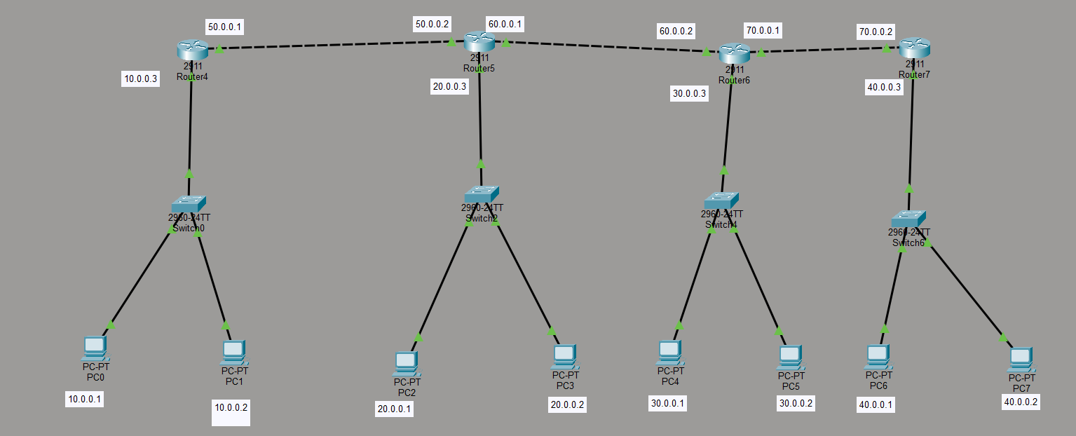

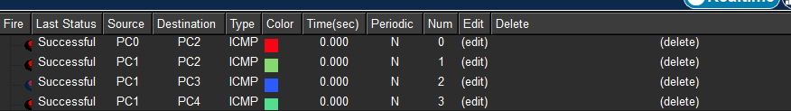

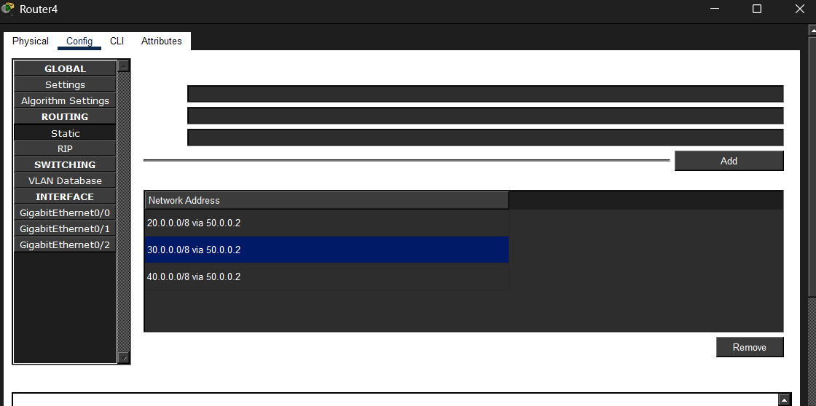
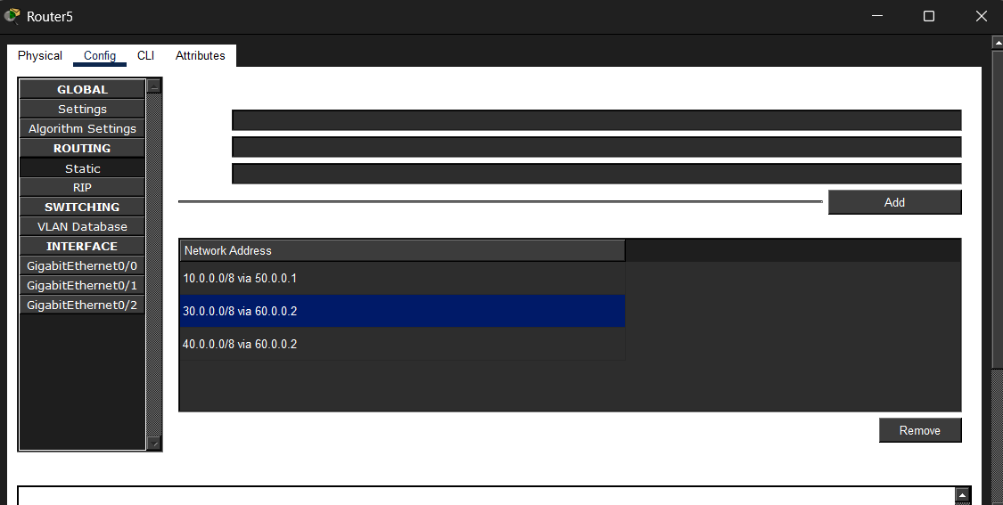

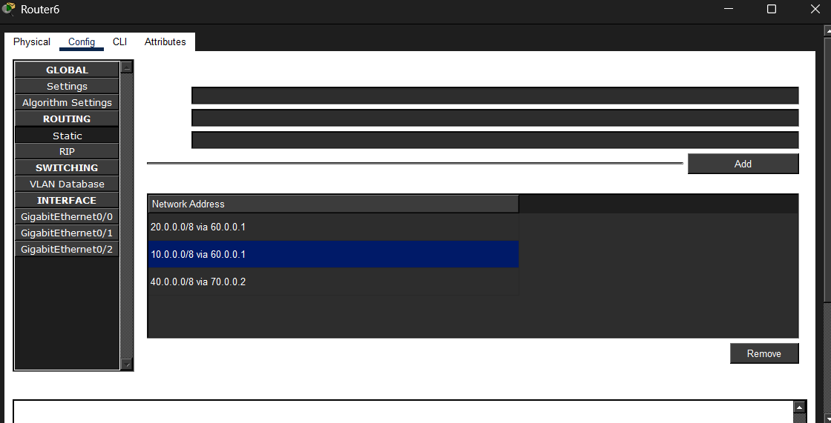
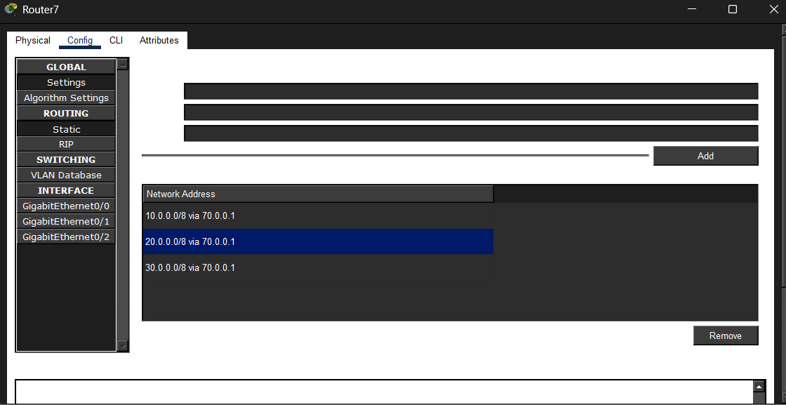

Ans 2:
Answer 2) VLAN Configuration
Step 1: Connect 6 PCs and 1 switch in the topology as shown in the picture.
Step 2: Assign IP addresses to all the PCs according to the given topology.
Step 3: Create VLANs HR, ADMIN, and Finance with VLAN IDs 10, 20, and 30 respectively using the following commands in privileged configuration mode:
vlan <VLAN ID>
name <VLAN Name>
For example:
vlan 10
name HR
Step 4: Assign HR VLAN (10) to Fa0/1 and Fa0/2 using:
interface fa0/1
switchport mode access
switchport access vlan 10
Repeat the same for Fa0/2.
Step 5: Assign ADMIN VLAN (20) to Fa0/3 and Fa0/4 using:
interface fa0/3
switchport mode access
switchport access vlan 20
Repeat the same for Fa0/4.
Step 6: Assign Finance VLAN (30) to Fa0/5 and Fa0/6 using:
interface fa0/5
switchport mode access
switchport access vlan 30
Repeat the same for Fa0/6.
Step 7: Configure Fa0/24 as a trunk port so that it can carry traffic from all the VLANs:
interface fa0/24
switchport mode trunk
Step 8: Verify that all three VLANs have been created using:
show vlan brief
Step 9: Verify that the respective interfaces are assigned to the correct VLANs and that Fa0/24 is in trunk mode using:
show interfaces trunk
Step 10: Test the network connectivity using ping between the PCs and verify that the VLAN configuration is working correctly.
