Aim of the Practical
To understand the basic structure of a PL/SQL program by creating and executing a simple PL/SQL block that includes declaration and execution sections, and to display output using built-in procedures.
Tool Used
Database Management System
- Oracle Database
Database Administration Tool
- SQL*Plus / Oracle SQL Developer
Objective
- To implement control structures in PL/SQL.
- To understand decision-making statements such as:
  - IF–ELSE
  - IF–ELSIF–ELSE
  - ELSIF Ladder
  - CASE Statements
Practical / Experimental Steps
- Open SQL*Plus or Oracle SQL Developer and connect to the database.
- Enable output using SET SERVEROUTPUT ON;.
- Write and execute a PL/SQL program using IF–ELSE to check whether a number is positive or non-positive.
- Write and run a PL/SQL program using IF–ELSIF–ELSE to display student grade based on marks.
- Write and execute a PL/SQL program using an ELSIF ladder to determine performance status.
- Write and run a PL/SQL program using CASE statement to display day name from day number.
- Modify input values and re-execute programs to test different conditions.
- Observe and record the outputs for each conditional control statement program.
I / O Analysis
IF–ELSE Statement
DECLARE
value_num NUMBER := -5;
BEGIN
IF value_num <= 0 THEN
DBMS_OUTPUT.PUT_LINE('Number is zero or negative');
ELSE
DBMS_OUTPUT.PUT_LINE('Number is positive');
END IF;
END;
/
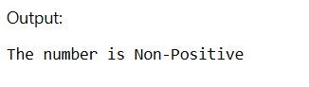
IF–ELSIF–ELSE Statement
DECLARE
score NUMBER := 85;
BEGIN
IF score >= 90 THEN
DBMS_OUTPUT.PUT_LINE('Grade obtained: A+');
ELSIF score >= 80 THEN
DBMS_OUTPUT.PUT_LINE('Grade obtained: A');
ELSIF score >= 70 THEN
DBMS_OUTPUT.PUT_LINE('Grade obtained: B');
ELSIF score >= 60 THEN
DBMS_OUTPUT.PUT_LINE('Grade obtained: C');
ELSE
DBMS_OUTPUT.PUT_LINE('Result: Fail');
END IF;
END;
/
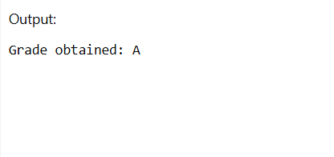
ELSIF Ladder
DECLARE
marks NUMBER := 72;
BEGIN
IF marks >= 90 THEN
DBMS_OUTPUT.PUT_LINE('Performance: Excellent');
ELSIF marks >= 75 THEN
DBMS_OUTPUT.PUT_LINE('Performance: Very Good');
ELSIF marks >= 60 THEN
DBMS_OUTPUT.PUT_LINE('Performance: Good');
ELSIF marks >= 40 THEN
DBMS_OUTPUT.PUT_LINE('Performance: Average');
ELSE
DBMS_OUTPUT.PUT_LINE('Performance: Poor');
END IF;
END;
/
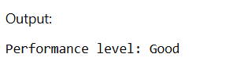
CASE Statement
DECLARE
day_no NUMBER := 4;
day_label VARCHAR2(20);
BEGIN
CASE day_no
WHEN 1 THEN day_label := 'Sunday';
WHEN 2 THEN day_label := 'Monday';
WHEN 3 THEN day_label := 'Tuesday';
WHEN 4 THEN day_label := 'Wednesday';
WHEN 5 THEN day_label := 'Thursday';
WHEN 6 THEN day_label := 'Friday';
WHEN 7 THEN day_label := 'Saturday';
ELSE
day_label := 'Day not valid';
END CASE;

DBMS_OUTPUT.PUT_LINE('Selected Day is: ' || day_label);
END;
/
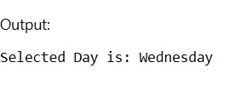

Learning Outcomes
- Understood the basic structure of a PL/SQL block, including the DECLARE and BEGIN…END sections.
- Learned how to declare and initialize variables for storing data values.
- Gained knowledge of using DBMS_OUTPUT.PUT_LINE to display results during execution.
- Practiced performing operations and implementing logic inside PL/SQL blocks.
- Developed understanding of decision-making using IF–ELSIF–ELSE conditional statements.
- Acquired practical insight into how PL/SQL can be used for database-related computations and control flow.

