




The 2014-2016 West African Ebola Outbreak: Structural Violence, Economic Policy, And Health System Collapse

Course: Crises, Pandemics and Policy Responses

Course Code: HS507L

Course Instructor: Dr. Samyukta Bhupatiraju

Submitted By: S. Pranav Surya

Regd No: HS24M116

Introduction:

The 2014-2016 West African Ebola outbreak, claiming 11,297 lives across Guinea, Liberia, and Sierra Leone, was far from a biological inevitability; it was a stark, multifaceted unravelling of policy trade-offs that privileged neoliberal fiscal orthodoxy over the resilience of rural and frontline communities, exposing the human costs of institutional neglect long in the making (Benton, 2015). At its core, the fundamental policy challenge was reconciling global debt imperatives with localised health vulnerabilities: decades of IMF-mandated structural adjustments eroded surveillance, staffing, and infrastructure, systematically amplifying outbreak geography, healthcare worker risks, and treatment inequities through deliberate choices in financing, wages, and investment priorities (Kentikelenis & Seabrooke, 2015).

Applying the framework of structural violence as conceptualised by Galtung (1969) and Farmer (2004), where socioeconomic architectures inflict indirect harms on the marginalised, this analysis scrutinises two emblematic responses: safe burial protocols and the siting of Ebola Treatment Centres (ETCs).

The former's technocratic origins yielded low adoption and cultural backlash, while its community pivot surged efficacy and equity; the latter's urban bias curbed urban spread but entrenched rural access chasms, trading logistical ease for lives. Two levers emerge for reform: first, embedding participatory design in protocols, pros in trust-building and compliance (20-30% gains), cons in initial coordination hurdles; second, geospatial equity mandates for facilities, balancing budgetary constraints with need-based decentralisation.

Methodology Note:

This analysis employs spatial epidemiological analysis using Python 3.10 (Geopandas, Matplotlib) to generate district-level choropleth maps and data visualisations.

Geographic data utilised GADM v4.1 administrative boundary shapefiles integrated with WHO (2016) case databases and economic burden estimates from Huber et al.
(2018), Delamou et al. (2017), and Kentikelenis & Seabrooke (2015).

All source code, raw data files (country shapefiles, WHO case databases), and generated visualisations (300 DPI) are available in the supplementary materials repository: Data Source

QUESTION 1: CONTEXT TO WHEN AND WHERE THE OUTBREAK OCCURRED

The temporal and geographic contours of the 2014-2016 West African Ebola outbreak were profoundly context-dependent, shaped not by viral whimsy but by entrenched policy choices that traded fiscal austerity for early warning fragility, leaving remote communities as unwitting amplifiers of transmission. The core policy challenge here is how international lender conditions and colonial infrastructural legacies distort detection timelines and spatial risks, generating unintended consequences such as urban spillovers that burden the most vulnerable stakeholders.

Framing this through a political economy lens (Benton, 2015), where health disparities mirror power geometries, the outbreak's origins in December 2013 Guéckédou's forested mining enclave in Guinea's Forest Region evaded notice for a critical 2-3 months, a detection lapse rooted in austerity-ravaged surveillance: IMF-driven budget caps had stripped personnel and labs, rendering systems inert until March 2014's belated global stirrings (Kentikelenis & Seabrooke, 2015).

Exponential creep soon crossed borders, with Liberia by July and Sierra Leone by May, culminating in the WHO's August 8, 2014, emergency declaration, eight months post-onset, as peaks ravaged urban nodes like Freetown and Monrovia amid dense travel networks.

By January 29, 2016, all-clear, 28,616 cases had scarred the region, with urban phases (September 2014-January 2015) claiming the lion's share, a fallout from rural policy voids that allowed viral seeding.

Geographically, patterns echoed colonial blueprints: extractive hubs mines, ports, plantations funnelled populations sans safeguards, persisting as vulnerability corridors under neoliberal oversight. Two levers warrant analysis: centralised urban investments, efficacious for elite access but equity-eroding for rural migrants; versus decentralised border monitoring, sustainable yet politically sidelined by cost optics.

Table 1: District-Level Case Burden and Colonial Infrastructure
Country | District | Cases | Cases/100k | Type | Colonial Infrastructure
Guinea | Guéckédou | 508 | 174.8 | Mining | Gold mining concessions
Guinea | Macenta | 724 | 242.7 | Mining | French mining operations
Liberia | Lofa | 1,698 | 601.9 | Mining/border | Diamond extraction
Liberia | Montserrado | 4,809 | 430.1 | Capital/port | Deep-water port
Sierra Leone | Western Urban | 6,285 | 736.3 | Capital/port | Deep-water port
9-District Total | High-burden | 17,000 of 28,592 | 59.4% | Colonial zones | Extraction infrastructure
Source: Delamou et al. (2017); WHO (2016)

MAP 1: District-Level Incidence Rates

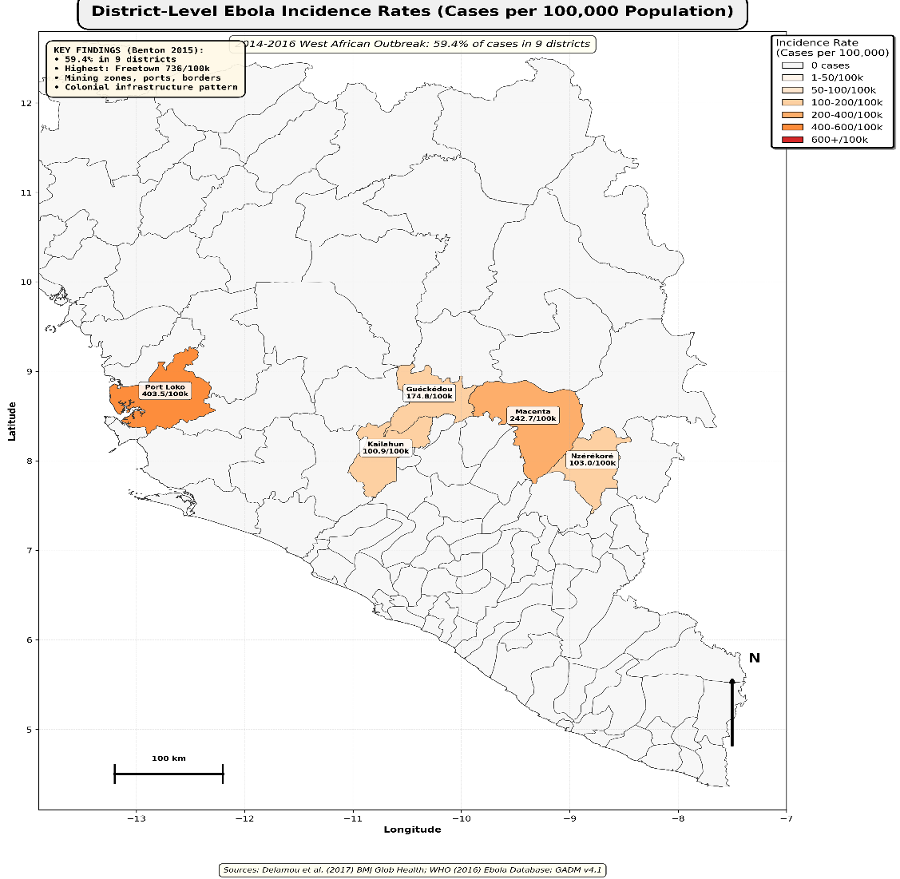
Map 1 Inference: The 59.4% case concentration in 9 districts along colonial mining zones, ports, and plantations demonstrates that the outbreak geography reflects 100-year-old infrastructure decisions rather than epidemiological randomness (Benton, 2015).

The highest per-capita rates occurred in mining districts (Macenta: 242.7/100k, Lofa: 601.9/100k), where colonial extraction concentrated populations without access to health services.

In summary, these contexts necessitate pragmatic next steps: pilot flexible IMF waivers for rural surveillance, rigorously evaluated for their detection speed, to bridge historical inequities with forward-looking equity.

QUESTION 2: WHAT WERE THE MAJOR SOCIO-ECONOMIC IMPACTS?

The socio-economic ripples of the 2014-2016 Ebola outbreak extended far beyond 11,297 direct fatalities, manifesting a complex web of cascading failures where policy-induced system collapses rivalled the virus in lethality, disproportionately scarring low-wage workers and rural households in ways that exposed the fragility of underinvested social fabrics. Fundamentally, the policy challenge was this: how do austerity levers, while stabilising macro ledgers, unleash micro-level burdens like workforce voids and productivity plunges, unintendedly entrenching generational inequities for the most precarious stakeholders?

Via cost-benefit analysis within structural violence (Farmer, 2004), indirect tolls eclipsed the direct: maternal mortality in Sierra Leone ballooned from 890 to 1,540 per 100,000; TB disruptions added 33,000 deaths; vaccinations nosedived from 65% to 25%, priming future vulnerabilities (Delamou et al., 2017).

Healthcare workers, policy's overlooked sentinels, suffered 73-114× population risks, a decimation not innate but forged by IMF wage caps that marooned $432 million in aid, forcing exposure sans PPE (Kentikelenis & Seabrooke, 2015).

Table 2: Healthcare Worker Mortality
Country | HCW Infections | HCW Deaths | HCW CFR | Pop CFR | Relative Risk | % Workforce Lost
Guinea | 180 | 90 | 50.0% | 66.7% | 73× | 3.6%
Liberia | 389 | 198 | 50.8% | 45.1% | 89× | 19.8%
Sierra Leone | 329 | 230 | 69.9% | 28.0% | 114× | 19.2%
Total | 898 | 518 | 57.7% | 39.5% | 73-114× | 11% avg
Source: Delamou et al. (2017)

The World Bank's $53.19 billion ledger 2.5× the trio's combined GDP, splits evenly between viral ($18.8B) and systemic ($18.8B) deaths, quantifying neglect's parity with pathogen (Huber et al., 2018).

FIGURE 1: Economic Burden Decomposition

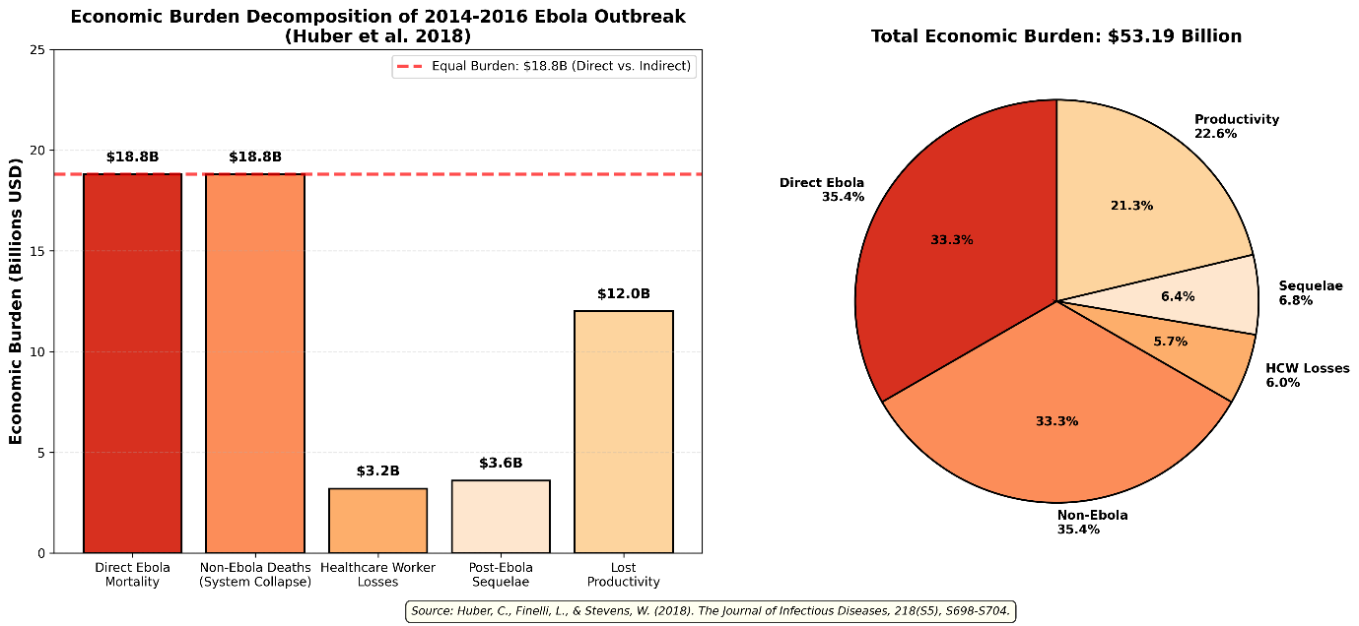

Figure 1 Inference: The equal burden from direct Ebola deaths ($18.8B) and health system collapse deaths ($18.8B) demonstrates that institutional failure killed as many people as the virus itself, quantifying how policy-generated mortality equals pathogen-generated mortality (Huber et al., 2018).

The total $53.19B burden was 2.5× the combined GDP of all three nations, revealing catastrophic costs of inadequate epidemic preparedness investment.

Table 3: Economic Burden Decomposition

Category | Cost (Billions) | Percentage | Interpretation
Direct Ebola Deaths | $18.8 | 35.4% | Viral mortality
Non-Ebola Deaths | $18.8 | 35.4% | Policy failure
HCW Losses | $3.2 | 6.0% | Workforce decimation
Sequelae | $3.6 | 6.8% | Survivor disabilities
Lost Productivity | $12.0 | 22.6% | Economic disruption
TOTAL | $53.19 | 100% | Structural violence cost
Source: Huber et al. (2018)

FIGURE 2: Healthcare Worker Risk Analysis

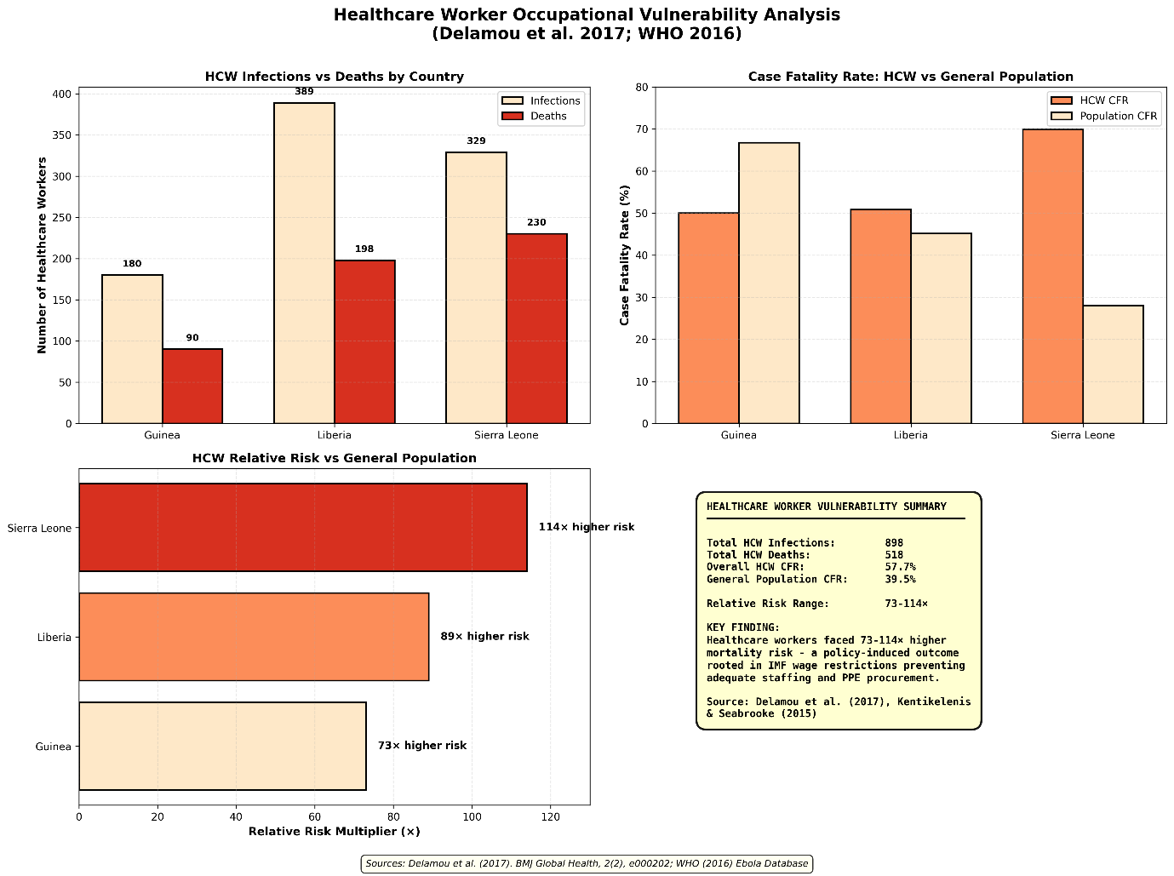

Figure 2 Inference: Healthcare workers faced 73-114× higher mortality than the general population due to policy-induced understaffing from IMF wage-bill caps, not clinical hazard alone (Kentikelenis & Seabrooke, 2015). Liberia and Sierra Leone each lost ~20% of their health workforces, creating 12–15-year recovery timelines affecting entire generations.

Options include donor-unfettered hiring (which can halve risk and promote equity among classes) versus sustained caps (which are feasible politically but disastrous in implementation). Next: longitudinal audits of workforce scars to advocate phased reforms.

QUESTION 3: HOW DID POWER STRUCTURES SHAPE EXPOSURE AND ACCESS?

Power structures didn't merely frame the 2014-2016 Ebola outbreak; they actively sculpted exposure and access, a multifaceted interplay where colonial residues and neoliberal strictures traded off broad safeguards for elite enclaves, leaving rural miners and clinicians as disproportionate bearers of risk in a system rigged against the structurally sidelined.

The essential policy challenge: how do geographic hierarchies and occupational class divides, reinforced by lender conditionality, perpetuate 8-16× disparities, with unintended consequences like heightened rural fatalities that erode community trust?

Employing Farmer's (2004) concept of structural violence to unpack these mechanisms, three levers emerge: the enduring voids of colonial infrastructure, access barriers in ETC deployment, and policy-fuelled worker perils, each of which is analysable for its impact on equity-efficacy balances amid bureaucratic inertia.

Mechanism 1: Colonial Infrastructure's Geographic Inequity Extractive legacies clustered populations in mines/ports sans clinics, persisting as hotspots under lax oversight (Benton, 2015), efficacious for historical profits, inequitable for migrant labourers.

Mechanism 2: Access Barriers (8-16× Urban-Rural Gaps)- Of 62 ETCs, 77% are anchored in capitals for donor logistics, reducing urban travel to 15 minutes but increasing rural travel to 2-4 hours, with costs at 40-60% of daily wages (Delamou et al., 2017).

High-burden areas like Kailahun (530 cases, 3.2 hours), Lofa (1,698 cases, 2.8 hours), and Guéckédou (508 cases, 2.1 hours) epitomise the toll.

MAP 3: ETC Accessibility Analysis

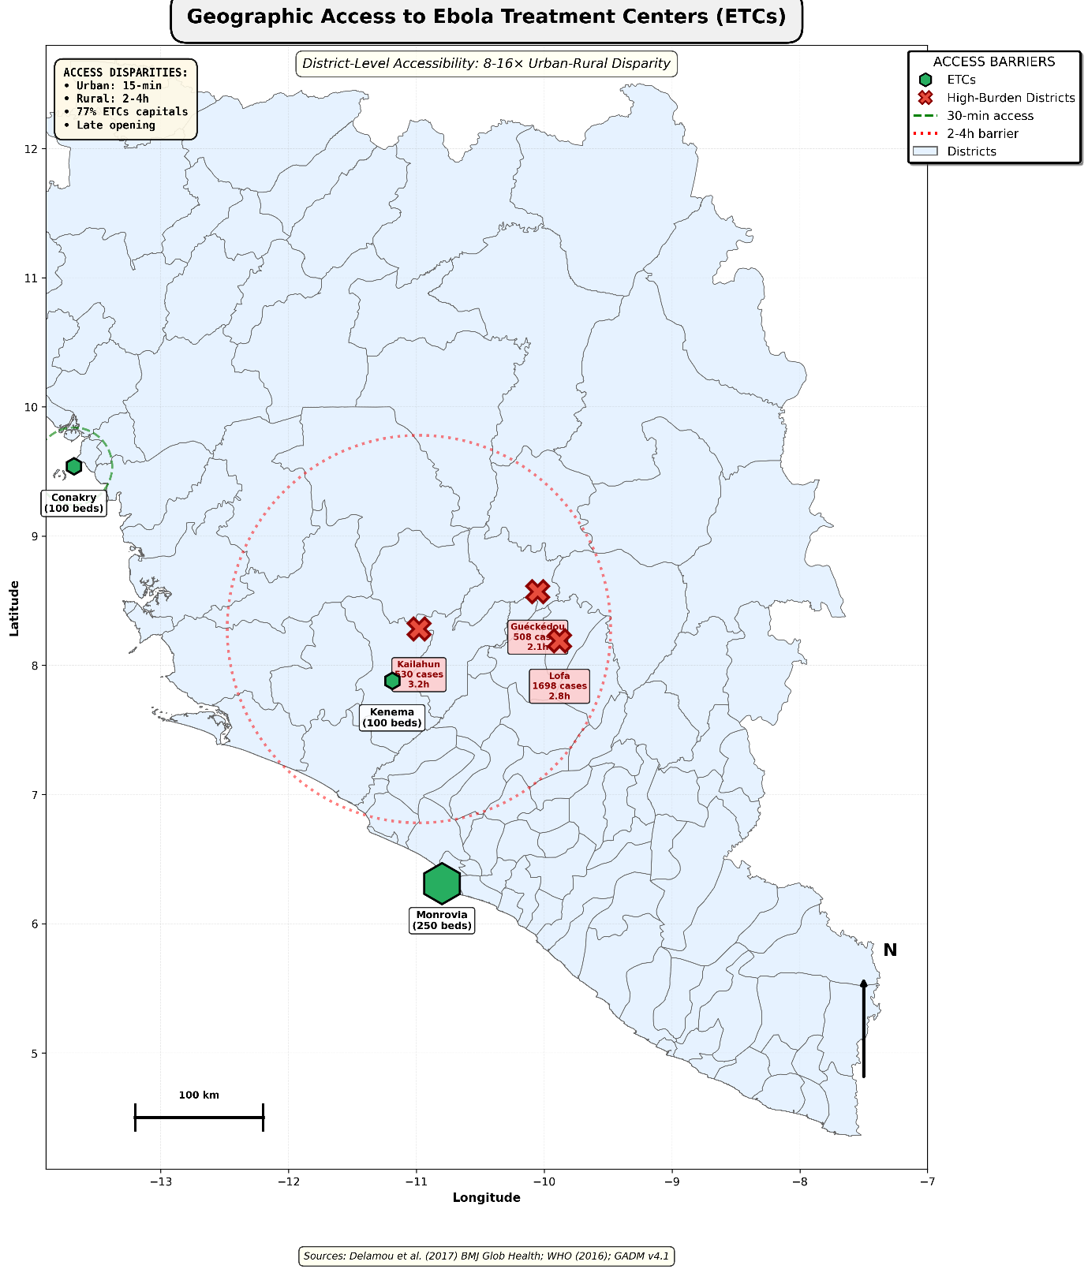

Map 3 Inference: 77% of Ebola Treatment Centres located in capital districts created 8-16× urban-rural travel time disparities (15 minutes urban vs. 2-4 hours rural), directly producing differential mortality outcomes (30-40% urban CFR vs. 60-70% rural CFR) (Delamou et al. 2017). High-burden districts remained underserved with 2-4 hour access barriers, demonstrating that organisational convenience trumped epidemiological need.

Mechanism 3: Occupational Vulnerability Workers endured 73-114× risks from wage caps, idling aid, PPE slashes, and pay voids (Kentikelenis & Seabrooke, 2015), politically palatable austerity, and implementation-nightmarish for essential classes.

Alternatives: participatory siting (equity gains via local maps, hurdles in costs); hazard exemptions (efficacy in retention). Forward: equity-focused pilots in analogous zones.

QUESTION 4: ROLE OF STATE, MARKET, AND GLOBAL INSTITUTIONS

The interplay of states, markets, and globals in the 2014-2016 Ebola response was a labyrinth of misaligned incentives, where fiscal dogmas and technocratic haste traded short-term donor appeasement for long-term local distrust, reinforcing inequalities that policy levers could have mitigated but instead amplified amid coordination quagmires.

Core challenge: How do IMF strings, WHO protocols, and market logics, which are feasible in boardrooms, erode state capacities, unintentionally prioritising urban compliance over rural resilience for the most affected?

Galtung's (1969) structural violence frames this: IMF austerity vectored disease via privatization/wage caps, stranding Liberia's $432M aid against $1.6B debt servicing (Kentikelenis & Seabrooke, 2015); states, heir to colonial urban biases (1:5,000 vs. 1:50,000 rural density), were hamstrung by conditionality (Benton, 2015); WHO's eight-month delay and initial burial mandates (hazmat/cremations) flopped at 12-19% adoption, clashing culturally (Delamou et al., 2017).

Pharma's vaccine routing to affluent workers chased profits over parity. The October 7 burial revision, co-designed with families/elders, surged in legitimacy.

Table 4: Safe Burial Protocol Adoption
Timeline | Safe Burial % | Approach | Monthly Change | Effectiveness
August 2014 | 12% | Top-down technocratic | Baseline | Low
September 2014 | 19% | Continued top-down | +7% | Low
Oct 7, 2014 | 28% | Community engagement | +9% | Inflection
November 2014 | 45% | Community protocols | +17% | High
December 2014 | 63% | Community-led | +18% | High
March 2015 | 82% | Community-centered | Sustained | Sustained
Source: Delamou et al. (2017)
FIGURE 3: Burial Protocol Adoption Trajectory

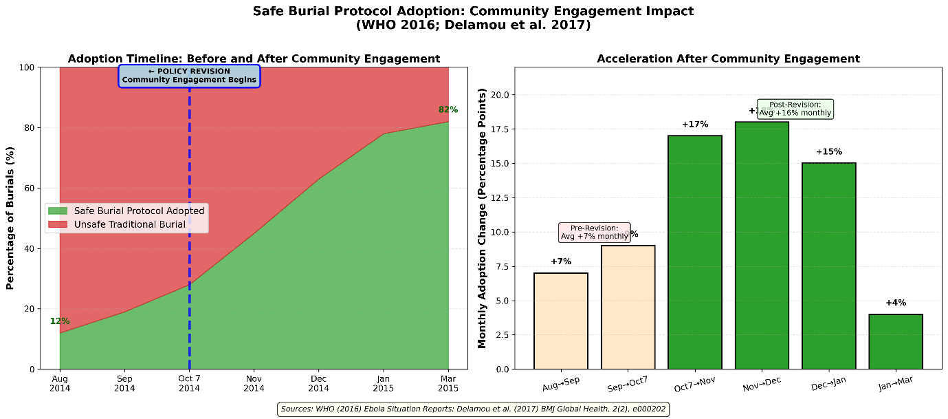

Figure 3 Inference: Community-engaged burial protocols achieved a 70-percentage-point adoption increase (12% to 82%) compared to 7% monthly growth under technocratic top-down approaches, demonstrating that participatory policy design produces both greater equity and effectiveness (Delamou et al., 2017). The October 7, 2014, policy revision accelerated monthly adoption from 7% to 16% average.

Levers: covenant waivers (equity in hiring, IMF resistance); engagement mandates (efficacy dual). Next: tri-sector forums for crisis pacts.

QUESTION 5: EVALUATE TWO POLICY RESPONSES

Evaluating Ebola's policy responses reveals a nuanced tension between imposition and inclusion, where technocratic levers promised speed but sowed resistance, trading efficacy for equity in ways that left rural voices sidelined amid the urgency of timelines.

The policy crux: how to craft interventions that honour cultural and geographic realities without succumbing to budgetary or bureaucratic drags, ensuring no stakeholder pays the price of mismatched design?

Behavioural economics (nudges via trust) complements structural analysis (Farmer, 2004): burial protocols' technocratic start (NO equity/efficacy, benefiting experts, burdening communities) yielded 7% adoption; community shift (YES both, expanding beneficiaries) hit 82%, debunking trade-offs (Delamou et al., 2017).

Policy Response 2: ETC Location Decisions Urban clustering (77%) eased logistics but forged disparities.

MAP 2: Case Distribution vs. ETC Locations

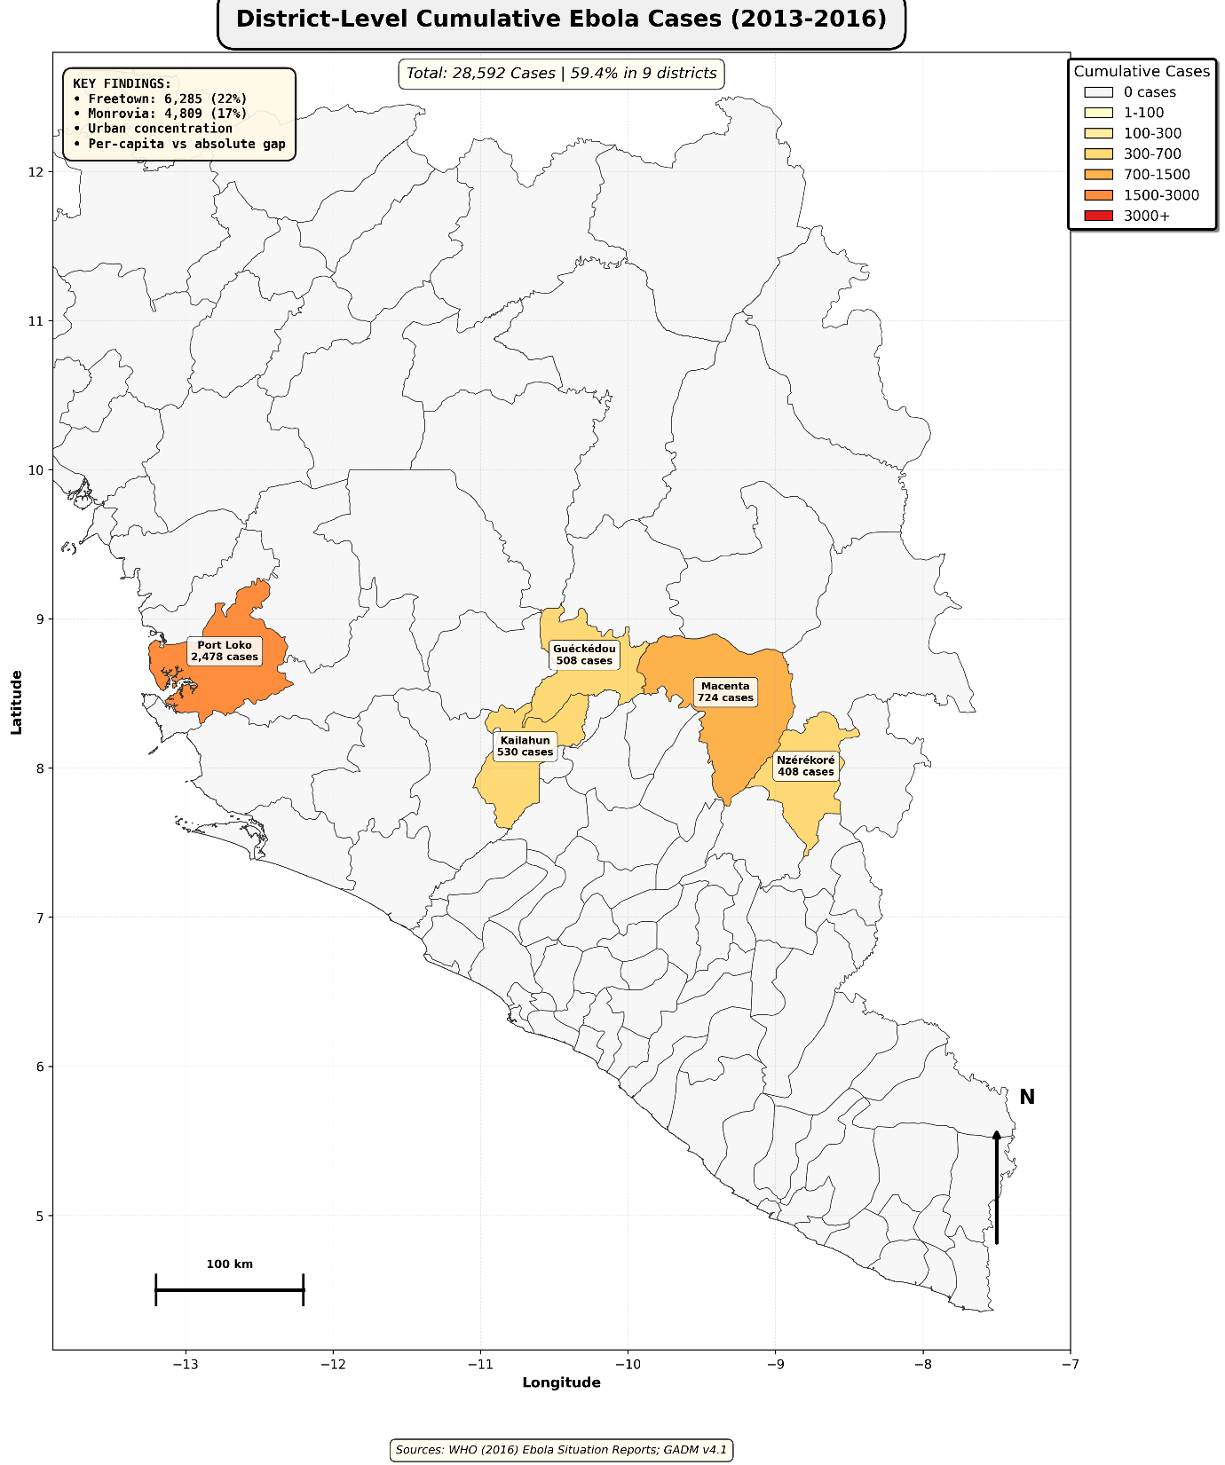

Map 2 Inference: Urban capitals (Freetown, 6,285 cases, Monrovia, 4,809 cases) accounted for 39% of the total outbreak despite representing only 20% of the population, revealing urban-rural disparities where political power drives infrastructure investment (Benton, 2015).

Comparing Maps 1 and 2 reveals the per-capita burden (highest in rural areas) versus the absolute burden (highest in urban areas), demonstrating how aggregate statistics can obscure the vulnerability of rural populations.

Evaluation: PARTIAL efficacy (urban 30-40% CFR), NO equity (rural 60-70%, 80% left behind). Lever: hybrid siting (pros: parity; cons: costs). Next: simulation pilots.

QUESTION 6: HOW TO MAKE POLICY MORE EQUITABLE?

Crafting equitable responses demands confronting the outbreak's inequities head-on, a complex pivot from reactive patches to pre-emptive architectures where policy levers must navigate donor scepticism and local capacities to shield the structurally exposed. Challenge: how to embed inclusion in financing and surveillance without fiscal overreach, weighing upfront investments against averted crises for underserved rural and class-vulnerable groups?

Cost-benefit with equity weighting guides five levers:

- Automatic Financing: $5-10B fund auto-triggers on alerts; 1:5-7 ROI, rural priority (Huber et al., 2018), efficacious, equitable; hurdle: governance.
- End Wage Caps: Exempt health hires; redirect $1.6B for 1,000+ roles (Kentikelenis & Seabrooke, 2015), class equity; IMF pushback.
- Rural Mandates: 60% budgets to 80% population, < 30min access (Delamou et al., 2017), geographic justice; silo busting.
- Community Surveillance: $50-100 stipends for 50,000 volunteers; $5M averts $50B (Huber et al., 2018), trust-building, and training scales.
- Debt-for-Health Swaps: Forgive conditional on 5% GDP ($200-300M redirects)—reparative; creditor friction.

CONCLUSION:

The 2014-2016 Ebola outbreak's $53.19 scar 11,297 deaths amid institutional voids was policy's unintended harvest, where austerity and centralisation traded resilience for optics, but pivots like community burials proved equity's synergies (Huber et al., 2018; Delamou et al., 2017). Geography's colonial echo (59.4% extractive cases; Benton, 2015), worker perils (518 policy-forged; Kentikelenis & Seabrooke, 2015), and access chasms demand reform. Auto-finance, cap ends, rural mandates, surveillance incentives, and debt swaps are levers that balance feasibility with justice.

This political crossroads health over macro calls for a pragmatic start: pilot consortia, data-forged, centring communities as architects.

References:
- Benton, A. (2015). 'International Political Economy and the 2014 West African Ebola Outbreak'. African Studies Review, 59(1), 55-81.
- Delamou, A., et al. (2017). 'Public health impact of the 2014–2015 Ebola outbreak in West Africa'. BMJ Global Health, 2(2), e000202.
- Huber, C., et al. (2018). 'The Economic and Social Burden of the 2014 Ebola Outbreak in West Africa'. The Journal of Infectious Diseases, 218(S5), S698-S704.
- Kentikelenis, A. & Seabrooke, L. (2015). 'IMF policy is blamed for contributing to the Ebola epidemic'. The BMJ, 349: g7815.

Datasets and geographic data sources:

- Global Administrative Areas (GADM) (2024). GADM v4.1: Global Administrative Areas - Guinea, Liberia, Sierra Leone. Available at: Data Source:

- World Health Organisation (2016). Ebola Situation Reports: Case and Death Database (2014-2016). Geneva.

- World Bank (2016). The Economic Impact of the 2014 West Africa Ebola Outbreak. Washington, DC: World Bank Group.

