**Purpose**:

The primary purpose of the On-Demand Home Service Platform is to create a user-friendly and efficient digital ecosystem that connects customers seeking various home services with qualified professionals. The platform serves as a centralized hub where users can seamlessly browse, book, and manage a diverse range of services, enhancing convenience and accessibility for both customers and service providers.

**Key Objectives:**

1. Enhanced Service Accessibility: The platform aims to provide a streamlined and easily accessible way for customers to discover and access a wide array of home services. By offering a comprehensive selection of service categories and providers, users can quickly find the assistance they need.

2. Effortless Booking Process: The platform's intuitive interface simplifies the process of requesting and scheduling services. Customers can easily browse service listings, choose a convenient appointment time, and interact directly with professionals.

4. Quality Assurance through Reviews: The platform encourages accountability and quality by allowing customers to leave reviews and ratings for services they've received. This feedback system promotes transparency and helps users make informed decisions.

5. Secure and Convenient Payments: Professionals can confidently make secure online payments for services, streamlining the payment process for professionals. Digital invoicing ensures clarity and accountability.

6. Efficient Appointment Management: The platform provides an efficient and organized approach to managing appointments. Both customers and professionals can keep track of bookings, reschedule when necessary, and ensure optimal scheduling.

7. Administrator Oversight: The platform's administrative tools enable effective oversight and management. Administrators can ensure platform integrity, address issues, and optimize user experiences.

8. Accessibility and Responsiveness: The platform is designed to be accessible and user-friendly, catering to a diverse range of users, including those with disabilities. Additionally, its responsive design ensures a consistent and seamless experience across various devices.

**Definitions, Acronyms and Abbreviations:**

SRS: Software Requirement Specifications

UI: User Interface

**References**:

[www.scnsoft.com/ecommerce/payment-gateway-integration](http://www.scnsoft.com/ecommerce/payment-gateway-integration)

[www.zipboard.co/blog/ui-ux/user-feedback-web-application-development/](http://www.zipboard.co/blog/ui-ux/user-feedback-web-application-development/)

[www.geeksforgeeks.org/create-a-simple-login-web-application-with-encrypted-password-in-java/](http://www.geeksforgeeks.org/create-a-simple-login-web-application-with-encrypted-password-in-java/)

[www.chetu.com/blogs/payments/how-to-integrate-a-payment-gateway-into-a-website.php](http://www.chetu.com/blogs/payments/how-to-integrate-a-payment-gateway-into-a-website.php)

**Overview**:

The On-Demand Home Service Web Application is a comprehensive and intuitive digital platform that seamlessly connects customers in need of various home services with skilled professionals who offer them. This innovative application is designed to enhance convenience, transparency, and efficiency for both customers and service providers, creating a user-centric environment that simplifies service discovery, booking, and management.

**Key Features and Functionality:**

1. User Roles and Profiles: The application accommodates three primary user roles: customers, professionals, and administrators. Each role enjoys personalized profiles and functionalities to cater to their specific needs.

2. Service Listings and Exploration: Professionals can create detailed service listings encompassing service descriptions, pricing and availability. Customers can explore a diverse array of services, view profiles, and assess reviews.

3. Appointment Booking and Scheduling: Customers can seamlessly request service appointments by selecting their preferred dates and times. Professionals can review and respond to these requests based on their availability, facilitating a smooth scheduling process.

5. Reviews and Ratings System: Upon service completion, customers can provide feedback by leaving reviews and ratings. This system promotes accountability and assists other users in making informed decisions.

6. Secure and Convenient Payments: The platform supports secure online payments for services, offering a range of payment methods. Professionals can generate digital invoices, streamlining the payment process.

7. Appointment Management: A user-friendly calendar interface empowers users to manage appointments efficiently. Customers and professionals can monitor bookings and maintain an organized schedule.

9. Administrator Tools and Oversight: Administrators have robust tools to manage professionals, services and platform settings. They can maintain system integrity, resolve disputes, and ensure optimal performance.

**Logical Characteristics of Product Functions:**

1. User-Centric Design: The application's functions are designed with user needs at the forefront, providing intuitive navigation, clear interfaces, and accessible features.

2. Real-Time Interactivity: The messaging system enables instant communication, enhancing user engagement and responsiveness.

3. Seamless Integration: All functions interact seamlessly, ensuring that appointments, payments, and communication flow smoothly for an enhanced user experience.

4. Data Privacy and Security: User authentication, data encryption, and secure payment processing maintain the confidentiality and security of user information.

5. Scalability: The application is designed to handle a growing user base, ensuring consistent performance and responsiveness.

**Hardware and Software Configuration:**

1. Servers: The application requires robust servers with ample storage, processing power, and memory to handle user requests, store data securely, and facilitate real-time communication.

2. Clients: Users access the application through standard web browsers on various devices, including desktops, laptops, tablets, and smartphones.

3. Software: The application is built using modern web technologies, including HTML5, CSS3, JavaScript, and utilizes frameworks such as React. Secure payment gateways and messaging APIs are integrated.

4. Databases: The platform employs relational databases (MySQL) to store user data, service listings, appointments, and reviews.

**Functional Requirements:**

1. User Management:

- Customers, professionals, and administrators can register and create accounts.

- Users can log in using their registered credentials.

- Users can update their profile information.

2. Service Listings:

- Professionals can create and manage service listings.

- Customers can browse and search for services.

- Service listings include service details, pricing, availability, and professional information.

3. Booking and Appointments:

- Customers can request service appointments.

- Professionals can view and manage appointment requests.

- Users can view upcoming and past appointments.

4. Communication:

- Users can communicate through real-time messaging.

- Professionals and customers receive notifications for new messages and updates.

5. Reviews and Ratings:

- Customers can leave reviews and ratings for services.

- Professionals can respond to reviews.

6. Payment Processing:

- Customers can make secure online payments for services.

- Professionals can generate and manage invoices.

7. Calendar and Schedule Management:

- Users can view appointments and availability in a calendar view.

- Professionals can set their availability and manage appointments.

8. Administrator Tools:

- Administrators can manage users, services, and appointments.

- Administrators can resolve disputes and address platform issues.

**Non-Functional Requirements**:

1. Performance:

- The application shall respond to user interactions within 2 seconds.

- The platform shall support a minimum of 500 simultaneous users.

2. Security:

- User passwords and sensitive data shall be securely encrypted.

- Secure authentication and authorization mechanisms shall be implemented.

- Payment transactions shall be processed securely using encryption.

3. Usability:

- The user interface shall be intuitive and user-friendly for customers and professionals.

- The application shall be accessible to users with disabilities, conforming to relevant accessibility standards.

4. Reliability:

- The platform shall have an uptime of at least 99.9%.

- Regular data backups shall be performed to ensure data integrity.

5. Compatibility:

- The application shall be compatible with major web browsers (Chrome, Firefox, Safari, Edge).

- The platform shall be responsive and usable on various devices, including mobile phones and tablets.

6. Documentation:

- User documentation shall be provided, including user guides and FAQs.

- Administrator documentation shall cover user management and platform maintenance.

7. Scalability

- The application architecture shall support scalability to accommodate a growing user base.

8. Privacy and Compliance

- The application shall adhere to relevant data protection and privacy regulations.

- Users' personal and payment information shall be kept private and secure.

9. Data Integrity:

- User-generated data (appointments, reviews) shall be stored securely and accurately.

10. Performance Monitoring:

- The application shall have monitoring tools to track system health and performance.

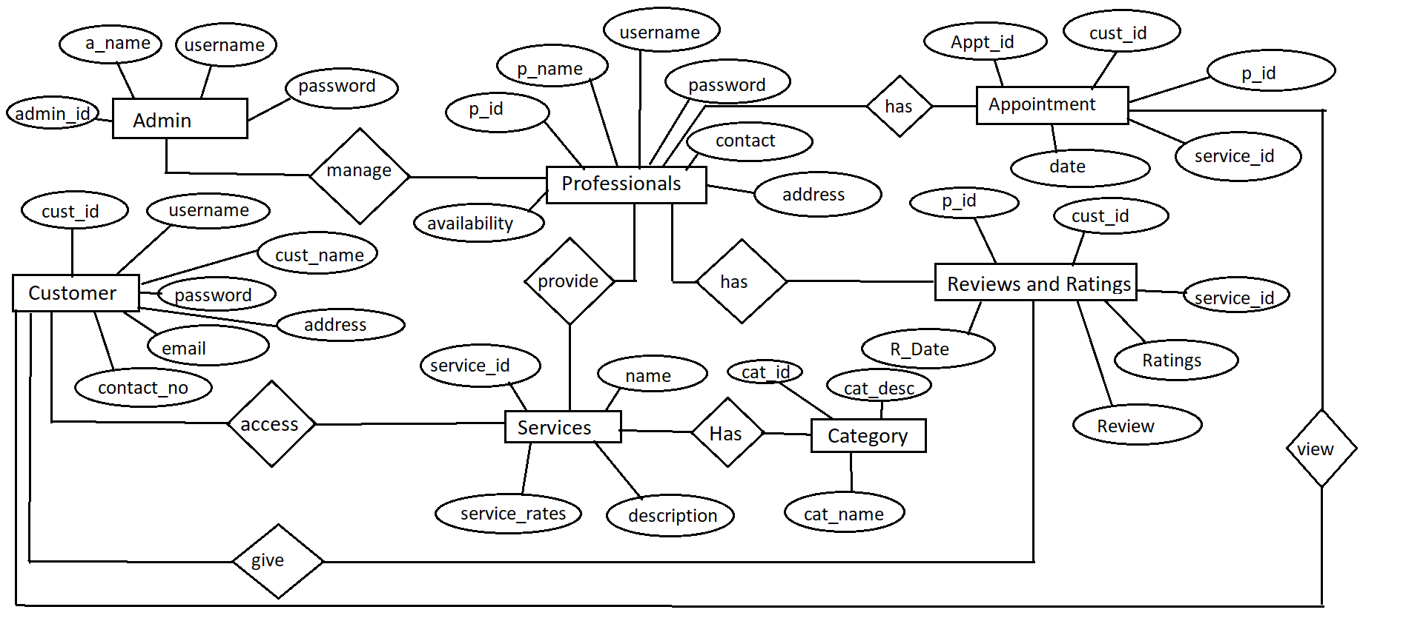

**Entity- Relationship Diagram:**

**Data Flow Diagram:**

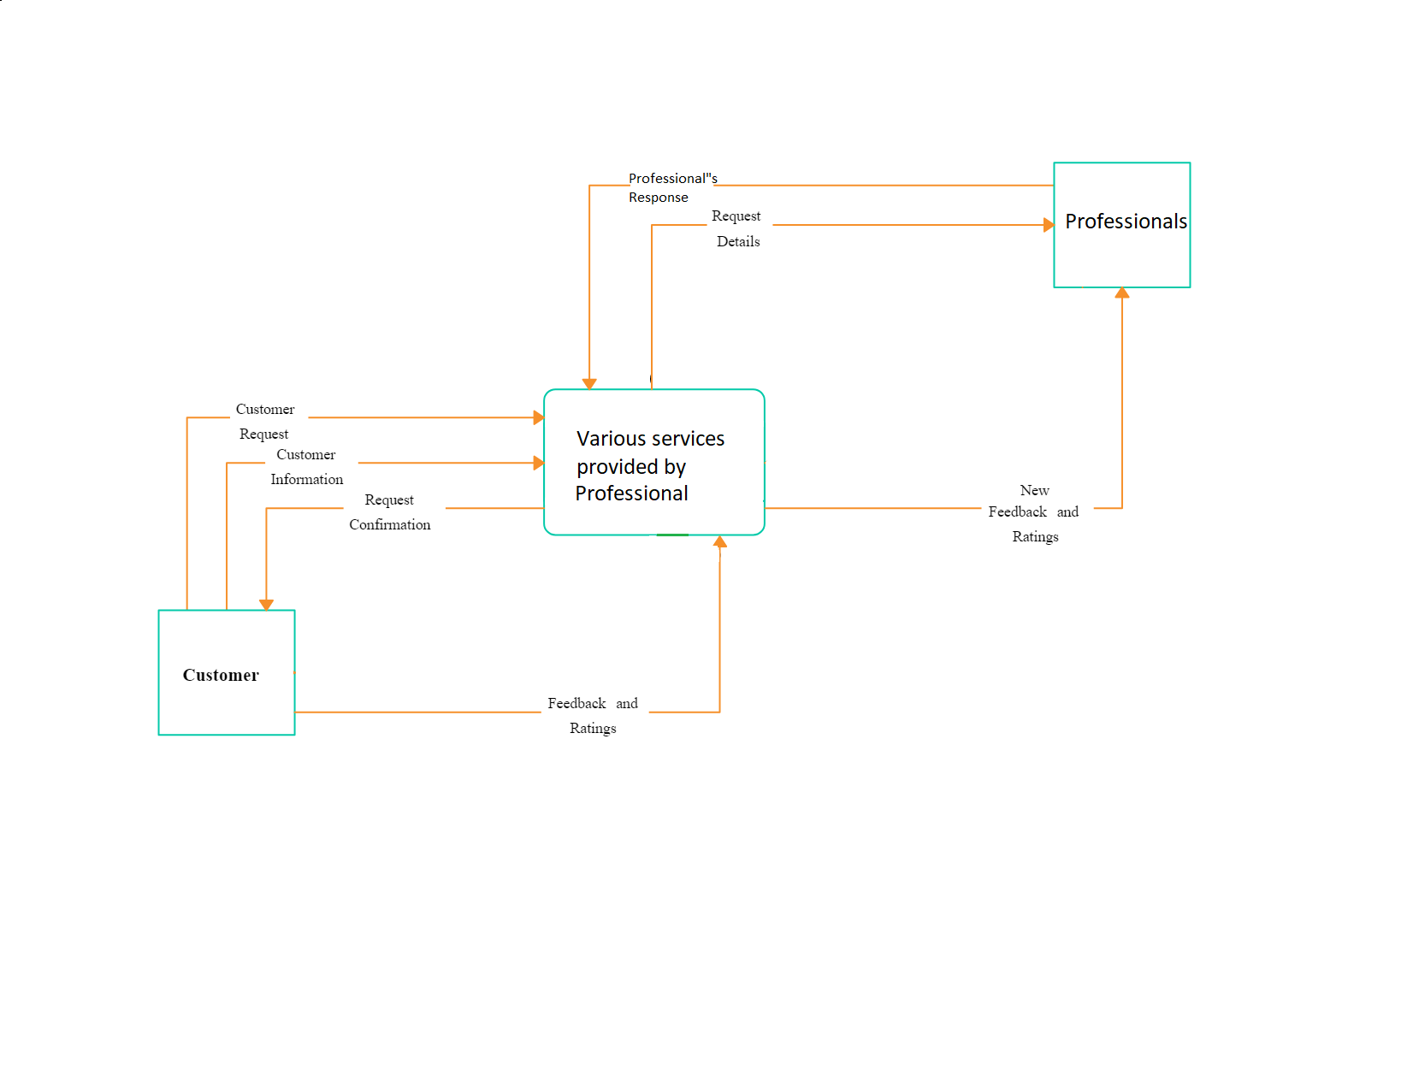

**Activity Diagrams:**

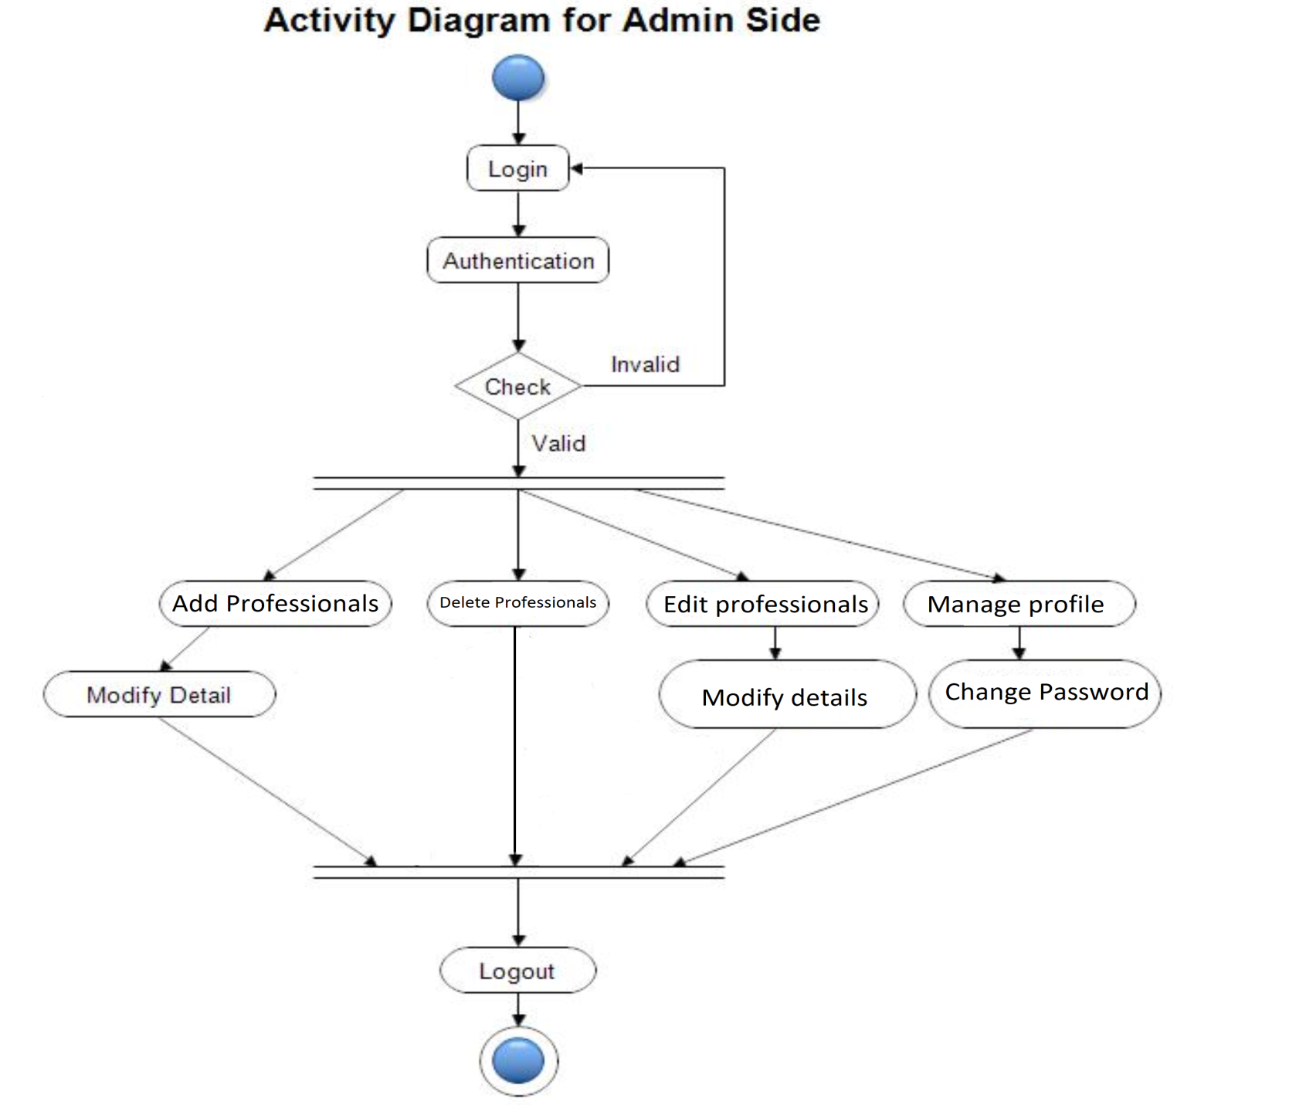

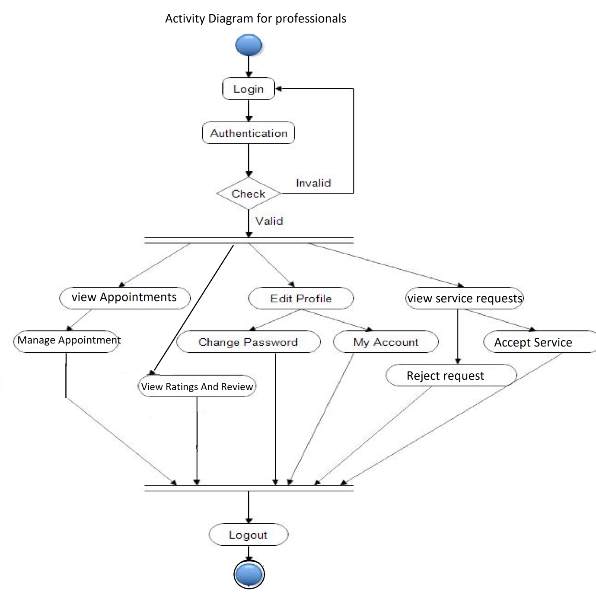

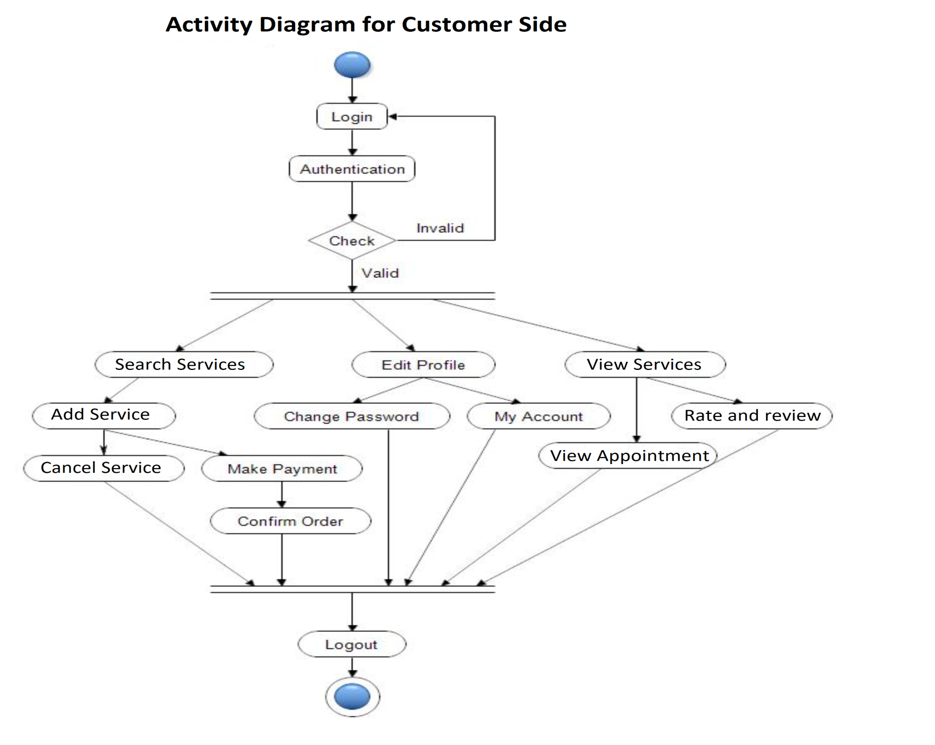

**Use Case Diagram:**

