**PROJECT REPORT**

**On**

**Faculty face recognition system**

Submitted to Rajasthan Technical University

in partial fulfillment of the requirement for the award of the degree of

**B.TECH.**

**in**

**COMPUTER ENGINEERING**

**Submitted By**

Pinku Kumar Jha (PIET15CE071)

Pranav Thakur (PIET15CE074)

Iva Tyagi (PIET15CE301)

**Under the Guidance of**

**Mr. Shruti BIjawat**

at



**POORNIMA INSTITUTE OF ENGINEERING & TECHNOLOGY, JAIPUR**

**Rajasthan Technical University, KOTA**

**APRIL, 2018**

**CERTIFICATE**

This is to be certified that the project entitled “Faculty face recognition system” has been submitted for the Bachelor of Computer Science and Engineering, Poornima Institute Of Engineering & Technology, Jaipur during the academic year 2018-2019 is a bonafide piece of project work carried out by “ **Pinku Kumar Jha, Pranav Thakur and Iva Tyagi**” towards the partial fulfillment for the award of the Degree (B.Tech.) under the guidance of “**Mrs Shruti Bijawat**” and supervision and no part of thereof has been submitted by them for any degree or diploma.

Project Guide Project Coordinator Mr. Deepak Moud

Mrs Shruti Bijawat Prof. (Dr.) Praveen Gupta (H.O.DCSE)

(Assistant Professor) (Professor)

**CANDIDATE’S DECLARATION**

We Pinku Kumar Jha **(Piet15ce071), Pranav Thakur (Piet15ce074) & Iva Tyagi (piet15ce301)** B.Tech (Semester- VIII) of “**Poornima Institute Of Engineering & Technology, Jaipur”**

hereby declare that the Project Report entitled **“ -”** is an original work and data provided in the study is authentic to the best of our knowledge.This report has not been submitted to any other Institute for the award of any other degree.

|  |  |  |
| --- | --- | --- |
| pinku kumar jha | Pranav thakur | iva tyagi |
| PIET15CE071 | PIET15CE074 | PIET15CE301 |

|  |  |
| --- | --- |
| **Place: Jaipur** |  |
| **Date: 19th oct 2018** |  |

**ACKNOWLEDGEMENT**

It is our pleasure to be indebted to various people, who directly or indirectly contributed in the development of this work and who influenced our thinking, behavior and acts during the course of study.

We express our sincere gratitude to ***Dr. O. P. Sharma,*** Director, PIET for providing us an opportunity to undergo this Major Project as the part of the curriculum.

We are thankful to ***Mr. Deepak Moud, HOD, CS*** for his support, cooperation, and motivation provided to us during the training for constant inspiration, presence and blessings.

We are thankful to ***Mrs Shruti Bijawat*** for his support, cooperation, and motivation provided to us during the training for constant inspiration, presence and blessings.

We also extend our sincere appreciation to***Prof. (Dr.) Praveen Gupta*** who provided his valuable suggestions and precious time in accomplishing our Project report.

Lastly, we would like to thank the almighty and our parents for their moral support and friends with whom we shared our day-to-day experience and received lots of suggestions that improved our quality of work.

PINKU KUMAR JHA PRANAV THAKUR IVA TAYGI

|  |  |  |
| --- | --- | --- |
| **PIET15CE071** | **PIET15CE074** | **PIET15CE301** |

**TABLE OF CONTENTS**

|  |  |  |
| --- | --- | --- |
| **CHAPTER NO.** | **TOPICS** | **PAGE NO.** |
|  | TITLE PAGE | I |
|  | CERTIFICATE | II |
|  | CANDIDATE’S DECLARATION | III |
|  | ACKNOWLEDGEMENT | IV |
|  | TABLE OF CONTENTS | V |
|  | TABLE OF FIGURE | VI |
|  | ABSTRACT | VII |
| 1 | **INTRODUCTION TO PROJECT** | 1 |
|  |  |  |
|  | Project Aim and Objective  Problem Statement  Background of the Project (Literature Survey)  Software Requirements  Hardware Requirements |  |
| 2 | **PRODUCT BACKLOG** |  |
|  | 1. PRODUCT Backlog 2. Sprint Backlog-1 3. Sprint Backlog-2 4. Sprint Backlog-3 5. Sprint Backlog-4 |  |
|  |  |  |
| 3 | **TECHNOLOGY APPLIED AND PROJECT MANAGEMENT** |  |
|  | Brief Description of All technology Apply in the Project.  Project management  Agile  Relevance to Society  Ethics  Life Long Learning  Project Finance  Environment and Sustainability |  |
|  |  |  |
|  |  |  |
| 4 | **PROJECT IMPLEMENTATION** |  |
|  | Sprint Backlog-1  Sprint Backlog-2  Sprint Backlog-3  Sprint Backlog-4 |  |
|  |  |  |
| 5 | **CONCLUSION** |  |
|  | Results  Conclusion  Future Scope |  |
| 6 | ANNEXURES |  |
|  | References |  |
|  | APPENDIX/ANNEXURES |  |
|  | Research Paper ( if Presented and approved for publication) |  |
|  | CV |  |
|  |  |  |

**LIST OF FIGURES**

|  |  |  |
| --- | --- | --- |
| **S. NO.** | **FIGURE** | **PAGE NO.** |
| 1  2. | Biometric Application  Structure of face recognition system |  |
|  |  |  |
|  |  |  |
|  |  |  |
|  |  |  |
|  |  |  |
|  |  |  |
|  |  |  |

**ABSTRACT**

Face (facial) recognition is the identiﬁcation of humans by the unique characteristics of theirFaces.Face recognition technology is the least intrusive and fastest bio-metric technology.It works with the most obvious individual identiﬁer the human face. With increasing se-curity needs and with advancement in technology extracting information has become muchsimpler. This project aims on building an application based on face recognition using dif-ferent algorithms and comparing the results. The basic purpose being to identify the faceand retrieving information stored in database. It involves two main steps. First to identifythe distinguishing factors in image n storing them and Second step to compare it with theexisting images and returning the data related to that image. The various algorithms usedfor face detection are PCA Algorithm and Gray Scale Algorithm.

**KEYWORDS:** **Face Recognition, PCA Algorithm, Gray Scale Algorithm, Eigenfaces.**

**CHAPTER 1**

**INTRODUCTION TO PROJECT**

**Project Aim and Objective :**

**\*Biometrics**

Biometrics is used in the process of authentication of a person by verifying or identifyingthat a user requesting a network resource is who he, she, or it claims to be, and vice versa.It uses the property that a human trait associated with a person itself like structure of datawith the incoming data we can verify the identity of a particular person [1]. There are manytypes of biometric system like detection and recognition, iris recognition etc., these traitsare used for human identication in surveillance system, criminal identiﬁcation , face detailsetc. By comparing the existing ﬁngerprint recognition.

**\* Face Recognition**

Human beings have recognition capabilities that are unparalleled in the modern computingera. These are mainly due to the high degree of interconnectivity, adaptive nature,learningskills and generalization capabilities of the nervous system. The human brain has numer-ous highly interconnected biological neurons which, on some speciﬁc tasks, can outperformsuper computers. A child can accurately identify a face, but for a computer it is a cum-bersome task. Therefore, the main idea is to engineer a system which can emulate whata child can do. Advancements in computing capability over the past few decades have en-abled comparable recognition capabilities from such engineered systems quite successfully.Early face recognition algorithms used simple geometric models, but recently the recogni-tion process has now matured into a science of sophisticated mathematical representationsand matching processes. Major advancements and initiatives have propelled face recognitiontechnology into the spotlight. Face recognition technology can be used in wide range of applications.Computers that detect and recognize faces could be applied to a wide variety of practical applications including criminal identiﬁcation etc. Face detection and recognitionis used in many places nowadays,verifying websites hosting images and social networkingsites. Face recognition and detection can be achieved using technologies related to computerscience. Features extracted from a face are processed and compared with similarly processedfaces present in the database. If a face is recognized it is known or the system may showa similar face existing in database else it is unknown. In surveillance system if a unknownface appears more than one time then it is stored in database for further recognition. Thesesteps are very useful in criminal identiﬁcation. In general, face recognition techniques can bedivided into two groups based on the face representation they use appearance-based, whichuses holistic texture features and is applied to either whole-face or speciﬁc face image andfeature-based, which uses geometric facial features (mouth, eyebrows, cheeks etc), and geo-metric relationships between them.

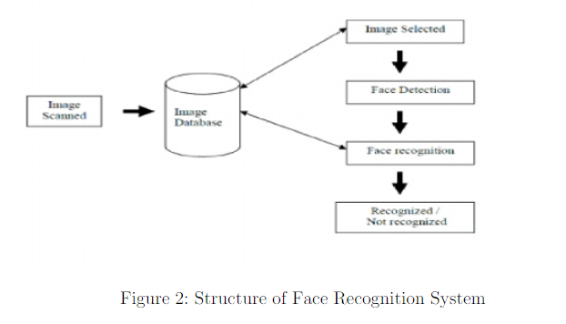

**Objectives**

1. Trying to ﬁnd a face within a large database of faces. In this approach the systemreturns a possible list of faces from the database. The most useful applications containcrowd surveillance, video content indexing, personal identiﬁcation (example: driverslicense), mug shots matching, etc.

**Problem Statement**

1. There are lot more issues with the attendance system now a days in the school and college . so we have designed a face recognition system for faculty members.

**Background of the Project(Literature Survey)**

Several algorithms and techniques for face recognition have been developed in the pastby researchers.These are discussed brieﬂy in this section.

1. **Face Recognition Based on Independent Component Analysis**:

A number of current face recognition algorithms use face representations found by unsuper-vised statistical methods. Typically these methods ﬁnd a set of basis images and representfaces as a linear combination of those images. Principal component analysis (PCA) is apopular example of such methods. The basis images found by PCA depend only on pairwiserelationships between pixels in the image database. In a task such as face recognition, inwhich important information may be contained in the high-order relationships among pixels,it seems reasonable to expect that better basis images may be found by methods sensitiveto these high-order statistics. Independent component analysis (ICA), a generalization of PCA, is one such method. We used a version of ICA derived from the principle of optimalinformation transfer through sigmoidal neurons. ICA was performed on face images in theFERET database under two diﬀerent architectures, one which treated the images as randomvariables and the pixels as outcomes, and a second which treated the pixels as random vari-ables and the images as outcomes. The ﬁrst architecture found spatially local basis imagesfor the faces. The second architecture produced a factorial face code. Both ICA representa-tions were superior to representations based on PCA for recognizing faces across days andchanges in expression. A classiﬁer that combined the two ICA representations gave the bestperformance.

1. **Eigen-spaces:**

Eigenspace-based face recognition corresponds to one of the most successful methodologiesfor the computational recognition of faces in digital images. Starting with the Eigenface-Algorithm, diﬀerent eigenspace-based approaches for the recognition of faces have been pro-posed. They diﬀer mostly in the kind of projection method used (standard, diﬀerential, orkernel eigenspace), in the projection algorithm employed, in the use of simple or diﬀeren-tial images before/after projection, and in the similarity matching criterion or classiﬁcationmethod employed. The aim of this paper is to present an independent comparative studyamong some of the main eigenspace-based approaches. We believe that carrying out indepen-dent studies is relevant, since comparisons are normally performed using the implementationsof the research groups that have proposed each method, which does not consider completelyequal working conditions for the algorithms.

1. **Elastic bunch Graph Matching**

Elastic Bunch Graph Matching is one of the well known methods proposed for face recog-nition. In this work, we propose several extensions to Elastic Bunch Graph Matching andits recent variant Landmark Model Matching. We used data from the FERET database forexperimentations and to compare the proposed methods. We apply Particle Swarm Opti-mization to improve the face graph matching procedure in Elastic Bunch Graph Matchingmethod and demonstrate its usefulness. Landmark Model Matching depends solely on Gaborwavelets for feature extraction to locate the landmarks (facial feature points). We show thatimprovements can be made by combining gray-level proﬁles with Gabor wavelet featuresfor feature extraction. Furthermore, we achieve improved recognition rates by hybridizingGabor wavelet with eigenface features found by Principal Component Analysis, which wouldprovide information contained in the overall appearance of a face. We use Particle SwarmOptimization to ﬁne tune the hybridization weights.[3]Results of both fully automatic and partially automatic versions of all methods are pre-sented. The best-performing method improves the recognition rate up to 22.6speeds up theprocessing time by 8 times over the Elastic Bunch Graph Matching for the fully automaticcase.

1. **Linear Discriminant Analysis**

Both PCA and ICA do not use face class informa-tion. Linear Discriminant Analysis (LDA)ﬁnds an ecient way to represent the face vector space by exploiting the class information. Itdierentiates individual faces but recognizes faces of the same individual ].LDA searches for vectors in the underlying space that best discriminate among classes. Forall the samples of all classes, two measures are deﬁned.

**SoftwareRequirements:** spyder, opencv library, face recognisation library

**Hardware Requirements:** laptop.

**CHAPTER 2**

**PRODUCT BACKLOG**

(20 to 30 page)

1. **PRODUCT Backlog**(Half page Introduction of product Backlog and then Print of Your Existing excel sheet , including All graphs)

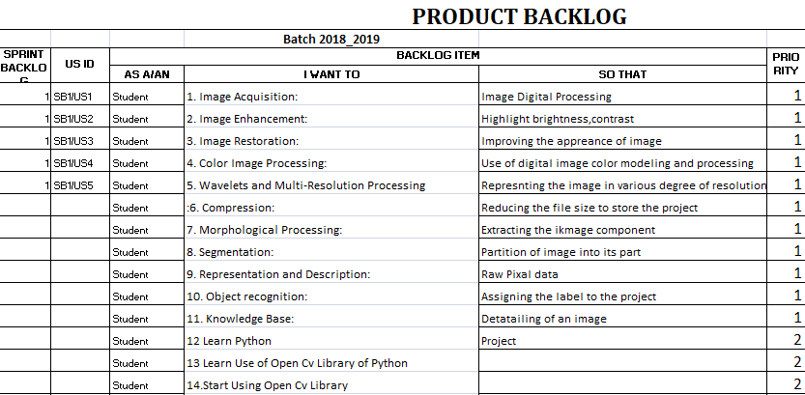

1. **Sprint Backlog-1**collection of data set and apply the pre processing process

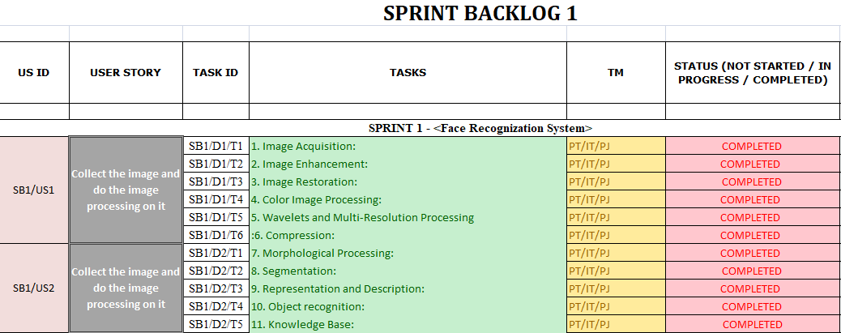

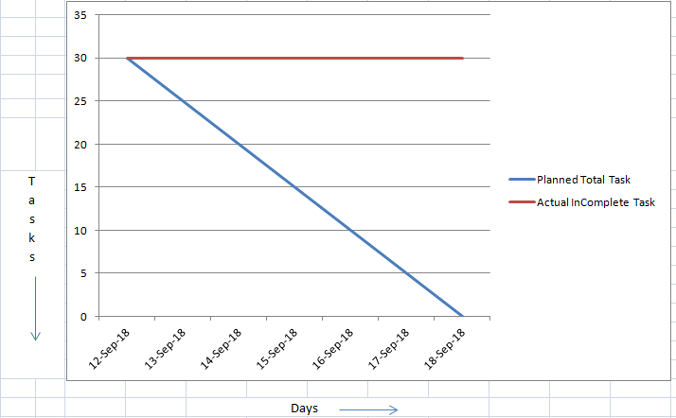

1. **Sprint Backlog-2**learing of python, learning of open cv library, use of open cv library, and its implementation

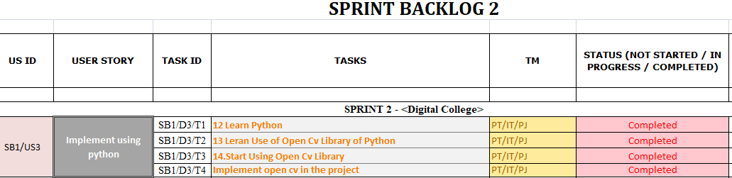

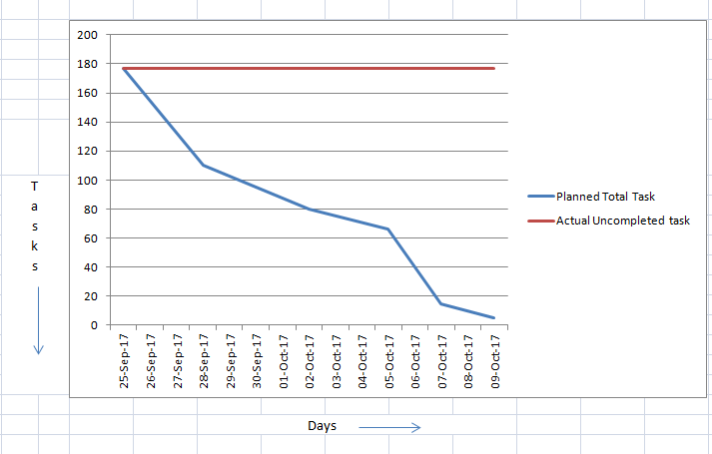

1. **Sprint Backlog-3**(Half page Introduction of Sprint Backlog -3 and then Print of Your Existing excel sheet , including All graphs)
2. **Sprint Backlog-4**

(Half page Introduction of Sprint Backlog -4 and then Print of Your Existing excel sheet , including All graphs)

**CHAPTER 3**

**TECHNOLOGY APPLIED AND PROJECT MANAGEMENT**

Brief Description of All technologiesAppled in the Project.

**Project management :**

Project management is the application of processes, methods, knowledge, skills and experience to achieve the project objectives. General. A project is a unique, transient endeavor, undertaken to achieve planned objectives, which could be defined in terms of outputs, outcomes or benefits.

Project management is the practise of initiating, planning, executing, controlling, and closing the [work](https://en.wikipedia.org/wiki/Work_(project_management)) of a [team](https://en.wikipedia.org/wiki/Project_team) to achieve specific goals and meet specific success criteria at the specified time. A [project](https://en.wikipedia.org/wiki/Project) is a temporary endeavor designed to produce a unique product, service or result with a defined beginning and end undertaken to meet unique goals and objectives, typically to bring about beneficial change or added value. The temporary nature of projects stands in contrast with [business as usual](https://en.wikipedia.org/wiki/Business_operations), which are repetitive, permanent, or semi-permanent functional activities to produce products or services. In practice, the [management](https://en.wikipedia.org/wiki/Management) of such distinct production approaches requires the development of distinct technical skills and management strategies.

**Software project management**

Software project management is the art and science of planning and leading software projects. It is a sub-discipline of [project management](https://en.wikipedia.org/wiki/Project_management) in which [software](https://en.wikipedia.org/wiki/Software) projects are planned, implemented, monitored and controlled.

The job pattern of an IT company engaged in software development can be seen split in two parts:

* Software Creation
* Software Project Management

A project is well-defined task, which is a collection of several operations done in order to achieve a goal (for example, software development and delivery). A Project can be characterized as:

* Every project may have a unique and distinct goal.
* Project is not routine activity or day-to-day operations.
* Project comes with a start time and end time.
* Project ends when its goal is achieved hence it is a temporary phase in the lifetime of an organization.
* Project needs adequate resources in terms of time, manpower, finance, material and knowledge-bank.

**Software Project**

A Software Project is the complete procedure of software development from requirement gathering to testing and maintenance, carried out according to the execution methodologies, in a specified period of time to achieve intended software product.

**Need of software project management**

Software is said to be an intangible product. Software development is a kind of all new stream in world business and there’s very little experience in building software products. Most software products are tailor made to fit client’s requirements. The most important is that the underlying technology changes and advances so frequently and rapidly that experience of one product may not be applied to the other one. All such business and environmental constraints bring risk in software development hence it is essential to manage software projects efficiently.

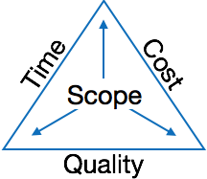

The image above shows triple constraints for software projects. It is an essential part of software organization to deliver quality product, keeping the cost within client’s budget constrain and deliver the project as per scheduled. There are several factors, both internal and external, which may impact this triple constrain triangle. Any of three factor can severely impact the other two.

Therefore, software project management is essential to incorporate user requirements along with budget and time constraints.

**Software Project Manager**

A software project manager is a person who undertakes the responsibility of executing the software project. Software project manager is thoroughly aware of all the phases of SDLC that the software would go through. Project manager may never directly involve in producing the end product but he controls and manages the activities involved in production.

A project manager closely monitors the development process, prepares and executes various plans, arranges necessary and adequate resources, maintains communication among all team members in order to address issues of cost, budget, resources, time, quality and customer satisfaction.

Let us see few responsibilities that a project manager shoulders -

**Managing People**

* Act as project leader
* Liaison with stakeholders
* Managing human resources
* Setting up reporting hierarchy etc.

**Managing Project**

* Defining and setting up project scope
* Managing project management activities
* Monitoring progress and performance
* Risk analysis at every phase
* Take necessary step to avoid or come out of problems
* Act as project spokesperson

**Software Management Activities**

Software project management comprises of a number of activities, which contains planning of project, deciding scope of software product, estimation of cost in various terms, scheduling of tasks and events, and resource management. Project management activities may include:

* **Project Planning**
* **Scope Management**
* **Project Estimation**

**Project Planning**

Software project planning is task, which is performed before the production of software actually starts. It is there for the software production but involves no concrete activity that has any direction connection with software production; rather it is a set of multiple processes, which facilitates software production. Project planning may include the following:

**Scope Management**

It defines the scope of project; this includes all the activities, process need to be done in order to make a deliverable software product. Scope management is essential because it creates boundaries of the project by clearly defining what would be done in the project and what would not be done. This makes project to contain limited and quantifiable tasks, which can easily be documented and in turn avoids cost and time overrun.

During Project Scope management, it is necessary to -

* Define the scope
* Decide its verification and control
* Divide the project into various smaller parts for ease of management.
* Verify the scope
* Control the scope by incorporating changes to the scope

**Project Estimation**

For an effective management accurate estimation of various measures is a must. With correct estimation managers can manage and control the project more efficiently and effectively.

Project estimation may involve the following:

* **Software size estimation**

Software size may be estimated either in terms of KLOC (Kilo Line of Code) or by calculating number of function points in the software. Lines of code depend upon coding practices and Function points vary according to the user or software requirement.

* **Effort estimation**

The managers estimate efforts in terms of personnel requirement and man-hour required to produce the software. For effort estimation software size should be known. This can either be derived by managers’ experience, organization’s historical data or software size can be converted into efforts by using some standard formulae.

* **Time estimation**

Once size and efforts are estimated, the time required to produce the software can be estimated. An effort required is segregated into sub categories as per the requirement specifications and interdependency of various components of software. Software tasks are divided into smaller tasks, activities or events by Work Breakthrough Structure (WBS). The tasks are scheduled on day-to-day basis or in calendar months.

The sum of time required to complete all tasks in hours or days is the total time invested to complete the project.

* **Cost estimation**

This might be considered as the most difficult of all because it depends on more elements than any of the previous ones. For estimating project cost, it is required to consider -

* + Size of software
  + Software quality
  + Hardware
  + Additional software or tools, licenses etc.
  + Skilled personnel with task-specific skills
  + Travel involved
  + Communication
  + Training and support

**Project Estimation Techniques**

We discussed various parameters involving project estimation such as size, effort, time and cost.Project manager can estimate the listed factors using two broadly recognized techniques

**Decomposition Technique**

This technique assumes the software as a product of various compositions.

There are two main models -

* **Line of Code** Estimation is done on behalf of number of line of codes in the software product.
* **Function Points** Estimation is done on behalf of number of function points in the software product.

**Empirical Estimation Technique**

This technique uses empirically derived formulae to make estimation.These formulae are based on LOC or FPs.

* **Putnam Model**

This model is made by Lawrence H. Putnam, which is based on Norden’s frequency distribution (Rayleigh curve). Putnam model maps time and efforts required with software size.

* **COCOMO**

COCOMO stands for COnstructiveCOstMOdel, developed by Barry W. Boehm. It divides the software product into three categories of software: organic, semi-detached and embedded.

**Project Scheduling**

Project Scheduling in a project refers to roadmap of all activities to be done with specified order and within time slot allotted to each activity. Project managers tend to define various tasks, and project milestones and they arrange them keeping various factors in mind. They look for tasks lie in critical path in the schedule, which are necessary to complete in specific manner and strictly within the time allocated. Arrangement of tasks which lies out of critical path are less likely to impact over all schedule of the project.

For scheduling a project, it is necessary to -

* Break down the project tasks into smaller, manageable form
* Find out various tasks and correlate them
* Estimate time frame required for each task
* Divide time into work-units
* Assign adequate number of work-units for each task
* Calculate total time required for the project from start to finish

**Resource management**

All elements used to develop a software product may be assumed as resource for that project. This may include human resource, productive tools and software libraries.

The resources are available in limited quantity and stay in the organization as a pool of assets. The shortage of resources hampers the development of project and it can lag behind the schedule. Allocating extra resources increases development cost in the end. It is therefore necessary to estimate and allocate adequate resources for the project.

Resource management includes -

* Defining proper organization project by creating a project team and allocating responsibilities to each team member
* Determining resources required at a particular stage and their availability
* Manage Resources by generating resource request when they are required and de-allocating them when they are no more needed.

**Project Risk Management**

Risk management involves all activities pertaining to identification, analysing and making provision for predictable and non-predictable risks in the project. Risk may include the following:

* Experienced staff leaving the project and new staff coming in.
* Change in organizational management.
* Requirement change or misinterpreting requirement.
* Under-estimation of required time and resources.
* Technological changes, environmental changes, business competition.

**Risk Management Process**

There are following activities involved in risk management process:

* **Identification -** Make note of all possible risks, which may occur in the project.
* **Categorize -** Categorize known risks into high, medium and low risk intensity as per their possible impact on the project.
* **Manage -** Analyze the probability of occurrence of risks at various phases. Make plan to avoid or face risks. Attempt to minimize their side-effects.
* **Monitor -** Closely monitor the potential risks and their early symptoms. Also monitor the effects of steps taken to mitigate or avoid them.

**Project Execution & Monitoring**

In this phase, the tasks described in project plans are executed according to their schedules.

Execution needs monitoring in order to check whether everything is going according to the plan. Monitoring is observing to check the probability of risk and taking measures to address the risk or report the status of various tasks.

These measures include -

* **Activity Monitoring -** All activities scheduled within some task can be monitored on day-to-day basis. When all activities in a task are completed, it is considered as complete.
* **Status Reports -** The reports contain status of activities and tasks completed within a given time frame, generally a week. Status can be marked as finished, pending or work-in-progress etc.
* **Milestones Checklist -** Every project is divided into multiple phases where major tasks are performed (milestones) based on the phases of SDLC. This milestone checklist is prepared once every few weeks and reports the status of milestones.

**Project Communication Management**

Effective communication plays vital role in the success of a project. It bridges gaps between client and the organization, among the team members as well as other stake holders in the project such as hardware suppliers.

Communication can be oral or written. Communication management process may have the following steps:

* **Planning** - This step includes the identifications of all the stakeholders in the project and the mode of communication among them. It also considers if any additional communication facilities are required.
* **Sharing** - After determining various aspects of planning, manager focuses on sharing correct information with the correct person on correct time. This keeps every one involved the project up to date with project progress and its status.
* **Feedback** - Project managers use various measures and feedback mechanism and create status and performance reports. This mechanism ensures that input from various stakeholders is coming to the project manager as their feedback.
* **Closure** - At the end of each major event, end of a phase of SDLC or end of the project itself, administrative closure is formally announced to update every stakeholder by sending email, by distributing a hardcopy of document or by other mean of effective communication.

After closure, the team moves to next phase or project.

**Configuration Management**

Configuration management is a process of tracking and controlling the changes in software in terms of the requirements, design, functions and development of the product.

IEEE defines it as “the process of identifying and defining the items in the system, controlling the change of these items throughout their life cycle, recording and reporting the status of items and change requests, and verifying the completeness and correctness of items”.

Generally, once the SRS is finalized there is less chance of requirement of changes from user. If they occur, the changes are addressed only with prior approval of higher management, as there is a possibility of cost and time overrun.

**Project management Tools:**

Project management required tools to manage the work , time and resources. At present many of the software are available for project management. Some of the popular software tools are as follows.

### 01. [Trello](http://send.getapp.com/aff_c?offer_id=677&aff_id=1371)

Trello is an project management tool, instead this app is a free visual way to to glance at the entire project with a single view. With Trello you can organise cards, these cards can be your thoughts, conversations and to-do lists and be placed on a board for everyone to collaborate on.

### 02. [Basecamp](http://send.getapp.com/aff_c?offer_id=637&aff_id=1371)

Basecamp is the granddaddy of project management apps. Basecamp is considered the leading project management tool around. It boost a simple and easy to use interface to collaborate with your team and client. It allows you to create multiple projects and setup discussions, write to-do lists, manage files, create and share documents, and organise dates for scheduling.

### 03. [Teamwork Projects](http://send.getapp.com/aff_c?offer_id=947&aff_id=1371)

Teamwork Projects is the ultimate productivity tool to manage projects with your team. Teamwork allows you to keep all your projects, tasks and files all in one place and easily collaborate with a team. Teamwork helps you to visualise the entire project through a marked calendar and gantt chart and setup reporting. Teamwork supports file management with Google Drive, Box.com and Dropbox. As well as integration with leading apps such as third party accounting software and customer support apps.

### 04. [Resource Guru](https://resourceguruapp.com/)

Billed as the "simple way to schedule people, equipment and other resources", Resource Guru is a streamlined resource scheduling and leave management tool that’s designed to keep your projects on track. You can plan your team's workloads, receive daily booking reminders, report on KPIs, and more. Apple, Saatchi & Saatchi and Deloitte are among some of the cloud-based team calendar’s heavyweight customers.

### 05. [ActiveCollab](http://send.getapp.com/aff_c?offer_id=949&aff_id=1371)

ActiveCollab recently released its new version 5.0. The new revamped app is now more powerful and focused project management tool. It offers team collaborating features, task management, time tracking and importing expenses. One of the biggest asset of ActiveCollab is it offers invoicing features. You are able to track payments and expenses and have invoices paid directly within ActiveCollab with PayPal, and other credit card payments.

### 06. [Zoho Projects](http://send.appdoubler.com/aff_c?offer_id=101&aff_id=1371)

Zoho offers a wide range of business software including Projects. Zoho Projects is an proficient tool to project plan and project coordinator from start to finish. It boost all the features you need for project management with some advance features including reporting, integration with Google Apps and Dropbox, bug tracking, setup Wiki Pages to build a repository of information, forums and more.

### 07. [Jira](http://send.getapp.com/aff_c?offer_id=281&aff_id=1371)

Jira is specifically targeted for software development teams. Jira offers abilities to raise issues and bugs. Jira makes it real easy to track bugs and see which issues are still outstanding and how much time was spent on each task. Jira offer other products including Confluence a document collaboration tool, and HipChat a team chat and video and file sharing platform and other products.

### 08. [Asana](http://send.getapp.com/aff_c?offer_id=587&aff_id=1371)

Asana is the easiest way for teams to track their work so everyone knows who's doing what, by when. With tasks, projects, conversations and dashboards, Asana keeps your work organized, and teammates accountable so you can move work forward faster. Asana also lets you keep track of your work wherever you are with mobile apps for both iOS and Android.

### 09. [Podio](http://send.getapp.com/aff_c?offer_id=951&aff_id=1371)

Podio is a ever growing tool to organise and communication tool for any business. Podio allows you to personalise this platform to fit your business needs. Besides being able to communicate with a team, setup task management, use as a file storage system, like a traditional project management app, Podio can be an internal intranet for all your colleagues and departments to interact.

### 10. [Freedcamp](https://freedcamp.com/)

Whatever your project may be, either setting up an event, a web project or organising a wedding, Freedcamp helps you organise and plan effectively. Freedcamp has an organised dashboard to view the entire project at a glance. You can easily setup tasks, use sticky notes to visually setup tasks and organise them into the calendar. Freedcamp provides advance add-ons for high level business use including CRM, invoicing, issue tracking and setting up wiki pages.

### 11. [Wrike](http://send.getapp.com/aff_c?offer_id=239&aff_id=1371)

Wrike is advance application to help you work smarter. By making sure you are always staying on track and ensure you have the adequate resources to finish on time and on budget.Setting up tasks, engage your team and integrate with your business tools including Google Apps, Microsoft Excel, Dropbox and many more is so easy with Wrike.

**PO and Their Relevance to project**

**PO1: Engineering knowledge:**Apply the knowledge of mathematics, science, engineering fundamentals and an engineering specialization to the solution of complex engineering problems.

In this project creation process engineering knowledge of the software engineering and Electronics engineering have been applied. we have used software engineering , HTML,xml, java , android , java script , php , j2ee, data base , oracle , my sql , mango and other programming language and database to the project. We have applied all above engineering subjects in our projects.

**PO2: Problem analysis:**Identify, formulate, review research literature, and analyze complex engineering problems reaching substantiated conclusions using first principles of mathematics, natural sciences, and engineering sciences.

In our projects we have identified an problem , once verified by the client we have worked to identify the solution using all of our theoretical and practical knowledge.

**PO3: Design/development of solutions:** Design solutions for complex engineering problems and design system components or processes that meet the specified needs with appropriate consideration for the public health and safety, and the cultural, societal, and environmental considerations.

**PO4: Conduct investigations of complex problems:** Use research-based knowledge and research methods including design of experiments, analysis and interpretation of data, and synthesis of the information to provide valid conclusions.

**PO5: Modern tool usage:**Create, select, and apply appropriate techniques, resources, and modern engineering and IT tools including prediction and modeling to complex engineering activities with an understanding of the limitations.

In the project development we have applied Integrated Development Environment IDE for the rapid development of the code, used web server for the software development.

**PO6: The engineer and society**: Apply reasoning informed by the contextual knowledge to assess societal, health, safety, legal and cultural issues and the consequent responsibilities relevant to the professional engineering practice.

In 1961 , the Conference of Engineering Societies of Western Europe and the United States of America defined "professional engineer" as follows.

A professional engineer is competent by virtue of his/her fundamental education and training to apply the scientific method and outlook to the analysis and solution of engineering problems. He/she is able to assume personal responsibility for the development and application of engineering science and knowledge, notably in research, design, construction, manufacturing, superintending, managing and in the education of the engineer. His/her work is predominantly intellectual and varied and not of a routine mental or physical character. It requires the exercise of original thought and judgement and the ability to supervise the technical and administrative work of others. His/her education will have been such as to make him/her capable of closely and continuously following progress in his/her branch of engineering science by consulting newly published works on a worldwide basis, assimilating such information and applying it independently. He/she is thus placed in a position to make contributions to the development of engineering science or its applications. His/her education and training will have been such that he/she will have acquired a broad and general appreciation of the engineering sciences as well as thorough insight into the special features of his/her own branch. In due time he/she will be able to give authoritative technical advice and to assume responsibility for the direction of important tasks in his/her branch.

**PO7: Environment and sustainability:** Understand the impact of the professional engineering solutions in and environmental contexts, and demonstrate the knowledge of, and need for sustainable development.

Sustainability is the ability to continue a defined behavior indefinitely. Sometimes environmental, social and economic are termed to be the three pillars of sustainability.

**PO8: Ethics**: Apply ethical principles and commit to professional ethics and responsibilities and norms of the engineering practice

The ethics of engineers and the fundamental principles for Engineers are as follows.

Engineers uphold and advance the integrity, honor and dignity of the engineering profession by:

I. using their knowledge and skill for the enhancement of human welfare;

II.being honest and impartial, and servicing with fidelity the public, their employers and clients;

III. Striving to increase the competence and prestige of the engineering profession; and

IV. Supporting the professional and technical societies of their disciplines.   
  
  
**PO9. Individual and team work**: Function effectively as an individual and as a member or leader in diverse teams, and in multidisciplinary settings.  
  
  
To work successful in team a team member must have following capabilities.

**1. The Ability to Listen**

it is important to listen to one another's ideas. Too often in a business setting, you have a group of people simply waiting for their turn to speak, not paying one iota of attention to the persons on their left or right. So it is a good teamwork skill to have the ability to listen

**2. Check Your Ego**

This isn't saying abandon your ego all together, because that isn't healthy. But leaving your ego at the door temporarily is a very important team work skill. The reason this is so essential is because there is always someone better than you at something, no matter how brilliant you are.

**3. Critique**

By critique, I mean constructive criticism. Be able to give others constructive criticism and be able to listen to others critique your ideas and work. There shouldn't be any offense taken to constructive criticism. You all want to succeed, and this is a vital step in doing so.

**4. Delegation**

The mentality must be applied to teamwork. Delegate roles to those who do them best.

**5. Show Respect**

If you and another person happen to be paired up and can't stand each other, you can still put that aside for a couple of hours, treat each other civilly, and complete the tasks at hand. You may even overcome the dislike toward one another.

**6. Be Helpful**

This is simple.If one of your teammates does not understand an idea, discussion, or task that is being completed, take the necessary time to explain it to them and work with them. There are no weak links when everyone helps one another. Some take longer to learn than others, but that doesn't mean that they are of less intelligence. If in a meeting someone asks a question because they don't understand, don't frown at them. Just answer the questions patiently and concisely.

**7. Question One Another**

If someone brings up a topic of discussion and a solution to this topic, question them. Respectfully question, don't badger. Rather, ask them how it will work, why it will work over the long-run, and how everyone else can implement the idea.

**8. Participation**

Have the entire team encourage shy people to engage in the topics of discussion. Don't demand it, but make them realize that you really want to hear their ideas.

**9. Rational Debate**

Bad ideas are bad for teams. Spirited, friendly, rational debate is where facts come forward, ideas are born, and quality rises to the top.

**10. Set The Right Environment**

Try to make the space in which your team is assembled as comfortable, relaxing, and inviting as possible. You do not want your team to be tense and with frayed nerves.

**PO 10: Communication:**Communicate effectively on complex engineering activities with the engineering community and with society at large, such as, being able to comprehend and write effective reports and design documentation, make effective presentations, and give and receive clear instructions.

**PO11: Project management and finance:**Demonstrate knowledge and understanding of the engineering management principles and apply these to one’s own work, as a member and leader in a team, to manage projects and in multidisciplinary environments.

Project management is the application of processes, methods, knowledge, skills and experience to achieve the project objectives. In general project is a unique, transient endeavour, undertaken to achieve planned objectives, which could be defined in terms of outputs, outcomes or benefits.

**PO12: Life-long learning**: Recognize the need for and have the preparation and ability to engage in independent and lifelong learning in the broadest context of technological change.

Life Long Learning means is the provision or use of both formal and informal learning opportunities throughout people's lives in order to foster the continuous development and improvement of the knowledge and skills needed for employment and personal fulfillment

**CHAPTER 4**

**PROJECT IMPLEMENTATION**

( Each Spring Backlog of 13-17 Pages total Chapter Size 50-70 pages)

1. Sprint Backlog-1
2. 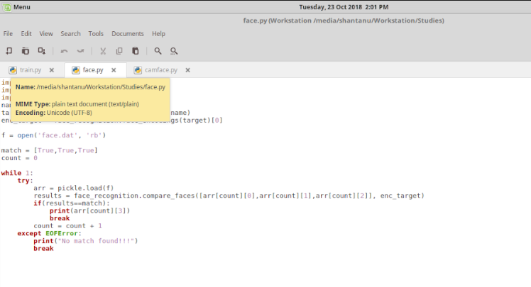
3. Sprint Backlog-2

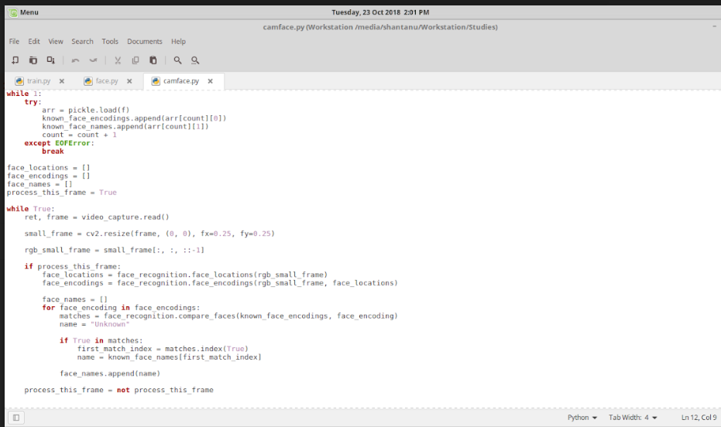

1. Sprint Backlog-3

( ***Project Design , Algo ,Database Design , ERD , Project Code ( Sample code only Limited to Max of 2-3 Page if needed , Project Screen Shots*** )

1. Sprint Backlog-4  
     
   ( ***Project Design , Algo ,Database Design , ERD , Project Code ( Sample code only Limited to Max of 2-3 Page if needed , Project Screen Shots*** )

**CHAPTER 5**

**CONCLUSION**

Results : we are able to recognize the image through of it

Conclusion :

Future Scope

**ANNEXURES**

References

1. Face Recognition by Independent Component Analysis Marian Stewart Bartlett,Member, IEEE, Javier R. Movellan, Member, IEEE, and Terrence J. Sejnowski, Fellow,IEEE2. Eigenspace-Based Face Recognition: A Comparative Study of Diﬀerent ApproachesJavier Ruiz-del-Solar, Member, IEEE, and Pablo Navarrete, Student Member, IEEE3. Face Recognition by Extending Elastic Bunch Graph Matching with Particle SwarmOptimization4. Discriminant Analysis of Principal Components for Face Recognition.5. www.wikipedia.com

**Instructions**

For Chapter Heading

Font: Times New Roman

Font Size: 14, Bold

Alignment: Center

Line Spacing 1.5

For Paragraph Heading

Font: Times New Roman

Font Size: 12, Bold

Alignment: Left

Line Spacing 1.5

For paragraph

Font: Times New Roman

Font Size: 12

Line Spacing 1.5

Alignment: Justify

Line Spacing 1.5