AgriTrace
Offline-First IoT & Blockchain-Enabled Farm-to-Fork Traceability
Product Requirements Document (PRD)
SIH Problem Statement 26232 | Ministry of Food Processing Industries (MoFPI)

Document Item | Specification
Product | AgriTrace — Low-Cost IoT Blockchain Node & Farm-to-Fork Traceability Platform
SIH PS | SIH26232
Category | Hardware
Theme | Agriculture, FoodTech & Rural Development
Primary users | Farmers/aggregators, logistics operators, processors, quality teams, auditors, consumers
Document status | Implementation-ready product requirements
Reference UI | Provided AgriTrace Monitoring, Traceability, Alerts and Analytics screens

1. Executive Summary
AgriTrace is a low-cost, rugged, offline-first shipment traceability platform designed around SIH26232. The system combines an IoT sensor node with local cryptographic storage, intermittent network synchronization, MQTT-based messaging, a backend traceability service, and a decentralized-ledger anchoring/verification layer. The web dashboard provides a truck-centric operational view of food shipments and makes environmental telemetry, offline synchronization, alerts and data integrity visible to operators.
The central product principle is: sensor data must remain available and verifiable even when the shipment temporarily loses cellular connectivity. Data is therefore captured locally, sequenced, cryptographically protected, queued for sync, and automatically transmitted after connectivity returns. The ledger stores verifiable proofs/anchors rather than requiring every raw sensor sample to be placed directly on-chain.

1.1 Product Value Proposition
- Affordable traceability for SMEs that cannot justify enterprise cold-chain hardware.
- Offline-first operation for agricultural and rural routes with intermittent connectivity.
- Tamper-evident telemetry using device-side cryptographic signing/hashing and chained records.
- Automatic synchronization after reconnection using lightweight messaging.
- Environmental monitoring for temperature, humidity and ethylene/gas, with GPS and device health telemetry.
- Auditable farm-to-fork history with QR-based verification for downstream users.
- Truck-centric visualization that maps each sensor/batch to a physical shipment compartment.

2. Problem Statement and Requirements Baseline
The supplied SIH26232 statement identifies two core market constraints: enterprise-grade traceability is expensive for SMEs, and standard loggers can lose connectivity in remote agricultural areas, producing blind spots. The expected solution explicitly requires a rugged, affordable, tamper-proof node; environmental logging; local cryptographic storage; energy harvesting; and automatic synchronization to a decentralized ledger after reconnection.
Requirement from PS | Product interpretation | Acceptance signal
Low-cost IoT node | Commodity MCU, sensors, cellular/GNSS, local storage and power management. | Prototype BOM stays within the team's target cost.
Rugged operation | Sealed enclosure, protected connectors, vibration-resistant mounting and environmental protection. | Node continues logging under representative moisture/dust/vibration tests.
Environmental logging | Temperature, humidity and ethylene/gas as core telemetry. | Timestamped readings are captured at configurable intervals.
Offline continuity | Local queue persists records when cellular/network is unavailable. | No sample loss across a controlled network outage.
Cryptographic storage | Signed/chained records and secure key storage where available. | Modified record fails verification.
Energy harvesting | Solar as primary practical prototype path; thermal harvesting as an optional extension. | Energy subsystem extends runtime and reports energy/battery state.
Lightweight sync | MQTT over TLS with batching and acknowledgements. | Queued records sync automatically after reconnection.
Decentralized ledger | Store/anchor verifiable hashes or Merkle roots; keep high-volume telemetry off-chain. | Dashboard can prove whether a record/batch matches its anchored proof.

3. Goals, Non-Goals and Success Metrics

3.1 Goals
- Deliver an end-to-end demonstrable prototype from physical sensor node to dashboard.
- Maintain data integrity during offline periods.
- Provide real-time monitoring when connectivity is available.
- Provide an explicit sync-state model: Live, Offline/Queued, Syncing, Synced, Verification Failed.
- Make shipment events and environmental excursions easy to audit.
- Keep the architecture modular enough to support different sensor and ledger implementations.

3.2 Non-Goals for MVP
- Full national-scale logistics optimization.
- Replacing regulated food-safety certification or laboratory testing.
- Putting every high-frequency raw sensor reading directly on a blockchain.
- Building a public marketplace or unrelated commerce module.
- Advanced predictive shelf-life modeling as a mandatory MVP feature.

3.3 Suggested Success Metrics
Metric | Target for prototype | Measurement
Data continuity | 100% of test samples retained through planned outage | Compare generated vs. received sequence numbers
Sync recovery | < 60 seconds after network recovery for a small queued batch | Device/backend timestamps
Integrity | 100% of deliberately modified test records detected | Verification test suite
Dashboard freshness | < 5 seconds for connected telemetry | MQTT publish to UI timestamp
Duplicate prevention | No duplicate sequence IDs accepted | Backend idempotency checks
Alert latency | < 10 seconds under normal connectivity | Sensor event to UI alert
Traceability | Complete batch event timeline | Create → assign → transit → exception → delivery

4. Users and Roles
Role | Primary needs | Key permissions
Farmer / Aggregator | Create shipment, attach device, see shipment health | Create/manage own shipments and devices
Logistics Operator | Monitor active trucks and connectivity | View live telemetry, acknowledge operational alerts
Quality / Food Safety | Review excursions and evidence | View history, verification, reports and export
Processor / Receiver | Verify shipment integrity before intake | Scan QR, view provenance and integrity status
Auditor | Trace immutable event history | Read-only access to events, proofs and verification
System Admin | Fleet, thresholds, users and devices | Full configuration and device management
Consumer | Simple provenance and trust information | Public QR consumer view; no operational controls

5. Product Scope and Information Architecture
The supplied reference screens show an AgriTrace sidebar with operational modules. For the SIH26232 MVP, the navigation should be streamlined to the modules below.
Priority | Page | Purpose
P0 | Dashboard | Fleet/shipment overview, live health, sync and critical exceptions.
P0 | Shipments | Create, assign, track and review shipments.
P0 | Devices | Register, provision, assign and monitor IoT nodes.
P0 | Monitoring | Live environmental telemetry and truck-centric visualization.
P0 | Traceability | Farm-to-fork event timeline, hashes, proofs and QR verification.
P0 | Alerts | Environmental, device, tamper and sync exceptions.
P1 | Analytics | Shipment/device trends and operational KPIs.
P1 | Reports | Exportable audit/quality reports.
P1 | Profile / Settings | User profile, thresholds, notification and organization settings.
External/Public | Consumer View | QR-accessible shipment provenance and integrity summary.

Remove Marketplace from the SIH MVP unless a separate business requirement is introduced. Consumer View should be reached through QR verification rather than being a primary operations sidebar destination.

6. UI/UX Product Requirements

6.1 Design Direction
- Use the supplied AgriTrace visual language: dark navy left navigation, white/light-gray workspace, restrained teal/green accents, rounded cards and compact data density.
- Keep the interface clean and operational; color should communicate state, not decorate every component.
- Use consistent status colors: green = healthy/verified, amber = warning/pending, red = critical/failed, blue = informational/sync.
- Every critical metric should expose its threshold or state where practical.
- Use responsive layouts for laptop/tablet; the operational dashboard is desktop-first.

6.2 Global Shell
- Persistent left sidebar with AgriTrace logo, primary navigation and collapse control.
- Top bar with page title/subtitle, global search for shipments/devices/batches, notification icon and user profile.
- Persistent status affordance for connectivity/sync when relevant.
- Toast notifications for successful sync, QR creation, device assignment and critical errors.

6.3 Dashboard
- KPI cards: Active Shipments, Devices Online, Devices Offline, Open Alerts, Pending Sync Records, Verified Shipments.
- Live shipment map with truck markers and route status.
- Compact critical-alert panel.
- Offline queue/sync health card showing queued records and last successful sync.
- Shipment status distribution and recent events.

6.4 Monitoring Page
- Top warning banner when environmental values are outside configured safe ranges.
- Metric cards for Temperature, Humidity, Gas/Ethylene and Battery.
- Telemetry history table with timestamp, values, sequence number and source state.
- Source badges must distinguish LIVE, OFFLINE QUEUED, SYNCED and VERIFIED where applicable.
- Truck visualization is the primary shipment-centric monitoring surface.
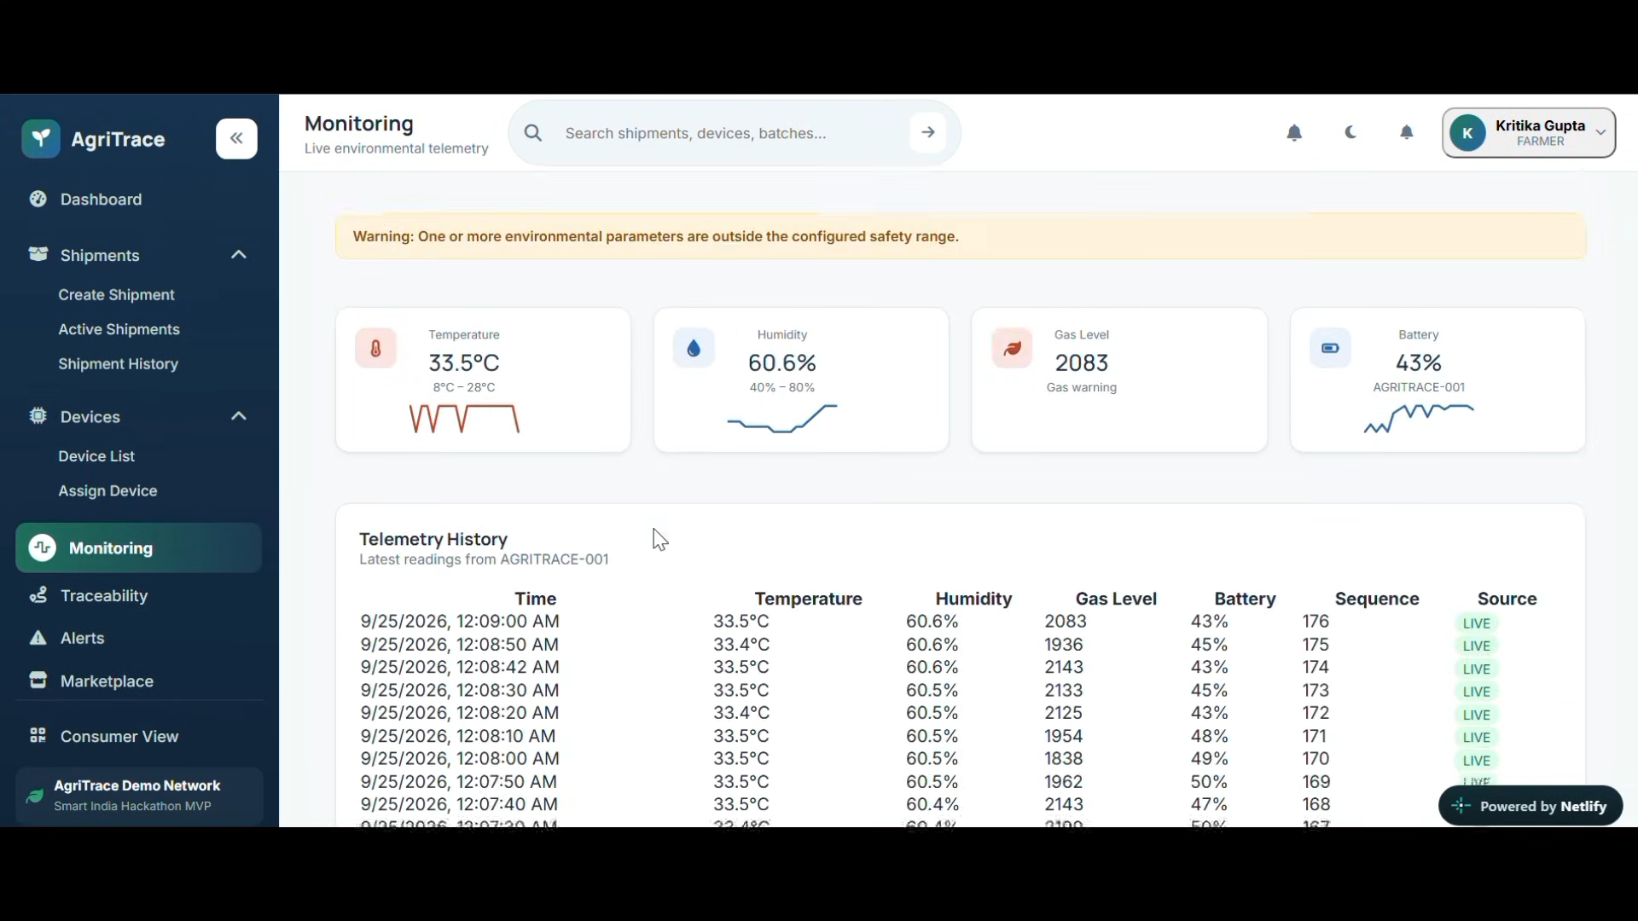
Reference 1 — Monitoring screen supplied by the user.

6.5 Truck Shipment Visualization
Use the provided truck WebP as the visual base layer. Do not split the truck into separate images. Render compartment readings as HTML/React overlays positioned relative to the cargo body.
Overlay | Required fields | Interaction
Cargo block | Batch ID, temperature, humidity, ethylene/gas, integrity state | Click opens detailed shipment/device panel
Truck header | Shipment ID, origin, destination, current state | Click opens shipment
Connectivity | Wi-Fi/cellular state, last seen | Click opens device status
Battery | Battery %, charging/harvesting state | Click opens device health
GPS | Lat/long or readable location, timestamp | Click centers route/map
Alert badge | Active alert count/severity | Click filters alerts

Recommended cargo overlay pattern:
<div className="relative">
<img src="/assets/truck1.webp" className="w-full h-auto" alt="Shipment truck" />
<CargoContainer batch="AG-2401" temperature={4.2} humidity={78} ethylene={0.8} integrity="verified" />
<CargoContainer batch="AG-2402" temperature={5.1} humidity={81} ethylene={1.0} integrity="warning" />
</div>

6.6 Traceability Page
- Vertical event timeline: device assigned, shipment created, departure, telemetry exception, offline period, sync completed, delivery and verification.
- Integrity panel showing current record hash, previous hash, sequence, verification result and ledger anchor.
- QR code panel for shipment verification.
- Record filtering by event type and time range.
- A verification failure must be visually prominent and explain what failed without exposing secret keys.
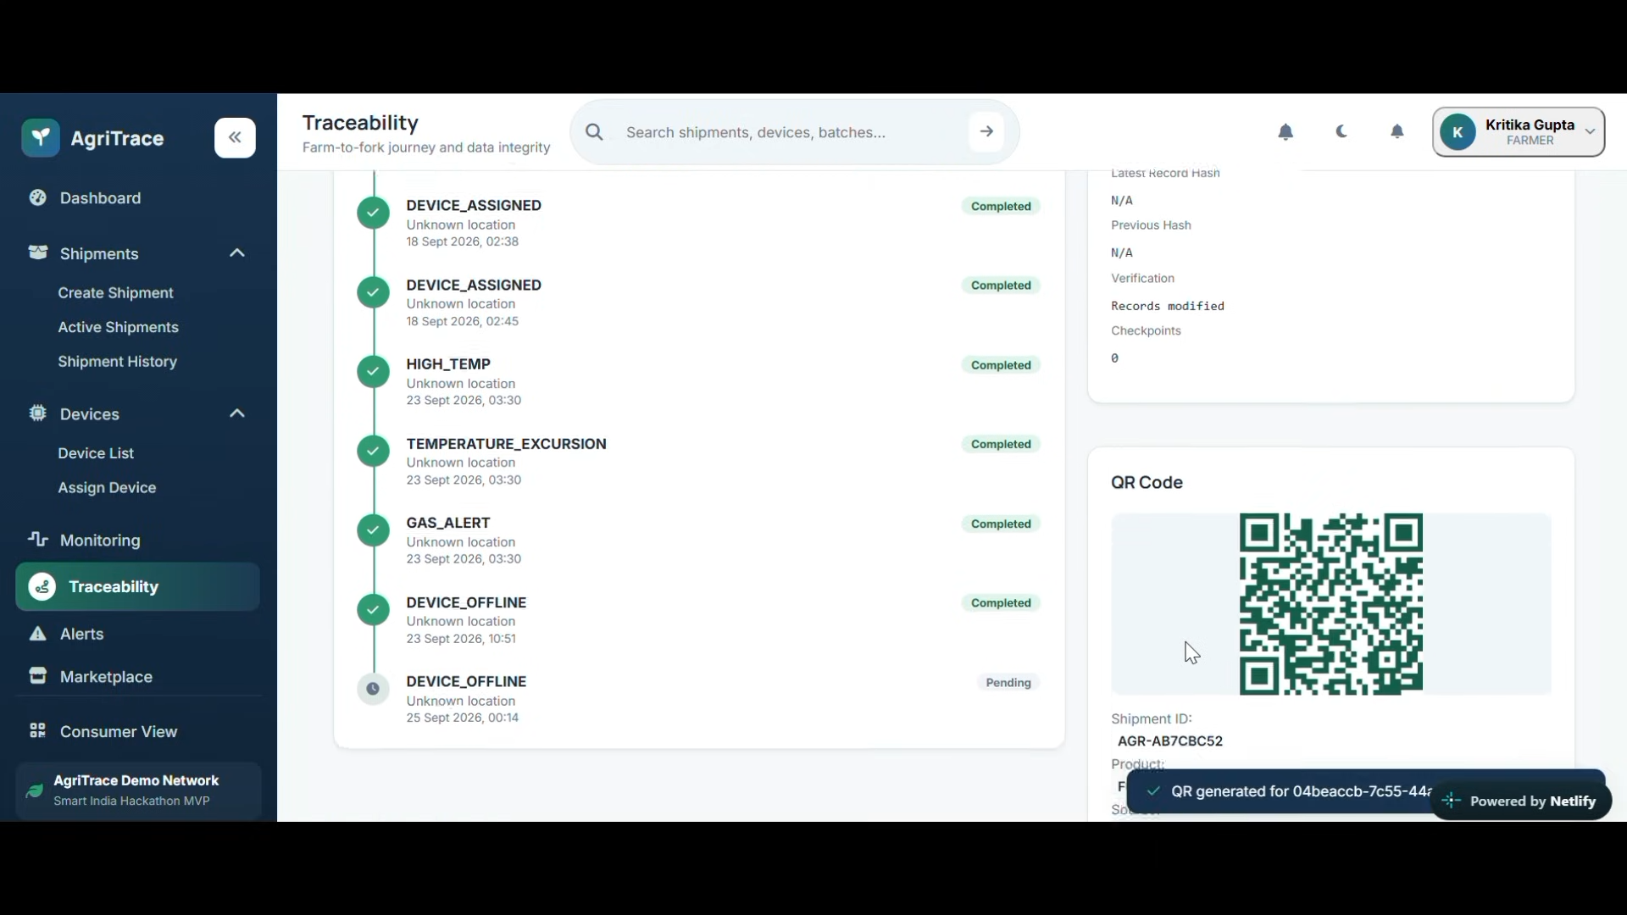
Reference 2 — Traceability screen supplied by the user.

6.7 Alerts Page
- Cards grouped by severity and status.
- Alert types: HIGH_TEMP, TEMPERATURE_EXCURSION, HIGH_HUMIDITY, GAS_ALERT, DEVICE_OFFLINE, TAMPER_DETECTED, INTEGRITY_FAILED, SYNC_FAILED, LOW_BATTERY.
- Actions: View Shipment, Acknowledge/Dismiss, Open Details.
- Each alert includes device, shipment, observed value, threshold, timestamp and event/sequence reference.
- Resolved alerts remain auditable.
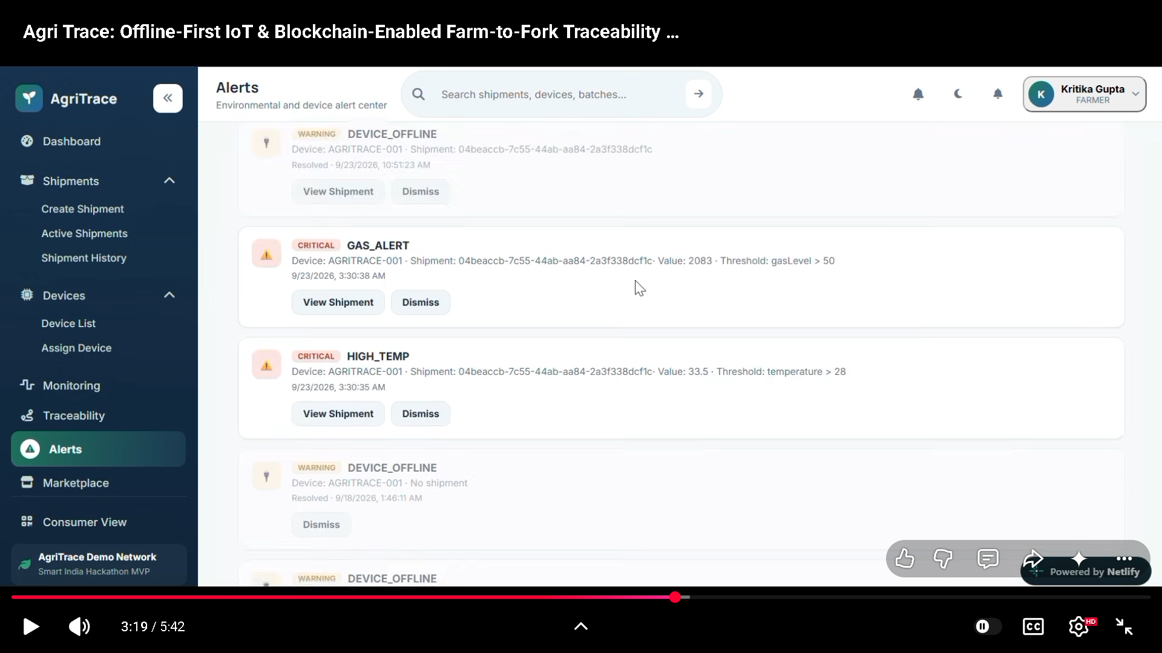
Reference 3 — Alerts screen supplied by the user.

6.8 Analytics Page
- Shipment volume trend.
- Shipment status distribution.
- Alert overview.
- Device online/offline/uptime view.
- Environmental excursion trend.
- Average sync delay and offline duration.
- Integrity verification success/failure counts.
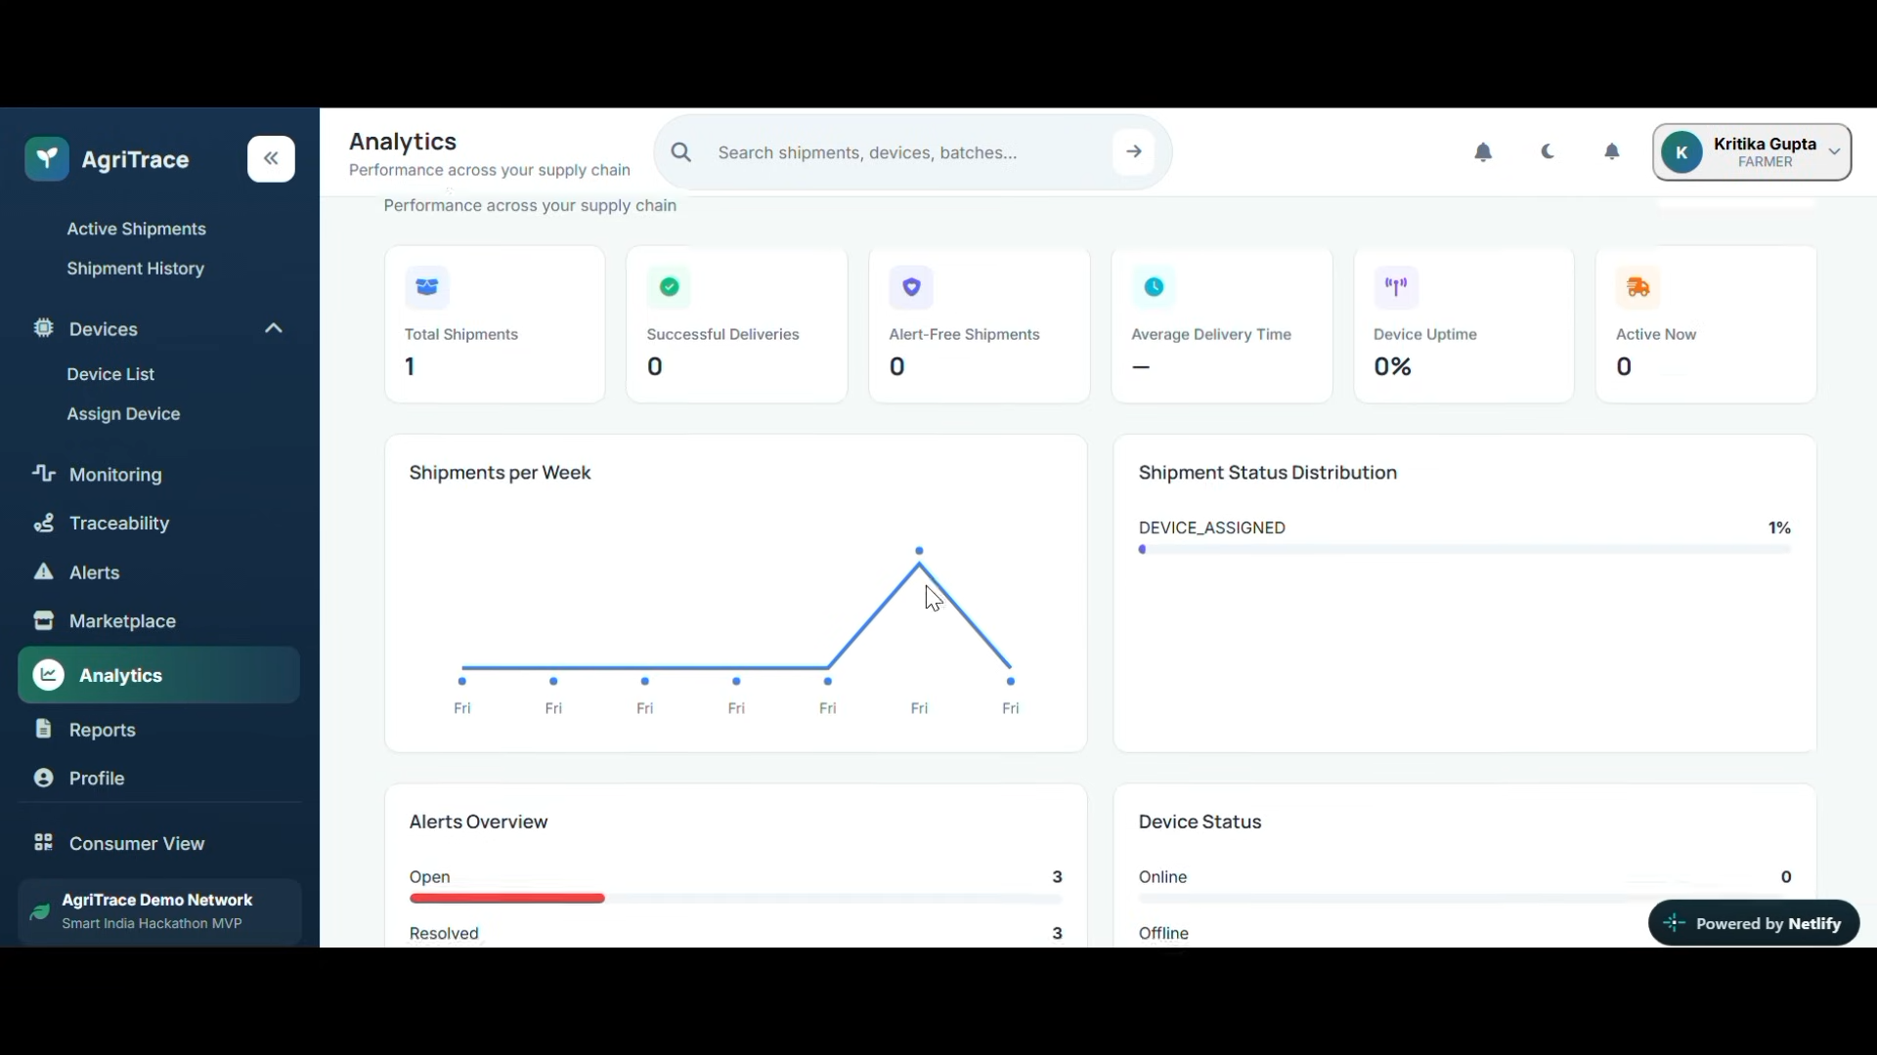
Reference 4 — Analytics screen supplied by the user.

7. Functional Requirements
ID | Requirement | Description
FR-01 | Authentication & roles | Users authenticate and receive role-scoped access.
FR-02 | Shipment creation | Create shipment with origin, destination, product/batch, expected conditions and device.
FR-03 | Device registration | Register a unique node ID and provision credentials.
FR-04 | Device assignment | Associate a device with one active shipment at a time.
FR-05 | Telemetry ingestion | Accept timestamped temperature, humidity, ethylene/gas, battery, GPS and connectivity data.
FR-06 | Offline capture | Device stores readings locally when network is unavailable.
FR-07 | Sequence integrity | Every telemetry record has monotonic device sequence number.
FR-08 | Cryptographic protection | Records are signed/hashed and linked to the prior record.
FR-09 | MQTT sync | Device publishes queued records securely after reconnecting.
FR-10 | Idempotent ingestion | Backend rejects or safely ignores duplicate sequence IDs.
FR-11 | Alert engine | Evaluate configurable thresholds and device conditions.
FR-12 | Traceability events | Create auditable shipment lifecycle events.
FR-13 | Ledger anchoring | Anchor batch/record proofs to a decentralized ledger.
FR-14 | Verification | Recompute and verify hashes against stored proof/ledger anchor.
FR-15 | QR verification | Generate a QR that opens a shipment verification view.
FR-16 | Analytics | Aggregate shipment, device, alert and sync metrics.
FR-17 | Reporting | Export traceability and excursion evidence.
FR-18 | Audit log | Record user actions and system security events.

8. IoT Hardware & Firmware Requirements

8.1 Recommended Prototype Stack
Subsystem | Recommended technology | Role
MCU | ESP32-S3 / ESP32-class MCU | Low-power processing, connectivity and sensor orchestration
Temperature/Humidity | SHT31/SHTC3-class sensor | Environmental telemetry
Ethylene/Gas | Ethylene-capable sensor module appropriate to the prototype | Food maturity/spoilage-related gas signal
GNSS | u-blox-class GNSS module | Shipment location
Cellular | LTE Cat-1/Cat-1 bis or NB-IoT/LTE-M module depending on coverage | Wide-area connectivity
Local storage | Industrial microSD or flash | Offline telemetry queue
RTC | Low-power RTC | Stable timestamping during connectivity loss
Tamper | Lid/reed switch + optional accelerometer | Physical tamper and shock/vibration detection
Power | Li-ion/LiFePO4 battery + BMS | Primary energy storage
Energy harvesting | Solar panel + charge controller | Runtime extension
Security | Secure element where practical | Device identity/key protection
Enclosure | Rugged sealed enclosure | Dust/moisture/vibration protection

Exact sensor selection must be validated against the food/product type, required gas range, calibration needs and environmental conditions. The SIH statement establishes ethylene/gas monitoring as a requirement but does not prescribe a specific sensor model.

8.2 Firmware Responsibilities
- Read sensors on a configurable interval.
- Timestamp and sequence each sample.
- Normalize/validate sensor values and attach quality flags.
- Build a canonical telemetry record.
- Hash/sign the record and link it to the previous record.
- Persist the record before attempting network transmission.
- Publish live telemetry when connected.
- Queue unsent records during outage.
- Retry with exponential backoff and batch uploads.
- Report battery, charging/harvesting, signal and firmware state.
- Detect tamper/open events and generate priority records.
- Support secure configuration and firmware update strategy for production.

9. Offline-First & Synchronization Architecture
Offline-first is a primary product requirement, not an edge case.
Sensor → Validate → Sequence → Hash/Sign → Local Durable Queue
↓
Network Available?
/ \
No Yes
↓ ↓
Keep queued MQTT/TLS batch
↓
Backend ACK
↓
Mark records synced
↓
Ledger proof/anchor
↓
UI verification
State | Meaning | UI treatment
LIVE | Record arrived directly from connected node. | Green LIVE badge
QUEUED | Record safely stored locally but not yet uploaded. | Amber offline badge
SYNCING | Queued records are being transmitted. | Blue sync indicator
SYNCED | Backend accepted the record. | Green/neutral synced state
VERIFIED | Cryptographic proof matches expected chain/anchor. | Green verification badge
FAILED | Integrity or synchronization failed. | Red alert + actionable details

9.1 MQTT Topic Design
agritrace/{deviceId}/telemetry
agritrace/{deviceId}/events
agritrace/{deviceId}/status
agritrace/{deviceId}/ack
agritrace/{deviceId}/config
- Use MQTT over TLS.
- Use QoS appropriate to the criticality of telemetry; the prototype can use QoS 1 for delivery-at-least-once semantics.
- Use message IDs/device sequence numbers for deduplication.
- Never rely on MQTT delivery alone as the integrity mechanism; the record itself must be cryptographically protected.

10. Cryptographic Integrity Model
The integrity model should make a modified historical record detectable without storing sensitive private keys in the dashboard. A simple prototype can use a hash chain; production hardware should use a secure element or equivalent key-protection mechanism.
record_n = {
device_id,
shipment_id,
sequence,
timestamp,
temperature,
humidity,
ethylene,
latitude,
longitude,
battery,
previous_hash
}
record_hash = SHA-256(canonical(record_n))
signature = Sign(private_device_key, record_hash)
- Canonical serialization must be deterministic so the same record produces the same digest.
- The previous_hash field links records into a tamper-evident sequence.
- The backend verifies sequence continuity and signature/hash before accepting a record.
- Periodic Merkle roots or batch hashes can be anchored on-chain to reduce transaction cost.
- The ledger should contain proof/anchor data, not secrets and not necessarily all raw telemetry.

11. Blockchain / Decentralized Ledger Layer
The dashboard requires a decentralized verification capability. For the MVP, the recommended pattern is off-chain telemetry with on-chain proof anchoring. This keeps high-frequency sensor traffic efficient while retaining verifiability.
Layer | Data | Reason
Device | Raw samples, local queue, hash/signature | Works offline and protects the source record
Backend DB | Telemetry, events, shipment metadata, hashes, sync state | Fast queries and dashboard analytics
Proof service | Batch hash/Merkle root and verification metadata | Build efficient integrity proofs
Ledger | Shipment/batch proof anchor, timestamp, reference | Independent tamper-evidence
Dashboard | Human-readable state and verification result | Operations and audit usability

The exact ledger/network choice is an implementation decision and should be finalized based on SIH judging requirements, deployment cost, transaction model, and available infrastructure. The PRD does not assume that a particular chain is mandatory.

12. Backend Architecture
IoT Node
│ MQTT/TLS
▼
MQTT Broker
│
▼
Ingestion Service ──► Validation ──► Integrity Verification
│ │
│ ├──► Alert Engine
│ ├──► Sync State
│ └──► Proof/Anchor Service
▼
PostgreSQL / Time-Series Storage
│
├── REST API / WebSocket
▼
React Dashboard

12.1 Recommended Software Stack
Layer | Recommended stack | Responsibility
Frontend | React + TypeScript + Vite | Dashboard UI
Styling | Tailwind CSS | Design system/layout
Charts | Recharts or Apache ECharts | Telemetry/analytics
Maps | Mapbox GL JS or Google Maps | GPS/routes
Backend | FastAPI + Python | REST/WebSocket and business logic
MQTT | EMQX/Mosquitto or managed broker | Device messaging
Database | PostgreSQL + PostGIS; optional TimescaleDB | Transactional + telemetry + geospatial data
Cache/queue | Redis | Short-lived state, jobs, rate limiting
Blockchain | EVM-compatible or other SIH-approved decentralized ledger | Proof anchoring/verification
Storage | Object storage | Reports/exports/firmware/artifacts
Deployment | Docker + cloud VM/container platform | Reproducible deployment

13. Database Model
Entity | Key fields
users | id, organization_id, name, email, role, status
devices | id, serial_number, firmware_version, public_key, battery, signal, status, last_seen
shipments | id, shipment_code, product, batch_code, origin, destination, status, created_at
device_assignments | device_id, shipment_id, assigned_at, unassigned_at
telemetry | id, device_id, shipment_id, sequence, timestamp, temp, humidity, ethylene, lat, lon, battery, hash, signature, sync_state
shipment_events | id, shipment_id, event_type, timestamp, location, metadata, hash
alerts | id, shipment_id, device_id, type, severity, observed_value, threshold, status, created_at, resolved_at
ledger_anchors | id, shipment_id, root_hash, transaction_id, network, anchored_at, verification_status
sync_batches | id, device_id, first_sequence, last_sequence, count, status, started_at, completed_at
audit_logs | id, actor_id, action, target_type, target_id, timestamp, metadata

14. API Specification
Method | Endpoint | Purpose
POST | /api/v1/shipments | Create shipment
GET | /api/v1/shipments | List/filter shipments
GET | /api/v1/shipments/{id} | Shipment detail
POST | /api/v1/shipments/{id}/assign-device | Assign device
GET | /api/v1/devices | List devices
POST | /api/v1/devices | Register/provision device
GET | /api/v1/devices/{id}/telemetry | Telemetry history
GET | /api/v1/shipments/{id}/timeline | Traceability timeline
GET | /api/v1/shipments/{id}/verification | Integrity verification result
GET | /api/v1/alerts | Alert list
PATCH | /api/v1/alerts/{id} | Acknowledge/resolve alert
GET | /api/v1/analytics/overview | Dashboard KPI data
GET | /api/v1/shipments/{id}/qr | Generate/retrieve QR payload
POST | /api/v1/sync/telemetry | Batch sync endpoint for gateway/direct integration

Use WebSocket/SSE for live dashboard updates where appropriate; REST remains the system-of-record API for queries and administrative operations.

15. Alert & Rule Engine
Rule | Example | Severity
Temperature high | temperature > configured upper bound | Critical/Warning
Temperature low | temperature < configured lower bound | Warning
Humidity high/low | humidity outside product range | Warning
Gas/ethylene | ethylene/gas signal above threshold | Critical
Device offline | No heartbeat for configured interval | Warning
Tamper | Enclosure opened or unexpected movement | Critical
Low battery | Battery below configured percentage | Warning
Integrity failed | Signature/hash verification mismatch | Critical
Sequence gap | Unexpected missing sequence range | Critical/Warning
Sync failed | Repeated MQTT/backend acknowledgement failure | Warning

Thresholds must be configurable per product/batch because safe environmental ranges are product-dependent. The reference screen's example values should be treated as demo configuration, not universal food-safety limits.

16. QR / Consumer Verification
- Each shipment receives a unique public verification identifier.
- QR resolves to a public consumer/auditor page.
- Show product/batch, origin, shipment dates, major checkpoints, environmental compliance summary and integrity status.
- Do not expose device private keys, internal credentials, personal information or raw infrastructure secrets.
- Verification page should explain whether the displayed history is verified, partially verified, pending synchronization or failed.

17. Security Requirements
- TLS for MQTT and HTTPS for APIs.
- Per-device identity and credential provisioning.
- Private keys never stored in frontend code.
- JWT/OAuth2-style session management with role-based authorization.
- Server-side validation for all telemetry and administrative inputs.
- Idempotency and sequence checks to prevent duplicate/replayed samples.
- Rate limiting and broker ACLs per device/topic.
- Secrets stored in a secret manager/environment configuration, never committed to source control.
- Audit logs for user actions and integrity events.
- Database backups and retention policy.
- Signed firmware/update mechanism should be planned for production.

18. Performance & Reliability Requirements
Area | Requirement
Live telemetry | UI should reflect connected sensor updates within the agreed latency target.
Offline queue | No data loss during planned connectivity outages within device storage capacity.
Scalability | Backend must process batched telemetry without blocking dashboard queries.
Availability | Critical ingestion path should degrade gracefully if analytics/ledger services are temporarily unavailable.
Consistency | Shipment/device assignment must be transactional.
Observability | Logs, metrics and health checks for broker, API, DB, sync and ledger services.
Recovery | Queued data must resume automatically after reconnection.

19. Testing & Acceptance Plan
Test category | Key tests
Sensor | Accuracy sanity checks, invalid values, disconnected sensor behavior
Offline | Disable cellular/network, generate records, restore network, verify complete ordered sync
Integrity | Modify a stored record and confirm verification failure
Replay | Resend same sequence and confirm idempotent handling
Gap | Delete/drop one sequence and confirm gap detection
MQTT | Broker disconnect/reconnect, retained state, QoS behavior
Alerts | Cross thresholds, resolve condition, confirm alert lifecycle
GPS | Valid fix, unavailable fix, stale location
Battery | Low-battery warning and charging/harvesting state
Tamper | Open enclosure / trigger sensor and confirm alert
Blockchain | Anchor proof, verify proof, simulate mismatch
UI | Responsive layout, loading, empty, offline, error and permission states
Security | Unauthorized API calls, expired token, invalid signatures, malformed payloads

20. MVP Delivery Plan
Phase | Deliverables
Phase 1 — Foundation | Repo setup, design system, auth, PostgreSQL schema, device/shipment CRUD
Phase 2 — IoT | Sensor firmware, local queue, sequence/hash chain, device status
Phase 3 — Messaging | MQTT broker, secure ingestion, acknowledgements, sync state
Phase 4 — Monitoring | Monitoring page, telemetry history, truck overlay, GPS
Phase 5 — Alerts | Rule engine, alert UI, notifications and resolution flow
Phase 6 — Traceability | Event timeline, integrity verification, QR view
Phase 7 — Ledger | Proof batching, ledger anchoring, verification service
Phase 8 — Analytics | KPIs, charts, reports and operational metrics
Phase 9 — Hardening | Security, offline tests, hardware enclosure/power tests, demo rehearsal

21. Recommended Repository Structure
agritrace/
├── apps/
│ ├── web/ # React + TypeScript dashboard
│ └── api/ # FastAPI backend
├── firmware/
│ └── node/ # MCU firmware
├── services/
│ ├── ingestion/ # MQTT consumer / validation
│ ├── alerts/ # Rules and notifications
│ ├── proof/ # Hash/Merkle + ledger anchoring
│ └── sync/ # Batch synchronization jobs
├── packages/
│ ├── types/ # Shared schemas/types
│ └── crypto/ # Canonicalization/integrity helpers
├── infra/
│ ├── docker/
│ └── mqtt/
├── docs/
│ ├── architecture/
│ ├── api/
│ └── hardware/
└── README.md

22. Key UI Data Contracts
TelemetryRecord {
deviceId: string
shipmentId: string
sequence: number
timestamp: string
temperatureC: number | null
humidityPct: number | null
ethylenePpm: number | null
latitude: number | null
longitude: number | null
batteryPct: number | null
network: "online" | "offline" | "unknown"
syncState: "live" | "queued" | "syncing" | "synced" | "failed"
integrity: "verified" | "pending" | "failed"
}

23. Demo Scenario for SIH Presentation
- Create a shipment for a food batch and assign an AgriTrace node.
- Start the truck view with normal temperature, humidity and gas readings.
- Show live GPS and battery/network state.
- Intentionally disconnect cellular connectivity.
- Continue generating sensor readings; the dashboard/device state changes to Offline/Queued.
- Demonstrate that sequence numbers continue and data remains stored locally.
- Reconnect the network.
- Show automatic MQTT batch synchronization and transition from Queued → Syncing → Synced.
- Generate a controlled temperature or gas excursion and show the Alerts page.
- Show the traceability timeline recording the excursion and offline event.
- Generate/verify the shipment QR.
- Show cryptographic verification and ledger proof/anchor.
- Open Analytics to show shipment, alert, device and synchronization metrics.

24. Risks and Mitigations
Risk | Impact | Mitigation
Poor cellular coverage | Delayed sync | Durable local queue + batch retry + store-and-forward
Sensor drift | False alerts | Calibration procedure + sensor health flags + product-specific thresholds
Battery depletion | Node stops logging | Solar harvesting + low-power firmware + battery alerts
Ledger outage | Proof delayed | Keep verified backend records and queue proof anchoring asynchronously
Duplicate messages | Duplicate telemetry | Device sequence IDs + backend idempotency
Tampering | Loss of trust | Secure keys + hash chain + tamper event + ledger anchor
Overloading blockchain | High cost/latency | Anchor batches/Merkle roots instead of raw telemetry
UI complexity | Poor operator usability | Truck-first visualization + concise cards + drill-down details

25. Open Decisions Before Hardware Freeze
- Final ethylene/gas sensor and calibration method.
- Final cellular technology based on target Indian deployment areas.
- Exact energy-harvesting architecture and expected duty cycle.
- Enclosure ingress-protection target and mechanical test plan.
- Final decentralized ledger/network selected for the SIH demonstration.
- Whether GNSS is always-on or duty-cycled based on movement.
- Data retention period and sampling frequency per product class.
- Exact environmental thresholds for each food category.
- Production-grade secure element and device provisioning workflow.

26. Final Product Definition
AgriTrace is not merely a dashboard. The product is an end-to-end trust pipeline: the physical node captures evidence, the offline-first firmware preserves that evidence during connectivity loss, the MQTT/backend layer transports and validates it, the integrity layer makes modification detectable, the ledger provides independent proof anchoring, and the dashboard makes the result operationally understandable.
For the SIH26232 prototype, implementation should prioritize a convincing end-to-end demonstration over unnecessary feature breadth. The highest-value flow is a real sensor reading → offline storage → network interruption → automatic sync → alert/traceability event → cryptographic verification → ledger proof → truck-centric dashboard/QR verification.

Appendix A — Reference Asset Usage
Asset | Use in product
Provided Monitoring screenshot | Reference for environmental metric cards and telemetry history
Provided Traceability screenshot | Reference for event timeline, integrity panel and QR verification
Provided Alerts screenshot | Reference for severity-based alert cards and actions
Provided Analytics screenshot | Reference for KPI cards, charts and device/shipment status
Provided truck WebP | Primary visual asset for truck-centric shipment monitoring

