VERICRED
Blockchain Deployment Process
A step-by-step account of how the smart contract was built,
deployed, and connected to a real public blockchain network
Team
CB.SC.U4CSE24730
CB.SC.U4CSE24528

Overview
This document explains, step by step, everything that was actually done to take the VeriCred blockchain layer from written code to a real, working connection on a public blockchain test network. It covers building the code, getting API access, setting up a wallet, obtaining free test currency, deploying the smart contract, connecting the code to it, and the final result — including the real problems encountered along the way and how each one was resolved.
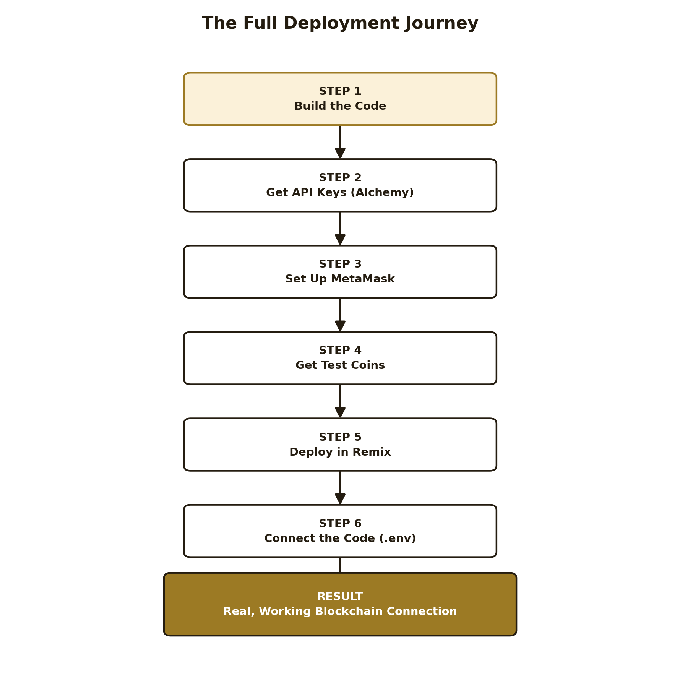
Figure 1: The full deployment journey, from writing code to a working connection

Step 1: Building the Code
Before any blockchain setup began, the application itself was built with two modes in mind: a simulated mode, where loan decisions are recorded in a local hash-chained ledger (blockchain.py) purely for demonstration and testing, and a real mode, where the exact same decisions are sent as genuine transactions to a public blockchain (blockchain_real/onchain_connector.py). Both modes use the same Flask application and the same user interface — only the underlying recording mechanism changes, controlled by a single setting.
The smart contract itself, GigWorkerLoanLedger.sol, was written in Solidity. It stores each loan decision as a structured record containing the applicant's scores, the requested amount, a Merkle root fingerprint of their ride data, the action taken, and who reviewed it. Writing and testing this contract came first, because every later step depends on having a working contract ready to deploy.

Step 2: Getting API Keys (Alchemy)
A personal computer cannot talk to a blockchain network directly — it needs a node, a computer that is already connected to that network and keeps a full copy of it. Running one's own node is expensive and complicated, so instead a free service called Alchemy was used. Alchemy runs nodes for many blockchain networks and lets anyone connect to them through a simple web address, called an RPC URL.
1. Created a free account at alchemy.com.
2. Created a new app inside Alchemy, named “GigLoanProject.”
3. Selected the chain as Polygon, and specifically the Amoy test network — not the real Polygon network, since this project uses test currency, not real money.
4. Copied the app's Endpoint URL, which looks like https://polygon-amoy.g.alchemy.com/v2/[a long key], from the “Node RPC Setup” tab. This URL is effectively an API key: it both identifies the project to Alchemy and provides the actual connection to the network.
One real mistake happened here: the Network dropdown on Alchemy's dashboard defaulted to “Polygon Mainnet” (the real network) rather than Amoy. This was caught before it caused any problem, and the dropdown was switched to Amoy, which changed the Endpoint URL to the correct test-network address.

Step 3: Setting Up MetaMask
MetaMask is a browser wallet — it holds the cryptographic keys that prove ownership of a blockchain account, and it is what actually signs and authorizes every transaction sent to the network. Without a wallet, there is no way to “be someone” on a blockchain.
1. Installed the MetaMask browser extension and created a new wallet, saving the 12-word recovery phrase securely.
2. Enabled “Show test networks” in MetaMask's settings, since test networks are hidden by default.
3. Added Polygon Amoy as a custom network, filling in the network name, the RPC URL copied from Alchemy in Step 2, the Chain ID (80002), the currency symbol (MATIC), and the block explorer URL (amoy.polygonscan.com).
The first attempt to add this network used a public, shared RPC URL instead of the Alchemy one, and MetaMask returned a “Could not fetch chain ID” error — public RPC endpoints are often unreliable since many people share them. Switching to the personal Alchemy URL from Step 2 fixed this immediately.

Step 4: Getting Free Test Coins
Every transaction on a blockchain costs a small fee, called gas, paid in the network's own currency — MATIC, in this case. On a test network, this currency has no real value and is given away for free through a faucet, specifically so that developers can test real transactions without spending anything.
1. Copied the full wallet address from MetaMask.
2. Visited Alchemy's Polygon Amoy faucet (alchemy.com/faucets/polygon-amoy), pasted the address, and requested test coins.
3. Received 0.1 test MATIC, confirmed by checking the balance shown in MetaMask.
This faucet allows one claim per wallet every 24 hours, so this step was repeated more than once over the course of the project as the balance was used up by later transactions.

Step 5: Deploying the Contract in Remix
Remix is a browser-based tool for writing, compiling, and deploying Solidity smart contracts. It was used here to actually publish the GigWorkerLoanLedger contract onto the Polygon Amoy network.
1. Opened remix.ethereum.org and created GigWorkerLoanLedger.sol, pasting in the contract's source code.
2. Compiled the contract using the Solidity Compiler tab, resolving version and syntax settings until a green “Compiled” confirmation appeared.
3. Switched to the Deploy & Run Transactions tab, and changed the Environment from the default “Remix VM” (a fake, temporary test blockchain built into Remix) to “Browser Extension” → “MetaMask,” connecting Remix to the real wallet from Step 3.
4. Confirmed the connected account showed the real wallet address, a real balance (not the fake “100 ETH” Remix VM shows by default), and the network read “Amoy (80002).”
5. Filled in the contract's constructor field, _oracle, with the wallet's own address — this designates that wallet as the one authorized to record decisions on the contract.
6. Clicked Deploy, and confirmed the transaction in the MetaMask popup.
The first deployment attempt failed with a “gas tip cap” error — the network's minimum required gas price at that moment was higher than what MetaMask had automatically estimated. Retrying the deployment resolved this, since MetaMask recalculated a valid gas estimate on the second attempt.
Once successful, Remix displayed the contract under “Deployed Contracts,” and the deployment was independently confirmed through Sourcify's contract verification service, which showed “Verification Successful.” The contract's address — its permanent location on the blockchain — was then copied for the next step.
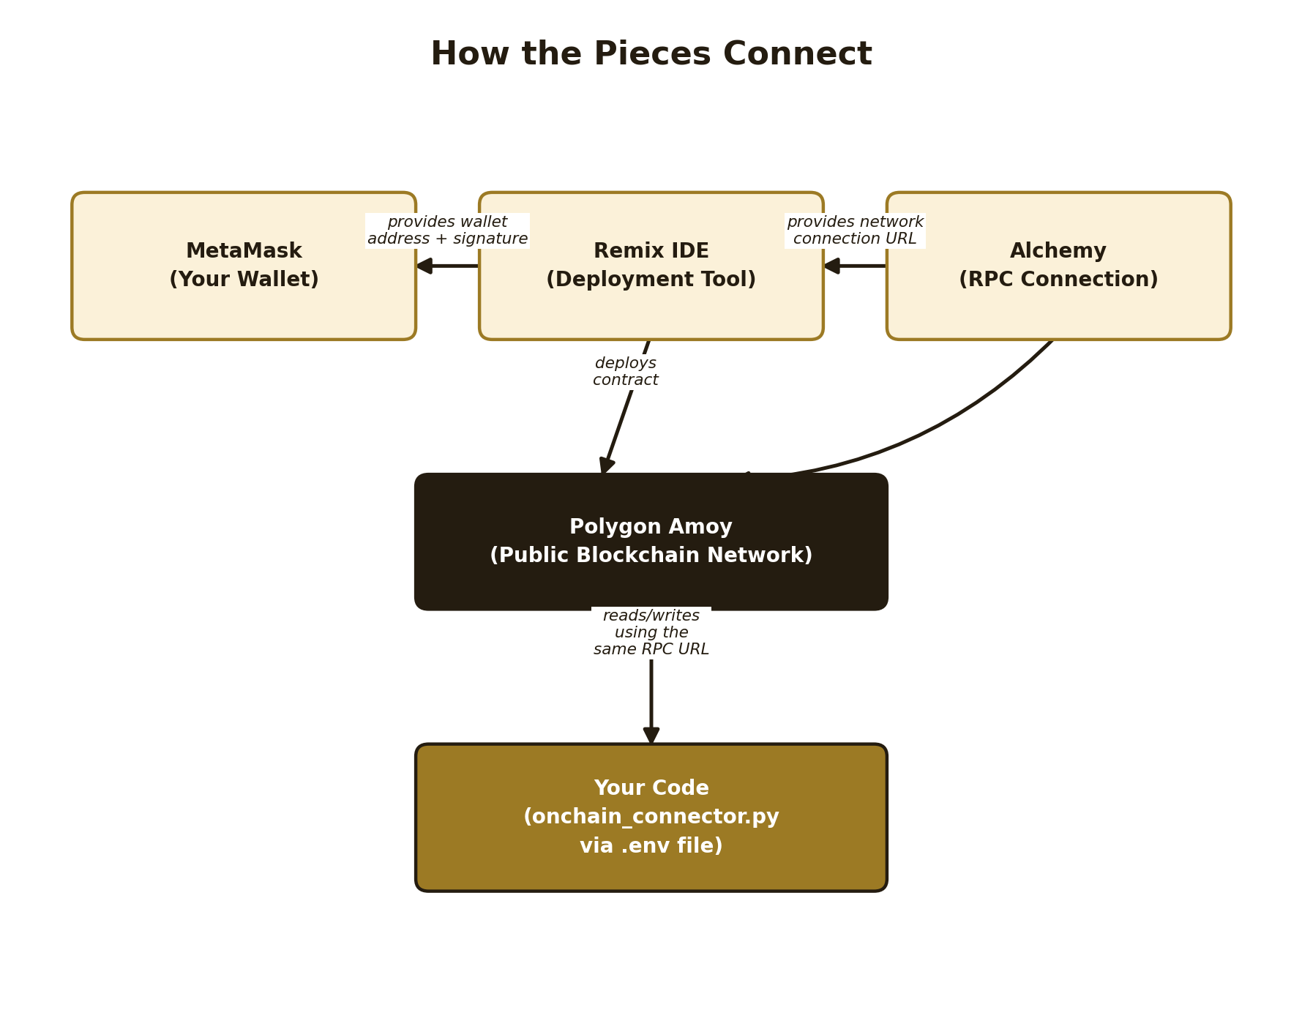
Figure 2: How MetaMask, Alchemy, Remix, and the project's own code relate to one another

Step 6: Connecting the Code
With the contract deployed, the last step was making the project's own Python code aware of it, so that clicking “Forward to Bank Manager” in the portal would send a real transaction instead of a simulated one.
1. Copied blockchain_real/.env.example and renamed the copy to .env.
2. Filled in three values: ALCHEMY_RPC_URL (from Step 2), ORACLE_PRIVATE_KEY (the wallet's private key, from MetaMask's Account Details → Show Private Key), and CONTRACT_ADDRESS (from Step 5).
3. Ran onchain_connector.py directly as a standalone test.
Checking connection to Alchemy...
Connected: True
Current block number: 46200777
Oracle account: 0xc9e3de4bFE199570B066C4Cc665547517790BbE5
Oracle balance: 0.005003160402266318 MATIC
Figure 3: Actual output confirming the code successfully connected to the live network
One small mistake was caught and fixed here: the private key copied from MetaMask was missing its leading “0x” prefix, which is the standard format for a private key. Adding it manually resolved this.

Result
The output above confirms a genuine, working connection: the code successfully reached Polygon Amoy through Alchemy, read the current block number directly from the live network, and correctly identified the deployed contract's authorized wallet and its real balance. This is not a simulation — every value shown came from the actual public blockchain.
With this working, clicking “Forward to Bank Manager” inside the portal (with real mode switched on) sends an actual transaction to the deployed contract. One further real-world issue was encountered at this stage: a transaction failed with an “insufficient funds” error, because the network's gas price had risen since the last faucet claim, and the wallet's remaining balance (about 0.005 MATIC) was no longer enough to cover it. This was resolved the same way as Step 4 — claiming more free test currency from the faucet.

Summary of Real Issues Encountered
Issue | Cause | Fix
MetaMask “Could not fetch chain ID” | Used a public, shared RPC URL | Switched to the personal Alchemy RPC URL
Alchemy defaulted to Mainnet | Dashboard's default network setting | Manually switched to Polygon Amoy
Remix deployment failed (gas tip cap) | Network's minimum gas price had risen | Retried deployment; MetaMask re-estimated correctly
Private key rejected / malformed | Missing “0x” prefix from MetaMask's copy | Added “0x” manually before the key
Real transaction failed (insufficient funds) | Gas price had risen since last faucet claim | Claimed more free test MATIC from the faucet
Each of these was a genuine, expected part of working with a real public network — not a flaw in the project's own code. The final working state, shown in Figure 3, is proof that the full pipeline — from a wallet, through a node provider, through a deployed smart contract, to the project's own Python code — works correctly end to end.

