VERICRED
AI and Blockchain Loan Verification for Gig Workers
Project Synopsis · Team: CB.SC.U4CSE24730, CB.SC.U4CSE24528
1. Abstract
Gig workers such as delivery and ride-hailing partners earn a steady income, but banks usually reject their loan applications because they have no salary slip and often no credit history. VeriCred is a prototype that turns a worker’s platform work history into one verified Risk Meter score, and records every officer decision on a tamper-evident blockchain ledger. An AI Work-History Score is computed from seven weighted signals, blended with the CIBIL score and bank balance, and shown to the bank officer in a web portal. Each forward or decline decision is written to a smart contract deployed on the Polygon Amoy test network, so no one can quietly change it later.
2. Problem Statement and Objectives
Traditional lending checks payslips and credit scores. Gig workers have neither in a form banks accept, even when their work record shows they are reliable. Manual review is also hard to audit.
- Score fairly: convert ride and delivery history into a single AI Work-History Score.
- Support the officer: blend that score with CIBIL and balance into one Risk Meter with clear risk bands.
- Make decisions verifiable: store each decision as a hash-linked, signed record on a blockchain.
- Prove it works end to end: connect a wallet, a web UI, a smart contract and a public test network.
3. Methodology
The AI Work-History Score is a weighted sum of seven signals, scaled from 0 to 100.
Signal | Weight | Signal | Weight
Customer rating | 25% | Complaint-free rate | 10%
Cancellations | 20% | Digital payment use | 5%
On-time completion | 20% | Earnings stability | 5%
Activity consistency | 15%

The Risk Meter then blends three inputs: 55% AI score, 30% CIBIL score and 15% bank balance adequacy. A higher value is safer. A score of 75 or more is Low Risk, 50 to 74 is Moderate Risk and below 50 is High Risk.
For the ledger, each decision is placed in a block that stores the SHA-256 hash of the previous block (a hash chain). A Merkle root summarises the worker’s ride dataset, so only a small fingerprint, never the raw data, is stored on-chain. Records are signed by an authorised oracle account.
4. System Architecture and Tools
Data flows in one direction: ride data (CSV) goes to the scoring engine, then the risk engine, then the Flask officer portal, and finally the blockchain layer.
Component | Tool used | Role
Wallet | MetaMask | Holds the oracle account, signs and pays for transactions
User interface | Python Flask, HTML/CSS, JavaScript, Chart.js | Officer portal: dashboard, Risk Meter, ledger, reports
Smart contract | Solidity 0.8.20, written and deployed in Remix IDE | GigWorkerLoanLedger stores each decision; only the oracle can write
Test network | Polygon Amoy (chain ID 80002) via Alchemy node | Public test blockchain for deployment and transactions
Connector | Web3.py | Python code sends decisions to the contract

The contract stores scores as whole numbers (93.85 is saved as 9385) because Solidity has no decimals. The Solidity source is opened, compiled and deployed in Remix IDE, and the deployed contract can be called there with functions such as recordDecision, getLatestDecision and verifyLatestMerkleRoot.
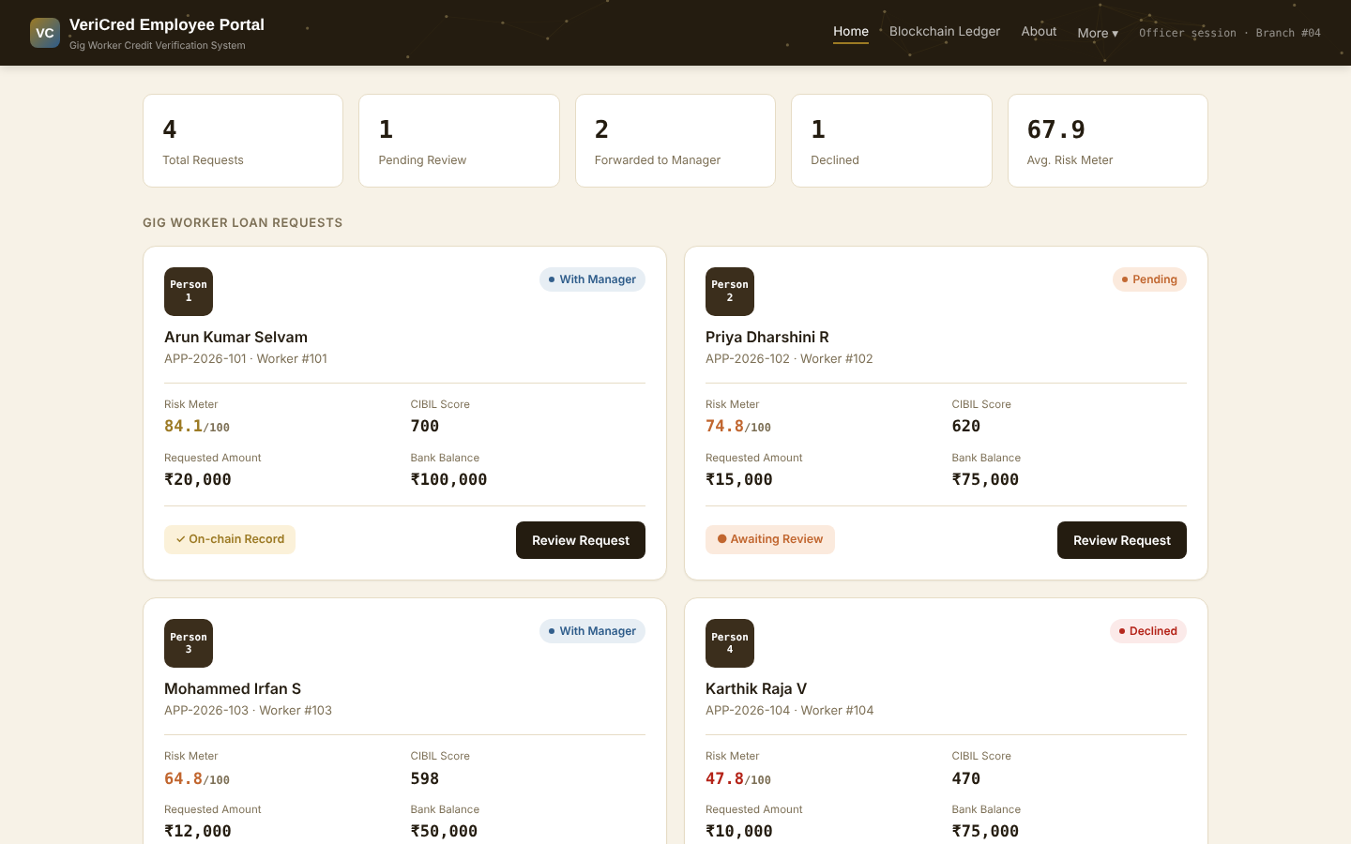
Figure 1: Officer dashboard showing the four loan requests with Risk Meter, CIBIL score and status
5. Results
Four synthetic applicants, one for each performance tier, were scored by the system.
Applicant | AI score | CIBIL | Risk Meter | Risk band
Arun Kumar Selvam | 93.85 | 700 | 84.1 | Low Risk
Priya Dharshini R | 84.14 | 620 | 74.8 | Moderate Risk
Mohammed Irfan S | 68.74 | 598 | 64.8 | Moderate Risk
Karthik Raja V | 47.40 | 470 | 47.8 | High Risk

- Ranking: scores follow work history, so more completed rides, higher ratings and fewer cancellations give a safer result.
- Tamper test: changing one value in a past record made the chain check fail immediately, which shows the ledger is tamper-evident.
- Deployment: the contract was deployed from Remix through MetaMask to Polygon Amoy and its source was verified on Sourcify. The Python connector reads live blocks from the network.
- Cost: recording one decision uses about 413,000 gas on the test network.
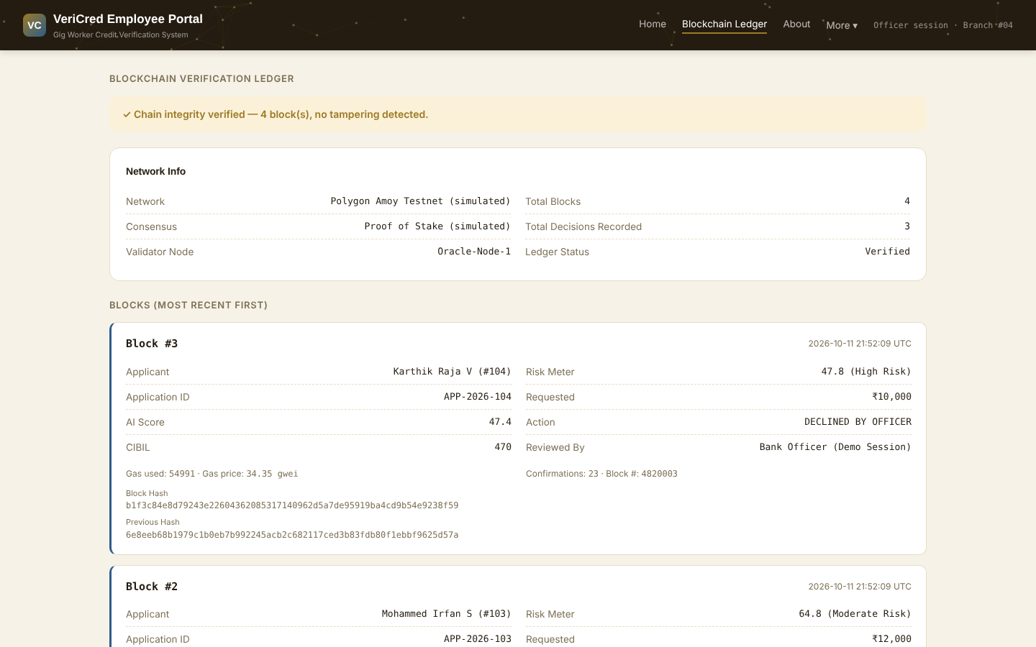
Figure 2: Blockchain ledger page with hash-linked blocks and a passing integrity check
6. Conclusion and Future Scope
VeriCred shows that platform work history can give a fair, explainable score for people without payslips, and that blockchain can make each lending decision auditable. The prototype uses synthetic data, fixed weights and a test network, so it is a proof of concept. Future work includes consent-based data from real gig platforms, a model trained on repayment outcomes, a security audit before any mainnet use, and a worker-facing app where people can see and share their own verified score.

