McCracken Materials

Window Ticket System
Operations and AI Knowledge Manual
Employee training reference and retrieval ready knowledge source

Purpose: This manual reorganizes the original Window Ticket training draft into clear procedures that can be read by employees and retrieved by an AI assistant. It preserves the operating rules in the source while adding searchable wording, question variants, cautions, and task focused sections.

Security: Credentials and edit passwords shown in the source draft are intentionally not reproduced here. Obtain current credentials through the approved internal process.

Source limitation: This manual only states procedures supported by the supplied training draft. Where the draft marks a feature as unavailable, inactive, restricted, or coming soon, this manual does the same.

Contents
- 1. Quick Start
- 2. Start of Day Setup
- 3. Create a Ticket
- 4. Add and Manage Trucks
- 5. Direction and Material Selection
- 6. Customer and Job Selection
- 7. Quantity, Unit, Date, Notes, and Printing
- 8. Search and Reprint
- 9. Edit and Void Tickets
- 10. Reports and Reconciliation
- 11. Daily Dispatch Dashboard
- 12. Customers
- 13. Trucks, Edit Trucks, Materials, and RFID
- 14. End of Day Workflow
- 15. Troubleshooting and Decision Rules
- 16. AI Retrieval Index and Question Bank

1. Quick Start
Search terms: process truck, new ticket, create ticket, print ticket, truck lookup, customer lookup, material, job
Example user questions: How do I process a truck? | How do I create a ticket? | How many ticket copies do I print?
Use this section: Use this when the truck is already known to the system and the transaction is a normal ticket. New trucks, uncertain materials, special customer handling, and corrections are covered later.

- Open the Window Ticket system using the approved internal access method.
- Open New Ticket.
- In Truck, type the first characters of the carrier or truck identifier, then choose the correct truck from the suggestions.
- Choose Direction, either IN or OUT.
- Choose the correct Material from the list that appears for the selected direction.
- In Customer, type the first characters of the paying customer and select the correct result.
- Enter or select the Job information supplied by the driver. For MREX, Petty, Eagle, and Redcon, select the option containing both the numeric job identifier and the job description.
- Leave Quantity as 1 and Unit as Load unless an authorized process says otherwise.
- Review the ticket information, then select Submit Ticket.
- When the second print screen appears, print two copies for a normal live transaction. Keep the signed copy for records and give the other copy to the driver. Close the remaining print screen manually if required.
Do not guess: If the truck, material, customer, or job is uncertain, stop and use the relevant section of this manual before submitting the ticket.

2. Start of Day Setup
Search terms: start day, open ticket system, three tabs, split screen, Daily Dispatch Dashboard, Reports, Daily Report
Example user questions: How do I set up the ticket window in the morning? | How do I open the Daily Dispatch Dashboard? | Why do we use three ticket tabs?
- Sign into the computer using your assigned profile credentials.
- Open the Window Ticket application using the approved internal access method.
- Open three Window Ticket browser tabs as described in the original workstation setup.
- Move the required tab to the right monitor.
- Open Reports from the top navigation, then open Daily Report to display the Daily Dispatch Dashboard.
- On the left monitor, arrange the ticket screens side by side using the operating system window snap controls.
- Keep the New Ticket screen available for truck processing and the dashboard available for day status checks.
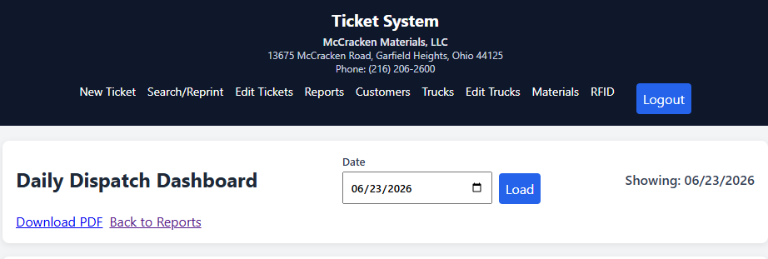
Original draft example of the Daily Dispatch Dashboard before and during operations.
Dashboard colors: The source draft identifies Petty Group jobs with a green header, MREX jobs with a blue header, and other jobs with a yellow header.

3. Create a Ticket
Search terms: New Ticket, Create Ticket, truck, direction, material, customer, job, quantity, unit, notes, submit ticket
Example user questions: What fields do I fill out on New Ticket? | What should I check before submitting a ticket? | How do I create a normal window ticket?

3.1 Required operating fields
Field | How it is used
Truck | Select the correct truck identifier. Search by typing the first characters.
Direction | Select IN for a truck coming to dump. Select OUT for material being loaded to leave for a jobsite.
Material | Choose the correct material after Direction is selected.
Customer | Choose who is paying for the load, not merely the broker or carrier.
Job | Enter or select the correct job or job code.
Quantity | Leave at 1 according to the source draft.
Unit | Leave at Load according to the source draft.
Notes | Use for information that needs to be retained or communicated.
Date and time | Use the current date and time for normal processing.
Submit Ticket | Processes the ticket and starts the printing workflow.
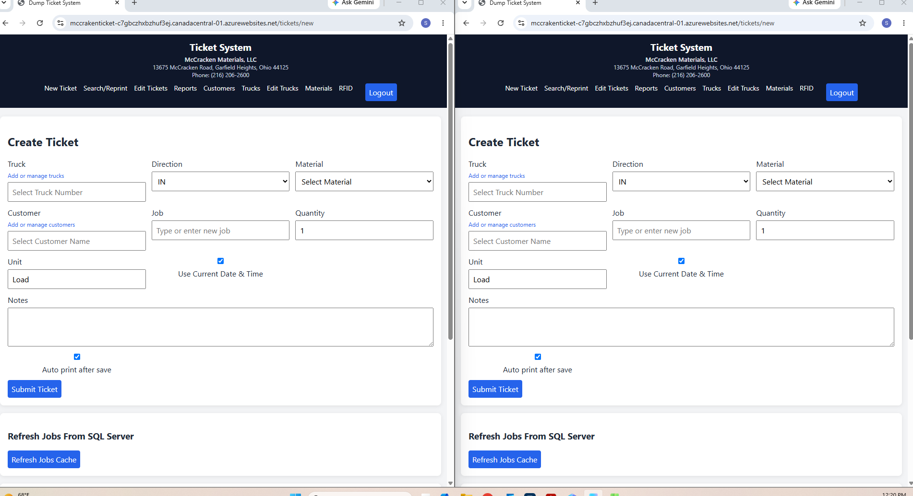
Create Ticket screen from the source draft, with operating fields and controls highlighted.

3.2 Before submitting
- Confirm the truck matches the vehicle at the window.
- Confirm Direction before choosing Material because the available materials change with Direction.
- Confirm the paying Customer.
- Confirm the Job, especially when a carrier works for more than one customer or job during the day.
- Confirm Quantity and Unit have not been changed from the documented defaults.
- Read Notes and remove stale information if it is no longer needed.

4. Add and Manage Trucks
Search terms: new truck, add truck, truck admin, truck number, description, hauler, carrier, license plate, truck size, axle
Example user questions: The truck is not in the system, what do I do? | How do I add a new truck? | What information is needed for Truck Admin?
Accuracy matters: The source states that truck setup affects how material in a load is billed. Verify the truck information before adding it.

- Open Add or manage trucks from the New Ticket screen, or open Trucks from the top navigation.
- Create an alphanumeric Truck Number that is easy to identify from the carrier and truck number.
- Enter a Description using the cab and bed color guidance in the source.
- Enter Hauled By using the carrier.
- Enter the License Plate.
- Select the Truck Size or axle size from the available list.
- Select Add Truck.
- Return to New Ticket. The source also instructs the user to refresh the page for a newly added truck to register.
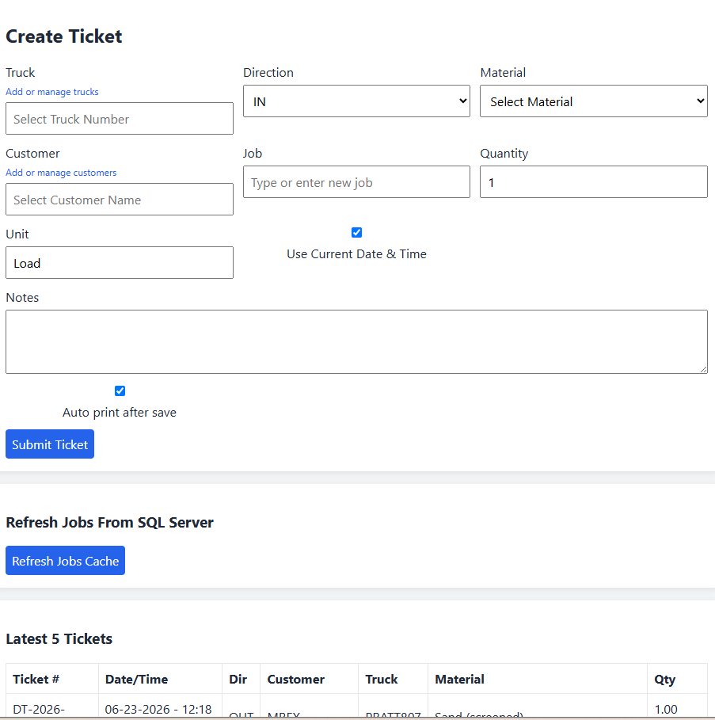
Truck Admin example from the source draft.

5. Direction and Material Selection
Search terms: IN, OUT, direction, material list, dump, load out, operator, material availability
Example user questions: What is the difference between IN and OUT? | Why did the material list change? | What do I do before processing an OUT ticket? | What if I cannot identify an incoming material?

5.1 IN
- IN means the truck is coming in to dump material.
- Direction affects pricing and which materials are available for selection.
- If the incoming material does not match the available choices, ask for help or contact the operator. The source says the operator can come to the window and inspect if needed.

5.2 OUT
- OUT means material is being loaded for the truck to take to a jobsite.
- Before processing an OUT ticket, radio or call the operator.
- Confirm the requested material is available.
- Confirm where the truck should meet the operator.
- Communicate any expected loading delay.
- If the truck is dumping first and then being loaded, tell the operator so timing expectations are clear.
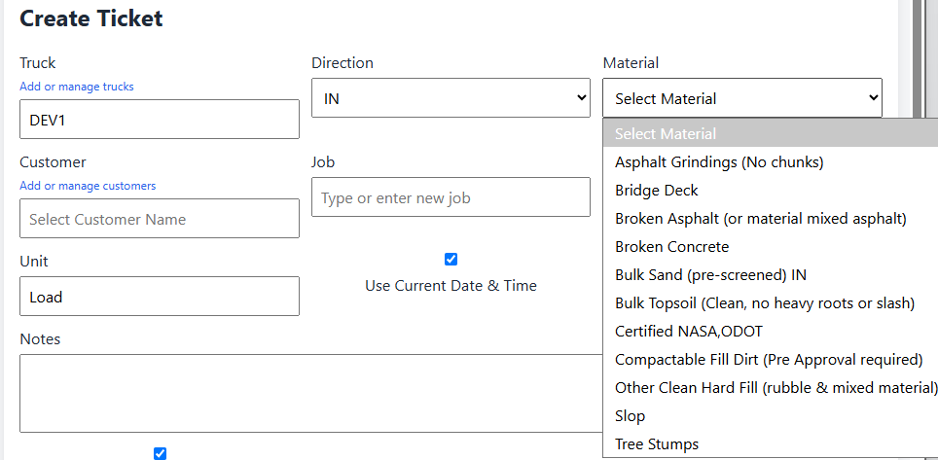
Source example showing that IN and OUT produce different material selections.
Billing rule: The source explicitly states that Direction and Material are critical for billing.

6. Customer and Job Selection
Search terms: customer, paying customer, broker, carrier, job, job code, job name, MREX, Petty, Eagle, Redcon
Example user questions: Which customer should I select? | The driver gave me a broker name, what do I enter? | How do I find a job if I do not know the job code? | Which job option should I choose when several appear?

6.1 Customer
- Customer identifies who is paying for the load.
- Do not assume the carrier or broker is the paying customer.
- A carrier can haul for different customers during the same day.
- A driver can be reassigned to another job or customer during the day.
- Type the first characters of the customer name, then select the correct result from the filtered list.
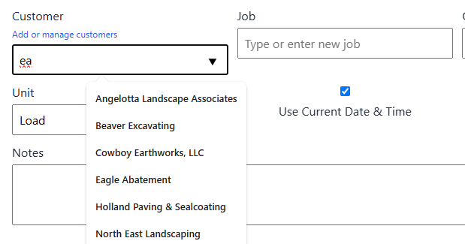
Customer search example from the source draft.

6.2 Job
- The Job or Job Name is used to assign the transaction to the correct work and billing designation.
- For MREX, Petty, Eagle, and Redcon jobs, the source requires the job information to be entered and selected from the list.
- If the job code is unknown, the source says the user can start typing the job name.
- When multiple options appear for MREX, Petty, Eagle, and Redcon, select the option that contains both the numeric identifier and the job description.
- For other customers, a job may use a customer supplied code or only a name. The driver is expected to provide this information.
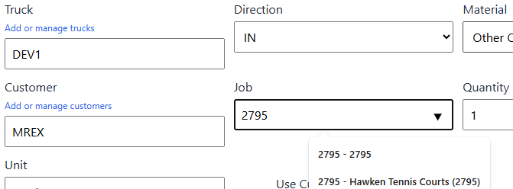
Job lookup by numeric identifier from the source draft.
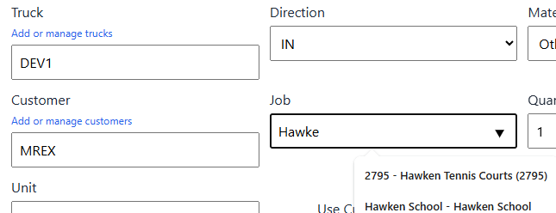
Job lookup by job name from the source draft.

7. Quantity, Unit, Date, Notes, and Printing
Search terms: quantity, unit, Load, current date time, previous day ticket, notes, auto print, submit, print two copies
Example user questions: Should I change Quantity? | Should I change Unit? | When do I uncheck current date and time? | What are Notes used for? | Is auto print active? | How many copies should I print?

7.1 Quantity and Unit
- Quantity is documented as 1.
- Unit is documented as Load.
- The source says these values work with truck information to support the proper cubic yard charge.
- Do not change them during normal ticket processing.

7.2 Current date and time
- Leave Use Current Date and Time selected for normal live processing.
- The source describes unchecking it when entering trucks from the previous day because no window person was available.
- For that previous day scenario, choose the appropriate date and time, print one copy, and add a note explaining the condition.

7.3 Notes
- Use Notes for information that needs to be shared or retained.
- The source states that notes can remain on every ticket for that truck until the next business day.
- If a note is no longer needed after the first occurrence, erase it so stale information is not carried forward.

7.4 Auto print and Submit Ticket
- The source draft states that Auto print after save is not active or not fully developed.
- After Truck, Direction, Material, Customer, and Job are entered, select Submit Ticket.
- For a normal live transaction, the source instructs the user to print two copies when the second print screen appears.
- The driver signs one copy for company records and keeps the other copy.
- The first print screen may need to be closed manually after printing.

8. Search and Reprint
Search terms: Search/Reprint, find ticket, old ticket, ticket number, truck, job code, customer, material, date from, date to, PDF, reprint
Example user questions: How do I find an old ticket? | How do I search by truck? | How do I search by customer and date? | How do I reprint a ticket? | Can I view the ticket PDF?
- Open Search/Reprint from the top navigation.
- Enter one or more search criteria. Supported criteria in the source include Ticket Number, Truck, Job Code, Customer, Material, Date From, and Date To.
- Select Search.
- Review the matching tickets.
- Use View when you need the associated image or view action shown in the interface.
- Use PDF to open the ticket PDF when available.
- Use Reprint to print the selected ticket again.
Today view: The source states that tickets run that day can also appear at the bottom when no date range has been entered.

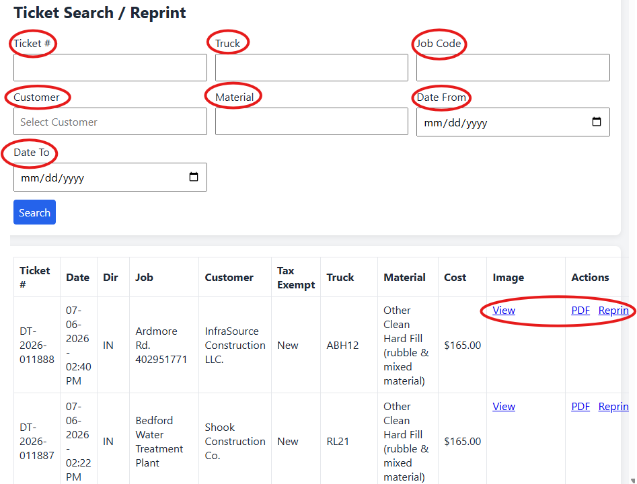
Search and Reprint screen with search criteria and ticket actions.

9. Edit and Void Tickets
Search terms: Edit Tickets, modify ticket, correct ticket, void ticket, delete ticket, previous week, billing
Example user questions: How do I correct a ticket? | How do I void a ticket? | Can I edit a ticket from last week? | Where is the Edit Tickets screen?
- Open Edit Tickets.
- Search using the available criteria, or locate the ticket in the recent ticket list.
- Select Edit for the correct ticket.
- Review every field before changing anything.
- Make only the required correction.
- Use the authorized edit credential through the approved internal process.
- Select Save to retain the correction, or Void only when the ticket must be removed.
Previous week restriction: Do not change a ticket from the previous week. The source warns that this affects billing and instructs the user to contact the designated internal person for assistance.

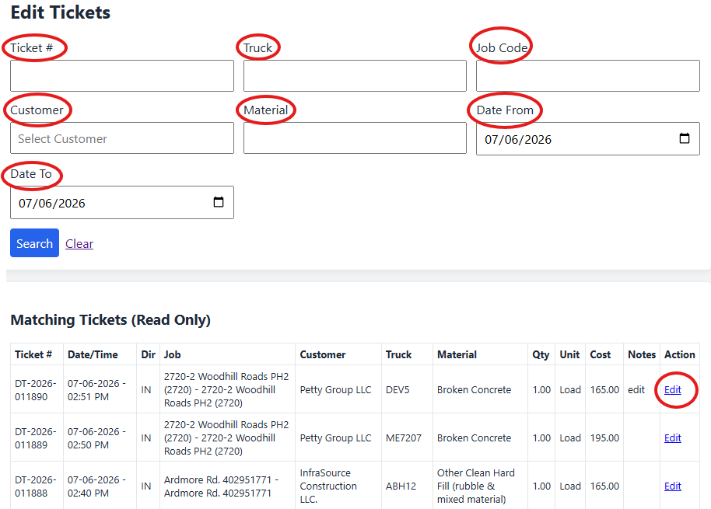
Edit Tickets search and selection screen from the source draft.
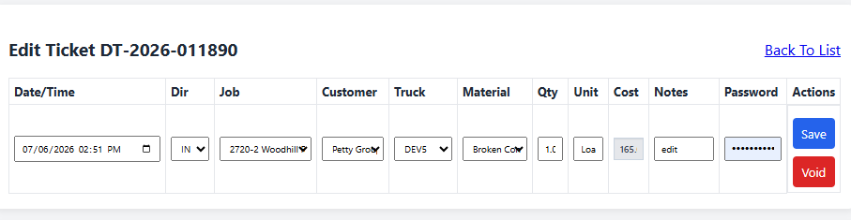
Individual Edit Ticket screen showing editable fields and Save or Void actions.

10. Reports and Reconciliation
Search terms: Reports, Ticket Reports, Run Report, Print Report, Print Customer Report, Export CSV, reconciliation, total quantity, matching tickets, credit card
Example user questions: How do I run a report? | How do I reconcile tickets at the end of the day? | What does Run Report show? | How do I create a customer grouped report? | How do I check one customer today?

10.1 Report filters
- The source report screen supports Date From, Date To, Direction, Job, Customer, and Material criteria.
- The criteria selected determine the report results.
- For end of day reconciliation, enter today in both date fields, then Run Report and Print Report.
- During the day, you can enter today in both date fields and a specific Customer to verify that customer’s tickets.

10.2 Run Report output
- Total Quantity by Unit shows quantity and total cost by unit.
- Total Quantity by Material shows materials, quantity, and total costs.
- Total Quantity by Direction separates IN and OUT and shows quantity and total costs.
- Matching Tickets shows ticket details that meet the selected criteria, including individual cost.
- The source notes that outgoing material tickets appear last regardless of ticket numbering order.
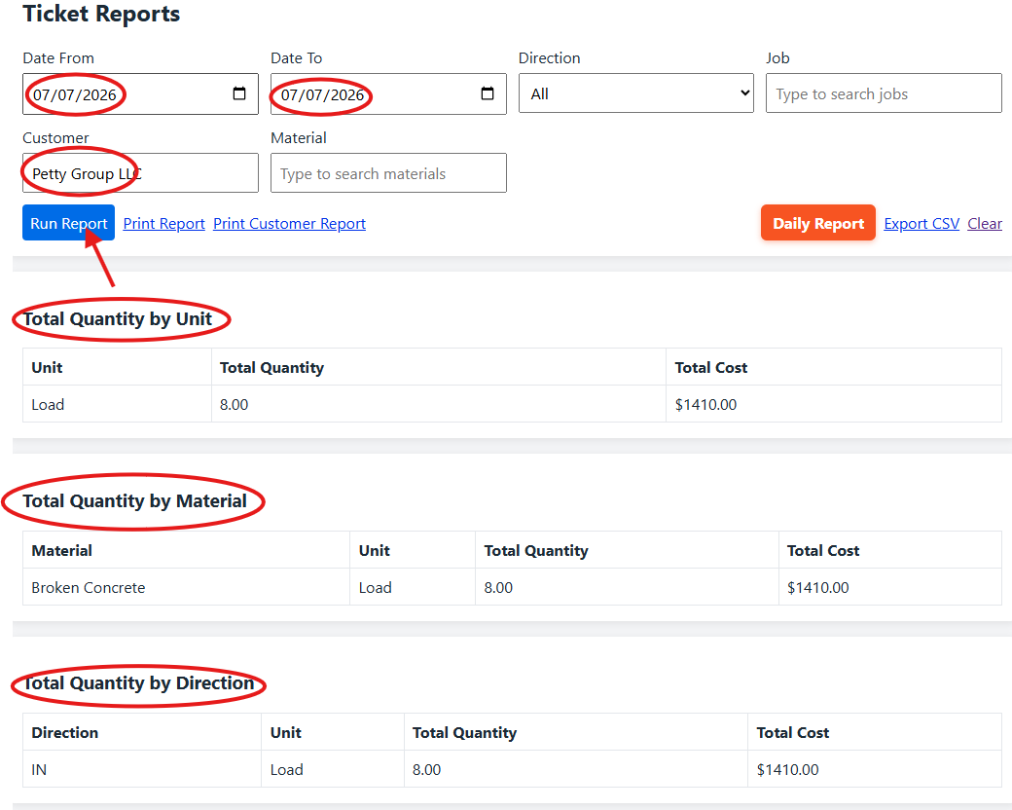
Run Report output showing quantity summaries and matching tickets.

10.3 Print Report
- Select Run Report first.
- Select Print Report to create the printable PDF described in the source.
- Use the printed report for end of day reconciliation by customer and for all tickets processed that day.

10.4 Print Customer Report
- Print Customer Report creates the customer grouped sales report described in the source.
- The source uses this report for end of day credit card processing and for accounts receivable review before billing.
- If there is more than one credit card customer during the day, include the Job. Without the Job, the source warns that all credit card customers can be returned together without the needed billing designation.
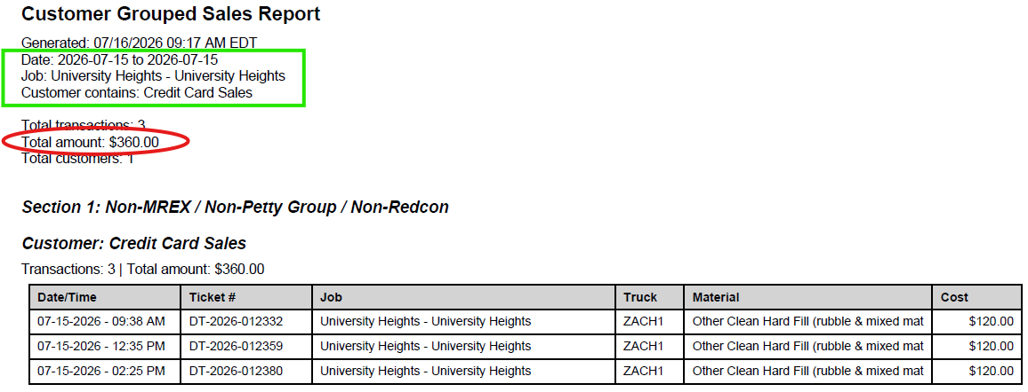
Customer Grouped Sales Report example and the filters used to create it.

11. Daily Dispatch Dashboard
Search terms: Daily Report, Daily Dispatch Dashboard, running total, loads in, loads out, customer, job, truck, change date, Load, Download PDF
Example user questions: What does the Daily Dispatch Dashboard show? | How do I view another date? | How do I download the Daily Dispatch PDF? | How can I see how many loads a truck has?
- The dashboard provides a running overview separated by Customer, Job, and individual Truck.
- It shows how many loads trucks have brought in or taken out.
- To view another date, select the date and then select Load.
- Download PDF creates a clean printable version of the dashboard.
- The source recommends printing the report at the end of the day to help prepare for likely repeating customers and jobs the next day.
- Back to Reports returns to the Ticket Reports screen.
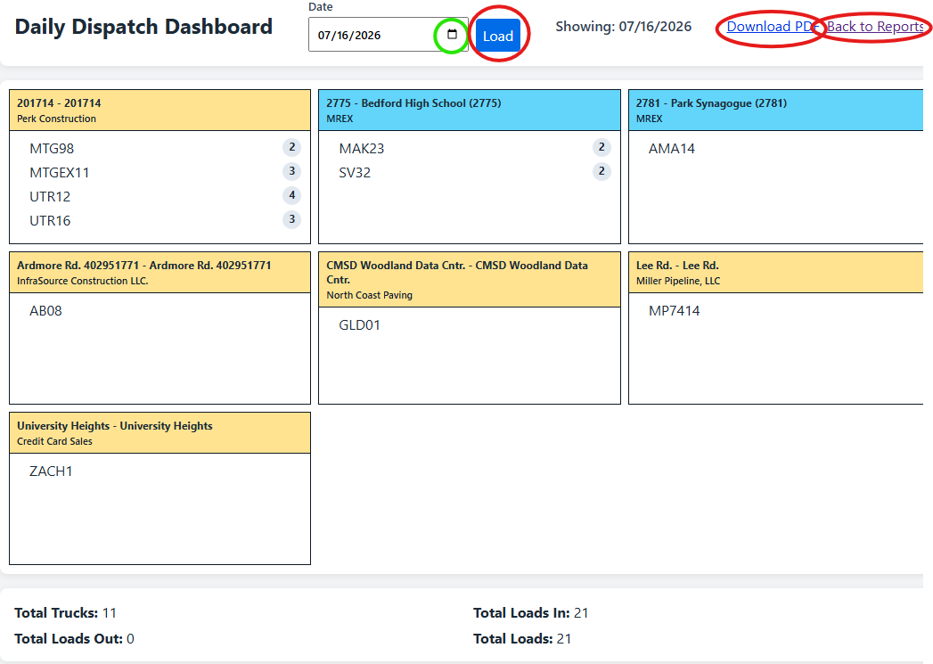
Daily Dispatch Dashboard with date, Load, Download PDF, and Back to Reports controls.
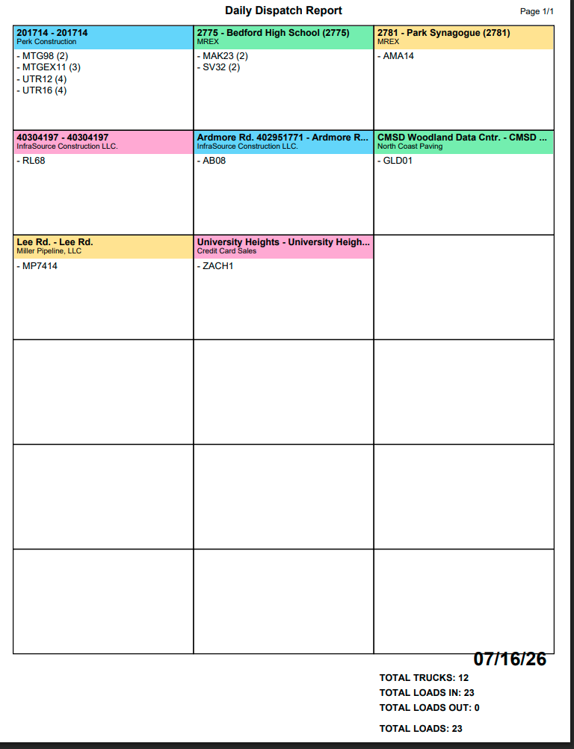
Printable Daily Dispatch Report example from the source draft.

12. Customers
Search terms: Customers, new customer, Customer Admin, Add Customer, contact person, phone, address, notes
Example user questions: How do I add a customer? | Can I edit a customer after I add it? | Who is allowed to create a customer?
Restricted action: Only add a customer when specifically instructed. The source says entries in this tab cannot be edited or deleted after they are entered, so verify the information before selecting Add Customer.

- Open Customers.
- Enter the customer information requested by the Customer Admin form, including Customer Name and the other available contact fields.
- Verify all information.
- Select Add Customer only after verification and authorization.
- Return to New Ticket from the top navigation or Back to New Ticket.
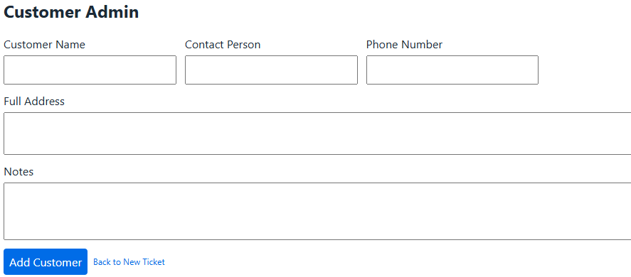
Customer Admin screen from the source draft.

13. Trucks, Edit Trucks, Materials, and RFID
Search terms: Trucks, Edit Trucks, Materials, RFID, admin only, coming soon
Example user questions: What is the Trucks tab for? | Can I edit trucks? | Can I manage materials? | Is RFID available?

13.1 Trucks
- The Trucks tab leads to the same truck administration area described in the New Ticket workflow.
- Enter Truck Number, Description, Truck Size or axle selection, Hauled By, and License Plate, then select Add Truck.
- The source instructs the user to refresh the page for the new truck to register.

13.2 Edit Trucks
- The source draft visually marks Edit Trucks as coming soon. It does not provide an operating procedure for this feature.

13.3 Materials
- The source draft states that Materials is currently an Admin Only feature. No standard window operator procedure is provided.

13.4 RFID
- The source draft visually marks RFID as coming soon. It does not provide an operating procedure for this feature.

Navigation area from the source draft showing Trucks, Edit Trucks, Materials, and RFID status.

14. End of Day Workflow
Search terms: end of day, reconcile, print report, daily dispatch, credit card report, billing
Example user questions: What should I do at the end of the day? | Which reports should I print before leaving? | How do I reconcile today’s tickets?
- Open Reports.
- Set Date From and Date To to today.
- Run the Ticket Report.
- Review the quantity summaries and Matching Tickets.
- Select Print Report and use it to reconcile the tickets processed that day.
- When needed, create the Customer Grouped Sales Report for credit card processing and accounts receivable review.
- Open Daily Report and review the Daily Dispatch Dashboard.
- Download or print the Daily Dispatch Report as described in the source to support preparation for the next day.
- Resolve any ticket discrepancies using the correction rules in this manual before the billing cycle is affected.

15. Troubleshooting and Decision Rules
Search terms: troubleshooting, wrong material, truck missing, wrong customer, wrong job, previous day, edit, billing, operator
Example user questions: What if the truck is missing? | What if I do not know the material? | What if the driver gives the wrong customer? | What if I made a mistake on a ticket?
Situation | Documented response
Truck does not appear | Use Add or manage trucks or Trucks, then add the truck accurately and return to New Ticket.
Incoming material does not match the list | Do not guess. Ask someone or contact the operator for identification.
OUT material requested | Contact the operator before processing to confirm availability, meeting location, and timing.
Driver gives a broker or carrier name | Determine the paying customer. The Customer field represents who is paying for the load.
Several job choices appear | For MREX, Petty, Eagle, and Redcon, select the option containing both the numeric job identifier and job description.
Ticket needs correction | Use Edit Tickets and make only the required correction.
Ticket is from the previous week | Do not edit it. Follow the internal escalation described in the source because billing can be affected.
Ticket is being entered for the previous day | Use the documented alternate date and time procedure, print one copy, and explain the condition in Notes.
Auto print does not work | The source states that Auto print after save is not active or fully developed.
Edit Trucks or RFID needed | The source marks these features as coming soon and gives no operating procedure.

16. AI Retrieval Index and Question Bank
How to use this section: This section intentionally repeats common terms and natural user wording. It is designed to improve semantic retrieval when the manual is indexed for an AI assistant.

Create Ticket
Search terms: new ticket, process truck, submit ticket, ticket entry
Example user questions: How do I make a ticket? | How do I check in a truck? | Where do I process a load?

Truck
Search terms: truck lookup, truck number, new truck, truck admin, carrier, license plate, axle size
Example user questions: The truck is not showing up | How do I add a truck? | How do I find a truck?

Direction
Search terms: IN, OUT, dump, load out, incoming, outgoing
Example user questions: Should this be IN or OUT? | What does OUT mean? | Why did my materials change?

Material
Search terms: material selection, incoming material, outgoing material, operator
Example user questions: I cannot find the material | Which material should I select? | Why is this material unavailable?

Customer
Search terms: paying customer, broker, carrier, customer lookup
Example user questions: Who do I put as the customer? | The driver gave me the broker | How do I search customers?

Job
Search terms: job code, job name, numeric job, MREX, Petty, Eagle, Redcon
Example user questions: I do not know the job code | Which job option do I select? | Can I search by job name?

Search and Reprint
Search terms: search ticket, reprint, old ticket, ticket PDF, date range
Example user questions: Find a previous ticket | Reprint a ticket | Search tickets for this truck

Edit Ticket
Search terms: correct ticket, modify ticket, void, save edit, billing
Example user questions: I entered the wrong material | How do I fix a ticket? | Can I delete a ticket?

Reports
Search terms: Run Report, Print Report, Ticket Reports, reconciliation, matching tickets
Example user questions: Show today’s tickets | How do I reconcile the day? | What does Run Report show?

Customer Report
Search terms: Print Customer Report, credit card sales, accounts receivable, billing
Example user questions: How do I get the credit card report? | How do I print a customer sales report?

Daily Dispatch
Search terms: Daily Report, dashboard, truck load count, Download PDF
Example user questions: How many loads did this truck bring? | How do I see today’s dashboard? | Can I view yesterday’s dispatch?

Notes and date
Search terms: notes, current date, previous day, back date
Example user questions: How do I enter yesterday’s ticket? | Why is this note still here?

Source Status Summary
- Auto print after save: documented as inactive or not fully developed.
- Edit Trucks: shown as coming soon.
- Materials: documented as Admin Only.
- RFID: shown as coming soon.
- Customer creation: only when specifically instructed; source says entries cannot be edited or deleted in that tab after creation.
- Previous week ticket editing: prohibited in the source because it can affect billing.
Maintenance recommendation: When the application changes, update the relevant section and its Search terms and Example user questions together. This keeps employee instructions and AI retrieval aligned.

