 

**Placement Empowerment Program**

***Cloud Computing and DevOps Centre***

**DAY 3 TASK:**

Set Up a Local Git Repository: Initialize a Git repository locally and version control your static website

**NAME:** PRANAVANITHYA T

**DEPARTMENT:** ADS

**INTRODUCTION AND OVERVIEW:**

What is Git?

Git is a distributed version control system (DVCS) used to track changes in source code during software development. It helps developers collaborate, maintain a history of changes, and manage different versions of their projects efficiently.

### **Why Learn Git?**

* Essential for **software development, DevOps, and cloud computing**.
* Enables **collaborative coding** and open-source contributions.
* Helps in **tracking and reverting changes** easily.
* Supports **continuous integration & deployment (CI/CD)**

**OBJECTIVE:**

In this poc , we will be learning how to install git,creating a local repository, staging and commiting files a d reviewing.

**EXPECTED OUTCOME:**

1. Gain insight into the importance of Git for managing and tracking changes in your projects
2. Learn how to initialize a Git repository to version control your static website locally
3. Understand how to stage and commit files to ensure every change is logged.
4. Maintain a clean and structured workflow for your static website, with the ability to roll back changes when needed.
5. Lay the groundwork to share your repository and collaborate with others using Git when required

**STEP BY STEP OVERVIEW**

Step 1:

* Search for "Git" in Chrome, download it, and click the "Downloads" option on the website.
* Click Windows and install .

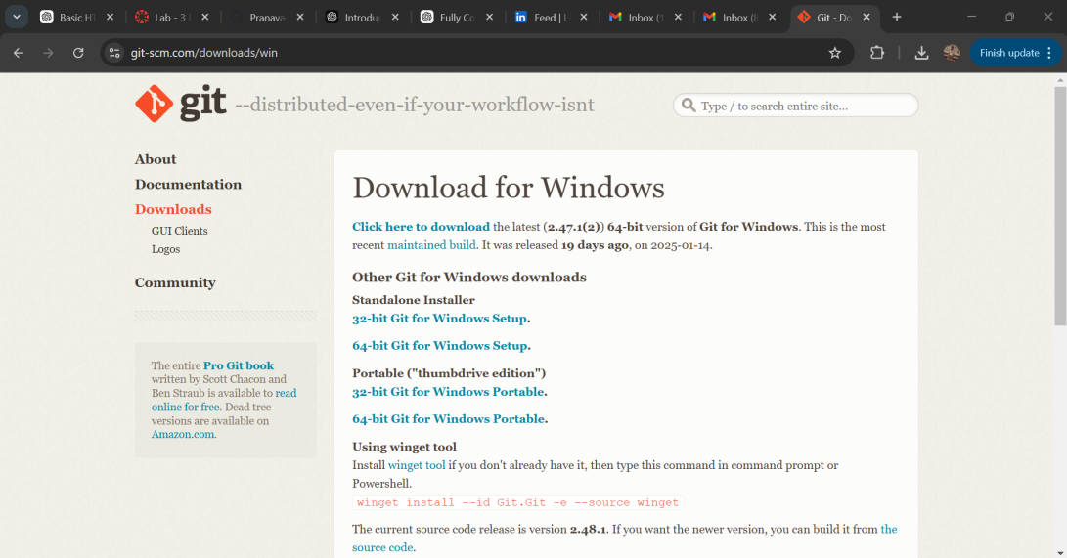

STEP 2:

* In desktop create a folder named as task for your static website.
* Inside the folder, create a html folder named as task3.html with some code in it.



STEP 3:

Open the cmd prompt and set the path to folder named as task3 we created.

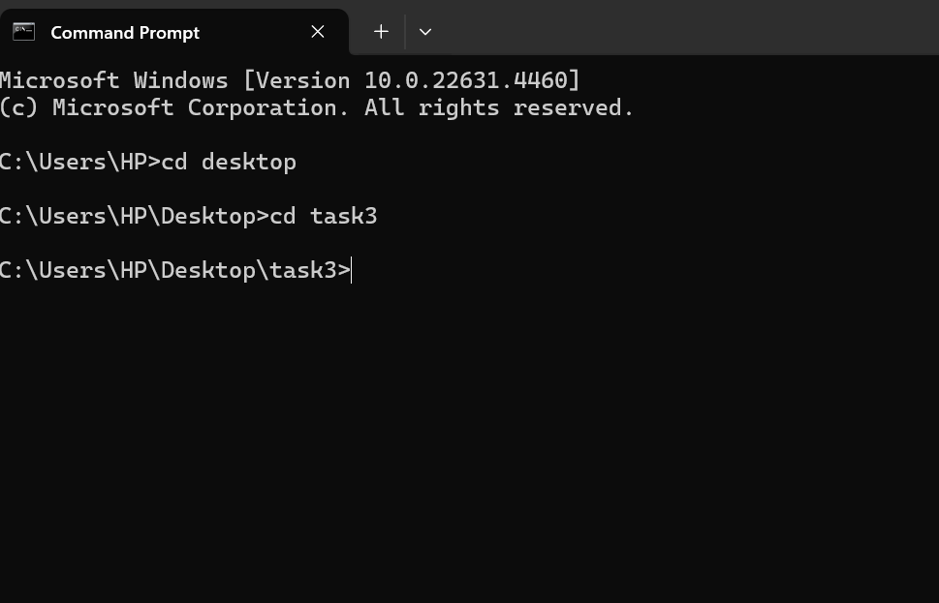

STEP 4:

Now initialize GIT by typing the command “git init”



STEP 5:

To add files to Git’s tracking system type “git add .”



STEP 6:

To set your name and mail so that Git can recognize who made the changes. Type the following commands:





STEP 7:

To save the changes, we need to commit them so that Git an take snapshots of the changes made.

The –m allows you to add a message about the changes made.

“initial commit” means that you are saving the work for the first time

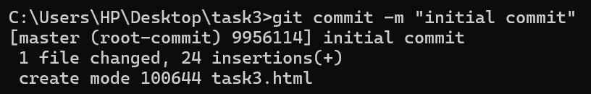

STEP 8:

Open a new repository in Github .

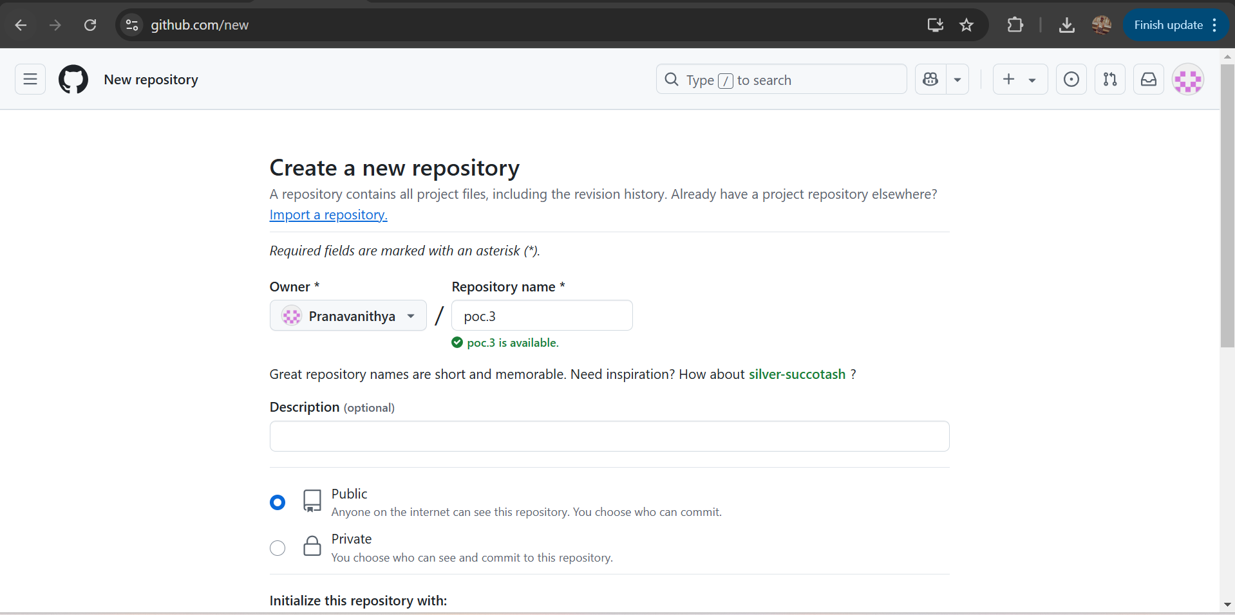

STEP 9:

Get back to cmd and type the following command to rename the current branch to main

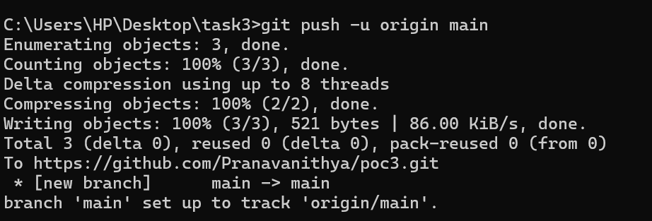

STEP 10:

Verify your files in Github.

