 

**Placement Empowerment Program**

***Cloud Computing and DevOps Centre***

**DAY 4 TASK:**

Create a Simple Backup Script:Create a script that backs up your entire Git repository to a local folder daily.

**NAME:** PRANAVANITHYA T

**DEPARTMENT:** ADS

**Objective**

Create a simple script to automatically back up important files from one folder to another, ensuring data safety and easy recovery.

**Introduction**

Regular backups are essential to protect critical data from accidental deletion, corruption, or system failures. Automating the backup process reduces manual effort and ensures that files are always up-to-date. This Proof of Concept (PoC) demonstrates how to create a simple backup script using a batch file in Windows. The script copies files from a source directory to a backup location, maintaining data integrity and security.

**Overview**

1. **Creating a Backup Script**: Write a batch script to automate file copying.
2. **Scheduling the Backup**: Use Windows Task Scheduler to run the script automatically.
3. **Verifying Backup Success**: Ensure files are copied correctly to the backup folder.

**Objectives**

By the end of this POC, you will:

1. Understand the importance of automated backups.
2. Create a batch script to back up files.
3. Schedule the script to run at specific intervals.
4. Verify that the backup process works correctly.

**Importance of Automating File Backup**

* **Data Protection**: Safeguard important files against accidental loss.
* **Time-Saving**: Eliminate manual backups.
* **Recovery Assurance**: Ensure quick restoration of data when needed.

**Step-by-Step Guide**

Step 1: Create Source and Backup Folders

1. Create two folders:
   * C:\SourceFolder (where the original files are stored).
   * C:\BackupFolder (where the files will be backed up).

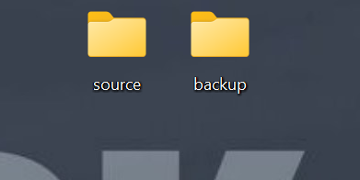

**Step 2: Write the Backup Script**

1. Open Notepad and type the following batch script:
2. @echo off
3. xcopy "C:\SourceFolder\*" "C:\BackupFolder" /E /H /C /I
4. echo Backup completed successfully!
5. Save the file as backup.bat.

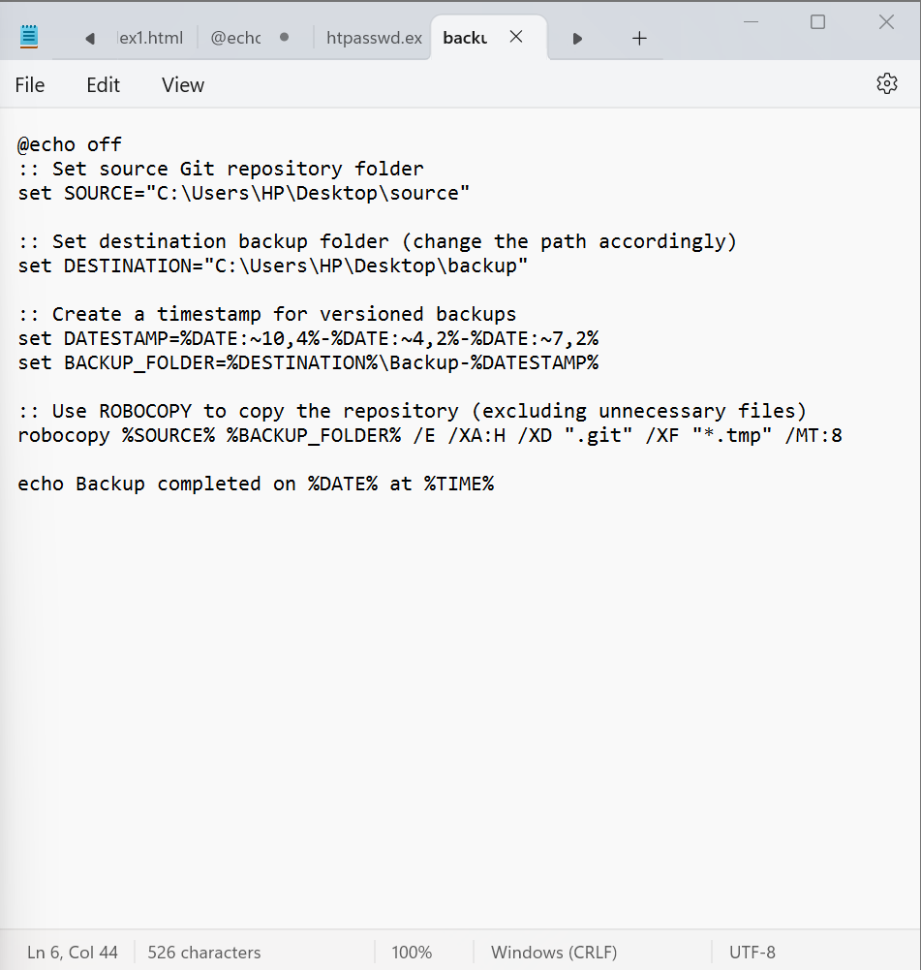

**Step 4: Schedule Automatic Backups**

1. Press **Win + R**, type taskschd.msc, and press Enter.
2. Click **Create Basic Task**.
3. Enter a **name and description** (e.g., "Automated Backup").Click **Next**.
4. Select **Start a Program** and click **Next**.
5. Browse and select backup.bat.
6. Click **Next**, then **Finish**.

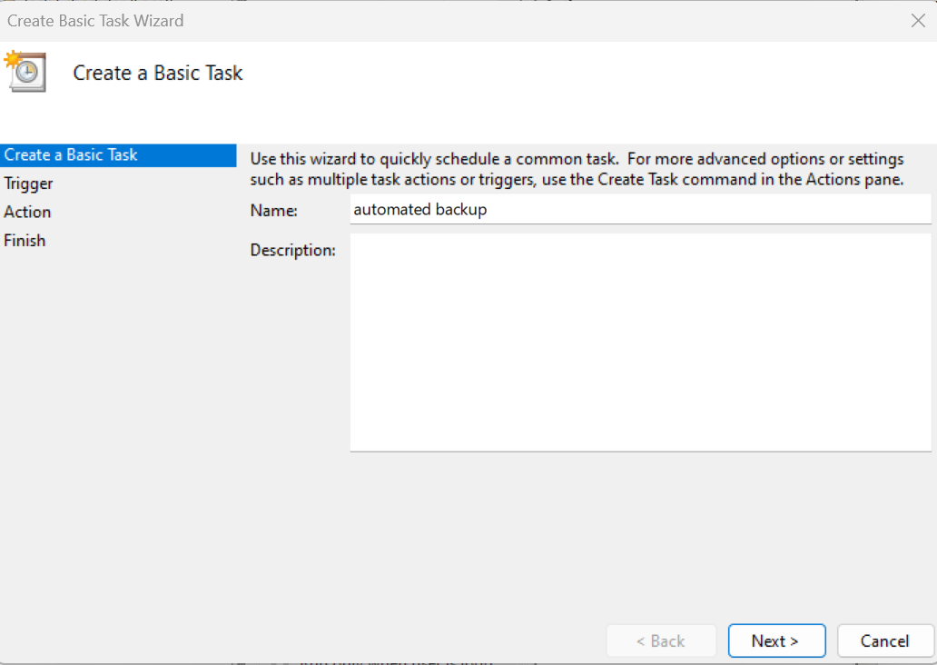

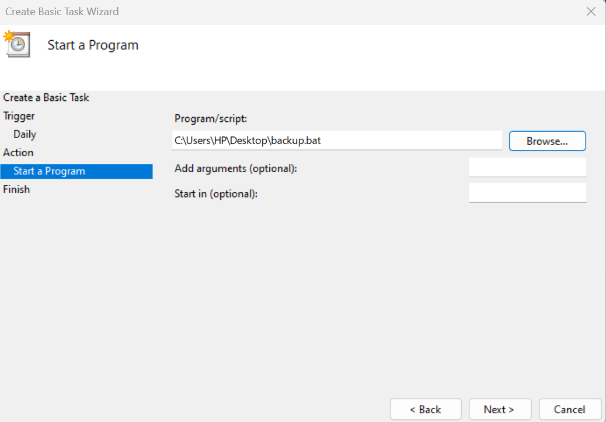

**Step 5: Verify Backup Process**

1. Open **Task Scheduler Library**.
2. Right-click your task and select **Run**.
3. Check C:\BackupFolder to confirm that the backup was successful.

