Nexera - NewFi
Solution Architecture Document

Table of Contents

1 Introduction 3
1.1 BACKGROUND 3
2 Solution Approach 4
2.1 Solution components 4
2.1.1 CMS driven marketing pages 4
2.1.2 Web application container 4
2.1.3 Workflow Engine 7
2.1.4 Enterprise Service bus 7
2.2 Technology Stack 7
2.3 Deployment diagram 8

Author | Shashank Tripathi, Rajeswari
Reviewer | Anoop Halgeri
Approver
Effective Date

Introduction

BACKGROUND
Nexera NewFi Loan Processing platform will provide an interactive, engaging and self service experience to prospective customers to evaluate different financing options, compare rates, apply for loan and track the progress of the application seamlessly. The NewFi application will showcase that Nexera provides the best interest rates anywhere and also they can quickly and easily obtain a mortgage to refinance their existing home loan or to purchase a new home.

This document talks about the overall solution considered for implementing the solution including the technology stack and the deployment considerations of the solution.

Solution Approach
The overall solution approach to NewFi application is as depicted below.

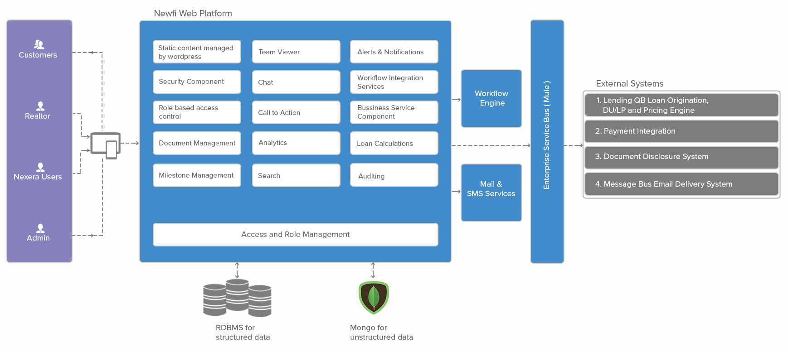

Figure 1 – High Level Solution

The diagram illustrates the various application components and their interaction in the Newfi system. The platform has following key modules:

- CMS driven marketing pages
- A Web application container housing the individual modules necessary for the application
- Custom workflow engine
- Enterprise service bus, in the form of Mule for all external application integration

Solution components

CMS driven marketing pages
Wordpress CMS engine is used to host all the static pages of the application. This will host the various pages, media objects and other artifacts necessary to render the newfi marketing page website. These pages will typically host all the static information targeted for end users of the system.

Web application container
A Java based web application will host all the dynamic application components in the overall solution. Following is a list of modules that are part of the system:

      - Login & Authentication Module – This module helps in authenticating users against database . Once authenticated user will be logged in .

      - Forgot Your Password Module – This module will be used by Customer/Internal Users to recover forgotten password. Email with a link a to change password will be sent to users registered email ID.

      - Authorization Module – This module will authorize the user based on their role . Depending on user role different access levels are provided to different set of users. This module will control which functionality and page will be visible to which set of users.

      - Dashboard Modules – Dashboard will provide all the major functionality to the users . On the basis of user type dashboard modules are divided into three categories.
    - Customer Facing Modules – modules described below will provide Customer side of functionality.
        - Loan Detail Module – This module will display complete details of customer loan. Customer can add/edit/delete loan information. This module will also show all the people (Loan Managers, Processers etc.) assigned to this loan .
        - User Profile Module – This module displays customers information and customer can add/edit their profile information using this module .
        - Payment Module – This module connect with payment gateway (brain tree) via a service layer and helps Customer make payment prior to lock interest rate and applying for loan .
    - Internal Facing Modules - Internal side of functionality will be provided by modules described below.
        - User & Team Management Module – This module displays all the loans/customers assigned to a loan managers. It also shows other users associated with particular customer or loan. Only the customers/loan associated with a particular user will be displayed to them. New loan managers/processers etc. can be assigned to customers/loans using this module .
        - Loan Management Module – This module will be used by Internal User (Loan Manager etc.) to manage customer loan completely . They will see complete loan details , current status of the loan , next steps required towards loan approval . They can add/edit any loan information on customers behalf using this module .
        - Need Management Module – This module will be used by Loan Managers to generate Need for information/documents from a particular customer in order to process their loan . For each loan type there will be predefined set of needs that will be raised but at the same time Loan Managers can add need for additional information/documents.
        - Admin & Reports Module – This module will be used by internal users to perform administrative tasks and also view different reports .

    - Common Modules – These modules would provide functionality to both Customers and Internal Users.
        - Alert & Notification Module –This module will be used to generate alert and notification to any type of user including customer and internal users . There are different type of alert and notification ( event based, action based , scheduled etc.) that can be configured. Users can either subscribe for alerts or schedule for the same. A email will also be triggered whenever a notification is send to the user .
        - Workflow & Milestone Management Module – This module will be used by any user to manage complete workflow for loan processing. Any loan when applied passes through various stages where action is required from different actors at different stage. This module will define and monitor the flow of any loan application and the milestone attached to those workflow . Milestone provide fixed dates to the workflow stages which helps in close tracking of any loan .

        - Chat Module - This module will be used by customers and Internal users to communicate amongst each other. This module will be connected to chat server and there will be single sign on between NewFi Application and chat server . The chat transcripts will be saved in database.
        - Notes Module - Along with chat users can also create notes , these notes can be public or can be assigned to particular user . If notes has been assigned to a particular user , email notification will be sent to that user .This module will save the notes related data in database .

        - Communication Log Module – This module will help in collecting and collating any kind of communication (chat/email/notes etc.) that happened between customer and Internal users . All this information is displayed in chronological order .All these information is picked up from database on the basis of customer id.

        - Document Management Module – This module will be used to upload/download any documents that are required for loan processing . User will be able to upload separate document for each need or can upload one file with all the documents .User can later assign specific document from the bulk file to specific need. This module will be integrated to Docitt to electronically and securely store files and retrieve them.
        - Survey Module – This module will be used by customer to provide survey feedback once the loan is closed . If the customer has not filled in the survey even after few days of loan closure , Loan Managers can send alert to Customers to complete the survey.

      - Utility Modules – Below are few of the modules that serves as utility to provide supporting functionalities to the application .

    - Caching Module – This EhCache based module will serve to cache data at different layers thus helping in performance improvement . Once such case is while fetching teaser rates for customer , LQB returns a set of rates pertaining to different programs . These rates will be cached so that when customers varies length and rate of loan , teaser rates are instantaneously reflected.

    - Logging Utility – This module will be used by complete NewFi application to log any info/debug or error statements. This utility will also put trigger at log level and generate system level alerts in case of any system error .
    - Security Module – This module will help in protecting application and user data from different kind of infosec threats like sql injection , click jacking etc. Different solution for majority of information vulnerability issues will be implemented as a part of this module . This module will be configured as filter in the application .
    - Virus scan Utility – This service based utility will be used to scan any of the documents uploaded by any of the users.
    - Email Utility – This will help in sending email to any email id.
    - Cron Scripts Utility – This utility will help in executing cron jobs in order to do various database level (sql level) tasks .This will be useful for triggering alert and notification when any action is expected from a user.

Workflow Engine

In order to manage the workflow states of the application, a custom workflow engine will be used to manage the state transitions of the overall application. All individual tasks on a particular loan along with the access control to carry out a particular activity will all be driven through the workflow engine.

Enterprise Service bus
Mule will be used as ESB in the application which will take care of interactions with all the external applications including the Loan originating system (LQB), Email services and so on.

Technology Stack
The technology stack proposed for the overall solution is as follows:

SlNo | Component Name | Description
1 | Mule | Mule is a lightweight enterprise service bus (ESB) and integration framework. The integration layer is used to integrate NewFi application with LQB APIs.  Version 3.6.0
2 | Amazon hosting service | The cloud app will be hosted on Amazon cloud. AWS services such as instances, EBS storage, S3, SES component for email will be used as part of the POC.  Version 2.1.3
3 | Spring Framework | The cloud app will be built using the J2EE spring framework, aspects such as Spring MVC, security, REST will be used as part of the cloud app  Version 4.1.4
4 | Hibernate ORM | Hibernate will be used as the ORM for database interactions.  Version 4.2.1
5 | EhCache | EhCache will be used as the caching framework in the application
6 | MySQL DB | Open source database will be used for implementing the application
7 | Tomcat Server / JBoss | The cloud app will be deployed on a plain tomcat server.  Version 7.0 or a community edition of JBoss.

Deployment diagram
Amazon Web services will be used to host the application. The overall application deployment architecture is as follows.

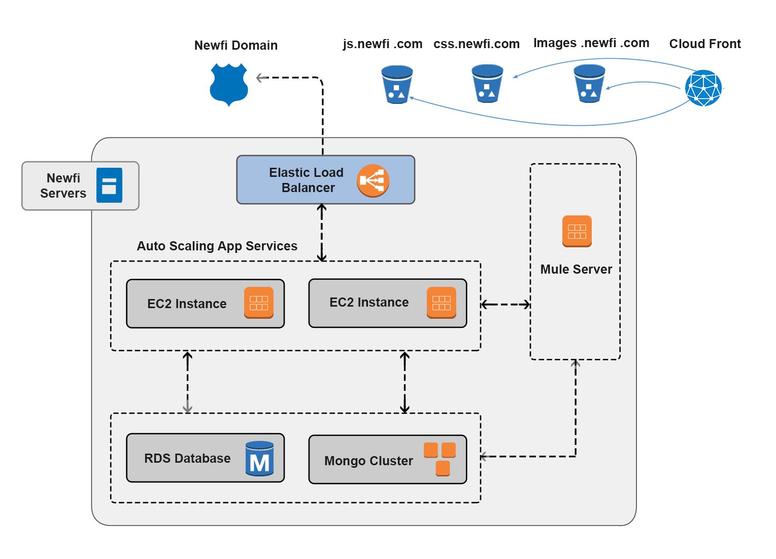

- The user’s DNS requests are served by Amazon route 53. The network traffic is routed to the infrastructure running the amazon instance.
- Static contents like images, javascripts and CSS are rendered through Amazon Cloudfront, an edge server. All requests are automatically routed through the nearest edge server of the cloudfront network.
- The request processing for dynamic content is routed to the Amazon ec2 instances hosting the newfi web application. This will be part of an auto-scaling group to take care of the amazon’s elasticity to manage the instances to increase or reduce depending on the application load.
- The Amazon EC2 instances will interact with Amazon RDS relational database and to the mongo cluster for retrieving appropriate data.
- The workflow engine is a logically independent component, which will have access to the RDS instance. This will take care of the workflow requirements of the application.
- Mule server will have access to the external applications and will connect to them on a need to need basis.

