Software Architecture and Design Specification
Project: Hospital Management System (HMS)
Version: 1.0
Authors: Team 11, Section F — Paras Agarwal (PES1UG24CS316); R Saurav Srrinivas (PES1UG24CS352); Pranav Chandrasekar (PES1UG24CS332); Shristi Saha (PES1UG24CS903)
Date: 07-10-2026
Status: Baselined for Part-1 submission

Revision History
Version | Date | Author | Change Summary
0.1 | 04-10-2026 | Team 11 | Architecture outline: layers, components, technology stack
1.0 | 07-10-2026 | Team 11 | Component diagram, security architecture, sequence diagrams, API design, error handling; traceability to SRS v1.0

Approvals
Role | Name | Signature / Date
Architecture owner | R Saurav Srrinivas (PES1UG24CS352) | R Saurav Srrinivas, 06-10-2026
Design owner | Pranav Chandrasekar (PES1UG24CS332) | Pranav Chandrasekar, 06-10-2026
Team representative | Paras Agarwal (PES1UG24CS316) | Paras Agarwal, 06-10-2026
Course faculty | Dr. Ashok Kumar Patil

1. Introduction

1.1 Purpose
This document specifies the architecture and design of the Hospital Management System (HMS) 1.0. It explains how the requirements of the SRS v1.0 are realised: which components exist, how they are arranged, how they interact, how security is built in, and how the public interfaces and error handling work.

1.2 Scope
Covers the complete HMS 1.0 console application: authentication and access control, patient records, doctors and availability, appointment scheduling, consultation records, reports, backup / restore and audit logging. Hospital hardware, network infrastructure and the operating system are outside the scope.

1.3 Audience
Developers (Team 11), QA engineers, security reviewers, course faculty and future maintenance teams.

1.4 Definitions
HMS, SRS, STP, RBAC, STRIDE, SHA-256, ADR (architecture decision record), CRUD, OPD, UML. Terms are defined in section 5.1 and in SRS Appendix A.

2. Document Overview

2.1 How to use this document
Section 3 gives the architecture (goals, component diagram, pattern, technology, risks, traceability, security architecture). Section 4 gives the detailed design (sequence diagrams, API design, error handling, UX). Developers should read 3.4 and 4.3 before coding a component; testers should read 4.2 and 4.4 to derive test cases; reviewers should read 3.9.

2.2 Related Documents
Document | Relationship
SRS v1.0 (HMS_SRS_v1.0) | Source of all requirement IDs (HMS-F-, HMS-NF-, HMS-SEC-) traced in section 3.8; Appendix C holds the full RTM.
STP v1.0 (HMS_Test_Plan_v1.0) | Test strategy, security validation (5.1) and the test cases that verify this design.
RTM | Requirement Traceability Matrix: SRS Appendix C, extended with code files as the sprints progress.

3. Architecture

3.1 Goals & Constraints
Goals
- Security first: clinical data visible to doctors only; every action attributable (SRS 6.3).
- Reliability: no confirmed record is lost, even if the program is killed (HMS-NF-005).
- Responsiveness: search ≤ 2 s and booking ≤ 1 s at 10,000 patients / 50,000 appointments (HMS-NF-001, 002).
- Modularity and testability: every business rule is in a service that can be unit-tested without the console (HMS-NF-008).
- Portability: one code base for Windows and Ubuntu (HMS-NF-007).
Constraints
- C/C++ is mandated; the team uses C++17. No database server and no network (single-site, single-user).
- Personal and health data: design must support protection under the DPDP Act 2023.
- Four-person team and one semester: simple, well-known patterns are preferred over sophisticated infrastructure.

3.2 Stakeholders & Concerns
Stakeholder | Concerns addressed by the architecture
Receptionist | Speed of registration, search and booking; simple menus; no accidental double booking.
Doctor | Correct patient identification; clinical records that cannot be altered; quick access to history.
Administrator | Account control, backup / restore, audit trail, ability to recover from data corruption.
Hospital management / regulator | Confidentiality of patient data, accountability, compliance with data-protection duties.
Developers / maintainers | Clear modules, low coupling, unit-testable services, portable build.
QA / security auditors | Testable components, deterministic error codes, audit log, security controls traceable to requirements.

3.3 Component (UML) Diagram
Figure 3-1 shows the 15 components in four layers plus the cross-cutting security services. Dependency rule: a component may call only components in its own layer or the layer directly below it; the presentation layer never touches repositories or files; every service calls AccessControl before acting and AuditService after acting.
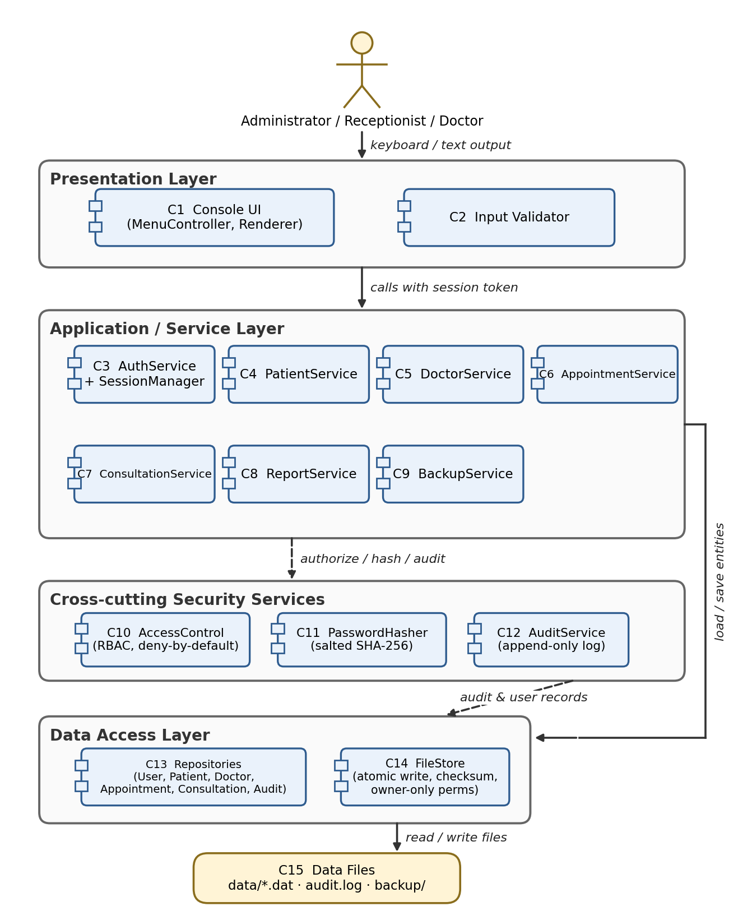
Figure 3-1: HMS component diagram (layered architecture)

3.4 Component Descriptions
ID | Component | Layer | Responsibilities | Planned source
C1 | Console UI (MenuController, Renderer) | Presentation | Displays role-specific menus, reads keyboard input (password entry masked), renders results and error messages. Contains no business rules. | src/ui/console_ui.cpp, menu_controller.cpp
C2 | Input Validator | Presentation / Security | Central validation of every user-supplied value (length, charset, range, date and phone formats) before it reaches a service. Uses std::string only; rejects over-long input. | src/security/validator.cpp
C3 | AuthService + SessionManager | Service | Verifies credentials, enforces lock-out (3 failures = 15 min), creates sessions, enforces 10-minute idle timeout, changes passwords, manages user accounts. | src/services/auth_service.cpp, session_manager.cpp
C4 | PatientService | Service | Registers, searches, updates and deactivates patients; duplicate detection; generates Patient IDs. | src/services/patient_service.cpp
C5 | DoctorService | Service | Maintains doctor profiles and weekly availability (30-minute slots); lists doctors by specialization. | src/services/doctor_service.cpp
C6 | AppointmentService | Service | Books, cancels and reschedules appointments; slot-conflict detection; status life-cycle; daily schedule. | src/services/appointment_service.cpp
C7 | ConsultationService | Service | Records diagnosis / prescription / notes, enforces immutability, handles addenda, returns patient history. | src/services/consultation_service.cpp
C8 | ReportService | Service | Builds the daily appointment report and doctor workload report; CSV export. | src/services/report_service.cpp
C9 | BackupService | Service | Creates time-stamped backups of all data files and restores a chosen backup. | src/services/backup_service.cpp
C10 | AccessControl (RBAC) | Security | Deny-by-default permission matrix (role x operation). Called by every service before any operation executes. | src/security/access_control.cpp
C11 | PasswordHasher | Security | Generates a 16-byte random salt and computes salted SHA-256 hashes; constant-time comparison. | src/security/password_hasher.cpp
C12 | AuditService | Security | Appends security-relevant events to the append-only audit log; never records passwords or clinical text. | src/security/audit_service.cpp
C13 | Repositories | Data access | UserRepository, PatientRepository, DoctorRepository, AppointmentRepository, ConsultationRepository, AuditRepository. In-memory indexes (hash map by ID, ordered map by name) built at start-up. | src/data/*_repository.cpp
C14 | FileStore | Data access | Atomic write (temp file + rename), SHA-256 checksum per file, owner-only permissions, file-lock to prevent two running instances. | src/data/file_store.cpp
C15 | Data Files | Storage | users.dat, patients.dat, doctors.dat, appointments.dat, consultations.dat, audit.log, and backup/ folders. | data/

Main collaborations. C1 calls C2 then a service (C3–C9). Every service (C4–C9) calls C10 first and C12 last; C3 also uses C11. Services read and write through C13, which uses C14 to reach C15. C9 uses C14 directly to copy and verify files.

3.5 Chosen Architecture Pattern and Rationale
Pattern: layered architecture (presentation → services → data access → storage) with the Repository pattern to hide file storage, and a cross-cutting security services group (access control, hashing, auditing) used by all services. The whole system is one process (a modular monolith).
Decision (ADR) | Options considered | Rationale
ADR-1: Layered modular monolith | Layered; MVC; client-server; microservices | Layers give clear separation of concerns and let services be unit-tested without the console. Microservices and client-server need a network and deployment effort that add attack surface and are unjustified for one OPD terminal (rejected). MVC was rejected because a console has no view components worth separating.
ADR-2: File-based storage behind repositories | Own files; SQLite; MySQL / PostgreSQL | No database server to install or secure; portable; fully under team control. The repository interface allows replacing the files by SQLite in a later release. SQLite remains the fallback if the Sprint-1 performance spike fails HMS-NF-002.
ADR-3: Console user interface | Console; Qt / desktop GUI; web UI | Minimum dependencies and risk; satisfies the problem statement; keyboard-only operation is fast for front-desk staff.
ADR-4: In-memory indexes, write-through persistence | Read from disk per query; load all at start | Loading ≤ 5 s (HMS-NF-003) gives O(1) ID lookup and fast name search; every change is written to disk before confirmation (HMS-F-060).
ADR-5: Atomic write by temp file + rename | In-place write; journal; temp + rename | Rename is atomic on both platforms, so a crash leaves either the old or the new file, never half a file (HMS-NF-005).
ADR-6: Salted, iterated SHA-256 for passwords | Plain SHA-256; salted SHA-256; bcrypt / Argon2 | SRS requires salted SHA-256 (HMS-SEC-001). The design iterates SHA-256 10,000 times over salt + password to slow guessing. bcrypt / Argon2 is preferable but needs an extra library; recorded as a future improvement (4.6).
ADR-7: Result<T> return values, no exceptions across layer boundaries | Exceptions; error codes; Result<T> | Explicit error codes map one-to-one to the catalogue (4.4) and to test cases; exceptions are caught at the lowest layer and converted.

3.6 Technology Stack & Data Stores
Item | Choice
Language / standard | C++17 (std::string, std::vector, std::filesystem, <chrono>)
Compilers / build | g++ 11+ or MSVC 2019; CMake 3.20+ (flags: -Wall -Wextra -Wpedantic -fstack-protector-strong -D_FORTIFY_SOURCE=2, PIE)
Cryptography | SHA-256 from OpenSSL libcrypto 3.x, or a bundled reviewed public-domain implementation (Windows fallback)
Persistence | UTF-8 text files, one record per line, fields separated by | with \| and \n escaped; last line #SHA256=<hex> holds the file checksum
Testing / quality | GoogleTest, gcov / lcov, cppcheck, Valgrind and AddressSanitizer, clang-format
Version control / tracking | Git (course repository), issue tracker for sprint tasks and defects

Data store (C15) | Content | Protection
data/users.dat | User accounts, role, salt, hash, lock state | Owner-only; checksum
data/patients.dat | Patient master records | Owner-only; checksum
data/doctors.dat | Doctors and weekly availability | Owner-only; checksum
data/appointments.dat | Appointments and status | Owner-only; checksum; atomic write
data/consultations.dat | Consultations, prescription items, addenda (append-only semantics) | Owner-only; checksum
data/counters.dat | Last used numbers for ID generation | Owner-only; checksum
data/audit.log | Audit entries (append only) | Owner-only; no edit API
backup/YYYYMMDD_HHMMSS/ | Copies of all data files | Owner-only

3.7 Risks & Mitigations
No. | Risk | Level | Mitigation
R1 | Data corruption or loss if the program or machine stops during a write | High | Atomic temp + rename write; per-file checksum; daily backup reminder; restore function (HMS-NF-005, SEC-007, F-061).
R2 | Memory-safety defects (buffer overflow, leaks) typical of C/C++ | High | std::string / containers only; central input validation; unsafe C functions banned in review checklist; AddressSanitizer / Valgrind in every test run (HMS-SEC-005, NF-009).
R3 | Rewriting a large appointments file on each change may exceed the 1-second target | Medium | Sprint-1 performance spike with 50,000 records; if too slow, split appointments by month or move the repository to SQLite behind the same interface (ADR-2).
R4 | Role checks implemented only in the UI could be bypassed | High | Authorisation enforced in the service layer by C10, tested by direct service calls (TC-AUTH-03).
R5 | Two copies of HMS running on one data folder corrupt data | Medium | File lock on the data directory at start-up (E043).
R6 | OpenSSL not available on a team member's Windows machine | Low | Bundled SHA-256 implementation behind the PasswordHasher interface.
R7 | Schedule pressure in a four-person team | Medium | Implement High-priority requirements first; one feature owner each (4.6); weekly review of the RTM.

3.8 Traceability to Requirements
Every SRS requirement maps to at least one component (3.4) and design element. Full detail including code files and test cases is in SRS Appendix C.
Requirement | Title | Component(s) | Design element
HMS-F-001 | Mandatory login | C3, C1 | SAD 4.2.1; 4.3.1 AuthService::login()
HMS-F-002 | Account lock-out | C3, C12 | SAD 4.2.1; 4.3.1 AuthService::login()
HMS-F-003 | Role-based functions | C10, C1 | SAD 3.9; 4.3.1 AccessControl::isAllowed()
HMS-F-004 | User account management | C3, C13 | SAD 4.3.1 AuthService::createUser()
HMS-F-005 | Session time-out | C3 | SAD 4.3.1 SessionManager::validate()
HMS-F-006 | Change password | C3, C11 | SAD 4.3.1 AuthService::changePassword()
HMS-F-010 | Register patient | C4, C13 | SAD 4.3.2 PatientService::registerPatient()
HMS-F-011 | Patient input validation | C2, C4 | SAD 4.3.2; 4.4 (E010)
HMS-F-012 | Search patient | C4, C13 | SAD 4.3.2 PatientService::search()
HMS-F-013 | Update patient details | C4, C12 | SAD 4.3.2 PatientService::updatePatient()
HMS-F-014 | Deactivate patient | C4, C10 | SAD 4.3.2 PatientService::deactivate()
HMS-F-015 | Duplicate detection | C4, C13 | SAD 4.3.2 PatientService::registerPatient()
HMS-F-020 | Doctor profile | C5, C13 | SAD 4.3.4 DoctorService::addDoctor()
HMS-F-021 | Doctor availability | C5 | SAD 4.3.4 DoctorService::setAvailability()
HMS-F-022 | List doctors by specialization | C5 | SAD 4.3.4 DoctorService::list()
HMS-F-030 | Book appointment | C6, C13 | SAD 4.2.2; 4.3.3 AppointmentService::book()
HMS-F-031 | Slot-conflict handling | C6 | SAD 4.2.2; 4.3.3 (E030, E031)
HMS-F-032 | Cancel appointment | C6 | SAD 4.3.3 AppointmentService::cancel()
HMS-F-033 | Reschedule appointment | C6, C14 | SAD 4.3.3 AppointmentService::reschedule()
HMS-F-034 | Daily schedule view | C6, C10 | SAD 4.3.3 AppointmentService::dailySchedule()
HMS-F-035 | Appointment status life-cycle | C6 | SAD 4.3.3 AppointmentService::markNoShow()
HMS-F-040 | Record consultation | C7, C6 | SAD 4.2.3; 4.3.5 ConsultationService::record()
HMS-F-041 | View medical history | C7, C12 | SAD 4.3.5 ConsultationService::history()
HMS-F-042 | Clinical data confidentiality | C10, C7 | SAD 3.9; 4.3.5
HMS-F-043 | Immutable consultation records | C7, C13 | SAD 4.3.5 ConsultationService::addAddendum()
HMS-F-050 | Daily appointment report | C8 | SAD 4.3.6 ReportService::dailyReport()
HMS-F-051 | Doctor workload report | C8 | SAD 4.3.6 ReportService::workloadReport()
HMS-F-060 | Data persistence | C13, C14, C15 | SAD 4.1; 4.4
HMS-F-061 | Backup and restore | C9, C14 | SAD 4.3.7 BackupService
HMS-F-062 | View audit log | C12, C13 | SAD 4.3.1 AuditService::query()
HMS-NF-001 | Search response time | C13 | SAD 4.1 (in-memory indexes)
HMS-NF-002 | Booking response time | C6, C14 | SAD 4.1; 4.3.3
HMS-NF-003 | Start-up time | C13, C14 | SAD 4.1
HMS-NF-004 | Capacity | C13 | SAD 4.1
HMS-NF-005 | Crash safety of stored data | C14 | SAD 4.4 (atomic write)
HMS-NF-006 | Usability | C1 | SAD 4.5
HMS-NF-007 | Portability | All | SAD 3.6
HMS-NF-008 | Maintainability | All | SAD 3.5; 3.6
HMS-NF-009 | Memory safety | All | SAD 4.4
HMS-NF-010 | Patient identity confirmation | C7, C1 | SAD 4.2.3
HMS-NF-011 | Write-failure notification | C14 | SAD 4.4
HMS-SEC-001 | Salted password hashing | C11, C13 | SAD 3.9; 4.3.1
HMS-SEC-002 | Deny-by-default RBAC | C10 | SAD 3.9; 4.3
HMS-SEC-003 | Audit logging | C12, C13 | SAD 4.4
HMS-SEC-004 | Password masking | C1 | SAD 4.5
HMS-SEC-005 | Input validation, memory safety | C2 | SAD 3.9; 4.4
HMS-SEC-006 | Owner-only file permissions | C14 | SAD 3.9
HMS-SEC-007 | Data-file integrity check | C14 | SAD 3.9; 4.4
HMS-SEC-008 | Generic login error | C3 | SAD 4.2.1

3.9 Security Architecture
Principles: defence in depth (UI validation, service authorisation, file protection); least privilege (three roles, Table 6.5-1 of the SRS); deny by default (a missing permission entry means "no"); fail secure (on error the operation is refused and nothing is half-saved); minimum data in logs and error messages; no network exposure.

Threat modelling (STRIDE)
Threat | Example in HMS | Control in the architecture | Component / Requirement
Spoofing | Someone logs in as another user by guessing or stealing a password | Salted, iterated SHA-256 hashes; 3-failure lock-out for 15 min; identical error for unknown user / wrong password; masked password entry; 10-minute session time-out | C3, C11 — F-002, F-005, SEC-001, SEC-004, SEC-008
Tampering | Editing a data file with a text editor; changing a saved diagnosis | Owner-only file permissions; SHA-256 checksum verified at load; atomic writes; consultations immutable (addendum only); input validation | C14, C7, C2 — SEC-005, SEC-006, SEC-007, F-043
Repudiation | A user denies having viewed or changed a record | Append-only audit log with ISO timestamp, user ID, action, target, outcome; no edit / delete API for the log | C12 — SEC-003, F-062
Information disclosure | Receptionist reads a diagnosis; password hashes or clinical text appear in logs / error messages | Deny-by-default RBAC in the service layer; clinical data restricted to Doctors; generic error texts; audit log carries IDs only; hashes never displayed | C10, C7, C12 — SEC-002, F-042, SEC-003
Denial of service | Over-long input, corrupted file, full disk, locked account used to block a colleague | 256-character input limit, bounded containers; checksum failure handled with restore offer; write failure reported (E041) without data change; lock-outs expire after 15 min; backups | C2, C14, C9 — SEC-005, SEC-007, NF-011, F-061
Elevation of privilege | Receptionist invokes a doctor-only operation; memory corruption used to run code | Authorisation inside every service method (not only in menus); no unsafe C functions; compiler hardening (stack protector, FORTIFY, PIE); AddressSanitizer in tests | C10, C2 — SEC-002, SEC-005, NF-009

Trust boundaries and data classification
The only trust boundary is between the human user (untrusted input) and the Presentation layer; everything the user types is validated by C2 before it crosses into the services. A second boundary separates the program from the file system, where the data files may be changed by other programs; C14 therefore verifies checksums and permissions on every load.
Class | Data | Handling
Restricted | Diagnosis, prescription, notes, addenda | Doctors only; every view audit-logged
Confidential | Patient demographics (name, DOB, phone, address, blood group) | Administrator, Receptionist, Doctor; changes audit-logged
Secret | Password hashes and salts | Never displayed or logged; compared in constant time
Internal | Appointments, doctors, audit log | Role-based, owner-only files

4. Design

4.1 Design Overview
HMS is built from small C++ classes, one header / source pair per component. The main design elements are:
- Entities (plain structs): User, Patient, Doctor, AvailabilityWindow, Appointment, Consultation, PrescriptionItem, Addendum, AuditEntry (fields as in SRS Appendix B and the ER diagram, Figure 4-2 of the SRS). Enumerations: Role, UserStatus, PatientStatus, AppointmentStatus.
- Session: struct Session { std::string token; UserId userId; Role role; DoctorId doctorId; TimePoint lastActivity; }. Created by AuthService, passed as the first argument of every service call and validated (10-minute idle limit) by SessionManager.
- Result<T>: every service call returns Result<T> holding either a value or an Error{code, message, details}. No exception leaves a service.
- Repositories: keep all records of an entity in memory (hash map by ID; ordered map by lower-cased name; map by phone) and write the whole entity file through FileStore on every change (write-through).
- ID generation: counters.dat gives P000001, D001, A00000001, C0000001, U00001; the counter is saved together with the record in one atomic step.
- Atomic persistence protocol (FileStore::save): (1) serialise records + checksum line to X.dat.tmp; (2) flush and fsync / FlushFileBuffers; (3) rename over X.dat; (4) apply owner-only permissions; (5) on any failure delete the temp file, keep the old file, return E041.
- Slot model: a doctor's week is a list of windows; slots are 30-minute multiples. An appointment key is (doctorId, slotStart); the repository holds a set of keys for O(1) conflict checks.

4.2 UML Sequence Diagrams
Three flows specific to HMS are shown: login with lock-out, booking an appointment with conflict handling, and recording a consultation.

4.2.1 Login with lock-out (HMS-F-001, F-002, SEC-001, SEC-008)
The UI validates the input, AuthService looks up the user and checks status and lock; the PasswordHasher compares the salted hash; success creates a session, failure increments the counter and locks the account on the third consecutive failure. All outcomes are audit-logged and the same message is returned for every failure cause.
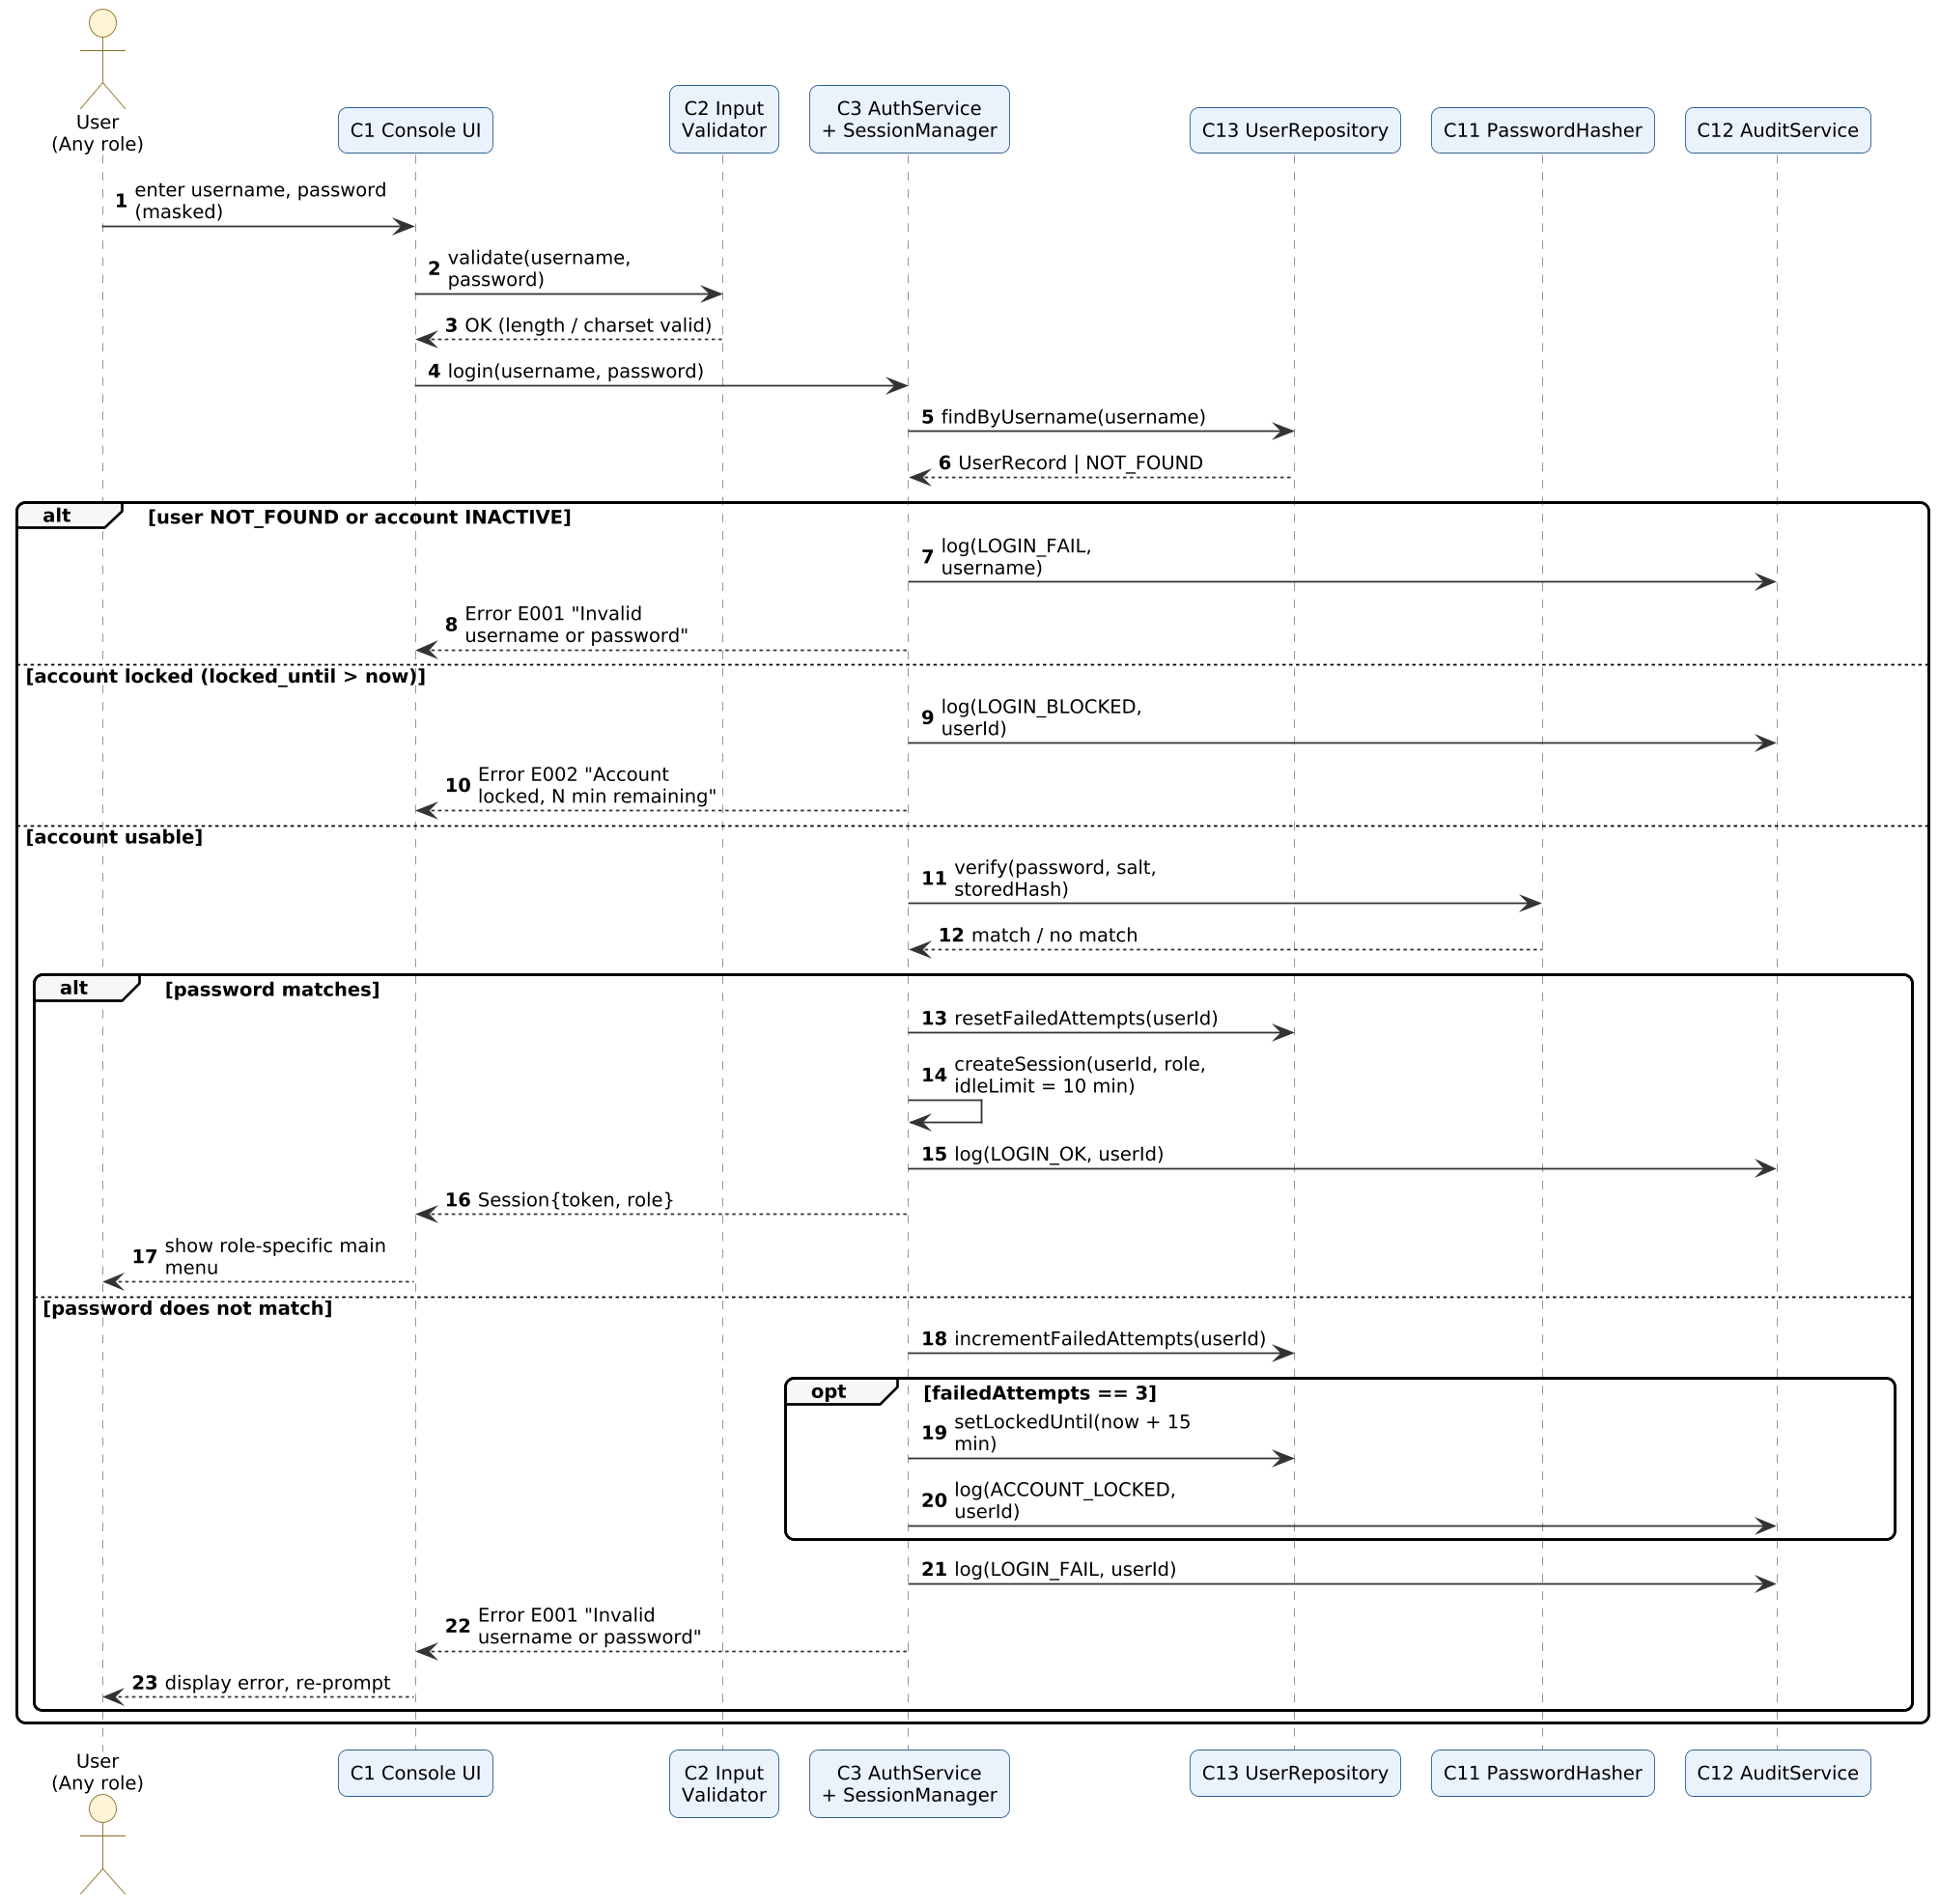
Figure 4-1: Sequence diagram — Login

4.2.2 Book appointment (HMS-F-030, F-031, F-060, SEC-002)
AppointmentService first asks AccessControl, then verifies the patient (Active) and the doctor's availability, checks the slot for conflict, and saves through the repository and FileStore. If the slot is taken, the next 3 free slots are returned with error E030.
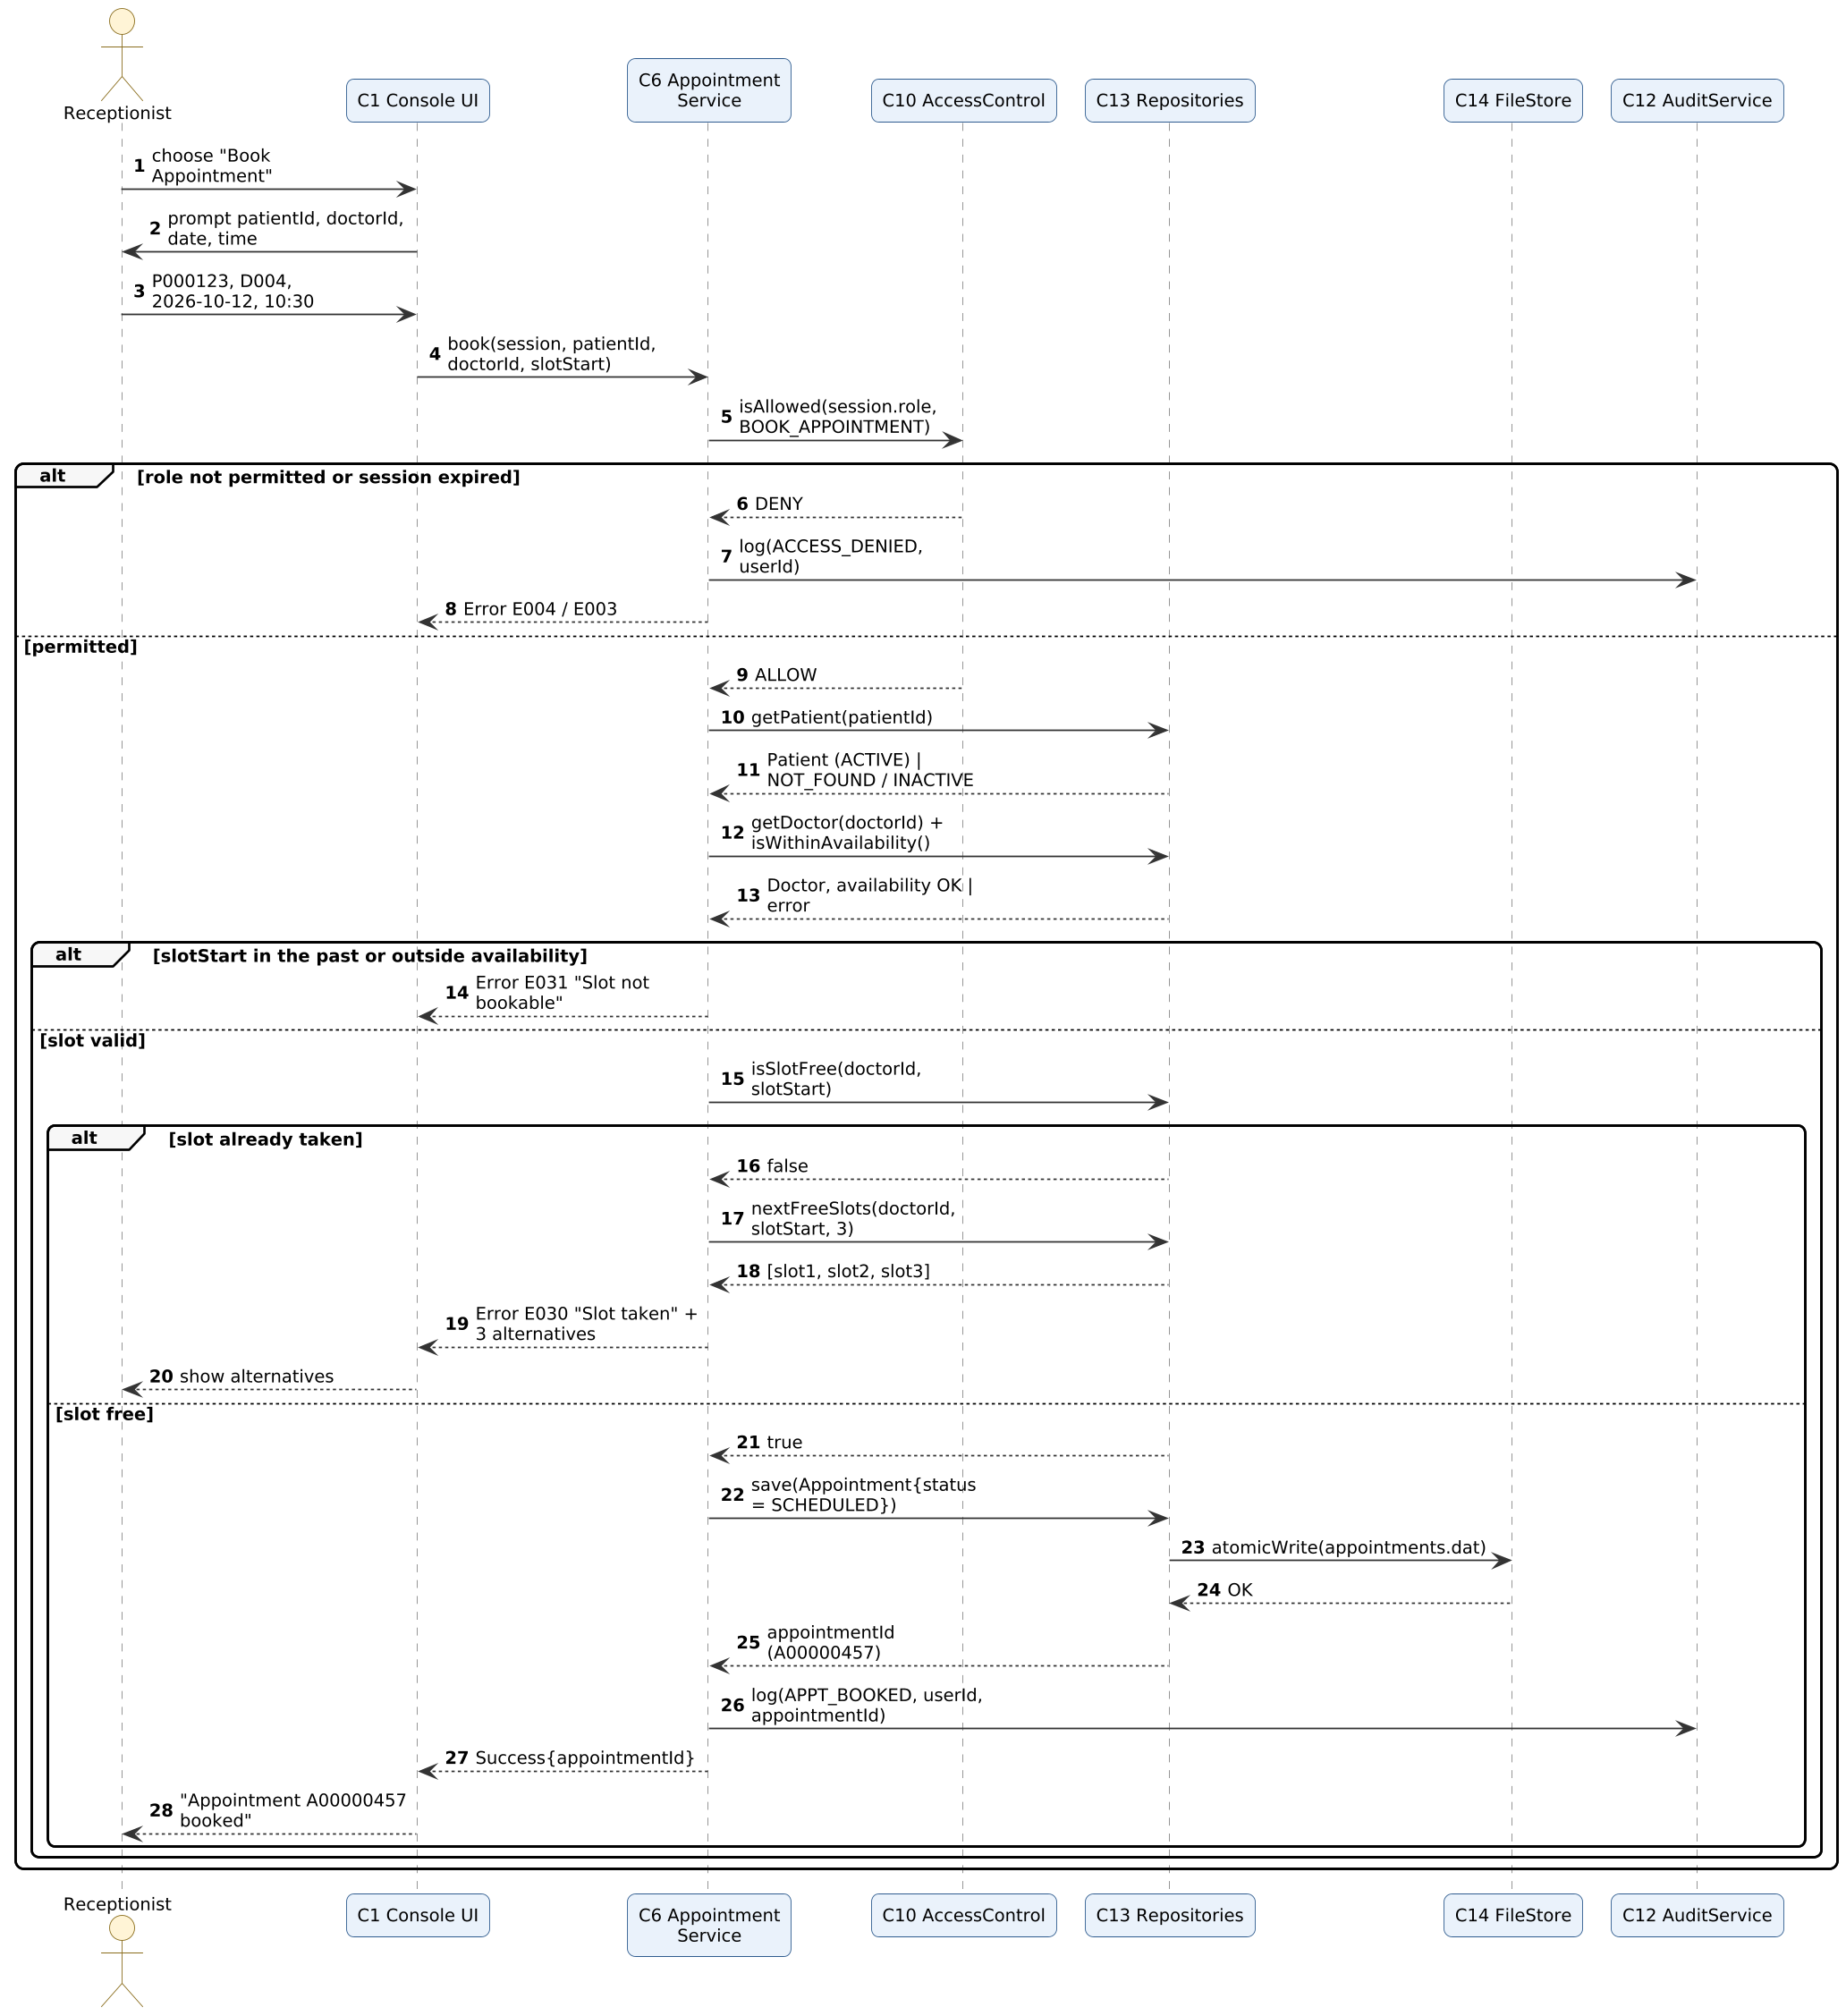
Figure 4-2: Sequence diagram — Book appointment

4.2.3 Record consultation (HMS-F-040, F-043, NF-010, SEC-003)
After validation and the identity confirmation (Y/N) in the UI, ConsultationService checks the role, that the appointment belongs to the logged-in doctor and is Scheduled, saves the immutable consultation, then marks the appointment Completed and audit-logs the action.
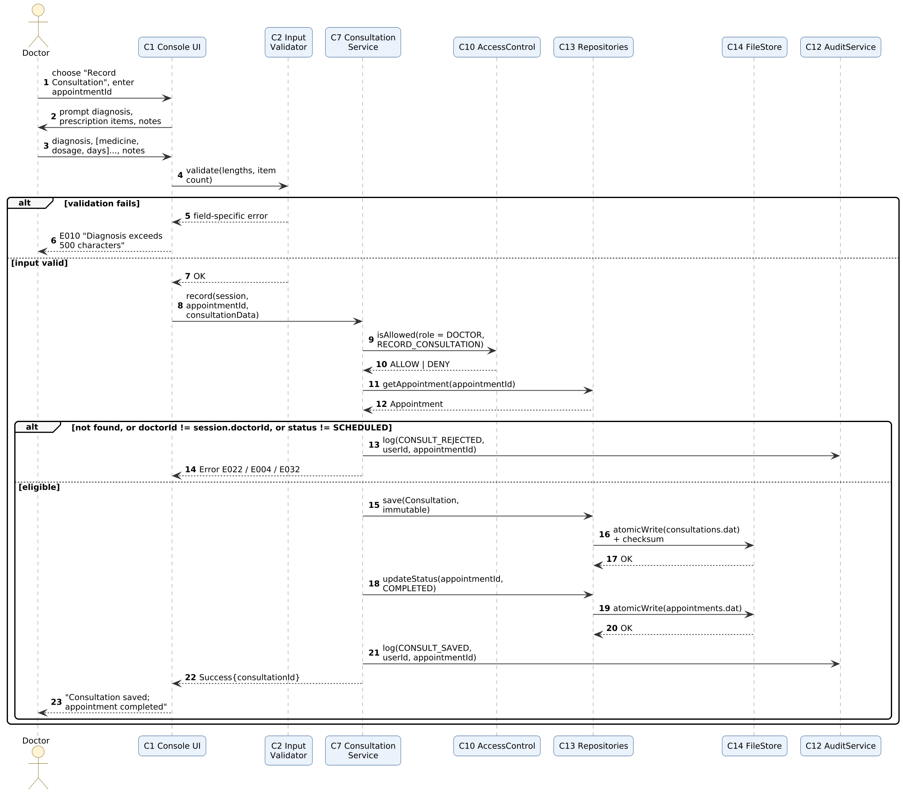
Figure 4-3: Sequence diagram — Record consultation

4.3 API Design
HMS is a stand-alone C++ program, so its "API" is the set of public C++ interfaces (header files) of the service components, called by the console UI and by the unit tests. Each operation is described by its request (parameters), response and errors, in the style of the template. Section 4.3.8 maps the key operations to the HTTP endpoints they would become if a web front end is added later.

Common types
enum class ErrorCode { OK, E001, E002, E003, E004, E010, E011, E020, E021, E022, E023, E024, E025,
E030, E031, E032, E040, E041, E042, E043, E099 };
struct Error { ErrorCode code; std::string message; std::string details; };
template<class T> class Result { // either a value or an Error
public: bool ok() const; const T& value() const; const Error& error() const; };
struct Session { std::string token; UserId userId; Role role; DoctorId doctorId; TimePoint lastActivity; };

4.3.1 AuthService, SessionManager and AuditService (C3, C12)
Operation | Request (constraints) | Response | Errors | Roles
Result<Session> login(string username, string password) | username 4–20 alphanumeric; password 8–32 chars | Session{token, userId, role, expiresAt} | E001 invalid credentials; E002 locked; E010 bad format | Any (not yet logged in)
Result<void> logout(const Session&) | valid session | OK | E003 | Any
Result<void> changePassword(const Session&, string current, string newPwd) | new: 8–32 chars, ≥1 letter and ≥1 digit, ≠ current | OK | E001 current wrong; E010 weak / same; E003 | Any
Result<UserId> createUser(const Session&, string username, string tempPwd, Role) | username unique; role one of 3 | UserId (U00001…) | E004; E010; E011 duplicate; E041 | Administrator
Result<void> setUserStatus(const Session&, UserId, UserStatus) | existing user; not the caller itself | OK | E004; E023 user not found; E041 | Administrator
Result<Session> SessionManager::validate(token) | token issued earlier | refreshed Session | E003 expired / unknown (idle > 10 min) | internal
bool AccessControl::isAllowed(Role, Operation) | role ∈ 3 roles; operation enum (permission matrix = SRS Table 6.5-1) | true / false (missing entry = false) | — (caller returns E004 and audits ACCESS_DENIED) | internal
Result<vector<AuditEntry>> AuditService::query(const Session&, Date from, Date to, string username) | from ≤ to; username optional | matching entries, newest first | E004; E010 | Administrator

4.3.2 PatientService (C4)
Operation | Request (constraints) | Response | Errors | Roles
Result<PatientId> registerPatient(const Session&, PatientInput, bool confirmDuplicate) | name ≤ 60; DOB ≤ today; gender M/F/O; phone 10 digits; address ≤ 120; blood group enum | PatientId (P000001…) | E004; E010 field-specific; E011 duplicate (existing ID in details) unless confirmed; E041 | Administrator, Receptionist
Result<Page<Patient>> search(const Session&, SearchKey key, string term, int page) | key ∈ {ID, NAME, PHONE}; term 1–60 chars; page ≥ 1 | ≤ 20 patients + hasNext | E003; E004; E010 | All roles
Result<void> updatePatient(const Session&, PatientId, PatientUpdate) | name / phone / address / blood group only | OK | E004; E010; E020 not found; E041 | Administrator, Receptionist
Result<void> deactivate(const Session&, PatientId) | existing patient | OK (status INACTIVE) | E004; E020; E041 | Administrator

4.3.3 AppointmentService (C6)
Operation | Request (constraints) | Response | Errors | Roles
Result<AppointmentId> book(const Session&, PatientId, DoctorId, DateTime slotStart) | patient Active; doctor exists; slot on 30-min boundary, in future, inside availability, free | AppointmentId (A00000001…), status SCHEDULED | E004; E020; E025 patient inactive; E021; E030 slot taken (+3 alternatives in details); E031; E041 | Administrator, Receptionist
Result<void> cancel(const Session&, AppointmentId) | status SCHEDULED; start time not passed | OK (CANCELLED) | E004; E022; E032; E041 | Administrator, Receptionist
Result<void> reschedule(const Session&, AppointmentId, DoctorId, DateTime newSlot) | status SCHEDULED; new slot valid and free | OK (atomic move) | E004; E022; E030; E031; E041 | Administrator, Receptionist
Result<void> markNoShow(const Session&, AppointmentId) | status SCHEDULED; start time passed | OK (NO_SHOW) | E004; E022; E032 | Administrator, Receptionist
Result<vector<AppointmentView>> dailySchedule(const Session&, DoctorId, Date) | Doctor role: own ID only | appointments ascending by time | E003; E004; E021 | All (Doctor: own)
vector<DateTime> nextFreeSlots(DoctorId, DateTime from, int n) | n = 3 | next n free slots | — | internal

4.3.4 DoctorService (C5)
Operation | Request (constraints) | Response | Errors | Roles
Result<DoctorId> addDoctor(const Session&, DoctorInput) | name ≤ 60; specialization / department ≤ 40; linked Doctor user | DoctorId (D001…) | E004; E010; E023; E041 | Administrator
Result<void> setAvailability(const Session&, DoctorId, vector<Window>) | weekday; start / end on 30-min boundary within 08:00–20:00; start < end | OK | E004; E010; E021; E041 | Administrator
Result<vector<Doctor>> list(const Session&, optional<string> specialization) | optional filter | doctors | E003; E004 | All roles

4.3.5 ConsultationService (C7)
Operation | Request (constraints) | Response | Errors | Roles
Result<ConsultationId> record(const Session&, AppointmentId, ConsultationInput) | diagnosis ≤ 500; ≤ 10 items (medicine ≤ 60, dosage ≤ 30, days 1–365); notes ≤ 1000; appointment SCHEDULED and own | ConsultationId (C0000001…); appointment → COMPLETED | E004; E010; E022; E032; E041 | Doctor
Result<vector<ConsultationView>> history(const Session&, PatientId) | existing patient | consultations newest first with addenda | E004; E020; E003 | Doctor
Result<void> addAddendum(const Session&, ConsultationId, string text) | text 1–500 chars | OK (time-stamped, author stored) | E004; E010; E024; E041 | Doctor
There is deliberately no edit or delete operation for consultations (HMS-F-043).

4.3.6 ReportService (C8)
Operation | Request (constraints) | Response | Errors | Roles
Result<DailyReport> dailyReport(const Session&, Date) | valid date | total, count per status, rows per doctor | E004; E010 | Administrator, Receptionist
Result<void> exportCsv(const DailyReport&, string path) | writable folder | CSV file (UTF-8, header row) | E041; E010 | Administrator, Receptionist
Result<WorkloadReport> workloadReport(const Session&, Date from, Date to) | from ≤ to | Completed / Cancelled / No-Show counts per doctor | E004; E010 | Administrator

4.3.7 BackupService (C9)
Operation | Request (constraints) | Response | Errors | Roles
Result<string> createBackup(const Session&) | — | path backup/YYYYMMDD_HHMMSS | E004; E042; E041 | Administrator
Result<vector<string>> listBackups(const Session&) | — | backup names, newest first | E004 | Administrator
Result<void> restore(const Session&, string name, bool confirm) | backup exists; confirm = true; backup checksums valid | OK; data reloaded | E004; E010; E040; E042 | Administrator

4.3.8 Equivalent HTTP endpoints (for a future web front end)
Endpoint | Method | Request | Response / errors
/api/login | POST | {username, password} | 200 {token, role}; 401 E001; 423 E002
/api/patients | POST | {name, dob, gender, phone, address, bloodGroup, confirmDuplicate} | 201 {patientId}; 400 E010; 409 E011
/api/patients?by=name&q=ani&page=1 | GET | — | 200 {items[≤20], hasNext}
/api/appointments | POST | {patientId, doctorId, slotStart} | 201 {appointmentId}; 409 E030 {alternatives[3]}; 422 E031
/api/appointments/{id}/cancel | POST | — | 200; 409 E032
/api/appointments/{id}/consultation | POST | {diagnosis, items[], notes} | 201 {consultationId}; 403 E004

4.4 Error Handling, Logging & Monitoring
Error handling. Every layer validates and returns Result<T>; unexpected C++ exceptions (for example std::bad_alloc, file-system errors) are caught inside the data layer or at the top of the menu loop, converted to E099 / E041, logged, and the user returns to the menu. The program never prints stack traces or file paths of internal data to the user, and an operation that fails changes no stored data (fail secure).
Code | Name | Meaning | Message shown to the user
E001 | INVALID_CREDENTIALS | Unknown user, wrong password, inactive account, or wrong current password | "Invalid username or password."
E002 | ACCOUNT_LOCKED | 3 consecutive failures; lock active | "Account locked. Try again in N minutes."
E003 | SESSION_EXPIRED | No valid session / 10-minute idle limit exceeded | "Session expired. Please log in again."
E004 | ACCESS_DENIED | Role lacks permission | "You are not authorised to perform this action."
E010 | VALIDATION_FAILED | Field empty, wrong format, too long | "<Field>: <rule>." (e.g. "Phone: must be exactly 10 digits.")
E011 | DUPLICATE_ENTRY | Duplicate username or duplicate patient | "A matching record exists (ID …). Confirm to continue."
E020–E024 | NOT_FOUND family | Patient / Doctor / Appointment / User / Consultation not found | "<Entity> not found."
E025 | PATIENT_INACTIVE | Booking for an Inactive patient | "Patient record is inactive."
E030 | SLOT_UNAVAILABLE | Slot already taken | "Slot taken. Next free slots: …"
E031 | SLOT_NOT_BOOKABLE | Slot in the past or outside availability | "Slot is in the past / outside doctor availability."
E032 | INVALID_STATE_TRANSITION | Status change not allowed | "Action not allowed for status <status>."
E040 | DATA_INTEGRITY_FAILURE | Checksum mismatch or unreadable file | "Data file damaged. Restore from backup?" (Administrator)
E041 | WRITE_FAILED | Disk write / rename failed | "Could not save data. Nothing was changed."
E042 | BACKUP_FAILED | Backup or restore failed | "Backup operation failed."
E043 | DATA_LOCKED | Another HMS instance is using the data folder | "HMS is already running on this data folder."
E099 | INTERNAL_ERROR | Unexpected condition | "Unexpected error. Please contact the administrator."

Logging. Two logs are kept. (1) The audit log (audit.log) records security-relevant events (SRS HMS-SEC-003): ISO timestamp, user ID, action, target ID, outcome. (2) The diagnostic log (hms.log) records errors E040–E099 and start-up checks with a timestamp and component name. No password, hash, diagnosis, prescription or note text is ever written to either log and personal identifiers are limited to IDs.
Monitoring. There is no network monitoring tool; instead, an Administrator "System status" screen shows: failed logins in the last 24 hours, number of locked accounts, time since the last backup (warning after 24 hours), data-file sizes and the result of the checksum self-check run at every start-up. Counters tracked for the Test Plan metrics: write failures, validation errors per day, and operation response times (debug build).

4.5 UX Design
- Role-specific menus (SRS Table 6.5-1): a user sees only the options allowed for the role, so there are no "access denied" dead ends in normal use.
- Consistency: numbered options, "0 = Back", the header line with user, role and time on every screen; the same prompt style "Field name (format): ".
- Guidance: every prompt shows its format and example, e.g. "Date of birth (YYYY-MM-DD): "; errors name the field and the rule and re-ask only that field.
- Safety prompts: the doctor sees Patient ID, name and age before saving a consultation; destructive actions ask "Confirm (Y/N)?".
- Efficiency: booking takes four prompts (patient, doctor, date, time); alternatives for a taken slot are numbered so one key selects one.
- Accessibility: plain 80-column text, no colour-only meaning (errors always start with "ERROR"), keyboard-only operation, compatible with screen readers and high-contrast terminals; password entry is silent.
Book appointment — Receptionist
Patient ID (e.g. P000123): P000123 -> Anita Rao, 36 y, F
Doctor ID (e.g. D004): D004 -> Dr. Meera Iyer, Cardiology
Date (YYYY-MM-DD): 2026-10-12
Time (HH:MM, 30-min steps): 10:30
ERROR E030: Slot taken. Next free slots: 1) 11:00 2) 11:30 3) 12:00
Choose 1-3, or 0 to cancel: 1
OK: Appointment A00000457 booked for 2026-10-12 11:00 with Dr. Meera Iyer.

4.6 Open Issues & Next Steps
Open issues / future enhancements
- Replace iterated SHA-256 by Argon2id or bcrypt (ADR-6).
- Optional AES-256 encryption of data files at rest, with key derived from an administrator passphrase.
- Performance spike (Sprint 1) for HMS-NF-002; fall back to monthly file split or SQLite (R3).
- Multi-terminal / networked version with TLS 1.2+, which would also need concurrency control.
- Billing, pharmacy and laboratory modules; patient self-service portal; drug-interaction checks.
Next steps — sprint plan and product ownership (each member owns one functional feature end-to-end, as required by the project guidelines):
Sprint | Planned work | Owner(s) | Exit check
Sprint 1 (07–21 Oct) | CMake skeleton, Result<T>, Validator, FileStore (atomic write, checksum), repositories; AuthService + SessionManager; PatientService; performance spike | Paras: SF-1; Saurav: SF-2; Shristi: FileStore / repositories | Unit tests green; TC-AUTH-01/02, TC-PAT-01/04 pass
Sprint 2 (22 Oct–4 Nov) | DoctorService, AppointmentService, ConsultationService | Pranav: SF-3; Shristi: consultation part of SF-4 | TC-DOC-01, TC-APT-01..06, TC-CON-01 pass
Sprint 3 (5–18 Nov) | ReportService, BackupService, audit viewer, security hardening, system tests, performance tests | Shristi: SF-4; Paras: audit and security tests | All High-priority test cases pass; coverage ≥ 70%

5. Appendices

5.1 Glossary
HMS Hospital Management System. ADR architecture decision record. RBAC role-based access control. STRIDE Spoofing, Tampering, Repudiation, Information disclosure, Denial of service, Elevation of privilege. SHA-256 256-bit cryptographic hash. Atomic write a write that either completes fully or leaves the old data intact. Repository component that hides how entities are stored. Result<T> return type that carries either a value or an error. Slot 30-minute appointment interval. Addendum time-stamped note appended to an immutable consultation.

5.2 References
- IEEE Std 42010-2022, Architecture description; IEEE Std 1016-2009, Software design descriptions.
- Team 11, Software Requirements Specification v1.0, 07-10-2026; Software Test Plan v1.0, 07-10-2026.
- OWASP Application Security Verification Standard 4.0; OWASP Secure Coding Practices; MITRE CWE Top 25.
- NIST SP 800-63B (digital identity / password guidelines); NIST SP 800-160 (systems security engineering).
- Microsoft STRIDE threat-modelling method; ISO/IEC 27001 Annex A (access control, logging) for guidance.

5.3 Tools
PlantUML and Graphviz (UML diagrams), matplotlib (component diagram), CMake, GoogleTest, lcov, cppcheck, Valgrind, AddressSanitizer, Git.

