Design and Implementation of a Low-Cost Portable AI Vision Device Using ESP32-CAM and Large-Scale Vision-Language Models

CAPSTONE PROJECT REPORT

Submitted by

Pranavdev.P.S – 99220040698
Rohit Raj– 99220040715
Ritu Raj – 99220040713
Polu Sai Haswanth Reddy - 99220040694

in partial fulfillment for the award of the degree
of
BACHELOR OF TECHNOLOGY
IN

COMPUTER SCIENCE AND ENGINEERING



SCHOOL OF COMPUTING
COMPUTER SCIENCE AND ENGINEERING
KALASALINGAM ACADEMY OF RESEARCH
AND EDUCATION
KRISHNANKOIL 626 126

April 2026
DECLARATION

We affirm that the project work titled “Machine Learning Model for Estimating Building Material and Labor Costs with Integrated Chatbot Support” being submitted in partial fulfilment for the award of the degree of Bachelor of Technology in Computer Science and Engineering is the original work carried out by us. It has not formed part of any other project work submitted for the award of any degree or diploma, either in this or any other University.
Pranavdev.P.S
99220040698
Rohit Raj
99220040715
Ritu Raj
99220040713
Polu Sai Haswanth Reddy
99220040694

This is to certify that the above statement made by the candidate is correct to the best of my knowledge.
Date:

Signature of supervisor
Dr. K. Vignesh
Associate Professor
Department of Computer Science and Engineering



BONAFIDE CERTIFICATE

Certified that this project report “Design and Implementation of a Low-Cost Portable AI Vision Device Using ESP32-CAM and Large-Scale Vision-Language Models” is the Bonafide work of “Rohit Raj (99220040715), Ritu Raj (99220040713), Pranavdev.P.S (99220040698), Polu Sai Haswanth Reddy (99220040694)” who carried out the project work under my supervision.

Guide Name | Dr. R.Raja Subramanian
Dr. K . Vigensh | HEAD OF THE DEPARTMENT
Associate Professor | Associate Professor & Head
Computer Science and Engineering | Computer Science and Engineering
Kalasalingam Academy of Research and Education | Kalasalingam Academy of Research and Education
Krishnankoil 626126 | Krishnankoil 626126
Virudhunagar District. | Virudhunagar District.

Submitted for the Project Viva-voce examination held on

Internal Examiner External Examiner
ACKNOWLEDGEMENT

We would like to begin by expressing our heartfelt gratitude to the Supreme Power for the immense grace that enabled us to complete this project.
We are deeply grateful to the late "Kalvivallal" Thiru T. Kalasalingam, Chairman of the Kalasalingam Group of Institutions, and to "Illayavallal" Dr. K. Sridharan, Chancellor, as well as Dr. S. Shasi Anand, Vice President, who has been a guiding light in all our university’s endeavours.
Our sincere thanks go to our Vice Chancellor, Dr. S. Narayanan, for his inspiring leadership, guidance, and for instilling in us the strength and enthusiasm to work towards our goals.
We would like to express our sincere appreciation to Dr. P. Deepa Lakshmi, Professor & Dean-(SoC), Director Accreditation & Ranking, for her valuable guidance. Our heartfelt gratitude also goes to our esteemed Head of Department, Dr. R.Raja Subramanian, whose unwavering support has been crucial to the successful advancement of our project.
We are especially thankful to our Project Supervisor, Dr.K.Vignesh, for his patience, motivation, enthusiasm, and vast knowledge, which greatly supported us throughout this work.
Our sincere gratitude also goes to Dr.T.Manikumar and Mr.N.R.Sathiskumar Overall Project Coordinators, for their constant encouragement and support in completing this Capstone Project.
Finally, we would like to thank our parents, faculty, non-teaching staff, and friends for their unwavering moral support throughout this journey.


SCHOOL OF COMPUTING
COMPUTER SCIENCE AND ENGINEERING
PROJECT SUMMARY
Project Title | Design and Implementation of a Low-Cost Portable AI Vision Device Using ESP32-CAM and Large-Scale Vision-Language Models.
Project Team Members (Name with Register No) | Rohit Raj – 99220040715  Ritu Raj – 99220040713  Pranavdev.P.S– 99220040698  Polu Sai Haswanth Reddy - 99220040694
Guide Name/Designation | Dr.K.Vignesh  Associate Professor
Program Concentration Area | Machine Learning & Artificial Intelligence
Technical Requirements | - Hardware: ESP32-CAM, OLED Display, Buzzer  - Software: Arduino IDE, C++, APIs  - Cloud Services: OpenAI GPT-4o Vision-Language Model  - Communication: Wi-Fi for API calls
Engineering standards and realistic constraints in these areas
Area | Codes & Standards / Realistic Constraints | Tick ✓
Economic | Budget estimation accuracy, cost optimization, reduction of financial risk, alignment with real market pricing. | ✓
Environmental | Consideration of eco-friendly materials and energy-efficient building options in cost modelling. | ✓
Manufacturability | Practical implementation aligned with real construction practices and material feasibility. | ✓

TABLE OF CONTENTS

TITLE |  | PAGE NO.
ABSTRACT |  | i
LIST OF TABLES |  | ii
LIST OF FIGURES |  | iii
LIST OF ACADEMIC REFERENCE COURSES |  | iv
CHAPTER I | INTRODUCTION | 1
1.1 | Background and Motivation | 2
1.2 | Problem Statement | 2
1.3 | Objective of The Project | 3
1.4 | Scope of the Project | 3
1.5 | Methodology Overview | 4
CHAPTER II | LITERATURE REVIEW | 5
2.1 | Overview of Related Work | 5
2.2 | Review of Similar Projects or Research Papers | 6
2.3 | Summary and Gap Identification | 8
CHAPTER III | SYSTEM ANALYSIS | 11
3.1 | Requirements Gathering | 11
3.2 | Functional Requirements | 13
3.3 | Non-Functional Requirements | 14
3.4 | Feasibility Study  - Technical Feasibility  - Operational Feasibility  - Economic Feasibility | 15  15  16  16
3.5 | Risk Analysis | 17
CHAPTER IV | SYSTEM DESIGN AND TRADE OFF ANALYSIS | 19
4.1 | Overview of Design Alternatives | 19
4.2 | Hardware Design Alternatives | 20
4.3 | AI Processing Alternatives | 20
4.4 | User Interface Alternatives | 21
4.5 | AI Monitoring and Debugging Alternatives | 21
4.6 | System Architecture Alternatives | 22
4.7 | Trade – Off Analysis | 23
CHAPTER V | SYSTEM DESIGN AND IMPLEMENTATION
5.1 | System Architecture | 25
5.2 | Block Diagram Explanation | 27
5.3 | System Component Design | 29
5.4 | Database Design | 32
5.5 | Implementation Strategy | 32
5.6 | Integration Approach | 33
CHAPTER VI | FEEDBACK AND ITERATIVE REFINEMENT
6.1 | User Feedback Collection | 34
6.2 | Evaluation and Prioritization of Feedback | 34
6.3 | System Refinements across Iterations | 34
CHAPTER VII | TESTING AND VALIDATION
7.1 | Types of Testing Performed | 35
7.2 | Test Result Summary | 36
7.3 | Bug Fixes and Improvements | 36
CHAPTER VIII | RESULT AND DISCUSSION
8.1 | Evaluation of The System | 37
8.2 | System Performance Results | 39
8.3 | Security and Sandboxing Results | 40
8.4 | Comparative Discussion | 40
CHAPTER IX | CONCLUSION & FUTURE SCOPE
9.1 | Conclusion | 41
9.2 | Future Scope | 41
REFERENCES : List of books, articles, research papers, and other resources used
PUBLICATION
CERTIFICATIONS
PLAGIARISM REPORT

ABSTRACT
This paper presents the design and implementation of a cheap, portable AI vision system that integrates the ESP32-CAM microcontroller with OpenAI’s state-of-the-art GPT-4o vision-language model via cloud API calls. The proposed system captures images in real-time, encodes them directly on the device, and transmits them securely to the cloud for semantic analysis without requiring custom model training or extensive on-device computational resources. The AI-generated descriptions and justifications are presented interactively on an integrated OLED screen with scrolling text functionality, and user response is provided through a buzzer. The paper demonstrates the merit of leveraging powerful cloud-based generative AI on edge devices to enable smart visual comprehension functions like object detection, scene summarization, and Context-based querying. The approach demonstrates IoT, automation, and embedded AI real-world uses, which demonstrate how limited hardware can effectively utilize high-level AI services to deliver rich user experiences. Dynamic querying and viewfinder support in real time will be added in future updates to further increase usability. This solution in general is a scalable and accessible model for embedding AI vision capability into small, energy-constrained devices

LIST OF TABLES

TABLES | DETAILS | PAGE NO.
Table 1 | Risk Mitigation Table | 18
Table 2 | Trade–Off Analysis of Design Alternatives | 23
Table 3 | Summary of Testing Perfomed | 36
Table 4 | Summary of System Performance Result | 39

LIST OF FIGURES
FIGURES | DETAILS | PAGE NO.
Figure 1 | Block Diagram | 27
Figure 2 | Embedded Hardware Component Design | 29
Figure 3 | Cloud Integration Component Design. | 30
Figure 4 | AI Processing Component Design. | 31
Figure 5 | Hardware Implementation of the System. | 37
Figure 6 | OLED Display and User Interaction Module. | 37
Figure 7 | Output Display of AI-Generated Result. | 38
Figure 8 | Accuracy Analysis under Different Conditions. | 38
Figure 9 | System Response Time Breakdown. | 39

LIST OF ACADEMIC REFERENCE COURSES
S. NO. | COURSE CODE | COURSE NAME
1 | 212CSE2304 | Machine Learning
2 | 213CSE3303 | Natural Language Processing Techniques
3 | 212CSE2301 | Data Structures
4 | 211ECE1401 | IoT Sensors and Devices
5 | 212CSE2302 | Digital Principles and Systems Design
6 | 212CSE2303 | Software Engineering

CHAPTER – I
INTRODUCTION
The “Design and Implementation of a Low-Cost Portable AI Vision Device Using ESP32-CAM and Large-Scale Vision-Language Models” is the availability of edge computing and Internet of Things (IoT) devices has brought the reach and accessibility of artificial intelligence (AI) applications far beyond their native cloud-based environment. Embedded vision systems are being used with growing frequency for real-time image processing in a wide range of applications including surveillance, smart inventory management, green monitoring, and assistive technology. However, the computational constraints of low-power microcontrollers like the ESP32-CAM often limit their ability to perform complex AI inference tasks locally.
This paper offers an innovative system that combines the ESP32-CAM microcontroller with OpenAI's GPT-4o vision-language model via cloud-based API calls to develop an intelligent and portable AI vision system. The system locally captures and compress images prior to sending the images to a cloud-based generative AI model to perform semantic analysis. The interpreted output is then displayed from an embedded OLED screen with audio feedback for enhanced user centricity and interaction, yet all without a heavy reliance on deep learning on a device, or more broadly on heavy computations. There are numerous ML-based cost prediction systems operating in the market, but they either have small datasets and limited geographic areas, and or they do not provide real-time adaptability. Studies suggest no existing platform integrates accurate predictions with accessible visual tools that address unique geographic needs. Most previous studies do not have an emphasis on the context of the Indian construction environment because the cost of construction in India is reliant on local economic conditions and resource availability, as well as local building regulations. No solutions have been developed to offer professionals access to a scalable AI-based cost estimating system, which would allow for specific regional needs to one project.
Unlike previous embedded vision initiatives that relied on lightweight artificial intelligence models or were special-purpose, our initiative capitalizes on today's generative AI APIs to furnish rich image interpretations, summarization of context, and parameterized querying without excessive installation and development expense on special-purpose hardware or software. This synergy affords a cost-effective, scalable method of delivering advanced AI functionality on resource-constrained devices that makes it easier to use and increases the possible applications into more areas of application.
  - Background and Motivation:
Significant progress has been achieved in the field of artificial intelligence, especially in computer vision and vision-language models. Various applications of computer vision and vision-language models have shown promising results in different domains, such as healthcare, security, and assistive technologies. However, most of the existing applications require high-performance computing and cloud-based platforms, making them expensive and not feasible for real-time and resource-constrained environments.

Currently, there is a growing need for affordable, portable, and efficient AI-based vision applications that can operate in a practical environment. Such applications can help visually impaired people, improve safety, and provide smart surveillance. To meet this need, affordable and efficient hardware devices, such as ESP32-CAM, are available, offering a promising solution for a practical and efficient vision system. Although this device lacks sufficient computing capabilities, it can be a promising solution for a practical and efficient vision system.

The motivation behind this work is to utilize affordable hardware and efficient large-scale vision-language models for a practical and efficient vision system. The proposed system utilizes edge computing for image acquisition and efficient AI for image interpretation. The proposed system can provide significant insights and practical results in a cost-efficient manner. This work demonstrates the utilization of efficient AI in a practical environment, eliminating the need for expensive hardware.

  - Problem Statement:

- Existing AI vision systems like Alexa or Google Vision are powerful but expensive, limiting accessibility for small-scale or educational use.
- Low-cost microcontrollers such as ESP32-CAM can capture images but cannot perform deep AI analysis due to limited memory and processing power.
- Previous research focuses mainly on basic object detection or streaming, not semantic understanding of images.
- There is a lack of portable, customizable, and cost-efficient solutions that combine embedded vision with large-scale AI models.
- Hence, there is a need for a hybrid edge-cloud system that brings advanced AI vision to affordable IoT hardware.

  - Objectives of the Project:
- To design and implement a low-cost, portable AI vision device using the ESP32-CAM microcontroller integrated with OpenAI’s GPT-4o vision-language model.
- To enable real-time image capture and semantic understanding on resource-constrained hardware without local AI model training.
- To develop a user-interactive embedded system that provides the AI’s response on an OLED display with buzzer feedback for ease of use.
- To promote the integration of AI, IoT, and embedded systems in a scalable, energy-efficient, and affordable design that can support assistive, educational, and automation applications

  - Scope of the Project:
This project focuses on the development of a low-cost, portable AI vision device utilizing the ESP32-CAM and cloud-based vision and language models. The device allows for the capture and interpretation of images in a smart manner, including object detection and scene analysis. The device is aimed to be affordable, scalable, and useful for practical applications.
- Uses ESP32-CAM module for capturing images
- Uses cloud-based vision-language models for AI processing
- Facilitates object detection, scene description, and context analysis
- Comes equipped with hardware components such as OLED display and buzzer
- Is portable, power-efficient, and cost-effective
- Can be utilized in assistive technology, security, and smart monitoring systems
- Requires internet connectivity for AI processing
- The future scope includes offline AI, video processing, and multimodal features.

  - Methodology Overview:
The methodology of the proposed system follows a sequential process, as depicted in the system flow diagram, to facilitate smooth interaction between hardware components and cloud-based AI services.

- System Initialization: The process starts by powering the system, initializing the ESP32-CAM, and the OLED display, which enables all the necessary components to function.

- Wi-Fi Connectivity: The system connects to a Wi-Fi network, which facilitates interaction with the cloud-based AI services.

- Handling User Input: The system continuously monitors for user input through the push button. If the button is not pressed, the system enters a waiting state.

- Image Capture: When the user presses the button, the ESP32-CAM captures an image of the surrounding environment.

- Image Processing: The captured image is compressed to an appropriate format, converting it to Base64 format for transmission over the network.

- Transmission to Cloud: The encoded image is transmitted to the cloud using a vision-language model (GPT-4o) using secure API requests.

- AI-Based Analysis: The transmitted image is analyzed by the cloud-based AI model, which generates meaningful information from the captured image.

- Handling Response: The AI-generated response is transmitted to the ESP32-CAM, which decodes the response for display.

- Output Display: The decoded response is displayed on the OLED display, and a buzzer is used to provide auditory feedback to the user.

CHAPTER-II
LITERATURE REVIEW
The role of the literature review is significant in understanding the current developments in computer vision, embedded systems, and vision language models. It gives an overview of the methodologies, architectures, and technologies developed in the past for the development of intelligent visual understanding systems. By understanding the limitations of the existing technologies, it is possible to realize the need for the proposed portable AI vision device.
This chapter examines earlier studies related to computer vision, embedded systems, and vision-language models, along with edge–cloud integration approaches for intelligent image understanding. Furthermore, it critically evaluates existing solutions and identifies the research gaps that motivate the development of a scalable, low-cost portable AI vision system using the ESP32-CAM integrated with large-scale vision-language models.
  - Overview of Related Work
In recent years, significant progress has been made in the field of computer vision and artificial intelligence, particularly in image understanding and multimodal learning. Traditional computer vision approaches relied on handcrafted features and classical machine learning algorithms. However, with the advent of deep learning, Convolutional Neural Networks (CNNs) and transformer-based models have significantly improved performance in tasks such as object detection, image classification, and scene understanding.
Modern vision-language models have further extended these capabilities by combining visual and textual information to generate meaningful interpretations of images. These models are trained on large-scale image-text datasets and are capable of performing tasks such as image captioning, visual question answering (VQA), and contextual reasoning.
Recent studies emphasize the importance of:
- Large-scale image-text dataset utilization for training robust vision-language models.
- Efficient feature extraction and representation learning using deep neural networks.
- Multimodal learning techniques for improved semantic understanding and reasoning.
- Real-time interactive systems for practical usability in real-world applications.
Additionally, there has been growing research interest in integrating intelligent AI systems with embedded and IoT-based platforms to improve accessibility and automation. These systems aim to assist users in tasks such as object recognition, scene understanding, contextual interpretation, and decision-making support.
However, most of the existing studies are either:
a. Dependent on high-performance hardware and computational resources
b. Limited to controlled environments or specific datasets
c. Focused primarily on model accuracy rather than system-level implementation
d. Lacking real-time deployment on low-cost embedded devices
Therefore, while significant progress has been made in computer vision and multimodal AI systems, a scalable, low-cost, and portable AI vision solution integrating embedded hardware like the ESP32-CAM with large-scale vision-language models remains underexplored.
Review of Similar Projects or Research Papers
Over the past decade, researchers have extensively explored the application of Artificial Intelligence and Machine Learning techniques in computer vision, embedded systems, and intelligent image understanding. Additionally, vision-language models and multimodal AI systems have been investigated for improving visual interpretation, contextual reasoning, and human–machine interaction. This section provides a detailed examination of relevant research contributions and analyzes their strengths and limitations.
- Computer Vision and Vision-Language Models: Several studies have demonstrated the effectiveness of deep learning models in improving the accuracy of image understanding compared to traditional computer vision techniques.
- Radford et al. (2021) introduced CLIP (Contrastive Language–Image Pretraining), a model capable of learning visual representations from large-scale image-text datasets. The model demonstrated strong zero-shot learning capabilities, enabling it to generalize across multiple vision tasks without task-specific training. However, CLIP relies heavily on large-scale training data and requires significant computational resources for deployment.
- Lu et al. (2019) proposed ViLBERT, a multimodal model that processes visual and textual data using a two-stream transformer architecture with co-attention mechanisms. The model achieved strong performance in visual question answering and reasoning tasks. However, it requires high computational power and is not suitable for deployment on low-cost embedded devices.
.
- Similarly, Tan and Bansal (2019) introduced LXMERT, which integrates object-level visual features with language representations using cross-modality transformers. The model demonstrated improved semantic understanding of images but depends on complex architectures and high-end hardware resources.

- Li et al. (2022, 2023) proposed BLIP and BLIP-2 models, which combine pretrained image encoders with large language models for efficient image-to-text generation. These models provide high-quality contextual outputs; however, they are primarily designed for cloud-based deployment and are not optimized for edge devices.
Other studies have explored object detection models such as YOLO, which provide real-time detection capabilities on edge devices. While YOLO achieves low latency and high speed, it lacks advanced contextual reasoning compared to vision-language models.
- Embedded Vision Systems and Edge AI: Parallel to advancements in AI models, researchers have explored embedded systems for real-time image processing and IoT-based applications.
- Studies on edge AI systems have shown that microcontrollers such as the ESP32-CAM can be used for image capture and basic processing tasks. These systems are cost-effective and energy-efficient but are limited in handling complex AI inference due to constrained memory and processing power.

- Researchers have implemented lightweight deep learning models on embedded devices using optimization techniques such as quantization and pruning. While these methods improve efficiency, they often reduce model accuracy and limit semantic understanding capabilities.

- Several works have proposed IoT-based smart surveillance systems using embedded cameras. These systems are effective for monitoring and detection but are typically limited to predefined tasks and lack adaptive intelligence.
- Hybrid systems integrating embedded devices with cloud APIs have demonstrated improved performance compared to standalone edge or cloud systems. Despite these advancements, most implementations are not optimized for low-cost, portable devices.
- Comparative Analysis of Existing Approaches: Based on the reviewed literature, several comparative observations can be made
- Traditional computer vision methods lack high-level semantic understanding.
- Deep learning models provide high accuracy but require significant computational resources.
- Vision-language models enable contextual reasoning but are dependent on cloud infrastructure.
- Embedded systems offer affordability and portability but are limited in processing capabilities.
- Edge-based models such as YOLO provide fast detection but lack rich semantic interpretation.
- Most systems are either high-cost or lack integration with advanced AI models.
- Limited research focuses on scalable, low-cost AI vision systems combining embedded hardware with large-scale vision-language models.
  - Summary and Gap Identification
The review of existing literature reveals that significant advancements have been made in the fields of computer vision, embedded systems, and vision-language models. Researchers have demonstrated that deep learning architectures, particularly Convolutional Neural Networks (CNNs) and transformer-based models, outperform traditional approaches in tasks such as object detection, image classification, and contextual understanding. Additionally, vision-language models have shown remarkable capabilities in generating semantic interpretations, enabling applications such as image captioning, visual question answering, and multimodal reasoning.
However, despite these advancements, several critical limitations and research gaps remain evident.
- First, most existing vision-language models rely on large-scale computational infrastructure and high-performance hardware. These systems are not suitable for deployment on low-cost embedded devices, limiting their accessibility and practical usability in resource-constrained environments.
- Second, while advanced AI models provide high accuracy and contextual understanding, many studies focus primarily on model development and benchmarking rather than real-world system integration. There is limited research on deploying such models in portable, embedded systems using hybrid edge–cloud architectures.
- Third, a majority of research contributions remain confined to experimental or simulation-based evaluations and do not extend into scalable, real-time deployment frameworks. The lack of practical implementation reduces their applicability in real-world scenarios such as assistive technology and smart monitoring systems.
- Fourth, existing embedded vision systems are typically limited to lightweight models such as object detection frameworks (e.g., YOLO), which provide fast inference but lack deeper semantic understanding and contextual reasoning capabilities offered by large-scale vision-language models.
- Fifth, integration between low-cost hardware platforms such as the ESP32-CAM and advanced cloud-based AI models remains underexplored. Most systems either rely entirely on edge processing or fully on cloud infrastructure, resulting in inefficiencies in cost, performance, or scalability.

  - Positioning of the Proposed Work
The present project addresses these identified gaps by
- Utilizing a hybrid edge–cloud architecture, where the ESP32-CAM is used for real-time image acquisition and preprocessing, while large-scale vision-language models handle advanced semantic analysis in the cloud.
- Implementing efficient image processing techniques such as compression and Base64 encoding to optimize data transmission between the embedded device and cloud-based AI services.
- Leveraging state-of-the-art vision-language models (e.g., GPT-4o) to generate contextual image descriptions, object recognition, and scene understanding without requiring on-device model training.
- Developing a real-time system capable of capturing images, transmitting data, and receiving AI-generated outputs with minimal latency, ensuring practical usability in real-world scenarios.
- Integrating a user-friendly interface using an OLED display and buzzer feedback system to enhance user interaction and accessibility, especially for assistive applications.
- Designing the system with a focus on low cost, portability, and energy efficiency, making it suitable for deployment in resource-constrained environments.
By combining low-cost embedded hardware, cloud-based artificial intelligence, and real-time system integration within a unified framework, this project contributes toward bridging the gap between advanced AI capabilities and practical deployment on portable, resource-limited devices.

CHAPTER-III
SYSTEM ANALYSIS
System analysis is a critical phase in the development of the proposed AI-based portable vision system. It involves understanding user requirements, identifying system constraints, evaluating feasibility, and analysing potential risks before implementation. This chapter provides a comprehensive examination of the requirements, operational expectations, feasibility considerations, and associated risks of the proposed system.

  - Requirements Gathering:
Requirements gathering is a systematic process of identifying, analyzing, documenting, and validating the needs and expectations of stakeholders before designing and implementing a system. In the context of the proposed AI vision device, this phase was crucial to ensure that the solution addresses real-world challenges rather than being purely a technical implementation.
The requirements were gathered through a structured approach consisting of domain analysis, stakeholder identification, workflow study, literature examination, and practical feasibility evaluation.
- Domain Understanding: The first step in requirements gathering involved understanding the operational environment of AI-based vision systems and embedded IoT devices. Real-time image understanding systems are influenced by multiple factors such as:
i. Image quality and resolution
ii. Lighting conditions and environmental variations
iii. Network connectivity and latency
iv. Hardware limitations (memory, processing power)
v. Power consumption and battery life
vi. Data transmission efficiency
vii. Accuracy of AI-generated outputs
Traditional embedded systems are limited to basic image capture and predefined processing. Through domain study, it was identified that these systems often result in:

- Limited intelligence and lack of contextual understanding
- Inability to perform complex AI inference on-device
- Dependence on fixed algorithms without adaptability
- Reduced usability in dynamic real-world environments.
- Stakeholder Identification: Effective requirement gathering requires identifying all relevant stakeholders who will directly or indirectly interact with the system.
i. Visually Impaired Users – Require real-time scene description and object recognition assistance.
ii. General Users – Need portable and easy-to-use AI-based vision support.
iii. Researchers and Developers – Require a scalable platform for testing AI models.
iv. Security Personnel – Need intelligent monitoring and detection systems.
v. IoT System Designers – Require integration of AI vision into smart environments.
vi. Educators and Students – Use the system for learning and experimentation.
- Methods Used for Requirement Collection: To ensure clarity and completeness, requirements were gathered using the following approaches.
- Literature Review Analysis: Existing research on computer vision, embedded systems, and vision-language models was analyzed to identify limitations and gaps.
- System Workflow Analysis: The working of embedded vision systems was studied to understand image capture, processing, and output generation pipelines.
- Comparative System Analysis: Existing AI vision devices and smart camera systems were analyzed to evaluate their strengths and limitations.
- Problem-Based Analysis: Real-world challenges such as limited hardware capability, lack of semantic understanding, and dependency on high-cost systems were translated into system requirements.

- Constraints Identified During Requirement Gathering: While gathering requirements, certain constraints were also identified:
- Hardware Constraint – Limited processing power and memory of embedded devices like the ESP32-CAM
- Network Constraint – Dependency on stable internet connectivity for cloud-based AI processing
- Power Constraint – Need for low energy consumption for portability
- Cost Constraint – Requirement to maintain affordability while integrating advanced AI capabilities.
The requirements gathering phase provided a structured understanding of stakeholder expectations, system challenges, and deployment constraints. It ensured that the proposed AI vision system is designed not merely as a technical prototype, but as a practical, real-world intelligent solution for accessible and portable visual understanding.
  - Functional Requirements
Functional requirements define the core operations and services that the proposed AI-based portable vision system must perform. These requirements describe the system’s behavior in response to user inputs and internal processing tasks.
The functional requirements were derived from stakeholder needs, domain analysis, and system objectives identified during the requirements gathering phase.
- Image Capture: The system must capture real-time images using the embedded camera module of the ESP32-CAM upon user interaction..
- Input Trigger Mechanism: The system should allow users to initiate image capture through a hardware button or trigger mechanism.
- Data Validation: The captured image must be validated for quality parameters such as resolution and clarity before further processing.
- Image Preprocessing: The system should compress and encode the captured image (e.g., JPEG and Base64 encoding) to make it suitable for efficient transmission.
- Cloud Communication: The system must securely transmit the encoded image to a cloud-based vision-language model via API requests.
- AI-Based Image Analysis: The system should process the image using a vision-language model to generate outputs such as object detection, scene description, and contextual understanding.
- Output Display: The AI-generated response must be displayed on an OLED screen in a readable format, including scrolling functionality if required.
- User Feedback Mechanism: The system should provide feedback using a buzzer or audio signal to indicate successful processing or error conditions.
- Error Handling: The system must handle failures such as network issues or API errors and notify the user appropriately.
- Continuous Operation: The system should return to a standby state after each operation and be ready for subsequent user inputs.
  - Non-Functional Requirements:
Non-functional requirements define the quality attributes and performance standards that the proposed AI-based portable vision system must satisfy. Unlike functional requirements, these focus on how efficiently and reliably the system performs its tasks. These requirements ensure system stability, usability, security, and scalability in real-world deployment.
The key non-functional requirements are as follows:
- Performance Requirement: The system must process captured images and generate AI-based responses within a short response time (ideally within 1–3 seconds) to ensure near real-time interaction.
- Accuracy Requirement: The vision-language model should provide accurate and meaningful interpretations of images with high semantic relevance and minimal errors.
- Scalability Requirement: The system should support future expansion, including integration with more advanced AI models, additional functionalities, and deployment across multiple devices without major redesign.
- Security Requirement: Secure communication protocols (e.g., HTTPS) and API authentication must be implemented to protect data transmission between the ESP32-CAM and cloud services.
- Reliability Requirement: The system should consistently provide stable performance, handle failures such as network interruptions gracefully, and ensure minimal downtime.
- Usability Requirement: The device interface must be simple, user-friendly, and easy to operate, with clear visual output and feedback mechanisms suitable for all types of users.
- Maintainability Requirement: The system architecture should allow easy updates, including firmware improvements, API modifications, and integration of newer AI models.
- Compatibility Requirement: The system should function seamlessly with standard Wi-Fi networks and be compatible with commonly used development platforms and cloud services.
  - Feasibility Study
A feasibility study evaluates whether the proposed AI-based portable vision system can be successfully developed and implemented within practical constraints. It analyzes the technical, operational, and economic aspects of the system to determine its viability. This study ensures that the project is realistic, achievable, and beneficial before full-scale deployment.
    - Technical Feasibility
Technical feasibility examines whether the required technology, tools, and infrastructure are available to build and run the system effectively.
- Low-cost embedded hardware such as the ESP32-CAM is readily available for image capture and processing.
- Vision-language models (e.g., GPT-4o) are accessible through cloud-based APIs for advanced image analysis.
- Embedded development platforms such as Arduino IDE support firmware development and hardware integration.
- Wireless communication (Wi-Fi) enables seamless data transmission between the device and cloud services.
- Cloud platforms provide scalable infrastructure for AI model inference and API management.
The computational limitations of the embedded device are effectively addressed using a hybrid edge–cloud architecture, ensuring that no specialized or high-cost hardware is required. Therefore, the system is technically feasible.
    - Operational Feasibility
Operational feasibility evaluates whether the system can function effectively in real-world construction planning environments.
- The system provides real-time image-based understanding, simplifying complex visual interpretation tasks.
- It enhances user experience by delivering instant AI-generated descriptions and contextual insights.
- It supports applications such as assistive technology, smart surveillance, and IoT-based monitoring.
- The device is portable and easy to operate, requiring minimal technical knowledge.
- The integration of OLED display and buzzer ensures intuitive user interaction and feedback.
Users such as visually impaired individuals, general users, and developers can easily adopt the system without requiring specialized training, making it operationally feasible.
    - Economic Feasibility
Economic feasibility assesses whether the benefits of the system outweigh its development and operational costs.
The primary costs involved include
- Hardware components such as ESP32-CAM, OLED display, and power supply.
- Development and testing efforts for firmware and system integration.
- Cloud API usage costs for vision-language model inference.
However, the benefits include:
- Low-cost implementation compared to high-end AI vision systems.
- Accessibility of advanced AI capabilities using affordable hardware.
- Reduction in dependency on expensive computing infrastructure.
- Scalability for deployment in multiple real-world applications.
- Improved usability and efficiency in tasks requiring visual understanding.
Overall, the system offers a cost-effective solution with significant practical benefits, making it economically feasible.
  - Risk Analysis
Risk analysis involves identifying potential problems that may affect the performance, reliability, or adoption of the proposed AI-based portable vision system. By analyzing possible risks in advance, appropriate mitigation strategies can be planned to reduce their impact. The major risks associated with the system are discussed below.
- Data Quality Risk: The accuracy of AI-generated outputs depends on the quality of images captured by the system. Poor lighting conditions, low resolution, or blurred images may lead to incorrect or incomplete interpretations.
- Model Accuracy Risk: Vision-language models may sometimes generate inaccurate or ambiguous descriptions, especially in complex or unfamiliar environments, affecting system reliability.
- Network Dependency Risk: The system relies on internet connectivity for cloud-based processing. Network instability or high latency may delay responses or interrupt system functionality.
- Technical Risk: Hardware limitations of embedded devices such as the ESP32-CAM, along with potential API failures or server downtime, may impact overall system performance.
- Security Risk: Data transmission between the device and cloud services may be vulnerable to unauthorized access if proper encryption and authentication mechanisms are not implemented.
- User Adoption Risk: Users may be hesitant to rely on AI-generated outputs, particularly in critical applications, due to concerns about accuracy and trust in automated systems.
By identifying these risks, the system can be designed with appropriate safeguards such as error handling, secure communication, and fallback mechanisms to ensure reliable and efficient operation.
Risk Category | Potential Risk | Impact | Likelihood | Mitigation Strategy
Data Quality Risk | Poor image quality (blur, low light, noise) may affect AI interpretation accuracy. | High | Medium | Use image preprocessing techniques, optimize camera settings, and guide users for proper image capture.
Model Accuracy Risk | Vision-language model may generate incorrect or ambiguous descriptions. | High | Medium | Use reliable pretrained models, validate outputs, and improve prompt engineering.
Network Dependency Risk | Unstable internet connection may delay or interrupt cloud-based processing. | High | Medium | Implement retry mechanisms, optimize data transmission, and allow fallback notifications.
Technical Risk | Hardware limitations of embedded device or API/server failure may affect performance. | Medium | Medium | Use efficient encoding techniques, optimize firmware, and ensure reliable cloud services.
Security Risk | Data transmission may be vulnerable to unauthorized access or attacks. | High | Low | Implement HTTPS communication, API authentication, and secure data handling.
User Adoption Risk | Users may hesitate to trust AI-generated outputs. | Medium | Medium | Provide clear outputs, improve system reliability, and demonstrate real-world use cases.
Scalability Risk | Increased usage may affect system performance and response time. | Medium | Medium | Use scalable cloud infrastructure and efficient API management.

Table 1. Risk Mitigation Table
The table 1. summarizes the major risks identified for the proposed AI vision system along with their impact, likelihood, and mitigation strategies. Proper system design, continuous monitoring, and regular updates can significantly reduce these risks during implementation and deployment.

CHAPTER – IV
DESIGN ALTERNATIVES AND TRADE-OFF ANALYSIS
Designing a low-cost portable AI vision system involves multiple architectural and technological decisions. Each component of the system — hardware platform, firmware design, cloud integration, user interface, and overall architecture — can be implemented using different approaches. Selecting the optimal design requires evaluating performance, scalability, cost, energy efficiency, and system complexity. This chapter presents the major design alternatives considered during development and provides a comparative trade-off analysis explaining the final choices.

  - Overview of Design Alternatives
The design of the proposed AI vision system required evaluating multiple technological and architectural alternatives before final implementation. Since the system integrates embedded hardware, real-time image processing, cloud-based AI inference, and user interaction, each component had to be carefully analysed.
The major areas where design alternatives were analysed include:
- Hardware Platform Selection: Different embedded devices were evaluated based on cost, processing capability, and camera integration.
- Image Processing Strategy: Alternatives for on-device processing versus cloud-based processing were analysed.
- AI Model Deployment: Options such as local lightweight models and cloud-based large-scale models were considered.
- User Interface Mechanism: Various output methods such as mobile apps, displays, and audio feedback were evaluated.
- System Architecture Model: Architectural approaches such as edge-only, cloud-only, and hybrid edge–cloud systems were analysed.
Each alternative was assessed by considering the following evaluation parameters:
- Performance and response time
- Cost efficiency
- Energy consumption
- Scalability
- Ease of implementation
- System reliability
After analysing these aspects, the most suitable combination of technologies and architectural strategies was selected.
  - Hardware Design Alternatives
The hardware layer is responsible for capturing visual data and enabling system portability.
- Alternative 1: High-End Embedded Boards (Raspberry Pi):
- High processing capability
- Supports local AI inference
- Flexible integration options
- Higher cost
- Increased power consumption
- Alternative 2: Low-Cost Microcontroller-Based System (ESP32-CAM):
- Very low cost
- Built-in camera and Wi-Fi
- Compact and energy-efficient
- Limited processing power
- Not suitable for heavy AI models
The ESP32-CAM was selected due to its affordability, compact design, and sufficient capability for image capture and transmission.
  - AI Processing Alternatives
AI processing is the core component responsible for generating intelligent outputs.
- Alternative 1: On-Device AI Processing:
- Low latency
- No internet dependency
- Better privacy
- Limited model capability
- Requires high-end hardware
- Alternative 2: Cloud-Based AI Processing:
- Access to powerful models
- High semantic understanding
- Scalable and updatable
- Requires internet connectivity
- Introduces latency
- Alternative 3: Hybrid Edge–Cloud Processing:
- Edge handles image capture and preprocessing
- Cloud performs complex AI inference
- Balanced performance and cost
- Reduces hardware requirements
- Requires stable connectivity
The hybrid edge–cloud approach was selected as it provides the best balance between cost, performance, and scalability.
  - User Interface Alternatives
The user interface determines how results are delivered to the user.
The following visualization alternatives were considered during the design process:
- Alternative 1: Mobile Application Interface:
- Rich UI capabilities Flexible interaction
- Suitable for displaying basic prediction values
- Requires additional development
- Dependency on smartphones
- Alternative 2: Web-Based Interface:
- Accessible from multiple devices
- Easy deployment
- Requires browser interaction
- Less portable
- Alternative 3: Embedded Display with Audio Feedback: Embedded Display with Audio Feedback:
- Fully portable system
- Real-time direct output
- Simple user interaction
- Limited display size
The embedded interface using OLED display and buzzer was selected for portability and simplicity.
  - AI Monitoring and Debugging Alternatives
In AI-based vision systems, maintaining the accuracy and reliability of outputs is a critical challenge. Unlike traditional software applications, vision-language models may produce inconsistent or inaccurate interpretations due to variations in input images, environmental conditions, or model limitations. Therefore, incorporating a monitoring and debugging mechanism becomes important to track system performance, detect anomalies, and ensure consistent output quality in the proposed AI vision system.
During the system design phase, different approaches were evaluated for monitoring and debugging the AI component. These approaches were analyzed based on their ability to detect errors, monitor output quality, and maintain transparency in system behavior.
- Alternative 1: Manual Monitoring Approach: In this approach, developers manually evaluate system performance by reviewing outputs and testing the system under different conditions.
- Simple implementation without additional system components
- Suitable for small-scale prototypes and testing
- Requires manual inspection of AI-generated outputs
- Time-consuming and prone to human error
- Difficult to maintain as system usage increases.
- Alternative 2: Log-Based Monitoring System: This method records system activities such as captured images, API responses, and system errors in logs for later analysis.
- Captures input-output interactions and system behavior
- Helps identify errors, failures, and inconsistencies
- Enables debugging through recorded logs
- Provides basic monitoring capability
  - System Architecture Alternatives
The system architecture defines how different components of the AI vision system interact with each other. It determines how images are captured, processed, transmitted, and interpreted, and how the results are delivered to the user. Selecting an appropriate architecture is important because it affects system scalability, performance, maintainability, and overall reliability.

During the design phase, several architectural approaches were analyzed to determine the most suitable structure for the system. These alternatives were evaluated based on system complexity, scalability, ease of development, and long-term maintenance.
- Alternative 1: Edge-Only Architecture
- Alternative 2: Cloud-Only Architecture
- Alternative 3: Hybrid Edge–Cloud Architecture
The hybrid architecture was selected as it provides a balance between performance, cost, and scalability.
  - Trade–Off Analysis
In the design of the AI-based portable vision system, several technological and architectural alternatives were evaluated before selecting the final implementation approach. Each alternative offered certain advantages while also presenting specific limitations. Therefore, a trade–off analysis was performed to compare different options and identify the most suitable solution for the proposed system.
The trade–off analysis focuses on evaluating different design alternatives based on important factors such as system performance, scalability, ease of development, cost efficiency, maintainability, and user experience. By comparing these aspects, the most balanced and practical solution was selected.
The following table summarizes the comparison between the major design alternatives considered during the system development.
Component | Alternative | Advantages | Limitations
Hardware Platform | High-End Boards (Raspberry Pi) | High processing capability | High cost, power consumption
 | ESP32-CAM | Low cost, portable, energy-efficient | Limited processing power
AI Processing | Edge Processing | Low latency, no internet dependency | Limited intelligence
 | Cloud Processing | High accuracy, powerful models | Requires internet, latency
User Interface | Mobile/Web Interface | Rich UI and flexibility | Less portable
 | Embedded Display | Portable and simple | Limited interaction
AI Monitoring | Manual Monitoring | Simple implementation | Time-consuming
 | Log-Based Monitoring | Better debugging capability | Requires storage and analysis
System Architecture | Monolithic | Easy to develop | Difficult to scale
 | Hybrid Architecture | Scalable, efficient | Requires integration effort

Table 2. Trade–Off Analysis of Design Alternatives
The trade–off analysis highlights that simpler approaches often reduce development complexity but may introduce limitations in scalability, performance, and intelligence. For example, edge-only systems provide faster responses but lack advanced AI capabilities, while cloud-only systems offer powerful processing but depend heavily on network connectivity. The selected hybrid architecture ensures a balanced solution by combining low-cost embedded hardware such as the ESP32-CAM with cloud-based AI intelligence, enabling efficient and scalable system performance.

CHAPTER – V
SYSTEM DESIGN AND IMPLEMENTATION
The System Design and Implementation chapter describes the structural and functional design of the proposed AI-based portable vision system. It explains how components such as embedded hardware, firmware, and cloud-based AI interact to generate intelligent visual outputs. This chapter also presents the system architecture, component structure, and implementation approach used to develop the system.

  - System Architecture
The system architecture defines the overall structure and organization of the proposed AI-based portable vision system and explains how different components interact to capture, process, and interpret visual data. A well-designed architecture ensures efficient data flow, better scalability, easier maintenance, and improved system reliability. Since the system integrates embedded hardware, cloud-based AI processing, and a user interface, a structured architectural approach is required.
The proposed system follows a hybrid layered architecture model, which divides the system into multiple layers where each layer performs a specific function. This architecture ensures that image capture, processing, AI inference, and output display are separated, allowing efficient operation and easier system upgrades in the future.
- Presentation Layer (User Interface Layer): This layer represents the interface through which users interact with the system. It is responsible for capturing user input and displaying AI-generated outputs.
- Capturing user input through a hardware button
- Displaying AI-generated results on the OLED screen
- Providing feedback using buzzer signals
- Presenting outputs in a readable and user-friendly format
- Ensures simple and intuitive interaction with the system.
- Application Layer (Processing Layer): The application layer acts as the core processing unit of the system. It handles image processing, communication, and system control.
The major functions of this layer include:
- Capturing images from the camera module
- Validating and preprocessing image data
- Encoding images (JPEG/Base64) for transmission
- Sending data to the cloud-based AI model
- Receiving and processing AI responses
- Communication Module
- Manages data transmission between device and cloud
- Handles API requests and responses.
- Data Processing Module
- Performs image compression and encoding
- Prepares data for efficient transmission
- Control Module
- Manages system flow and user interaction
- Handles error detection and recovery
- Cloud AI Layer (Inference Layer): This layer is responsible for performing advanced AI-based image analysis.
Key responsibilities include:
- Receiving encoded image data from the device
- Processing images using vision-language models
- Generating outputs such as object detection and scene description
- Returning results to the embedded system

- Hardware Layer (Edge Device Layer): This layer consists of physical components responsible for data acquisition and output.
The functions performed by this module include:
- ESP32-CAM for image capture
- OLED display for output visualization
- Buzzer for user feedback
- Power supply for portable operation
- Handles real-time interaction with the environment.

This layered architecture ensures efficient data flow, scalability, and reliable performance by combining embedded hardware with cloud-based AI processing.
  - Block Diagram Explanation
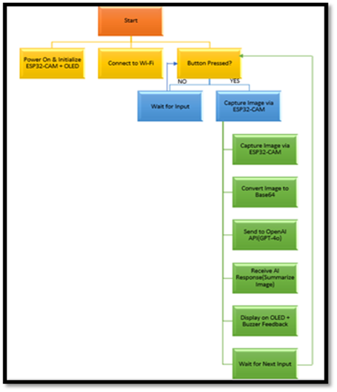
The block diagram represents the overall workflow of the proposed AI-based portable vision system and illustrates how different modules interact to capture, process, and interpret visual data.

Fig. 1. Block Diagram.
It provides a visual representation of the system’s functional flow, starting from user interaction and ending with AI-generated output. Each block in the diagram performs a specific function in the processing pipeline, ensuring that the captured image is efficiently processed and converted into meaningful insights.
The block diagram helps in understanding how the embedded device communicates with cloud-based AI services, how the image data is processed, and how the results are delivered back to the user. The major blocks involved in the system are explained below.
- User Input Module: This is the first stage of the system where the user interacts with the device.
The main functions of this module include:
- Triggering image capture through a button press
- Initiating system operation for processing
- Sending the signal to the embedded system
- Provides a simple interface for user interaction
- Ensures easy and quick system activation.
- Image Acquisition Module: Once the system is triggered, the image is captured using the camera module.
- Capturing real-time images using the ESP32-CAM
- Ensuring proper resolution and clarity
- Preparing the image for further processing
- Captures environmental visual data
- Sends the captured image to the preprocessing stage
- Data Preprocessing Module: The captured image is processed before being sent to the cloud.
- Compressing the image (JPEG format)
- Encoding the image into Base64 format
- Preparing data for efficient transmission
- Ensures optimized data size for network transfer
- Converts image into API-compatible format.
- Cloud AI Processing Module: This module performs advanced AI-based image analysis.
- Sending encoded image to the vision-language model via API
- Processing the image for object detection and scene understanding
- Generating descriptive and contextual outputs.
- Utilizes powerful cloud-based AI models.
- Returns processed results to the device
- Backend Communication Module: This module manages communication between the device and cloud services.
- Handling API requests and responses
- Managing Wi-Fi-based data transmission
- Ensuring secure and reliable communication
- Output and Feedback Module: The final stage presents the AI-generated output to the user.
- Displaying results on the OLED screen
- Providing feedback through buzzer signals
- Ensuring clear and readable output
- Notifying the user upon completion
This workflow ensures efficient integration of embedded hardware with cloud-based AI, enabling real-time intelligent visual interpretation in a portable and cost-effective system.
  - System Component Design
The system component design describes the internal structure of the major modules that form the proposed AI-based portable vision system. Each component is responsible for performing specific tasks within the system, and collectively they enable efficient image capture, processing, and intelligent interpretation. The system is divided into three primary components: the embedded hardware component, the backend/cloud component, and the AI processing component.
These components work together to capture visual data, process and transmit it, generate AI-based interpretations, and present the results to the user in a clear and understandable format. The modular design approach improves maintainability, scalability, and flexibility of the system.
- Embedded Hardware Component Design: The embedded component represents the physical and interaction layer of the system and is responsible for capturing images and providing output to the user.
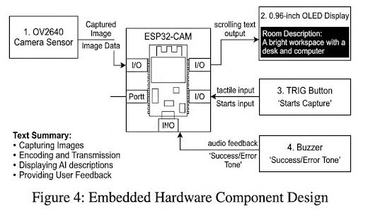
Fig. 2. Embedded Hardware Component Design
It allows users to interact with the system and receive real-time AI-generated outputs.

Main functions of the frontend component include:
- Capturing images using the camera module
- Triggering system operation through a button
- Sending image data to the cloud
- Displaying results on the OLED screen
- Providing feedback through buzzer signals
Major embedded modules include:
- Image Acquisition Module:
- Captures real-time images using the ESP32-CAM
- Ensures proper image quality and resolution
- User Interaction Module:
- Handles button input for triggering operations
- Manages system control flow
- Output Display Module:
- Displays AI-generated results on OLED
- Provides buzzer feedback for notifications
- Communication Module:
- Sends captured image data to backend/cloud
- Receives processed results from AI services
- Backend / Cloud Component Design: The backend component acts as the processing and communication layer of the system. It handles data transmission, manages API communication, and coordinates between the embedded device and AI models.
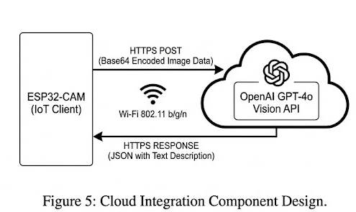
Fig. 3. Cloud Integration Component Design.
The backend ensures efficient data flow and reliable communication between system components.
Major responsibilities of the backend include:
- Handling API requests from the embedded device
- Managing secure data transmission over Wi-Fi
- Forwarding image data to AI models
- Receiving AI-generated outputs
- Sending results back to the embedded system
- AI Processing Component Design: The AI component is the core intelligence of the system. It is responsible for analysing captured images and generating meaningful outputs using vision-language models.
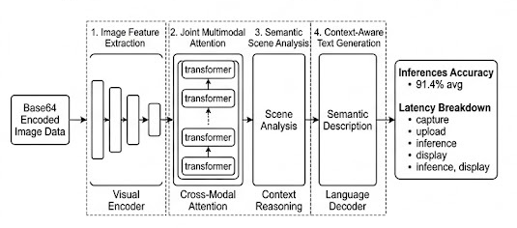
Fig. 4. AI Processing Component Design.

The AI model processes visual input and produces descriptive and contextual outputs.
- Image input processing
- Feature extraction from visual data
- Generating descriptive outputs (object detection, scene description)
- Returning results to the backend system.
This modular component design ensures efficient integration of embedded hardware with cloud-based AI, enabling real-time intelligent vision capabilities in a portable and cost-effective system.

  - Database Design
The database design defines how data used by the proposed AI-based portable vision system is organized, stored, and managed. A well-structured data management approach ensures that system data is easily accessible, secure, and efficiently maintained. Although the primary functionality of the system relies on real-time AI processing, data storage plays an important role in maintaining system logs, user interactions, and configuration settings.
The data structure is designed to support efficient data handling and maintain consistency across different system components. It allows the system to store input data, AI-generated outputs, and system-related information for monitoring, analysis, and future improvements.
The database design mainly focuses on managing the following types of information:
- Captured image metadata and processing logs
- User interaction data (button triggers and system usage)
- AI-generated outputs such as object descriptions and scene summaries
- System configuration and API-related information.
  - Implementation Strategy
The implementation strategy defines the approach followed to develop and deploy the AI-based portable vision system. It outlines the steps involved in building the system, integrating its different components, and ensuring efficient operation. The implementation process focuses on combining embedded hardware, firmware development, and cloud-based AI services into a unified system capable of generating intelligent visual outputs.
The development of the system was carried out in a structured and modular manner, where each component was implemented and tested independently before full integration. This approach helps in identifying issues early and improves overall system reliability.
- System Development Approach: The system was developed using a modular approach, where hardware, firmware, and cloud components were implemented separately and later integrated.
- Technology Stack Selection: Appropriate technologies such as Arduino IDE for firmware development, Wi-Fi communication protocols, and cloud-based AI APIs were selected to ensure efficiency and scalability.
- AI Model Integration: The AI component was integrated using cloud-based vision-language models, enabling advanced image understanding without requiring high computational resources on the device.
- Embedded System Implementation: The hardware implementation focuses on using the ESP32-CAM for image capture, along with OLED display and buzzer for output and feedback.
- Communication Implementation: The system establishes a connection between the embedded device and cloud services using API requests for data transmission and response handling.
- Testing and Validation: After implementing individual modules, the system was tested under different conditions to ensure accuracy, reliability, and real-time performance.
  - Integration Approach
The integration approach describes how the different components of the proposed AI-based portable vision system are connected and coordinated to function as a unified system. Since the system consists of multiple modules such as embedded hardware, firmware processing, cloud-based AI services, and output interface, proper integration is essential to ensure smooth communication and efficient data flow between these components.
The integration process focuses on connecting the embedded device with cloud-based AI services and ensuring seamless data transmission and response handling. The ESP32-CAM captures images, preprocesses them, and sends the data to the cloud through API requests. The cloud-based vision-language model processes the input and returns meaningful outputs, which are then received and displayed on the device through the OLED interface along with buzzer feedback.

This integrated approach ensures that image capture, data transmission, AI processing, and output generation work together efficiently, enabling real-time intelligent visual interpretation in a portable and cost-effective system.

CHAPTER – VI
FEEDBACK AND ITERATIVE REFINEMENT
This chapter describes how feedback from users and evaluators was collected and used to improve the proposed AI-based portable vision system. User feedback helps identify system limitations, usability issues, and potential improvements. Based on the feedback received, necessary refinements were made to enhance system performance, usability, and output accuracy.

  - User Feedback Collection: User feedback was collected from testers, project evaluators, and potential users such as students and developers who interacted with the system. Their feedback helped in identifying areas where the system could be improved.
- Testing the system functionality and image processing workflow
- Observing user interaction with the device and output display
- Gathering suggestions for improving usability and output clarity
  - Evaluation and Prioritization of Feedback: After collecting feedback, the suggestions and issues were carefully evaluated to determine their importance and impact on the system. The feedback was categorized based on priority and feasibility.
- Identifying critical system issues such as response delay and image quality
- Prioritizing improvements that enhance usability and interaction
- Selecting feasible modifications that could be implemented within the project scope.
  - System Refinements across Iterations: Based on the evaluated feedback, several improvements were implemented in different stages of system development. These refinements helped enhance the overall functionality and reliability of the system.
- Improving image capture quality and preprocessing efficiency
- Enhancing AI response accuracy through better prompt handling
- Optimizing system performance and reducing response latency

CHAPTER – VII
TESTING AND VALIDATION
Testing and validation are important steps in the development of the proposed AI-based portable vision system. This process ensures that the system functions correctly, produces accurate outputs, and provides a reliable user experience. Various testing methods were used to verify that each component operates as expected and that the integration between modules works smoothly.

  - Types of Testing Performed: Several testing techniques were used to ensure that the system functions properly and meets the desired performance standards.
The main types of testing performed include:
- Unit Testing: Unit testing was conducted to verify the functionality of individual modules in the system.
- Image capture using the ESP32-CAM
- Image preprocessing and encoding functions
- API communication and response handling
- Integration Testing: Integration testing was performed to ensure smooth communication between different components of the system.
- Embedded device communication with cloud APIs
- Data flow between image capture and AI processing
- Response handling between cloud and device
- Functional Testing: Functional testing verified that the system performs all required functions according to the project specifications.
- Capturing images through user interaction
- Processing image data and sending it to the cloud
- Generating AI-based outputs using vision-language models
- Displaying results on the OLED screen
- User Interface Testing User interface testing was conducted to evaluate the usability and responsiveness of the system.
- Display clarity on OLED screen
- User interaction through button input
- Feedback using buzzer signals

  - Test Result Summary: After conducting the various testing procedures, the system demonstrated reliable performance and satisfactory functionality. The results showed that the system is capable of capturing images, processing data, and generating meaningful AI-based outputs in real time.

Test Type | Module Tested | Description of Testing
Unit Testing | Hardware Components | Verified camera capture, encoding, and basic device operations
 | Communication Module | Tested API request and response handling
 | AI Processing | Verified output generation from cloud AI model
Integration Testing | Device – Cloud | Tested communication between embedded device and cloud services
 | Data Flow | Verified complete pipeline from image capture to output display
Functional Testing | Full System Workflow | Tested complete process from input trigger to AI output
User Interface Testing | Device Interface | Checked usability, display clarity, and feedback mechanisms
Performance Testing | System Response Time | Verified response generation within acceptable time limits

Table 3. Summary of Testing Perfomed
  - Bug Fixes and Improvements: During the testing phase, several minor issues were identified and addressed to improve the system’s reliability and performance. Fixing these issues helped enhance the usability and efficiency of the system.
The major improvement made include:
- Improved Input Validation: Ensured that captured images meet basic quality requirements (clarity, lighting) before processing to improve AI output accuracy.
- Enhanced error handling to manage issues such as network failures, API errors, and invalid responses, preventing system crashes.
CHAPTER – VIII
RESULT AND DISCUSSION
This chapter presents the results obtained from the proposed AI-based portable vision system and discusses the overall system performance. It includes evaluation of the system output, efficiency, and comparison with conventional approaches. The results demonstrate the effectiveness and reliability of the proposed system.

  - Evaluation of The System: The performance of the machine learning model was evaluated using appropriate evaluation metrics and output observations. The model was trained on construction-related data and tested with various input parameters such as area, material quality, and labor cost.
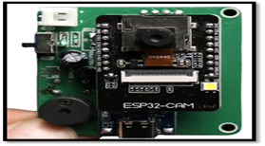
Fig. 5. Hardware Implementation of the System.
Fig. 5 shows the hardware setup of the system, including the ESP32-CAM and supporting components used for image capture and processing.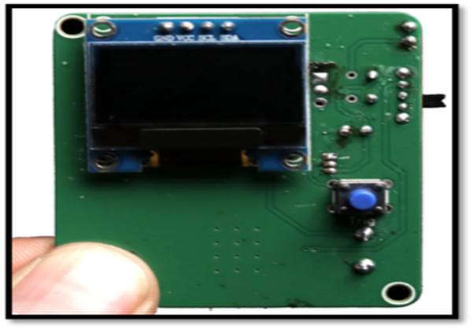
Fig. 6. OLED Display and User Interaction Module.
Fig. 6 illustrates the OLED display and button interface used for user interaction and output visualization.
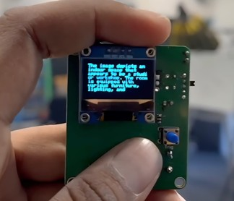
Fig. 7. Output Display of AI-Generated Result.
Fig. 7 demonstrates the output generated by the system, where the OLED screen displays the scene description or detected objects.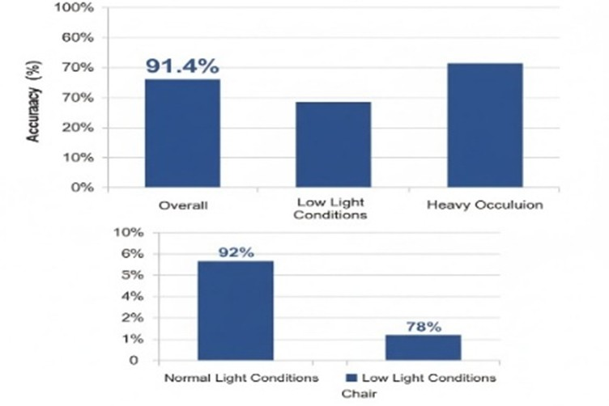
Fig. 8. Accuracy Analysis under Different Conditions.
Fig. 8 illustrates the accuracy of the system under various conditions such as normal lighting, low light, and occlusion. The results indicate that the system performs effectively in real-world scenarios with acceptable accuracy.
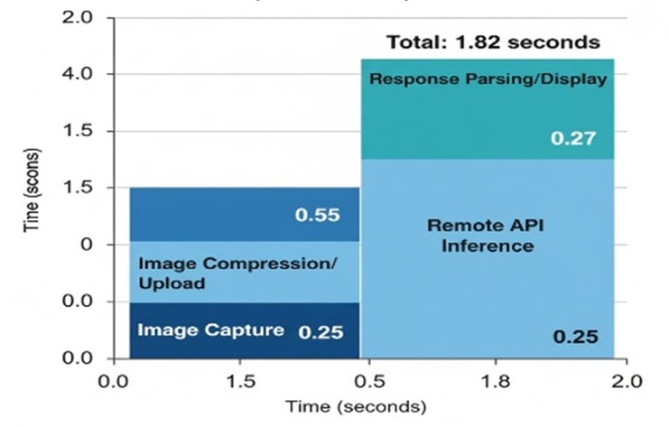
Fig. 9. System Response Time Breakdown.
Fig. 9 presents the response time analysis of the system, including image capture, data transmission, AI processing, and output display stages. The total response time is observed to be approximately 1–3 seconds.

  - System Performance Results: The system performs efficiently with minimal response time and stable execution. The embedded device captures images quickly, and the cloud-based AI model generates outputs with acceptable latency. Overall, the system demonstrates good performance suitable for real-time applications.
Metric | Description | Result
Response Time | Time taken from image capture to output display | 1- 3 Seconds
Accuracy | Correctness of AI-generated output | High
System Reliability | Ability to perform consistently without failure | Stable
Scalability | Ability to handle multiple requests via cloud APIs | Moderate
Resource Utilization | Memory and power usage of device | Optimized
Table 4. Summary of System Performance Result
  - Security and Sandboxing Results: Basic security mechanisms were implemented to ensure safe system operation. Secure API communication, input validation, and error handling prevent misuse and ensure reliable performance. The system handles network interruptions and API failures gracefully.
  - Comparative Discussion: The proposed system offers several advantages compared to traditional visual interpretation methods.
- Provides real-time image understanding
- Reduces human effort in analyzing visual information
- Ensures consistent and AI-driven outputs
- Offers portability and low-cost implementation
Overall, the system demonstrates an efficient and scalable approach for integrating embedded devices with advanced AI capabilities.

CHAPTER - IX
CONCLUSION & FUTURE SCOPE

  - Conclusion
The proposed AI-based portable vision system was successfully developed to provide an efficient and low-cost solution for real-time visual understanding. The system integrates embedded hardware with cloud-based vision-language models to capture images, process them, and generate meaningful outputs such as object detection and scene description.
The project addressed the limitations of traditional vision systems, which often require high computational resources and expensive hardware. By leveraging a hybrid edge–cloud architecture, the system enables advanced AI capabilities using affordable components such as the ESP32-CAM. The developed system demonstrates fast response time, reliable performance, and practical usability, making it suitable for applications such as assistive technology, smart monitoring, and IoT-based environments.

  - Future Scope
Although the current system performs effectively, there are several areas where further improvements can enhance its capabilities and make it more suitable for real-world deployment.
- Advanced AI Models:
- Real-Time Data Optimization
- 3D Scene Understanding
- Mobile Application Development
- Audio Output Integration
- Offline AI Capability

REFERENCES

- Alec Radford, Jong Wook Kim, Chris Hallacy, Aditya Ramesh, Gabriel Goh, Sandhini Agarwal, Girish Sastry, Amanda Askell, Pamela Mishkin, Jack Clark, Gretchen Krueger, and Ilya Sutskever, “Learning Transferable Visual Models from Natural Language Supervision,” arXiv preprint arXiv:2103.00020, 2021.
- Jiasen Lu, Dhruv Batra, Devi Parikh, and Stefan Lee, “ViLBERT: Pretraining Task-Agnostic Visiolinguistic Representations,” Advances in Neural Information Processing Systems (NeurIPS), 2019.
- Hao Tan and Mohit Bansal, “LXMERT: Learning Cross-Modality Encoder Representations from Transformers,” Proc. of the 2019 Conference on Empirical Methods in Natural Language Processing (EMNLP), pp. 5099–5110, 2019.
- Edoardo Alayrac, Jean-Baptiste Alayrac, Iro Laina, Stella X. Yu, Aaron van den Oord, Olivier Bachem, and Andrew Zisserman, “Flamingo: a Visual Language Model for Few-Shot Learning,” arXiv preprint arXiv:2204.14198, 2022.
- Tianlang Chen, Jiajun Wu, Xun Wang, Minghao Zhang, Xiangyu Zhang, Yi Yang, Jianwei Yang, and William T. Freeman, “OFA: Unifying Architectures, Tasks, and Modalities Through a Sequence-to-Sequence Framework,” arXiv preprint arXiv:2109.04401, 2021.
- Junnan Li, Dongxu Li, Caiming Xiong, and Steven Hoi, “BLIP: Bootstrapping Language-Image Pre-training for Unified Vision-Language Understanding and Generation,” arXiv preprint arXiv:2201.12086, 2022.
- Junnan Li, Dongxu Li, Caiming Xiong, Steven Hoi, and Xiaodong He, “BLIP-2: Bootstrapping Language-Image Pre-training with Frozen Image Encoders and Large Language Models,” arXiv preprint arXiv:2301.12597, 2023.

- Alexey Bochkovskiy, Chien-Yao Wang, and Hong-Yuan Mark Liao, “YOLOv4: Best Speed and Accuracy of Object Detection,” arXiv preprint arXiv:2004.10934, 2020.
- A. Dosovitskiy et al., “An Image is Worth 16x16 Words: Transformers for Image Recognition at Scale,” International Conference on Learning Representations (ICLR), 2021.
- C. Szegedy, W. Liu, Y. Jia, P. Sermanet, S. Reed, D. Anguelov et al., “Going Deeper with Convolutions,” Proc. IEEE Conf. on Computer Vision and Pattern Recognition (CVPR), pp. 1–9, 2015.
- K. He, X. Zhang, S. Ren, and J. Sun, “Deep Residual Learning for Image Recognition,” Proc. IEEE Conf. on Computer Vision and Pattern Recognition (CVPR), pp. 770–778, 2016.
- S. Ren, K. He, R. Girshick, and J. Sun, “Faster R-CNN: Towards Real-Time Object Detection with Region Proposal Networks,” Advances in Neural Information Processing Systems (NeurIPS), 2015.
- M. Tan and Q. V. Le, “EfficientNet: Rethinking Model Scaling for Convolutional Neural Networks,” International Conference on Machine Learning (ICML), pp. 6105–6114, 2019.
- Z. Zhang, Y. Zhao, and J. Wang, “Edge Intelligence: On-Demand Deep Learning Model Co-Inference with Device-Cloud Synergy,” Proc. ACM SIGCOMM, pp. 1–14, 2022.
- J. Kwon and S. Yoon, “Tiny Machine Learning on ESP32 for Real-Time Image Classification,” IEEE Access, vol. 10, pp. 88321–88333, 2022.

PUBLICATION
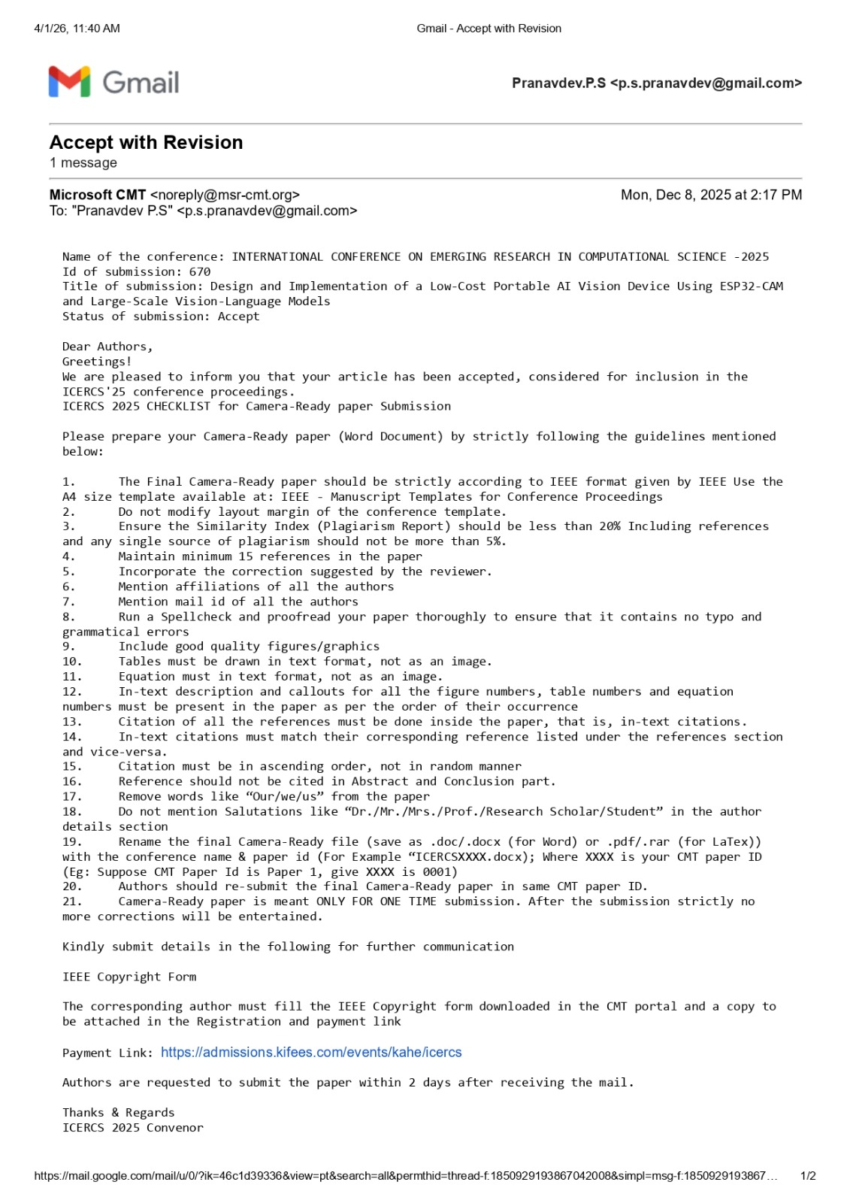

CERTIFICATIONS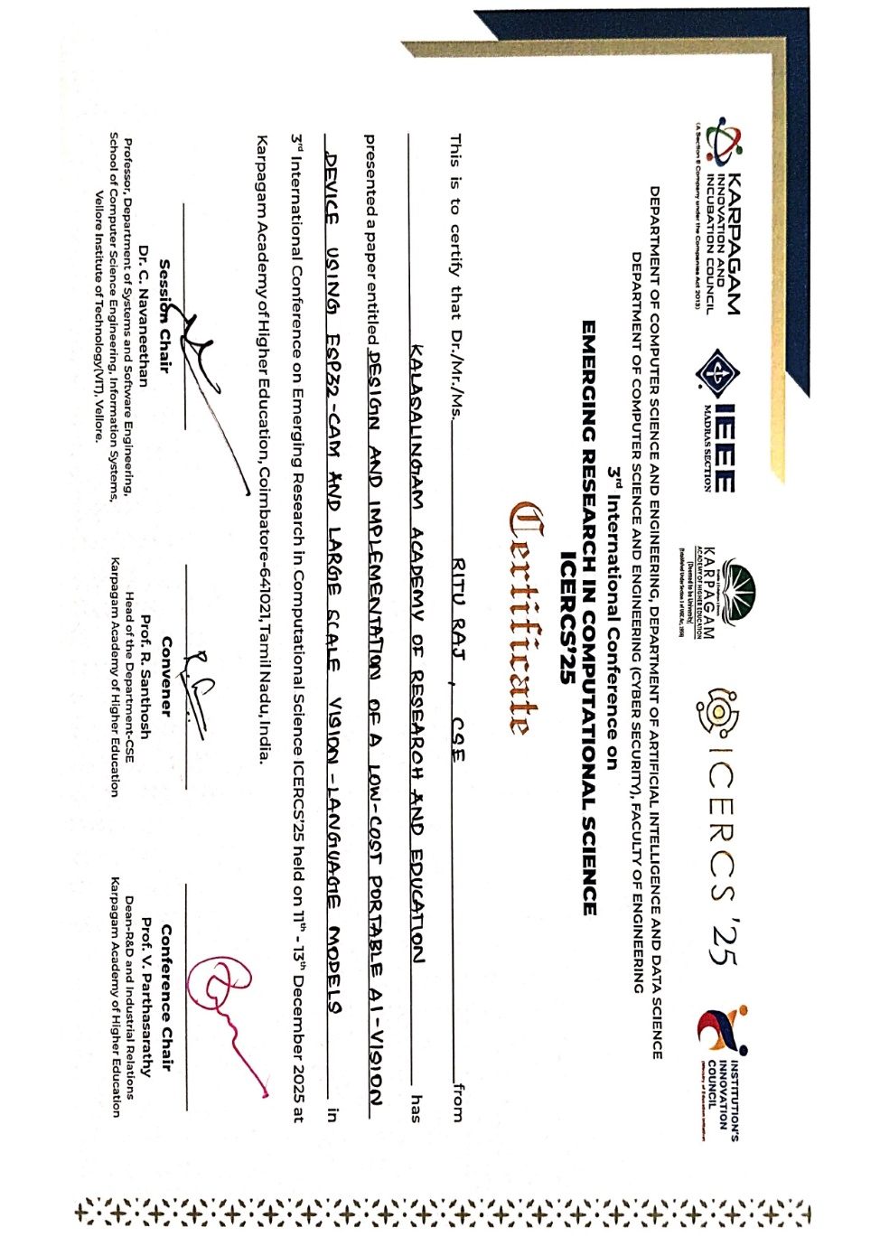
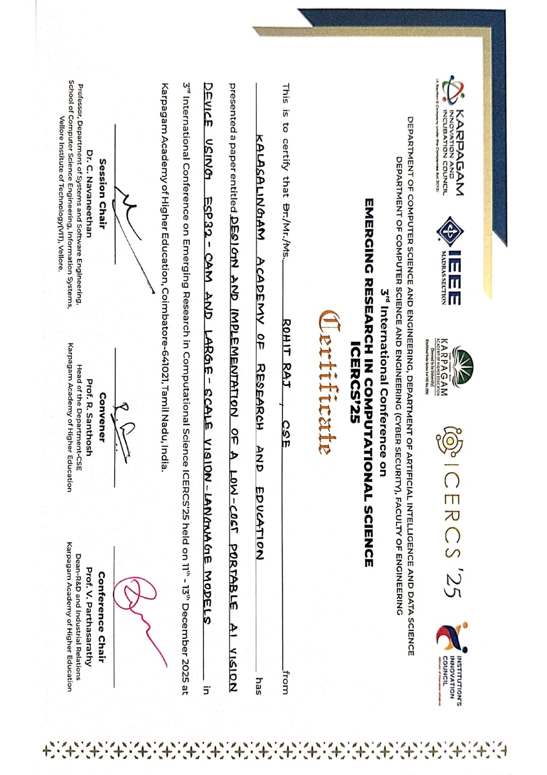

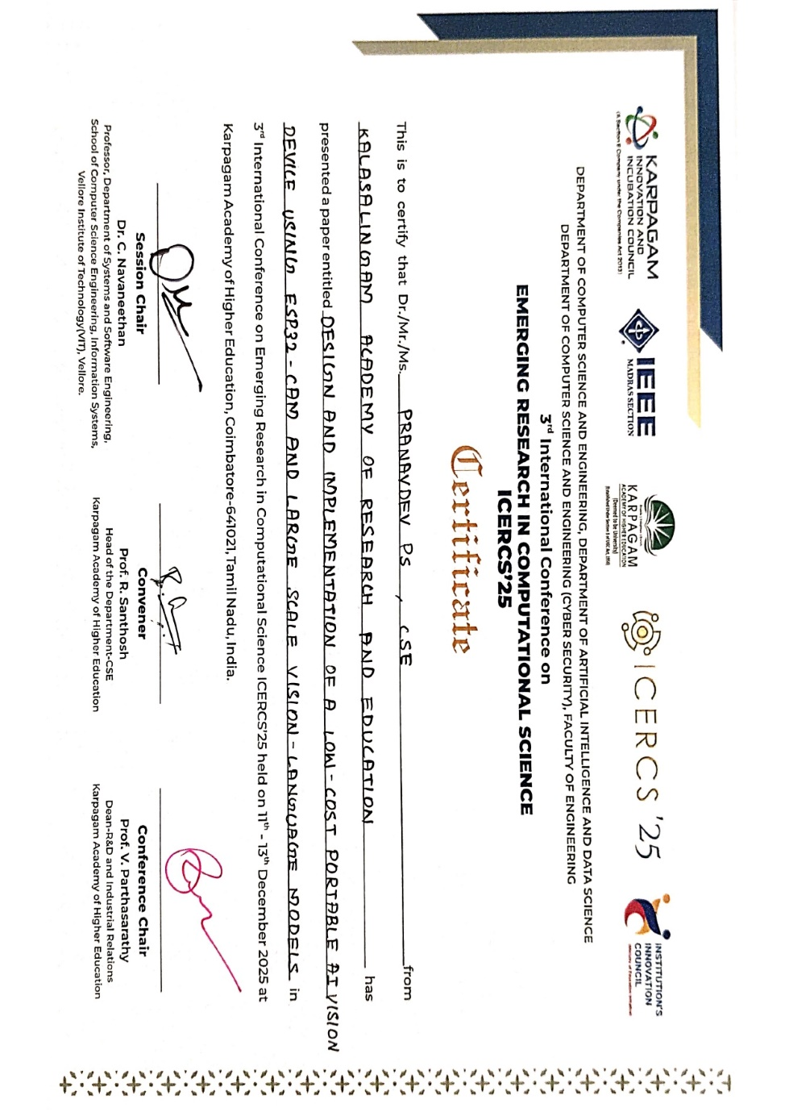
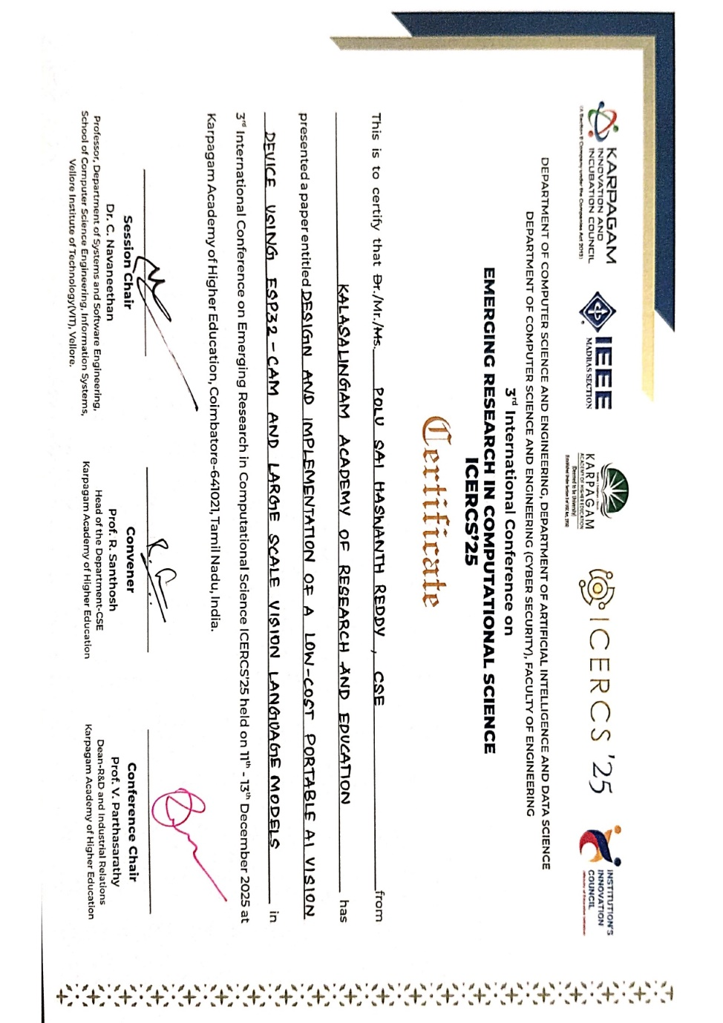

PLAGARISM REPORT


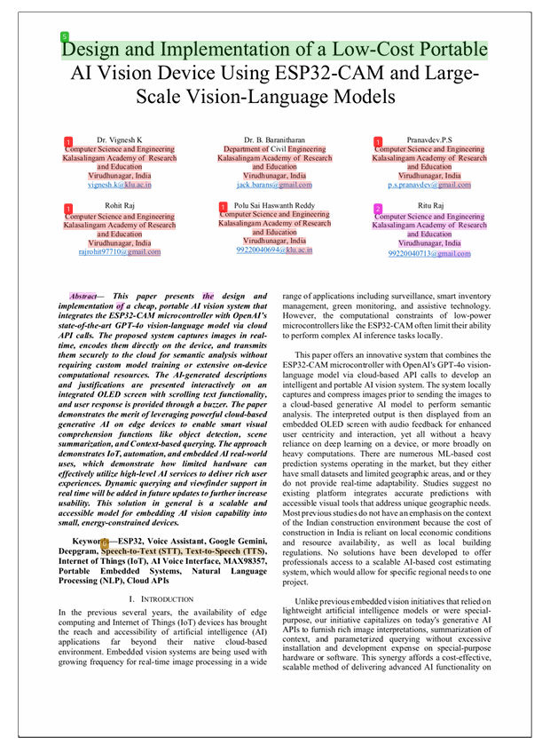




INTERNAL QUALITY ASSURANCE CELL
PROJECT AUDIT REPORT

This is to certify that the project work entitled Design and Implementation of a Low-Cost Portable AI Vision Device Using ESP32-CAM and Large-Scale Vision-Language Models categorized as an internal project done by Rohit Raj, Ritu Raj, Pranavdev.P.S , Polu Sai Haswanth Reddy of the Department of Computer Science and Engineering, under the guidance of Dr. K. Vignesh during the Even semester of the academic year 2025 – 2026 are as per the quality guidelines specified by IQAC.

Quality Grade

Deputy Dean (IQAC)

Administrative Quality Assurance Dean (IQAC)

